SOAP Format
Trainee Handouts

Table of Contents

Training Objectives…………………………………………………………………………...2
SOAP Format 3
Medical EPSS (STR Tool) 4
Components and Variations of SOAP 5
Review Practical Exercise 6

TRAINING OBJECTIVES

At the end of this training course, you will be able to:

- Recall each part of SOAP from memory,

- Using the trainee handouts, identify the SOAP format utilized in STRs with 100% accuracy and,

- Using the trainee handouts, identify the variations of the SOAP format in STRs with 100% accuracy.

SOAP Format

SOAP method in service treatment records (STRs) is the most commonly utilized method of documenting a treatment visit. When a service member visits a clinic or hospital, the treatment provider usually utilizes the SOAP format to document the visit. These documents comprise our service treatment records (STRs).

SOAP stands for:
- Subjective
- Objective
- Assessment
- Plan

A service member may visit a treatment provider or medical staff and the visit will be documented in this format. It is important to note that not all STRs are documented using this format. You will generally see this format in the more recent STRs, especially in electronically documented STRs.

Medical EPSS (STR Tool)

Medical EPSS is a tool and a reference to use when reviewing service treatment records (STRs). Specifically, the “STR Tool” within Medical EPSS may aid in the review of STRs and determining the components of SOAP format.

MEDICAL EPSS (found in the C&P Training Website)

- Click on “Tools”
- Click on “STR Tool”
- Click on “Standard Form 509, Progress Notes”
- Click on “Note”
- SOAP Format is utilized in this particular treatment report.

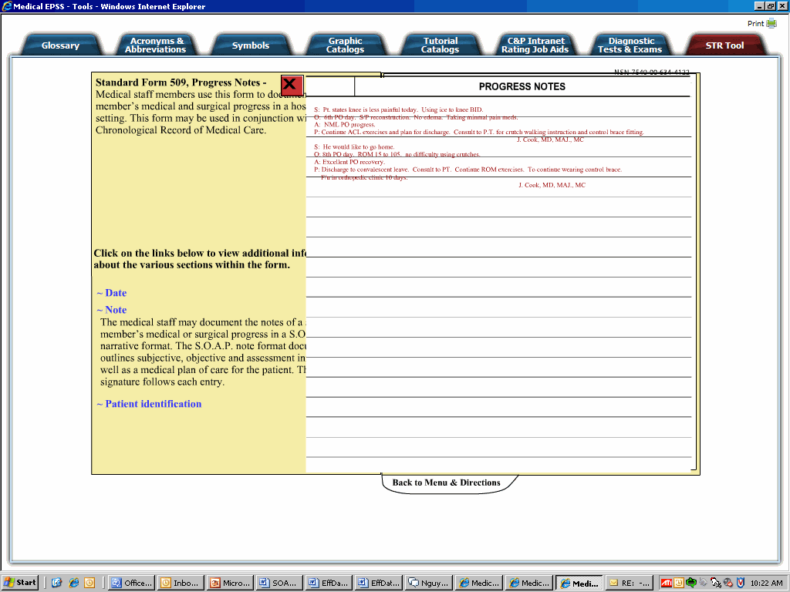

Components and Variations of SOAP

Please fill out the components of SOAP as discussed in classroom. Also, list their variations usually found in service treatment records (STRs):

S: ____________________________________

O: ____________________________________

A: _____________________________________

P: _____________________________________

What is the main difference between “Subjective” and “Objective” portions of a treatment report?

_____________________________________________________________________

Review Practical Exercise

This exercise will give VSRs the opportunity to apply knowledge to claims cases by identifying various components of SOAP format within service treatment records.
(See answer key for suggestion).

Instructions: In the following scenarios, please provide the correct SOAP component for each.

- “Diagnosis: Left knee strain”
__________________________________________________________________

- “Patient complains of sore throat. Patient says that redness and swelling of throat causes painful swallowing. Took 2 Aleve in past 1 hour.”
__________________________________________________________________

- “Patient should continue back exercises to alleviate lower back pain. Patient should alternate ice & heat when pain occurs at nighttime. 800mg Motrin prescribed up to 3 x day.”
__________________________________________________________________

- “S/P ACL reconstruction. Dry & intact. No mottling of lower leg. Toes warm to touch, no discoloration of nail beds. Full mobility of toes.”
__________________________________________________________________

- “Patient says he cannot lift left arm above shoulder. Prognosis is: left shoulder rotator cuff syndrome.”
__________________________________________________________________

