MAP-D evidence and notes

Training Handout
PREREQUISITE TRAINING | Prior to this training lesson, you must have completed COVERS and SHARE training.
PURPOSE OF LESSON | The purpose of this lesson is to teach you the use of MAP-D notes and how to properly update solicited and unsolicited evidence in the MAP-D system.  At the completion of the lesson you will be able to:  - Define and administer the use of MAP-D notes  - Identify mail that is part of an on-going claim (update existing controls)  - Administer use of “received” filed to record evidence received
Time Required | 1-hour classroom; 30 minutes for a demonstration of updating evidence requested and received and 30 minutes practical exercise.
Materials/ Training Aids | - MAP-D PowerPoint Presentation  - MAP-D Trainee Handout

References

MAP-D User Guide
Fast Letter 06-11 with Attachment
MAP-D Quick Reference Guide (02/08, 08/08, 02/09 & 05/10)

Table of Contents

References ………………………………………………………………… | 2
What is MAP-D?…………………………………………………………… | 4
Use of Contact Notes……………………………………………………… | 5
Use of Development Notes……………………………….………………. | 5
Notes………………………………………………..………………………. | 6
Add Notes…………………………….…………………………………….. | 7
View Notes……………………………………….………………………… | 8-9
Editing or Viewing Note Text……………………………….……………. | 9
Removing a Note…………………………………………………………. | 10
Displaying Notes for all Claims or Current Claim………………………. | 11
Changing the View………………………………………………………… | 11
Displaying CAPS Notes…………………………………………………… | 13
Launching IRIS…………………………………………………………….. | 14
Development-Waiting for Evidence……………………………………… | 14
Process Evidence…………………………………………………………. | 15
Inventory Management…………………………………………………… | 16
All Evidence Received/Ready to Rate………………………………….. | 17
Practical Exercise…………………………………………………………. | 19

What is MAP-D?


Modern Award Processing – Development (MAP-D) is a tool to help perform claims development, but most importantly, it is a way for the VA to provide good customer service to our veterans and their families.

MAP-D, like any other application, depends completely on the user’s data input. The more you put into the system, the more you will get out of it. The opposite is also true. This application can help you provide excellent customer service. When development actions are taken using MAP-D, and all these items are automatically inserted into the Customer Service Tracking screen, inquiries can be quickly and easily resolved. You will know, just by looking at the screen, what development actions were taken, what evidence has been received and what evidence is still outstanding.

You can record contacts with claimants using this system. MAP-D also has links, or launches, to the following applications: Share, COVERS, VACOLS, and IRIS. With a click of a button, you can move from one application to the next.

There are two basic ways to use MAP-D --- automatic development and directed development.

Notes

Use of Contact Notes (Public Contact Team)
- All stations should routinely prepare Contact/Development Notes following contact bearing on the claim with a claimant or other interested party.
- Not every call needs to be reflected in the MAP-D Contact Notes. State the facts only, not opinions. Do not write anything in MAP-D, or any other VA records system, that you would not want to be seen before the general public or the Court.
- The following scenarios should be noted in Contact Notes by the public contact team:

  - Commitments or promises made to the caller.
  - Information produced by the phone call that would be helpful to the
      - next VSR.
  - Actions taken as a result of the call.
  - Occurrence of “difficult” phone calls.
  - Specific items requested by phone development or claims received
over the phone (38 CFR 3.155) (also send a VAF 119 via e-mail to the
regional office of jurisdiction (ROJ).

Use of Development Notes - Update development notes when telephone development supplements letter development.

Notes

The Notes screen is used to enter notes that are associated to a claim or a participant. Some notes have default suspense dates, which means they also have a status code. These notes are tracked until they are "closed" by the VSR or the system.

Notes can be modified or removed if this is done by midnight of the date the note was created. Notes are considered a permanent part of the claims file once that deadline has passed.

MAP-D has three types of notes: Contact Notes, Development Notes, and Notes to Myself.

Contact Notes - are like a VA Form 0820. When you speak to a claimant, documentation of this conversation will be in the form of a Contact Note. These notes may or may not be associated with a particular claim. These notes, if not altered by the end of the day, become a permanent part of the claims file.

Development Notes - are those note that you make to remind yourself about some aspect of the development of the case. For instance: you could make yourself a note that says, "When the DD214 comes in, check for Character of Discharge." These notes, if not altered by the end of the day, become a permanent part of the claims file.

Notes to Myself - are viewable only to the person who typed the note.

Notes can also have a suspense date associated to them. If a suspense date is entered, the system will have a tracked item associated to the note. When the suspense date is reached, the user is notified via the Work List that the date has been reached. Notes can also satisfy the periodic notification requirement. When selected, the system resets the notification to claimant counter.

Add Notes

The Add Notes screen is used to enter notes that are associated to a claim or a participant. The VSR can enter a textual comment or note. Some notes have default suspense dates, which means they also have a status code. These notes are tracked until they are "closed" by the VSR or the system.

The Add Notes screen displays from the Claimant Letter, Claims Work Assignment, Contentions, Claims Level Suspense Method, Print Screen, Third Party Development, Notes, or Work List screens.

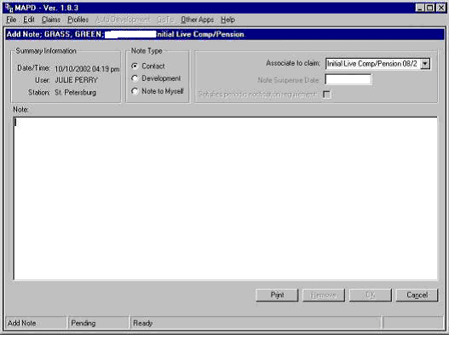

Adding a Note

Use the following procedure to add a note.

- If you are adding a note from the Claims Work Assignment or Work List screen, highlight the claim (line) to add a note to. The Add button is enabled when a single line is highlighted.
- Select: Add from one of the available screens.
- The Add Note screen displays. All fields are enabled. The Note Type is set to Contact by default.
- Enter note information in the fields.
- A selection is required for the Note Type (Contact, Development, or Note to Myself).
- To associate this note with a particular claim, click on down arrow in Associate to Claim and make appropriate selection. Only one selection per note is allowed.
- To set a suspense date (will appear in your Work List under Suspense Dates Past Due), you merely type in the date.
- If this note will satisfy case management criteria, click on the Satisfies periodic notification requirement field (this places a check mark in the field). If the note satisfies case management, no suspense date is required (or allowed). The Claimant Contact Interval clock is reset and you are notified via Work List when case management activity is again required.
- Type the body of your note in the Notes field. You can also cut and paste from other sources into the note screen
- Select: OK to accept the note. The previous screen displays.

View Notes

The Notes screen that is displayed when View is selected in the Notes box will show a grid view of the notes for the current claim. The Text Box View button, when pushed, will show the full text of all notes. You can print this history of note text by selecting the Print button. If there are more notes than can be displayed on the screen, you can get to those notes by using the DOWN ARROW.

If there are other claims under this file number, selecting All Claims will display all notes. The text of these notes too, can be printed. If there are more notes than can be displayed on the screen, you can get to those notes by using the DOWN ARROW.

The View Notes screen is used by the VSR to view any notes that have already been entered. If desired, while viewing existing notes, the VSR may enter a new one. Filters are available to narrow down the number of notes that will be retrieved. You can request to see the notes for All Claims, or restrict the notes to just the notes on the current claim.

If the claim was a CAPS claim in the past, the notes that were a part of that CAPS claim will be available to you for viewing by selecting Claims in the menu bar, then selecting CAPS notes.

Some notes have default suspense dates, which means they also have a status code. These notes are tracked until they are "closed" by the VSR or the system.

The user shall be able to view notes about:

- Contacts with the claimant. This note can be associated to the claimant or claim, may not contain a suspense date, may satisfy periodic notification requirements (when associated to a claim), and cannot be altered or removed after the calendar day it was created.
- Development notes. This note must be associated to the claimant, may contain a suspense date, may not satisfy periodic notification requirements, and cannot be altered or removed after the calendar day it was created.
- Notes to myself. This note must be associated to a claim, may contain a suspense date, may not satisfy periodic notification requirements, may only be viewed by the original author, and may be altered or removed by the original author at any time.
- Messages between users. (A message is not a note, however, it is discussed here to show the distinction between a message and a note). Messages are not maintained as notes and are not part of the permanent record and do not contain a suspense date (however, they can be viewed through the Work List)

The View Notes screen displays from the Claimant Letter, Claims Work Assignment, Contentions, Claim Level Suspense Method, Print Screen, Third Party Development, Notes, or Work List screens.

Editing or Viewing Note Text

Use the following procedure to view/edit note text.

- Select: View from one of the available screens.
- The View Notes screen displays.
- Highlight the note that you wish to view.
- Select: View/Edit. The entire note is displayed.
You will notice that on the View Notes screen there are filters to narrow down the number of notes that will be retrieved. You can request to see the notes for All Claims or restrict the notes to just the notes on the Current Claim.

Removing a Note

Use the following procedure to remove a note.
- Highlight the desired note on the View Notes screen.
- Select: Edit. The entire note is presented for review.
- Select: Remove
- If the note has been added during the current day, you will be advised that removing the note will make it unrecoverable and asked if you want to proceed. If Yes is selected, the note is removed.

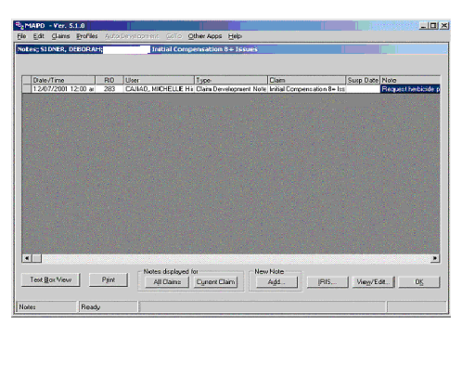

Displaying Notes for All Claims or Current Claim

Notes can be viewed for all claims associated with the participant or the current claim only.
Use the following procedure to view notes associated with all claims in the View Notes screen.

- Select: View from one of the available screens.
- The View Notes screen displays.
- Select: All Claims in the Notes displayed for frame.
- The grid displays all associated claims.

Use the following procedure to view notes associated with the current claim only in the View Notes screen.

- Select: View from one of the available screens.
- The View Notes screen displays.
- Select: Current Claim in the Notes displayed for frame.
- The grid displays only notes for the current claim.

Changing the View

There are two options available to view notes: Text Box View and Grid Box View. The Text Box View displays all of the notes in a list. All of the entered information displays for viewing. The Grid Box View displays all of the notes in a grid. Information that displays outside the column width cannot be viewed, unless the column width is changed. A toggle button is used to change the view

Use the following procedure to change the note text view.

- Select: Text Box View to change the view to the text box view

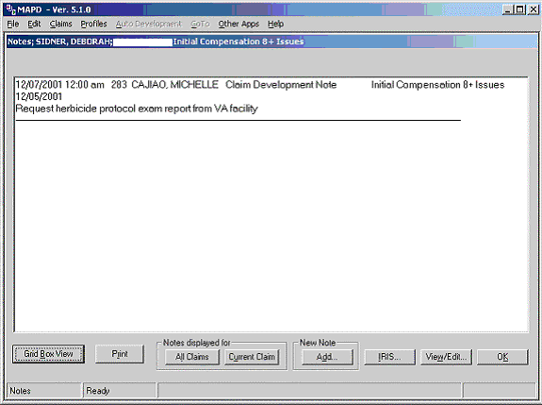

  - OR –

Select: Grid Box View to change the view to the grid box view

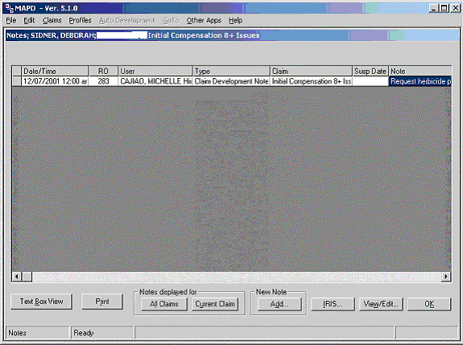

Displaying CAPS Notes

If the claim was a CAPS claim in the past, the notes that were a part of that CAPS claim will be available to you for viewing.

Use the following procedure to view CAPS notes.

- Select: Claims from the menu bar.
- Select: CAPS Notes and the notes are displayed.

Launching IRIS

The IRIS system can be launched from the View Notes screen.
Use the following procedure to launch IRIS.
- Select: View from one of the available screens.
- The View Notes screen displays.
- Select: IRIS
- The IRIS system is launched.

Printing a Note

Use the following procedure to print a note.
- Select: Print on the Add (Edit) Notes screen.
- The note that is currently displayed prints on the attached printer.

Development – Waiting for Evidence

Process | Action | Specifications | Typical  Responsibility
Development-  waiting for evidence | Requested evidence is received or additional evidence is developed. Suspense dates expired. | Evidence is recorded using the actual date received or date additional evidence is requested. Items can be closed when it is determined that we have not received a response and the suspense period has expired. | Triage  Pre-D  Post-D  Public Contact

Process

Once evidence and/or information is requested, track each request to record the responses received and situations where no response is received.

The MAP-D tracked items grid has several possible dispositions for a request, including:

Received – Use this when evidence requested is received, or a negative response from the information provider is received.

Closed – Use this to administratively close a tracked item for non-receipt. The earliest date an item can generally be closed is upon review that the suspense date has expired and the timeframe given for a response has elapsed. This includes any necessary follow-ups.

Use other dispositions, including “in error” and “follow-up,” as the circumstances dictate. The “in error” should reflect tracked items erroneously requested, while “follow-up” denotes a subsequent request for the same information.

- Each time a new piece of requested evidence is received, it is recorded as received in the tracked-items grid.

- The date to be used for receipt of evidence is the actual date it was received, which is generally indicated by the date stamp

- In the event there is no date stamp, the date is whatever day it can be reliably determined that the evidence was received by VA, or in the case of intra-agency material, the date it was received by the regional office (RO).

- Any evidence or response, which is obtained by telephone, will be recorded using the date of contact.

- If no response is received within the appropriate time limits, to include any necessary follow-ups, the tracked item will be closed.

- If a duty-to-assist development letter is sent and the claimant responds within the appropriate time limit with information regarding treatment or other evidence, the initial tracked item would be marked “received” and a new one, such as for sending a request for records to a private health care provider, would be established.

- If a tracked item is closed due to non-receipt but the evidence is later received while the claim is still pending, the new “received” date will supercede the prior “closed” date.

Inventory Management

Summary Reports

At the present time, both “evidence receipt” and “time to close" are computed using an average of all tracked items received or closed. Two items received in 30 and 90 days would show an average of 60 days.

Average Evidence Receipt Time

In the “to be” state, this measurement will compute the time from when development for the first tracked item is initiated until the last tracked item is received. The resulting receipt time is based on longest span from when the first piece of evidence is requested until the last piece is received.

Using the example above with two items received at 30 and 90 days, if both were requested on the same date, the result would be 90 days. In this case, 90 days represents the actual time VA waited to receive the requested evidence.

Average Time to Close

In the “to be” state, this measurement will compute the time from when a tracked item is requested until the last tracked item is closed. The resulting closed time is based on the longest span from the date the first piece of evidence is requested until the last piece is closed.

Using the example of three tracked development items, if two were received in 30 and 45 days, the evidence receipt time would be 45 days. The third item required a follow-up at 60 days, and was finally closed out 30 days after the follow-up. The time to close would show 90 days, which could be compared to the evidence receipt time of 45 days. Using both can provide a greater degree of accuracy as to delays in the claims process.

Note: These indicators are mutually exclusive at the tracked item level. A tracked item cannot be both received and closed.

All Evidence Received and Ready to Rate

Process | Action | Specifications | Typical  Responsibility
All evidence received – Ready for decision? | All requested items received or closed | No tracked items related to the issues being rated should be left open. This does not apply to issues that will be deferred. | Triage  Pre-D
Claim determined ready for decision | Assessed as ready for decision | Date assessed as ready for decision | Pre-D

Process

- In the claims process, receiving all the evidence requested, or expiration of the suspense date, triggers the next step in the process.

- In order to get to that step, it must be determined that all the evidence has been received or the tracked items closed.

- The fact that all the tracked items are received or closed does not automatically mean that the claim is ready for a decision. Such a determination must be based on analysis of the evidence of record. Determinations of ready-for-decision cases should be made in the Pre-Determination Team.

- A claim is considered “ready for decision” after all the requested evidence has been received or otherwise accounted for, ensuring that VA’s obligations to assist the claimant have been met.

All open tracked items must be shown as received, closed, or in error BEFORE a VSR changes the status to “Ready for Decision.”

In the event that a claim is ready for a partial grant, only close the items relating to that issue. All other items must be left open for receipt of the evidence requested.

In cases where items are not received but all issues can be granted without the requested items, DO NOT close the items until such time the suspense period has expired or the items have been received, whichever is earlier.

In all of these claims (above), the status should be changed to “Ready for Decision.”

- The date of “ready for decision” is based on the actual day the claim was determined to be ready for a decision and then sent, or made available to, the responsible team.

- If a case is returned to the Pre-Determination Team because it is not ready to rate, the RVSR or other Rating Team member will change the ready for decision status to open.

Practical Exercise

1. Name the three types of notes in MAP-D. Describe the functions.

2. List the name and content of the four different notes the user should be able to view.

3. What are the two options available to view notes? What do they display?

4. List the procedure used to view CAPS notes.

5. When is a claim considered “Ready for Decision”?

