COVERS mail, FOLDER and report CONTROL
training handout

PREREQUISITE TRAINING: | Prior to this training the trainee should have completed training for Introduction to COVERS.
PURPOSE OF LESSON:  OBJECTIVE | The purpose of this lesson is to teach the trainees the proper procedures for processing folder requests and mail searches using COVERS. Trainees will also learn how to run reports using COVERS.  This lesson will present the following material to the trainee:  - Describe the functions used for folder requests and mail search in COVERS  - Demonstrate proper procedure to request folders through COVERS  - Demonstrate how to change/delete folders and mail in COVERS  - Demonstrate how to use the report function in COVERS
TIME REQUIRED: | Total 2 hrs (lecture and demonstration)
Materials/ Training Aids: | - COVERS Trainee Handouts

TABLE OF CONTENTS

References…………………………………………………………………………………3
Folder Request and Mail Searches…………………………………………... …………...4
Request………………….…………………………………………………………………5
Request A Folder & Change/Delete Search ………………………………...………….……..6
Delete Search for a Single Folder…………………..……………………………………..7
Delete Search for a Specific Criteria…………….………………………………………..8
Delete Mail Search In Bulk……………………………………….………………………9
Re-assign Search & Reports……………………...……………………….……………..10
Select a Report…………………………………………………………..……………….11
Multiple Folder Inquiry………………………………………………………………….13
Mark Folder For Mail Screen……………………………………………………………14
Delete Search For A Single Folder Screen…………………………………………...15/16
Delete Search For A Specific Criteria Screen……………………………………………17
Delete Mail Search In Bulk Screen………………………………………………….…...18
Change/Delete Screen……………………………………………………………………19

REFERENCES

COVERS Guide located at:
http://vbaw.vba.va.gov/bl/21/System/covers.htm

VETSNET System Access Guide (pg 6-9)

M21-1MR, Part III, Subpart ii, Chapter 4 (Files and Folder Control)
FOLDER REQUESTS and MAIL SEARCHES

Each RO will have its own procedures for responding to folder and mail searches. In most cases, there will be clerks who will use a Search List report to physically locate folders with associated searches.

Mark For Mail: Use this function to inform COVERS that there is mail to attach to a folder. When the folder is received at any location, the recipient will be notified that there is associated action mail via Info/Error Messages on the Main Menu.

Request: Use this function to request that a folder be sent to the user's location.

Change/Delete: Use these functions to delete or reassign searches.

Mark Folder For Mail
Use this function to inform COVERS that there is mail to attach to a folder. If you receive a folder marked for mail, you will be notified that there is action mail for that folder. Use local office procedures to associate the mail with the folder.

Note: Because COVERS does not actually associate mail with a folder, the user who attaches the mail must delete the corresponding mail search from COVERS using the Search Change/Delete function. COVERS allow folders to be marked as needing mail to be attached.

To mark a folder for mail

- Select the Search Mark For Mail button on the COVERS Main Menu. The Enter Folder Identification (Mark Folder For Mail) window will appear.
- Enter the file number for the folder, or scan the label on the folder. If scanning, remember that the cursor must be in the file number field. If scanning, skip to step 6.
- Select the folder type. This will default to 'CLAIM' if left blank.
- Select the volume number, if applicable. This will default to '1' if left blank.
- Select the OK button to continue the process, Clear button to clear the current entry, or Main Menu button to cancel the process and return to the Main Menu.
- COVERS will initiate the mail search (search type "M"). If the mail search cannot be established, one of the following problems may have occurred:
- The folder may already be at the location.
- The folder may be PTO; mail searches are not allowed.
- There may already be a search from this location.
- If the user is a SO, access to this function is not allowed.
REQUESTS

Use this function to request a folder be sent to the user's location. If a folder with a folder search is received, the user will be notified that a request has been made.

This process establishes a search request for a folder, indicating that the user requires the physical folder for reasons other than for attaching mail. The Enter Folder Identification screen is displayed and the user enters a folder number and an option priority. Data entered on the screen is validated, and if no errors are found, a folder search request ("O") is issued for the folder. Various messages might be displayed about the status of the folder, as it relates to search request establishment.

All users have access to this process, however, a VSO user may not issue a search request for a folder for which they do not have POA authority.

Folder Access Restrictions

COVERS enforces a type of access restriction that may prevent the user from retrieving information on a folder.

- Veterans Service Organization (VSO) users must have a power of attorney (POA) recorded in COVERS for in order to retrieve information through a folder inquiry. If a VSO user does not have a POA, or if the folder has multiple POAs or contains restricted data, the inquiry will be denied. These will be logged in the unauthorized messages.

This function is also available from the Folder Data screen of the Single Inquiry function. See Request A Folder
REQUEST A FOLDER

To request that a folder be sent to your location

- Select the Search Request button the COVERS Main Menu. The Enter Folder Identification (Request Folder) window will appear.
- Enter the file number for the folder.
- Select the folder type. This will default to ‘CLAIM’ if left blank
- Select the volume number. This will default to ‘1’ if left blank.
- Select a priority code if desired. If your RO has not assigned any priority codes, this filed will not be available.
- Select the OK button to continue the process, Clear button to clear the current entry, or Main Menu button to cancel the process and return to the Main Menu.
- COVERS will initiate the folder search (search type “O”). If the search request was rejected, on of the following problems may have occurred:
- The folder may already be at the users’ location.
- The user may have already issued a search request for this folder.
- You do not have POA for the folder.
- The folded contains restricted material.
- The folder has multiple POA’s.
- The folder may be PTO; folder searches are not allowed.

Change/Delete
The Change/Delete Search screen is the entry point to all processes that involve deleting or reassigning search requests. When this screen is displayed, all processes that the user may not access are grayed out. From this screen, the user selects the process desired, and the appropriate command is performed.

Authorized non-VSO users have access to these functions. Authorized VSO users have access only to the "Delete Search for a Single Folder" function and may only delete their own searches.

To get to the Change/Delete Search menu

- Select the Search Change/Delete from the COVERS Main Menu. The following functions apply:

  - Delete Search For A Single Folder
  - Delete Search For A Specific Criteria
  - Delete Mail Search In Bulk
  - Re-assign Search

Delete Search For A Single Folder
This function allows the user to cancel a search for a single folder. To cancel a set of searches matching a specific set of criteria, use the Delete Search For A Specific Criteria function.

This process allows users to delete mail and/or folder search requests for a particular folder. Users are granted access to this process by the Delete Search for Single Folder indicator in CSS under Application Operations. Access to this process enables non-VSO users to delete mail and folder search requests issued from the current User Location.

To delete a request for a single folder
- Select the Delete Search For A Single Folder on the CHANGE/DELETE SEARCH menu. The Enter Folder Identification (Delete Search for a Single Folder) window will appear.
- Enter the file number for the folder, or scan the label on the folder. If scanning, remember that the cursor must be in the file number field. If scanning, skip to step 6.
- Select the folder type. This will default to 'CLAIM' if left blank.
- Select the volume number. This will default to '1' if left blank.
- Select the OK button to continue the process, Clear button to clear the current entry, or Main Menu button to return to the Main Menu.
- If COVERS were unable to locate the file, there are no searches for the file, or there are no searches the user is authorized to delete, COVERS will display a brief error message. Otherwise, the user will be presented with a list of all active searches for which delete authority is available.
- Select the search or searches to be deleted. Use CONTROL+CLICK or SHIFT+CLICK to select a collection of searches. Select the Clear button to clear the selections. Select the Delete All Searches button to delete all listed searches.
- Select the OK button to continue the process, Clear button to clear the current entry, or Main Menu button to return to the Main Menu.
- The user may also delete a request for a single folder from the Single Inquiry Screen.
- Select the Single Inquiry button. Type or scan in the file number. A search message will be displayed if there is a search for the file. The Folder Data screen will display.
- Select the Search tab.
- Select the Delete Search button.

Delete Search For A Specific Criteria
This function allows the user to cancel a set of searches matching specific criteria. To cancel a search for a single folder, use the Delete Search For A Single Folder function.

Non-VSO users are granted access to this function through CSS.

To delete a request for a set of folders matching specific criteria

- Select the Delete Search For Specific Criteria button on the Change/Delete Search menu. The Specify Search Criteria (Delete Search for Specified Criteria) window will appear.

Note: Sets of default values are shown in several of the option fields. These defaults are for selecting all searches for all dates. If the user does not wish to further specify the search criteria, skip to step 6. Notice that the default values for the folder locations and search locations are "ALL". The default TD range is 00-99 (all TDs) and the default for search dates is blank (indicating that there are no restrictions; therefore, all dates are used). In addition, both "M" and "O" search types are indicated.

Note: If the user selects the OK button without changing any default values, all searches will be deleted!

- To limit the criteria to specific search locations, select a search location from the pull-down menu. Locations that cannot issue searched will not be shown in the selection box. This includes the location BICO, TRANS and LNF.
- Select TD range if default range is not correct.
- Specify search date range if desired. Date format is MM/DD/YYYY. The user may select the Clear Dates button to clear any date range entered to correct errors.
- Select search types if the default is not correct. At least one search type must be selected.
- Select the OK button to submit the request, Prev Screen to return to the previous screen, or Main Menu to return to the Main Menu.
- COVERS will issue a request to locate and delete all search requests meeting the selected criteria. The request will be processes after hours. COVERS will notify the user of the results via Info/Error Messages on the Main Menu.

NOTE: If selecting the OK button without changing any default values, all searches will be deleted!

Delete Mail Search In Bulk
This function allows the user to cancel a number of mail searches issued by a location in a single batch.

Non-VSO users are granted access to this function by the 'Delete Mail Search In Bulk' indicator in CSS under Application Operations.

To delete mail searched in bulk

- Select the Delete Mail Search In Bulk button on the Change/Delete Search menu. The Delete Main Search In Bulk window will appear.
- Enter or scan the file number for the folder.
- Select the folder type. This will default to 'CLAIM' if left blank.
- Select the volume number. This will default to '1' if left blank.
- Select the Enter button to add this folder to the deletion list.
- Repeat steps 2-4 until the list is complete. Up to forty folders may be selected. Select the Clear button to clear all entries from the deletion list or clear a single entry by double-clicking the entry. This does not delete the mail search; it simply clears the entry or entries.
- Select the Delete button to delete mail searches for all folders on the list, Cancel button to return to the previous screen, or Main Menu to cancel and return to the Main Menu.
- A completion message will be received for each folder.

Re-assign Search
This function allows the user to reassign searches from one location to another. For example, if a clerk is absent for a period of time, it may be necessary to shift the clerk's outstanding searches to another location for completion.

Non-VSO users are granted access to this function by the 'Del Search For Special Cr' indicator in CSS under Application function.

To re-assign Search

- Select the Re-assign Search button on the Change/Delete Search menu. The Re-Assign Search window will appear.
- Select a 'From' location from the pull-down menu. Up to four 'From' locations may be selected for re-assignment. Double-click on a 'From' location in the 'Search Reassignment' panel to remove it.
- Select a single 'To' location for the re-assignment.
- Both the 'From' and 'To' locations will only include locations that may issue searches. This does not include BICO, TRANS and LNF.
- Select the OK button to issue a request for the re-assignment, Cancel to return to the previous screen, or Main Menu return to the Main Menu.
- COVERS will submit a background job that will execute after normal working hours. Results notification will be received via Info/Error Messages in the Main Menu.

Reports
COVERS provides twenty-three reports to help authorized users track various aspects of system usage. Reports are available from the Utilities menu.

To generate a COVERS Report

- Select the Reports button or the Utilities button from the COVERS Main Menu.
- If utilizing the Utilities Menu, select the Reports button. The Reports Selection menu will appear.
- Request a report by clicking on the name of the report and selecting the OK button, or by double-clicking on the name of the report.

Note For some reports, COVERS immediately issue the report request. For others, the user will be asked to enter more information before the request for the report is issued. The Folder Search Review report is a screen display rather than a printed report; it displays as soon as the data is available.

For all printed reports, except the Validation Tables Reports, once the report is requested, a message will be received stating the report

- has been requested and will be emailed after 6:00PM Central Time, or that no searched satisfied the screen criteria.
- The Validation Tables Report will print as soon as it is requested.

Select A Report
This category is available with options for Permanent Transfer and Temporary Transfer .

For Permanent Transfer, the following options apply:

In Transit To Another Station: The report will show all folders that are currently PTOs to another RO from the user's station. There will be page breaks for each station to which folders are PTO'd.

Pending Receipt At This Station: The report will show all folders that are currently PTId to the location from another RO. There will be page breaks for each station that has transferred folders to the user's station. When 'Requested By This Station' is selected, the report shows all folders that the user's station has requested. There will be page breaks for each station with requested folders transfers.

Requested by Other Stations-All: The report will show all folders other ROs have requested from the user's facility. There will be page breaks for each station that has requested a folder from the user's facility.

Requested by Other Stations-New: The report will show new folders (from the date selected) other ROs have requested from the user's facility. There will be page breaks for each station that has requested a folder from the user's facility.

Requested by This Station: The report will show all folders that the user's station has requested from other facilities. There will be page breaks for each station that the user's station has requested a folder.

Folder Request Responses: The report will show responses from other ROs to transfer requests the user's station has made. There will be page breaks for
each station for which there are responses. The possible responses are Charged Out To, Forward the Claim To, and No Record. All are denials for the folder request.

Outstanding Folder Request by Other Stations: This report option is only available for RMC users. This report will show folders other ROs have outstanding requests from the user's facility. This report will be printed after 6:00 PM central time.

For Temporary Transfer, the following options apply:

All TTO Folders: The report will show all folders which are currently TTO'd to another facility from the user's station.
Overdue Folders: The report will show all folders currently TTOs to another facility from the user's stations that are overdue to be returned.

TTO Folders Due back By: The report will show all folders currently TTOd to another facility from the user's station that are due back by a specific date. When the user selects 'TTO Folders Due Back By', a box will appear on the screen to enter the specific date. Use the mm/dd/yyyy format.

Multiple Folder Inquiry
The Multiple Folder Inquiry screen displays all of the inquiries for folders at a specified location.
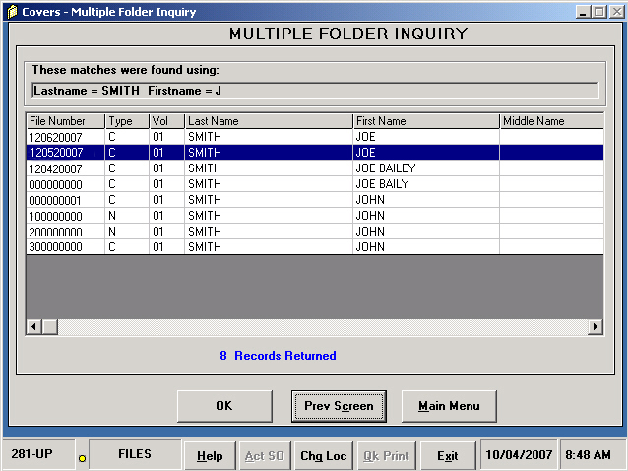

Mark Folder For Mail screen
The Mark Folder For Mail screen is used to inform COVERS that there is action mail to attach to a folder.

The screen contains the following fields:

- File Number
- Folder Type
- Volume
- Comment
- Message Area

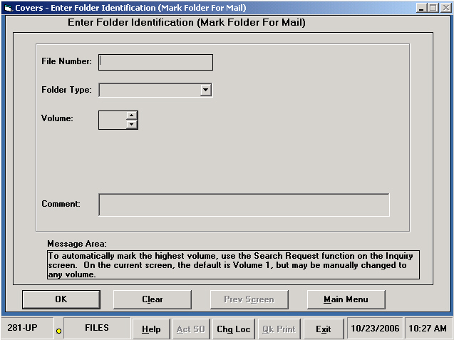

Delete Search For A Single Folder screen
The Delete Search For A Single Folder screen will allow the user to delete a search for a specified folder.

If more than one search is located for a folder, a grid will be displayed with all of the outstanding searches.

The Delete Search For A Single Folder screen contains the following fields:

- File Number
- Folder Type
- Volume

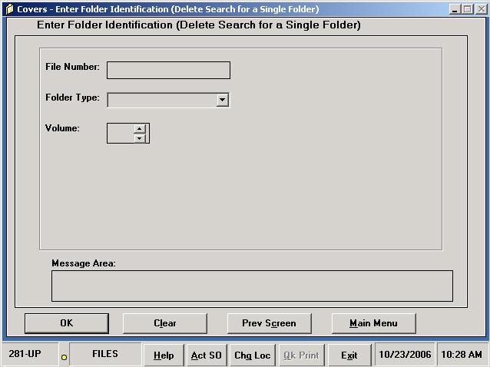

- Message Area
- Location
- Date
- Type
- Priority
- Delete All Searches

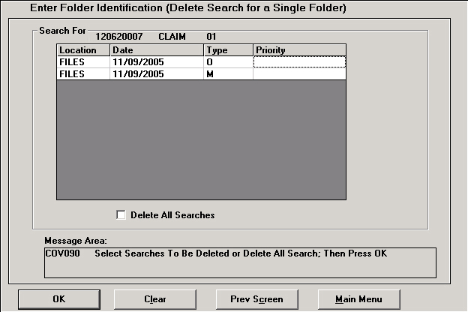

Delete Search For A Specific Criteria screen
The Delete Search For A Specific Criteria screen allows the user to specify report search criteria for folders.

The Delete Search For A Specific Criteria screen contains the following fields:

- Folder Locations
- Search Locations
- TD Range
- Search Date
- Search Type(s)
- Priority Code
- TTO Option

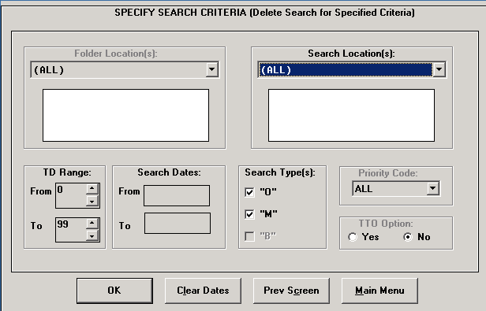

Delete Mail Search In Bulk screen
The Delete Mail Search In Bulk screen will allow the user to delete searches in bulk for a specified folder.

The Delete Mail Search In Bulk screen contains the following fields:

- File Number
- Folder Type
- Volume
- Return Status Message

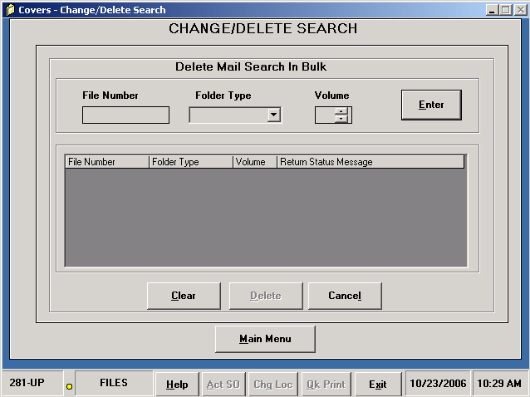

Change/Delete screen
The Change/Delete screen contains command buttons to allow the user to access all change and delete searches for folders.

