Application of the Amputation Rule, Pyramiding, and Gunshot Wounds
Handout
PREREQUISITE TRAINING | Prior to this training the students must have completed the RVSR Challenge course and/or have reached the RVSR Journey Level. Additionally, students must already have a thorough knowledge of rating issues involving the musculoskeletal system.
PURPOSE OF LESSON | The purpose of this lesson is to provide refresher training to Journey Level RVSRs to reinforce their rating skills on application of the amputation rule, avoidance of pyramiding, and evaluating residual gunshot wounds.  This lesson will present the following material to the trainee:  - application of the amputation rule  - avoidance of pyramiding  - evaluating residual gunshot wounds (muscle injuries)
Time Required | 4 hours
Instructional Method | Lecture, participatory discussion and practical exercise
Materials/ Training Aids | Classroom or private area where a discussion may be held. Chairs and writing surfaces are required.  Large writing surface such as an easel pad, chalkboard, dry erase board, overhead projector, etc., with appropriate markers, or computer with projection equipment and PowerPoint software.  - Student Guide  - Rating Job Aids – Medical EPSS  - Review exercise  - PowerPoint presentation

Table of Contents

References ………………………………………………………………………….………...….2
Definitions of amputation rule ………………….……………………………….………...……3

Definition of pyramiding ……………………………………………………….………...……..6

Gunshot Wounds………………………………………………………………………………...7

Types of muscle …………………………………………………………………………………7
The 23 rating schedule muscle groups (MG’s)…………………………………………………..7
Muscle group graphic catalog (pictures)…………………………………………………………8
The standard muscle grading system…………………………………………………………….13
Muscle injuries evaluations…………………………………………………………………..13-14
Evaluating gunshot wounds…………… ………………………………………………………14

Practice Exercise………………………………………………………………….…………… 15

References

Amputation Rule
- 38 CFR §3.323 (a)
- 38 CFR, Part 4; §38 CFR 4.68
- M21-1MR, Part III, iv. 4.A.7a
- FAQ: Amputation Rule - 7-8-03
- RVSR Training Program Anatomy Plates
- Medical EPSS (Musculoskeletal)

Pyramiding
- 38 CFR §4.14
- VAOPGPREC 23-97, dated July 1, 1997
- VAOPGPREC 9-98, dated August 14, 1998
- VAOPGPREC 9-2004, dated September 17, 2004
- Decision Assessment Document (DAD), Esteban v. Brown, No 92.693

Gunshot Wounds
- 38 CFR §4.40; §4.55; 38 §4.56; and 4.73
- M21-1MR, Part III, iv.4.A.1.b
- Training Letter (TL) 00-05 Muscle Injuries and Related Problems
- Tropf v. Nicholson, August 24, 2006

Note: You may access all reference material simply by clicking on the reference.
What is the amputation rule?
Simply put, the amputation rule states that, “The combined rating for disabilities of an extremity shall not exceed the rating for the amputation at the elective level, were amputation to be performed. “

38 CFR §4.68 | The combined rating for disabilities of an extremity shall not exceed the rating for the amputation at the elective level, were amputation to be performed. For example, the combined evaluations for disabilities below the knee shall not exceed the 40 percent evaluation, under diagnostic code (DC) 5165.  This 40 percent rating may be further combined with evaluation for disabilities above the knee but not to exceed the above the knee amputation elective level. Painful neuroma of a stump after amputation shall be assigned the evaluation for the elective site of reamputation..  Note: The amputation rule applies to musculoskeletal conditions only. Other, unrelated disabilities affecting the same extremity can combine at a rate higher than the elective amputation site. Additionally associated neurologic residuals are included in amputation rule. See the FAQ: Amputation Rule dated 07-08-03, and VBN Broadcast 05/03 for an example of disabilities warranting an evaluation above the amputation level. (When you are evaluating an amputation, and its residuals, including nerve damage, the amputation rule applies to that evaluation. also See Moyer v. Derwinski, 2 Vet. App. 289 (1992))
Review §4.71a Schedule of Rating Musculoskeletal System (amputation codes) | Review diagnostic codes 5120 - 5156; and 5160 -5173.  - Diagnostic Codes 5160 through 5173 – pertain to amputation of the lower extremities  - Diagnostic Codes 5120 through 5156 – pertain to amputation of the upper extremities (evaluations are higher for like amputations of the dominant extremity, when compared to the non-dominant)  Note: Regardless of the amount of time you have been rating, it is a good practice to review the codes for amputation each time you prepare a musculoskeletal rating decision and consider whether applying the amputation rule is appropriate.

§4.71a Schedule of ratings—musculoskeletal system
(example)

Amputations: Upper Extremity

Rating
Major Minor
Arm, amputation of:

5120 Disarticulation 901 901

5121 Above insertion of deltoid 901 801

5122 Below insertion of deltoid 801 701

Forearm, amputation of:

5123 Above insertion of pronator teres 801 701

5124 Below insertion of pronator teres 701 601

5125 Hand, loss of use of 701 601

multiple finger amputations

5126 Five digits of one hand, amputation 701 601

Four digits of one hand, amputation of:

5127 Thumb, index, long and ring 701 601
5128 Thumb, index, long and little 701 601
5129 Thumb, index, ring and little 701 601
5130 Thumb, long, ring and little 701 .601
5131 Index, long, ring and little 60 50
Three digits of one hand, amputation of:

5132 Thumb, index and long 60 50
5133 Thumb, index and ring 60 50
5134 Thumb, index and little 60 50
5135 Thumb, long and ring 60 50
5136 Thumb, long and little 60 50
5137 Thumb, ring and little 60 50
5138 Index, long and ring 50 40
5139 Index, long and little 50 40
5140 Index, ring and little 50 40
5141 Long, ring and little 40 30
Two digits of one hand, amputation of:
5142 Thumb and index 50 40
5143 Thumb and long 50 40
5144 Thumb and ring 50 40
5145 Thumb and little 50 40

5146 Index and long 40 30
5147 Index and ring 40 30
5148 Index and little 40 30
5149 Long and ring 30 20
5150 Long and little 30 20
5151 Ring and little 30 20

(a) The ratings for multiple finger amputations apply to amputations at the proximal interphalangeal joints or through proximal phalanges.

(b) Amputation through long phalanges will be rated as prescribed for unfavorable ankylosis of the fingers.

(c) Amputations at distal joints, or through distal phalanges, other than negligible losses, will be rated as prescribed for favorable ankylosis of the fingers.

(d) Amputation or resection of metacarpal bones (more than one-half the bone lost) in multiple fingers injuries will require a rating of 10 percent added to (not combined with) the ratings, multiple finger amputations, subject to the amputation rule applied to the forearm.

(e) Combinations of finger amputations at various levels, or finger amputations with ankylosis or limitation of motion of the fingers will be rated on the basis of the grade of disability; i.e., amputation, unfavorable ankylosis, most representative of the levels or combinations. With an even number of fingers involved, and adjacent grades of disability, select the higher of the two grades.

(f) Loss of use of the hand will be held to exist when no effective function remains other than that which would be equally well served by an amputation stump with a suitable prosthetic appliance.

single finger amputations

5152 Thumb, amputation of:

With metacarpal resection 40 30
At metacarpophalangeal joint or through proximal phalanx 30 20
At distal joint or through distal phalanx 20 20

5153 Index finger, amputation of

With metacarpal resection (more than one-half the bone lost) 30 20

5153 Index finger, amputation of (cont.)

Without metacarpal resection, at proximal interphalangeal joint
or proximal thereto 20 20
Through long phalanx or at distal joint 10 10

5154 Long finger, amputation of:

With metacarpal resection (more than one-half the bone lost) 20 20
Without metacarpal resection, at proximal interphalangeal joint
or proximal thereto 10 10

5155 Ring finger, amputation of:

With metacarpal resection (more than one-half the bone lost) 20 20
Without metacarpal resection, at proximal interphalangeal joint
or proximal thereto 10 10

5156 Little finger, amputation of:

With metacarpal resection (more than one-half the bone lost) 20 20
Without metacarpal resection, at proximal interphalangeal joint
or proximal thereto 10 10

Note: The single finger amputation ratings are the only applicable ratings for amputations of whole or part of single fingers.

1Entitled to special monthly compensation.

Amputations: Lower Extremity

Thigh, amputation of:

5160 Disarticulation, with loss of extrinsic pelvic girdle muscles 902

5161 Upper third, one-third of the distance from perineum to knee joint
measured from perineum 802

5162 Middle or lower thirds 602

Leg, amputation of:

5163 With defective stump, thigh, amputation recommended 602

5164 Amputation not improvable by prosthesis controlled by
natural knee action 602

5165 At a lower level, permitting prosthesis 402

5166 Forefoot, amputation proximal to metatarsal bones (more than
one-half of metatarsal loss) 402

5167 Foot, loss of use of 402

5170 Toes, all, amputation of, without metatarsal loss 30

5171 Toe, great, amputation of:

With removal of metatarsal head 30
Without metatarsal involvement 10

5172 Toes, other than great, amputation of, with removal of metatarsal head:

One or two 20
Without metatarsal involvement 0

5173 Toes, three or four, amputation of, without metatarsal involvement:

Including great toe 20
Not including great toe 10

2Also entitled to special monthly compensation.

What is pyramiding?
Pyramiding is simply evaluating the same disability under various diagnoses or diagnostic codes. 38 CFR §4.14 however prohibits pyramiding.
38 CFR §4.14 | Evaluating the same disability under various diagnoses must be avoided. Disability from injuries to the muscles, nerves, and joints of an extremity may overlap, so special rules are included in the regulation for evaluating each body system. Dyspnea, tachycardia, nervousness, fatigability, etc., may result from many causes; some may be service connected, and others not. Using manifestations not resulting from service-connected disease or injury to establish the service-connected evaluation and evaluating the same manifestation under different diagnoses are to be avoided.
Note: One of the most common mistakes made by RVSRs, at all levels, is pyramiding. Often, the symptoms may seem to be different, but are in fact duplicating and overlapping from the same manifestation.

Refer to the DAD  Esteban v. Brown | Esteban v. Brown, 6 Vet. App. 259, 261-62 (1994)  Court Decisions often determine(s) how we grant benefits. Such is the case in the Esteban v. Brown decision.  What the Esteban decision means is that we have to look at all manifestations of a disability to see if they are adequately covered by one diagnostic code, or if we must separate the manifestations and rate them under multiple diagnostic codes.  In making such a decision, there are four factors that should be carefully considered:  - What are the objective manifestations shown by medical evidence?  - Do those manifestations result in distinct functional impairments?  - What diagnostic codes in the rating schedule most accurately reflect the objective manifestations of the disability, and  - Are the manifestations of a disability covered under one diagnostic code duplicative or overlapping of manifestations covered under another diagnostic code

Rating Tip | It is a good idea to write down the manifestations, symptoms and applicable diagnostic codes in a chart form. As you consider the objective manifestations; distinct functions (if any) and symptoms, it will become clear they are covered under one diagnostic code or are duplicative or overlapping of manifestations covered under another diagnostic code.
Evaluating Gunshot Wounds
In order to properly evaluate the residuals of gunshot wounds, you must understand how to evaluate disabilities of the musculoskeletal system. It is also important that you know how and when to apply the concepts of functional loss, the amputation rule; and provisions of 38 CFR §4.14, which regulates the avoidance of pyramiding.
Before you can rate residuals of a gunshot wounds, you must also familiarize yourself with the provisions of 38 CFR §4.55 and §4.56 and have a general understanding of muscle injuries. The topics below will provide a general overview of muscle injuries, but will not compensate for reading and understanding the regulations. You should refer to the regulations each and every time you rate a muscle injury/gunshot wound.
Types of Muscles  Skeletal  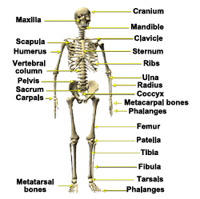 |  |  | There are three types of muscles:  - skeletal or striated – are under voluntary control and , are often attached to bone;  - cardiac – a specialized type of skeletal muscle found only in the heart; and  - smooth or visceral or involuntary - not under voluntary control, are found in walls of digestive tract and blood vessels.  Note: Muscle action is controlled by the nervous system.- A muscle injury rating must not be combined with a peripheral nerve paralysis rating of the same body part, unless the injuries affect different functions 38 CFR §4.55 (so as not to pyramid 38 CFR §4.14).
Muscle Groups  (you can refer to TL 00-05 for a break down of these MG) |  | Rating schedule muscle groups (MG’s)  For rating purposes, the skeletal muscles of the body are divided into 23 muscle groups in 5 anatomical regions: 6 muscle groups for the shoulder girdle and arm (diagnostic codes 5301 through 5306); 3 muscle groups for the forearm and hand (diagnostic codes 5307 through 5309); 3 muscle groups for the foot and leg (diagnostic codes 5310 through 5312); 6 muscle groups for the pelvic girdle and thigh (diagnostic codes 5313 through 5318); and 5 muscle groups for the torso and neck (diagnostic codes 5319 through 5323).

Muscle Group Graphic Catalog
  Group I  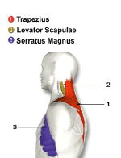 |  | Group II  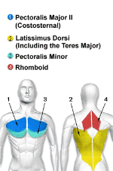
  Group III  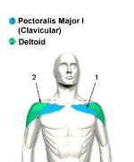 |  | Group IV  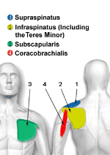
  Group IX  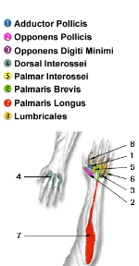 |  | Group V  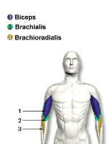
  Group VI  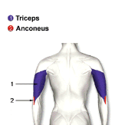 |  |  |  |  | Group VII  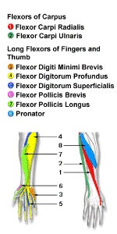
  Group VIII  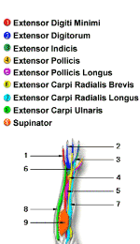 |  | Group X  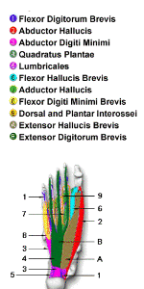
  Group XI  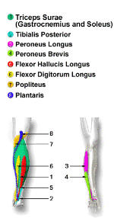 |  |  | Group XII  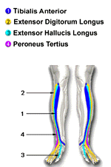
  Group XIII
  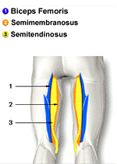
  Group XIX  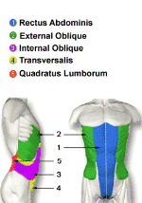 |  | Group XIV  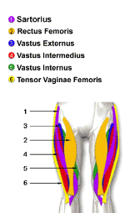
  Group XVI  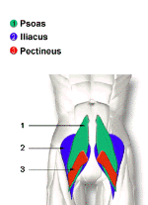 |  | Group XV  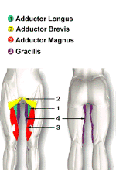
  Group XVIII  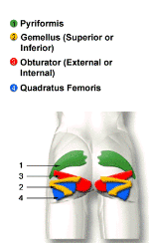 |  | Group XVII  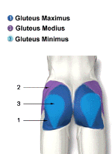
  Group XXI  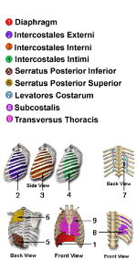 |  | Group XX  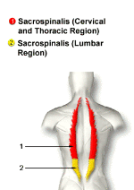
  Group XXIII  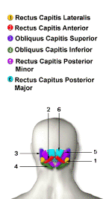 |  | Group XXII  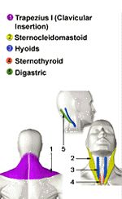
38 CFR §4.55 | Principles of combined ratings for muscle injuries.  Please familiarize yourself with 38 CFR §4.55. You can click on the link from this student guide or use your rating schedule. The first principle prohibits pyramiding. You cannot rate a gunshot wound until you know how to apply the principle of the combined rating for muscle injuries. Remember – don’t assume gunshot wounds are rated only as a scar, as this is a common error that many RVSRs make.  Listed below are some of the principles of combining and evaluating muscle injuries. For complete, detailed and specific regulatory guidance, refer to 38 CFR §4.55 and §4.56.  - Don’t combine a muscle injury rating with a rating for peripheral nerve paralysis rating of the same body part, unless the injuries affect entirely different functions.  - Don’t assign a rating for muscle groups that act on an ankylosed joint except  - if the knee is ankylosed and there is disability of muscle group (MG) XIII. In that case, rate MG XIII, but at the next lower level than would otherwise be assigned. Or  -if the shoulder is ankylosed and MGs I & II are severely  disabled, evaluate the shoulder joint under DC 5200 as  unfavorable ankylosis, if not already assigned; but do not  assign an evaluation for MG I or II (see 38 CFR §4.55)  - When there is an injury of more than one muscle group acting on a single, unankylosed joint, assign a combined evaluation for the muscle group that is lower than the evaluation for unfavorable ankylosis of that joint (except for MGs I and II acting on the shoulder; (see 38 CFR §4.55))  - Consider special monthly compensation (SMC) for loss of use of any extremity, or loss of use of both buttocks.  - When there are multiple muscle groups injuries that:  - are in the same anatomical region, AND  - are NOT acting on the same joint, AND  - are compensable;  rate the most severely injured MG one level higher than would otherwise be assigned, and use this as the combined  evaluation for all affected muscle groups in this region.  Note: When rating combined muscle group injuries, go through an orderly process of evaluation. Determine the level of severity for each affected MG. Determine whether they are in the same anatomic region or not. Determine whether more than one MG is acting on a single joint. Determine whether the joint is ankylosed or not. Determine whether there is a nerve injury in the same area as the muscle injury. Then, go through these principles step-by-step-by-step to determine how to rate them.
Standard muscle grading system | Muscles are graded on a standard scale from 0- 5 with 0 being the worse as no contraction is felt and 5 being normal.  (0) Absent: No contraction felt.  (1) Trace: Muscle can be felt to tighten, but no movement is produced.  (2) Poor: Muscle movement is produced only with gravity eliminated.  (3) Fair: Muscle movement is produced against gravity, but cannot overcome resistance.  (4) Good: Muscle movement is produced against resistance, however, less than “normal” resistance.  (5) Normal: Muscle movement can overcome “normal” resistance.

Evaluation of muscle disabilities

38 CFR §4.56 specifies how the degree of muscle injury is determined.

- Slight disability of muscles
- Moderate disability of muscles
- Moderately severe disability of muscles
- Severe disability of muscles

Very Important: Pay special attention to 38 CFR §4.56 (b) as a through-and-through wound injury with muscle damage shall be evaluated as no less than a moderate injury for each group of muscles damaged. Remember when rating muscle injuries, we must consider all factors set forth in the regulations and make determinations based on the facts specific to the particular case. No single factor is controlling for rating purposes.
Evaluating gunshot wounds
- What is a through-and-through wound?
A through-and-through wound is one in which an injuring instrument enters and exits the body; leaving two wounds, an entrance and exit wound.
- A gunshot wound penetrates the body. It destroys muscle tissue in its direct path by crushing it. The amount of damage and relative size of the entrance and exit wounds depends on many factors: the caliber of the bullet, the distance from the victim; and the organs, bone, blood vessels and other structures hit. As a general rule, exit wounds are larger than entrance wounds. Bullets are essentially sterile when they reach the body, but carry particles into the wound, which could become sources of infection.

Note: As there are currently many wounds incurred from improvised explosive devices (IEDs), RVSRs should be aware that fragments often result from such devices.
- Fragments from Explosive Devices - Most result in decreased tissue penetration, compared to denser rifle bullets. When struck by multiple fragments in a localized area, the crush mechanism results in massive tissue disruption.
Note: Remember, when rating wounds of the chest or abdomen, you must rate the muscle groups penetrated, as well as any affected internal organs.

REVIEW EXERCISE
- Define the amputation rule and cite the regulation that governs it.
- Combined evaluations for disabilities involving the middle third of the thigh and below (including multiple disabilities of the knee) cannot exceed what percentage?
- Combined evaluations for disabilities below the knee cannot exceed what percentage?
- Disarticulation of the thigh and below cannot exceed what percentage?
- The amputation rule applies to all conditions in 38 CFR Part §4, Schedule for Rating Disabilities. Only unrelated disabilities affecting the extremity can combine at a rate higher than the elective amputation site. True or False?
- A Veteran is service connected for arthritis of the knee, with limitation of extension to 45 degrees under DC 5261 at 50%. He is filing a claim for increase. Examination findings reveal instability of the same knee, severe, which would warrant a 30% evaluation. The combined rating table computes a 70% evaluation. Is this evaluation correct or incorrect? What regulation supports the maximum evaluation that can be assigned?
- Read the following scenario. How would you evaluate the Veteran’s knee disability, being careful to avoid pyramiding?
During service, the Veteran suffered fracture of the tibia requiring surgery. The tibia healed with residual malunion of the bone and mild ankle problems. During surgery, some damage occurred to the anterior tibial nerve. There was a residual surgical scar, which was tender on palpation. Symptoms on post-service VA exam were as follows: x-ray evidence of malunion (bone healed in a faulty position); limited motion of the ankle 25 degrees plantar flexion; 20 degrees dorsiflexion (normal range of motion is 45 degrees plantar flexion and 20 degrees dorsiflexion). There is numbness along the front of the leg and tenderness on palpation of surgical scar.
- What regulation governs the principles of combined rating for muscle injuries?
- For rating purposes, the skeletal muscles of the body are divided into how many muscle groups and how may anatomical regions?
- How are the degrees of muscle wounds determined?
- What is a through-and-through wound?
- According to 38 CFR §4.56 (b), how should a through-and-through wound be evaluated?
- Identify the manual references that apply to the amputation rule.
- Define pyramiding and explain why it is to be avoided.
- Identify the manual references that apply to pyramiding.

