Rating Vision and Eye Conditions (Journey)
Trainee Handout

Table of Contents

Objectives 2
References 3
Topic 1: Requirements for Vision Examinations 4
Topic 2: Application of the Rating Schedule 6
Attachment A: Exercise – Requirements for Vision Examinations 10
Practical Exercise 11

Objectives
- Using 38 CFR and M21-MR as references, differentiate general rating considerations for rating visual impairment, with 100% accuracy.
- Using 38 CFR and M21-MR as references, identify components of an adequate vision examination, with 100% accuracy.
- Using 38 CFR and M21-MR as references, demonstrate application of the rating schedule for evaluating disease of the eyes, with 100% accuracy.
- Using 38 CFR and M21-MR as references, demonstrate application of the rating schedule for evaluating visual acuity, with 100% accuracy.
- Using 38 CFR and M21-MR as references, demonstrate application of the rating schedule for evaluating field of vision, with 100% accuracy.
- Using 38 CFR and M21-MR as references, demonstrate application of the rating schedule for evaluating muscle function, with 100% accuracy.

References
- 38 CFR 3.350(a)(4)
- 38 CFR 3.951
- 38 CFR 4.75-79
- VA Training Letter 09-03
- Fast Letter 09-01, Revised Eye Examination Worksheet
- M21-1MR, Part IV, Subpart ii, Chapter 2, H.39.j
- Fast Letter 09-10, Enclosure 1

Topic 1: Requirements for Vision Examinations

Evaluation of Visual Impairment
Visual impairment for VA purposes is divided into three components:
- Impairment of visual acuity (excluding developmental errors of refraction)
- Impairment of visual field
- Impairment of muscle function
General Rating Considerations
The general rating considerations for visual impairment are:
- If visual impairment of only one eye is service-connected, the visual acuity of the other eye will be considered to be 20/40 for purposes of evaluating the service-connected visual impairment.
- The evaluation for visual impairment of one eye must not exceed 30% unless there is anatomical loss of the eye.
- Evaluations for visual impairment of one eye may be combined with evaluations for other disabilities of the same eye, such as disfigurement under DC 7800.
- When the claimant has anatomical loss of one eye and is unable to wear a prosthesis, increase the evaluation for visual acuity under diagnostic code 6063 by 10 percent
- When evaluating visual impairment SMC is always a consideration.
Vision Examinations
Prior to evaluation of vision loss, a VA examination, adequate for rating purposes is necessary. For vision examinations:
- The examination must be conducted by a licensed optometrist or by a licensed ophthalmologist.
- The examiner must identify the disease, injury, or other pathologic process responsible for any visual impairment found.
- Conduct visual field and muscle function tests as medically indicated.
- Provide fundus exam with pupils dilated (unless medically contraindicated).

Visual Acuity Examinations
Examination of visual acuity must include:
- The central uncorrected and corrected visual acuity for distance and near vision.
- Near vision using Snellen's test type or its equivalent.
Visual Fields Examination Instruments
Examination of visual fields must use one of the following:
- Goldmann Kinetic Perimetry
- Humphrey Model 750
- Octopus Model 101
Visual Fields Examination Requirements
The visual fields examination requirements include the following:
- The results must be recorded using a standard Goldmann chart and included in the examination report.
- The examiner must chart the 16 meridians 22 ½ degrees apart.
- If the examination indicates additional testing is necessary, then the examiner must use a tangent screen or a 30-degree threshold visual field with the Goldmann III stimulus size.

Visual Fields Goldmann Chart – Components of the Chart of Visual Fields
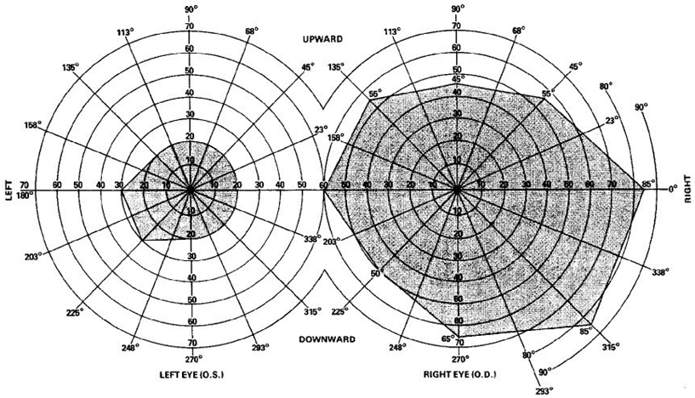
Chart of Muscle Function
For examinations of muscle function, the examiner must:
- Use a Goldmann perimeter chart that identifies the central ring and four major quadrants.
- Chart the areas of diplopia and include the plotted chart with the examination report.
Topic 2: Application of the Rating Schedule

Rating Schedule for Organs of Special Sense
The rating schedule for the Organs of Special Sense (Vision) is divided into four distinct sections:
- Diseases of the Eye (DC 6000-6037)
- Impairment of Central Visual Acuity (DC 6061-6066)
- Impairment of Visual Fields (DC 6080-6081)
- Impairment of Muscle Function (DC 6090-6091)
Diseases of the Eyes
- Diagnostic Codes range from DC 6000-6037
- DC 6000-6009, are evaluated based on:
  - Visual impairment, or
  - Incapacitating episodes, whichever results in the higher evaluation
Diseases of the Eye (DC 6010-6037)
Diseases of the Eye, DC 6010-6037, are evaluated based on:
- Specific scheduler criteria for the diagnostic code
- Visual impairment, or
- Other considerations, as most appropriate under different body systems (such as disfigurement DC 7800/skin)
Visual Acuity
Evaluation of visual acuity:
- Evaluate central visual acuity on the basis of corrected distance vision with central fixation.
- When the lens required to correct distance vision in the poorer eye differs by more than three diopters from the lens required for the better eye, and either the poorer eye or both eyes are service-connected, evaluate the poorer eye based on uncorrected or corrected visual acuity, whichever results in the higher combined visual acuity.
Contact Lens (Visual Acuity)
When the claimant wears contact lenses, evaluate the visual acuity affected by a corneal disorder that results in severe irregular astigmatism, as corrected by contact lenses.
Near and Distance Corrected Vision (Visual Acuity)
In any case where the examiner reports a difference equal to two or more scheduled steps between near and distance corrected vision, with the near vision being worse, the examination report must include:
- At least two recordings of near and distance corrected vision.
- An explanation of the reason for the difference.
In these cases, evaluate based on corrected distance vision adjusted to one step poorer than measured.
Between Sequentially Listed Visual Acuities (Visual Acuity)
When a claimant has impairment of visual acuity reported between two sequentially listed visual acuities, use the visual acuity that permits the higher evaluation.
Visual Fields
To evaluate visual field loss, determine the average concentric contraction of the visual field of each eye by:
- Measuring the remaining field (in degrees) at each of the eight principle meridians 45 degrees apart (reported on the Goldmann Perimeter Chart)
- Adding the measurements
- Dividing the sum by eight
Reading a Visual Field Goldmann Chart
The eight principle meridians are:
- Temporal
- Down temporal
- Down
- Down nasal
- Nasal
- Up nasal
- Up temporal
Prime Meridians Field of Vision Test
Associate the assigned degrees for each meridian for each eye.

Evaluating Visual Field
Once the average concentric contraction for each eye is determined, apply the results to the rating criteria under DC 6080 as appropriate.

Ranges of Concentric Contraction
DC 6080 divides evaluation criteria into six ranges of concentric contraction with an evaluation for unilateral involvement or bilateral involvement.
The six ranges of concentric contraction are:
- Loss of temporal, nasal, inferior or superior half of visual field
- Less than 5 degrees remaining
- Remaining field 6-15
- Remaining field 16-30
- Remaining field 31-45
- Remaining field 46-60
Evaluation of Field Vision Loss Under DC 6080
The criteria for evaluation of field of vision loss under DC 6080 are:
- If only one eye is service-connected, then application of the unilateral evaluation shown in the determined range is appropriate.
- If both eyes are service-connected and the average concentric contraction for each eye falls within the same range, then the bilateral evaluation for that range is appropriate.
- If both eyes are service-connected and the average concentric contraction of each eye falls into a different range, apply the equivalent visual acuity for that eye as noted for each range and evaluate under the appropriate visual acuity loss diagnostic code.
- Only one overall evaluation for visual impairment is appropriate; however, when there is both a visual acuity loss and a field of vision loss, separate evaluations for each loss to be determined and then combined under 38 CFR 5.25 to determine the overall visual impairment loss.
Muscle Function
For evaluation of muscle function:
- An evaluation for diplopia will be assigned to only one eye.
- If the claimant has both diplopia and decreased visual acuity or visual field defects, assign a level of corrected visual acuity for the poorer eye (or the affected eye if disability of only one eye is service-connected) that is:
  - One step poorer than it would otherwise warrant if the evaluation for diplopia under DC 6090 is 20/70 or 20/100.
  - Two steps poorer if the evaluation under DC 6090 is 20/200 or 15/200.
  - Three steps poorer if the evaluation under DC 6090 is 5/200.
However, this adjusted level of corrected visual acuity is never to exceed 5/200.
Diplopia Extending Beyond Quadrants or Range of Degrees
When diplopia extends beyond more than one quadrant or range of degrees:
- Evaluate diplopia based on the quadrant and degree range that provides the highest evaluation.
- When diplopia exists in two separate areas of the same eye, increase the equivalent visual acuity under diagnostic code 6090 to the next poorer level of visual acuity, not to exceed 5/200.
- Diplopia that is occasional or correctable with spectacles is evaluated at 0% disabling.
Goldmann Perimeter Chart Description
Review the Goldmann Perimeter Chart and the plotting of diplopia within the central 20-degree ring or four major quadrants with evaluation under DC 6090.

Attachment A: Exercise – Requirements for Vision Examinations
- The Veteran’s corrected distant visual acuities are no light perception in the right eye and 20/100 in the left eye. What disability evaluation is warranted? (Question2 under Visual Acuity Scenario
________________________________________________________________________________________________________________________________________________________________________________________________________________________________________________________________________________________________________________________________________________________________________
- The Veteran’s corrected distant visual acuities are 20/40 in each eye. What disability evaluation is warranted? (Question 3 under Visual Acuity Scenario)
________________________________________________________________________________________________________________________________________________________________________________________________________________________________________________________________________________________________________________________________________________________________________
- The Veteran’s corrected distant visual acuities are light perception only in the right eye and 5/200 in the left eye. What disability evaluation is warranted? (Question 4 Visual acuity Scenario)
________________________________________________________________________________________________________________________________________________________________________________________________________________________________________________________________________________________________________________________________________________________________________

Practical Exercise
- A Veteran is service-connected for cataracts in both eyes. He has undergone surgery to remove the cataracts, and there were no complications from the surgery. A replacement lenses is noted to be in place. VA vision exam noted the corrected distant visual acuities are 20/70 in the right eye and 20/40 in the left eye. What disability evaluation is warranted?
________________________________________________________________________________________________________________________________________________________________________________________________________________________________________________________________________________________________________________________________________________________________________

- A Veteran is service-connected for glaucoma, and the corrected distant visual acuity is noted to be 20/50 in each eye. In addition, the VA examination revealed the following visual field testing results. Please determine the correct disability evaluation.

Right Eye: |  |  | Left Eye
Temporal | 75 |  | Temporal | 40
Down Temporal | 70 |  | Down Temporal | 40
Down | 60 |  | Down | 50
Down Nasal | 45 |  | Down Nasal | 40
Nasal | 50 |  | Nasal | 30
Up Nasal | 45 |  | Up Nasal | 40
Up | 40 |  | Up | 30
Up Temporal | 50 |  | Up Temporal | 40

- A review of a VA vision examination shows the Veteran has developed diabetic nerve damage to the right eye. This Veteran was previously service-connected for type II diabetes and has no other vision disorders. The VA examination visual field test reveals diplopia is present in the right eye for the down quadrant at 25 degrees. The left eye is reported as normal with a visual acuity of 20/25 when corrected for distant visual acuity.
Please provide the correct disability evaluation for any service-connected eye disorder.
_______Review Exercise Question________________________________________________________________________________________________________________________________________________________________________________________________________________________________________________________________________________________

