Hospitalization Adjustments
Trainee Handout

Table of Contents

Objectives 2
References 3
Topic 1: Hospitalization Adjustments Provisions 4
Topic 2: Processing Hospitalization Adjustments 7
Attachment A: VA Form 10-7131 10
Attachment B: VA Form 10-7132 11
Attachment C: Reduction Chart 12
Attachment D: Topic 1 Exercise - Hospitalization Adjustments Provisions 13
Attachment E: Inputting Adjustments Into VETSNET 14
Attachment F: Due Process MAP-D Letter 17
Attachment G: Post Hospital Reduction Letter- PCGL PP5 19
Attachment H: Topic 2: Exercise - Processing Hospitalization Adjustments 20
Practical Exercise 21

Objectives
- Given the Student Handout Packet and available references, identify hospitalization adjustment provisions, with 85% accuracy.
- Given the Student Handout Packet and available references, interpret the dates that reduction and reinstatement of benefits will occur, with 85% accuracy.
- Given the Student Handout Packet and available references, identify 38 CFR 3.552 exceptions, with 85% accuracy.
- Given the Student Handout Packet and available references, differentiate the requirements to process a hospitalization adjustment, with 85% accuracy.
- Given the Student Handout Packet, available references, and the EPSS, demonstrate the ability to process hospitalization adjustments, to the instructor’s satisfaction.

References
- 38 CFR 3.31, 3.105(e), 3.350, 3.551, 3.552, 3.556
- 38 CFR 4.28, 4.29, 4.30
- M21-1 MR I.2.B.6.c
- M21-1 MR III.ii.2.A.5
- M21-1 MR III.v.6.C.12 and D.18
- M21-1 MR IV.ii.2.J.59-65
- M21-1 MR V.iv.2.1.a
- M21-1 V 5.08
- M21-1, Part I, Appendix B
- M21-1, Part III, Chapter 11
- Fast Letter 05-23 dated December 28, 2005
- Fast Letter 08-05 dated February 26, 2008
- VETSNET Awards Handbook
- EPSS VSR Assistant (Hospital Adjustments)

Topic 1: Hospitalization Adjustments Provisions
Aid and Attendance
Aid and Attendance (A&A) is an additional allowance that is available to Veterans, as well as their spouses and parents. A&A is usually awarded to Veterans with mental or physical disabilities that require the regular aid and attendance of another person to perform personal functions required for everyday living.
The following are some of the criteria that a Veteran must meet to qualify for A&A:
- Inability to dress or undress
- Inability to keep clean and presentable
- Frequent need for adjustment of any special prosthetic or orthopedic appliances
- Inability to feed self through loss of coordination of upper extremities or extreme weakness
- Inability to attend to the wants of nature
- Incapacity, physical or mental, which requires care on a regular basis to protect the Veteran from hazards within the daily environment

Hospitalization Adjustments
When a Veteran becomes hospitalized at VA expense, it may be necessary to adjust the amount of Special Monthly Compensation (SMC).
The three provisions under 38 CFR governing hospitalization adjustments are:
- 38 CFR 3.551 – Veterans with no dependents, in receipt of pension, are reduced if they are provided with domiciliary or nursing home care at VA expense.
- 38 CFR 3.552 – Veterans, with A&A entitlement, are reduced to the housebound rate when provided care at VA expense.
- 38 CFR 3.557 – Veterans, who were rated incompetent by the VA with no dependents, were subject to termination of benefits when they were institutionalized at government expense with an estate in excess of $1,500.
Notes:
This lesson is primarily focused on reductions under 38 CFR 3.552.
38 CFR 3.551 reductions are under the jurisdiction of the Pension Management Center (PMC). When we receive notification of hospitalization for a Veteran in receipt of pension, we should send the notification to the Pension Management Center (PMC).
38 CFR 3.557 reductions have been eliminated. This withholding for institutionalized incompetent Veterans was eliminated under the provisions of Public Law 107-103, effective December 27, 2001
Notification of Hospitalization
There are three possible methods that a VA Medical Center (VAMC) utilizes to notify the Regional Office (RO) when a Veteran has been hospitalized:
- Electronically through the CAPRI/AMIE system
- VA Form 10-7131, Exchange of Beneficiary Information and Request for Administrative and Adjudicative Action (Attachment A)
- VA Form 10-7132, Status Change(Attachment B)
Note: Notification of hospitalization information can also come through email notification from the hospital coordinator contacts at the VAMC. Often, the VAMC will email the nursing home/hospital adjustment coordinator an excel spreadsheet every few months that should be reviewed for possible adjustments.
Benefits Adjustments
38 CFR 3.552 mandates that Veterans receiving A&A must be reduced to the Housebound rate when provided hospital, domiciliary, or nursing home care at VA expense.
The VA determined that Veterans would not require A&A because VA authorized medical care facilities are capable of providing similar services. The logic behind the choice infers that nurses and doctors in the facilities will aid and attend to the Veterans special needs.
Notes:
Housebound is another form of SMC available to Veterans.
A Veteran may be eligible for Housebound benefits if the following requirements are met:
- The Veteran was evaluated with a disability that is 100% disabling and they are confined to their immediate premises.
- The Veteran has a disability rated at 100% disabling in addition to another disability rated at 60% or more disabling.
A Veteran cannot receive both A&A and Housebound benefits at the same time.
Reduction of Benefits
According to 38 CFR 3.552 the following criteria must be met in order to reduce A&A compensation:
- The Veteran must receive SMC with an A&A allowance.
- The Veteran must be hospitalized at VA expense
- The Veteran’s disability may not be paraplegia, Hansen’s Disease, or blindness.
The Veteran receiving institutionalized care at VA expense will have his or her A&A benefits reduced to the Housebound rate effective the first day of the second calendar month following admission to the hospital, domiciliary or nursing home. (Attachment C)

Example: if the Veteran was admitted into a VA hospital on 3/14/2008, the reduction would be effective on 5/01/2008.
Reinstating Benefits
A&A benefits should be reinstated effective on the date of discharge from the hospital, domiciliary, or nursing home.
Example: If a Veteran was discharged from the VA hospital on 5/02/2011, then 5/02/2011 is also the date that A&A would resume.
Exceptions
According to 38 CFR 3.552(a)(2), reduction of A&A benefits is not made for cases that involve any of the following conditions:
- Paraplegia with paralysis of both lower extremities
- Hansen’s Disease ( leprosy)
- Blindness
Exception to the Exception
If A&A entitlement is established under 38 U.S.C. 1114(r)(1) or 38 U.S.C. 1114(r)(2), then A&A must be discontinued during hospitalization regardless of the disability involved.

Topic 2: Processing Hospitalization Adjustments

Hospitalization Adjustments Process
The hospitalization adjustments process requires you to:
- Assess the Veteran hospitalization and claim information,
- Make adjustment decisions based on the 38 CFR 3.552 criteria
- Perform the necessary steps to complete the adjustment.

Determine the Source of A&A
Once the hospitalization notice is received, the VSR should determine the source of A&A. The source can be either from Special Monthly Compensation (SMC) or Special Monthly Pension (SMP).
- If the Veteran is receiving SMC with A&A, then an EP 135 should be established.
- If the Veteran is receiving SMP with A&A then the information should be forwarded to the appropriate Pension Management Center and no additional action should be taken locally.
Determine if a Reduction is Necessary
Once an EP 135 is established, refer to 38 CFR 3.552 to ensure the reduction is necessary based on the following criteria:
- The Veteran must receive SMC with A&A.
- The Veteran must be hospitalized at VA expense
- The Veteran disability may not be paraplegia, Hansen’s Disease, or blindness.

Reduction is Necessary
If the reduction is necessary:
- PCLR the EP 135
- Annotate the C-file with the date and your initials
- Establish an EP 600 (annotated accordingly)
- Input data into VETSNET
- Use Map-D to prepare and send two due process letters (One to the institution the Veteran is hospitalized in, the other to the Veteran’s address of record.
- Set suspense for 65 days
- Maintain EP control for 65 days due process period
Demonstration/VETSNET Steps:
- Click on Add.
- Select the Institution Type/Event.
- For VA hospitalizations, select the State in which the Veteran is hospitalized.
- Select the VHA Facility.
- The Institution name will be system populated for VHA admissions, but must be entered if the Institutionalization Type is Incarceration Period.
- Enter the From and To Dates as necessary.
- Select Accept to update the screen.
- Select Adjust to open the second screen where the details regarding the decision to adjust benefits can be recorded.
- Note that the details of the institutionalization are shown in the upper part of the screen.
- Select the Add button.
- Record the Adjustment Type.
- The From and To dates will be system populated based on the begin date and end date of the institutionalization and the adjustment type recorded.
- Select Accept to update the screen.
Select OK to save the decision and close the Institutionalization Adjustments screen.

Reduction is Not Necessary
If reduction is not necessary:
- PCAN the EP 135
- Annotate the C-file with the date and your initials
- Send the file back to the file bank

Reduce A&A to Housebound Rate
When either the 65-day due process period has expired or the Veteran has requested action, reduce the compensation to the Housebound rate immediately.
Send Final Notice
Complete the final notice to inform the Veteran that compensation has been reduced to the Housebound rate. Be sure to include the new rates as well as the effective dates.
If the Veteran has not yet been discharged, request that the Veteran notify the RO upon discharge so A&A benefits can be reinstated.

Electronic Performance Support System (EPSS)
The VSR Assistant Electronic Performance Support System (EPSS) is a tool that is available to aid in reinforcement as well as just-in-time training of complex claims processes. The advantages of using the EPSS are:
- Reduced level of complexity of numerous step claims
- Providing the performance information as a VSR needs it to perform a task
- Providing a decision support system that enables a VSR to identify the action that is appropriate for a particular set of conditions
- Calendar dates of reduction for notification letters can be calculated in system
Attachment A: VA Form 10-7131
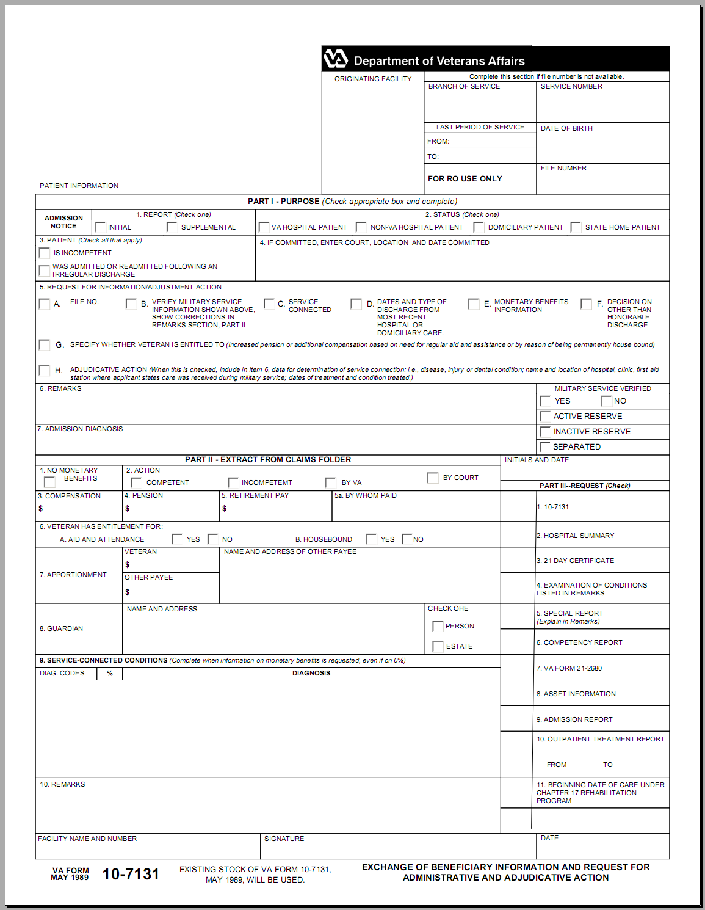
Attachment B: VA Form 10-7132

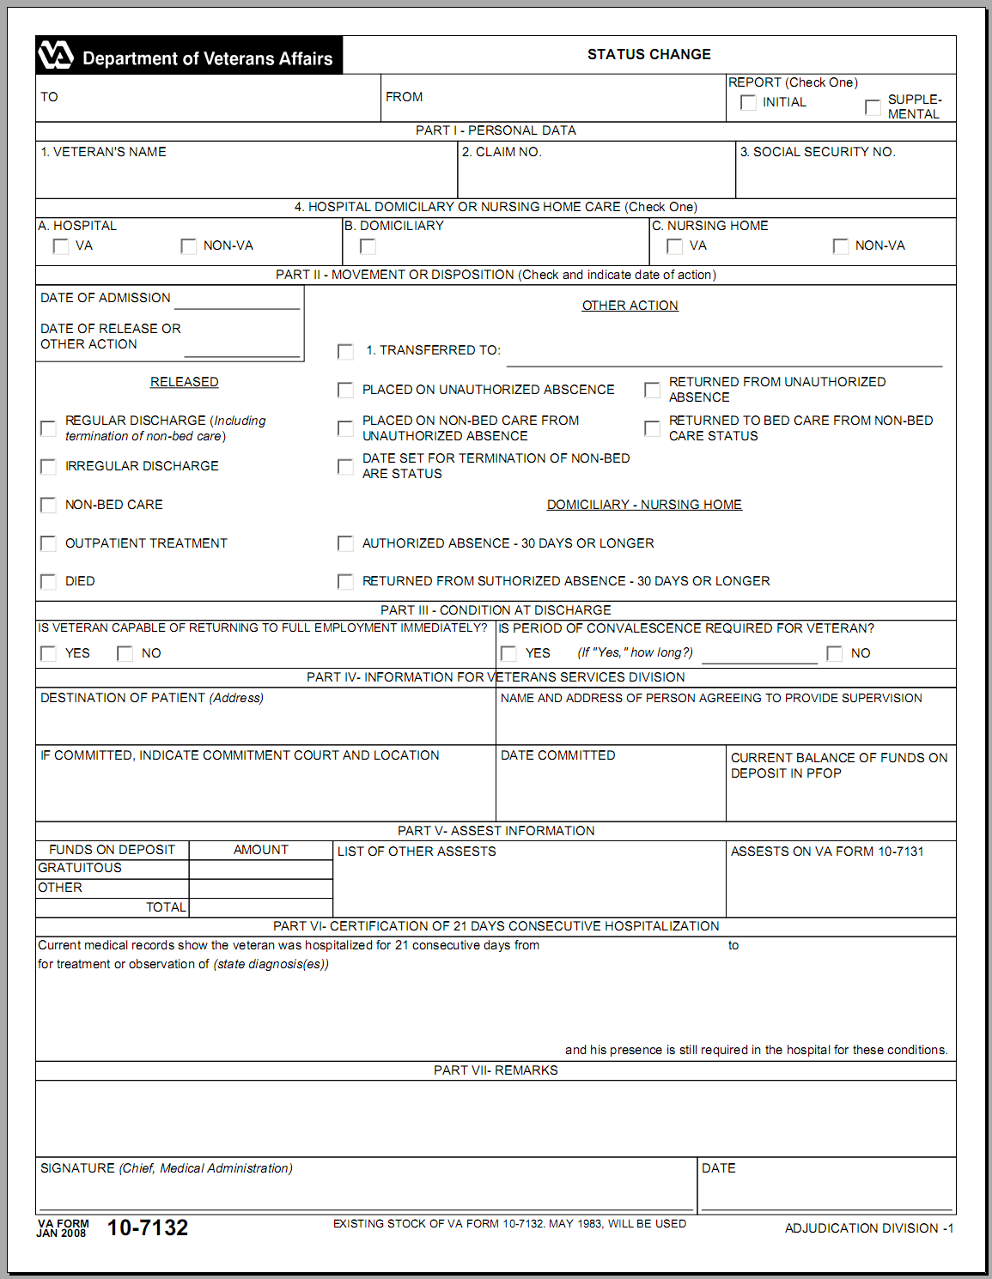
Attachment C: Reduction Chart

Reduction Chart
38 CFR 3.552 A/A Reduction
Month Admitted | Month Reduced
Jan | Mar
Feb | Apr
Mar | May
Apr | Jun
May | Jul
Jun | Aug
Jul | Sep
Aug | Oct
Sep | Nov
Oct | Dec
Nov | Jan
Dec | Feb
Attachment D: Topic 1 Exercise - Hospitalization Adjustments Provisions
Instructions: Take about five minutes to complete the following questions.
A Veteran is in receipt of Aid & Attendance (A&A) and was hospitalized at VA expense from 02-01-2008 until 09-09-2008.
- What is the date of reduction of Special Monthly Compensation (SMC)?
____________________________________________________________
- What is the date A&A will resume?
____________________________________________________________
- If the Veteran suffered from paraplegia, would the reduction of benefits occur? Explain.
____________________________________________________________
Attachment E: Inputting Adjustments Into VETSNET

Record Decision Screen

Select the Institutionalizations button to access the Institutionalizations decision screen.

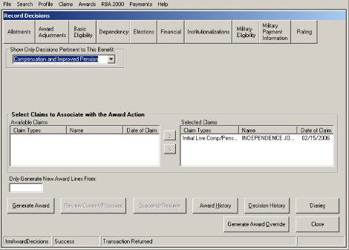

Institutionalizations Screen
The first screen displayed is the Institutionalizations screen where information regarding the type, location, and date of institutionalization can be recorded.

- Click on Add.
- Select the Institution Type/Event.
- For VA hospitalizations, select the State in which the Veteran is hospitalized.
- Select the VHA Facility.
- The Institution name will be system populated for VHA admissions, but must be entered if the Institutionalization Type is Incarceration Period.
- Enter the From and To Dates as necessary.
- Select Accept to update the screen.
- Select Adjust to open the second screen where the details regarding the decision to adjust benefits can be recorded
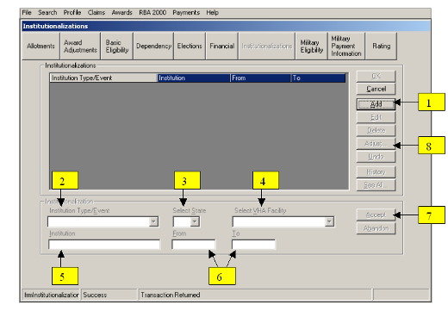

Institutionalization Adjustments Screen
Upon selection of the Adjust button, the second Institutionalization Adjustments Screen will display. This screen is where the type of adjustment is recorded.

- Note that the details of the institutionalization are shown in the upper part of the screen.
- Select the Add button.
- Record the Adjustment Type. The Adjustment Types that can be recorded are:
SMC Adjustment
Estate Adjustment
Incarceration Adjustment
- The From and To dates will be system populated based on the begin date and end date of the institutionalization and the adjustment type recorded.
- Select Accept to update the screen.
- Select OK to save the decision and close the Institutionalization Adjustments screen.
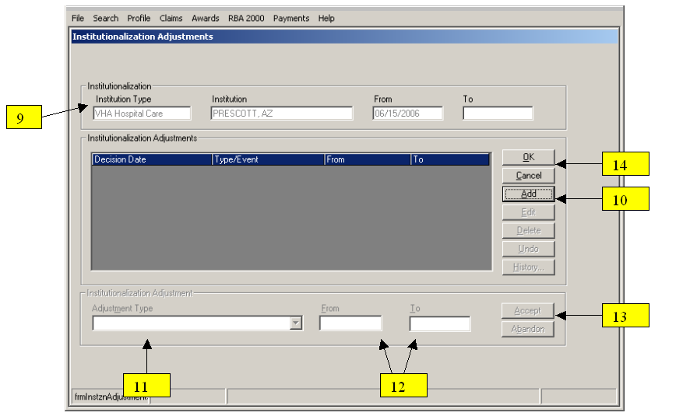
Attachment F: Due Process MAP-D Letter

The sample letter below was generated using MAP-D. Be sure to always proof and check the letter for formatting prior to release to the Veteran.

IMPORTANT -- reply needed

Dear VETERAN:

Our VA Medical Center in CITY, told us you were admitted for treatment on DATE OF ADMISSION.

We plan to stop the special monthly aid and attendance allowance included in your payments because this care continued more than one full calendar month. The laws allowing payment of the special monthly amount you receive require this action.

We propose to reduce your monthly benefit payments from $to $effective DATE OF ADMISSION.

This adjustment will result in an overpayment of benefits which have been paid to you. If the proposed action is implemented, you will be notified of the exact amount of the overpayment and given repayment information.

Submission of Evidence

We will continue your payments at the present rate for 60 days following the date of this notice. This is to allow you time to submit new evidence showing that we should not take the proposed action. You may submit evidence in person, by mail or through your accredited representative.

Minimizing Potential Overpayment

You may not be due the full amount paid for the next 60 days. If you accept the payments and we decide to take the proposed action, you will have to repay all or part of the benefits you receive during the 60 days. We can reduce the potential overpayment by adjusting your benefits before the 60-day period ends. If you would like us to take this action, send us a statement asking that we adjust your payments beginning with your next check. If you make this request, and at the end of 60 days our review shows that you should have received the higher rate, we will restore the full rate from the date it was reduced.

Personal Hearing

You can request a personal hearing to present evidence or argument on any important point in your claim. We will arrange a time and place for the hearing. You may bring witnesses who have personal knowledge of the circumstances. We will consider their testimony and keep it as part of our permanent records. We will furnish the hearing room, provide hearing officials, and prepare the transcript of the proceedings. We cannot pay for other expenses of the hearing, since we hold a personal hearing only upon a claimant's request.

If we receive your request for a hearing within 30 days we will continue payments at the present rate until the hearing is held and we review the hearing testimony. However, this will not change the proposed adjustment date if we decide to take the proposed action. Please understand that by continuing the current rate during this period, we may be overpaying you. If you request a hearing but wish to reduce the possible overpayment, send us a statement asking that we reduce or suspend your benefits beginning with your next check.

After 30 days you may request a hearing, but benefits will have been adjusted as explained earlier in this notice.

Unless we hear from you within 60 days, we will assume you have no additional evidence and do not want a hearing. We will make our decision using the evidence we already have.

Our policy is to assist a person with his or her claim in every reasonable way. We want you to have every benefit that you are entitled to under the law.

Representation

An accredited representative of a Veterans' organization or other service organization recognized by the Secretary of Veterans Affairs may represent you, without charge. An accredited agent or attorney may also represent you. However, under 38 U.S.C. 5904(c), an accredited agent or attorney may only charge you for services performed after the date you file a notice of disagreement to our decision. If you desire representation, let us know and we will send you the necessary forms. If you have already designated a representative, no further action is required on your part.

Where Should You Send What We Need?

Please send what we need to this address:

Department of Veterans Affairs
123 Veteran Street
Anywhere, USA 12345

How Soon Should You Send What We Need?

We strongly encourage you to send any information or evidence as soon as you can. If we do not hear from you, we may make a decision on your claim after 60 days. However, you have up to one year from the date of this letter to submit the information and evidence necessary to support your claim. If we decide your claim before one year from the date of this letter, you will still have the remainder of the one-year period to submit additional information or evidence necessary to support your claim.

How Can You Contact Us?

If you are looking for general information about benefits and eligibility, you should visit our web site at http://www.va.gov. Otherwise, you can contact us in several ways. Please give us your VA file number, NUMBER, when you do contact us.

- Call us at 1-800-827-1000. If you use a Telecommunications Device for the Deaf (TDD), the number is 1-800-829-4833.
- Send us an inquiry using the Internet at https://iris.va.gov.
- Write to us at the address at the top of this letter.

We look forward to resolving your claim in a fair and timely manner.

Sincerely yours,
J. Smith
Joe Smith
Veterans Service Center Manager

Enclosure(s): VA Form 21-0790

cc: POA

Name___________________________ Claim # _________________________

I was admitted to the VA Medical Center in _____________________________ on ____________________. Please take immediate action to reduce my payments to the proper rate as authorized by law.

_________________________________ __________________________
Signature Date

Attachment G: Post Hospital Reduction Letter- PCGL PP5
Dear VETERAN:

Our VA Medical Center in CITY confirms they admitted you for treatment on DATE OF ADMISSION , and said you are still there/said you were released DATE OF RELEASE

In our letter of DATE OF DUE PROCESS LETTER we told you that the law requires us to reduce your Compensation benefit after one full calendar month of treatment at VA expense.

We have asked the hospital to tell us when you leave. We will restore the aid and attendance allowance beginning the date of release.

NOTE: On the letter closing logic screen select 002t for payment chart or 002tw for payment chart with withholding.

What You Owe

We have created an overpayment in your account because the information we received showed that we paid you too much. You will receive a separate letter, which will explain how much we overpaid you, and how you can repay this debt.

What You Should Do If You Disagree With Our Decision

If you do not agree with our decision, you should write and tell us why. You have one year from the date of this letter to appeal the decision. The enclosed VA Form 4107, "Your Rights to Appeal Our Decision," explains your right to appeal.

If You Have Questions or Need Assistance

If you have any questions, you may contact us by telephone, e-mail, or letter.

If you | Here is what to do.
Telephone | Call us at 1-800-827-1000. If you use a Telecommunications Device for the Deaf (TDD), the number is 1-800-829-4833.
Use the Internet | Send electronic inquiries through the Internet at https://iris.va.gov.
Write | Put your full name and VA file number on the letter. Please send all correspondence to the address at the top of this letter.

In all cases, be sure to refer to your VA file number NUMBER.
If you are looking for general information about benefits and eligibility, you should visit our website at https://www.va.gov, or search the Frequently Asked Questions (FAQ's) at https://iris.va.gov.

We sent a copy of this letter to your representative, POA, whom you can also contact if you have questions or need assistance.

Sincerely yours,

Attachment H: Topic 2: Exercise - Processing Hospitalization Adjustments
Instructions: Place the steps in the order required to reduce Aid & Attendance (A&A) to the Housebound rate.
Steps | Options
1. ____  2.____  3. ____  4. ____  5. ____  6. ____ | - Input Award Data  - Prepare Predetermination Notice  - Maintain EP Control for 65 Days Due Process Period  - PCLR EP 135  - Set Suspense for 65 Days  - Establish EP 600

Practical Exercise
Complete the EPSS VSR Assistant-Hospital Adjustments Module.

