AUTHORIZATION INTRODUCTION
Handout

PREREQUISITE TRAINING |  | All authorizers should have basic knowledge of awards processing, as well as, the ability to research pertinent policies and procedures as they relate to claims processing. This includes knowledge obtained from manuals and regulations, and the mechanics of VBA systems such as SHARE, VETSNET Awards, MAP-D, Virtual VA and COVERS.
 | PURPOSE OF LESSON |  | The purpose of this lesson is to introduce autherizers to the review process and computer actions involved in authorization activities. Authorizers will learn the elments of authorizating an award, and will be able to apply the lessons learned through pracicing on actual cases.  At the end of this lesson, authorizers will have knowledge of:  - Basic Award Authorization Requirements  - Importance of Accuracy  - Required VETSNET Award Screens and Other Applications Involved with the Authorization Process
Time Required: |  | 6 hours (3.00 Hours Classroom Instruction, 3.00 Hours Practice and Review)
Table of Contents

References 3
Workflow Process 4
Roles of an Authorizer 4
Quality Reviews 4
SHARE Screens 5
BIRLS Inquiry 6
VID Screen 6
Miscellaneous Info Screen 6
Corporate Inquires 7
Claims/Denials Screen – Benefit Claim Information 7
Awards/Ratings Screen – General Information 8
Awards/Ratings Screen – Award Information 8
Awards/Ratings Screen – Rating Information 9
PIF Inquiry 9
VETSNET Processing 10
All Awards Screen 10
Record Decisions Screen 11
Diaries Screen 12
Proposed Award Screen 13
CP Payment Address Screen 13
Print Award Option 14
MAP-D Updates 16
Tracked Items 16
Change Claim Status 16
Virtual VA 18
COVERS 18
Handouts 19
STAR Rating Quality Review Checklist 19
STAR Authorization Quality Review Checklist 21
ASPEN Quality Worksheet 23
Exercise 1 28

References

- M21-1MR, III.I.1.5.a
- M21-1MR, III.v.2.A.2.a
- M21-4, Chapter 3
- SHARE User’s Guide
- VETSNET Awards Handbook
- MAP-D User’s Guide
- Virtual VA TEACH

Workflow Process
M21-1MR, III.1.5.a

Most authorizers are Journey-level VSRs, Senior or Super Senior VSRs, Assistant Coaches, and Coaches. Authorization is primarily viewed as a function of the Post-Determination environment, whereas activities may involve the development and processing of non-rating end products (EPs), promulgation of ratings, preparing notification letters, and completing entitlement determinations.

Note: Not all authorizers are in a Post-Determination team, and some authorization functions are carried out in other teams.

Roles of an Authorizer
M21-1MR, III.v.2.A.2.a

Authorizers serve as the final reviewer in completing a claim, and they must ensure that everything is done correctly, from beginning to end. As such, some of the duties involve co-signing of awards when no errors are involved, returning work when there are errors, dating and releasing notification letters, and returning the claims folder to the files activity. There are many detailed steps in the process, and this lesson will introduce the authorizer to some of the duties involved.

Quality Reviews
M21-4, Chapter 3

When an authorizer reviews a case, they should ensure that all work is completed in accordance with current policies and procedures. Often, this requires an in-depth knowledge of the rules and regulations involved with claims processing, and a keen sense of researching material when necessary.

There are two methods used in structuring the review. The first involves a measurement of quality based on the guideline provided by the Systematic Technical Accuracy Review (STAR) checklists in M21-4, Chapter 3. Appendix A and B of this chapter provides checklists for reviewing both Rating and Authorization workload. The critical factors for Rating issues include: A) Address all Issues, B) Proper Development, C) Grant or Denial, and D) Award actions. The critical factors for Authorization issues include: A) Address All Issues, B) Proper Development, C) Income Issues, D) Dependency Issues, E) Burial Issues, F) Accrued Benefits Issues, G) Adjustments (Hospitalization or Incarceration), H) Payment & Effective Dates. A review under the STAR protocol also involves non-critical issues that should also be considered during an authorizer’s review, and these are discussed in detail on the aforementioned checklists.

Another method used in structuring your review, is to use the checklists provided by Automated Standardized Performance Elements Nationwide (ASPEN). These checklists provide more detailed guidelines on reviewing workload.

SHARE Screens
SHARE User’s Guide and M21-1, Pt. II, Chapter 6

SHARE is a delivery network of benefits system that replaced our old Benefits Delivery Network (BDN) system. There are three major components that we use in SHARE during the authorization process, BIRLS Inquiry (VID, ICP, Miscellaneous Info), Corporate Inquiries, and the PIF inquiry. These key components are needed to verify important information prior to finalizing a claim, and you can access them through the VBA READY SCREEN in SHARE.

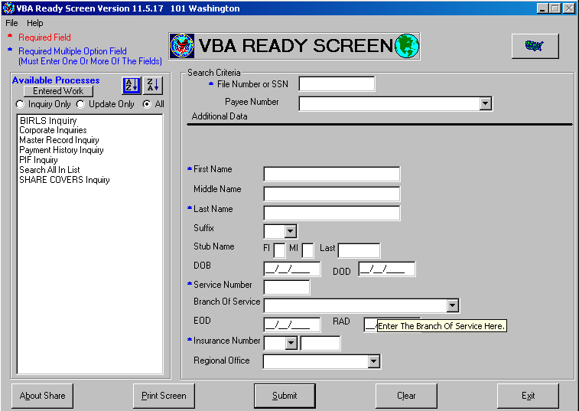

As an authorizer, you should compare the information in these subsystems to the information and evidence provided in the claims folder. If there are unresolved discrepancies, the authorizer should return the file to the VSR who worked the claim, without authorizing it. The VSR who worked the claim is responsible for resolving any discrepancies prior to generating an award and sending it to the authorizer for review. In cases where there are minimal updates involved, an authorizer may choose to update systems themselves. In all circumstances, claims processors at all levels (i.e. VSRs, Seniors, RVSRs, etc.) are responsible for working the claim in an expeditious manner.

BIRLS Inquiry

VID Screen

On this screen you will verify military service information and the Power of Attorney.

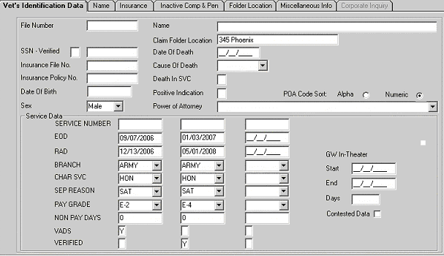

Miscellaneous Info Screen

Here you will review to determine if the Veteran is in receipt of military Retire Pay of SBP, Severance Pay, Separation Pay, or Readjustment Pay.

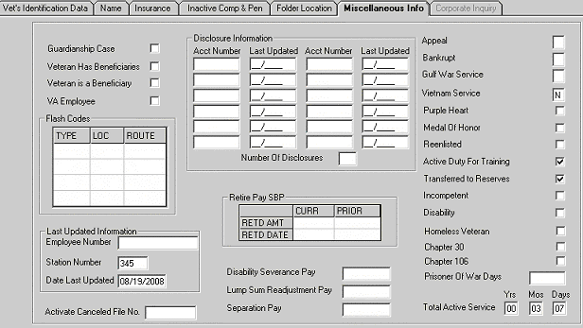

Corporate Inquires

The Corporate Inquiry in SHARE allows you to view different types of information about a Veteran under the following categories: Person Screen, Military Screen, Claims/Denials Screen, and the Award/Rating Screen. Updates to these screens are completed in a number of ways, such as updating the Participant Profile, promulgating a Rating Decision, updating BIRLS, entering dependent information during CEST or PIF Change, etc. Prior to authorization, you should ensure that the information in the Corporate record is accurate and up to date. Some of these updates are completed as part of the award generation process, and authorizers should keep this in mind when reviewing claims.

Claims/Denials Screen – Benefit Claim Information

This screen is used for verification of the Veteran’s Benefit Claim Information, and includes the Life Cycle Status (Open, Ready for Decision, Rating Decision, Closed, etc.), Claim Type, and other pertinent information as it pertains to authorization:

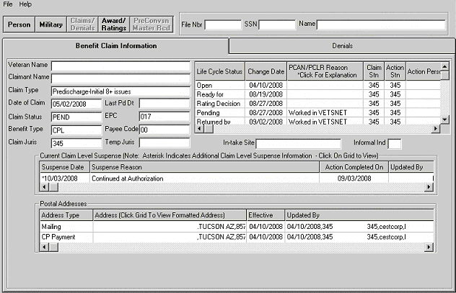

Awards/Ratings Screen – General Information

This screen provides you with General Information and includes the Current Monthly Rate of payment. On an original grant this screen will not show Pay Status or Current Monthly Rate until after the award is authorized.

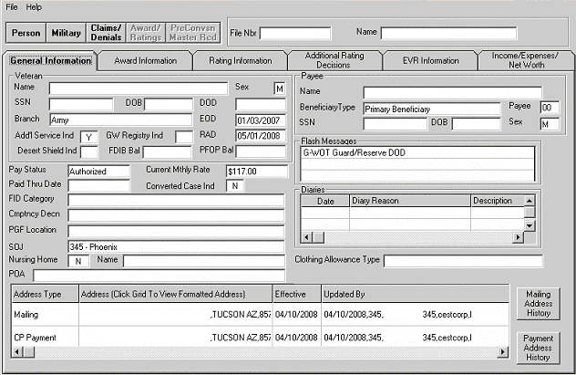

Awards/Ratings Screen – Award Information

This screen provides you with current running award data. On an original grant this screen will not show Pay Status until after the award is authorized.

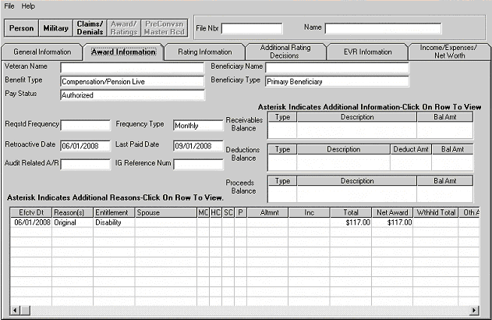

Awards/Ratings Screen – Rating Information

This screen verifies the last coded Rating Information.

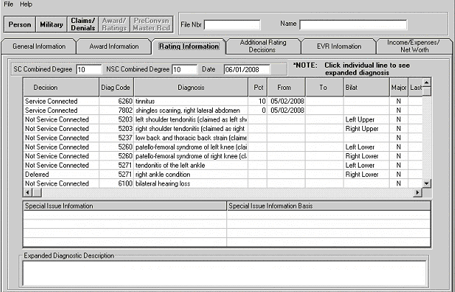

PIF Inquiry

When a claim is established through SHARE, a Pending Issue File (PIF) is created to hold the claim data entered (i.e. Date of Claim, POA, Suspense Date, etc.) The PIF is a working file that contains data for a pending claim and maintains control until an award or disallowance is processed. It also provides data that is used for workload measurement and control. Authorization of the completed claim clears the pending issue out of the PIF and generates end product credit.

If benefits are granted when the claim is complete, data contained in the PIF is sent to Hines to create or update a Corporate Master Record. If the claim is disallowed, data contained in the PIF will be sent to Corporate Master Record where it will create or update a corporate record through VETSNET action. Not all of the PIF data is sent to the corporate record, as some of the data stored in a PIF is statistical and used only to update workload management tools, such as VOR reports.

It is important to check your pending end product through a PIF Inquiry to ensure that the correct EP has been assigned to the award action prior to authorization, and to verify if there are any other EPs pending that may or may not be related to our award action. Some EPs pending in addition to our promulgating of a rating could be taken in conjunction with the award action (e.g. a 130 EP could exist at the time of authorization of a rating EP). In this situation, the 130EP would be PCAN’d and we would include the dependency on the rating EP award action. In other situations, the wrong EP could have been established and you would need to change it during the authorization process through a PCHG. In either case, you can access the PIF Cancel or PIF Change in SHARE to accomplish these tasks.

VETSNET Processing

Record(s) Found Screen

- Here we will enter the Veteran’s claim number
- Click on Search.
- Our next step is to locate the type of claim that we are going to authorize. Once we have done this, double click onto the claim type to bring up the next screen.

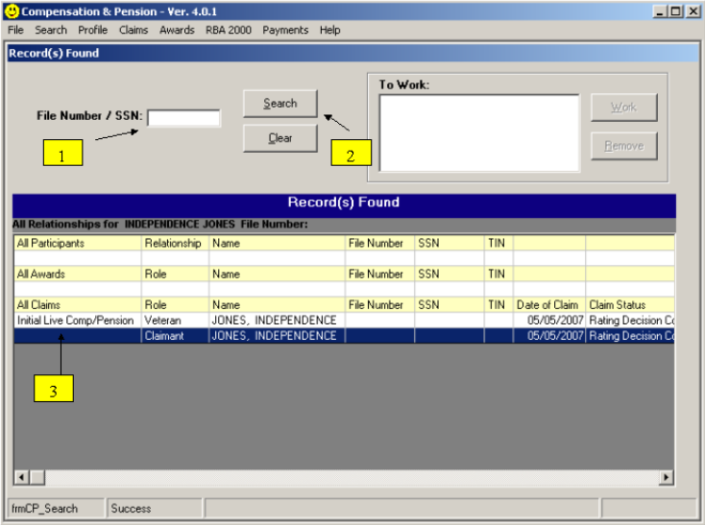

All Awards Screen

- On this screen click on Record Decision to take us to the next screen.
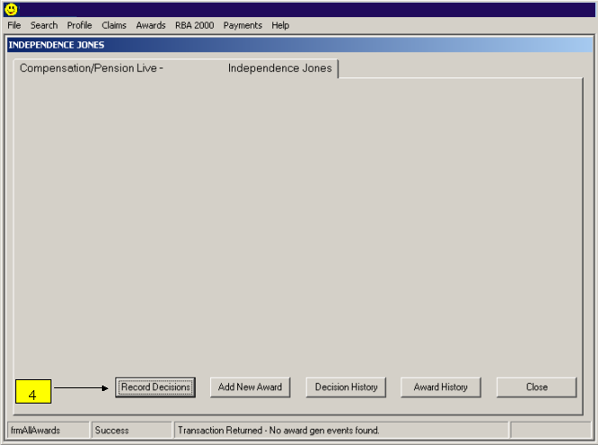

Record Decisions Screen

- Click on OK to proceed.
- Review the data relative to the claim, and ensure that everything was completed with no errors.
- Click on Diaries if there is a Future Exam on the coded page of the Rating Decision. See next screenshot for Diary Screen.
- Click on Review Current/Proposed to proceed with authorization.

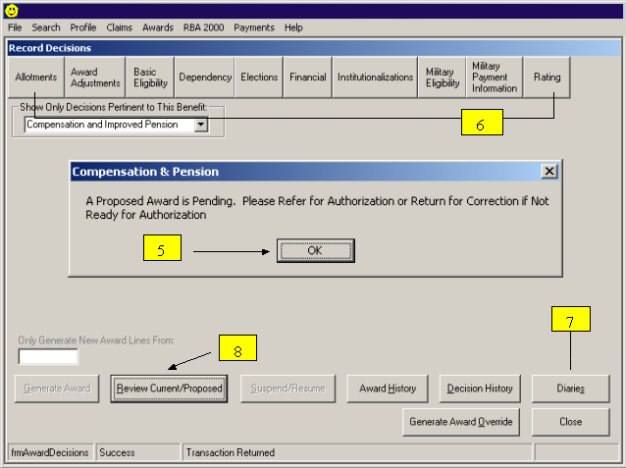

Diaries Screen

If there is a required Future Exam, a Diary should appear within the Active Diary Data window. If no Diary for Future Exam appears and there should be one, you can still add it at this point prior to Authorization by clicking onto the Add icon bar. Afterwards, simply click onto either the cancel or OK icon bar depending on whether you were required to add a Diary or the VSR had already entered the required information.

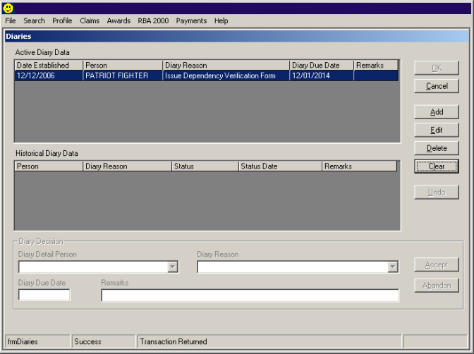

Proposed Award Screen

- If necessary, select a New Benefit Claim Type
- The important next step to take prior to authorizing the award from this screen is to first determine if the EP should be continued with your authorization action. Should you need to continue the EP, click on the drop down box arrow and then highlight the text for Continued At Authorization.
- If the Status is changed to ‘Continued at Authorization’, record the Suspense Date.
- If all of the action is correct, then you are ready to click on Authorize.

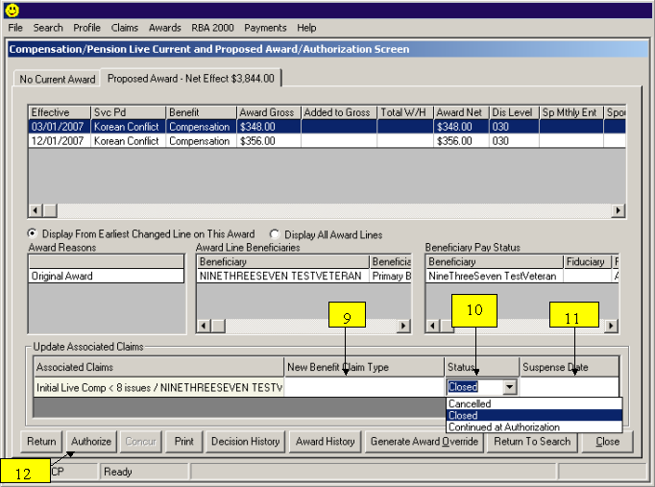

CP Payment Address Screen

The next window that will appear will be the Beneficiary Claim Address and CP Payment Address window. Here you will want to verify that we are making payment to the correct address/EFF/EFT provided information. Check CAPRI, claims folder, PIF Inquiry and MAP-D notes for any address changes. Should you need to change the payment address, then click onto the Change Address icon bar and proceed to the change process screen which will appear next. Once you are ready to finalize your authorize action, click the Continue Authorization icon bar and the next window will appear.

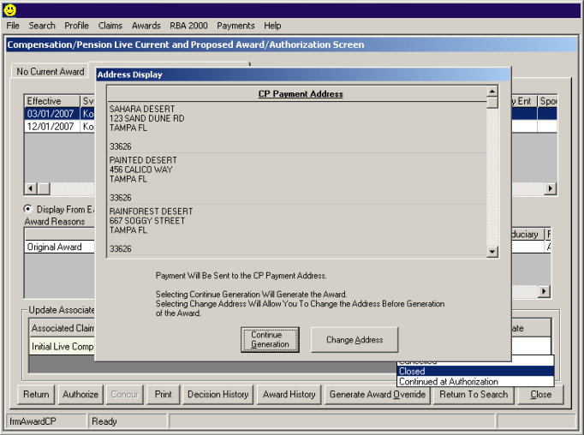

Print Award Option

The next window which pops up is asking you if you would like to print the award document. At this point the person completing the work should have printed out the award document, so it will not be necessary for you to re-print it. If this is the case, click on No.

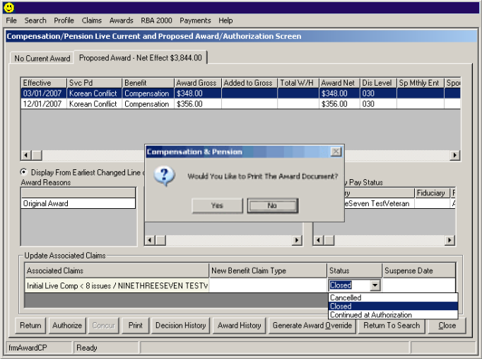

- The snapshot below, is your final action required in completing your authorization action. Notice that at the bottom of the screen, there is an icon bar which reads Return To Search. Click on this option and you will return to the Awards Search screen.

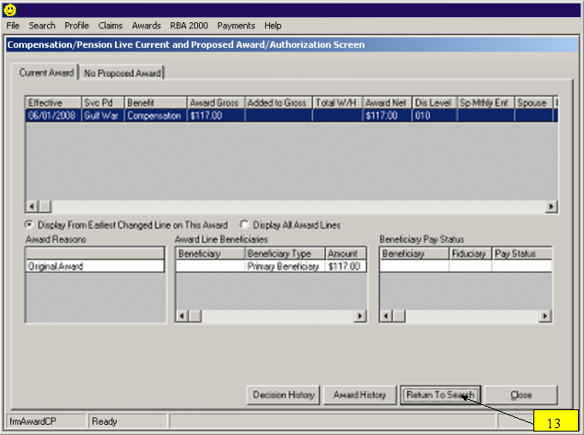

MAP-D Updates

Tracked Items

Prior to authorization, all Tracked Items for the particular claim should be updated. The Customer Service (Tracked Items) screen is used to view the development action/letters that are associated with a claim. This screen shows the date the development action/letter was Requested, the date the item is Closed or Received. Closed is to indicate to the system that you no longer want to tack this item. Received is to show that you actually, physically received what you requested. Tracked Items that you will not receive the necessary reply should be 'Closed'. Example: you asked for a DD214 and the reply was "I don't have it". Close this item. Tracked items that you DO receive, should be marked as 'Received'.

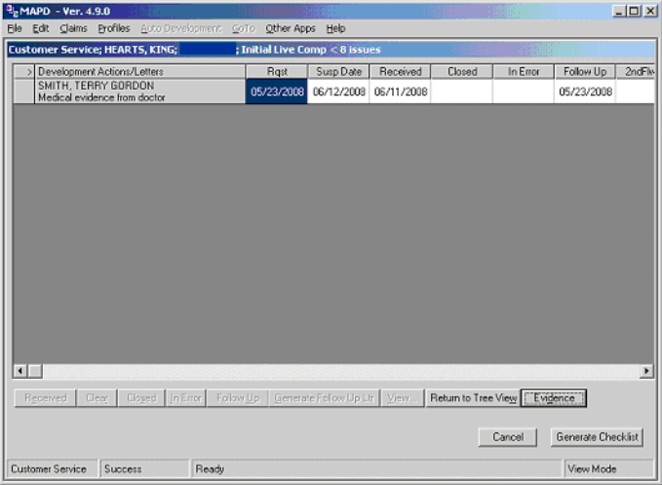

Change Claim Status

Once an award has been authorized through VETSNET, it will automatically be changed from an open status to a closed status as shown on the next screen snapshot. If there was a deferred action on the rating decision which requires that we Continue the EP for another decision, you will need to go into MAPD and re-open the claim. In order to do this, select Change Claim Status.

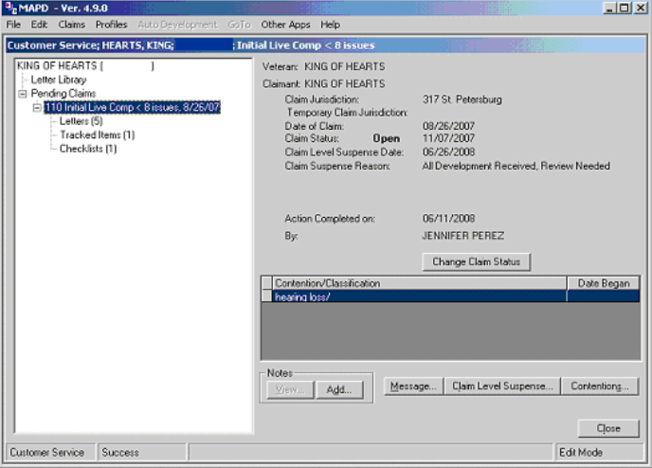

On this screen snapshot you can see that the window provides you with the Claim Status History. You will notice in the first two lines that the award was authorized and reflects that it is now in the Closed status. This shows that the award was authorized through VETSNET. On this sceen you will be able to change the status from Closed to Open by clicking the drop down arrow under Claim Status and following the appropriate steps as instructe by the system.

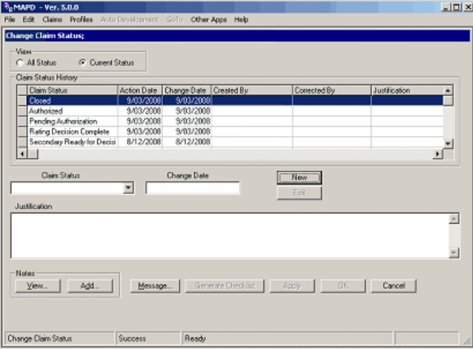

Virtual VA

Once you have authorized the award and date stamped the notification letter, you would need to upload the letter into Virtual VA. From the Virtual VA Homepage, there is a link to the Virtual VA Barcode Capture. Once you have clicked on this link, a pop-up box will appear on the lower right-hand side of the screen entitled, Virtual VA Barcode Capture. By scanning the barcode on your PCGL letter, this will upload the letter into the system. Upon a successful insertion of a barcode into the Virtual VA application, the barcode count in the lower left corner of the pop-up box will increase by one.

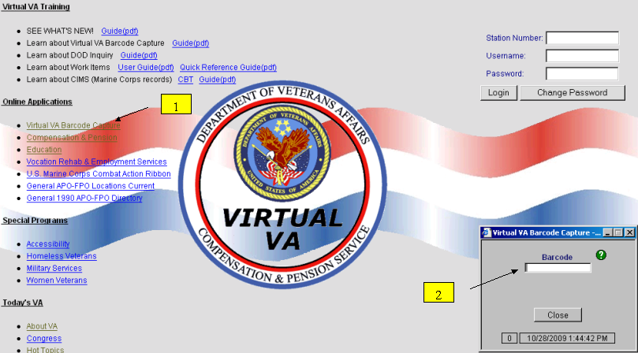

COVERS

After you have finished all of the above steps in authorization always make sure that you update COVERS to show the appropriate location of the file. In most cases the file will be returned to the to the file bank, or routed to different team if necessary.
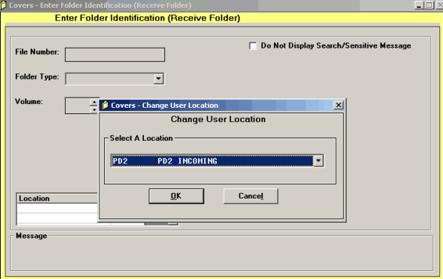

Handouts

STAR Rating Quality Review Checklist

The following is a sample of the rating checklist and STAR review addendum.

Regional Office Number _______ | Claim Number _______________
End Product _________________ | Name ______________________
Rating Checklist
 |  | YES | NO | N/A
BENEFIT ENTITLEMENT
Address All Issues
A1) Were all claimed issues addressed?
A2) Were all inferred and/or ancillary issues addressed?
Proper Development
B1) Was Section 5103 pre-decision “notice” provided and adequate?
B2) Does the record show development to obtain all indicated evidence (including a VA exam, if required) prior to deciding the claim?
IF NO, SPECIFY DEFICIENCY:
____ Private Medical ____VAMC Records _____Service Records
____VA Exam ____Medical Opinion _____Other

Grant or Deny
C1) Was the grant or denial of all issues correct?
C2) Was the percentage evaluation assigned correct (including combined eval.)?
Award Actions
D1) Are all effective dates affecting payment correct?
D2) Were all payment rates correct?
DECISION DOCUMENTATION/NOTIFICATION
Decision Documentation
E1) Was all pertinent evidence discussed?
E2) Was the basis of each decision identified and each denial explained?
Decision Notification
F1) Was notification sent?
F2) Was the notification correct?
F3) Were appeal rights included?
F4) Was the Power of Attorney indicated, correct, and notification properly documented?

ADMINISTRATIVE

Appropriate Signatures (Internal Controls)
G1) Was appropriate second signature documented?
G2) Were third signatures appropriately documented when required?

Examination & Medical Opinion Requests
H1) If a VA examination was requested, was that examination necessary and if an opinion was requested was the opinion an appropriate medical (not legal) question?
H2) Examination Requests – Were correct worksheets requested?
H3) Examination Requests – Were issues (disabilities claimed) clearly identified?
H4) Examination Requests _ When necessary or requested by VAMC was the claims folder provided by the regional office?
H5) Medical Opinion Requests – If a medical opinion was requested, were pertinent issues clearly identified and appropriate question(s) clearly asked?
H6) Medical Opinion Requests – Was the claim folder made available to the medical center by the regional office?

Expedited Favorable Decision
I) When evidence was sufficient to grant partial benefits, were those benefits granted promptly, while developing other issues?
Comments | YES
J1) Errors not associated with end product subject to review?
J2) Disability Determination
J3) Notification
Special Issue Identification
FORMER POW
RADIATION CLAIM
GULF WAR CLAIM
AGENT ORANGE CLAIM
PTSD CLAIM
BVA REMAND
Brokered Case |  | Regional Office: |  | Resource Center:
Brokered Case |  | None selected |  | None selected
TIGER TEAM CASE
BDD PROCESSING
ALLEN CASE
Pension Maintenance Center Case

FOR EACH “NO” ANSWER RECORDED, PROVIDE A BRIEF NARRATIVE SUMMARY OF THE ERROR AND STATUTORY, REGULATORY, OR MANUAL REFERENCES ON THE ATTACHED NARRATIVE SUMMARY SHEET.

STAR Authorization Quality Review Checklist

The following is a sample of the authorization checklist and STAR review addendum.

Regional Office Number ____________ | Claim Number______________
End Product _________________________ | Name_______________________

Authorization Checklist

 | YES |  | NO |  | N/A
BENEFIT ENTITLEMENT
Address All Issues
A1) Were all claimed issues addressed?
A2) Were all inferred issues addressed?
Proper Development
B1) Was Section 5103 pre-decision “notice” provided and adequate?
B2) Does the record show development to obtain all indicated evidence prior to deciding the claim?
Income Issues
C1) Was Net Worth determination correct?
C2) Was income counted in the correct reporting period?
C3) Was total family income counted properly?
C4) Were all deductions including unreimbursed medical expenses calculated correctly?
Dependency Issues
D1) Was a dependent spouse correctly established or removed?
D2) Were dependent children correctly established or removed?
D3) Were dependent parents correctly established or removed?
D4) Was a surviving spouse correctly established or removed?
D5) Were surviving children correctly established or removed?
Burial Issues
E1) Was the proper claimant paid (or properly denied)?
E2) Were transportation charges applied correctly?
E3) Was the Burial/Plot/Headstone payment correct (or properly denied)?
Accrued Benefits Issues
F1) Was the proper claimant paid (or properly denied)?
F2) Was the correct amount paid?
Adjustments (Hospital or Incarceration)
G1) Were required adjustments accomplished and correct?
G2) Was restoration of benefits correct?

Payment & Effective Dates
H) Are all payment dates and rates correct?
DECISION DOCUMENTATION/NOTIFICATION
Due Process Issues
I1) Was a predetermination notice sent?
I2) Was the notice fully informative?
I3) Was the claimant given 60 days before the due process period expired?
J1) DENIAL - Was all applicable evidence discussed?
J2) DENIAL - Was the basis of each decision explained?
J3) Were required formal apportionment decisions completed and
correct?
rccorrectcorrect?
Notification
K1) Was notification sent and documented in the file?
K2) Was the notification correct?
K3) Were appeal rights included?
K4) Was Power of Attorney indicated, correct and notification properly documented?
ADMINISTRATIVE
Appropriate Signature (Internal Control)
L) Was the appropriate second signature documented?
Comments | YES
M1) Errors not associated with end product subject to review?
M2) Notification?
Special Case Identification
N1) Brokered Case |  | Regional Office: | Resource  Office:
N1) Brokered Case |  | None selected | None Selected
N2) Pension Maintenance Center Case

FOR EACH “NO” ANSWER RECORDED, PROVIDE A BRIEF NARRATIVE SUMMARY OF THE ERROR AND STATUTORY, REGULATORY, JUDICIAL OR MANUAL REFERENCES ON THE REVERSE OF ATTACHED NARRATIVE SUMMARY SHEET.

ASPEN Quality Worksheet

BENEFIT ENTITLEMENT
{a} Administrative Requirements | YES | NO | N/A
A. Are the end product and claim number label correct?
B. Does the payee name and stub match?
C. Is the payee's address correct?
D. Is the date of claim correct?
E. Were contentions, classifications, special issues and flashes entered correctly?
F. Were all tracked items entered correctly?
G. Were MAP-D tracked items updated correctly as received, closed, or in error?
H. Is the appropriate claim status (RFD, RDC, OPEN, etc) reflected in MAP-D?
I. Are existing suspense dates entered correctly? *
J. If necessary, was the POA updated in all systems and correspondence?
{b} Service Verification Requirements | YES | NO | N/A
A. Was service verified?
{c} Medical Evidence Requirements | YES | NO | N/A
A. Does the record show all VCAA required development initiated?
B. Section 5103 Notice (evidence required to substantiate claim)
C. Treatment VA Facility
D. Treatment non-VA Facility or private treatment records
E. Recent treatment
F. Accident/injury medical records
G. Service medical/dental records
H. A/A Nursing Home
I. Housebound
J. PTSD stressor development
K. Other (list):
{d) Administrative Decision Requirements | YES | NO | N/A
A. Does the record show evidence was requested, if required, to make a determination for an administrative decision?
1. Net Worth
2. Deemed Valid
3. Apportionment
4. Common Law
5. Line of Duty
6. Continuous Cohabitation
7. Willful Misconduct
8. Character of Discharge
9. Insanity
10. Other (list):
{e} Income Requirements | YES | NO | N/A
A. Was income documentation developed properly?
1. Veteran income
2. Spouse income
3. Child(ren) income
4. Parent income
5. Business/rental income
6. Farming income
7. Unemployment income
8. SSA benefit
9. Retirement income
10. Other (specify):
B. Was expense documentation developed properly?
1. General expenses
2. Medical expenses
3. Last expenses
4. Insurance
5. Hardship expenses
6. Other (specify):
{f2}} Income Decision | YES | NO | N/A
A. Was Net Worth determination correct?
B. Was income counted in the correct reporting period?
C. Was total family income counted properly?
D. Were all deductions including unreimbursed medical expenses calculated correctly?
{g1} Dependency Requirements | YES | NO | N/A
A. Was dependency documentation developed properly?
1. SSN request
2. VA Form 21-686c
3. VA Form 21-674
4. Helpless child
5. Marriage certificates
6. Divorce documentation
7. Birth certificates
8 Cohabitation
9. Parents
{g2} Dependency Decision | YES | NO | N/A
A. Was a dependent spouse correctly established or removed?
B. Were dependent children correctly established or removed?
C. Was a surviving spouse correctly established or removed?
D. Were surviving children correctly established or removed?
E. Was a formal apportionment decision required?
F. Was formal apportionment decision complete and correct?
{h1} Burial Requirements | YES | NO | N/A
A. Has the proper claimant been identified?
B. Is a death certificate of record?
C. Do we have a receipt/bill for funeral expenses?
D. Reimbursement Waiver sent – VA Form 21-5328?
{h2} Burial Decision | YES | NO | N/A
A. Was the proper claimant paid (or properly denied)?
B. Were transportation charges applied correctly?
C. Was burial/plot/headstone payment correct (or properly denied)?
{I} Accrued Benefits Decision | YES | NO | N/A
A. Was the proper claimant paid (or properly denied)?
B. Was the correct amount paid?
{j1} Incarceration Requirements | YES | NO | N/A
A. Has documentation been requested to determine if conviction of felony?
B. Has VA Form 21-4193 been sent to vet/facility for date of incarceration?
{j2} Hospitalization or Incarceration Decision | YES | NO | N/A
A. Were required adjustments accomplished and correct?
B. Was restoration of benefits correct?
{K} Writeouts
A. Were required adjustments accomplished and correct?
B. Was the proper claimant paid (or properly denied)?
C. Was the correct amount paid?
D. Is the date of claim correct?
{L} Payment and Effective Dates | YES | NO | N/A
A. Are all payment dates and rates correct?
{M} Due Process Decision | YES | NO | N/A
A. Was a predetermination notice sent?
B. Was the notice fully informative?
C. Was claimant given 60 days before the due process period expires?
D. Contemporaneous Notice?
{N} Notification | YES | NO | N/A
A. Was notification sent and documented in the file?
B. Was the notification correct?
C. DENIAL - was all applicable evidence discussed? (either in the notification or attached rating)
D. DENIAL - was the basis of each decision explained? (either in the notification or attached rating)
E. Were appeal rights included?
F. Was the Power of Attorney indicated, correct and notification properly documented?
Comments:

Practical Reviews

Exercise 1

- What are two methods used in structuring the quality review?

- ______________________________________________________________
- ______________________________________________________________

- What are the three major components used in SHARE during the authorization process?

- ______________________________________________________________
- ______________________________________________________________
- ______________________________________________________________, and how do you access them?
- ______________________________________________________________

- On what screen would you find Military Retired Pay of SBP, Severance Pay, Separation Pay or Readjustment Pay?

- ____________________________________

- Where would you find the following categories: Person screen, Military screen, Claims/Denial screen, and the Award/Rating screen?

- ____________________________________

- Where would this statement appear? “A Proposed Award is Pending. Please Refer for Authorization for Correction, if not, Ready for Authorization.”

- ____________________________________

- Prior to authorization when should tracked items for a particular claim be updated?

- ____________________________________, and what screen is used to view the development action/letters that are associated with a claim?

- ___________________________________________________________

- An authorized award through VETSNET will automatically be changed from an open status to a closed status. What action process would be taken for a deferred issue on the rating decision.

(a) ___________________________________________________________

- In what section of the STAR Quality Review Checklist would you find dependency
issues?

(a) ______________________________________________________________

- Where would you annotate a notification error on the STAR Quality Review
Checklist?

(a) ____________________________________________________

10. List the nine issues that require or may require an Administrative Decision.

(a) ____________________________________________________________

(b) ____________________________________________________________

(c ) ____________________________________________________________

11. What are the critical factors for Rating issues?

- _________________________________________
- __________________________________________
- __________________________________________
- __________________________________________

12. What are the critical factors for Authorization issues?

- ________________________________________
- _______________________________________
- ______________________________________
- ______________________________________
- ______________________________________
- ______________________________________
- ______________________________________
- ______________________________________

