Helpless Child
Trainee Handout

Table of Contents

Objectives 2
References 3
Topic 1: Requirements to Establish Helpless Child Dependency 4
Topic 2: Evidentiary Requirements for Initial Development 6
Topic 3: Promulgation of Benefits 8
Attachment A: VETSNET Awards Processing 11
Attachment B: Topic 1 Exercise 13
Attachment C: Topic 2 Exercise 14
Attachment D: Topic 3 Exercise 15
Practical Exercise 17

Objectives
- Given references, the trainee handout packet, and the EPSS, identify the components required when establishing dependency, with 85% accuracy.
- Given references, the trainee handout packet, and the EPSS, differentiate evidentiary requirements when initiating development, with 85% accuracy.
- Given references, the trainee handout packet, and the EPSS, differentiate the requirements for promulgation of helpless child benefits, with 85% accuracy.
References

- 38 CFR 3.57
- 38 CFR 3.315(a)
- 38 CFR 3.356
- M21-1MR, Part III, iii.5.F
- M21-1MR, Part III, iii.5.G
- M21-1MR III.iii.7.1
- M21-1MR, III.iii.7.2
- M21-1MR III.v.2.A.2
- M21-1MR III.v.2.B.9
- Awards User Guide – p. 4-9 to 4-20 and p. 17-59 to 17-56

Topic 1: Requirements to Establish Helpless Child Dependency
Definitions
To effectively rate helpless child claims, it is important to understand the definition of child and helpless child.
Child
For VA purposes, a child is an unmarried dependent of the Veteran who is one of the following:
- A biological child of the Veteran (legitimate or illegitimate)
- An adopted child of the Veteran prior to the child’s 18th birthday
- A stepchild who acquired stepchild status prior to age 18
Helpless Child
38 CFR 3.315 states that a child of a Veteran may be considered a helpless child after age 18 for purposes of benefits under title 38, USC, if found by a rating determination to have become, prior to age 18, permanently incapable of self-support to include the age requirement for disability onset. The child must be:
- Under age 18
- Between the ages of 18 and 23, if pursuing an approved course of education
- Rated incapable of self-support
Establishing Dependency
The Veteran must meet the following VA requirements for adding a dependent to an award:
- The child must be established as a dependent of the Veteran for VA purposes
- The child must be within three months of his or her 18th birthday or older before the helpless child claim can be processed
- Medical evidence must show that the child became incapable of self-support prior to reaching the age of 18
- Medical evidence must show that the condition still exists
Adding a Dependent
Information needed to add a child as a dependent on the Veteran’s award includes:
- Name
- Date of birth
- Social security number
- Place of birth
In most cases, a statement from the Veteran is sufficient to establish dependency for a child.
Documentary Evidence
Documentary evidence of birth is required if the:
- Claimant does not reside within a state
- Statement on face value raises a question of validity
- Statement conflicts with other evidence of record
- Claimant has shown reasonable indication of fraud or misrepresentation
Confirming Dependency
Confirming dependency requires a complete review of the following:
- Claims folder
- Submitted documentation
- Claimant Master Record
The VA may have previously recognized the child as a dependent of the Veteran. If so, there should be a record of it, either in the claims folder or in the Master Record.

Topic 2: Evidentiary Requirements for Initial Development
Substantive Evidence
M21-1MR, III.iii.7.1.b lists the evidence needed to establish a disability or a child as incapable of self-support:
- Physical or mental deficiencies of the child:
  - Ability to perform self-care functions
  - Ability to perform ordinary age-appropriate tasks
- School attendance and maximum grade completed
- Improvement in condition (if any)
- Employment of the child
  - Nature and dates
  - Pay received
- Marriage (if any)
- Description of the present condition
If evidence received tends to show permanent incapacity for self-support, refer the claim to the rating team for a decision. Evidence may be received at any point throughout the timeline of the claim.
Personal Statements
Personal statements can be used as substantive evidence in a helpless child claim. They must include the following:
- Be signed by the person making the statement
- Include that person’s contact information
- Give detailed information of all facts known regarding the child’s:
  - Mental condition at age 18
  - Physical condition at age 18
  - Current condition
Initial Development
If incapacity of a child is alleged and substantive evidence has not been received, follow these procedures:
- Ensure an EP 020 is established with a suspense date for 30 days
- Send the claimant a Section 5103 notice requesting the claimant submit:
  - Evidence within 30 days from date of request
  - Medical or psychiatric exams
  - Vocational or educational assessments
  - Employment history
  - Statements from teachers or social workers with knowledge of facts and observations of the child's condition
  - Statements from institutions where the child was maintained
  - Statements that describe the child's condition in detail at age 18 including:
    - Extent of disability
    - Whether facts are based on personal observation
- Set suspense for 30 days
Section 5103 Notice
The Section 5103 notice should inform the claimant of:
- Thirty day time limit
- Evidence or statements needed describing the child's condition at age 18
- Evidence or statements regarding the extent of the disability
- Whether facts are based on personal observation
Section 5103 notice Expiration
If the Section 5103 notice period expires and no reply has been received, refer the case to the rating board to determine if:
- A favorable decision can be made
- The claim should be denied as not supported by the evidence
- The evidence of record establishes a reasonable probability of a valid claim which would warrant a request for a VA examination
Topic 3: Promulgation of Benefits
Review of Actions
The promulgation and notification process is the same regardless of whether the rating activity awards or denies the helpless child claim.
Actions in Every Claim
Review the requirements for:
- Effective dates
- Payment dates
- Reason codes
Allowance of Benefits Steps
The allowance of benefits steps are:
- Process award data
- Prepare notification letter to claimant
- Forward claims folder, award, and notification letter to SVSR
Process Award Data
The VETSNET system is a reliable interface between development, rating, and awards applications. It allows the VSR to easily process a rating.
The helpless child award is promulgated as any other dependency award, with the VSR ensuring:
- Award Status field shows Helpless Child
- Decision field shows Rated helpless
- No termination date is listed
Prepare Notification Letter
38 CFR 3.103 sets notification requirements. In each award and denial letter, VA must inform the claimant of and include the following:
- Decision made
- Summary of the evidence considered
- Reason for the decision
- Monthly VA rates
- Applicable effective dates
- Benefits being withheld
- Reason for withholding benefits
- Notice of procedural due process and appellate rights of the claimant including:
    - Rights to a hearing
    - Right to representation
    - Rights to appeal
    - Information about additional benefits or entitlements that may be due the claimant
When a decision is the result of a rating, notification letters do not need to summarize the evidence considered or state the reason for the decision. Instead, the rating decision should be attached to the notification letter.
VSR Assistant Module
If assistance is needed with a non-converted case, utilize the VSR Assistant module for helpless child by completing the following:
- Handle an apportionment for a helpless child in the same manner as for a minor child, but do not use a future termination date.
- Use PCGL to create the notification letter. Remember to review the letter to ensure the accuracy and readability of the information.
Disallowance of Benefits Steps
Decisions for helpless child claims will be determined by the rating activity.
When a rating decision denies entitlement to helpless child benefits, take the following steps:
- PCLR the end product (EP) associated with the claim
- Prepare a notification letter to the claimant
- Forward the claims folder and all award documents and letters to your SVSR
Reconsideration Due to Marriage
Marriage of a child permanently incapable of self-support discontinues entitlement to benefits, except in these cases of a child of a (n):
- Spanish-American War Veteran
- Indian War Veteran
If the beneficiary, fiduciary, or the Veteran or surviving spouse (in cases where an additional allowance is being paid to the Veteran or surviving spouse for the child) informs VA of the marriage, termination of helpless child benefits would be processed.
38 CFR 3.500(n) should be used to determine the effective date to discontinue benefit entitlement. Since this information is primary evidence, a contemporaneous notice would be sent instead of due process.
Third Party Evidence
If evidence is received from a third party:
- Apply due process
- Send notice of potential adverse action
- After 60 days, weigh any and all evidence received
Termination of Benefits
If evidence verifies the child is married, terminate benefits.
If no evidence is received at the end of the due process period, weigh all evidence of record under the rule of reasonable doubt, 38 CFR 3.102, and notify the payee/beneficiary of the final decision.
Not all cases that are based on third party information will result in discontinuance of benefits.
For more information regarding the marriage of a helpless child, see M21-1MR III.iii.7.5 and M21-1MR III.iii.5.H.
VETSNETS Awards Processing
To promulgate the award, follow the steps for VETSNET Awards:
- Check to make sure that there is a rating decision to support the payment
- Add helpless child through the dependency screen
- Select the Rating button on the Record Decisions screen
- View the Family Member Ratings tab

Attachment A: VETSNET Awards Processing
To promulgate the award, using VETSNET Awards, follow the steps below. Before adding a helpless child through the dependency screen, first check to make sure that there is a rating decision to support the payment.
- Select the Rating button on the Record Decisions screen.
- View the Family Member Ratings tab. A helpless child decision should display as shown below.
1
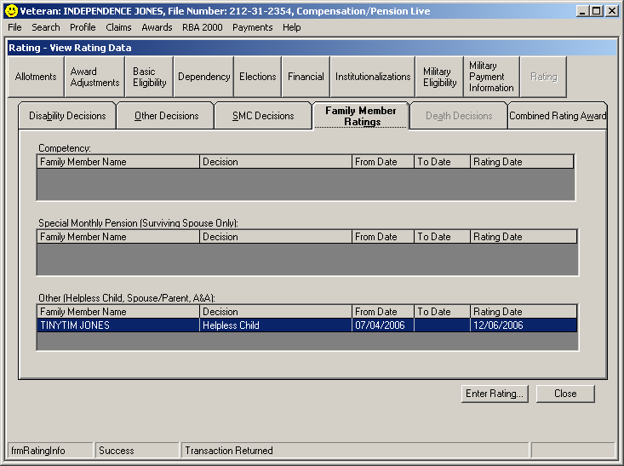
2

- Select the Dependency button in the row of decision screen buttons to open the Dependency decision screen.

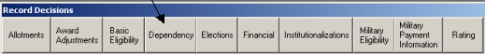

- Select the Add button.
- Select the Person for whom the dependency decision will be made.
  - The system will list all dependents that have been previously established as family members during the Share CEST or PIF Change process.
- The Relationship Type, Date of Birth, and SSN information will automatically populate based on the information entered in SHARE during the CEST or PIF Change process.
- Enter the Event Date. In this case we are working a helpless child rating and will use the effective date of the rating, 07/04/2006.
- Select the Award Status of Helpless child.
- Select the Decision of Rated Helpless.
- Once the Decision is selected, the system will automatically record the Award Effective Date. This field can be modified if needed.
- Select the Accept button to update the grid.
- Select the OK button to save the decision and close the screen.

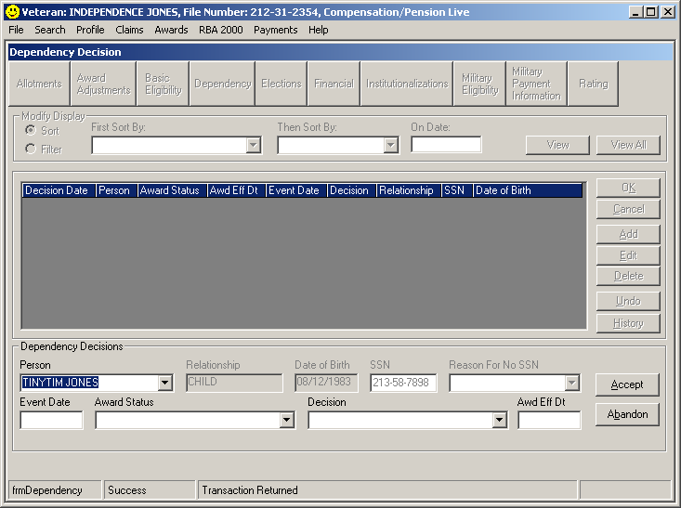
4
5
6
7
8
10
11
9

Attachment B: Topic 1 Exercise
Using available references, answer the following questions.
- What is the definition of helpless child?
______________________________________________________________________________________________________________________________________________________________________________________________________
- What are the age requirements for a child to be considered a Veteran’s dependent?
______________________________________________________________________________________________________________________________________________________________________________________________________

- Which regulation provides the general description of a child? Provide a synopsis of that definition.
______________________________________________________________________________________________________________________________________________________________________________________________________

- What type of evidence is generally sufficient to establish a dependent for VA purposes?
______________________________________________________________________________________________________________________________________________________________________________________________________

- Which section of the manual provides general information regarding relationship and dependency?
______________________________________________________________________________________________________________________________________________________________________________________________________

Attachment C: Topic 2 Exercise
Using available references, answer the following questions.
- Which manual and section addresses a child’s permanent incapacity for self-support?
__________________________________________________________________
- What is the earliest that benefits can be paid for a helpless child?
__________________________________________________________________
- What are the 38 CFR references that outline the rating criteria used to determine permanent incapacity for self-support?
__________________________________________________________________
- What is the earliest date that a claim for helpless child benefits can begin processing?
__________________________________________________________________
- What information is needed to provide substantive evidence in a claim for a helpless child?
______________________________________________________________________________________________________________________________________________________________________________________________________

- If incapacity of a child is alleged and substantive evidence has not been received, what procedure should be followed?
______________________________________________________________________________________________________________________________________________________________________________________________________

Attachment D: Topic 3 Exercise
Determine whether all requirements are met for these claims to be granted and the next course of action. If the requirements are not met, explain why. Use the EPSS Helpless Child Module and manual references to check your answers.

- Shirley Lowe filed an original compensation claim, which was received by VA on December 2, 2003. She completed the dependency segment of VA Form 21-526 showing that she and her husband have a daughter, Jill, who was in a car accident last year, July 2002, which left her completely paralyzed. Shirley furnishes all the required dependency information for her husband and daughter as well as medical evidence pertaining to Jill’s accident. Jill’s birthday is March 22, 1982. You receive the rating decision on February 25, 2004, which grants 40% disability compensation to Shirley Lowe.
______________________________________________________________________________________________________________________________________________________________________________________________________________

- George Wesley has a running 50% compensation award. He is being paid for his wife, Theresa, whom he married just last year. He states that his wife’s son has come to live with them and he would like to have the child added to his compensation award as a helpless child. He furnishes all the required dependency information and medical evidence showing the child suffered a swimming accident, which cut off the oxygen supply to his brain, causing severe and permanent damage. The child’s birthday is April 23, 1992. You are working this claim today, May 26, 2004.
_______________________________________________________________________________________________________________________________________________________________________________________________________________

- In what circumstance(s) would a VSR administratively discontinue an award for helpless child benefits?
_______________________________________________________________________________________________________________________________________________________________________________________________________________

- What is the status code and reason code for helpless child?
_____________________________________________________________________
- In VETSNET, what must you first do before generating an award?
______________________________________________________________________________________________________________________________________________________
Practical Exercise
Determine whether all requirements are met for these claims to be granted and the next course of action. If the requirements are not met, explain why. Use the EPSS Helpless Child Module and Manual references to check your answers.

- Harold Halbert has a running disability compensation award at 60%. He files a claim which states that he wants to add his son to his award as a helpless child. VA receives the claim December 3, 2003. His son, Timmy, was born February 6, 1986. Harold furnishes all required dependency evidence as well as medical evidence showing Timmy was diagnosed with multiple sclerosis at age 14. Today’s date is December 20, 2003.
______________________________________________________________________________________________________________________________________________________________________________________________________________

- Norman New is a 60% service-connected Veteran awarded for a spouse and two children. He submits VAF 21-4138 stating that his youngest child has suffered permanent brain damage and must now be cared for daily. The form was received in the office on May 9, 2009 with no other evidence. How would you proceed?
______________________________________________________________________________________________________________________________________________________________________________________________________________

- L.B. Jeffries is the adult child of Alfred Jeffries, who is a deceased Vietnam Veteran. L.B. files a claim for DIC and claims he is incapable of self-support. As no evidence is of record, you send a Section 5103 notice requesting evidence of L.B.’s medical diagnosis and the earliest date of symptom onset. Medical records are submitted within the 30 day period. How would you proceed?
______________________________________________________________________________________________________________________________________________________________________________________________________________

- Eve Kendall applied for helpless child benefits for her 19-year-old daughter on January 25, 2003. A Section 5103 notice was sent to Ms. Kendall on February 8, 2003 and requested medical evidence of her daughter’s inability for self-support. Ms. Kendall returned two signed and completed VA Form 21-4142s on March 30, 2003 for Indian Path Pavilion and Mt. Region Pediatrics. The case was referred to the rating activity on April 15, 2003. Was all development completed correctly? If not, please describe the proper development procedure.
______________________________________________________________________________________________________________________________________________________________________________________________________________

- On March 14, 2009, Danny Ocean, who is receiving service-connected compensation at 30%, submitted evidence showing his daughter, Eva, was diagnosed with cerebral palsy and is not able to attend school. Eva’s birthday is May 9, 1991. How would you proceed with the case?
______________________________________________________________________________________________________________________________________________________________________________________________________________

- Based on the following rating for Barry Farve (on the next page), how would you proceed with promulgation?
______________________________________________________________________________________________________________________________________________________________________________________________________________

DEPARTMENT OF VETERANS AFFAIRS
Training RO
PO Box 123
Technical Training, USA 45678
Barry H. Farve
VA File Number
xxx xx xxxx
Represented by:
N/A
Rating Decision
May 1, 2008

INTRODUCTION
The records reflect that Barry H. Farve was a Veteran of the World War II, Korean Conflict, and Vietnam Era. The Veteran served in the Army from June 4, 1942 to November 30, 1962. The Veteran died on January 25, 1999 and a new claim was received on January 21, 2008. Based on a review of the evidence listed below, we have made the following decision(s) on your claim.

DECISION
Permanent incapacity for self-support is not established for Julia Farve.

EVIDENCE
Letter from Julia Farve dated January 18, 2008
Report from Fairville Community Mental Health Center dated March 24, 2008
Letter to Julia Farve requesting evidence dated January 15, 2008
Reply from St. Luke’s Hospital received April 10, 2008

REASONS FOR DECISION
Permanent incapacity for self-support of Julia Farve
For purposes of establishing entitlement to VA benefits, a child over 18 years of age must be shown to be permanently incapable of self-support by reason of mental or physical defect by the age of 18. The extent and nature of the claimed disability is not sufficient to establish that you, Julia Farve, are permanently incapable of self-support prior to age 18 on October 20, 1976.
The report from Fairville Community Mental Health Center dated March 24, 2008 stated that you are currently seeing Dr. Seago for bi-polar disorder. The report did not show that due to your condition you are currently incapable of self-support nor were prior to the age of 18. A letter dated March 12, 2008 was sent to St. Luke's Hospital c/o Records for Dr. Wellish requesting treatment records from January 1, 1958 to October 20, 1976 for you. A response was received on April 10, 2008 indicating Dr. Wellish has been deceased for more than 10 years and they have no treatment records for you. Also, you were asked to provide medical records from St. Luke's Hospital. There has been no reply to this request.

REFERENCES:
Title 38 of the Code of Federal Regulations, Pensions, Bonuses and Veterans' Relief contains the regulations of the Department of Veterans Affairs which govern entitlement to all Veteran benefits. For additional information regarding applicable laws and regulations, please consult your local library, or visit us at our web site, www.va.gov.

Rating Decision | Department of Veterans Affairs  Training RO |  |  | May 1, 2003
NAME OF VETERAN  Barry H. Farve | VA FILE NUMBER | SOCIAL SECURITY NR | POA  N/A |  | COPY TO  N/A

ACTIVE DUTY
EOD | RAD | BRANCH | CHARACTER OF DISCHARGE
Not Tested | Not Tested | Not Tested | Not Tested

LEGACY CODES
ADD’L SVC  CODE | COMBAT  CODE | SPECIAL  PROV CDE | FUTURE EXAM  DATE
Not Tested | Not Tested | Not Tested | None

JURISDICTION: | New Claim Received 01/21/2008

Associated Claim(s): | 020; Helpless Child; 01/21/2008

FAMILY MEMBER RATING DECISIONS
Julia Farve – Not Helpless from 10/20/1976

- Based on the following rating for Stanley Warbucks Jr. (on the next page), how would you proceed with promulgation?
______________________________________________________________________________________________________________________________________________________________________________________________________________

DEPARTMENT OF VETERANS AFFAIRS
Training RO
PO Box 123
Technical Training, USA 45678
Stanley H. Warbucks
VA File Number
xxx xx xxxx
Represented by:
N/A
Rating Decision
February 1, 2003

INTRODUCTION
The records reflect that you are a Veteran of the Vietnam Era. You served in the Army from July 16, 1968 to March 20, 1970. We received your new claim for benefits on January 9, 2003. Based on a review of the evidence listed below, we have made the following decision(s) on your claim.

DECISION
Permanent incapacity for self-support is established for Stanley Warbucks Jr.

EVIDENCE
Reports from Dr. A. W. Pingpank dated 12/06/02 and 12/08/02
Report from Paula Templeton, Johnson High School, dated 01/07/03

REASONS FOR DECISION
Permanent incapacity for self-support of Stanley Warbucks Jr.
For purposes of establishing entitlement to VA benefits, a child over 18 years of age must be shown to be permanently incapable of self-support by reason of mental or physical defect by the age of 18. The evidence establishes that your son, Stanley Warbucks Jr., became permanently incapable of self-support prior to age 18 on December 23, 2002, by reason of physical or mental disability diagnosed as Shwachman's Syndrome.
The medical report shows a diagnosis of Shwachman's Syndrome. The report from Johnson High School indicates that Stanley has been identified as physically unable to achieve independence in life.

Rating Decision | Department of Veterans Affairs  Training RO |  |  | February 1, 2003
NAME OF VETERAN  Stanley H. Warbucks | VA FILE NUMBER | SOCIAL SECURITY NR | POA  N/A |  | COPY TO  N/A

ACTIVE DUTY
EOD | RAD | BRANCH | CHARACTER OF DISCHARGE
Not Tested | Not Tested | Not Tested | Not Tested

LEGACY CODES
ADD’L SVC  CODE | COMBAT  CODE | SPECIAL  PROV CDE | FUTURE EXAM  DATE
Not Tested | Not Tested | Not Tested | None

JURISDICTION: | New Claim Received 01/09/2003
Associated Claim(s): |  | 020; Helpless Child; 01/09/2003
FAMILY MEMBER RATING DECISIONS
Stanley Warbucks Jr. – Helpless Child from 12/23/2002

