

DEPARTMENT OF VETERANS AFFAIRS Veterans Benefits Administration Washington, D.C. 20420
September 18, 2014
Director (00/21C) Fast Letter 14-09 All VBA Regional Offices and Centers
ATTN: All Veterans Service Center Personnel
SUBJ: Compensation Service National Training Curriculum for Fiscal Year 2015

Purpose
It is critical that the Compensation Service National Training Curriculum (NTC) is consistent and aligned with VA’s organizational goals. VA regional offices (ROs) provide specific employee training to enhance the delivery of quality service to Veterans. Each RO is responsible for establishing training plans at the beginning of every fiscal year (FY) to ensure that employees complete the designated number of national curricula hours.
In general, all Veterans Service Representatives (VSRs), Rating Veterans Service Representatives (RVSRs), Decision Review Officers (DROs), and Quality Review Team (QRT) members must complete 85 hours (or more) of training in FY 2015. The five hours of annual VA training such as Privacy, HIPAA, Ethics, VBA Continuity of Operations, and Prevention of Harassment/No Fear Training items will be monitored by the Office of Employee Development and Training (ED&T). The Compensation Service Training Staff, in coordination with the Quality Assurance Staff, has developed an 80hour curriculum that includes technical training specific to the level of experience for:
• VSRs, including VSRs working in Public Contact Team (PCT)
• RVSRs
• DROs
• QRT members
• Integrated Disability Evaluations System (IDES)-Military Services Coordinator
(MSC) Personnel Page 2.
Director (00/21C)
The NTC also provides developmental training appropriate to address skill enhancement for all employees and mandatory agency-wide curricula for all employees. Topics identified as mandatory consist of issues of high interest and/or quality concerns. This fast letter is intended to facilitate the understanding, implementation, and recording of the Compensation Service FY 2015 NTC. All ROs must ensure that the information outlined in the enclosed standard operating procedure (SOP) is implemented upon receipt of this directive.

FY15 Compensation Positions
The NTC FY15 training requirement will include the below listed positions. Please note the SOP includes special instructions for assigning curricula in the Talent Management System (TMS) for each position.
• VSRs
• RVSRs
• DROs
• QRT members (Authorization and Rating)
• PCT VSRs processing claims in PCT
• IDES MSC Personnel
• Claims Assistants

Training Procedures
The SOP for the Compensation Service FY 2015 NTC provides more specific information regarding the training requirements, procedures, and certification of completed courses. All training being delivered as part of the NTC must have a Compensation Service nationally-assigned TMS number. Training provided by ROs that does not have a Compensation Service TMS number assigned will not be counted as part of the required 80 hours.
In addition, the SOP defines training per Title 5 of the United States Code (U.S.C.), Part III, Chapter 41at § 4101(4), and outlines the elements of training that must be met for training to be credited. All mandatory training must be delivered in accordance with the intent of the lesson. ROs must ensure that:
- Each individual selected to provide instruction meets the qualifications as outlined in the SOP, and
- Selected instructors teach courses according to the approved lesson plans. (For example, if the lesson plan states that the course is “instructor-led,” then the instructor must provide instructor-led training and utilize all practical exercises associated with the particular course.)

Page 3.
Director (00/21C)
The required training identified in the NTC supports the agency goal to meet quality standards, and it allows employees to feel more empowered and confident in their jobs.

Questions
E-mail questions concerning this letter to VAVBAWAS/CO/C&PTraining.
/S/ Thomas J. Murphy Director Compensation Service
Enclosure:
Standard Operating Procedure
Standard Operating Procedure Compensation Service Fiscal Year 2015 National Training Curriculum

Index
Introduction .......................................................................................................... 2 Target Audience .................................................................................................. 2 Definitions ............................................................................................................ 2 Compensation Service FY 2015 NTC Training Requirements for Members of Specified Audiences ............................................................................................ 3 Compensation Service FY 2015 NTC Training Standards .................................. 4 Compensation Service FY 2015 NTC Major National Training Curricula ............ 5 Assigning the Compensation Service National Training Curricula in TMS through Class Assignments ................................................................................. 7 Locally Created Training ...................................................................................... 7 Training Material Comments and Updates .......................................................... 8 NTC Make-up Training ........................................................................................ 8 NTC Refresher Training for TMS Comprehension Assessment .......................... 8 Instructor Expectations ........................................................................................ 9 Training Compliance Reporting Requirement .................................................... 10 Training Plan Reporting Requirement ............................................................... 10 Questions ........................................................................................................... 10 Appendix A: Prorating Training Availablity Time for Compensation Service FY 2015 NTC .......................................................................................................... 11 Appendix B: Reset TMS Assessments ............................................................. 13 Appendix C: Resources .................................................................................... 14
Introduction
This standard operating procedure (SOP) provides guidance and direction to support understanding, implementation, and recording of the Compensation Service Fiscal Year (FY) 2015 National Training Curriculum (NTC) at Veterans Benefits Administration (VBA) regional offices (ROs).
This SOP does not apply to Pension Management Center VSRs, RVSRs, DROs, or positions that fall under the jurisdiction of the Benefits Assistance Service (BAS) or any business line other than Compensation Service.
Target Audience
The Compensation Service NTC is required annual training for all employees in the Veterans Service Center who are involved with processing compensation claims.
• Veterans Service Representatives (VSRs) • Rating Veterans Service Representatives (RVSRs) • Decision Review Officers (DROs) • Quality Review Team (QRT) Authorization Quality Review Specialists (AQRSs) and
Rating Quality Review Specialists (RQRSs) • Public Contact Team (PCT) VSRs • Integrated Disability Evaluations System (IDES)-Military Services Coordinator (MSC)
Personnel • Claims Assistants (CAs) • Other employees who process Compensation Claims
This SOP will guide training managers in ensuring employees receive quality training according to Compensation Service guidelines.
Definitions
• Training: In accordance with Title 5 of the United States Code (U.S.C.), Part III, Chapter 41at § 4101(4): “Training” means the process of providing for and making available to an employee, and placing or enrolling the employee in, a planned, prepared, and coordinated program, course, curriculum, subject, system, or routine of instruction or education, in scientific, professional, technical, mechanical, trade, clerical, fiscal, administrative, or other fields, which will improve individual and organizational performance and assist in achieving the agency’s mission and performance goals.
• Trainee status: The status of an employee during their initial time period in a position defined by the timeframe needed to complete required training curricula and to demonstrate basic proficiency in job-related tasks.
• Curriculum: A course of study designed for a particular purpose.
• Compensation Service-Mandated Training Curriculum: Courses on specific topics identified by VBA Central Office based on national quality trends and emerging issues.
• Compensation Service One-Time Mandated Curriculum: Courses on specific topics that the identified target audience must complete one time during their career in a job position.
• Talent Management System (TMS): The VA system of record for all VA training records
• VBA Learning Catalog: An online training catalog that is organized specifically to support the way VBA structures and manages its training programs. The training catalog is the designated focal point to recognize the target areas of Compensation Service training items. Searchable functions identify mandated items, one-time mandated items, and target audiences. Items are also searchable by job position, TMS item number, curriculum, etc. The catalog is available at: http://hvnc.gdit.com/lc/
Compensation Service FY 2015 NTC Training Requirements for Members of Specified Audiences
VSR and RVSR Trainees: Entry-level VSRs and RVSRs are required to complete the appropriate Challenge training and the intermediate (follow-on) curricula, as well as any newly-assigned Mandatory Items.
Central Office will assign the following items in TMS to VSR and RVSR Challenge Graduates:
- Challenge completion credit
- One-Time Mandated curricula
- FY15 Mandated Training Items
- Beginning in FY15, graduates of Challenge Session 2014-1 and future Challenge sessions will be added by Central Office to the appropriate primary NTC class for their position upon reaching Intermediate status.

Training Managers will need to assign the designated FY15 NTC classes to all employees who graduated Challenge prior to Session 2014-1 (see Assigning the Compensation Service National Training Curricula in TMS through Class Assignments section).
Recommended Training Plans for VSRs, RVSRs, and CAs entry level employee are found on the Compensation Service Training webpage.
Claims Assistants New and Continued NTC: CA curriculum will also have Mandated and Station-Selected training items. They will have a total of 16 training hours to complete in FY15. Mandated items will be identified throughout the FY as emerging issues arise.
CAs are in Trainee Status for six months from the time they are assigned to the position. Within this time, employees will complete the Compensation Service-prescribed initial curriculum located at: Training Plans for Claims Assistants The training curricula must be assigned locally.
Continuing NTC: All VSRs, MSCs, RVSRs, DROs, and QRT members in the target audience must complete a minimum of 80 hours of NTC training in FY15. This training consists of two parts.
1. Compensation Service-Mandated Training: At least 10 hours of courses mandated by Compensation Service as listed in the VBA Learning Catalog. The mandated items address changes in regulations and procedures at a national level, as well as trends identified during monthly quality reviews by STAR, fast letters, training letters, and court decisions. These items will be added to curriculum during the FY as they are identified. TMS item numbers will be assigned and the items will be centrally added to this curriculum when published. All employees who have been assigned the Mandatory Training Curriculum will have these items appear on their learning plans automatically. All Compensation Service-Mandated Training will be delivered by Compensation Service to ensure consistency in both information and delivery.
2. Compensation Service Station-Selected Training: 70 hours of courses selected from a specific pool of items by each RO based on local quality reviews, Compensation Service Quality Assurance Reviews , national quality trends, and requirements for a particular position.
a. Compensation Service One-Time Mandated: These items are required to be taken one time during the employee’s career in that job position. The One-Time Mandated items are position specific and can apply to CA, VSR, MSC, RVSR, and DRO positions.
b. Compensation Service Consistency Studies: Compensation Service administers Consistency Studies and Inter-Rater Reliability Studies which will count toward NTC training curriculum. The studies are assigned to participants by Centeral Office. Questions or comments should be submitted the Compensation Service Quality Assurance staff at QRT.VBACO@va.gov

Compensation Service FY 2015 NTC Training Standards
• ROs will only use training materials and lesson plans available from the VBA Compensation Service website, VBA Learning Catalog, or online through TMS to ensure consistency of training across VBA. NTC courses must be taught according to the approved lesson plans provided by Compensation Service. For example, if the lesson plan states the lesson is instructor-led, it must be taught as an instructor-led course. If there is a practical exercise, the practical exercise must be used in the class.
• Employees must complete the evaluations and/or comprehension assessments, if applicable, in TMS to receive credit for completing the course.
• Training session attendance sheets for instructor-led items are required to be completed at the time of training to include all attendees’ signatures. Beginning in FY15, hardcopy sign in sheets and now electronic sign-in sheets will be accepted. The RO will utilize the signed attendance sheets to ensure compliance with credit received in TMS for the attendees. Note: The RO is required to keep the attendance sheets for the previous and current FY.
Compensation Service FY 2015 NTC Major National Training Curricula
The TMS Class IDs for each job position are listed below. Adding employees to a class will automatically assign the job-specific curriculum in TMS. NOTE: As a reminder, do not add employees who graduated Challenge after Session 2014-1 to a FY15 NTC class.
• Compensation Service NTC FY15 VSR Primary Class (VBA-262)
• Compensation Service NTC FY15 PCT VSR Specialized Class (VBA-263) • Compensation Service NTC FY15 IDES MSC Specialized Class (VBA-264) • Compensation Service NTC FY15 AQRS Specialized Class (VBA-265) • Compensation Service NTC FY15 RVSR/DRO Primary Class (VBA-266) • Compensation Service NTC FY15 RQRS Specialized Class (VBA-267) • Compensation Service NTC FY15 CA Primary Class (VBA-268) • Compensation Service FY15 Special Ops RVSR Class (VBA-316) • Compensation Service FY15 Special Ops VSR Class (VBA-317) • Compensation Service FY15 DRO Specialized Class (VBA-318)
Assign employees to classes in TMS, based upon job position, as follows:
Position | Primary TMS Class | Additional Specialized TMS Class | Curriculum Automatically Assigned by Central Office
VSR | VBA-262 | n/a | VBA-527
PCT VSR | VBA-262 | VBA-263 | VBA-527 & VBA-396
IDES MSC | VBA-262 | VBA-264 | VBA-527 & VBA-529
AQRS | VBA-262 | VBA-265 | VBA-527 & VBA-530
Special Ops VSR | VBA-262 | VBA-317 | VBA-527
RVSR | VBA-266 | n/a | VBA-531
DRO | VBA-266 | VBA-318 | VBA-531
RQRS | VBA-266 | VBA-267 | VBA-531 & VBA-532
Special Ops RVSR | VBA-266 | VBA-316 | VBA-531
CA | VBA-268 | n/a | VBA-533

Diagrams of the curricula for these classes are as follows.
Notes: • Apply the primary TMS Curricula for all positions.
• Mandated items which exceed 10 hours will cascade into the Station-Selected Training hours.
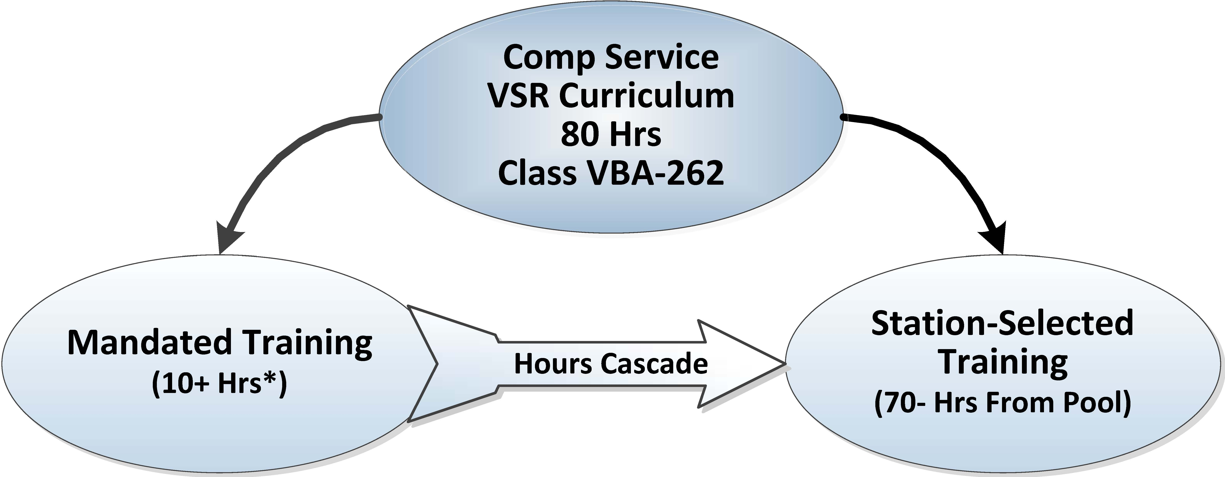
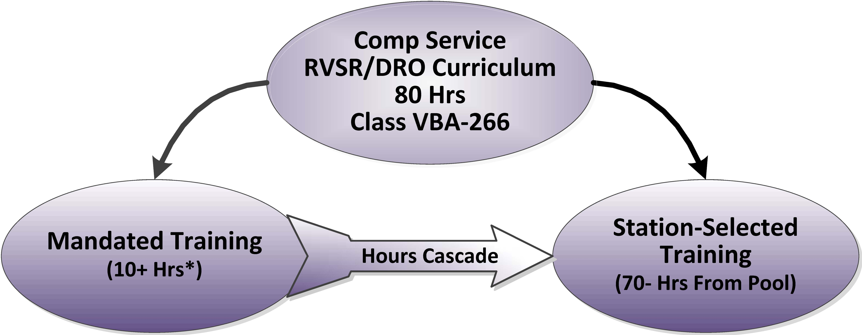
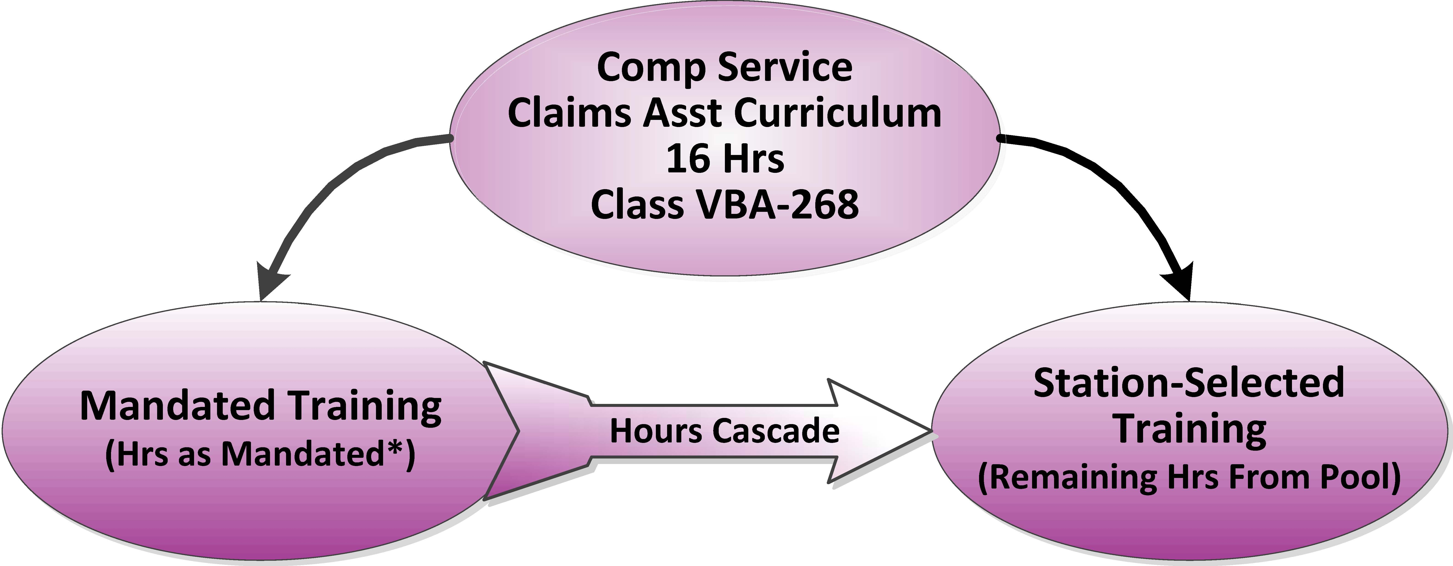
*Actual required Mandated Training hours will be determined by emerging National trends.
Assigning the Compensation Service National Training Curricula in TMS through Class Assignments
Beginning in FY15, national Class Assignments will be created in TMS. Training Managers will follow the guidelines for assigning the NTC through Class Assignments in TMS. Please refer to the TMS job aid for instructions on adding employees to classes. The classes make it possible to track and report progress toward meeting the NTC requirement. By adding employees to the class based upon job position, ROs will have the ability to easily track employees’ progress toward NTC requirements and create required reports.
• The initial set of Compensation Service-Mandated training items will automatically appear on the employees’ learning plans upon class assignment. New items (e.g., fast letters, court decisions) will appear on employees’ learning plans as they are released throughout the FY.
• ROs must assign all Station-Selected Training items, to include the recommended item groups for specific positions/duties. Training Managers or TMS administrators will place each item or curriculum on the employee’s learning plan. Upon successful completion of any online content (evaluation, comprehension assessment, etc.), the employee will receive credit for that item.
• One-time Mandated Items will be assigned centrally to VSR and RVSR Challenge graduates. All one-time mandated items, including due dates, are identified in the VBA Learning Catalog for each position.
• The Technical Training and Evaluation (TT&E) Staff in the Office of Employee Development and Training (ED&T), will monitor, analyze, and complete reporting requirements for evaluations and comprehension assessments in TMS to ensure compliance within the NTC standards. Note that the TMS evaluations and assessments are requirements of the training item and are applicable to whoever takes the item, and that training credit may be withdrawn if the TMS evaluation and/or comprehension assessment is not completed. Training Managers will be alerted before training credit is withdrawn.
Locally Created Training
Local RO created training materials cannot be used for RO training until approved by Compensation Service. ROs must submit the lesson plan, student handout and PowerPoint presentation, practical exercises and answer keys (complete lessons) to the Compensation Service Training mailbox at CPTraining.VBACO@va.gov for approval.
Compensation Service requires a minimum of 30 days to review the material and process the lesson through concurrence before it is approved for use in the field. Upon lesson approval, Compensation Service will create a national TMS item number and assign it to the appropriate curricula ID numbers within the NTC.
Compensation Service holds the sole authority to include training items in the NTC curriculum.
Training Material Comments and Updates
Regional Offices are encouraged to submit comments or suggested updates for training materials to the Compensation Service Training mailbox at CPTraining.VBACO@va.gov.
NTC Make-up Training
All employees considered members in a target audience as defined by this SOP are required to complete the Mandated Training; therefore, each RO must develop a strategy for conducting make-up training sessions as necessary. Procedures for the make-up training sessions should include the following:
• The Compensation Service lesson plan for each training item will be followed for all training offerings.
• The approved materials and handouts, including online exercises and/or evaluations, provided by Compensation Service for each training offering, will be distributed to training participants.
• Typically the same instructor will facilitate every offering of a required training item.
• If a videotaped session is provided as a make-up session, a subject matter expert (SME) in the training topic must be made available as point of contact during the training should questions arise.
• Station-Selected Training make-up will be determined at the station level and by individual training needs using approved materials.
• Make-up sessions must take place as soon as possible within the same FY for the Compensation Service-Mandated items.
• A sign-in sheet must be used to record instructor-led training attendance, including the name of the SME who facilitated the make-up session.
NTC Refresher Training for TMS Comprehension Assessment
Comprehension assessments attached to TMS item content will allow three attempts of successful completion. After three attempts, the following actions must be taken when an employee does not pass the comprehension assessment in TMS associated with a training item:
1. The immediate supervisor or instructor will discuss the issue with the employee to determine the root cause for not passing and provide appropriate refresher training. The supervisor will complete a checklist related to this process. (See Appendix B)
2. After remedial training has been provided and verified, the supervisor will give the Training Manager the completed checklist, and the Training Manager request that the
assessment be “unlocked” for another attempt by contacting the VBA Curriculum Support Team at: VBACurriculumSupport@Camber.com. The Training Manager will request one unlock per employee in each request.
3. The VBA Curriculum Support Team will assign the Refresher Training TMS Item number.
4. The employee will immediately complete the evaluation attached to the Refresher Training TMS Item number. The evaluation questions will identify remediation procedures and help to identify problem areas in the training which may require revisions.
5. The employee will attempt to successfully complete the comprehension assessment in TMS on the original training.

Note: This process continues until the employee successfully completes the comprehension assessment. The Refresher Training TMS item number will not include a time allowance for credit.
Instructor Expectations
The Instructor Training Courses (ITC) are strongly recommended for an employee to be considered an authorized instructor. The ITC may be required for Challenge Instructors and QRT staff. The ITC can be found in the VBA Learning Catalog under >Audience >Other>Instructors(ITC).
Authorized instructors may receive TMS credit for time spent preparing for and instructing courses in accordance with the approved lesson plans. ROs may grant the following credit to instructors:
- A RO may grant an instructor up to 20 hours of credit for course preparation time each FY. The Training Manager can assign TMS item VA 3786223 as completed, which is a 2-hour item that can be re-assigned as needed to match the actual preparation time. These hours will count toward NTC requirements.
- Training Managers may also add the item the instructor taught on the instructor’s learning plan. Upon successful completion of any online content (assessment, instructor evaluations, etc.), the instructor may receive NTC credit for NTC items taught.
- Challenge Instructor credit: Instructors are eligible to receive up to 20 hours* of training credit each FY for course preparation. Compensation Service will send the completed form to the local RO Training Manager to update the instructor’s TMS record. Course preparation time for each class taught will be given as shown in bullet #1 above.

*Note: Instructors are limited to a total of 20 hours credit per fiscal year for instructor preparation.
Training Plan Reporting Requirement
ROs are required to submit a Training Plan for each target audience within 45 calendar days of the release of this fast letter. The Training Plans will be uploaded to Compensation Service Training Staff SharePoint site FY15 RO Training Plans by the Training Managers.
The RO may use the Recommended Training Plans published on the Compensation Service Training Webpage as a guidance tool.
Training Compliance Reporting Requirement
All ROs are required to submit quarterly training reports to Compensation Service to demonstrate reasonable progress towards the yearly training requirement. The RO will upload their reports to a secure SharePoint site and send an email to CPTraining.VBACO@va.gov to confirm the reports have been uploaded. These reports are due at the end of each quarter by the dates listed below. The format for these reports will be based on readily available TMS reports. TMS-related guidance, report formats, and help documents pertaining to the execution of these requirements will be available at
http://vbaw.vba.va.gov/bl/edt/Job_Aids.htm
Report Due Dates for FY 2015:
• January 8, 2015
• April 8, 2015
• July 8, 2015
• October 8, 2015
Questions
Please send all questions about the execution of this SOP to the Compensation Service Training Mailbox at: VAVBAWAS/CO/C&PTraining CPTraining.VBACO@va.gov
Appendix A: Prorating Training Availablity Time for Compensation Service FY 2015 NTC
Prorating training availability time for Compensation Service FY 2015 NTC training requirements will be allowed in the following circumstances:
• Challenge Instructors: NTC requirements may be prorated for details lasting more than 30 days. However, Challenge instructors will complete all items associated with the Compensation Service-Mandated Curricula.
• Employees becoming eligible for NTC training after the first month of the FY.
• Employees on extended periods of excused absence from their RO. Examples of extended periods of excused absence may include the following:
- o Consecutive active duty or active duty for training absence for 30 consecutive days or more
- o Accumulative active duty or active duty for training absence for 30 days or more
- o Consecutive leave for 30 days or more including leave under the Family and Medical Leave Act (FMLA)
- o Accumulative sick leave or FMLA for the same illness or disease of 30 days or more; single days of sick leave that are not excused by a physician’s approval will not count as time applied for prorated hours

Proper documentation will be maintained with the Training Manager for the current FY for compliance purposes. A memorandum from the employee’s immediate supervisor will suffice as proper documentation to include the name of the employee, period of time, and amount of days that have been approved as extended periods of leave. The documentation will be kept confidential and will only be presented to the RO Director’s Office for compliance purposes. The RO Director will certify the proper documentation is of record and all prorated training requirements are in compliance.
Example of documentation for extended excused absence
Memorandum From: (Employee’s Immediate Supervisor’s Name)
To: (Regional Office Name) Training Manager Subject: (Employee Name) approved extended leave The above-mentioned employee has been authorized extended absence as follows: March 1 to April 1, 2015: Extended approved sick leave 31 days
June 1 to July 1, 2015: Extended approved military leave 30 days Signed by (Immediate Supervisor)
Calculating prorated items
Calculation of prorated items: • Proration will only apply to Station-Selected Training items. • Mandated items typically represent changes in process or procedures, and therefore
must be completed by everyone.
Applying proration:
• Proration is automatically calculated in the Compensation Service FY2015 NTC Progress Report builder located at: http://www.ttande.org/ntcprogressreport/
• Follow the guidance in the Creating Compensation Service NTC Quarterly Training Reports for FY15 job aid to apply proration to the quarterly reports.
Appendix B: Reset TMS Assessments
Employee________________________________ Supervisor_______________________________ Discussion Date____________________
Mark if True (X) Action Description
Employee misread question(s)
Employee could describe main points in material
Employee needed additional remediation/discussion with SME
Employee thought question(s) poorly written (Describe)
Employee thought answer(s) were poorly written (Describe)
Employee experienced technical problems verified by TMS Administrator
Other-Describe:
Remediation complete. Provide date completed_______________________

Supervisor’s Signature__________________________________ Date Submitted________________________________________
Appendix C: Resources
Websites:
• VBA Learning Catalog • Compensation Service Training Website • Recommended Training Plans for VSRs, RVSRs, and CAs
TMS Job Aids: http://vbaw.vba.va.gov/bl/edt/Job_Aids.htm • Adding employees to classes in TMS • NTC FY15 Compliance Report Job Aid
Points of Contacts: • Compensation Service Training Staff email: CPTraining.VBACO@va.gov • Compensation Service Quality Assurance Staff email: QRT.VBACO@va.gov
• VBA Curriculum SupportTeam: VBACurriculumSupport@Camber.com
SharePoint Sites for Reports:
• NTC FY15 Quarterly Compliance Report uploads: Compensation Service Training Staff SharePoint site FY15 NTC Quarter Reports • NTC FY15 Training Plan uploads: Compensation Service Training Staff SharePoint site FY15 RO Training Plans

