DEPARTMENT OF VETERANS AFFAIRS
Veterans Benefits Administration
Washington, D.C. 20420

September 11, 2012

Director (00/21) In Reply Refer To: 214D
All VA Regional Offices and Centers Training Letter 12-01

ATTN: All Veterans Service Center Managers and Pension Management Center Managers

SUBJ: Proper use of the “Priority of Exam(s)” field when ordering a new Compensation and Pension (C&P) examination in Compensation and Pension Record Interchange (CAPRI)

Purpose

In an effort to standardize use and enhance data collection efforts, the Compensation Service is providing guidance on the proper selection in the “Priority of Exam(s)” field when requesting one or more C&P examinations in CAPRI.

Background

When requesting a C&P examination via the “Add New C&P Exam” screen in CAPRI, one of the required fields is “Priority of Exam(s)” (see figure 1).
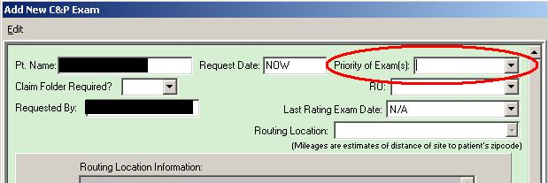
Figure 1
Though the system requires an entry in the field, there is currently no clear guidance on how employees should populate the field. As a result, reports generated based on the “Priority of Exam(s)” field do not accurately represent the priority requested.

Guidance

When selecting an option in the “Priority of Exam(s)” drop-down box on the “Add New C&P Exam” screen in CAPRI, make one selection using the following order of precedence (see table 1). If a claim fits into multiple categories, select the first category type from the table below.

Order | Priority Type | Explanation
1. | Terminal | Veteran/Service member is suffering from a terminal condition
2. | POW | Veteran/Service member is a former prisoner of war
3. | DES Claimed Condition By Svcmbr | Claim under the Integrated Disability Evaluation System (IDES)
4. | Ben Deliv At Dischg | Claim is part of the Benefits Delivery at Discharge (BDD) program
5. | Quick Start | Claim is part of the Quick Start program
6. | Agent Orange | A claimed contention is related to exposure to Agent Orange
7. | Review | e.g., routine future examinations, review needed for reevaluation, etc.
8. | Original SC | 50 percent or more of the claimed contentions are for original service connection of a condition (see next item)
9. | Increase | A majority of the claimed contentions are for an increased evaluation in a previously service-connected condition (see previous item)
10. | Original NSC | Original claim for non-service-connected pension
11. | Other | No other priority type categories apply (use sparingly)
12. | Insufficient Exam | Please use the “Add An Insufficient Exam Request” button from the “View C&P Exam” screen to request an examination of this type. Doing so will automatically select this priority type, and also will mark the previous examination as the insufficient one. For more information, please refer to the CAPRI user manual available on the VA Software Document Library.
Table 1

NOTE: The “DES Fit for Duty” priority code should not be used at this time.

Examples:
- An original claim is received for a terminal illness. Choose Priority 1, “Terminal”.
- An IDES claim is received and includes referred conditions only, or it includes both referred and claimed conditions. Choose Priority 3, “DES Claimed Condition By Svcmbr”.
- A BDD claim is received for new SC conditions and an increased evaluation of an existing SC condition. Choose Priority 4, “Ben Deliv At Dischg”.

Questions

Questions regarding this letter may be e-mailed to CAPRI.VBACO@va.gov.

/s/ /s/

Thomas J. Murphy David R. McLenachen
Director Director
Compensation Service Pension and Fiduciary Service

