Veterans Benefits Administration
Document Conversion Services
Centralized Mail Processing
Document Exception Portal User Manual

Version 2.0



Prepared by:

Systems Made Simple, Inc.
149 Northern Concourse
Syracuse, NY 13212

April 2014

Table of Contents

1. URL Address & Technical Support 1
1.1. Production Link 1
2. Log In 1
2.1. Login 1
3. Work Queues 2
3.1. Main Exception Portal Screen 2
3.2. Options at the Top of the Screen 2
3.3. Workflow Process Queues 3
3.4. Select Work Queue 4
4. Processing 5
4.1. Work Queue: Package Level Processing 5
4.2. Work Queue: Document Level Processing 7
4.3. Notes 11
5. View Buttons and Tools 12
5.1. Image Navigation 12
5.2. Rotating Images 12
5.3. Zoom 12
5.4. Brightness and Contrast 13
5.5. Append Pages (not currently activated) 13
5.6. Replace Content (not currently activated) 13
5.7. Version Number and Toggle (not currently activated) 13
5.8. Save or Print a Document 13
5.9. Hot Keys 14
5.10. Error Messages 14
6. Acronyms 15

List of Tables
Table 1: Acronyms 15

List of Figures
Figure 1: Collybus System login 1
Figure 2: Default Workflow Window 2
Figure 3: Work Queue Newark 3
Figure 4: Number of Documents 4
Figure 5: Work Queue Sample 5
Figure 6: Hold Queue Sample 5
Figure 7: Work Queue Newark 5
Figure 8: Processing Window 5
Figure 9: Hide Thumbnail View 6
Figure 10: Re-Route/Hold/Complete/Index/Close 7
Figure 11: View and modify Documents 8
Figure 12: Split 9
Figure 13: Save 9
Figure 14: Hold 10
Figure 15: Hold Newark 10
Figure 16: User Name 10
Figure 17: Return 10
Figure 18: User Work Processing Queue 11
Figure 19: Notes Icon 11
Figure 20: Doc Notes Window 12
Figure 21: Notes Icon 12
Figure 22: Edit Pages 13
Figure 23: Print Page 14
Figure 24: Index Package 15

URL Address & Technical Support

Production Link
Production Environment Link:
https://cmp-prod.datadimensions.com/CMP

Log In

Login
Enter the Username and Password assigned and select “Log On”.
Figure 1: Collybus System login
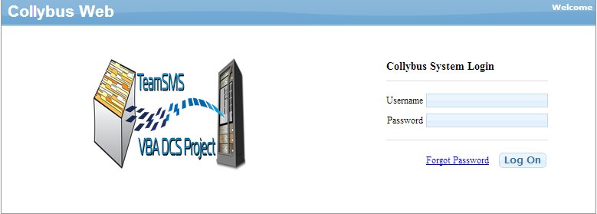
Reset Password:
Left Click: Forgot Password
The system will send a temporary password to the user’s email account associated to the user logon.
Copy and Paste the temporary password into ‘Password’
Left Click ‘Log On’
The system will prompt the user to create a new password.

Work Queues

Main Exception Portal Screen
After logging in, the user is presented with their default Workflow screen.
Figure 2: Default Workflow Window
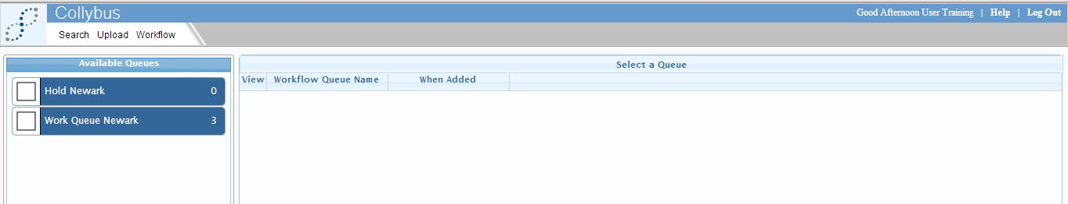
Users: Will be presented with ‘WORK Queue ‘RO’ and HOLD ‘RO’ Queue

Options at the Top of the Screen
The options available at the top of the screen will vary by user permissions.

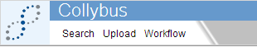
Search: The search feature allows the user to filter on document index values for document retrieval. This feature is currently not available.
Upload: The upload feature allows the user to upload a new document directly into the workflow. This feature is currently not available.
Workflow: The workflow feature allows the user to select pre-defined work queues for document processing and routing.
User Management: The user management feature allows administration level users to add or disable users & assign them to work groups.

Workflow Process Queues
Users will be assigned to groups which will correlate to pre-defined work queue assignment. The user may select which work queue he / she wants to begin work processing.
- Work Queue ‘RO’; contains new documents pending processing assigned to each specific user by the Super User(s) within a given Regional Office (RO).
- Hold ‘RO’; contains documents the user placed on hold; such as documents that require additional information to be supplied to the Department of Veteran Affairs (VA) to continue processing.
Below depicts a sample of ‘NEWARK RO’
Figure 3: Work Queue Newark
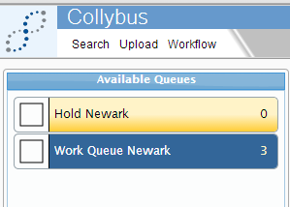
Users: Assigned to RO groups within the domain will include:
- Work Queue ‘RO’
- Hold ‘RO’
Each work queue will have the total number of documents available for processing listed to the far right for work queue management.
Figure 4: Number of Documents

Select Work Queue
The user can select the desired work queue by placing a checkmark (single left click) in the checkmark box to the left of the work queue name or hover over the work queue name and click.
Work Queue Selection Type 1: If the user chooses to ‘checkmark’ select; the system will return a listing of all available documents currently waiting processing in a results grid.
The results grid will include:
- View Document Indicator
- Workflow queue name
- Date / Time the document was added to the queue
- SMS Package Tracking #
- SSN #
- Veteran File ID (Index Value)
- Veteran First Name (Index Value)
- Veteran Last Name (Index Value)
- Received Date (Index Value)
- Hold Initiator (Only applies to Hold Queue)
- Reason (Only applies to Hold Queue)

Figure 5: Work Queue Sample

Figure 6: Hold Queue Sample
Figure 7: Work Queue Newark
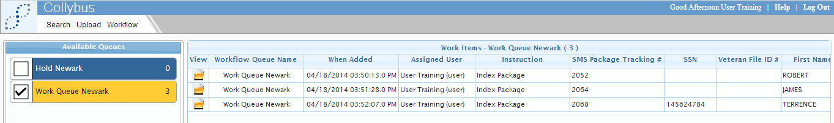
Work Queue Selection Type 2: If the user chooses to ‘hover’ and select; the application will automatically launch the first available document for processing in the processing window.
Figure 8: Processing Window
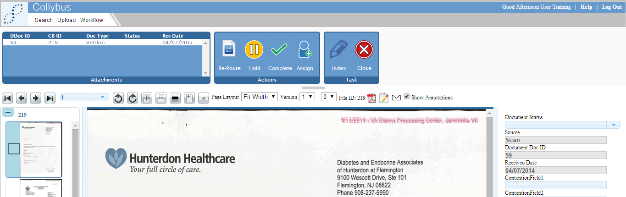

Processing

Work Queue: Package Level Processing
The grid at the top left provides the user a view of the mail package level. The mail package level contains:
- DDoc ID (VBMS Document ID Code)
- CB ID (Unique control number assigned to each document by scanning vendor)
- Doc Type (Always Vet Doc)
- Status (Document level status that is assigned based on action taken by users)
- Received Date
To select the document:
- Hover over the desired row within the grid
- Left click once
After selecting the document; the application will display the first page of the document in the main image view window and all the document pages along the left as thumbnails.
The user can choose to hide the thumbnail view:
- Left click the ‘grey’ shaded panel bar
Figure 9: Hide Thumbnail View
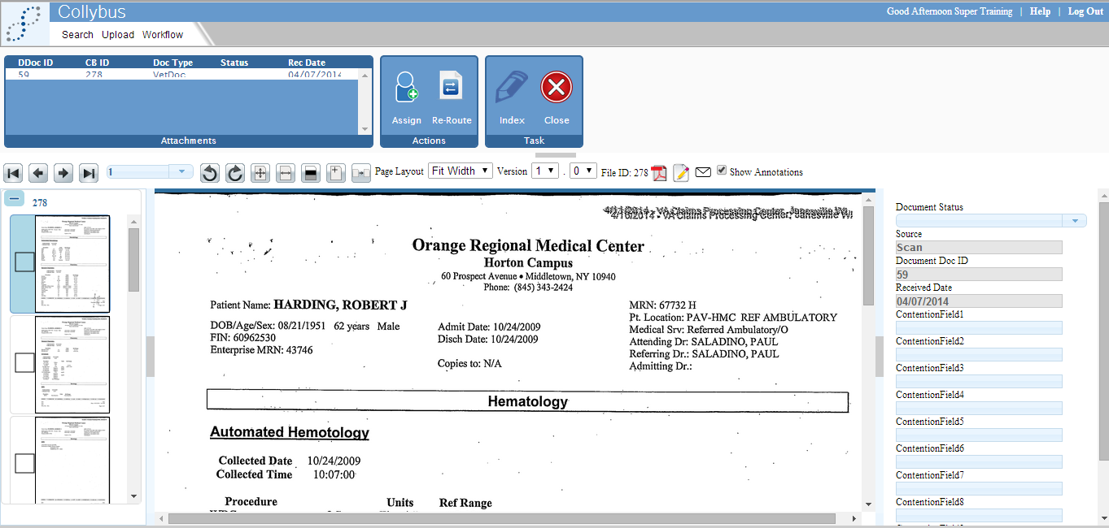
The user has the ability to:
- Re-Route a package
- This will move the entire package to a Super User to authorize and finalize re-assignment to appropriate ‘RO’ designation
- Place a package on Hold
- This will move the entire package into the ‘RO’ designated Hold work queue to process at a later time/date
- Mark a package Complete
- This will move the entire package into a back-end work processing stage ‘Ready for Upload’ and will execute file transfer to VBMS.
- Index a package
- This allows the user to update the following index values associated to the package; these fields are MUST BE PRESENT to complete Upload to VBMS:
  - Veteran First Name
  - Veteran Last Name
  - Veteran File ID Number
- Close a package
- This allows the user to close out of the current mail package and return to the results grid under the main search screen
Figure 10: Re-Route/Hold/Complete/Index/Close
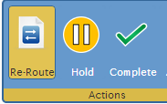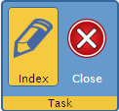

Work Queue: Document Level Processing
The user can select any of the documents within the mail package to view & modify index values associated; some index values are restricted and cannot be edited by the user. Non-editable fields are highlighted in grey. The fields that are editable by a user include:
Figure 11: View and modify Documents
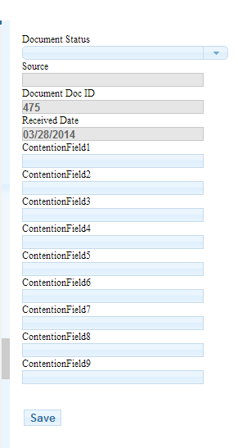
- Document Status
- The user can modify the document status to one of the following:
  - Complete
    - User should select this if the document is OK to send to VBMS
  - Re-scan
    - User should select this if the document image contains a double feed (2 documents scanned one atop another) or if the image is obscured (folded corner).
NOTE: All rescan requests will be routed first to a Super User for approval and to a COR user for authorization and approval.
  - Split
    - User should select this if the document contains more than one document type (Doc ID) or mixed veteran information that should be processed individually.
NOTE: All split requests will be routed to a Super User for authorization and approval.
  - Reject – Return to RO
    - User should select this if the document (physical source) should be pulled and returned to VA RO. Document Image and Index values will NOT be uploaded to VBMS when this feature is selected.
  - Reject – Do Not Process (DNP); Send to long-term storage (LTS) Only
    - User should select this if the document (physical source) should NOT be uploaded to VBMS but the source should be sent to LTS.
Figure 12: Split
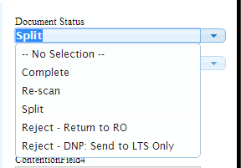
After the document status has been properly updated; user should click ‘SAVE’ and select the next document from the mail package grid at the top left of the window
Figure 13: Save
NOTE: It is not necessary to update the status on each document prior to marking the package level complete; but it is recommended that each document / images be reviewed prior to marking the mail package complete. If no action is needed on a document; status can be left blank.
The user can mark a mail package on ‘Hold’
Figure 14: Hold
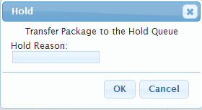
The user is able to enter a hold reason and click ‘OK’ to move the mail package from the work processing queue into a ‘Hold’ queue until such time the mail package can be completed.
The package will move from the ‘RO Work Queue’ to the ‘Hold’ queue.
Figure 15: Hold Newark
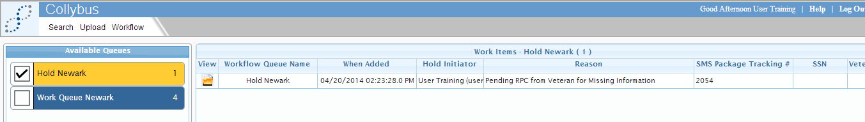
The system will also display the user name that placed the document on hold and the reason within the results grid.
Figure 16: User Name
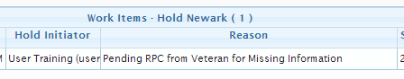
The user has the ability to ‘Return’ mail package to ‘RO Work Queue’ for processing
Figure 17: Return
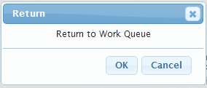
The application will move the mail package back into the user work processing queue
Figure 18: User Work Processing Queue

Notes
Notes can be added to any document and be available for view by anyone with permission to view the document. Access the notes screen by clicking the ‘Notes’ icon .
Figure 19: Notes Icon
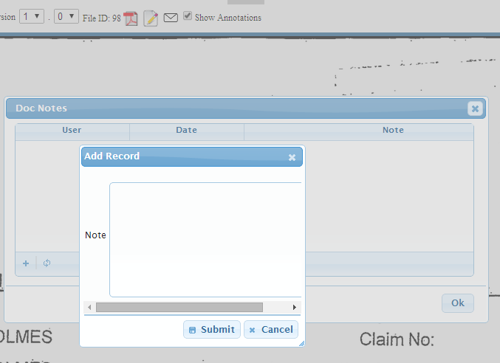
Previous notes can be viewed in the pop-up screen. New notes can be added by selecting “+”.
Figure 20: Doc Notes Window
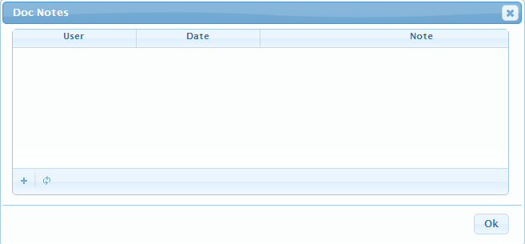
When notes have been added to a document, the notes icon will be highlighted yellow. Click on the yellow note icon to view notes.
Figure 21: Notes Icon

View Buttons and Tools

Image Navigation
Click the “Arrow” buttons to navigate between documents.
Use the page number selector to jump to a specific page.

Rotating Images
 Click the “Rotate” buttons to turn pages within the document.
Rotating an image only affects the view of the document as displayed to the current user and does not change the underlying file (i.e. saves rotation).

Zoom
Click the “Fit All” button to see entire document.
Click the “Fit Width” button to expand width to entire width of view.
Use the page layout drop down menu to choose view percentage.

Brightness and Contrast
Click the “Adjust Brightness and Contrast” button to adjust the brightness and contrast.

Append Pages (not currently activated)
Click the “Append Pages” button to insert a document.

Replace Content (not currently activated)
Click the “Replace Content” button to replace a document with a new document.

Version Number and Toggle (not currently activated)
Use the Versions drop down menu to select, view and/or download a previous version of the document. This applies when the original image file is modified via ‘edit’, ‘append’ or ‘replace’ functions.

Save or Print a Document
Once a document is presented, you may find the need to print a hard copy. To print, select the first “Adobe PDF” icon. Choose from the following download options:
Figure 22: Edit Pages

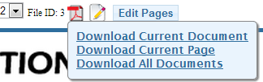

- Download Current Document: Brings up all pages to view in Adobe Acrobat Reader.
- Download Current Page: Brings only the image currently in the image viewer to view in Adobe Acrobat Reader.
- Download All Documents: Is used when viewing several documents (i.e., Portfolio).
From Adobe Acrobat, select “Print” to choose the print options required.
Figure 23: Print Page
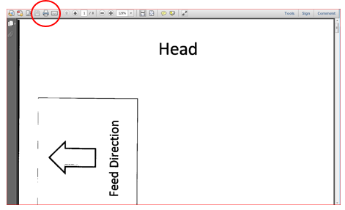

Hot Keys
The Hot Keys may be used in the View mode for quicker document manipulation.
- Ctrl + 1 = zoom to 10%
- Ctrl + 2 = zoom to 30%
- Ctrl + 3 = zoom to 50%
- Ctrl + 4 = zoom to 70%
- Ctrl + 5 = zoom to 100%
- Ctrl + 6 = zoom to 120%
- Ctrl + 7 = zoom to 140%
- Ctrl + 8 = zoom to 160%
- Ctrl + 9 = zoom to 180%
- Ctrl + Pg Up = previous page
- Ctrl + Pg Dn = next page
- Ctrl + Home = first page
- Ctrl + End = last page

Error Messages
A required field has not been entered. “Enter valid text for “Field Name”. Required fields are highlighted in yellow when data is not present as a visual indicator to the user that is must complete before action can be taken.
Figure 24: Index Package
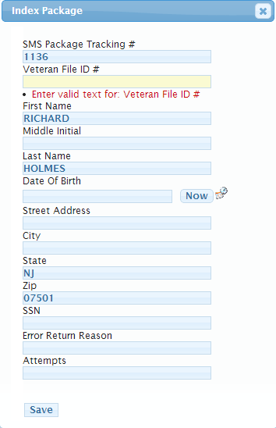

Acronyms
Table 1: Acronyms
Acronym | Definition
DNP | Do Not Process
LTS | Long-Term Storage
RO | Regional Office
VA | Department of Veteran Affairs

