Veterans Benefits Administration
Document Conversion Services
Centralized Mail Processing
Document Exception Portal Super User Manual

Version 1.0



Prepared by:

Systems Made Simple, Inc.
149 Northern Concourse
Syracuse, NY 13212

April 2014

Table of Contents

1. URL Address & Technical Support 1
1.1. Production Link 1
2. Log In 1
2.1. Login 1
3. Work Queues 2
3.1. Main Exception Portal Screen 2
3.2. Options at the Top of the Screen 2
3.3. Workflow Process Queues 3
3.4. Select Work Queue 4
4. Processing 6
4.1. Assignment Queue: Package Level Processing 6
4.2. Re-Assign RO Work Queue: Re-Route to another RO 8
4.3. Authorization RO Work Queue: Approve or Deny Rescan, Split and Print / Download requests by users 9
4.4. Work Queue: Document Level Processing 10
4.5. Notes 13
5. View Buttons and Tools 15
5.1. Image Navigation 15
5.2. Rotating Images 15
5.3. Zoom 15
5.4. Brightness and Contrast 15
5.5. Append Pages (not currently activated) 15
5.6. Replace Content (not currently activated) 15
5.7. Version Number and Toggle (not currently activated) 15
5.8. Save or Print a Document 16
5.9. Hot Keys 16
5.10. Error Messages 17
6. Acronyms 18

List of Tables
Table 1: Acronyms 19

List of Figures
Figure 1: Collybus System Login 1
Figure 2: Default Workflow Window 2
Figure 3: Available Queues 3
Figure 4: Search Upload Workflow 4
Figure 5: Work Queue Sample 5
Figure 6: Hold Queue Sample 5
Figure 7: Assignment Queue Newark 5
Figure 8: Processing Window 5
Figure 9: Hide Thumbnail View 6
Figure 10: Assign/Re-Route/Index/Close 7
Figure 11: User to Assign 7
Figure 12: Select an Instruction 8
Figure 13: Re-Route 8
Figure 14: Route/Index/Close 8
Figure 15: Route to Assign to 9
Figure 16: Route Drop-Down Menu 9
Figure 17: Approve/Deny 9
Figure 18: Document Status 10
Figure 19: Reject 11
Figure 20: Save 12
Figure 21: Hold 12
Figure 22: Hold Newark 13
Figure 23: Work Items 13
Figure 24: Return 13
Figure 25: Hold Newark 13
Figure 26: Notes Icon 14
Figure 27: Doc Notes 14
Figure 28: Note Icon 14
Figure 29: Edit Pages 16
Figure 30: Print 16
Figure 31: Index Package 18

URL Address & Technical Support

Production Link
Production Environment Link:
https://cmp-prod.datadimensions.com/CMP

Log In

Login
Enter the Username and Password assigned and select “Log On”.
Figure 1: Collybus System Login
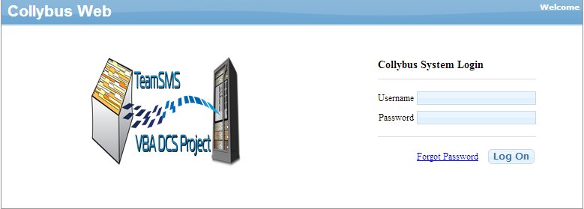
Reset Password:
Left Click: Forgot Password
The system will send a temporary password to the user’s email account associated to the user logon.
Copy and Paste the temporary password into ‘Password’
Left Click ‘Log On’
The system will prompt the user to create a new password.

Work Queues

Main Exception Portal Screen
After logging in the user is presented with their default Workflow screen.
Figure 2: Default Workflow Window
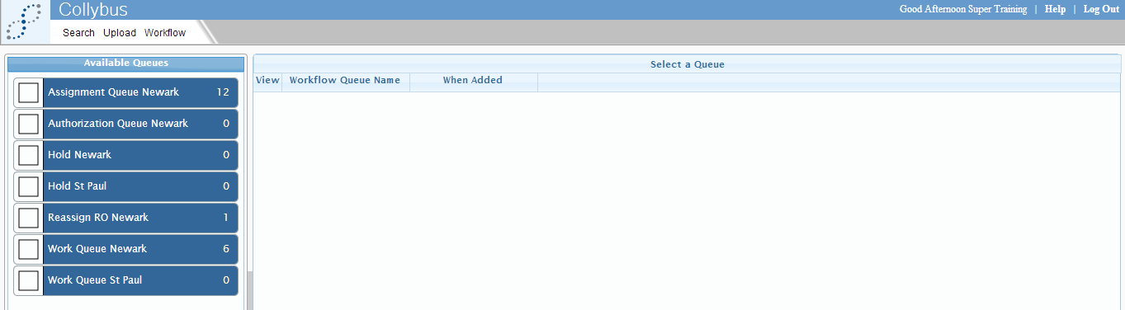
Super Users: Will be presented with ‘Assignment Queue RO’, ‘Authorization Queue RO’, ‘ReAssign RO’, ‘WORK Queue ‘RO’ and HOLD ‘RO’ Queue.

Options at the Top of the Screen
The options available at the top of the screen will vary by user permissions.
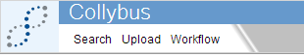
Search: The search feature allows the user to filter on document index values for document retrieval. This feature is currently not available.
Upload: The upload feature allows the user to upload a new document directly into the workflow. This feature is currently not available.
Workflow: The workflow feature allows the user to select pre-defined work queues for document processing and routing.
User Management: The user management feature allows administration level users to add or disable users & assign them to work groups.

Workflow Process Queues
Super Users will be assigned to groups which will correlate to pre-defined work queue assignment. The Super User may select which work queue he / she wants to begin work processing.
- Assignment Queue ‘RO; contains new documents pending work assignment to a user level resource.
- Authorization Queue ‘RO’; contains documents a user level requested for ‘rescan’, ‘split’ or ‘print/download’ that requires supervisor authorization for action.
- Reassign ‘RO’ Queue; contains documents that require re-routing to a different Regional Office (RO) for processing either marked by the Super User or the User.
- Work Queue ‘RO’; contains new documents pending processing assigned to each specific user by the Super User(s) within a given RO.
- Hold ‘RO’; contains documents the user placed on hold; such as documents that require additional information to be supplied to the VA to continue processing.
Below depicts a sample of ‘Newark & St. Paul RO’
Figure 3: Available Queues
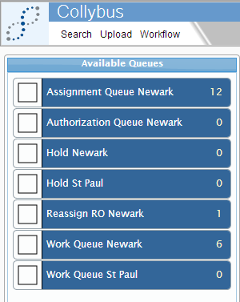
Each work queue will have the total number of documents available for processing listed to the far right for work queue management.
Figure 4: Search Upload Workflow

Select Work Queue
The user can select the desired work queue by placing a checkmark (single left click) in the checkmark box to the left of the work queue name or hover over the work queue name and click.
Work Queue Selection Type 1: If the user chooses to ‘checkmark’ select; the system will return a listing of all available documents currently waiting processing in a results grid.
The results grid will include:
- View Document Indicator
- Workflow queue name
- Date / Time the document was added to the queue
- SMS Package Tracking #
- SSN #
- Veteran File ID (Index Value)
- Veteran First Name (Index Value)
- Veteran Last Name (Index Value)
- Received Date (Index Value)
- Hold Initiator (Only applies to Hold Queue)
- Reason (Only applies to Hold Queue)
Figure 5: Work Queue Sample

Figure 6: Hold Queue Sample
Figure 7: Assignment Queue Newark
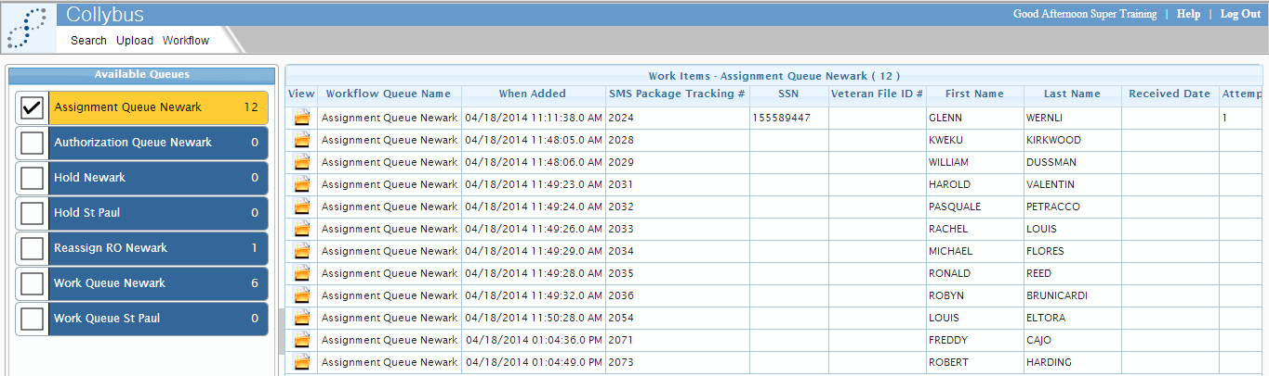
Work Queue Selection Type 2: If the user chooses to ‘hover’ and select; the application will automatically launch the first available document for processing in the processing window.
Figure 8: Processing Window
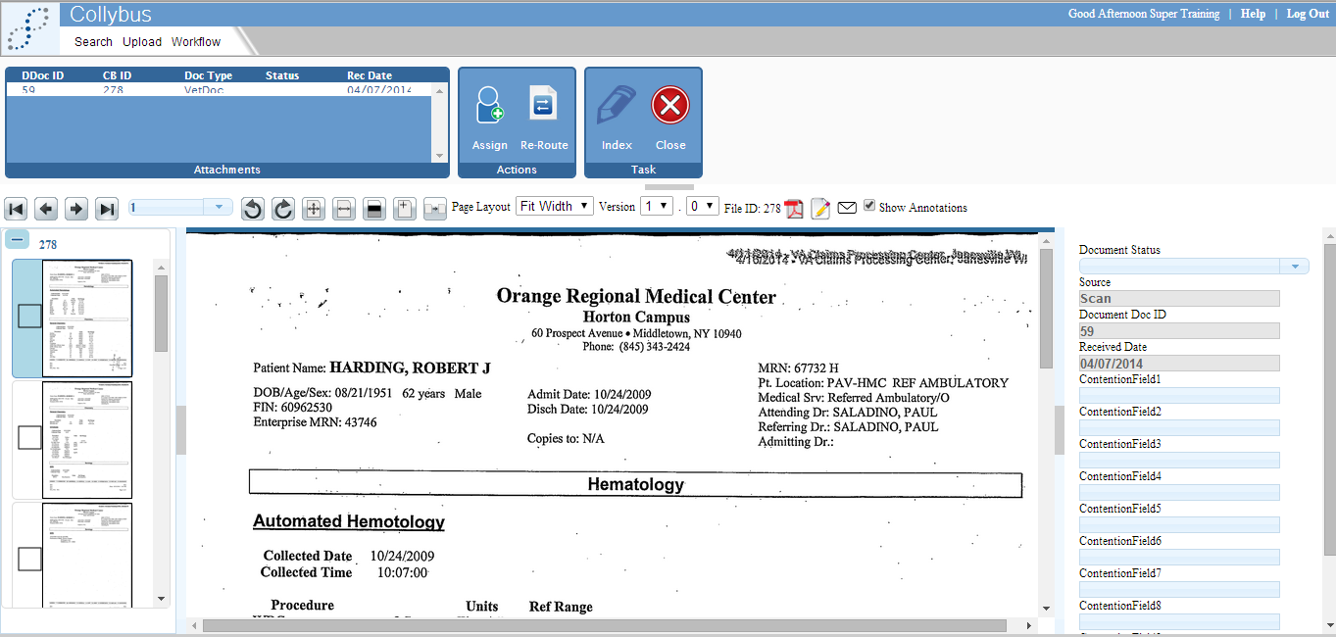

Processing

Assignment Queue: Package Level Processing
The grid at the top left provides the user a view of the mail package level. The mail package level contains:
- DDoc ID (VBMS Document ID Code)
- CB ID (Unique control number assigned to each document by scanning vendor)
- Doc Type (Always Vet Doc)
- Status (Document level status that is assigned based on action taken by users)
- Received Date
To select the document:
- Hover over the desired row within the grid
- Left click once
After selecting the document; the application will display the first page of the document in the main image view window and all the document pages along the left as thumbnails.
The user can choose to hide the thumbnail view:
- Left click the ‘grey’ shaded panel bar
Figure 9: Hide Thumbnail View
The super user has the ability to:
- Assign a package
- This will move the entire package to the designated user selected from the assignment drop down
- Re-Route a package
- This will move the entire package to the Re-assign RO Work Queue
- Close a package
- This will take the Super User back out to the main workflow results screen
- Index a package
- Not available for use in this work queue
Figure 10: Assign/Re-Route/Index/Close
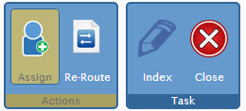
To assign a package the Super User will select the ‘assign’ button. The program will return an assignment select pop-up window
Figure 11: User to Assign
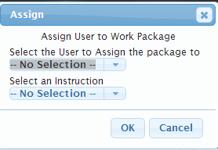
The Super User will select the user name from the ‘select the user to assign the package to’ drop down as well as select the instruction for action from the ‘select an instruction’ drop down.
Figure 12: Select an Instruction
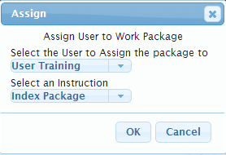
This will route the mail package to the defined user for processing.
To re-route a package the Super User will select the ‘re-route’ button. The program will return a ‘re-route’ pop-up window.
Figure 13: Re-Route
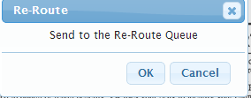
This will send the mail package to the ReAssign ‘RO’ work queue for processing.

Re-Assign RO Work Queue: Re-Route to another RO
The super user has the ability to route a mail package to another RO.
Figure 14: Route/Index/Close
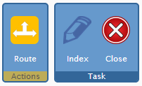
From the drop down the Super User will select the appropriate RO processing location.
Figure 15: Route to Assign to
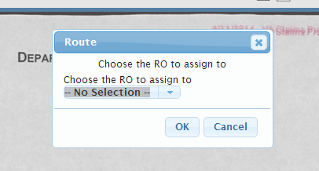

Below is a sample where St. Paul RO was selected from the drop down for package level re-assignment.
Figure 16: Route Drop-Down Menu
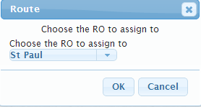

Authorization RO Work Queue: Approve or Deny Rescan, Split and Print / Download requests by users
The Super User has the ability approve or deny a rescan, split or print / download request by a User.
Figure 17: Approve/Deny
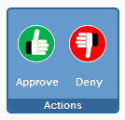
- Approved Rescan requests will be routed for 2nd level authorization by the COR user group.
- Approved Split requests will be routed to scanning vendor for corrective action on mail package.
- Approved Print / Download requests will be routed back to the requesting user.
- Denied Rescan requests will be routed to the Work Assignment queue with a denial error.
- Denied Split requests will be routed to the Work Assignment queue with a denial error.
- Denied Print / Download requests will be routed to the Work Assignment queue with a denial error.

Work Queue: Document Level Processing
The user can select any of the documents within the mail package to view & modify index values associated; some index values are restricted and cannot be edited by the user. Non-editable fields are highlighted in grey. The fields that are editable by a user include:
Figure 18: Document Status
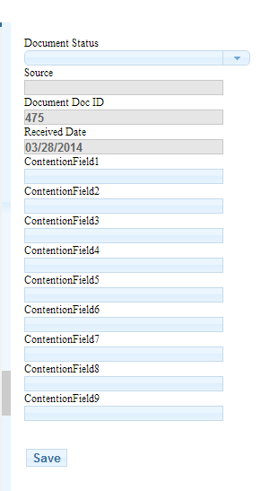
  - Document Status
  - The user can modify the document status to one of the following:
    - Complete
      - User should select this if the document is OK to send to VBMS
    - Re-scan
      - User should select this if the document image contains a double feed (2 documents scanned one atop another) or if the image is obscured (folded corner).
NOTE: All rescan requests will be routed first to a Super User for approval and then to a COR user for authorization and approval.
    - Split
      - User should select this if the document contains more than 1 document type (Doc ID) or mixed veteran information that should be processed individually.
NOTE: All split requests will be routed to a Super User for authorization and approval.
    - Reject – Return to RO
      - User should select this if the document (physical source) should be pulled and returned to VA RO. Document Image and Index values will NOT be uploaded to VBMS when this feature is selected.
    - Reject – Do Not Process (DNP); Send to long-term storage (LTS) Only
      - User should select this if the document (physical source) should NOT be uploaded to VBMS but the source should be sent to LTS.
Figure 19: Reject
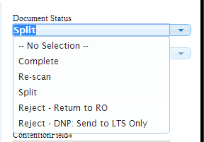
After the document status has been properly updated; user should click ‘SAVE’ and select the next document from the mail package grid at the top left of the window.
Figure 20: Save
NOTE: It is not necessary to update the status on each document prior to marking the package level complete; but it is recommended that each document / images be reviewed prior to marking the mail package complete. If no action is needed on a document; status can be left blank.
The user can mark a mail package on ‘Hold’.
Figure 21: Hold
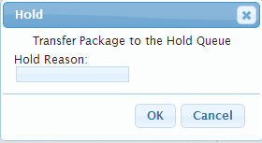
The user is able to enter a hold reason and click ‘OK’ to move the mail package from the work processing queue into a ‘Hold’ queue until such time the mail package can be completed.
The package will move from the ‘RO Work Queue’ to the ‘Hold’ queue.
Figure 22: Hold Newark
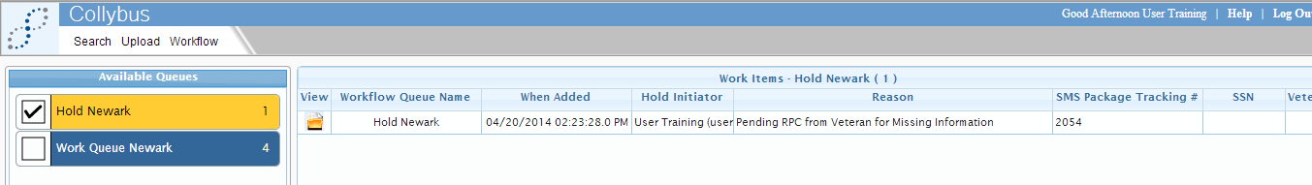
The system will also display the user name that placed the document on hold and the reason within the results grid.
Figure 23: Work Items
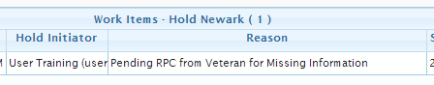
The user has the ability to ‘Return’ mail package to ‘RO Work Queue’ for processing
Figure 24: Return
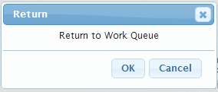
The application will move the mail package back into the user work processing queue
Figure 25: Hold Newark

Notes
Notes can be added to any document and be available for view by anyone with permission to view the document. Access the notes screen by clicking the ‘Notes’ icon .
Figure 26: Notes Icon
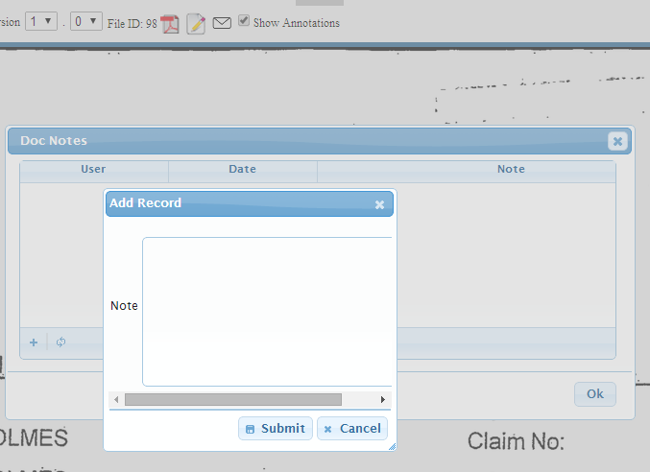
Previous notes can be viewed in the pop-up screen. New notes can be added by selecting “+”.
Figure 27: Doc Notes
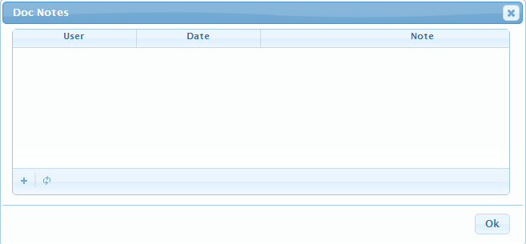
When notes have been added to a document, the notes icon will be highlighted yellow. Click on the yellow note icon to view notes.
Figure 28: Note Icon

View Buttons and Tools

Image Navigation
Click the “Arrow” buttons to navigate between documents.
Use the page number selector to jump to a specific page.

Rotating Images
 Click the “Rotate” buttons to turn pages within the document.
Rotating an image only affects the view of the document as displayed to the current user and does not change the underlying file (i.e. saves rotation).

Zoom
Click the “Fit All” button to see entire document.
Click the “Fit Width” button to expand width to entire width of view.
Use the page layout drop down menu to choose view percentage.

Brightness and Contrast
Click the “Adjust Brightness and Contrast” button to adjust the brightness and contrast.

Append Pages (not currently activated)
Click the “Append Pages” button to insert a document.

Replace Content (not currently activated)
Click the “Replace Content” button to replace a document with a new document.

Version Number and Toggle (not currently activated)
Use the Versions drop down menu to select, view and/or download a previous version of the document. This applies when the original image file is modified via ‘edit’, ‘append’ or ‘replace’ functions.

Save or Print a Document
Once a document is presented, you may find the need to print a hard copy. To print, select the first “Adobe PDF” icon. Choose from the following download options:
Figure 29: Edit Pages
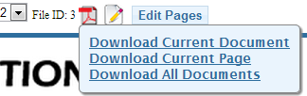

  - Download Current Document: Brings up all pages to view in Adobe Acrobat Reader.
  - Download Current Page: Brings only the image currently in the image viewer to view in Adobe Acrobat Reader.
  - Download All Documents: Is used when viewing several documents (i.e., Portfolio).
From Adobe Acrobat, select “Print” to choose the print options required.
Figure 30: Print
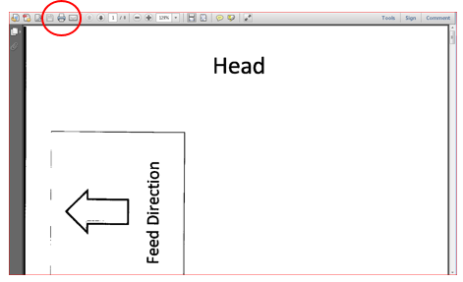

Hot Keys
The Hot Keys may be used in the View mode for quicker document manipulation.
- Ctrl + 1 = zoom to 10%
- Ctrl + 2 = zoom to 30%
- Ctrl + 3 = zoom to 50%
- Ctrl + 4 = zoom to 70%
- Ctrl + 5 = zoom to 100%
- Ctrl + 6 = zoom to 120%
- Ctrl + 7 = zoom to 140%
- Ctrl + 8 = zoom to 160%
- Ctrl + 9 = zoom to 180%
- Ctrl + Pg Up = previous page
- Ctrl + Pg Dn = next page
- Ctrl + Home = first page
- Ctrl + End = last page

Error Messages
A required field has not been entered. “Enter valid text for “Field Name”. Required fields are highlighted in yellow when data is not present as a visual indicator to the user that is must complete before action can be taken.
Figure 31: Index Package
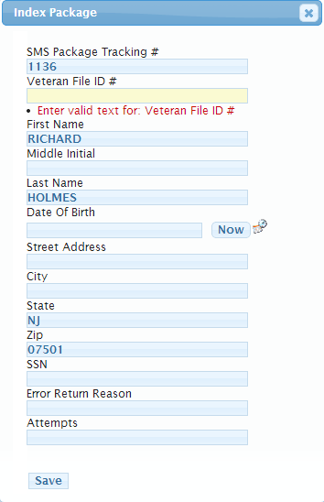

Acronyms
Table 1: Acronyms
Acronym | Definition
DNP | Do Not Process
LTS | Long-Term Storage
RO | Regional Office

