

Dependency and Indemnity Compensation (DIC),
Death Pension, and Accrued Training Aid
Table of Contents
Introduction 3
Claims Applications 3
Original And Re-Opened Claims 4
Types Of Benefits 5
Evidence Requirements 6
Reviewing The Application 6
Establishing Relationship 9
Review The Evidence - Develop, Ready To Rate, Or Finalize? 12
BDN Awards 13
Vestnet Awards (Accrued And DIC) 16
Accrued 16
DIC Spouse 19
Pay Additional Allowance When The Veteran Died On Or After January 1, 1993 23
Add Dependents 23
SBP – Record The Amount And Set The Indicator 24
SBP - No Overpayment 25
SBP – Overpayment Exists 25
DIC Child 25
Month Of Death Payments 33
Notification 33
Summary 33
Manual References For Application 35
Manual References For Aid And Attendance 36
Manual References For Death Pension 37
Manual References For Dependent Child 39
Manual References For DIC 42
Manual References For Marriage 45
SBP Explained 47

Dependency and Indemnity Compensation (DIC), Death Pension, and Accrued

Introduction
This training guide is intended to assist the VSR in processing claims for Dependency and Indemnity Compensation (DIC), Death Pension, and Accrued benefits. It does NOT replace laws, regulations and manuals, but rather is a quick reference to explain the routine issues and processes, and identify some of the unique situations that occur.

Death benefits come with multiple classes of claimants, different rules for each, and a large variety of situations. It will not be unusual to find something new or different in the first case you work or the one-thousandth case. So be alert, because that easy grant or denial may actually be just the opposite.

An index to applicable regulations with some excerpts is at the end of this aid.

Claims Applications
There are three primary applications you will encounter for death benefits -

VA Form 21-534 - Application for Dependency and Indemnity Compensation, Death Pension, and Accrued Benefits by a Surviving Spouse or Child (Including Death Compensation if Applicable)

VA Form 21-535 - Application for Dependency and Indemnity Compensation by Parent(s) (Including Accrued Benefits and Death Compensation when Applicable)

VA Form 21-601 - Application for Accrued Amounts Due a Deceased Beneficiary

You may also encounter as an associated claim VA Form 21-530, Application for Burial Benefits.

VA Form 21-534: This is the most common application you will receive. On original claims, it serves as a claim for all three benefits - DIC, death pension, and accrued. It is also to be considered as a claim for month of death payment for the surviving spouse. Both surviving spouse and surviving child use this application. An abbreviated version, VA Form 21-534a is used for in-service deaths and is currently handled by the Philadelphia RO.

VA Form 21-535: This application is used for claims of DIC and accrued benefits by a parent or parents. There is no death pension benefit for a parent, although income is a determining factor for their eligibility for DIC.

VA Form 21-601: This application is used for claims of accrued benefits. Although a surviving spouse, child, or parent may submit this form; they should submit their claim on the VA Form 21-534 or 535. Individuals who have paid the Veterans just debts and last expenses and are seeking reimbursement should use VA Form 21-601.

Original and Re-opened Claims

Similar to live Veteran’s claims, a proper application form signed by the claimant is required to establish an original formal claim. Once an adjudicated formal claim is of record, a re-opened claim can be submitted in any format. Death claim end products are always established as CPD.

Original End Products: EP 140 (commonly referred to as DIC claim) is used for any claim indicating that the claimant is requesting consideration of DIC or review of the Veteran’s record indicates that DIC is in order.

EP 190 (death pension) is used when the claimant makes no indication that DIC is desired and review of the record also shows no indication of entitlement to DIC.

EP 165 (accrued) is used when VA Form 21-601 is received and there is no EP 140 or EP 190 currently established for the same claimant. Proper establishment is payee 00, with an A/C line in the address.

EP 130 is used when an additional claimant, such as a surviving child from a previous marriage, submits an original claim. Normally the surviving spouse submits the first claim and is assigned EP 140, payee 10 with the child established under EP 130, payee 11. However, if the child’s claim is received first, it is the 140/11 and the surviving spouse’s claim EP 130/10.

Re-Opened End Products: EP 020 is used for claims of DIC previously denied and will require a rating decision. A common situation is when a claimant is denied for failure to provide and later submits the required evidence. This end product is also used for a claim of aid and attendance after DIC has been granted.

EP 120 is used when death pension is requested and a previous decision has been made under EP 140 or 190. A claim for special monthly pension also would be worked under this end product. If the reopened death pension claim is based solely on income, then the proper EP is an EP 150.

EP 130 is also used on re-opened claims of DIC based on dependency issues and a previous rating is of record. This commonly occurs when a surviving spouse’s re-marriage caused benefits to be terminated, and has now ended the disqualifying marriage through divorce or death.

Note: Often, a surviving spouse whose health has deteriorated, submits VA Form 21-534 several years after the Veteran’s death. The Veteran’s claim file has been retired to RMC or FARC and an NOD folder is made at the station. Unless the claimant indicates a claim was previously submitted or the corporate database shows a previous original claim, you must treat the application as an original claim, thus addressing all three issues. If the claims file is later combined and shows an original claim previously adjudicated, change the end product to a re-opened at that time.

TYPES OF BENEFITS

DIC: There are four ways a Veteran’s death may establish entitlement to DIC benefits.

First is an in-service death. This is normally an authorization issue unless there is a question of in line of duty, which requires a rating decision. Philadelphia handles all current in-service deaths cases.

Second is service connected conditions relating to the cause of death. This could be a condition that the Veteran was previously receiving compensation for or a presumptive condition under 3.309 such as lung cancer for a Vietnam service Veteran.

Third is under 38 USC 1318 where a Veteran previously received compensation at the 100% rate (including I/U) for the immediate previous 10 years, even if the cause of death is unrelated to service. The time requirement is reduced to only 1 year for POWs, and 5 years if the Veteran was continuously rated 100% immediately upon discharge and has not been out of service for 10 years at the time of death.

The fourth is less common, however it can be the most difficult to process. 38 USC 1151 allows entitlement to DIC if the cause of death can be determined to be the result of VA medical treatment.

Death Pension: There are two main factors of consideration different from DIC.

First is qualifying service. The Veteran must have served during a war time period, same as for live pension requirements.

Second is income and net worth qualifications. Net worth is worked the same as for live pension. Income is handled basically the same for counting purposes, however, there are two major issues that are different.

A large percentage of original death pension claims involve an increase in Social Security benefits at the time of the Veteran’s death. Knowledge of the SHARE SSA Inquiry screen is essential. The rates are counted two months (1st of the month after receipt) after the benefit date indicated (eligibility date) except for COLA, which is used the same date. Thus, many surviving spouses may be entitled to death pension for one month(and sometimes two) because the new rate does not get counted until the second month.

Also, if the Social Security claim is not timely, a retroactive payment may be indicated. This amount is counted one month after the indicated payment date. Fortunately SSA benefits are now being processed timely and few retro payments are seen. Although not everyone receives the $255 Social Security death benefit, the manual re-write now says to assume payment of the benefit if the Veteran was receiving Social Security benefits. Count this income for one year from the first month if the actual date of receipt is not know.

The second major difference is the exclusion of final expenses, which include burial, expenses for last illness and just debts. These expenses can be considered for one year to reduce the countable income. Expenses for last illness expenses include medical expenses during the last year before death related to the Veteran’s last acute illness. Just debts can be counted if paid by the claimant after the Veteran’s death.

Accrued: Accrued benefits are monies owed to the Veteran. They can be the result of a claim or appeal pending at the time of death, or payments that were withheld such as the processing of a fiduciary. Beneficiaries fall into two categories: a surviving dependent or reimbursement of paid just debts / last expenses made for the Veteran.

A line of succession determines entitlement: Spouse, dependent children, parents, then to others for reimbursement. If there is a surviving spouse, there is no entitlement to any other in the line of succession, regardless of whether the spouse submits a claim or not. Also, if there are no surviving dependents, accrued benefits are limited to the amount of reimbursement.

There is a one year time limit to apply for accrued benefits with the exception of Nehmer class cases.

Evidence Requirements

Proof and cause of death: Basically, there are two ways to typically satisfy this requirement - a copy of the death certificate or the discharge summary from a VAMC or other federal facility (see 38 CFR 3.211 for a complete list of acceptable proofs of death). A DD 1300 casualty report is necessary for in-service deaths. When none of these are available, alternative procedures are necessary.

The death certificate must show the cause of death and contributing factors. Often a death certificate indicates that the cause of death is pending. This is insufficient and an amended death certificate or autopsy report will be necessary.

If a claim is received without a death certificate, consider searching for CAPRI records to see if the Veteran died at a VAMC. Also, check to see if a burial claim was submitted with a death certificate, or identified the funeral home so a faxed copy may be obtained.

Service: The Veteran must have verified service that was not dishonorable for DIC. Service must also include a wartime period for death pension.

Medical: If the death certificate or summary does not show a condition that is related to the Veteran’s service, medical evidence will be required to support a claim of service-connected death. Development procedures are the same as for a living Veteran.

Reviewing the Application

This is where the hard work begins for the VSR. The latest edition of VA Form 21-534 has instructed the claimant to skip various portions if certain conditions are met.

Date of claim: Review the date of receipt with the date of the Veteran’s death. If the date of receipt is within one year of the Veteran’s death, then all benefits granted are payable from the first of the month of the Veteran’s death.

If over one year, then the effective date is the date of claim for DIC or death pension. Accrued benefits should be denied as not claimed within the time limit.

Note: Although the time limit has passed, it is not improper to deny accrued for no benefits owed in the notification letter if applicable.

Veteran data: Identify the Veteran’s record through his name, SSN, service number, and C-file #. If a C-file # is assigned, correct identification is usually correct. Older Veterans who are assigned NOD folders with SSN as the file number should be carefully reviewed for the existence of a C-file #. This is particularly important on death pension claims several years after the Veteran’s death.

Claimed benefit: Determine the intention of the claimant of benefits being sought. If ‘yes’ was checked for service-connected death, then the claim is for DIC. If the income sections are completed, then consider the claim for both death pension and DIC.

If ‘no’ is selected, the intent is most likely for death pension only. However, watch for inferred DIC conditions such as 100% rating at time of death. Also, the submission of medical evidence or VA Form 21-4142 for a Veteran’s records should be considered intent for a claim of service connected death.

If either box is not selected, or “unknown” is indicated, presume the claim is for DIC. This occurs often when the Veteran was 100% for an unrelated condition.

Occasionally an application will be for death pension Medicaid nursing home rate only. The manual states that DIC (if entitled) should be paid as the greater benefit and to inform the claimant to elect the $90 rate. However, recent national STAR reviews have indicated that DIC should not be paid as it may do irreparable harm to the claimants Medicaid benefits. Clarification with the claimant may be in order for these claims.

Claimant data: Determine whether the claimant is a surviving spouse, child, or spouse with child. A parent must always claim benefits on VA Form 21-535. Address and date of birth is required. A social security number is required except for non-resident aliens and children under age 2. Resident aliens must provide a letter from Social Security explaining why they don’t have a number assigned.

Military service: This is a section that the claimant is told to skip if the Veteran was receiving benefits. It is common to see ‘in file’ or ‘of record,’ especially if a service officer assisted the claimant in completing the claim. This is usually acceptable. However, in cases where a C-file # isn’t identified and the Veteran’s SSN was not in BIRLS, this poses a problem and delays processing.

For entitlement to benefits, the service must be other than dishonorable. If the information is missing on the application, but BIRLS shows verified service, accept the BIRLS record. If the Veteran was receiving benefits, consider the service verified as honorable.

If there is no record, a copy of the Veteran’s discharge document must be submitted or sufficient information submitted to get verification from the military.

Marital history: Unless there is evidence or an indication of a conflict, accept the statement of marital history as is.

The manual specifically states that being established on the Veteran’s award does NOT establish entitlement as the surviving spouse. The reasoning for this is continuous cohabitation. A Veteran needs not to be living with the spouse to claim them as a dependent on live compensation. However, continuous cohabitation is required for a surviving spouse to be eligible for death benefits. Due to the number of cases that would be unduly developed, current station policy is to assume continuous cohabitation was not broken if the claimant was on the Veteran’s award.

A second problem that frequently arises from this section is establishing a valid marriage. The claimant often states ‘in file,’ ‘of record’ or ‘unknown’ for the Veteran’s prior marriages. When the file is reviewed, the information isn’t of record. Also, incomplete information is often provided, missing the city or month of the divorce or death for terminating the marriage. This information is required for a deemed valid marriage.

Dependent children: Be careful not to miss this section. Also, review the Veteran’s file and clarify the status of any child on the Veteran’s award that isn’t being claimed. Requirements to establish a surviving child are covered below.

Additional benefits: Review the application for requests of aid and attendance. Even if not claimed on the application, consider medical evidence or physician statements for the claimant as a claim for aid and attendance. If the claimant is in a nursing home, aid and attendance is an authorization grant and neither medical evidence nor a rating decision are needed. This applies to both DIC and death pension. Housebound is for death pension only and requires a rating decision.

Also, this section is usually when the $90 Medicaid nursing home rate claim is indicated. If Medicaid has been applied for, consider it as granted per regulations.

Income and Net Worth: This section must be completed for any claim for death pension. There can be no empty boxes. If there is none, there must be an indication by the claimant. The application states this is done by entering either 0 or none. However, the manual rewrite and national STAR has indicated that intent is sufficient.

Any unambiguous entry on the EVR such as “none,” “O,” or “n/a,” is acceptable. Accept lining through the block as an acceptable way of indicating “none.” Treat any indefinite entry such as “?” or “unknown” as no response.

If the boxes are inconsistently marked and omitted, then clarification must be made. Telephone development is acceptable and encouraged.

If interest assets are reported (any amount), then development for the amount of interest is required. If interest or dividends are reported, but does not report the source of the interest/dividends income as net worth, you will need to develop for this net worth.

Always review SHARE for SSA benefits, regardless of what is reported by the claimant.
Note: If DIC is granted, it is unnecessary to have completed income information. It is also common for a claimant to leave the section totally blank or say “DIC only.” Do not develop for income in these cases.

Signature: Make sure the claimant signed the application. It must contain at least an X with two witnesses. Court ordered guardianship and VA ‘friend of the claimant’ are the only exceptions. Family member signatures that have general power of attorney forms are not acceptable for VA purposes.

Establishing Relationship

Surviving Spouse: The prior marriage history of the Veteran and claimant showing the name of their prior spouse(s) and the reason, date (month & year) and place (city & state) the marriage(s) terminated is required. There is no exception for the claimant; however, a deemed valid decision may be used if the Veteran’s information is incomplete.

Marriage requirements: A claimant who was divorced from the Veteran at the time of death is not eligible for benefits. To qualify for DIC, death pension, and ancillary benefits, they must have been married for the immediate year prior to death or married at the time of death and had a child born to them. To qualify for accrued benefits, a surviving spouse need only to have been legally married to the Veteran at the time of death.

A third method to qualify is the date of marriage, depending on the benefit. For death pension, the marriage must have occurred prior to the delimiting dates for each war era. For service-connected DIC, the marriage must have occurred within 15 years of the qualifying service for cause of death. There are no marriage dates for DIC under 38 USC 1318.

There are four major issues to establish a claimant as the surviving spouse. They are continuous cohabitation, deemed valid, common-law marriage, and re-marriage.

Continuous cohabitation: If the claimant was on the Veteran’s award, unless information to the contrary is present, presume the requirements of continuous cohabitation as being met. If the claimant indicates continuous cohabitation was broken, determine the reason. Often a claimant may indicate continuous cohabitation was broken when the Veteran was in the hospital. If the cause of the separation was not the fault of the claimant, annotate the application or document providing the evidence used that continuous cohabitation is conceded with date and initials.

Note: Regardless of the situation and circumstances, if the claimant and Veteran were living together at the time of death, even just one day, continuous cohabitation has been satisfied.

Continuous cohabitation is an issue that arises usually when the Veteran was receiving pension prior to death. Due to financial reasons, the Veteran often claims he is separated or not married to avoid reporting the spouse’s income. Another indicator of continuous cohabitation being broken is a previous apportionment award for the claimant. These cases need development of the facts and reasons for the separation. VAMC medical notes often provide a good source of evidence. A negative decision for the claimant requires an administrative decision. A decision in favor of the claimant requires only annotation in the file of concession by the VSR.

Deemed valid marriage: A valid marriage is one that is considered legal under the laws of the State in which the marriage took place. VA may also deem valid a marriage for the purposes of death benefits if it is shown that the claimant entered into the marriage without any knowledge of a legal impediment and believed both parties were free to marry.

A deemed valid administrative decision is required when a claimant does not or is unable to provide the complete marriage history of the Veteran.

Common-law marriages: Currently only 11 states recognize common-law marriages to be established today. Several states have a cut-off date for previously established common-law marriages, while others prohibit all together. Texas is a state that allows a common-law marriage, however, the proper term in State statutes is “Informal Marriage.” During the Veteran’s lifetime, it is relatively simple to establish the marriage as both parties submit evidence to the agreement. In death cases it is more difficult as only the claimant can provide the information.

VA regulations state that a common-law marriage can be recognized if it meets the laws of the State in which it was established. Most states, such as Texas, require that both parties be in agreement to the marriage, cohabitation exists, and the parties represent themselves to the public as husband and wife. Texas also requires that both parties are free to marry, therefore, a common-law marriage may not exist if one of the parties has a previous marriage that was not legally terminated. A previously established common-law marriage must be terminated by legal means, in other words, there is no “common-law divorce.” There are exceptions – such as in Texas if two parties do not legally establish the existence of the marriage, such as filing for benefits or loans as husband and wife, then if neither party takes steps to claim the existence of the marriage within 2 years from the termination of cohabitation, the marriage is deemed to never have existed. This is a change to Texas Family Code Section 1.91 amendments in 1989 and 1995 eliminating ‘inference’ and requiring ‘direct evidence.’ Since PMC will be working death cases from several states, it will be important that common-law marriage regulations for each state be reviewed in detail.

An administrative decision is required to establish (or deny) a common-law marriage for VA purposes, unless the marriage was registered with the State and a copy is of record. This certificate is equivalent to a ceremonial marriage certificate. A misconception as to the evidence required is frequently confused by VSRs. In addition to the prescribed forms and affidavits of supporting witnesses and VA Forms 21-4170/1, the manual also specifically requires supporting documents. These documents can be anything that shows status as husband and wife. These documents are not required if a child was born from the marriage.

Applications for credit, medical insurance, and tax returns are the best documents as joint bank accounts, utilities, and renters contracts are common among ‘roommates.’ The manual says these MAY indicate but are not absolute. Evaluate each case on their merits and avoid personal emotions.

Other sources of evidence can be VAMC medical notes and next of kin information. The Veteran will often disclose to the VAMC their perspective of the relationship by describing their living situation - alone, fiancée, girl friend, or wife.

Re-marriage: Often a claimant was previously receiving benefits, or never applied, and had their eligibility terminated because of re-marriage. Regulation changes of October 31, 1990, PL 101-508 and PL 102-86, prohibited the restoration of eligibility if the marriage terminated after November 1, 1990.

Regulation changes, PL 105-178, Section 8207 , June 9, 1998, allowed for DIC eligibility for DIC only to be restored effective October 1, 1998.

PL 106-117, Section 502, effective December 1, 1999, restored eligibility to ancillary benefits such as DEA, CHAMPVA, and Loan Guaranty.

Effective January 1, 2004, the Veterans Benefits Act of 2003 (PL 108-183, section 101) removed the requirement to terminate DIC benefits for these same benefits if the claimant remarries after age 57. Ancillary benefits continue if the marriage takes place after age 55.

Death pension benefits are terminated after remarriage and there are no provisions for restoration of eligibility if the marriage is terminated after November 1, 1990.

Surviving child: There are three classifications of a surviving child - biological, step and adopted. These children may be a minor child under age 18, school age under 23, or helpless.

A biological child is self explanatory, and normally has been previously established in the Veteran’s file. If not, a copy of the birth certificate is required. An issue to watch for is the custodial parent. If the surviving spouse is not the biological parent, it must be shown that the claimant has custody and the child is not living with the other natural parent.

A stepchild must have been a member of the Veteran’s household at the time of death. Evidence showing the claimant as the biological parent is required. A member of the Veteran’s household includes a school age or helpless child that the Veteran and claimant provided half of their care.

An adopted child must have an adoption decree granting the Veteran custody prior to the 18th birthday. A surviving spouse may also adopt a child within two years of the Veteran’s death, provided the child was a member of the Veteran’s household at the time of death.

A surviving school age child has the same rules to be established as for a live Veteran. However, benefits are paid directly to the child on a separate award. Care must be taken not to duplicate benefits with CH 35 DEA as the child may not receive both benefits. Application for benefits requires VA Form 21-534 and VA Form 21-674, Request for Approval of School Attendance. If the child was previously on a surviving spouse’s award as a minor, only VA form 21-674 is required to start the award in his or her own right.

Helpless child status requires an application from the child or the custodial parent. The child must be determined helpless prior to age 18 and a member of the Veteran’s household at the time of death. Payment of benefits is made in a separate award.

Surviving parent: There can be only one surviving mother and father. The evidence must show the biological connection, a required birth certificate, or supporting documents showing that the claimant was the significant parent at the time the Veteran reached the age of majority. This could be a marriage certificate for a step parent, adoption papers, etc.

Note: Factors such as abandonment by a parent, court judgments and length of relationship before the Veteran entered service may affect the claim.

Eligibility for a surviving parent in addition to relationship requires two standards: the Veteran’s death must be determined service-connected and income requirements must be met. Note: For parents’ DIC, annual retirement income such as SSA is counted at 90%.

Review the evidence - develop, ready to rate, or finalize?

After reviewing the evidence for the benefits sought, many cases can be resolved quickly. Don’t automatically assume a Section 5103 Notice (formerly VCAA Notice) is required. If the benefit sought can be granted, no notice is required. Sometimes only a piece of information or clarification by telephone can eliminate the need of further development.

Immediate denial: All benefits - the evidence shows the claimant was not the surviving spouse, such as divorced. Be sure to check for children on the application before denying. You may also deny a child if the evidence demonstrates that they are over age 23.

Death pension - no wartime service or excessive income. You must deny for no wartime service before denying for excessive income. Deny DIC if no indication of entitlement and it was not claimed and deny accrued if there was no claim pending at death. Use care and determine that aid and attendance was not claimed. If it was, income must exceed the higher rate.

Immediate grant: DIC - In service death and DD 1300 of record or a previous rating decision granting service-connected burial or DIC to another class claimant.
Death pension - if surviving dependent, net worth, income, and service requirements are met. Deny DIC if no indication and deny accrued if no claim pending at death.

Accrued - Occasionally a rating decision before the Veteran’s death is of record that wasn’t promulgated. This accrued benefit may be paid without a new rating decision. Also, any monies previously withheld may be paid as an accrued benefit.

Ready to rate: DIC - cause of death shows a condition the Veteran was previously rated service connected for; Veteran was 100% for previous 10 years or other 1318 requirements; Veteran was rated 100% for a vital organ; or the cause of death was a presumptive condition.

Aid and attendance - Physician statement clearly demonstrates requirements met. Consult your assigned RVSR if likely but you’re unsure.

Accrued - If a rating decision after the date of death grants the Veteran’s claim. (New rating required.)

There is no rating required for death pension.

Develop: If the above situations don’t apply, then Section 5103 notification is required. In addition to specific evidence being requested, attach the corresponding WEMS for each benefit that you do not grant up front. Normally this would be DIC, death pension, and accrued, with aid and attendance if claimed. If you pay pension and defer DIC, do not include the pension WEMS.

Remember, you are writing to surviving dependents. Watch the wording in your letters and use terms they understand as this is probably the first time they have dealt directly with the VA.

A recent STAR review and later a court decision have contradicted manual requirements saying Section 5103 notification is not necessary for accrued benefits since all evidence must be in file at time of death and there is nothing the claimant may add. The accrued WEMS currently only applies to reimbursement type claims since claims by relationship are either eligible or not. However, due to the recent decisions, unless the RVSR makes a favorable decision, current station policy is to send a Section 5103 Notice (formerly VCAA Notice) for accrued whenever an appeal or claim was pending at death, regardless if DIC and death pension are adjudicated without Section 5103 notification. Additional court rulings have also indicated that a Veteran’s claim that was finalized but the appeal period not expired can be appealed as an accrued claim. This subject has been under constant evolution due to court decisions so it is incumbent upon the VSR to stay abreast of changing regulations and policies.

BDN Awards

BDN claims are processed as CPD. Accrued and burial benefits are payee 00. With the implementation of death claim consolidation, these claims are being converted to Vetsnet Awards.

BDN screens: All information concerning the use of BDN screens are in M21-1 Part V. M21-1MR does show some examples of screens and awards.

DIC- The 401 screen is used for payment of DIC benefits for a surviving spouse. Benefits for a surviving child require the 304 screen, with or without a surviving spouse. Parent’s DIC are entered via the 306 screen.

Death pension uses the 306 screen, along with the 304/336 screens for children, and the 401 screen for SMP and month of death payment. Accrued payments are entered on the 407 screen. All denials are entered on the 405.

401: This screen is used to enter the effective date of DIC, effective date of A/A or H/B, entitlement to month of death, special law codes, and Medicaid nursing home rate. If this page is entered, the claimant’s ssn must be entered. Also, the claimant’s date of birth must be entered on the PIF. A common error when paying pension with SMP is the entry in the Veteran’s grade. Delete this entry to process death pension. It is only used for Veterans whose date of death was prior to January 1, 1993.

304: This screen is used for all surviving dependent children entries. You may generate a child’s DIC award directly from this screen. A child’s death pension also requires a 336 screen. Note that access to the 336 screen requires checking no income and 00 net worth with the child’s ssn on the 306 screen first.

306/336: Standard income and net worth information required. Multiple screens are commonly required to input SSA increase, last expenses, and one time SSA payments with a one year corresponding line to remove the last expenses and one time incomes.

407: This screen is used for accrued benefits only. For a grant, entries (X) are required under the payment basis (usually relationship); this share and total entitled (usually 01 and 01 for a spouse); and entitlement code (the Veteran’s entitlement ie 21 or 2L). Accrued is normally for benefits based on the Veteran’s death, however there are a few occasions that a surviving spouse dies while the claim is pending and a claim is submitted for those benefits. In this case the entitlement code would be 27 or 2D.

The manual indicates that benefits for awards granted for pending claims should be entered as a computed amount. However, the ending date used in the computations is supposed to be the last day of the month prior to the Veteran’s death. This entry results in one day of benefits missing, so it is acceptable to do an audit sheet and make a lump sum entry for payment.

Proceeds are used for monies returned or not issued for various reasons and are owed to the Veteran. This amount will appear on the master record and does not require a rating.

If a compensation A/R is of record and the accrued benefits cover the period of the over payment, use the offset amount to pay the A/R and apply to the payee (normally 00 for the Veteran).

An accrued denial for EP 165 is also entered on the 407 screen. Select the appropriate disallowance reason to generate the award.

405: Use this screen to deny DIC, death pension and accrued on one award. An entry in accrued denied is not allowed unless there is also an entry in SC death denial and Income or Net Worth denial. Entry in any other reason such as relationship not established or no qualifying service will prohibit entry in accrued denied.

Enhanced DIC 38 USC 1311(a)(2) -- This is an additional benefit payable to a surviving spouse of a Veteran rated 100% (including I/U) the immediate 8 years prior to death and who was married to the Veteran those same 8 years. Prior to 1993, additional benefits were based on the highest rank of the Veteran, thus the alternate DIC rate tables. Payment of this benefit requires special law code 23 on the 403 screen. Entry on the 401 is also made after the 403 has generated the proper rates.

Do not confuse this requirement with 1318. DIC under 1318 may be granted (10 years, 100%) but no enhanced as marriage was only for 5 years. Also, enhanced may be paid on service connected DIC even if the Veteran was 100% only 8 years, as long as the marriage covered the same 8 years.

Special law codes:

06 - surviving spouse is entitled to SBP from the military.
14/18 – used for future income changes on death pension
19 - 1318 granted
23 - enhanced 1311(a)(2)
24 - terminated remarriage ‘Retread’ widow
25 - POW 1318
27 - continued DIC, married after age 57
28 - additional $250 child allotment

If there are 3 special law codes needed, such as 06, 19, and 23, enter the 06 and 23 on the 403 screen and ink in the 19 on the award print. The manual prescribes that the entries 06 and 19 be entered, however this will not generate the proper rate and will produce a monthly write out.

Special law code 06 is for surviving spouses who may be entitled to SBP payments from the military. An explanation of the program and offset for DIC is attached.

Special law code 27 is used when a surviving spouse remarries after their 57th birthday. EP 137 is used to generate a record purpose only award to input SLC 27 and make a name change if requested. Request the completion of VA Form 21-686c for the claimants new spouse.

Special law code 28 is for a surviving spouse with a minor child. A $250 supplement is payable to a surviving spouse with a child on the award for two years or until the first of the month after the last child turns 18, whichever is first. Reason code 29 is used on the 403 for the removal of the $250. If the child turns 18 prior to two years, the child is removed on the 18th birthday and the $250 the first of the month following.

VESTNET Awards (Accrued and DIC)
(Note: These screen shots were taken from the VETSNET Handbook, and have been condensed. To see full images, please refer to the VETSNET Handbook.)

Accrued
To process an Accrued award in VETSNET, begin by searching for the deceased Veteran.

- Enter the File Number/SSN.
- Select the Search button.

A records found grid will display showing information about the people and organizations related to the Veteran (family members, fiduciary, power of attorney), the Veteran’s awards, and pending claims.

- Select the Veteran row in the grid in the All Claims section by double clicking with the mouse or using the tab key followed by the down arrow and enter keys.

The All Awards screen will then be displayed, allowing you to add the Accrued Award type for the Veteran.

If the Veteran did not have a VETSNET Award, a blank All Awards screen will be displayed.

If the Veteran had a VETSNET Award record, the record will be displayed.

- Select the Add New Award button to create the Accrued Award tab.

1

The Add New Award Type selection grid will be displayed.

- Click on the arrow in the Award Type pick box.
- Scroll down until the Accrued Award type is visible.
- Select the Accrued type and select the Accept button.

The system will then display an Accrued Award tab as shown below.

This is the record where all accrued decisions for the Veteran will be recorded after selecting the Record Decisions button.

- Select the Record Decisions button.

5

The Accrued Award Decisions screen will be displayed.

From this screen, decisions regarding eligibility to Accrued benefits can be recorded.
- Select the Accrued decision button to record the eligibility decision.

6

The Accrued decision screen will be displayed.

- Select the Add button.
- Select the Claimant.
- Select the Decision.
- Select the Benefit Upon Which the Accrued Payment is Based.
- Select the Service Period.
- If paying based on Relationship, enter the Number of Shares to be paid to this claimant and the Total Shares to be paid.
- If paying based on Reimbursement, enter the Total Expenses and the Amount Paid by Claimant.
- Enter the dollar amount of the Accrued payable in one or more of the Payment Basis blocks: Proceeds, Lump Sum, Computed Amount.
- If there is an overpayment amount to be offset, enter that amount in the Offset Amount block.
- Select Accept to update the screen.
- Select OK to save the decision and close the screen.

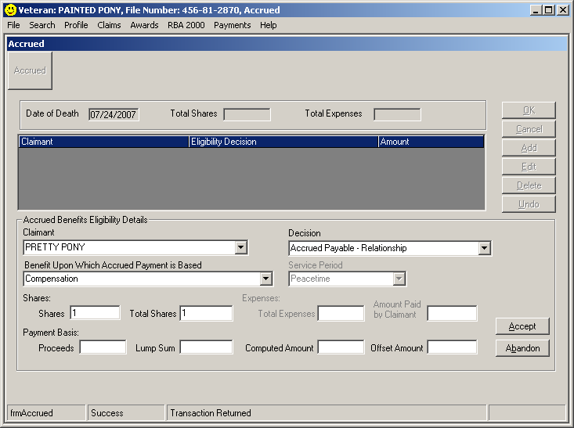
1
2
3
4
5
6
7
8
9
10
11
Generate the award.

The proposed Accrued award will display as shown below.

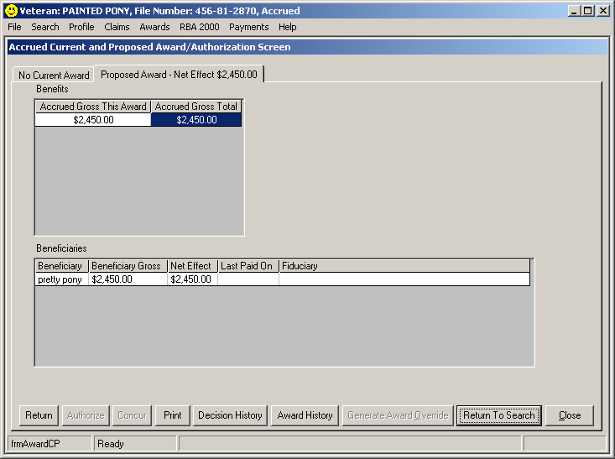

If a posthumous award is necessary to compute the accrued amount due, three actions must be completed:

- Have a rating completed for accrued purposes.
- Establish a live compensation claim type in Share for use in generating the posthumous CPL award.
- Generate the CPL Award to calculate the accrued amount due.
  - Record the Basic Eligibility Decision of Death of Beneficiary and record the date of death and award effective date to terminate the award calculation.
  - Record any other decisions that would have been used for determining entitlement for the Veteran (dependency, severance/separation pay offsets, retired pay offsets, etc).
  - If a retroactive time limit must be observed, use the GAO screen to modify the begin date of the award period and generate from that screen.

DIC Spouse
Dependency and Indemnity Compensation processing for a surviving spouse in VETSNET Awards is very similar to Live Compensation processing.

Since many of the processes do not differ from live processing, they are not covered in depth here. Refer to the live compensation processing chapters of the VETSNET Awards Handbook for any decision types not found here.

Begin the award process by searching for the Veteran in VETSNET Awards.

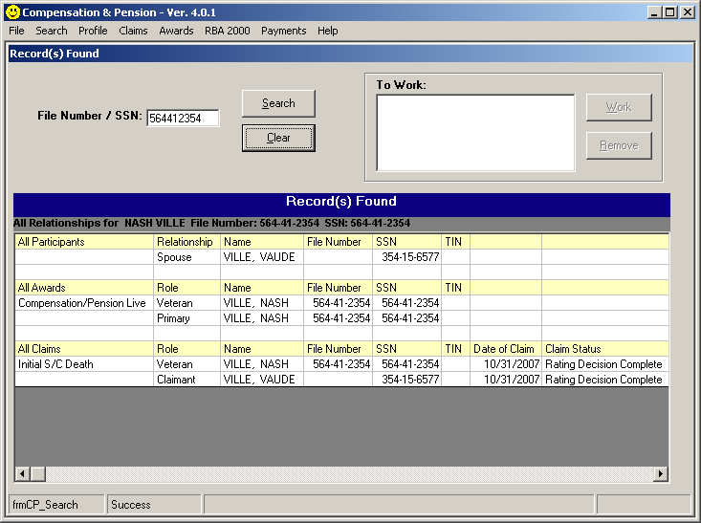

Select the claimant row in the All Claims section to add a CPD Spouse award record.

Add the Award Type of CPD Spouse as shown below:

All decisions related to Dependency and Indemnity Compensation and Improved Death Pension for a widow are processed on the CPD Spouse award tab.

On the CPD Spouse award tab, select the Record Decisions button to access the decision screens that will support generation of an award.
Note the names of the decision screens available for CPD Spouse processing are the same as those for CPL processing. However the decisions available on each of the screens apply only to CPD processing.

Two types of information are required for paying DIC Spouse benefits:
1. Rating/Service determination of entitlement (one of the following):

- Death in Service indicator.
- Rating determination of service connection for cause of death.
- Rating determination of an 1151 condition for cause of death.
- Rating determination of entitlement based on 38 U.S.C. 1318.

2. Basic Eligibility:

- A Basic Eligibility decision is always required when paying DIC benefits.
- Select the appropriate eligible Decision type, the Event Date, and the Award Effective Date to support payment of benefits.

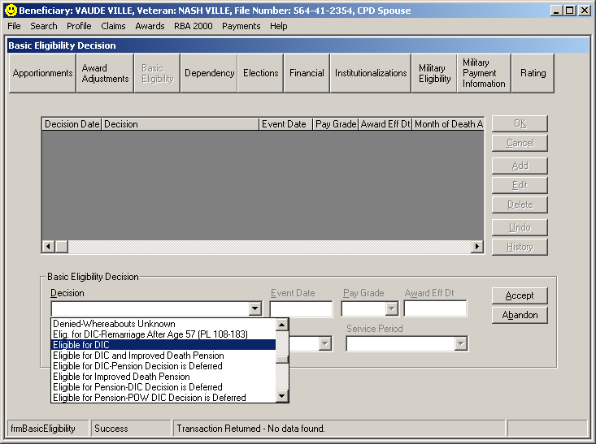

The Basic Eligibility screen decisions include decisions that establish entitlement, deny entitlement, and terminate a running award.

Eligible Decisions | - Eligible for DIC  - Eligible for DIC and Improved Death Pension  - Eligible for Improved Death Pension  - Eligible for DIC – Pension Decision is Deferred  - Eligible for Pension – DIC Decision is Deferred  - Eligible for DIC – Remarriage After Age 57 (PL 108-183)  *Additional decisions if Date of Death is 09-01-1999 or later  - Eligible for POW DIC  - Eligible for POW DIC and Improved Death Pension  - Eligible for POW DIC – Pension Decision is Deferred  - Eligible for Pension – POW DIC Decision is Deferred  *For any date of death after 12-01-62  - Eligible for Veteran’s Rate Month of Death  *For any date of death on or after 01-01-93 where the Veteran was totally disabled for 8 years immediately preceding death and was married to the claimant for the same 8 years  - 8&8 Criteria is Met from Original Eligibility Date  - 8&8 Criteria is Met After Orig. Eligibility Date

Reinstate Decisions | - Reinstate DIC  - Reinstate DIC and Improved Death Pension  - Reinstate Improved Death Pension  - Reinstate DIC – Remarriage After Age 65 (PL 108-183)  - Reinstate DIC – Remarriage Terminated  - Reinstate DIC and Imp. Death Pension – Remarriage Term.  *Additional decisions if Date of Death is 09-01-1999 or later  - Reinstate POW DIC  - Reinstate POW DIC and Improved Death Pension

Denial Decisions | - Denied – Claim Withdrawn  - Denied – Death Cannot be Presumed  - Denied – Death of Claimant  - Denied – Elected Under Another Veteran’s Service  - Denied – Failed to Furnish Requested Evidence  - Denied DIC – Elected FECA  - Denied DIC – Election Required Due to FECA Eligibility  - Denied DIC – RECA Payment is a Bar  - Denied – Fraud  - Denied – Marriage Requirements Not Met  - Denied – Not Properly Signed  - Denied – Not the Proper Claimant  - Denied – Not Well Grounded  - Denied – Relationship Cannot be Established  - Denied – Treason  - Denied – Unfavorable Homicide Decision  - Denied – Whereabouts Unknown  - Denied DIC – Death Not Service Connected  - Denied DIC – No Indication of Entitlement Shown  - Denied 8x8 – Criteria is Not Met  - Denied – Legal Surviving Spouse Entitled  - Denied Statutory A&A – Criteria Not Met  - Denied – Forfeiture  - Denied – Fugitive Felon

Terminate Decisions | - Terminate – Administrative Error  - Terminate – Beneficiary Error  - Terminate – Death of Beneficiary  - Terminate – Elected Under Other Veteran’s Service  - Terminate – Failed to Furnish Requested Evidence  - Terminate DIC – Elected FECA  - Terminate DIC – RECA Payment is a Bar  - Terminate – Forfeiture  - Terminate – Fraud  - Terminate – Marriage or Inference of Marriage  - Terminate – Treason  - Terminate – Renouncement  - Terminate – Whereabouts Unknown  - Terminate – Legal Surviving Spouse Entitled  - Terminate – Fugitive Felon

Pay additional allowance when the Veteran died on or after January 1, 1993
If the Veteran was in receipt of, or entitled to receive, compensation for a Service Connected disability rated totally disabling (including a rating based on individual unemployability) for a continuous period of at least eight years immediately preceding death and the surviving spouse was married to the Veteran for those same eight years, an additional monthly benefit is payable.

To pay the additional allowance, two decisions must be recorded:
- Eligible for DIC
- 8&8 Criteria is Met from Original Eligibility Date.

Record the Eligible for DIC decision first to establish basic eligibility and follow with the 8&8 decision to record the additional benefit payable.

The second decision recorded replaces the special law code 23 recorded when processing awards in the BDN.

Add Dependents
Widow’s may receive an additional allowance for dependent minor children.

The system will automatically add the additional amount payable for minor children for a two year period or until the last child reaches age 18, whichever is sooner.

The process for adding dependent minor children does not differ from the processed used for live compensation awards. Refer to the Dependency section of Chapter 4.

School Children and Helpless Children will be paid in their own right on separate child awards. Refer to Chapter 12 for information regarding Dependency and Indemnity Compensation in VETSNET Awards for Children.

SBP – Record the amount and set the indicator

SBP information will be recorded on the Military Payment Information screen.

This process is similar to that used for retired pay processing for live Veterans except that it is for informational purposes only and no withholding will be recorded.

To record the SBP information and set the indicator:

Access the Military Payment Information screen.

- Select the Add button.
- Select the Retired Pay Type = Survivor’s Benefit Plan.
- Enter the Effective Date.
- Enter the Gross Amount.
- Select Accept to update the screen.
- Select OK to close the screen.
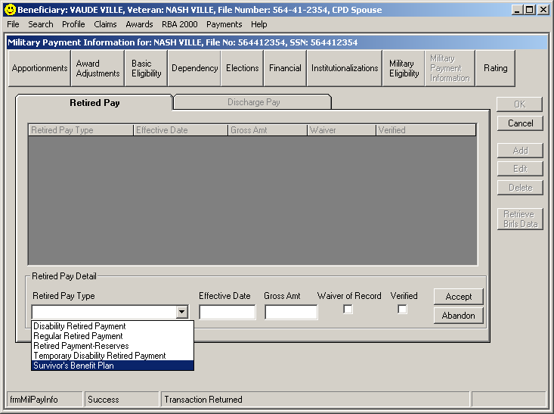
- Note the SBP indicator has been set.

SBP - No Overpayment
If there is SBP for the widow with no overpayment, record the SBP information as described above and process the DIC Spouse award without referral to the Finance division.

SBP – Overpayment Exists
If an overpayment does exist, take the following steps to ensure the overpayment is established prior to authorization of the VETSNET award.

- Record the SBP gross amount as described above.
- Record all decisions supporting the grant of Dependency and Indemnity Compensation benefits to the surviving spouse.
- Generate the award but do not authorize.
- Refer the case to your local Finance division so the overpayment amount can be established.
- When notified by the Finance division that the overpayment has been established, have the award authorized. The overpayment amount will be recouped from the amount payable.

DIC Child
Begin the award process by searching for the Veteran in VETSNET Awards.

Select the first claimant for which an award decision will be recorded in the All Claims section to add a CPD Child award record.

Add the Award Type of CPD Child as shown below:

All decisions related to Dependency and Indemnity Compensation and Improved Death Pension for a widow are processed on the CPD Spouse award tab.

On the CPD Child award tab, select the Record Decisions button to access the decision screens that will support generation of an award.

Four types of information are required for paying DIC Child benefits:

- Rating/Service determination of entitlement

One of the following must be present to pay DIC benefits:

- Death in Service indicator.
- Rating determination of service connection for cause of death.
- Rating determination of an 1151 condition for cause of death.
- Rating determination of entitlement based on 38 U.S.C. 1318.

- Basic Eligibility:

- A Basic Eligibility Decision is always required when paying DIC benefits.
- Select the appropriate eligible Decision type, the Event Date, and the Award Effective Date to support payment of benefits.

Note: A basic eligibility decision must be recorded for each child.

The Basic Eligibility screen decisions include decisions that establish entitlement, deny entitlement, and terminate a running award.

Eligible Decisions | - Eligible for DIC  - Eligible for DIC and Improved Death Pension  - Eligible for Improved Death Pension  - Eligible for DIC – Pension Decision is Deferred  - Eligible for Pension – DIC Decision is Deferred  *Additional decisions if Date of Death is 09-01-1999 or later  - Eligible for POW DIC  - Eligible for POW DIC and Improved Death Pension  - Eligible for POW DIC – Pension Decision is Deferred  - Eligible for Pension – POW DIC Decision is Deferred

Reinstatement Decisions | - Reinstate DIC  - Reinstate DIC and Improved Death Pension  - Reinstate Improved Death Pension  *Additional decisions if Date of Death is 09-01-1999 or later  - Reinstate POW DIC  - Reinstate POW DIC and Improved Death Pension
Denial Decisions | - Denied – Claim Withdrawn  - Denied – Death Cannot be Presumed  - Denied – Death of Claimant  - Denied – Elected Under Another Veteran’s Service  - Denied – Failed to Furnish Requested Evidence  - Denied DIC – Elected FECA  - Denied DIC – Election Required Due to FECA Eligibility  - Denied DIC – RECA Payment is a Bar  - Denied - Forfeiture  - Denied – Fraud  - Denied – Not Properly Signed  - Denied – Not the Proper Claimant  - Denied – Not Well Grounded  - Denied – Relationship Cannot be Established  - Denied – Treason  - Denied – Unfavorable Homicide Decision  - Denied – Whereabouts Unknown  - Denied DIC – Death Not Service Connected  - Denied DIC – No Indication of Entitlement Shown  - Denied – No Independent Entitlement  - Denied – Elects Chapter 35  - Denied – On Active Duty  - Denied – Stepchild Not in Household at Time of Death  - Denied – Stepchild Not Receiving 50% Support  - Denied – Fugitive Felon

Terminate Decisions | - Terminate – Administrative Error  - Terminate – Beneficiary Error  - Terminate – Death of Beneficiary  - Terminate – Elected Under Other Veteran’s Service  - Terminate – Failed to Furnish Requested Evidence  - Terminate DIC – Elected FECA  - Terminate DIC – RECA Payment is a Bar  - Terminate – Forfeiture  - Terminate – Fraud  - Terminate – Marriage or Inference of Marriage  - Terminate – Treason  - Terminate – Renouncement  - Terminate – Whereabouts Unknown  - Terminate – Elected Chapter 35  - Terminate – On Active Duty  - Terminate – Fugitive Felon

- Status of All Children:

This screen is similar to the Dependency screen used for CPL and DIC Spouse award decisions.

The status of all children who may share in the DIC Child award is recorded on this screen.

The information recorded here will be used to determine the rate payable to each child.

The information recorded on this screen is common for all children on the award.

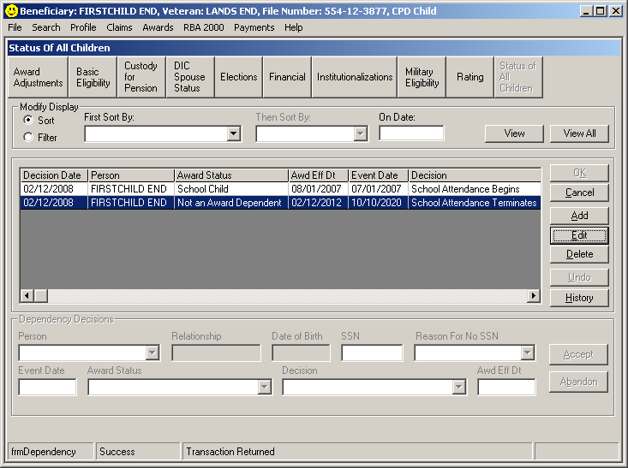

- DIC Spouse Status:

The decision recorded on this screen will be used in determining the rate payable to the child(ren).

The two decision types that can be selected are:
DIC Spouse Award Exists
No DIC Spouse Award Exists

The decision recorded on this screen is common for all DIC Children for the award.

Basic Flow for generating a DIC Award for a child

After adding an award record for the claimant:

- Review the rating data by accessing the rating tab and selecting the Death Decisions tab.

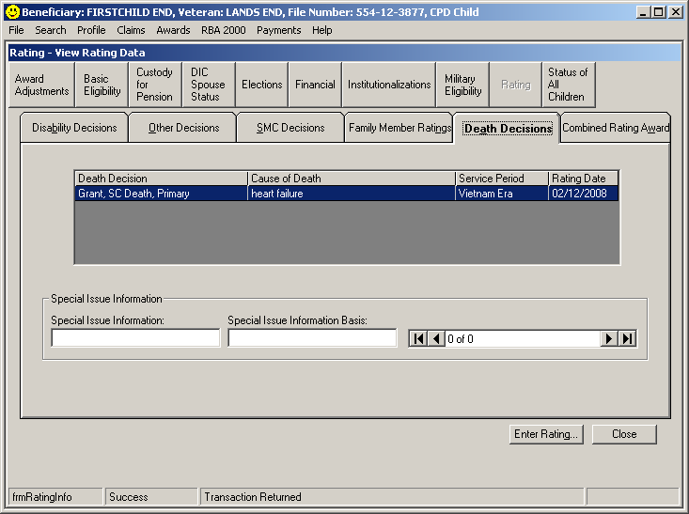
1

- Note the service connected death decision.

- Access the Basic Eligibility screen to record an eligibility determination for the claimant and record the Event Date and Award Effective Date.
3

- Access the Status of All Children screen to record the details for the child.

If there are other children who may file claims at a later time, record the information about those children here now so the proper rate will be generated.
4

- Access the DIC Spouse Status screen to record information about the Spouse DIC Award.

If there is not currently a spouse in receipt of DIC benefits but the spouse still may file a claim, record the decision that there is a DIC Spouse award so that the proper rate will be generated.

The decision can be deleted or changed at a later date when it is determined that the spouse will not be awarded benefits.

5

- Generate the award.

Month of Death Payments
When the Veteran dies, the record is terminated the first of the month of death. Only the surviving spouse may be entitled to payment of the month of death.

Refer to VBA Letter 20-09-51 and M21-1MR IV.iii.3.B.12 for processing of Month of Death payments.

Notification

Every letter must address all claimed issues. Original claims must address DIC, death pension, and accrued, whether claimed or not. The two basic letters are found under C&P in PCGL, grant or denial. The effective date for DIC and death pension is the first of the month of the Veteran’s death if received within one year, otherwise it is the date of claim.

When counting pension income and expenses, the date of death is the beginning of the initial year. If the claimant did not provide income information, deny death pension because they claimed DIC only and did not provide income information. If DIC is granted, deny pension because we granted DIC benefits as the greater benefit and they are not entitled to both benefits.

If DIC is granted, include ancillary benefits information for CHAMPVA and Loan Guaranty.
Chapter 35 DEA benefits and Commissary privileges are included for any surviving dependents of a Veteran rated 100% at death.

Summary

As you can see, death claims have many variables and issues to be considered. Sometimes they are simple and all information is of record and ready for a grant. Other times you may require development, initiative, research, creativeness, administrative decisions, rating decisions with multiple awards and letters. Be patient and take time to read the manual as this guide will not cover every situation you will see. Remember, these claimants have under gone a tremendous loss recently, and need your compassion and assistance. They have usually just lost their primary source of family income and need our benefits yesterday! That extra effort you take to call the funeral home for a death certificate, look in Capri, or find a divorce on the Internet will be greatly appreciated.

Manual References for Accrued M21-1MR, Part VIII

Chapter 1. Eligibility
Table of Contents
1. General Information about Eligibility 1-1
2. Pending Claims 1-5
3. Elections and Automatic Increases Pending at Death 1-6
4. Evidence in File 1-8
5. Entitlement on the Basis of Relationship 1-10

Chapter 2. Development
Table of Contents
1. Separate Claim Not Required 2-1
2. Separate Claim Required 2-3

Chapter 3. Rating
Table of Contents
1. General Information on Accrued Rating Decisions 3-1
2. Preparing Accrued Rating Decisions 3-5

Chapter 4. Authorization and Notification
Table of Contents
1. General Information on Authorization and Notification 4-1
2. Time Limitations 4-4
3. Determining Amount of Accrued 4-6
4. Checks Not Negotiated Prior to Death 4-9
5. Accrued Lump Sum for Old Law Pension Cases 4-13
6. Personal Funds of Patients (PFOP) Accounts 4-16
7. PFOP Accrued Distinguished from Lump Sum Accrued 4-17
8. Action by Local Finance Activity 4-20
9. Transfer (Redeposit) of Funds 4-22
10. Responsibilities of the Veterans Service Center (VSC) 4-23
11. Payment of Accrued Benefits as Reimbursement 4-26
12. Allowance Items of Expense–Statements of Accounts 4-29
13. Claims Involving Political Subdivisions 4-32
14. Establishing Shares of Claimants 4-33
15. Railroad Retirement Act Death Benefits 4-36
16. Personal Funds 4-37
17. Receipted Bills 4-38
18. Exhibit: Entitlement to Accrued Benefits 4-39

Manual References for Application
M21-1MR, Part III, Subpart ii, Chapter 2, Section C

Section C. Original Death Claims
Topic | Topic Name | See Page
9 | Identification of Original Death Claims | 2-C-2
10 | Policies for Original Death Claims | 2-C-3
11 | Claims Involving Accrued Benefits | 2-C-5
12 | Claims Involving Death Compensation Entitlement | 2-C-9
13 | Claims for Social Security Survivors’ Benefits | 2-C-11

VA Form 21-534, Application for Dependency and Indemnity Compensation, Death Pension and Accrued Benefits by a Surviving Spouse or Child (Including Death Compensation If Applicable), represents a claim for

- Dependency and Indemnity Compensation (DIC) (including claims for an additional monthly allowance payable under 38 U.S.C. 1311a(2))
- death pension, and
- accrued benefits.

Important: Remember that
- all three benefits should be given proper consideration to include development for all necessary evidence.
- all claims by survivors of former prisoners of war (POWs) must be processed expeditiously, see M21-1MR, Part IV, Subpart iii, 1.7.

Note: If no accrued amount exists, deny the claim for accrued benefits without development. Explain the reason for denial in the notification letter

Manual References for Aid and Attendance

December 13, 2005 M21-1MR, Part V, Subpart ii, Chapter 3

Chapter 3. Special Monthly Pension (SMP) Ratings
Table of Contents
1. Ratings for Aid and Attendance (A&A) Allowance 3-1
2. Ratings for Housebound Benefits 3-4

M21-1MR, Part IV, Subpart iii, Chapter 2

Chapter 2. Rating DIC and Death Compensation Claims

1. Ratings Involving Death Benefits 2-1
2. Aid and Attendance (A&A) and Housebound Benefits for Survivors 2-4

Aid and Attendance (A&A) benefits under 38 CFR 3.351 may be paid to surviving spouses and parents who are receiving or entitled to receive
- death pension, including protected pension and old war service pension,
- DIC, or death compensation.

Only surviving spouses who are receiving or entitled to receive DIC or Improved Pension may qualify for the Housebound rate under 38 CFR 3.351(d).

A rating is required when entitlement to A&A benefits may not be granted based on nursing home patient status.

Authorize the payment of A&A benefits without a rating decision if evidence establishes the claimant is a patient in a nursing home.

If a period of hospitalization of 90 days or less results in a discharge to a nursing home, authorize payment of A&A benefits from the date of hospital admission, subject to the effective date provisions in 38 CFR 3.402(c) or 38 CFR 3.404.

Important: Housebound benefits may not be authorized without a rating decision.

Manual References for Death Pension

M21-1MR, Part V
Chapter 3. Pension Reductions for Medicaid-Covered Nursing Facility Care
Table of Contents
1. General Information on Pension Reductions for Medicaid-Covered Nursing
Facility Care 3-1
2. Medicaid Definitions 3-2
3. Identifying Medicaid-Covered Facilities 3-4
4. Verifying Nursing Facility Status and Medicaid Plan Coverage 3-5
5. Effective Dates for Payments - No Running Award 3-9
6. Effective Dates for Reductions - Running Award 3-10
7. Retroactive Increase for Running Awards During Period of Medicaid-
Covered Nursing Facility Care 3-12
8. Restoration of Full Benefits Upon Discharge, Change to Private Pay Status,
or Establishment of a Dependent 3-16
9. Entitlement Under More Than One Law - Elections 3-18
10. Special Law (SL) Codes and Medicaid Nursing Home Care (NHC) Field 3-21

Chapter 1. The Effect of Income and Net Worth on Pension and Parents’ Dependency and Indemnity Compensation (DIC)
Table of Contents

Section A: General Information on the Effect Income and Net Worth Have
on Pension and Parents’ DIC
Overview 1-A-1
1. General Information on Pension and Parents’ DIC Programs 1-A-2
2. General Information on Concurrent Income and Net Worth Development
in DIC and Death Compensation Claims 1-A-9
3. Income Reporting for Pension and Parents’ DIC 1-A-12
4. Action to Take When Income for VA Purposes (IVAP) Is Uncertain 1-A-14
5. Denying a Claim Because Income Exceeds the Maximum Annual Pension
Rate (MAPR) or Income Limit and Time Limits for Submitting Amended Income Information 1-A-17
6. Pension and Parent’s DIC Award Effective Dates and Payment Dates 1-A-28
7. General Information on Payment Period Commencement Under 38 CFR 3.31 1-A-29
8. Specific Exclusions to Payment Period Commencement Under 38 CFR 3.31 1-A-38

Section B: Social Security Administration (SSA) Benefits Program
Overview 1-B-1
9. Overview of the SSA Benefits Program 1-B-2
10. Medicare 1-B-7
11. Computing Monthly SSA and Medicare Benefits 1-B-10
12. Sources for Accessing Social Security (SS) Information 1-B-15
13. Terminated Disability SS and Withdrawn SS Applications 1-B-17

Section C: Section 306 Pension and Old Law Pension
Overview 1-C-1
14. Determination of Countable Income for Section 306 or Old Law Pension 1-C-2
15. Counting the Income of a Spouse for Section 306 or Old Law Pension 1-C-9
16. Deductible Expenses 1-C-16
17. Adjustments Based on Changes in Income 1-C-22
18. Changes in Marital and Dependency Status 1-C-30
19. Handling Another Beneficiary’s Award When a Surviving Spouse’s or
Child’s Award Is Terminated 1-C-39
20. Sale or Transfer of Real Estate or Personal Property 1-C-41

Section D: Parents’ DIC
Overview 1-D-1
21. Original and Reopened Awards 1-D-2
22. Deductible Expenses 1-D-9
23. Proportionate Calculation of Income for Veterans Affairs Purposes (IVAP) 1-D-16
24. Adjustments Based on Changes in Income 1-D-20
25. Waiver of Retirement Income 1-D-26
26. Changes in the Marital or Dependency Status of Parents 1-D-32
27. Sale or Transfer of Real Estate or Personal Property 1-D-38

Section E: Improved Pension – Basic Rate Determinations
Overview 1-E-1
28. Determining the Monthly Rate of Payment 1-E-2
29. Determining the Maximum Annual Pension Rate (MAPR) 1-E-6
30. Veterans Who Are Married to Each Other 1-E-8
31. Surviving Child Entitled to Improved Death Pension in His/Her Own Right 1-E-10
32. Income Classifications 1-E-16
33. Counting Income for Department of Veterans Affairs Purposes (IVAP) 1-E-19
34. Counting Income During the Initial Period 1-E-30
35. Award Notice to Claimant 1-E-39
36. Using Special Law (SL) Codes 14 and 18 1-E-41

Section F: Improved Pension – Dependents
Overview 1-F-1
37. Establishing Dependents for Improved Pension Purposes 1-F-2
38. Counting the Income of Dependents 1-F-7
39. Removing Dependents From Improved Pension Awards 1-F-20
40. Removing the Income of Dependents 1-F-25

Manual References for Dependent Child

Chapter 5. Relationship and Dependency
Table of Contents
Section A: General Information on Relationship and Dependency
Overview 5-A-1
1. General Policies Regarding the Establishment of Relationship and
Dependency 5-A-2
2. Burden of Proof 5-A-8
3. Jurisdiction Over Relationship Determinations 5-A-10
4. Methods of Obtaining Information, Including Handling Information Received by Telephone, E-Mail, or Fax 5-A-15

Section F: Establishing Child Relationship
Overview 5-F-1
30. General Requirements to Be Considered a Child 5-F-2
31. Eligibility Requirements for a Child 5-F-4
32. Establishing Date of Birth (DOB) and Relationship 5-F-6
33. Establishing a Child’s Age: Primary and Secondary Evidence 5-F-8
34. General Information on Award Adjustments for Dependents 5-F-12
35. Additional Compensation for Dependents 5-F-14
36. Adjustments Due to Loss of a Dependent 5-F-16

Section G: Establishing Relationship for a Biological Child, Adopted Child, and Stepchild
Overview 5-G-1
37. Establishing the Relationship Between the Veteran and His/Her Biological Child 5-G-2
38. Establishing the Relationship of the Adopted Child to the Veteran 5-G-4 39. Adoption by the Surviving Spouse 5-G-8
40. Foreign Adoptions 5-G-9
41. Child Adopted Out of the Veteran’s Family 5-G-13
42. Establishing the Relationship Between the Veteran and His/Her Stepchild 5-G-16

Section H: Marriage of a Child
Overview 5-H-1
43. Effect of a Child’s Marriage 5-H-2
44. Termination of a Child’s Marriage 5-H-6

Manual References for Development M21-1MR, Part IV, Subpart iii, Chapter 1

Use the information below to determine when to develop for income and net worth information.

If … | Then …
- only partial income and net worth information was provided on the application, and  - basic entitlement to pension otherwise exists | develop for the missing information.
- the claimant has alleged that death of the Veteran was SC, and  - all income and net worth information was completely omitted | do not develop for income and net worth information.  Notes:  - Inform the claimant, in the notification letter, that death pension was not considered because evidence of income and net worth was not provided.  - If basic entitlement to pension does not exist, deny the claim without regard to income or net worth.  Example: In a case in which there is no qualifying service, deny the claim for no qualifying service rather than for excessive income.
basic entitlement to pension does not otherwise exist, as in cases in which there is no qualifying service | do not develop income and net worth information.
d. Evidence Required to Determine Entitlement to DIC | Generally, to determine entitlement to DIC, VA needs evidence showing  - the cause of death, and  - that the cause of death was  - related to, or hastened by, a service-connected (SC) condition, or  related to a disease or injury that existed during active military service.
e. Obtaining Evidence Relating the Cause of Death to a Service- Connected Condition | Evidence to support a claim for DIC may be obtained from  - the claims folder, if service connection for a disease or injury was previously established,  - VA medical center treatment reports or VA outpatient clinic records,  - service medical records, or  private doctor or hospital treatment records.
f. Referring Cases to the Rating Activity | Once development is complete, refer the claim to the rating activity for a decision on the issue of service connection for the cause of death.  Note: Some death claims may be referred to the rating activity as soon as they are received. This is particularly true if service connection for a disease or injury was established during the Veteran’s lifetime.
g. Developing for Proof of Death | Develop for evidence listed in 38 CFR 3.211 that constitutes proof of death.  When acceptable evidence cannot be obtained, the fact that death occurred may still be conceded under the provisions of 38 CFR 3.211(f). These cases must be  - fully developed for facts and circumstances that support a presumption of death, and  - submitted to the rating activity for determining  - service connection for the cause of death  - the existence of a disability related to service at the time of death, or  - discharge from service for a service-connected (SC) disability.  Reference: For more information on proof of death, see M21-1MR, Part III, Subpart v, 1.H.

Manual References for DIC

December 13, 2005 M21-1MR, Part IV, Subpart iii, Chapter 1, Table of Contents

Chapter 1. Developing Claims for Dependency and Indemnity Compensation (DIC) and Death Compensation
1. General Information on Developing Claims for Death Benefits 1-1
2. Considering Death in Service 1-6
3. Casualty Assistance, Death in Service, and DIC 1-7
4. Considering Entitlement to DIC 1-9
5. Developing for Pay Grade Data 1-12
6. Developing DIC Claims Under 38 U.S.C. 1151 1-14
7. Claims by Survivors of Former Prisoners of War 1-18
8. Locations of Other Information Pertaining to Developing for DIC and Death Compensation Claims 1-19
9. Exhibit: Former POW Survivor Folder Flash 1-20

M21-1MR, Part IV, Subpart iii, Chapter 2

Chapter 2. Rating DIC and Death Compensation Claims

1. Ratings Involving Death Benefits 2-1
2. Aid and Attendance (A&A) and Housebound Benefits for Survivors 2-4

Chapter 3. Authorization and Notification in DIC and Death Compensation Claims

Section A: General Authorization and Notification Issues
Overview 3-A-1
1. Determining the Pay Grade for DIC Awards 3-A-2
2. DIC Under 38 U.S.C. 1318 3-A-4
3. Denial When a Claimant Fails to Prosecute a Claim 3-A-6
4. Adjustments Based on Claims Filed With the Social Security
Administration (SSA) 3-A-7
5. DIC Reform Under Public Law (PL) 102-568 3-A-9
6. DIC Reform Under PL 106-117 3-A-11
7. DIC Reform Under PL 108-454 3-A-13
8. Exhibit: BDN 401 Screen 3-A-15

Section B: Initial Awards to Dependents
Overview 3-B-1
9. General Information on Initial Awards to Dependents 3-B-2
10. Determining the Effective Date When the Veteran Dies After
Separation From Service 3-B-4
11. Determining the Surviving Spouse’s Entitlement to Benefits for the
Month of Death 3-B-7
12. Payment of the Veteran’s Benefit for the Month of Death Under 38 CFR 3.20(c) 3-B-12
13. Application of 38 CFR 3.107 on Awards to Surviving Spouses or Children 3-B-17
14. Application of 38 CFR 3.107 on Awards to Parents 3-B-20
15. Application of 38 CFR 3.650 When Additional Dependents File a Claim 3-B-21

Section C: Awards to Survivors Upon the Death of a Dependent of a Deceased Veteran
Overview 3-C-1
16. General Information on Awards to Survivors Upon the Death of a Dependent 3-C-2
17. Awards to Survivors Upon the Death of a Surviving Spouse, Child, or Parent 3-C-4

Section D: DIC in Nonservice-Connected (NSC) Death Cases
Overview 3-D-1
18. General Information on DIC Payable in NSC Death Cases 3-D-2
19. Rating Activity Review to Determine if Cause of Death Is
Service-Connected (SC). 3-D-5
20. Prohibition Against Duplication of Benefits 3-D-6

Section E: DIC to Children Pending Determination of a Surviving Spouse’s Entitlement
Overview 3-E-1
21. Paying DIC While the Surviving Spouse’s Award Is Pending 3-E-2
22. Determining DIC Depending on the Surviving Spouse’s Entitlement 3-E-6

Section F: Remarriage of a Surviving Spouse
Overview 3-F-1
23. General Information on the Effect of a Surviving Spouse’s Remarriage 3-F-2
24. Conduct Warranting the Inference of the Remarriage of a Surviving Spouse 3-F-8
25. Suspending and Terminating Payments to a Surviving Spouse After Remarriage
When No Children Are Involved 3-F-14
26. Processing Payments to Children After the Surviving Spouse’s Remarriage 3-F-16
27. Handling Improved Pension and DIC Cases Following the Remarriage of a
Surviving Spouse 3-F-19
28. Handling Section 306 and Old Law Pension Cases Following the Remarriage of a
Surviving Spouse 3-F-23
29. Action on Children’s Awards Following the Remarriage of a Surviving Spouse 3-F-24
30. Effect of the Termination of a Surviving Spouse’s Remarriage 3-F-27
31. Termination of Surviving Spouse’s Remarriage: Remarriage Alleged to Be Void 3-F-30
32. Termination of Surviving Spouse’s Remarriage: Remarriage Annulled 3-F-31
33. Resumption of DIC Eligibility After Termination of Remarriage 3-F-33
34. Resumption/Continuation of DIC Eligibility Based on Remarriage After Age 57 3-F-38

Section G: DIC Benefits Under 38 U.S.C. 1151
Overview 3-G-1
35. General Information on the Prohibition Against Duplication of Benefits 3-G-2
36. Awards Involving the Prohibition Against Duplication of Benefits 3-G-4
37. Determining the Offset Effective Dates and Amounts of Offsets 3-G-7
38. Preparation of Awards 3-G-9
39. Providing Notice of Awards 3-G-11

Section H: Elections Between DIC and Death Compensation Benefits
Overview 3-H-1
40. General Information on Elections Between DIC and Death Compensation 3-H-2

Section I: Survivor Benefit Plan (SBP)
Overview 3-I-1
41. General Information on the SBP and DIC Offset 3-I-2
42. A Surviving Spouse’s Benefit and Potential Offset 3-I-5
43. Service Department Handling of SBP Payments 3-I-7
44. Department of Veterans Affairs (VA) Action in Response to a Service
Department Notice Concerning SBP 3-I-8

Section J: Awards Barred by Receipt of Federal Employees Group Life Insurance (FEGLI)
Overview 3-J-1
45. General Information on Awards Barred by Receipt of FEGLI 3-J-2
46. Action to Take on Claims Involving FEGLI Benefits 3-J-3

Section K: Allowance, Allotments, or Service Pay Under 38 U.S.C. 5110(j)
Overview 3-K-1
47. General Information on Handling Allowance, Allotments, or Service Pay
Under 38 U.S.C. 5110(j) 3-K-2
48. Determining the Effective Dates of Claims 3-K-5
49. Award Action 3-K-7

M21-1MR, Part V
Chapter 1. Overview of Eligibility Requirements and Development for Pension and Parents’ Dependency and Indemnity Compensation (DIC)

1. General Information on Types of Pension and Eligibility Requirements 1-1
2. Service Requirement for Pension Eligibility 1-3
3. Eligibility Requirements for Section 306 Pension and Old Law Pension 1-5
4. Entitlement Requirements and Development for Parents’ DIC 1-7

Manual References for Marriage
M21-1MR, Part III, Subpart iii, Chapter 5, Table of Contents

Chapter 5. Relationship and Dependency

Section A: General Information on Relationship and Dependency
Overview 5-A-1
1. General Policies Regarding the Establishment of Relationship and
Dependency 5-A-2
2. Burden of Proof 5-A-8
3. Jurisdiction Over Relationship Determinations 5-A-10
4. Methods of Obtaining Information, Including Handling Information Received by Telephone, E-Mail, or Fax 5-A-15

Section B: General Information on Establishing Marital Relationship
Overview 5-B-1
5. Requirements and Development Guidelines for Establishing Marital
Relationship 5-B-2
6. Development Procedures 5-B-5
7. Termination of Marriage Through Annulment or Divorce 5-B-9
8. Termination of Marriage Through Death 5-B-11
9. Determining Whether a Marriage Is Void 5-B-14
10. Documentary Evidence to Prove Dissolution of Prior Marriages 5-B-16
11. Removal of Impediments to Marriage 5-B-18

Section C: Establishing Common Law Marriages
Overview 5-C-1
12. Common Law Marriage Requirements 5-C-2
13. Development to Establish a Common Law Marriage 5-C-6
14. Validity of Common Law Marriages By State 5-C-8
15. Validity of Common Law Marriages Outside the U.S. 5-C-9
16. Establishing a Common Law Marriage for a Claimant Not Living in a State
Recognizing Common Law Marriages 5-C-10
17. Establishing a Common Law Marriage Against the Claimant’s Will 5-C-14
18. Administrative Decision Required to Recognize or Reject a Common Law
Marriage 5-C-16

Section D: Establishing Other Types of Marriages
Overview 5-D-1
19. Tribal, Proxy, and Transgender Marriages 5-D-2

Section E: Establishing Marital Relationship in Death Cases
Overview 5-E-1
20. Establishing a Valid Marriage in Death Cases 5-E-2
21. General Information on the Marriage Dates Requirement 5-E-5
22. Marriage Dates Requirement and Pension Claims 5-E-7
23. Marriage Dates Requirement and Dependency and Indemnity Compensation (DIC)
Claims 5-E-9
24. Marriage Dates: Multiple Marriages to Veteran 5-E-11
25. Continuous Cohabitation 5-E-13
26. Deemed Valid Marriage 5-E-17
27. Deemed Valid Marriage: Lack of Knowledge of Impediment 5-E-20
28. Deemed Valid Marriage: Multiple Claimants 5-E-22
29. Deemed Valid Marriage: Multiple Claimants As Surviving Spouse; Legal
Surviving Spouse’s Income Exceeds Limits for Pension 5-E-26

SBP Explained

Basically, it works like this: The vet contributes a monthly premium to maintain SBP. This amount varies by rank and coverage, but for the most part it's over $1k per year. When a surviving spouse is already receiving SBP payments and we grant DIC, two things can happen -- 1st is if SBP is greater than DIC, then they will simply reduce the monthly SBP by the DIC amount and normally they will withhold the SBP balance until it equals our retro DIC amount. However if it was a long time running benefit, they may ask us to withhold the amount as it becomes a risk to recover due to amount and life expectancy.
2nd, if SBP is less than DIC, the widow gets a cost refund of all the premiums paid by the Veteran. If the benefits paid out are less than the total contribution, there is no overpayment and she is refunded the difference. If benefits paid are more than the contributions, then we have an overpayment.
Examples: 1. Vet pays $100 monthly for 25 years for $30,000. Widow gets SBP at $800/mo for 10 months when we grant DIC for a total of $8,000. She will get the balance of $22,000 for the cost refund and there is no overpayment.
2. Vet pays $100/mo for 6 yrs totaling $7,200. Widow gets $800/mo for 10 months when we grant DIC for a total of $8,000. Since her cost refund is only $7,200, there is an $800 overpayment that we must collect.
As you can see, overpayments are rare if our claims are processed timely because they seldom go back more than a year, unless it's a Nehmer type claim and most of the vets retired many years ago. These examples above would be cases where we pay DIC back to the date of death. Now on some of these reinstatement cases (age 57, etc) the widow has been getting SBP for years but our effective date would be date of claim, the overpayment would only be the amount of DIC due or SBP paid (whichever is less) from date of claim to the award processing date, so it is important to watch retired pay cutoff dates on overpayment cases. The best way to comprehend the withholding process is to read the PCGL paragraph for SBP withholding.

