Incomplete Claims
Statement need for an incomplete FDC Claim
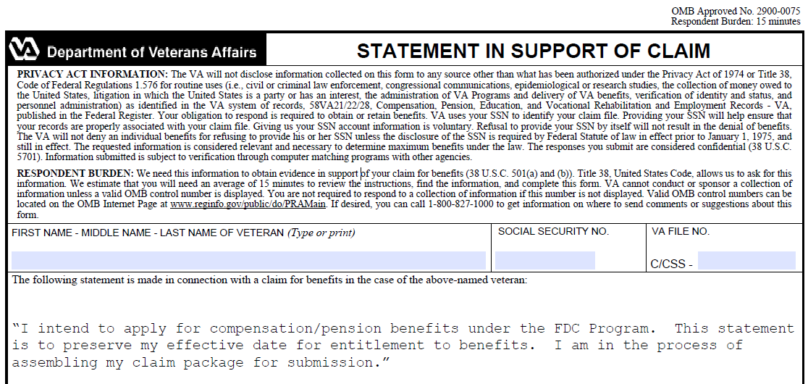
Ensure you do not list any disabilities. If you list disabilities we must take it as a traditional claim and it will be worked outside of the FDC program.

