The Notice
Some key parts of the notice (Page 1 thru 6 for the VA Form 21-526EZ)
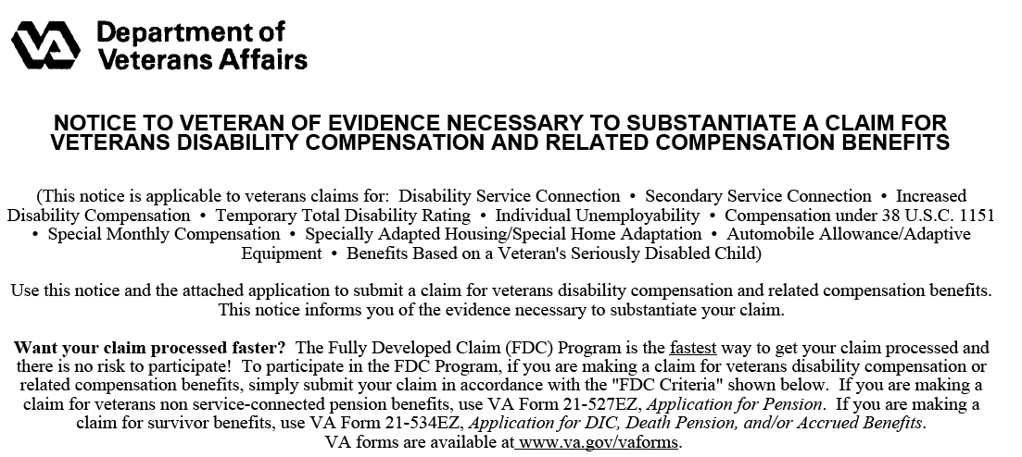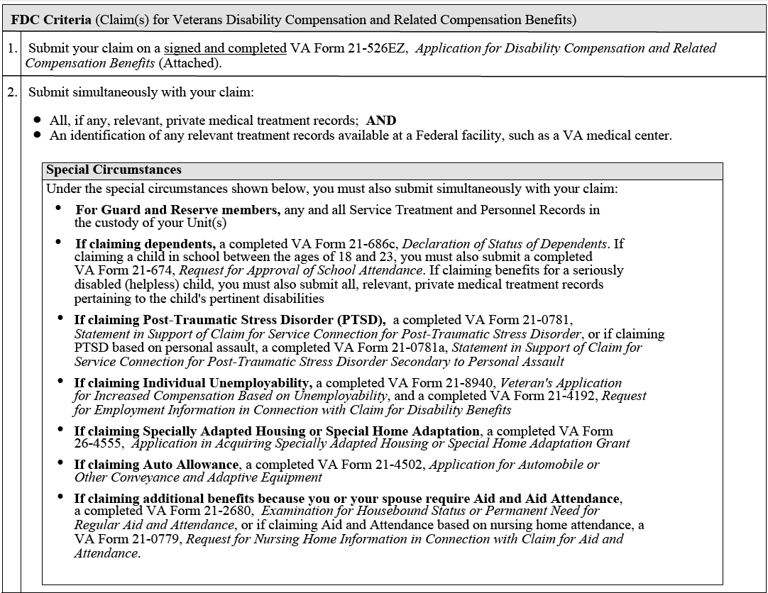
FDC Criteria
Please note: The Veteran must sign the VA Form 21-526ez
Special Circumstances
Please note: Additional forms may be needed depending on the claim you are filling (Example: VA Form 21-0781 is need for a claim for PTSD).
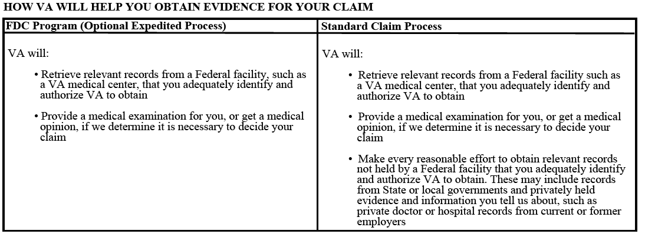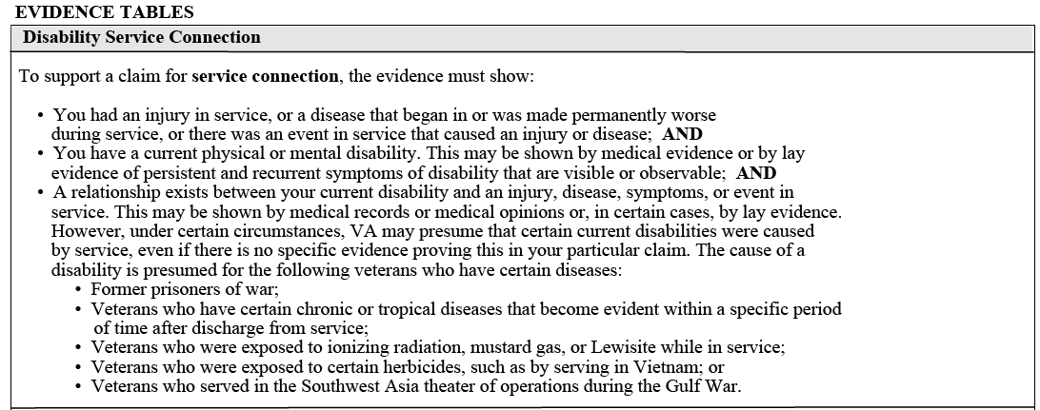
List the differences between the FDC Program and Standard Claim Process
Evidence and What the Evidence Must Show
