Addendum

AGENT ORANGE OUTSIDE OF VIETNAM

We would once again like to clarify our policy with respect to claims involving Agent Orange exposure outside of Vietnam.

In the March 2003 VSCM conference call, we provided information regarding the use of Agent Orange along the Korean DMZ in 1968 and 1969, including a list of units that were rotated to the DMZ during that timeframe. In an email sent to RO Directors’ mailboxes on July 3, 2003, we asked that you concede exposure for veterans who allege service at the DMZ and who were assigned to those units during that timeframe.

All of the information that we have with respect to the use of Agent Orange in Korea was conveyed during that conference call. We do not have information regarding whether other units may have been deployed to the affected area, or information that herbicides were used in any other location in Korea. There is no need to contact C&P Service where a veteran alleges herbicide exposure in Korea.

We learned recently that operational control of certain units of the 2nd Infantry Division was transferred to the 7th Infantry Division in early 1969. Those units are the 3rd battalion of the 32nd infantry (3/32) and

Last year C&P Service received from DoD an inventory of herbicide operations in locations other than Vietnam and Korea. After full development of the issue of exposure, to include obtaining a specific description of the exposure (approximate date(s), location and nature of exposure), contact Cheryl Konieczny via email. She will consult DoD’s inventory of herbicide operations to determine whether herbicides were used or tested as alleged.

The records we have do not refer to the use of Agent Orange or other herbicides in routine base maintenance activities, such as spraying along railroad tracks, on rifle ranges or along air strips. We have been informed that records of such use do not exist. Also, we are unable to provide evidence to support allegations such as exposure via servicing planes returning from Vietnam and exposure via contact with Vietnam veterans. Please do not contact C&P Service to attempt to verify these types of exposures.

Changes for MAPD 2.4.0

We removed many of the 'attachments' from the website as they were not approved documents.

We removed development action 1151 from the claimant letter screen. There is no 'specific' 1151 development, per M21. Any development that would be initiated by the rating specialist is no different than other development.

We disengaged the automatic generation of any ‘WHAT THE EVIDENCE MUST SHOW’ attachments. We felt that the newest attachments could not be definitively associated with one particular end product. This being the case, we decided, with help from a poll taken from field users, that to have some automatically generated and some having to be selected manually was more confusing. Therefore, ALL What the Evidence Must Show attachments will need to be manually selected. The proper amount of copies WILL be generated. The selection of VCAA attachments can be found on the Claimant letter screen. Go to Development Type drop down box, then to What the Evidence Must Show at the bottom of the drop down list.

When there is no development required of the claimant BUT VCAA must still be provided, when you select the appropriate What the Evidence Must Show off the Claimant letter screen/Development Type/What the Evidence Must Show, a letter will be generated. This ‘no development’ letter will not have a banner on the front page, and the language under What Do We Still Need From You? paragraph is different.

Added a new column to the Tracked Items grid called ‘Received’. Users, this is different from 'Closed'. It is for indicating that evidence has been actually received. Tracked items that you will not receive the necessary reply should be ‘Closed’. Example: you asked for a DD214 and the reply was “I don’t have it”. Close this item.
Tracked items that you DO receive, should be marked as ‘Received’.

I noticed that the NSC pension What the Evidence Must Show has one line that flops over onto another page. You can, if you want, adjust that attachment to fit on one page. Just remove a blank line or something.

774 - Menu -New Help Menu item - Suggestion Box. Added a new menu item under Help named: MAP-D Suggestion Box above the About item. "Send any ideas or suggestions for this application to VAVBAWAS/CO/215a.".

928 - Contentions - All buttons should not be disabled when there are no contentions and the user selects the Automatic Development button.

1156 - Work list - Removed the default selection for when the screen loads. This will improve performance of the application, as well as allow users that don't need work list to proceed with their work quicker. User will have to select which view they wish to see.

1170 - Login (Splash) screen – A Run time errors appear on Win95 and Win2K if the user tries to get out of the application before it has completed loading.

1254 - Customer Svc and Notes; when there are a number of claimants in the tree view for a particular participant, the notes were not being discriminate.

1257 - Third Party- there needs to be another space between the last word, 'possible' and the first word in the next sentence....'No'

1259 - MAP-D Terminal Server Implementation issues.

1317 - VSR list on the Station combo-list contains several names listed multiple times. Selection of a name causes screen to hang up and when Close is selected, run time error appears.

1321 - Another space issue in the Asbestos Para, Send us medical evidence dev action. After sentence 4, after last word "location." before sentence 5, word "We", there should be double space.

1322 - Add a space between ‘severity’ and ‘This’ in the s/c increase paragraph.
In the Severance pay paragraph: add period after ‘payment’.

1329 - When you have completed a letter to a veteran, and printed it out of Word, then when you are back on the Print letter screen, if you hit the Close button, your changes are not saved, and they should be. This may occur when you print the letter out of Word, Close the case. Then later, need to go back in to adjust the letter (or hit Done with Development if actions have been approved). Changes will now still be available.

1348 - On the What is the status of your claim and how can you help attachment, the sentence "Service Development Rules Needed" is being inserted into the first section and should not be.

1366 - Character of Discharge pre determination letter. Remove ‘s’ after decision; change ‘made’ to ‘make’.

1387 - Put the IRIS link in closing paragraph with the new language approved by Policy and Procedures.

1388 - When the work list loads, security checks every case before presenting it. This takes a long time. Needs to be fixed to take less time.

1389 - Must allow the use of Claims Work Assignment to actually reassign claims. Houston initially reported that they were unable to use Claims Work Assignment to reallocate workloads. They were limited to only doing one case at a time. During test of this version, we were able to call up over 1000 cases and reassign them with no problem.

1400 - On widow’s claims, only 2 copies print even if POA in letter. During testing, I did not find that this was fixed.

1404 - CAPRI/AMIE switch.

1408 - A change in 3rd party address does not change in the letter. If you change the addressee, the name and address in the letter must change.

1417 - The wrong Veteran's information is being displayed on the title bar of the Customer Service screen. The title bar must actually reflect the correct veteran’s name.

1421 - Letter Change. Please amend the phrase "help prove your claim" in the letter paragraph to agree with the attachment title "What the Evidence Must Show." “Help Prove Your Claim” is no longer in the title of the attachment and the letter needs to change to refer to the attachment correctly.

1422 - Letter change. Remove the phrase, "and when you will hear from us" from the second paragraph of the first page of our current MAP-D letter. Please also remove the phrase, "how long the claims process will take" from the same paragraph. The new sentence will read "This letter will give you information about what we will do, and what you can do to help us."

1434 - Amend Language in Time Limit Paragraph/STD Data. Change ‘many’ to ‘may’.

1435 - Modify the Agent Orange paragraph/STD Data to comply w/ changes desired by Policy and Procedures.

636 - Third Party - When changing/updating any of the development actions that update claimant letter.

861 - Third Party---when I have made changes to the claimant letter in Word, then have gone back to 3rd party to add another dev action, 1. I do not get the prompt about regenerating the claimant letter 2. the claimant letter is automatically updated with new information and previous manual changes gone regardless. The prompt is now presented. Please read the prompt when making a decision about whether or not to regenerate the letter.

1072 - Unsolicited Evidence - Add the Evidence Name(s) in the drop down box to a type table. Currently, they are hard coded in the application.

1262 - Printing Actions - when user selects the Word button, the application is regenerating the document - it should not.

SHARE VERSION 9.4
Release Notes

Austin GUI Changes

- The zip code field will be populated with the corresponding numerical code for the city name versus the last 5 letters of the city name. Situation: Presidential Memorial Certificate is not requiring user to enter a zip code. If it is left blank, the last 5 letters of the city name are moved to zip code field. (VBA00000064) Fixed.

- Stretched the fields to correct the 101 Screen - Truncating fields. Situation: When selecting from the drop-down list boxes, some of the following fields are truncating: Power of Attorney, Postal Code, and Country. (VBA00000112). Fixed

- Corrected the 101 to check for the null marks before displaying. At times, the 101 form or the 601 form will display || in one or more on it address line. This is because a control line feed character had been inserted as part of the address. This problem has been found and SHARE will clear any "special" characters that it finds in. it's address lines on both the 101 and 601 forms. (VBA00000183)

- 101 Screen - Veteran/Claimant should usually be blank. Incorrect records are being created by SHARE because the veteran/claimant name on the 101 screen is populated, by default, with the veteran's name. This selection should be blank, requiring the user to enter the correct claimant name, except for CPL claims where the payee code is 00 (the vet), in which case it should be populated with the vet's name. (VBA00000504)

- VID-SRH VID60 message was corrected to read “data” versus “date”. (VBA00001059)

- Corrected the Loc Screen - tab click negates the errors usually triggered by update command button. You have been allowed to click off the LOC screen without making a valid entry and as a result, perhaps the wrong type of file is created. (VBA00001093)

- BSTB not an expected reply. Message appears "SHR RDY14 No Birls record found for BIRLS Inquiry Processing. BSTB (search on stub name) transaction is sent, however when the reply received is returned, SHARE is not prepared for a BSTB in the first four characters. (VBA00001206)

- CFID 601-The Modify radio button is disabled during a CFID with an org fiduciary. Functions as designed. Using CFID to modify an existing org fiduciary will bring up the 601 screen with the Modify radio button disabled and the Add radio button selected. This prevents the user from changing the existing org fiduciary's information. I am not sure this is fixed as we want it yet. What does ‘Modify’ mean? (VBA00001305)

- CFID 601-The Modify radio button is disabled during a CFID with an org fiduciary. Functions as designed (VBA00001388) Duplicate

- Corrected Ready Screen - VSO User BINQ form not loading first time in. Situation: When you sign on as a VSO user and you do a BINQ (first one) the BINQ form is not loaded. If you change functions and then go back and do a BINQ it does load correctly. (VBA00001392)

- The Folder Data tab was set to be the default when no searches are present. Situation: While doing a SHARE COVERS Inquiry the default screen is the Search screen when there are no searches present. It should default to the Folder Data screen. (VBA00001393)

- PIF Extended Inquiry - Reject Indicator, not displaying Reject message on the tree view of the Ready Screen. Situation: When setting the reject indicator to zero on a PIF record it does not show a message on the tree view of the Ready screen. Functions as designed. (VBA00001473)

- Valid Zip Code check is working correctly on Presidential Memorial Certificate. (VBA00001483) Duplicate.

- Added a message to Sensitive Check Inquiry-When edit box is left empty, "Record Is Not Sensitive!" appears. If the user does not enter anything for Sensitive Check Inquiry, Share brings up the message "SHR RDY90: Record Is Not Sensitive!". Previously it would bring up the message "SHR RDY12: Sensitive Parameter Error". If the user enters non-numeric data, Share brings up the message "SHR RDY25: Invalid File Number". (VBA00001491)

- Corrected PCHG-Claim Type changes when Incremental is entered for an EPC that has multiple descriptions, ie 020. Situation: If the record has two 020 - Helpless Child claims, one will become a 021 - Helpless Child. If the user tries to PCHG the 021 by using the Incremental field, the Claim Type will revert to 020 - Claim for Increase. (VBA00001542)

- Selecting the “Ready” button on the PMC screen will prompt the error message “No PMC will be generated at this time”. The user will be returned to the Ready screen and no PMC will be generated. This provided the screen is not completed by the user. (VBA00001545)

- The labels on the 405 screen have been corrected to reflect the correct labels in BDN. (VBA00001548)

- VID-GW In-Theater dates is not accepted prior to EOD and RAD dates. Share does not issue the SHR VID72 warning message when the GW In-Theater fields have valid Gulf War dates (post 8.02.90 for Start), none of the service columns contain dates which include the GW In-Theater dates, and one of the tours of duty on the VID has an EOD greater than the Ending GW In-Theater field, and it should. (VBA00001554)

- For fiduciary type, “Superintendent BIA” is no longer available for payee codes 31-39. (VBA00001561)

- VID CEST Service data entered correctly gets error msg. Functions as designed. Situation: Service Data entered during a CEST fit acceptable criteria but got an error message anyway. (VBA00001573)

- Corrected 91 error when selecting a Node that has a Level ? access required. When doing a Search All and the record is sensitive and the Node line contains "Level ? Access Required" you get a 91 error when selecting the node. (VBA00001583)

- PCHG allows the DOB for payee 31-39 when updating a record. (VBA00001586)

- The veteran’s name was reformatted to read “Last, First, Middle, Suffix” to eliminate the punctuation problem. PMCs will no longer be rejected for punctuation. (VBA00001588)

- In the SHR CMN05 error message, the word “mispelled” has been corrected to read “misspelled”. (VBA00001626)

- PMC rollover (mouseover) text for city reads correct “Enter a city” versus “Enter a state”. (VBA00001639)

- Getting SHR RDY07 message occasionally when completing a CEST or FNOD. Situation: Getting the SHR RDY07 message after completing a CEST or FNOD when I log into Share at station 281 and then use the icon to switch stations. It doesn't happen consistently. (VBA00001642)

- Corrected data not showing on the 403 screen. Situation: Initially the 403 form will not display it's data, but if you select another form then go back to the 403, the data will be seen. (VBA00001679)

- Corrected Error message encountered while performing COVERS Inquiry function in SHARE on the Folder LOC screen. Error message is "An Error Has Occurred Retrieving BIRLS Record" "Error Code" (VBA00001682)

- Getting a run-time error 13 on the 601 screen when using CADD to update a vet's address. CADD address was changed successfully when CADD was first process chosen. (VBA001685)

- Corrected the CEST defect when no information is present in the 101 screen. Message appears warning that changes must be made in the CFID command. Situation: User is warned "Any change to address or fiduciary must be completed using the CFID command." when a CEST is attempted on a file having a Corporate record (CR) with a payment code of 5 and having a Master record (MR) with a payment code of 1. fiduciary information is not passed to the 101 b/c the CR doesn't contain the information. The reverse situation is described in VBA1334 (MR has payment code 5 and CR has payment code of 1). (VBA00001760)
Austin/Hines Service Side Changes to SHARE

- Modified the (VID) screen to check the month and day if the year difference is 13. According to SHR VID100 a valid EOD cannot be entered before the vet's 13th birthday. It appears this edit check only verifies the difference in the years. (VBA00001589)

- Modified VID to prevent VID-GW info from being accepted when EOD is before GW Start date and RAD is between the GW Start and End dates. (VBA00001592)

- Modified VID to prevent GW-VID info from being accepted when EOD is after GW Start date.

- Folder Loc Tab -General Form 70-7575 is allowing invalid input. Modified form frm7575 in workset Share_Src_Client_9.4 to make Box 1 check boxes and Box 26 check boxes to be mutually exclusive. (VBA00001675)

- Corrected Corp MINQ-Tux error message that appears when submitted without any data after clearing SHR CMNQ01 message. Added edit check looking for blanks in the file number field when doing a CORP MINQ Inquiry. Situation: If the user clicks Submit on a Corp MINQ without inputting any data in the File Number or SSN field, a "SHR CMN06: Tuxedo Error TUX-10213" message appears. (VBA00001690)

- Corrected the name update in BIRLS on Corp/BIRLS database mismatch. The user will now get the CINQ04 message, but will be allowed to continue with processing. Note: This will have to be addressed again. Field should not be allowed to continue without making sure that BIRLS and Corporate AGREE. (VBA00001709)

- Corrected code in (VID screen) paragraph EditVidPhase2 to allow for the Social Security Number to be changed when the Social Security Number Indicator is erased. (VBA00000660). NOTE: This too will have to be readdressed. The field should not be allowed to Delete an SSN with the SSN has a verified indicator. They should be able to update/change the number though, to the correct one, if appropriate.

- Corrected the PMC screen appearing for a dishonorable vet by modifying the response code to check if the Character of Service is Dishonorable. If it is, bypass the Presidential Memorial Certificate (PMC) screen. Ready CEST and basCKResponse have been modified to not create a Presidential Memorial Certificate on a Vet with a Dishonorable discharge on the VID screen. (VBA00000187)

- Corrected VID to display a message whenever the EOD and RAD are not within time frame for the GULF WAR and the Gulf War Indicator is set on the MSC screen. (VBA00000645)

- Corrected Invalid set of GW indicators by requiring both a script to be run (which has been run in cert) and that the share lists service be built using the right schema/login. . Situation: FARC address for (031) National Archive Building was not on the Corporate Database (VBA00001035)

- Corrected the LOC screen from freezing up when trying to establish a NOD folder. Allowed a BUPD command with station 101 or 376 to update Date of Death and Cause of Death fields on the VID screen. (SetAttributesByCommand) in frmVetData. (VBA00001116)

- Corrected BFLD-Warning message that appears each time Folder Loc tab is accessed from other tabs. Added switch to frmVetData4.frm (Load_Form), Share.bas (General Declarations), basParseRecords (ParseBINQ) Situation: The SHR LOC01 message now appears each time the user clicks from the Loc screen and then returns to the Loc screen. Previous versions of Share did not exhibit this behavior. The message would only appear once. (VBA00001289)

- Added in check for diagnostic suppression on sensitive file. If that indicator is set no one, VSOs or regular users, will view the description. If that indicator is not set, view is determined by what is in the suppress diagnostics indicator of the user's CSUM record. (VBA00001538)

- Added Corp Inquiry displaying VETSNET Award Data (M12) (VBA00001184)

- Added database name to Corp Inquiries screens. When screen prints come in it would be nice to know from looking at the print which db is being used. (VBA00001300)

- Added Corporate Gen Search data to be displayed. there are many many duplicate and incorrect records being generated. One reason is because the information displayed on the Corporate General Search - Person or Fiduciary screen is very limited. It has name, ssn, dob, dod and military info. In order to more correctly identify the individual that you may need, Share should present more information. If there is a corporate record for the name, present the current C&P payment address for the possibles. If the current C&P payment address is DD EFT, show, in addition to the DD EFT information, the mailing address. As always, it is up to the user to make the proper selection to avoid adding duplicate people to the database. When this happens, a ticket has to be opened and the record corrected by one person in CO. Very time consuming for the field to wait for this to occur. (VBA00001492)

- Added Corp Inquiry displaying VETSNET Award Rating Data (M13) (VBA00001557)

Enhancements/Modifications for COVERS Version 5.3

COVERS Version 5.3 will be released to the field on September 7, 2004. It will include the following enhancements and modifications (system defect fixes):

V5.3 Enhancements:

- Request Transfer of Folder – The comments text box on the Transfer Request screen has been increased from 3 to 80 characters.

- Folder Search- The Folder Search screen has been changed to include a Comments line.

- Qk Print- The “QK Print” functionality has been changed to allow the QK print button to be clicked only once. After the user clicks QK Print, the focus will be set to the Previous Screen button.

- Printer Not Installed- COVERS has been changed to allow a user to access COVERS without having a printer installed at his or her workstation.

- Reprint Transfer Slip- COVERS has been changed to allow a user to reprint a transfer slip in the event the transfer slip is lost or damaged.

Correction: The release notes for V.1 stated that a new Transfer Slip Report is available for BVA users only. This is incorrect. COVERS has a special “Transfer Slip” for the Appeals Management Center, AMC only. For routing purposes, the AMC address is included on the Transfer Slip.

V5.3 Modifications (System Defect Fixes):

- RO User Options Screen – COVERS has been changed to include TEMP folders as a folder type in the drop-down list. Note: This function will normally be performed by System Administrators and others with the authority to access the “Utility Menu”.

- Terminating COVERS- Users will no longer receive the “Run Time 91” error message when terminating an open COVERS application by using the 'X' in the upper right hand corner of the screen.

- Single Inquiry Screen- On the “Single Inquiry” screen, the word “Location” was misspelled and has been corrected.

- Transfer of Non-Existent Folders- Users were receiving the message “COV424- The Folder’s Current Location is Not at Your Station” when attempting to transfer a non-existent folder in COVERS. COVERS has been changed to display the message “Folder Not Found in COVERS” if a user attempts to transfer out a NOD or CLAIMS folder that does not exist.

- Folder Aging for a Location Report- Covers has been fixed to allow for numeric characters only in the “Other: [To] – [From] Days” fields.
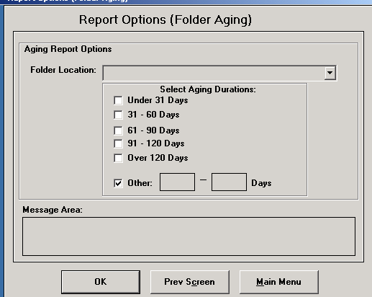

If a user enters alpha characters in this field, he or she will receive the following error message:
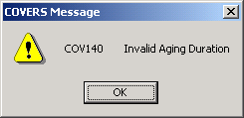

- Change to COVERS User Guide- RMC users (Station 376) have the option of printing the Permanent Transfer Report by “terminal digit” order or by “folder number”. The COVERS User's Guide page 8-28 states: “If you are an RMC user, the only Report Sequence option available to you is terminal digit”. This is incorrect. The online COVERS user’s guide has been amended to reflect that both options are available for RMC users.

- Prevent Permanent Transfer to AMC 397- COVERS has been changed to prevent permanent transfer to the Appeals Management Center (Station Location 397) and the Central Office (Station Location 101) and Board of Veterans Appeals (Station Location 101). Just a reminder: Station Location 101 is shared by Central Office and Board of Veterans Appeals. As a way to reduce the amount of misrouted folders, users must remember to state where the folder is going by annotating the “Route to” and the “Remarks” section on the transfer-out screen. For example, if the folder is going to the STAR review staff (101), the user should annotate “101/214B VA Central Office” in “Route To” and “National STAR Review” in the remarks section of the Transfer screen. If the folder is going to BVA (101), the user should annotate “Board of Veterans Appeals” in the “Route To” section and the reason for transfer in the remarks section of the Transfer screen. The Transfer Slip will contain the specified routing information. User should always print the Transfer Slip and attach it to the outside of the folder prior to transfer.

- Utilities Menu/Organization Codes Maintenance screen – On the “Organization Codes Maintenance” screen, the “Represented By” list box was not being loaded. COVERS has been fixed to show the service organization/power of attorney codes and descriptions. Note: This function will normally be performed by System Administrators and others with the authority to access the “Utility Menu”.

- Utilities Menu/Organization Codes Maintenance screen- On the “Organization Codes Maintenance” screen, users are now allowed to select a service organization/power of attorney and delete (clear) the “Represented By” field, if required. Note: This function will normally be performed by System Administrators and others with the authority to access the “Utility Menu”.

- Adding Volumes- Previously, upon adding the 50th volume in COVERS, users were receiving an error message. COVERS has been fixed to allow up to 99 claims folder volumes to added.

- Adding Volumes- COVERS has been changed to add a message box that will
stop process of adding volume when 99 volumes exist.

- Adding Volumes – In the prior version, users were receiving the error message “COVO51 Folder Not Found” when attempting to add a new volume after performing a single inquiry on the folder. This issue has been fixed.

- Single Inquiry/ Display Folder Data screen- In the previous version, if a claim folder volume was added in COVERS and a TEMP folder existed, the focus would set at the TEMP folder in the Current Folder Location grid. COVERS has been fixed to set the focus to the last claims folder volume added instead of the TEMP folder.

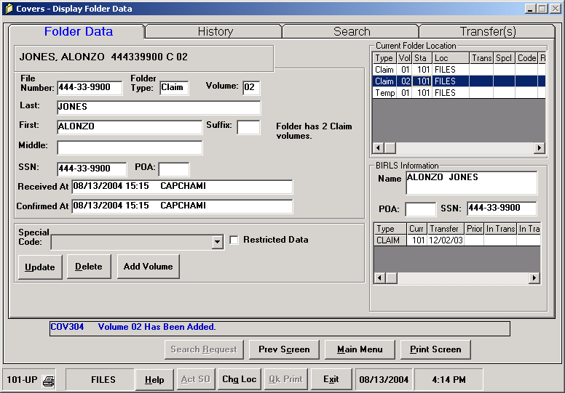

Just a Reminder: If both the TEMP folder and CLAIMS folder exist at the RO with permanent jurisdiction, the TEMP folder should be consolidated with the CLAIMS folder and deleted from COVERS.

- Scanning of NOD folders- In the prior version, users were unable to scan NOD barcode labels after generating the label in COVERS. COVERS has been fixed to allow for scanning of NOD barcode labels.

- Transfer Slips- COVERS has been fixed to display the correct VA file number format on the transfer slip. For example, In the prior version, an 8 digit file number was appearing as XX XX XXXX on the transfer slip. The correct format is XX XXX XXX.

- Temporary Transfer- In the prior version, users were allowed to select the generic location “999 OTHER OFFSITE TTO” for folders being transferred to a location not found in COVERS. The user would receive a pop up-box which asking for the name of the location. COVERS has been changed to allow the user to enter transfer information in the “Route To” and the “Remarks” fields on the Transfer Folder screen. The pop-up box will no longer be displayed.
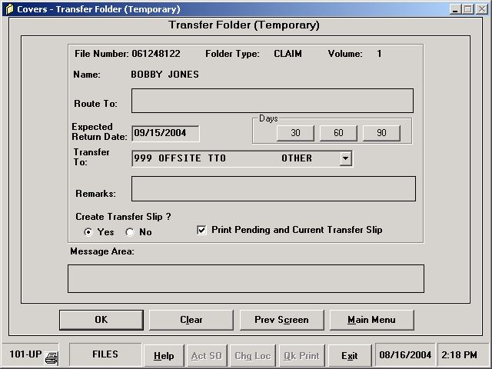

16. Transfer Slips/Surprise Receive – Previously, if a user at a “Surprise Receive” location generated a Transfer Slip, the Transfer Slip would print out at the originating office. COVERS has been fixed to generate the transfer slips at the “Surprise Receive” location. For example: If the originating location- 306 New York sends the claims folder to 313 Baltimore in COVERS but 372 Washington DC actually receives the claims folder, this event is a “Surprise Receive”. somehow 37(Location send a folder to The “Surprise Receive” location is a location which means that the folder was not sent to that location in COVERS), the Transfer Slip would generate at the originating office instead of the “Surprise Receive” location. COVERS has been fixed to generate the transfer slips at the “Surprise Receive” location.

17. Display Folder Data Screen/Quick Print – Previously, the Display Folder Data screen would appear after the user performed a Single Folder Inquiry. If the user then clicked the “Qk Print” button to print the barcode label, the focus would be set back to Qk print. COVERS has been changed to set the focus to the Prev Screen button. The Previous Screen button returns the user back to the Single Inquiry screen.

18. Transfer Out/Enter Folder Identification (Transfer Folder) screen – Previously, even if the last transfer action was a “temporary” transfer, the focus was being set back to the “Permanent” transfer type. COVERS has been fixed to reset the focus to either “Permanent” or “Temporary” depending on the last transfer action.
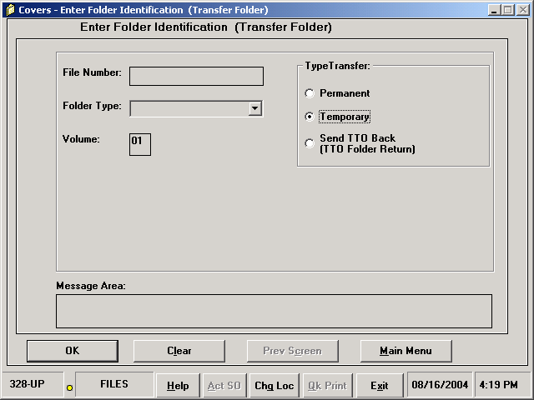

19. In-Transit/Received At and Confirmed At fields on the Single Inquiry screen- Previously when a user performed a single inquiry, the “Received At” and “Confirmed At” fields were blank if the folder was In-Transit; and only the User ID would show up if the user clicked another folder then returned to the original folder. COVERS has been fixed to display both the “Received At” and “Confirmed At” time stamps, as well as the User ID when the folder is In-Transit.

20. Generate Labels- COVERS has been changed to remove the “Comments” text box from the Generate Labels screen. The “Comment” text box will remain on the “Mark for Mail” and the “Request Folder” screens.

21. Single Inquiry/Search Request – COVERS has been changed to set a better focus on the ADD REQUEST button after the user selects the Search Request button from the Single Inquiry –Display Folder Data screen. An illustration of this change is shown below:

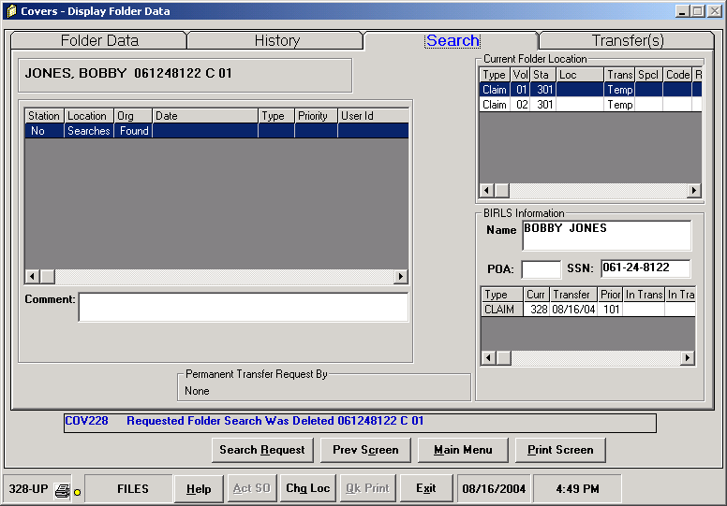
1. From the Display Folder Data screen, click the Search Request button.

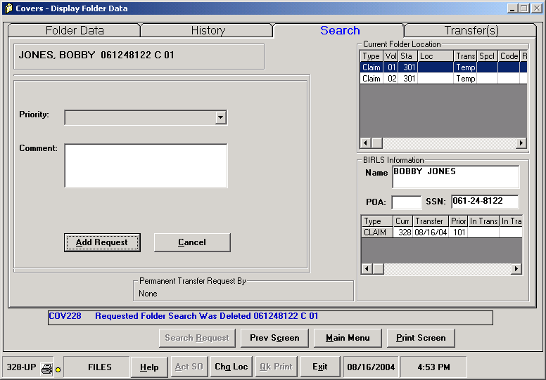
2. Click the Add Request button.

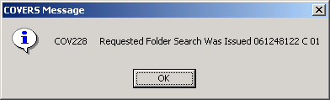
3. To commit the action, either hit the enter key or click OK to the message.

22. Better Warning Message for Deleting Searches in Bulk- COVERS has been changed to give a better warning message when a user is about to delete all of the stations’ searches. The message box has been changed to read "COV416 WARNING!!!! ALL SEARCHES WILL BE DELETED BECAUSE YOU DID NOT CHANGE THE DEFAULT CRITERIA. Do You Want To Continue?"

23. Utilities/Location Codes Table- COVERS has been changed to prevent users from adding an internal location without a description. Prior to this change, there would be errors in the Refresh function and the “Folder Aging by Location Report” would be insufficient because it did not display all folder locations. Note: Adding an internal location in COVERS is performed by the System Administrator and someone with the authority to access the “Utility Menu”.

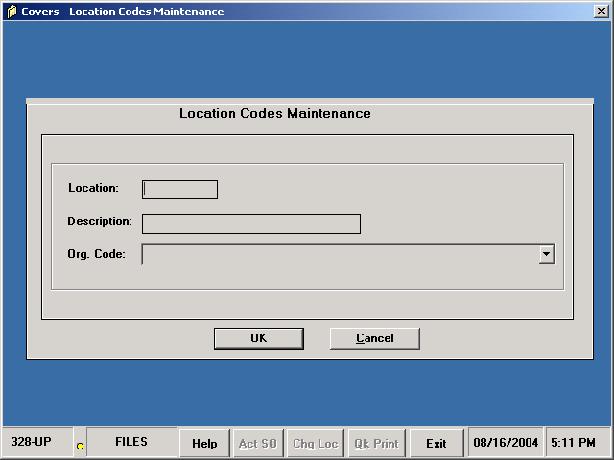

24. Single Inquiry- Previously, users would receive an application error message when performing an inquiry on a folder which had over 20 search requests. COVERS will not longer display an error message in this instance.

25. Search Request/Comment Box- Previously, if text was entered in the Comments box on the Search Request screen, the text would remain in the comments box after the user clicked OK to add the search request. COVERS has been changed to clear the comments box after the user clicks OK.

26. Single Inquiry/Display Folder Data screen – COVERS has been fixed to default to the Folder Data tab if there are no search requests. See below.

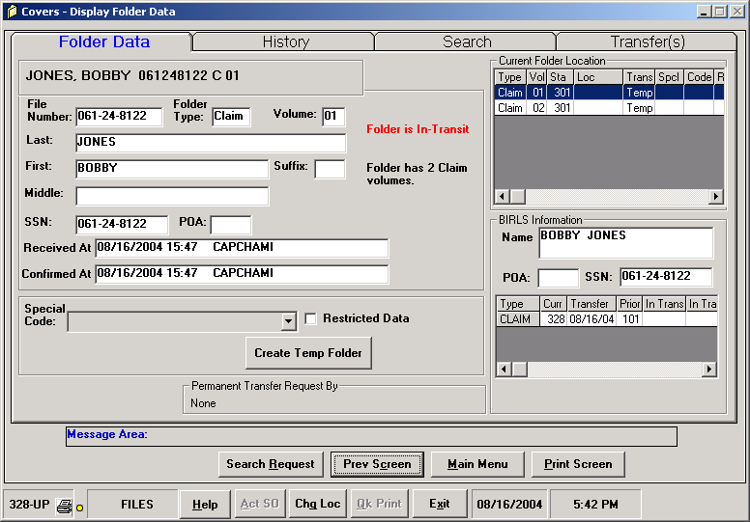

Note: If there are search requests, COVERS will default to the Search tab as shown:

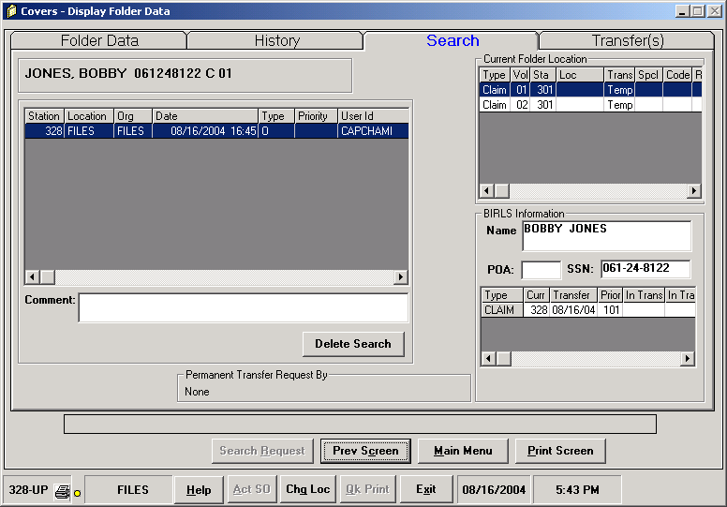

COVERS Sequence Check
Release Notes
Application Version 5.3

COVERS Sequence Check Version 5.3 will be released to the field on
September 7, 2004. It will include the following defect modifications:

CSUM Access

To run this utility, a user must be given COVERS access in CSUM. No specific COVERS functions are required.

Defect Modifications-

The following changes have been made to show consistency in the appearance and operation of “Sequence Check” as compared to “COVERS”:

- The banner at the bottom of the “Sequence Check” screen is now consistent with banner in “COVERS”.

- Change locations in “COVERS” and “Sequence Check” did not match. “Sequence Check” has been changed to match location found in “COVERS”.

- On the update “COVERS” screen the “Change Loc” button will now show
“Chg Loc” as shown in “COVERS”.

Other Modifications:

- The “Help – About COVERS Sequence Check” button now contains correct version release 5.3.

- In previous version, users received an error message “COV 368-
Unexpected Visual Basic Error” when trying to enter the file number. This issue has been corrected.

- Default location has been changed to “LAN”.

- The “folder type” and “volume” fields on the Update COVERS screen have been changed to a smaller and more appropriate size.

- Previously, users were receiving “COV097 Tux Error” message when switching from LAN to Stand Alone back to LAN. This issue has been resolved.

- Fields have been added to allow the user to easily enter the folder’s type and volume number by hand if necessary.

M21-1 and M21-1MR Revisions
since July 22, 2004

M21-1, Part II, Change 56, Chapter 1. Paragraph 1.08 is revised to remove references to CAPS and replace the words “CAPS claim suspended reports” with “Pending Detail reports under Inventory Management System (IMS) Detail Reports.”

Paragraph 1.09a(1) is revised to delete education forms as examples of priority mail at Veterans Service Centers, to reflect that claims by former prisoners of war and survivors of former prisoners of war are considered priority mail, and to show a reference to Part III, paragraph 2.14e.

M21-1, Part III, Change 123, Chapter 2. Paragraph 2.14e is added to provide instructions on expediting claims by survivors of former prisoners of war (POWs). Addendum A is added as a sample of a claims folder flash to be used in connection with claims from survivors of former POWs.

M21-1, Part IV, Change 199, Chapter 8. Paragraph 8.34 is revised to reflect that a claimant's representative has the authority to withdraw a notice of disagreement or substantive appeal. The reference to 38 CFR 20.204(c) is changed to 38 CFR 20.204.

Paragraph 8.36b is removed because, although legal advice from the Regional Counsel or General Counsel may provide a basis for a decision on a claim, only a regional office is authorized to render the decision. Former paragraphs 8.36c through k are redesignated as paragraphs 8.36b through j.

The note in paragraph 8.37a(1) is revised to reflect that the worksheet displayed in Exhibit B is the approved certification worksheet that must be completed prior to certification of any appeal to the Board of Veterans' Appeals.

Paragraph 8.37a(2) is revised to clarify the use of the VA Form 8 retained in the Veterans Service Center and to include a reference to paragraph 8.40a.

M21-1, Part IV, Change 200, Chapter 32. Paragraph 32.15 is amended to show (314) 552-9817 as the current fax number for the REPS Processing Unit at the St. Louis Regional Office.

Paragraph 32.18 is amended to show (314) 552-9803 as the current telephone number for VA personnel and beneficiaries to use when inquiring about REPS benefits.

M21-1, Part IV, Change 201, Chapter 12 and 20. Paragraph 12.04e. is added to provide directions for verifying the validity of common law marriages outside the United States. Subsequent paragraphs in 12.04 have been renumbered.

Paragraph 12.04f: In the paragraph heading, and in 12.04f.(2)(a), "state" is replaced by "jurisdiction."

Paragraph 12.14f(2) is revised to add, after the last sentence, "Special law code 24 is to be used when eligibility to DIC is reinstated." This language was omitted by Change 157, but the requirement remains in effect.

"Adjudication Officer," "Section Chief," and "Adjudicator" are replaced by "Veterans Service Center Manager (VSCM)", "Coach," and "Veterans Service Representative (VSR)" where necessary.

Paragraph 20.17d is amended to remove a statement that VA Form 21-8951 requires the signature of the unit commander or designee. The change makes this paragraph consistent with paragraph 20.19 which requires the unit commander's signature only if the veteran reports fewer training days than the number shown on the form.

M21-1, Part IV, Change 202, Chapter 1. A note is added to paragraph 1.14a to reflect that claims by survivors of ex-prisoners of war must receive expedited processing.

