ADC 206-
Musculoskeletal disabilities
STUDENT GUIDE

PREREQUISITE TRAINING | Prior to this training, the trainees should have demonstrated proficiency in basic development skills or should have completed the VSR Curriculum Training for the Pre-Determination Team at http://cptraining.vba.va.gov/C&P_Training/vsr/VSR_curriculum.htm.  Trainees should also have completed all 100 level course materials and the following 200 level courses:  - ADC 200—Claims for Increase  - ADC 201—Direct Service Connection/Aggravation  - ADC 202—Secondary Conditoins  - ADC 203—Reopened Conditions  - ADC 204—Presumptive Conditions  - ADC 205—Diabetes Mellitus
PURPOSE OF LESSON | The purpose of this lesson is to teach trainees the principles of developing claims for musculoskeletal disabilities as they relate to VA’s duty to assist requirements mandated under the Veterans Claims Assistance Act of 2000. The module will teach the trainee  - How to identify and develop claims for amputation of an extremity  - How to identify and develop claims to obtain information regarding functional loss of a joint  - How to identify and develop claims for different types of arthritis  - How to review examinations for rating adequacy  - How to determine if a claim is ready for a decision
Time Required | 2.5 hours
Instructional Method | Lecture, participatory discussion, practical exercise, and shared feedback. The lesson is divided into two parts.
Materials/ Training Aids | - Note pad and writing utensil  - Access to reference material  - Advanced Development Curriculum Student Handbook and Student Guide

What are musculoskeletal disabilities?

Disability of the musculoskeletal system is primarily the inability, due to damage or infection in parts of the system, to perform the normal working movements of the body with normal excursion, strength, speed, coordination and endurance.

What are the different types of musculoskeletal disabilities?

There are 2 basic types of musculoskeletal disabilities:

- Anatomical loss, otherwise known as amputation
- Functional loss

Anatomical Loss:
May be the result of a traumatic injury, such as a crush injury or a mine or improvised explosive device (IED).
May also be due to a disease process, such as peripheral vascular disease.

Functional Loss:
Makes up the majority of musculoskeletal disabilities.
Mostly affect joints, which include the spine.
May be due to trauma or disease
Describes the degree to which a joint is damaged, causing the joint to be unable to perform its normal working movement.

What rating considerations do I need to know for anatomical loss cases?

The Rating Schedule evaluates anatomical losses as progressively more disabling as a greater part of the body is missing. Prosthetics may restore the ability to walk for a below-the-knee amputation, but there may not be a suitable prosthetic for other losses. In general, when there is a greater loss of body, the evaluation is correspondingly greater.

Whenever there is a service-connected anatomical loss, SMC is an issue.

In order to rate the case, the evidence must show the level of the amputation. This is usually expressed as a distance in inches or centimeters from a bony landmark or joint. If there is surgery to revise a previously service-connected amputation, refer immediately to the RVSR, as a temporary total evaluation should be considered.

If a VA examination doesn’t clearly indicate the level of amputation, it is insufficient for rating purposes. The examiner should also address additional disability due to the amputation, such as nerve or muscle problems. If the exam addresses only the amputation, it may be adequate; refer the claim to the RVSR for consideration.

Anatomical Loss Review Questions:

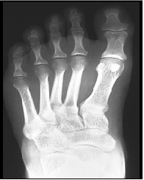

- Look at the diagnostic codes 5163, 5164, and 5165 for leg amputations. What physical findings are required for a 60 percent evaluation instead of a 40 percent evaluation?

- What is the difference between the 60, 80, and 90 percent evaluations under diagnostic codes 5162, 5161, and 5160?

What rating considerations do I need to know for functional loss cases?

Musculoskeletal disabilities are generally evaluated based on functional loss. Functional loss may be caused by trauma or disease of a joint. To evaluate the functional loss the following factors are considered:

- Less movement than normal
- More movement than normal
- Weakened movement
- Excess fatigability
- Incoordination or impaired ability to execute skilled movements smoothly
- Pain on movement
- Swelling
- Deformity
- Atrophy of disuse
- Instability of station
- Disturbance of locomotion, or
- Interference with sitting, standing and weight-bearing

Because of the specific information needed for rating purposes, VA exams are almost always necessary for musculoskeletal disabilities. Private medical evidence will rarely be sufficient for rating purposes for evaluating functional loss, because treating physicians rarely have a need to document actual range of motion and may not provide any details regarding additional limitation.

DeLuca Considerations

The requirements imposed by the Court of Appeals for Veterans’ Claims’ (CAVC) DeLuca decision have been incorporated into the Joints Examination Worksheet and the Rating Schedule, so your concern will only be to make sure that the examiner complied with these requirements.

There are two major points to look for:

- Did the examiner provide the actual range of motion, which is measured using an instrument called a goniometer?

- Did the examiner comment on additional limitation of motion due to:
- Pain
- Fatigue
- Weakness
- Lack of endurance
- Incoordination

If the examiner cannot determine any additional functional loss, they would need to so state. For example: “I cannot determine any additional limitation due to repetitive motion without resorting to speculation.” If either actual range of motion or additional limitation of motion is not addressed, the exam is technically inadequate for rating purposes. You should follow local policy and attempt to obtain clarification prior to returning it to the hospital as inadequate.

Types of Arthritis

A veteran may claim service connection for arthritis of a joint, with the assertion that the arthritis “spread” to another joint.

Traumatic arthritis is the most common forms of arthritis. They are joint-specific disabilities, meaning that they do not “spread” to other joints. This is generally evaluated under diagnostic code 5010 in the Rating Schedule. If the veteran is service connected for degenerative arthritis or traumatic arthritis for one joint and claims service connection for arthritis of another joint we would need a medical opinion relating the two in order to grant service connection.

Degenerative arthritis (also diagnosed as osteoarthritis or hypertrophic arthritis) is a type of arthritis marked by progressive cartilage deterioration in synovial joints and vertebrae. This is generally evaluated under diagnostic code 5003 in the Rating Schedule. Once degenerative arthritis has been clinically diagnosed, we should evaluate each joint as it becomes affected, with X-rays used to establish involvement of individual joints. If it has been medically established that the veteran has degenerative arthritis, and not traumatic arthritis, there is no need for a medical opinion to service connect each affected joint.

Rheumatic arthritis is a systemic disease process that will “spread” to other joints. So if the veteran has it in one joint it will manifest itself in other joints, which would have to be service connected.

Case Scenario: Knee Pain

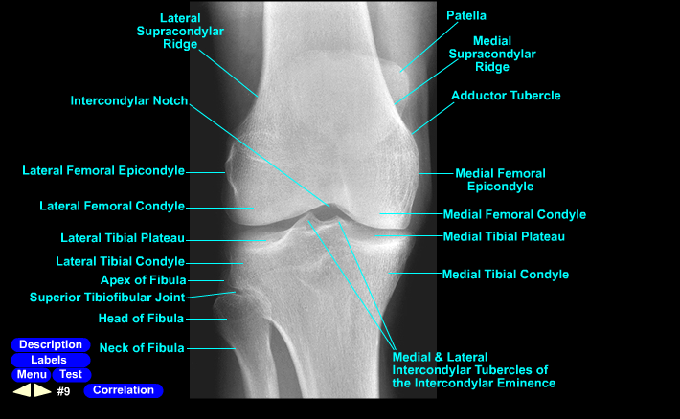

The veteran enlisted on 9-16-64 and was released on 9-15-70. His entrance examination is silent for any pre-existing condition, and his separation exam noted no defects or chronic disease. During service, he visited the clinic on 3-20-67, complaining of knee pain. The doctor’s physical exam notes tenderness over the patellar tendon and hamstrings, right worse than left. No x-rays were ordered. Rest, ice, compression and elevation were ordered, and an oral anti-inflammatory was given. He again visited the clinic on 3-27-67; improvement was noted, and the doctor recommended four weeks of physical therapy and gradual increase in activity, as tolerated. There is no record of physical therapy, and the remainder of the medical record is silent for any further treatment for knee pain.

Treatment notes from the veteran’s primary care physician have been received and show treatment from 6-22-02 to 11-19-04. The first treatment record shows complaint of knee pain. The physical exam indicated swelling and redness over the knee bilaterally. X-rays were done, and the radiologist noted possible early arthritis affecting the lateral femoral epicondyles bilaterally. Subsequently, the veteran reported use of chondroitin and glucosamine supplements and underwent Synvisc injections beginning on November 2004.

The veteran filed a claim for bilateral knee arthritis on June 22, 2005. He enclosed a written statement indicating that his knees have hurt ever since he ran a 10-K race on St. Patrick’s Day in 1967.

To Order or Not to Order: VA examination for in-service knee pain? Why?

Answer: Order the exam and ask the doctor’s opinion. There is no evidence of a chronic condition or disease in service; however, there is evidence of symptom of a 3.309 disease (painful motion is a symptom of arthritis) and an event or injury has been identified in his written statement (St. Patrick’s Day was Friday 3-17-67 and he went to the clinic the following Monday). There is a current diagnosis of arthritis. The fact in question is not a legal issue, but a medical one: are the 1967 findings representative of early arthritis as alleged?

Alternative scenario 1: Same scenario, except there is no current medical evidence of a disease. What do you do?

Order the exam and ask the doctor’s opinion. The vet cannot diagnose arthritis (a disease process); however, the regulation only requires competent lay evidence of a diagnosis, and he reported painful knees since St. Patrick’s Day 1967.

Alternative scenario 2: The vet provided no statement to support his claim or reply to our VCAA letter and no private treatment records. What do you do?

Refer the claim to the Rating Board. The vet has not meet his responsibility to provide competent lay or medical evidence; he is not competent to diagnose arthritis and there is no corroborating medical evidence or lay statement relating symptoms relative to the in-service event.

Alternative scenario 3: There is no mention of any knee condition in service. Vet’s private medical evidence indicates a diagnosis of disease and his statement links the current disease to pain following the 3-17-67 St. Patrick’s Day 10-K. Now what do you do?

REFERENCES

- 38 CFR 4.40
- 38 CFR 4.45
- 38 CFR 3.159
- 38 CFR 3.303(b)
- 38 CFR 4.71a-11
- Joints Exam Worksheet (http://vbaw.vba.va.gov/bl/21/rating/Medical/exams/disexm34.htm)
- M21-1MR III.iv.4.A

