Compensation Service Pre-Discharge Staff host this call to announce updates, address issues and field questions related to Pre-Discharge Programs (BDD/IDES). All Military Services Coordinators (MSCs), Disability Rating Activity Sites (DRAS), Regional Offices and other VA personnel supporting Pre-Discharge Programs are invited to participate.

This Read-Ahead (R/A) is provided to facilitate discussion during the Conference Call.

Call Notes from the June 2024 Call (there was no July Call) are in Appendix 1. The TMS # for this month’s call will be provided during the call and a Calendar Blast will notify the field when the TMS # is active.

**Call-in Information (New beginning Feb 2024)**

Microsoft Teams meeting

[Click here to join the meeting](https://teams.microsoft.com/l/meetup-join/19%3ameeting_N2I0Y2MxMmItZjI3Ni00NmFkLWFjOTMtMWM1YmUzNzQwYWE5%40thread.v2/0?context=%7b%22Tid%22%3a%22e95f1b23-abaf-45ee-821d-b7ab251ab3bf%22%2c%22Oid%22%3a%22a0338b5c-0526-4e13-9809-5d0ecc8cdeb8%22%7d)

Meeting ID: 228 636 845 446   
Passcode: oJhBDy

**Or call in (audio only)**

[+1 872-701-0185,,205533754#](tel:+18727010185,,205533754# )

Phone Conference ID: 205 533 754#

Remember to mute your microphone and turn off your camera.

To ask a question after the call begins, please raise your hand (click the hand icon) or type it in the Teams Chat—**do not unmute to ask a question, comment, or respond to questions until called upon**. Once your question/comment is addressed, lower your hand (click the hand icon again). Scenario/Case Specific questions will not be answered on the call. Send an email with details to the appropriate staff email box. Ask questions about the topic(s) being discussed, all other questions should be asked during Open Floor.

Please sign-up for the [Calendar Subscriptions (va.gov)](https://gcc02.safelinks.protection.outlook.com/?url=http%3A%2F%2Fvbacoweba5.vba.va.gov%2Fbl%2F21%2FCalendar%2Fcal_Subscribe.asp&data=05%7C01%7C%7C21879ad3ed524078df7108dbb3930978%7Ce95f1b23abaf45ee821db7ab251ab3bf%7C0%7C0%7C638301216315397959%7CUnknown%7CTWFpbGZsb3d8eyJWIjoiMC4wLjAwMDAiLCJQIjoiV2luMzIiLCJBTiI6Ik1haWwiLCJXVCI6Mn0%3D%7C3000%7C%7C%7C&sdata=IblMTyApGDJdc7op5Ca6KMk320%2FdtSPPk7tkR9h7IvM%3D&reserved=0) to receive notification that monthly R/A’s are available, TMS numbers are active and other VA info that might be relevant/important to you.

General Topics for Discussion

**Call Rules and Expectations**

1. The Pre-Discharge Staff is committed to ensure MSCs and other field personnel have accurate and up-to-date information regarding BDD and IDES policy and procedures.
2. The call is being recording and transcribed for training purposes and will be posted in TMS.
3. You are expected to conduct yourself in a professional courteous manner to include refraining from inappropriate language and comments.
4. Pre-approval by our staff is required before anyone provides guidance/updates/other info that is related to BDD or IDES.
5. Do not forward the invite or Read Ahead to or invite non-VA employees.

**The 2023 BDD/IDES Call Chat**

As a reminder, the call chat is open to MSCs and other BDD/IDES stakeholders for Q & A and advice on VA and/or BDD/IDES policy and procedures from your fellow MSCs/stakeholders. The Pre-Discharge Staff will not answer an inquiry in the chat in most cases. If assistance is needed from the Pre-Discharge Staff, email the [IDES Mailbox](mailto:VAVBAWAS/CO/IDES%20%3cIDES.VBACO@VA.GOV%3e) or [BDD Mailbox](mailto:VAVBAWAS/CO/PREDISCHARGE%20%3cPredischarge.VBACO@va.gov%3e).

Note: Be professional, respectful, and avoid personal comments and complaints

**DD214s with no SS# (only Electronic Data Interchange Personal Identifier (EDIPI)**

The Air Force and Marine Corps are issuing DD214s that only show the EDIPI (also known as the DoD ID). An enhancement to add EDIPI as a search option in VBMS is being worked with a projected date of early FY25. In the meantime, to find the SS# from an EDIPI, search VTA (IDES cases) or Veterans Information Solution (VIS) see below. You can also search VBMS by Name and DoB.

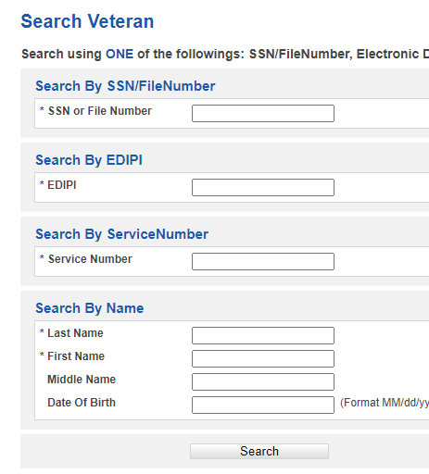

The Joint Longitudinal View (JLV) can also be used as an EDIPI lookup tool to obtain the Veteran’s SSN/File number. While alternate advance search methods exist through SHARE and VBMS-Core, JLV will accurately capture all data and check against the DD Form 214. Alternate Search Method: JLV > Patient Search > DoD ID

**Correspondence Uploads to VBMS**

VBMS users should follow the guidance below when uploading correspondence to an eFolder.

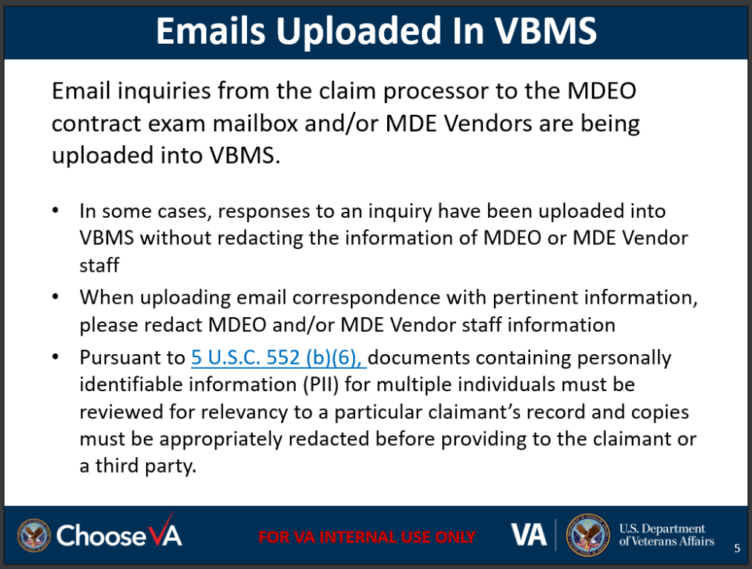

**Index of DBQ/Exams by Disability (Updated)**

A Calendar Blast was sent on June 26 regarding the DBQ Index. The info and link are cited below.

|  |
| --- |
| **Wednesday, June 26, 2024**  The [Index of DBQ/Exams by Disability](https://gcc02.safelinks.protection.outlook.com/?url=http%3A%2F%2Fvbacoweba5.vba.va.gov%2Fbl%2F21%2FDBQ%2FDBQByDisab.asp&data=05%7C02%7C%7Ceb346de856a94fb31f1a08dc960bf68d%7Ce95f1b23abaf45ee821db7ab251ab3bf%7C0%7C0%7C638550225328582773%7CUnknown%7CTWFpbGZsb3d8eyJWIjoiMC4wLjAwMDAiLCJQIjoiV2luMzIiLCJBTiI6Ik1haWwiLCJXVCI6Mn0%3D%7C0%7C%7C%7C&sdata=JdqFI2zlW4AUVfYPhypfGaGK9cO8VpJ75zb1XyxT71Y%3D&reserved=0), also known as the DBQ Index, has been updated to include relevant hyperlinks to the eCFR. For assistance with this resource please contact the [MDEO Web Team](mailto:VBAVACOMDEOWebTeam@va.gov?subject=Index%20of%20DBQ/Exams%20by%20Disability). |

Click the link and enter your search criteria. Your results will display (example Diabetes).

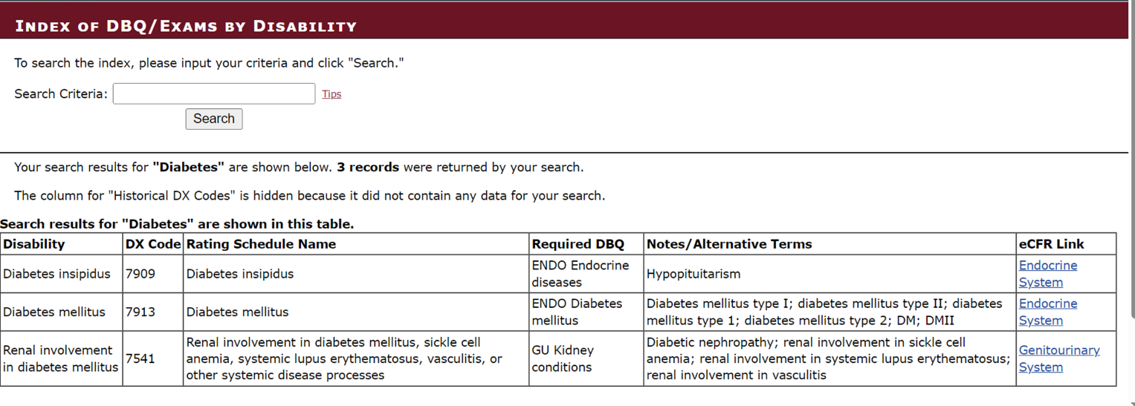

BDD Topics for Discussion

SHA Part A Mislabeled as VA Examination

A review of pending EP 336s revealed instances where the Separation Health Assessment (SHA) Part A has been mislabeled as “VA Examination” for claims sent through the SMS Portal. Pre-Discharge Staff have reached out to Customer Relationship Management (CRM), and they confirmed a technology limitation requiring an update has since resolved the issue. MSCs should review all documents and correct the “Document Type” to “DBQ – Separation Health Assessment (SHA) – Part A” when this issue is discovered.

*Examples:*

*Incorrect:*

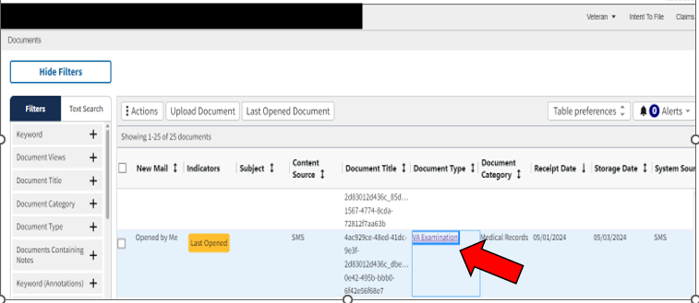

*Correct:*



**Reminder to Change EP 336 to Rating EP**

MSCs are reminded to change the EP 336 to a rating EP once the exams are requested in accordance with [M21-1, X.i.6.B.2.d.](https://vaww.vrm.km.va.gov/system/templates/selfservice/va_kanew/help/agent/locale/en-US/portal/554400000001034/content/554400000177950/M21-1-Part-X-Subpart-i-Chapter-6-Section-B-Benefits-Delivery-at-Discharge-BDD-and-Initial-Processing?query=M21-X.i.6.B.2.d.) Failure to change the EP will prevent the claim from recalling to NWQ and may delay the SM’s claim.

IDES Topics for Discussion

**HAIMS vs SAFE**

MSCs are reminded that HAIMS is the official and first system to be used for the transfer of IDES documents. The use of HAIMS is not a choice. If HAIMS transfer fails, the use of SAFE is then ok, however, PEBLOs and MSCs should see “HAIMS to VBMS STRs/DBQs Transfer Training Slides” located under ‘What’s New” on the [IDES Homepage](https://vbaw.vba.va.gov/vbadod/IDES.asp). The slides provide info on how to report an issue. If issues are not reported, issues can’t be fixed. MSCs will email the [IDES Mailbox](mailto:VAVBAWAS/CO/IDES%20%3cIDES.VBACO@VA.GOV%3e) with the VTA case # and details when a HAIMS transfer fails/has issues.

**Clarity/Specificity on Extremities**

The DRAS’ has asked us to remind MSCs to clarify any issue that affects extremities if the impacted extremities are not specified. This is most important for referred conditions on the 21-0819 received from the PEBLO, but also includes any conditions listed on the 21-526. Some examples are radiculopathy, peripheral neuropathy, knee condition, shoulder pain, carpal tunnel, bunions, etc. This clarification can be documented in an 0820 or 4138, a new claim form is not necessary.

**Transfer from Intake Site Special Issue**

Per [M21, X.i.6.F.3.d.](https://vaww.vrm.km.va.gov/system/templates/selfservice/va_kanew/help/agent/locale/en-US/portal/554400000001034/content/554400000177955/M21-1-Part-X-Subpart-i-Chapter-6-Section-F-Integrated-Disability-Evaluation-System-IDES-Development-and-Examinations) (Actions MSCs Must Take Once All Examination Reports Are Deemed Complete) MSCs will apply

the Transfer from Intake Site Special Issue to the first contention listed under the EP 689.

Applying this special issue will transfer the claim to DRAS via automated NWQ routing.

Some MSCs are using the “IDES Transfer to DRAS” Special Issue, which is incorrect. We are working to get it removed.

**Exit Interviews**

MSCs are reminded you are required to offer the SM an Exit, conduct the Exit if SM requests one and update VTA accordingly. If the case is disenrolled prior to VTA inputs, a note will be added to the VBMS eFolder.

Notes:

* The below email is now being sent to the SM after the Final Disposition Date is entered in VTA.

Please Do Not reply to this Message—

Prior to exiting IDES, your MSC will contact you to offer an IDES Exit Interview. Be on the lookout for an email or a telephone call from your MSC or contact your MSC if you do not receive an email/phone call. This interview is highly valuable regardless of whether you are medically or administratively separating, or returning to duty as you will be given information on next steps in regard to your VA disability claim. We encourage you to accept your MSC’s offer and promptly coordinate with your MSC to schedule the IDES Exit Interview, either in-person or by telephone.

MSC email: the MSC's email address

MSC telephone #: the MSC's telephone #

* As of 8/12/24 there were 461 cases pending an Exit Interview over the 14-day goal

**Who to Email with IDES Questions**

It has come to our attention that many MSCs are emailing the DRAS boxes with non-DRAS questions. If your question does not deal with something that is DRAS specific (ratings, are exams good, etc.) the question should be sent to the [IDES Mailbox](mailto:VAVBAWAS/CO/IDES%20%3cIDES.VBACO@VA.GOV%3e) after checking with your fellow MSCs or Coach. Pre-Discharge Staff, not the DRAS’, is the lead on IDES and VTA policy and procedures.

In-Person vs Tele-Health Exams

There have been some recent discussions regarding In-Person vs Tele-Health Exams. Tele-Health Exams are authorized for certain conditions, and it is the vendors decision (based on examiner availability, timeliness and other factors) on which type of exam to schedule. If the vendor schedules a Tele-Health Exam (that is authorized per the condition) even though an In-Person was originally requested, MSCs will not cancel and submit a new request for an In-Person Exam per a request from the SM. Contact the [IDES Mailbox](mailto:VAVBAWAS/CO/IDES%20%3cIDES.VBACO@VA.GOV%3e) as needed.

Providing Exam Info to PEBLOs

Per [M21-1, X.i.6.F.1.e.](https://vaww.vrm.km.va.gov/system/templates/selfservice/va_kanew/help/agent/locale/en-US/portal/554400000001034/content/554400000177955/M21-1-Part-X-Subpart-i-Chapter-6-Section-F-Integrated-Disability-Evaluation-System-IDES-Development-and-Examinations) (Handling Evidence Submitted by Participants) MSCs will provide the following after ordering needed examinations:

* copy of the completed VA Form 21-526EZ (or notice that the participant declined to submit a VA claim, if applicable), and
* a list of examinations requested

PEBLOs/MTFs/Commanders can get exam appts/dates/times from the SM. SMs have access to the appt info thru the vendors portal and they also receive the info via phone, email and/or mail (USPS or FedEx/UPS/other).

Note: We are receiving an increase in emails from the Services about MSCs not providing the 526, this action must happen. For those struggling to provide in a timely manner, get in the habit of sending the 526 right after you complete your exam entries in VTA.

Veterans Tracking Application (VTA)

Number of Claimed Conditions Data Field

MSCs are reminded of the definition of this field - “If the participant submitted a VA claim, enter the total number of conditions claimed for VA purposes (to include those referred by the Service); if the participant declined to file a VA claim, enter 0”. We continue to see cases with claimed conditions greater than or equal to one (1) and SM did not file a claim.

Notes:

* If the case only has a referred condition(s) (no claimed conditions), the data field will be zero (0)
* Until a 526 is received with claimed conditions, the data field will be zero (0)
* When a 526 is received, the data field can then be updated
* If you receive the 526 after ordering exams for the referred conditions, and exams will not be ordered for claimed conditions, the data field will be zero (0).
* If exams will be ordered for claimed conditions, update the data field accordingly.

Screen shot shows in-correct VTA entries. The five (5) should be a zero (0) if SM Declined to File.

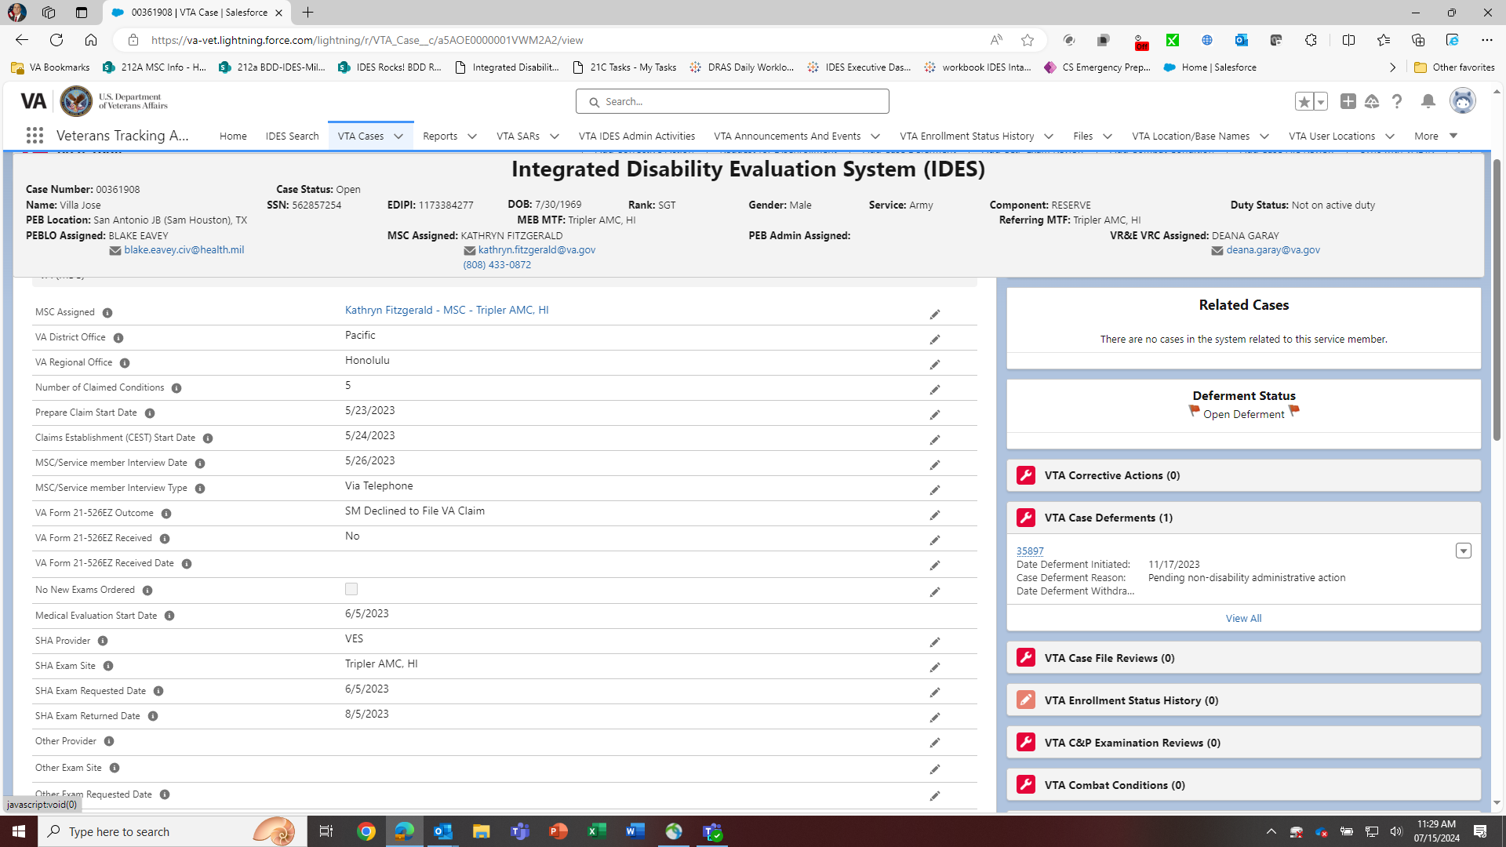



MSC Assigned Data Field

MSCs should select their name that corresponds with the case MEB MTF, even though it may not be where the MSC is located. An MSCs name should be associated with every MEB MTF they are assigned.

Screen shot shows options for Reese. If the location you are searching for does not initially display, click

“Show more results for …” and more options will display.

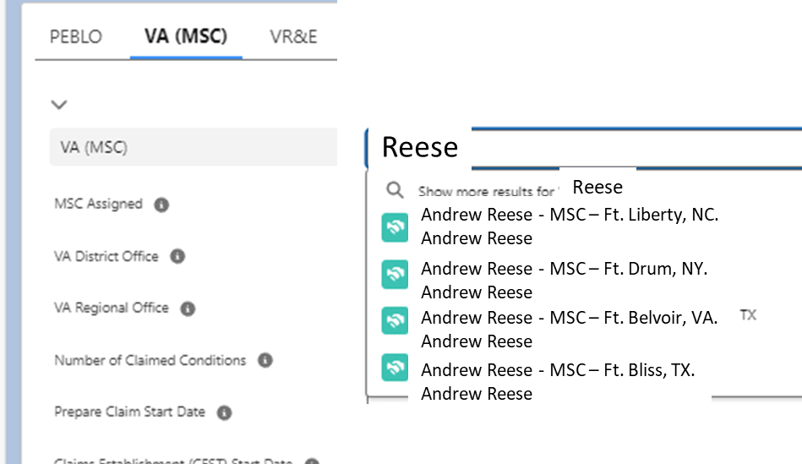

If you are assigned to an MTF and your name/MTF does not display, email [vrst@vba.va.gov](mailto:vrst@vba.va.gov).

Upcoming Conference Calls

The next BDD/IDES Call is scheduled for **Tuesday, September 10**, at 2PM ET. Please submit IDES questions and proposed topics for discussion to the [IDES Mailbox](mailto:VAVBAWAS/CO/IDES%20%3cIDES.VBACO@VA.GOV%3e), and BDD questions and proposed topics for discussion to the [BDD Mailbox](mailto:VAVBAWAS/CO/PREDISCHARGE%20%3cPredischarge.VBACO@va.gov%3e) no later than close of business (COB), Monday August 26.

Open Floor

**Appendix 1: Call Notes from the June 2024 BDD/IDES Conference Call**

**Question:** If a SM claims hearing loss and tinnitus on the 21-526EZ, should they be listed separately?

**Answer:** Hearing Loss and Tinnitus are separate issues and should be listed separately. MSCs are encouraged to assist the SM with filling out the 21-526 EZ. SMs should be advised that hearing loss and tinnitus should be listed separately since they are rated separately.

**Question:** If an exam takes a month to be received even though the tracked item is closed (specifically to LHI), will I receive an error for not releasing to the PEBLO. Typically, we are waiting on the last exam addendum or notes from the provider.

**Answer:** Please refer to the [EMS Troubleshooting Guide](https://vbaw.vba.va.gov/bl/21/MDEO/dao_EMS_toolkit.htm). In addition, you should put in a help ticket and add a note about the issue, to include the help ticket #. Exams should not be released to PEBLO (entry of Medical Evaluation End Date) until all exams and associated documents are reviewed and available.

**Question:** We are seeing an influx of BDD Claims received by VSRs that meet all the requirements of BDD claim and no exams are being scheduled and the VSRs are adding secondary tracked items requesting STRs and the 214.

**Answer:** Please send all claims of this nature to the BDD Mailbox.

**Question:** When a SM does not have paper records and only has Genesis records are present, some contract vendors are kicking the exams back and requesting an aggravation exam. Is there any guidance for this?

**Answer:** If these documents are available and the MSC needs to draw attention to them, he/she can either break them out and upload separately or draw the vendors attention to the document in the ESR indicating where the document can be found.