Monthly Compensation Service Pre-Discharge Programs

(BDD and IDES--212A)

Conference Call Read Ahead

January 11, 2022, 2PM ET

The Compensation Service BDD/IDES hosts this call to announce updates and address issues and questions related to the BDD/IDES Programs. All Military Services Coordinators (MSCs), Disability Rating Activity Sites (DRAS), Regional Offices and other VA personnel supporting BDD/IDES are invited to participate.

This Read-Ahead (R/A) is provided to facilitate discussion during the conference call.

The Call Notes for the November 2021 Call are located in Appendix 1. The TMS # for this month’s call will be provided during the call and will be active within a week of the call’s completion. A Calendar Blast will notify the field when the TMS # is active.

**Call-in Information**

Microsoft Teams meeting

[Click here to join the meeting](https://teams.microsoft.com/l/meetup-join/19%3ameeting_MGQ3YzU1N2EtMWJiOC00NzA4LWJmYmYtYTc3ZjhlYjFmNWY5%40thread.v2/0?context=%7b%22Tid%22%3a%22e95f1b23-abaf-45ee-821d-b7ab251ab3bf%22%2c%22Oid%22%3a%22a0338b5c-0526-4e13-9809-5d0ecc8cdeb8%22%7d)

[+1 872-701-0185: 63193284#](tel:+18727010185,,63193284# )

The R/A and slides will be attached to the Chat (you may have to scroll up in the Chat) and can also be found in the Files link on the call. They are also located on the [IDES](https://vbaw.vba.va.gov/vbadod/IDES.asp) and home pages.

Note: The slides will not be available on the homepages until about noon of call day.

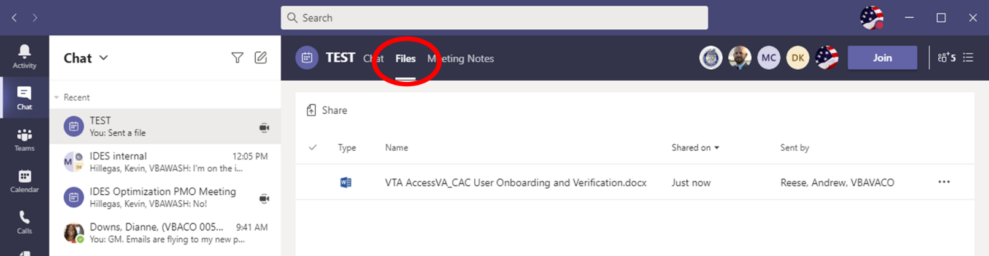

** After the call starts, the Teams Chat **will only** be used to ask questions. Call attendees **will not** make comments or respond to any of the questions.

Please mute your microphone and turn off your camera by clicking on the appropriate icon. (See Figure 1)

Figure 1:

Below (Figure 2) is what your microphone and camera icons should look like when it is muted/turned off. Click the microphone icon to unmute if you need to ask a question (do not unmute if you do not need to speak). If you are dialed in via your phone, ensure your phone is muted.

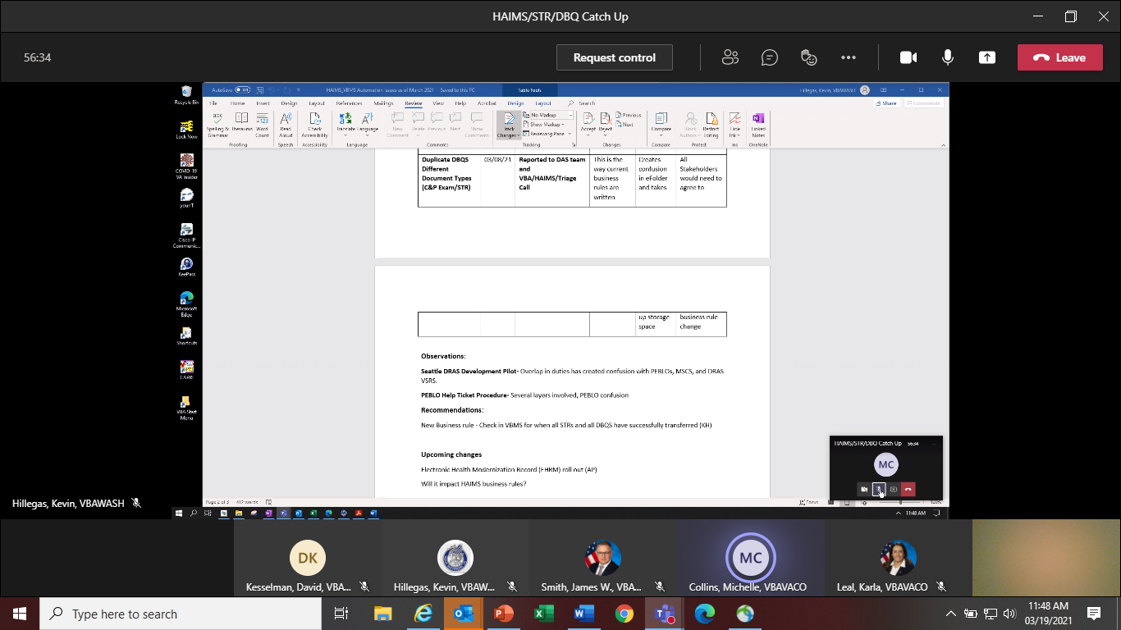

Figure 2:

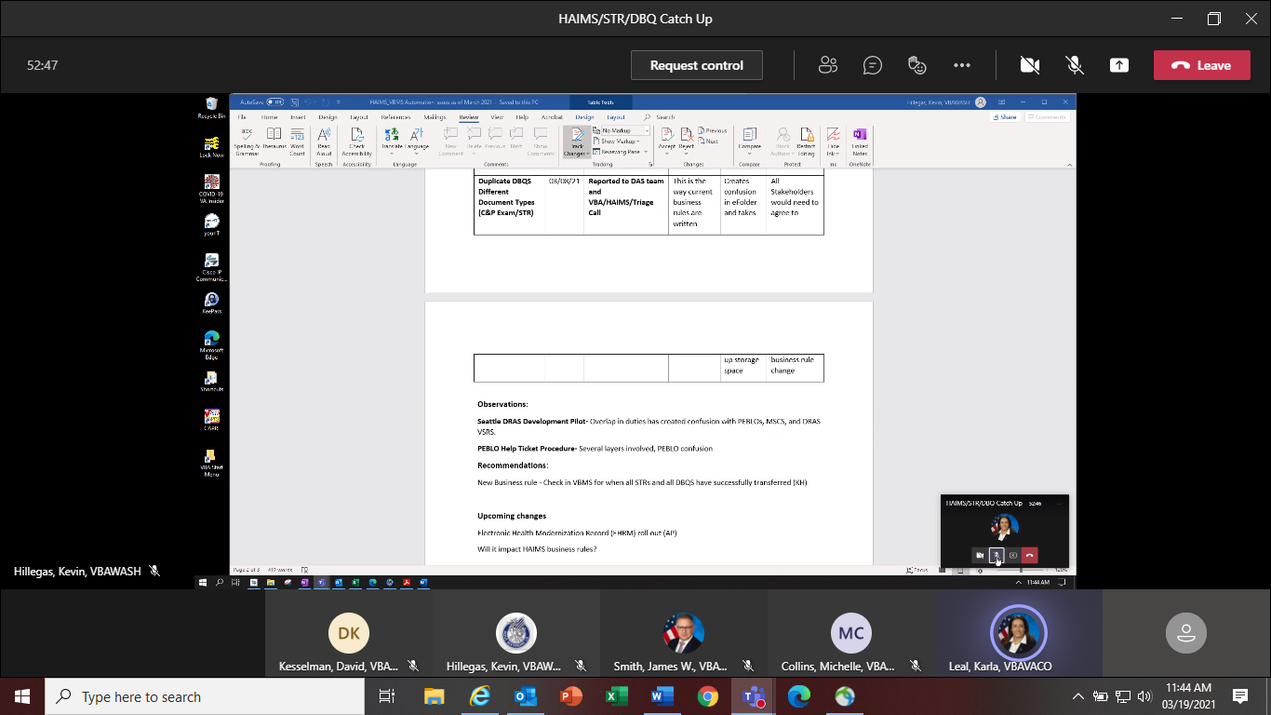

To ask a question over the phone, use the Raise your Hand option (click the hand and it will change color) in the Teams Meeting and you will be called upon for your question/comment. Once your question/comment is addressed lower your hand (click the hand again) (Figure 3). **Please do not talk/blurt out your question/comments unless called upon.** Scenario/Case Specific questions will not be answered on the call. Send an

email with details to the appropriate staff email box. Ask questions in reference to the topic(s) being discussed, all other questions should be asked during Open Floor

Figure 3:



Please sign–up for the [C&P Calendar Subscription Service](http://vbacodmoint1.vba.va.gov/bl/21/calendar/cal_Subscribe.asp) to receive notification that the R/A is available and for notification when the TMS number is active.

General Topic for Discussion

Read Ahead Information

All MSCs, DRAS personnel, and Coaches should review the R/A whether or not they attend the call to ensure they know what information is being discussed/put out. We continue to see issues/non-compliance with information that is in the R/A/discussed on the call. Those who do not attend the call should listen to the recording in TMS to know/understand guidance from the call.

**Home Improvements and Structural Alterations (HISA) Grant**

As part of our ongoing series to have guest speakers on upcoming calls to present various topics, today we have Dr. Shayla Mitchell, PhD, MS, CRC. She is a Program Analyst with Veterans Health Administration’s (VHA) Prosthetic & Sensory Aids Service. Her slides will be available on our “What’s New” section of our intranet website. Public information on the HISA Grant may be found here: [Home Improvements and Structural Alterations (HISA) - Rehabilitation and Prosthetic Services (va.gov)](https://www.prosthetics.va.gov/psas/hisa2.asp) and:

[](https://gcc02.safelinks.protection.outlook.com/?url=https%3A%2F%2Fwww.prosthetics.va.gov%2Ffactsheet%2FPSAS-FactSheet-Benefits.pdf&data=04%7C01%7C%7C3d18192c2e6f463e314408d98d13738b%7Ce95f1b23abaf45ee821db7ab251ab3bf%7C0%7C0%7C637695936937722715%7CUnknown%7CTWFpbGZsb3d8eyJWIjoiMC4wLjAwMDAiLCJQIjoiV2luMzIiLCJBTiI6Ik1haWwiLCJXVCI6Mn0%3D%7C1000&sdata=HtQStk2Y6lEavfQL7VXYTX8ob84nYmuzZ%2F81E%2FpSPsk%3D&reserved=0)

**Medical Disability Examination Office (MDEO) using the GovDelivery To Alert Claimants about Upcoming Examinations**

The Medical Disability Examination Office (MDEO) successfully began using the GovDelivery system to contact Veterans/Service members via email concerning scheduled Compensation and Pension (C&P) examinations. The email advises that the Medical Disability Examination (MDE) vendor will be contacting them to schedule an examination to complete their claim. It also provides all necessary vendor contact information so the Veteran/Service member can recognize the phone number or text (as described on page 3 of [November 9, 2021 BDD/IDES call](https://vbaw.vba.va.gov/VBADOD/docs/predischarge/November2021BDDIDESCallReadAheadFinal.docx)). Here is a sample email:



**VA Form 21-526EZ Non-Substantive Form Release Update**

VBA has made several non-substantive edits to [VA Form 21-526EZ, Application for Disability Compensation and Related Compensation Benefits](https://www.vba.va.gov/pubs/forms/VBA-21-526EZ-ARE.pdf) and released the updated form on October 22, 2021.

IMPORTANT: Non-substantive changes, such as changing the formatting, modifying pre-existing questions, or clarifying instructions, do not change version dates. The following non-substantive changes have been made to the existing September 2019 version of this form:

* The GENDER question has been modified to accept an additional option: MALE/FEMALE/OTHER.
* Under the BDD Program Criteria in the evidence table titled ‘Compensation Claims Submitted Prior to Discharge’ (Page 5), an additional bullet has been added to state: submit copies of service treatment records for the current period of service with the BDD claim.
* Radial button programming has been modified in several questions throughout the form to only allow one option to be picked.

Note: To accommodate the slight differences in forms with the same version date, claim processors will process and accept the information from the Veteran if everything requested on the submitted VA Form 21-526EZ (September 2019) is provided.

**VHA and IDES/BDD Exams**

VHA is not to be used for IDES and BDD exams unless the condition meets one of the Contract Examination Exclusions below.

**Contract Examination Exclusions**

Circumstances under which contract examinations must not be requested include, but are not limited to, the following:

* Former Prisoner of War (FPOW) Protocol Examination is required
* Examination requires hospitalization or surgical evaluation, such as colonoscopy or laparoscopy
* Veteran is an inpatient at a Veterans Health Administration (VHA) facility, nursing home, extended care

facility, or domiciliary (including state-operated Veterans' homes), or

* Veteran is an employee of the contract examination vendor scheduled to conduct the examination

Note: Place a note in VTA with the reason if VHA exams are ordered.

**Quality Review Questions**

The Pre-Discharge Staff has received several quality review questions in our corporate mailbox specifically after errors were called. Our staff is not a part of the quality review process and cannot assist with overturning errors. We ask that you work with your immediate supervisors to review evidence and challenge errors that you feel were incorrectly called. If questions related to quality errors are received in our mailbox, they will be forwarded to the quality review staff to address.

**BDD Specific Topics**

**BDD-Excluded Pre-Discharge Type**

The most recent VBMS update on December 26, 2021, ([VBMS Release 24.5 Release Notes](https://vbaw.vba.va.gov/VBMS/docs/VBMS_24_5_Release_Notes_Final.docx)), changed the “Quick Start” Pre-Discharge type to “BDD-Excluded”. “Quick Start” will remain an option for any existing claims with the “Quick Start” type already selected prior to this VBMS update. It is vital that the correct Pre-Discharge type is selected for the labeling accuracy of the Notification of Interest (NOI) requests for service treatment records (STRs) sent to the Department of Defense (DoD).

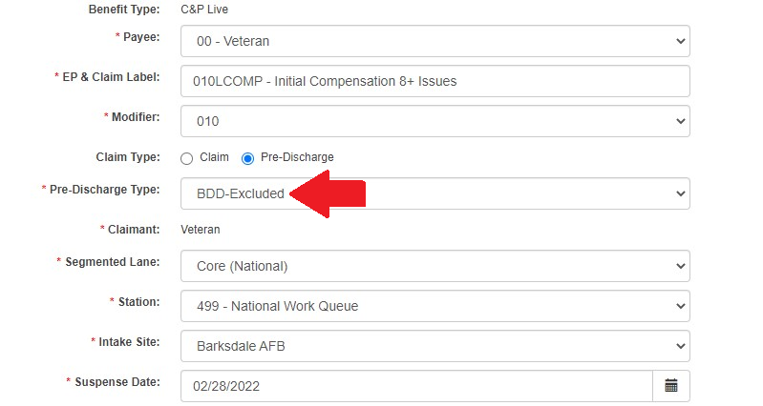

**Participant Profile and VBMS**

Military service information for BDD and BDD-Excluded claims can be entered in the Military Service tab in VBMS instead of Participant Profile. Page two of the [Search Participant Profile (SPP) Functions Added to VBMS Core 22.1](https://gcc02.safelinks.protection.outlook.com/?url=https%3A%2F%2Fvbaw.vba.va.gov%2FVBMS%2Fdocs%2FSPP_Functions_in_VBMS_Core.docx&data=04%7C01%7C%7C5b3e31f4ed694541105608d9ba6e8c6a%7Ce95f1b23abaf45ee821db7ab251ab3bf%7C0%7C0%7C637745806224551978%7CUnknown%7CTWFpbGZsb3d8eyJWIjoiMC4wLjAwMDAiLCJQIjoiV2luMzIiLCJBTiI6Ik1haWwiLCJXVCI6Mn0%3D%7C3000&sdata=wLMO0AlhV%2B7D2AqcB5JAyqIK4GTT%2BXnytTUa3qdmiJU%3D&reserved=0) from April 2021 shows further information, which is below.

The Claims Automation 17.1.2 release of VBMS Core contains changes to allow for updates to Military Service Information that were previously available only in the SPP application.

The following SPP functions can now be done in VBMS Core:

* Add/Edit/Delete Military Tours
* Add/Edit/Delete Prisoner of War (POW) information
* Add/Edit/Delete Military Theater information
* Update Veteran Date of Birth

**MSC Intake Site Information Pre-Discharge Intranet**

MSC contact information for each intake site is now on the [Pre-Discharge intranet site](https://vbaw.vba.va.gov/vbadod/predischarge.asp) under the “Contact Information” heading listed as [MSCs Assigned to Installations Nearest Regional Offices](https://vbaw.vba.va.gov/VBADOD/docs/predischarge/MSCsIntakeSiteList.xlsx). If any information is incorrect, please request that your supervisor update the “BDD MSC List” information on the [MSC Sharepoint](https://gcc02.safelinks.protection.outlook.com/?url=https%3A%2F%2Fdvagov.sharepoint.com%2Fsites%2FVBA21C212%2F212D_MSC_Info%2FSitePages%2FHome.aspx&data=04%7C01%7C%7C1d128d9cda924105aa1d08d9cbca25d5%7Ce95f1b23abaf45ee821db7ab251ab3bf%7C0%7C0%7C637764891337731269%7CUnknown%7CTWFpbGZsb3d8eyJWIjoiMC4wLjAwMDAiLCJQIjoiV2luMzIiLCJBTiI6Ik1haWwiLCJXVCI6Mn0%3D%7C3000&sdata=pmBjVDtWRfEPL19fXj4Qdt4kZY%2Fr3gAJWCo%2F5Dux3j8%3D&reserved=0). The BDD staff will post an updated list quarterly.

**Current BDD Program Timeliness**

As VA’s frontline contact with SMs and Veterans, it is vital that we are transparent in our communications regarding claims processing times. Below is the current program timeliness data as of January 5, 2022.

|  |  |  |
| --- | --- | --- |
| **BDD Timeliness Data** | | |
| **Data Points** | **Goal** | **January 5, 2022** |
| **Completed FYTD** |  | **12,137** |
| **Receipts FYTD** |  | **8,539** |
| **Pending** |  | **6,678** |
| **# Completed w/in 30 Days of Discharge** |  | **4,642** |
| **% Completed w/in 30 Days of Discharge** | **100%** | **39.5%** |
| **Avg. Days to Complete FYTD** | **30** | **75.4** |

***Source:*** *Tableau BDD History Report, January 5, 2022*

IDES Specific Topics

**Conclusion of DRAS Development Pilot and Transition to Standard Procedure**

On January 4, 2022, the Office of Field Operations announced that decision had been made toclose the IDES Development Centralization DAC Project and discontinue the pilot. To facilitate the return to standard procedure, Army IDES claims must be handled in accordance with the following specifications:

* Any Army IDES case with a Prepare Claim Start Date (PCSD) of January 4, 2022, or earlier will be considered a “pilot case” and processed to completion in accordance with pilot procedures.
* Cases with a PCSD of January 5, 2022, or later, must be processed entirely under standard IDES procedure (i.e., MSCs will order exams, and transfer to DRAS upon completion of exams).
* Seattle DRAS will maintain responsibility for all exam-related activity in pilot cases including exam requests, communication of results to PEBLOs, and responding to clarification requests.
* Seattle DRAS VSRs will continue to case manage IDES exam activity until all Army cases with a PCSD of January 4, 2022, or earlier have completed the Medical Evaluation Stage.

**Required Use of New Special Issue to Replace Brokering Action**

Effective January 10, 2022, all MSCs processing IDES cases must discontinue the practice of brokering EP 689s to DRAS, and instead begin applying a special issue, *Transfer from Intake Site,* at the time the case is ready to be transferred to DRAS. Application of this special Issue will prompt National Work Queue to transfer of the claim to DRAS. Please refer to Appendix 2, which shows this change in the context of the previous procedure.

This change is effective January 10, 2022 and will impact only cases transferred to DRAS on or after that date; MSCs should **not** add the new special Issue to cases that have been previously brokered. Compensation Service will update the M21-1 as appropriate to reflect this change. Until those changes are published in the manual, this message (and Appendix 2) should be considered interim guidance.

**HAIMS/VBMS/STR/DBQ Update**

The IDES Program Office, in coordination with DoD, continues to track the HAIMS/VBMS/STRS/DBQ procedures implemented February 1, 2021.

* The staff continues to work with VBMS, DAS and HAIMS to resolve any challenges identified.
  + Illegible DBQs in HAIMS- Fix deployed December 6, 2021.
  + HAIMS DOD Error Message- Resolved December 2021
  + STR HAIMS/VBMS Transfer Fails- Resolved December 2021
* Ensure you are running the Pending CEST Report daily.
* If MTFs are having issues with uploading or not aware of the HAIMS/VBMS/DBQ transfer process, send details including VTA Case ID (if applicable) to the [IDES Mailbox](mailto:VAVBAWAS/CO/IDES%20%3cIDES.VBACO@VA.GOV%3e)

Current IDES Program Timeliness

As outreach specialists and VA’s frontline contact with SMs and Veterans, it is vital that we are realistic in our communications regarding claims processing times. Current program timeliness data (ADC) for December 2021.

|  |  |  |
| --- | --- | --- |
| **Stage/Phase** | **IDES Goal (AD/NAD)** | **December 2021 (AD/NAD)** |
| **Claim Dev** | **5/11** | **6/9** |
| **Medical Stage** | **32** | **52/47** |
| **Proposed Ratings** | **20** | **9/16** |
| **Recon Ratings** | **4** | **8/7** |
| **Exit Interviews** | **14** | **8/7** |
| **Final Ratings** | **20/na** | **21/na** |

***Source:*** *VTA Completed Reports (Days to Complete Including Deferment) January 4, 2022 (9ET).*

***Note:*** *VA using the goals from the 230-day process.*

VTA Specific Topics

Changing/Removing VTA Data

We covered this in November, but still are seeing occurences. VTA users are reminded they should not update/remove data entered by another user unless coordination is made or you work on the same team/staff. If you are having issues with data entry, contact [VRST@vba.va.gov](https://dvagov.sharepoint.com/sites/VBA21C212/212D/VDPO%20Monthly%20IDES%20Call/2022/Jan%2022/VRST@vba.va.gov).

Upcoming Teleconferences

The next BDD/IDES Call is scheduled for **Tuesday, February 8, 2022**, at 2PM ET. Please submit IDES questions and proposed topics for discussion to the [IDES Mailbox](mailto:VAVBAWAS/CO/IDES%20%3cIDES.VBACO@VA.GOV%3e), and BDD questions and proposed topics for discussion to the [BDD Mailbox](mailto:VAVBAWAS/CO/PREDISCHARGE%20%3cPredischarge.VBACO@va.gov%3e) no later than close of business (COB), Monday, January 24, 2022.

Open Floor

**Appendix 1: Call Notes from the November 2021 BDD/IDES Conference Call**

**Question: Can we get clarification on the use of TMJ DBQ?**

**Answer:** Per the MDEO Staff, the SHA is the only DBQ that is required for TMJ. If any vendors are still returning/requesting a TMJ DBQ, please send inquiry including all details to the Medical Disability Examination Office (MDEO) [VAVBAWAS/CO/Contract Examination Inquiries](mailto:ContractExam.VBAVACO@va.gov).

**Question: Can you provide an update on the Joint Disability Evaluation System (JDES)?**

**Answer:** Response provided in R/A above.

**Question: Can you provide the correct process for MSCs when establishing an EP 336 for a BDD claim?**

**Answer:** Per [M21-1, X.i.6.B.2.d](https://vaww.vrm.km.va.gov/system/templates/selfservice/va_kanew/help/agent/locale/en-US/portal/554400000001034/content/554400000177950/M21-1-Part-X-Subpart-i-Chapter-6-Section-B-Benefits-Delivery-at-Discharge-BDD-and-Initial-Processing#2d), MSCs/VSRs should establish the EP 336 and request the necessary exams and complete any other development actions needed. Once development actions have been taken, MSCs/VSRs will change the EP 336 to the appropriate rating EP. MSCs/VSRs **do not** have to wait until exams have been accepted to change the EP 336 to the rating EP. National Work Queue (NWQ) has stated they will route any rejected exams and the contract exam staff has also stated there are no negative impacts to changing the EP immediately following the exam request. Please send any inquiries to the [BDD Mailbox.](mailto:VAVBAWAS/CO/PREDISCHARGE%20%3cPredischarge.VBACO@va.gov%3e)

**Appendix 2: NWQ Routing of EP 689— Modified Claim Transfer Procedures**

The table below reflects modified procedures to implement new NWQ routing functionality in IDES claims (the change to current process is highlighted in step 11). EP 689s will no longer be brokered to DRAS; instead, MSCs must apply the *Transfer from Intake Site* special issue as indicated below and NWQ will route the claim to DRAS.

MSCs must take the actions described in the table below as soon as *all* examination reports are available in the eFolder and have been deemed complete.

|  |  |  |  |  |  |  |  |  |  |  |  |  |  |  |  |  |  |  |  |  |  |  |  |  |  |  |  |  |  |  |  |  |  |
| --- | --- | --- | --- | --- | --- | --- | --- | --- | --- | --- | --- | --- | --- | --- | --- | --- | --- | --- | --- | --- | --- | --- | --- | --- | --- | --- | --- | --- | --- | --- | --- | --- | --- |
|  | | **Step** | **Action** | | --- | --- | | 1 | Update the SHA RETURNED DATE on the MSC Tab in VTA to reflect the date that *all* examinations requested from the SHA provider became available to the MSC.    ***Notes***:   * The provider (VHA, QTC, MTF or VES) to which the SHA DBQ was requested from is considered the “SHA provider.” * When multiple DBQs were requested from the SHA provider, the SHA RETURNED DATE must reflect the date the last DBQ from the SHA provider was returned. | | 2 | Were examination requests submitted to multiple providers (e.g., both QTC and VHA)?   * If *yes*, go to the next step. * If *no*, go to Step 4. | | 3 | Update the OTHER EXAM RETURNED DATE in VTA to reflect the date that all examinations requested from the other provider became available to the MSC.    ***Notes***:   * A provider who completes DBQs in an IDES case, but does not complete the SHA DBQ is considered the “other provider.” * When multiple DBQs were requested from the other provider, the SHA REQUESTED DATE must reflect the date the last DBQ was returned. | | 4 | Update the EXAM END DATE field in VTA to reflect the date when ***all***the participant’s examination reports became available to the participant’s MSC. | | 5 | Review VBMS notes for the message *SHA exam results have been successfully transferred to DoD (HAIMS)*.  ***Important***:  If this message is not shown, MSCs must compete the actions outlined in [**M21-1, Part X, Subpart i, 6.F.3.e**](https://vaww.vrm.km.va.gov/system/templates/selfservice/va_kanew/help/agent/locale/en-US/portal/554400000001034/content/554400000177955/M21-1-Part-X-Subpart-i-Chapter-6-Section-F-Integrated-Disability-Evaluation-System-IDES-Development-and-Examinations#3e) before going to the next step. | | 6 | If any previously completed DBQs (i.e., not associated with the current IDES examination request), will be used for IDES purposes, ensure that they have been provided to the PEBLO via acceptable alternative means.    ***Rationale***:  Previously completed DBQs are not transferred to DoD via automated process.    ***Note***:  PEBLOs require copies of *previously completed* DBQs when   * the results of recently completed examinations are used IDES purposes, (as discussed in [**M21-1, Part X, Subpart i, 6.F.2**](https://vaww.vrm.km.va.gov/system/templates/selfservice/va_kanew/help/agent/locale/en-US/portal/554400000001034/content/554400000177955/M21-1-Part-X-Subpart-i-Chapter-6-Section-F-Integrated-Disability-Evaluation-System-IDES-Development-and-Examinations#2)), and * when a PTSD Review DBQ was completed for a participant who was referred to IDES on the basis of PTSD (as discussed in [**M21-1, Part X, Subpart i, 6.F.2**](https://vaww.vrm.km.va.gov/system/templates/selfservice/va_kanew/help/agent/locale/en-US/portal/554400000001034/content/554400000177955/M21-1-Part-X-Subpart-i-Chapter-6-Section-F-Integrated-Disability-Evaluation-System-IDES-Development-and-Examinations#2)).   ***Reference***:  For more information about acceptable alternative means of document transfer, see [**M21-1, Part X, Subpart i, 6.E.3.f**](https://vaww.vrm.km.va.gov/system/templates/selfservice/va_kanew/help/agent/locale/en-US/portal/554400000001034/content/554400000177953/M21-1,-Part-X,-Subpart-i,-Chapter-6,-Section-E---Integrated-Disability-Evaluation-System-(IDES),-Referrals,-and-Initial-Processing). | | 7 | If the claim required development other than VA examinations, ensure that   * all required development actions have been initiated, and/or * any required follow-up requests are made on development items with past due suspense dates   ***Important***:  Go to the next step after ensuring all required development has been *initiated*.  Do not delay action on the remaining steps in this table because development actions (unrelated to VA examinations) are not yet resolved. | | 8 | Ensure all tracked items have been updated to reflect the appropriate disposition per [**M21-4, Appendix D, 1**](https://vaww.vrm.km.va.gov/system/templates/selfservice/va_kanew/help/agent/locale/en-US/portal/554400000001034/content/554400000036576/Appendix-D.-Index-of-Claim-Stage-Indicators).  ***Notes***:   * All examination tracked items must be marked *Closed*, *Received*, or *In Error* before transferring the case to DRAS. * When development remains pending on any other issue (not related to examinations) the associated tracked items must remain open with appropriate suspense dates; DRAS will ensure that these tracked items are resolved. | | 9 | Ensure that the [***IDES Development Checklist***](https://vbaw.vba.va.gov/VBADOD/docs/IDES/IDESDevelopmentChecklist.pdf) has been completed and incorporated into the eFolder (or forwarded to the scanning vendor under a DCS).  ***Note***:  If the MSC uploads the checklist directly into the eFolder, he/she must use the indexing values specified on the checklist.  ***Reference***:  For more information on the use of the [***IDES Development Checklist***](https://vbaw.vba.va.gov/VBADOD/docs/IDES/IDESDevelopmentChecklist.pdf), see [**M21-1, Part X, Subpart i, 6.E.3.a**](https://vaww.vrm.km.va.gov/system/templates/selfservice/va_kanew/help/agent/locale/en-US/portal/554400000001034/content/554400000177953/M21-1,-Part-X,-Subpart-i,-Chapter-6,-Section-E---Integrated-Disability-Evaluation-System-(IDES),-Referrals,-and-Initial-Processing). | | 10 | Update the claim status of the EP 689 to *Ready for Decision (RFD)*.  ***Note***:  The claim status must reflect RFD, even if non-exam related tracked items remain open. | | 11 | ~~Broker the EP 689 to the DRAS per instructions in the~~[**~~VBMS Job Instruction Sheet – Broker Claim~~**](http://vbaw.vba.va.gov/VBMS/Resources_Job_Instruction_Sheets.asp)~~.~~  Apply the *Transfer from Intake Site Special Issue* to the first contention listed under the EP 689.  ***Note:*** Application of this special issue will result in the claim being transferred to DRAS via automated National Work Queue (NWQ) routing. | | 12 | Update the MEDICAL EVALUATION END DATE field according to the table below.   | **If …** | **Then, update the MEDICAL EVALUATION END DATE field to reflect …** | | --- | --- | | all examination results were transferred via automated transfer process | the current date. | | the MSC had to take action to provide the results to the PEBLO | the date the examination results were sent the PEBLO. |   ***Notes***:   * Entry of the MEDICAL EVALUATION END DATE serves to notify   + DRAS that the case is ready for rating preparation, and   + the PEBLO assigned that the results are available in HAIMS. * MSCs must make every effort to take the actions outlined in Steps 5 through 12 of this table on the same day. | |