Monthly Benefits Delivery at Discharge (BDD) and

Integrated Disability Evaluation System (IDES)

Conference Call Read Ahead

Compensation Service

BDD/IDES (212A)

November 9, 2021 — 2 PM ET

The Compensation Service BDD/IDES hosts this call to announce updates and address issues and questions related to the BDD/IDES Programs. All Military Services Coordinators (MSCs), Disability Rating Activity Sites (DRAS), Regional Offices and other VA personnel supporting BDD/IDES are invited to participate.

This read-ahead is provided to facilitate discussion during the conference call.

The Call Notes for the October Call are located in Appendix 1. The TMS # for this month’s call will be provided during the call and will be active within a week of the call’s completion. A Calendar Blast will notify the field when the TMS # is active.

**Call-in Information**

[Join Microsoft Teams Meeting](https://teams.microsoft.com/l/meetup-join/19%3ameeting_MzlhN2FlN2YtYTFhNS00NjExLWEwMzMtYWEwYjE0YzU1Y2Qx%40thread.v2/0?context=%7b%22Tid%22%3a%22e95f1b23-abaf-45ee-821d-b7ab251ab3bf%22%2c%22Oid%22%3a%22a0338b5c-0526-4e13-9809-5d0ecc8cdeb8%22%7d)

[+1 872-701-0185](tel:+1%20872-701-0185,,448196643# )  United States (Toll)

Conference ID: 448 196 643#

The readahead and slides will be attached to the Chat (you may have to scroll up in the Chat) and can also be found in the Files link on the call. They are also located on the [IDES](https://vbaw.vba.va.gov/vbadod/IDES.asp) and home pages.

Note: The slides will not be available on the homepages until about noon of call day.

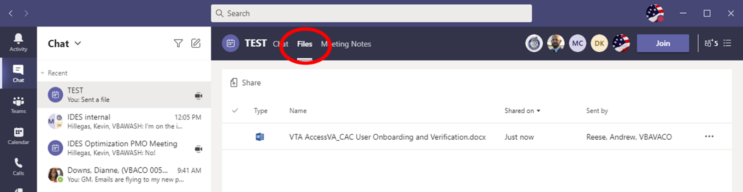

** After the call starts, the Teams Chat **will only** be used to ask questions. Call attendees **will not** make comments or respond to any of the questions. Please adhere to this request.

Ask questions over the phone or send an email to the appropriate staff corporate mailbox.

Please mute your microphone and turn off your camera by clicking on the appropriate icon. (See Figure 1)

Figure 1:

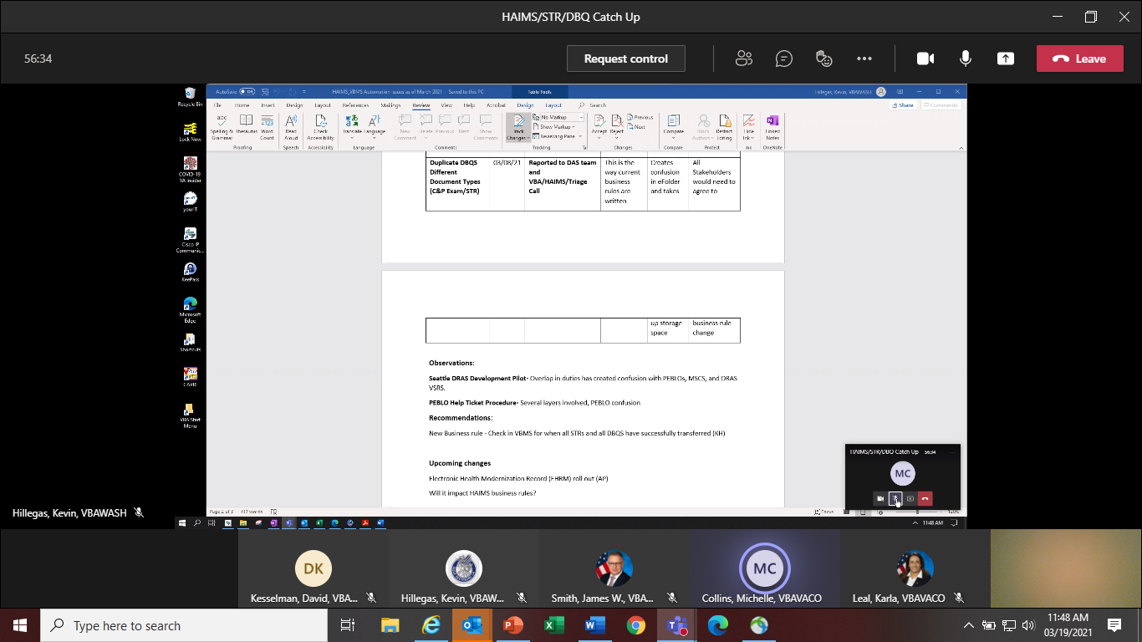

Below (Figure 2) is what your microphone and camera icons should look like when it is muted/turned off. Click the microphone icon to unmute if you need to ask a question (do not unmute if you do not need to speak). If you are dialed in via your phone, ensure your phone is muted.

Figure 2:

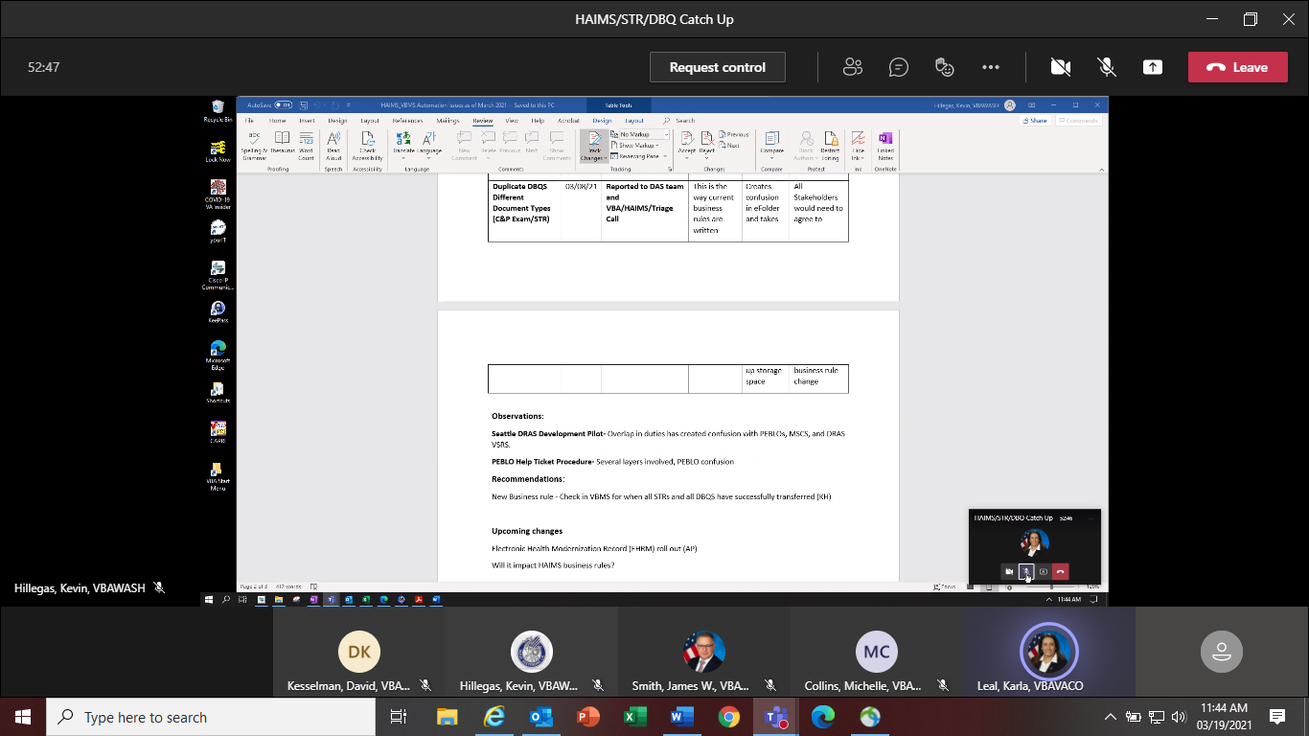

To ask a question, use the Raise your Hand option (click the hand and it will change color) in the Teams Meeting and you will be called upon for your question/comment. Once your question/comment is addressed lower your hand (click the hand again) (Figure 3). **Please do not talk/blurt out your question/comments unless called upon.** Scenario/Case Specific questions will not be answered on the call. Send an

email with details to the appropriate staff email box. Ask questions in reference to the topic(s) being discussed, all other questions should be asked during Open Floor

Figure 3:



Please sign–up for the [C&P Calendar Subscription Service](http://vbacodmoint1.vba.va.gov/bl/21/calendar/cal_Subscribe.asp) to receive notification that the Read Ahead is available and for notification when the TMS number is active.

General Topic for Discussion

**Veteran Readiness and Employment (VRE) Transition Assistance**

As presented in October, we will be having guest speakers on upcoming calls to present various topics. Today, the Supervisor for VRE Outreach & Engagement, Robyn Trulock, is here to present on VRE Transition Assistance. For your local Vocational Rehabilitation Counselor (VRC) serving your installation(s), please see the [VR&E Office Directory](https://vbaw.vba.va.gov/VOCREHAB/directory.asp) or contact [VREOUTREACH.VBACO@va.gov](mailto:VREOUTREACH.VBACO@va.gov) for this information.

**Vendor Contract Information**

Regional Office personnel should not provide Veterans or Service members (SMs) with any vendor contact information outside of the vendors’ designated public use phone numbers. If a Veteran or SM requests contact information for an MDE vendor, please provide them the following information only:

* [**Logistics Health Incorporated (LH)**](https://logisticshealth.com/index.aspx): 1-866-933-8387
* [**QTC**](https://www.qtcm.com/)**:** 1-800-545-9448 or 1-877-232-3223
* [**Veteran Evaluation Service (VES)**](https://www.vesservices.com/)**:** 1-877-637-8387

Land lines and most cellular calls are now displaying the following when a vendor calls a Veteran or

SM:

* VA Exam – LHI
* VA Exam – QTC
* VA Exam - VES

**Veterans Benefits Management System (VBMS) Document Properties**

On last month’s call, a number of attendees mentioned the inability to view Document Properties. This VBMS feature may be modified in various ways, but it is not part of the “Show/Hide Columns” functionality. Document properties are added to documents when they are uploaded to the eFolder and can be viewed and edited from the eFolder Actions menu, from a read-only view of the document, or from the document annotator. Please see page 228-229 of [**VBMS Core User Guide - Release 19.0.5**](https://vbaw.vba.va.gov/VBMS/docs/VBMS_Core_User_Guide_Release_19_0_5.pdf) . The [**VBMS User Roles Guide - Release 19.0**](https://vbaw.vba.va.gov/VBMS/docs/VBMS_User_Roles_Guide_Release_19_0.pdf) indicates editing is almost universal, however if you are unable to perform this act work with your Supervisor on being assigned a proper roll.

**BDD Specific Topics**

**Machine Claims Establishment (CEST) and Entering of Contentions**

20C has been overseeing an effort to automate CEST and contention listing actions. As observed in [Veterans Benefits Management System (VBMS) Notes](https://vbaw.vba.va.gov/VBMS/docs/VBMS_Core_User_Guide_Release_19_0_5.pdf) section, if you encounter a claim that was established by “283-vbmsrobotsyacct”, this indicates that the claim was established by Mail Automation Services (MAS, a “BOT” and not a human). When you see “any employees name – 101”, this indicates a SURGE contractor (human) has established the claim.

The BOTs utilize optical character reader to capture what is written on the form; therefore, a variety of factors such as readability, poor scanning, handwriting etc. may impact its functionality. Here is an example of BOT-entered issues based off of a handwritten application (**Figure 1**):

**Figure 1**

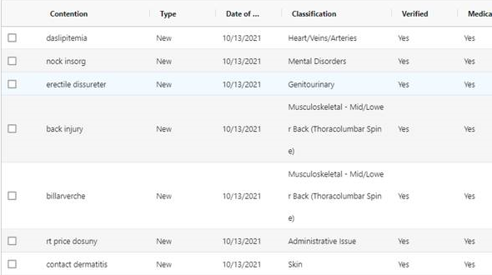

While these BOTs are constantly learning and training from items processed, some contentions will require revisions. All employees reviewing a claim are responsible for ensuring all contentions are correct and verified, see [M21-1, III.i.2.F.2.b.](https://vaww.vrm.km.va.gov/system/templates/selfservice/va_kanew/help/agent/locale/en-US/portal/554400000001034/content/554400000046277/M21-1-Part-III-Subpart-i-Chapter-2-Section-F-Record-Maintenance-During-the-Development-Process?query=listing%20contentions#2b) Notes associated with a claim can also be viewed from the Claim Notes tab on the Development Plan task bar in VBMS.

**BDD Examinations and ACE**

When requesting BDD examinations, select "Veteran Must Report To Exam” for every contention on BDD and IDES examinations. When the "Veteran Must Report To Exam" option is selected, the below required ACE exclusion language is generated on the exam request.

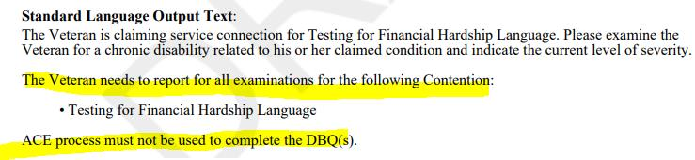

**Current BDD Program Timeliness**

As VA’s frontline contact with SMs and Veterans, it is vital that we are transparent in our communications regarding claims processing times. Below is the current program timeliness data as of November 3, 2021.

|  |  |  |
| --- | --- | --- |
| **BDD Timeliness Data** | | |
| **Data Points** | **Goal** | **November 3, 2021** |
| **Completed FYTD** |  | **4,675** |
| **Receipts FYTD** |  | **2,878** |
| **Pending** |  | **8,820** |
| **# Completed w/in 30 Days of Discharge** |  | **1,814** |
| **% Completed w/in 30 Days of Discharge** | **100%** | **39%** |
| **Avg. Days to Complete FYTD** | **30** | **77** |

***Source:*** *Tableau BDD History Report, November 4, 2021*

IDES Specific Topics

**HAIMS/VBMS/STR/DBQ Update**

The IDES Program Office, in coordination with DoD, continues to track the HAIMS/VBMS/STRS/DBQ procedures implemented February 1, 2021.

* Challenges have been identified with some STR and DBQ transfers. The staff continues to work with VBMS, DAS and HAIMS to resolve
  + Illegible DBQs in HAIMS
  + HAIMS DOD Error Message
  + STR HAIMS/VBMS Transfer Fails
* If MTFs are having issues with uploading or not aware of the HAIMS/VBMS/DBQ transfer process, send details including VTA Case ID (if applicable) to the [IDES Mailbox](mailto:VAVBAWAS/CO/IDES%20%3cIDES.VBACO@VA.GOV%3e)
* Ensure you are running the Pending CEST Report daily. We are seeing an uptick in cases with high Pending Claims Development days and no MSC assigned.

**Holiday Leave and SM Availability during the Claims Development and Examination Phases**

We talked this last month and wanted to remind MSCs again about this topic. As we approach the holidays, MSCs are reminded to inquire about approved leave (non-emergency) during the initial interview that could interfere with the IDES process (this inquiry should be made during every interview, just not during the holidays). If the SM indicates he or she has approved leave that would prevent the timely completion of exams/delay VA processes, the MSC should return the referral to the PEBLO as an improper referral and remove the PCS Date. MSCs should confirm with the PEBLO that they are aware of the upcoming leave and see if something can be worked out (e.g., SM will attend exams while on leave, etc.). Do not accept a case or submit exam requests if you know the SM will not be available to report for exams.

Notes:

1. DoD policy allows commanders to grant leave to IDES SMs for the welfare or morale of the SM, provided that the leave does not prevent timely completion of IDES appointments.

2. Deferment should not be used by PEBLOs as a reason for cases where the SM is going on leave. If you hear of this being done, contact the IDES Mailbox.

**IDES Participant Flash**

MSCs and DRAS’ are reminded that the IDES Participant Flash will not be removed from the case file no matter the final disposition.

Current IDES Program Timeliness

As outreach specialists and VA’s frontline contact with SMs and Veterans, it is vital that we are realistic in our communications regarding claims processing times. Current program timeliness data (ADC) for October 2021.

|  |  |  |
| --- | --- | --- |
| **Stage/Phase** | **IDES Goal (AD/NAD)** | **October 2021 (AD/NAD)** |
| **Claim Dev** | **5/11** | **6/9** |
| **Medical Stage** | **32** | **54/59** |
| **Proposed Ratings** | **20** | **10/16** |
| **Recon Ratings** | **4** | **8/8** |
| **Exit Interviews** | **14** | **8/8** |
| **Final Ratings** | **20/na** | **19/na** |

***Source:*** *VTA Completed Reports (Days to Complete Including Deferment) November 2, 2021 (8 ET).*

***Note:*** *VA using the goals from the 230-day process.*

Seattle DRAS VSC Development Pilot Info

The Pilot has been extended until further notice.

VTA Specific Topics

**Cases put in Deferment with Leave/TDY/Recovery Time/Other as Case Deferment Reason**

We are seeing too many cases where DoD enters the Prepare Claim Start Date (PCSD) and almost immediately (same or next day) puts the case in deferment with a reason of Leave/TDY/Other. If this happens the MSC should not accept the case, remove the PCSD and return the case to the PEBLO. DoD can resubmit when the SM is available. VA will not be on the clock because the SM is unavailable due to Leave/TDY/Recovery time, etc., and that reason for unavailability was known when the PCS Date was entered. Contact the [IDES Mailbox](mailto:VAVBAWAS/CO/IDES%20%3cIDES.VBACO@VA.GOV%3e) or an IDES Analyst as needed.

The screen shots below (taken 10/20/21) show the PCSD and a Deferment Date of 9/23/21.

MSC should have removed PCSD and returned case to PEBLO. In current state SM is unavailable and VA Claims Development time is pending almost 30 days.

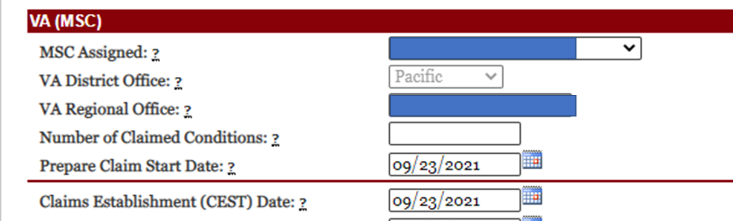

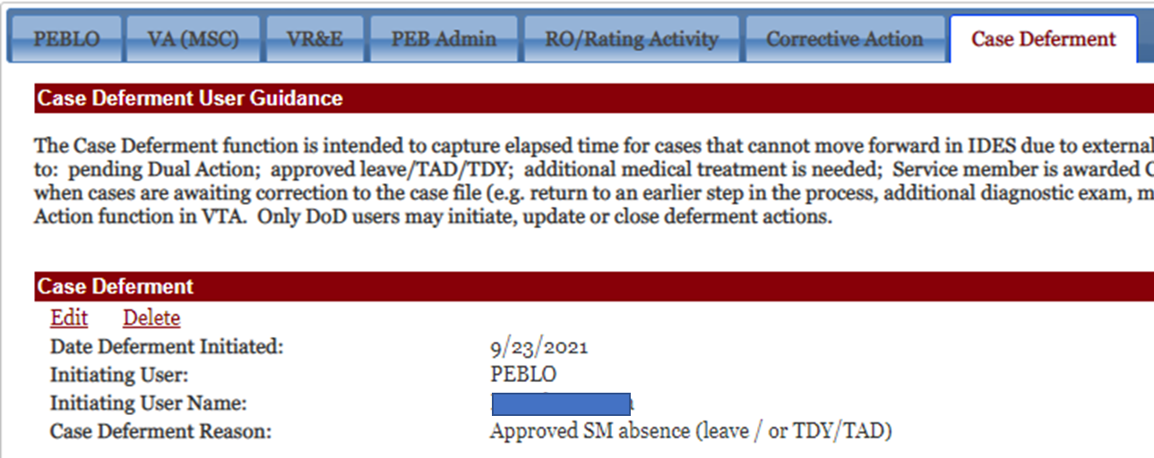

**Changing/Removing VTA Data**

VTA users are reminded they should not update/remove data entered by another user unless coordination is made or you work on the same team/staff. Example: A non-Seattle MSC was having issues entering Exit Interview data and removed the Medical Evaluation End Date which was input by the Seattle DRAS. The Medical Evaluation End Date was not re-entered by the MSC. MSC should not of removed the data and contacted the help desk.

Upcoming Teleconferences

The next BDD/IDES Call is scheduled for **Tuesday, January 11, 2022**, at 2PM ET. A new invite will be sent for 2022. Please submit IDES questions and proposed topics for discussion to the [IDES Mailbox](mailto:VAVBAWAS/CO/IDES%20%3cIDES.VBACO@VA.GOV%3e), and BDD questions and proposed topics for discussion to the [BDD Mailbox](mailto:VAVBAWAS/CO/PREDISCHARGE%20%3cPredischarge.VBACO@va.gov%3e) no later than close of business (COB), Monday, December 20, 2021.

The BDD/IDES Coaches Call is cancelled until further notice. Outlook cancellation sent.

Open Floor

**Appendix 1: Call Notes from the October 2021 BDD/IDES Conference Call**

***Public IDES Website Updated***

**Question: We are still experiencing additional DBQs being auto-selected along with the SHA, what is status of this being resolved?**

**Answer:** No system updates currently. Reminder, EMS prevents an ESR being released before it has been previewed by a claims processor. Please see page 325 of VBMS Core User Guide - Release 19.0.5. Claims processors are to take advantage of this functionality to review the entire request prior to submission, to include checking to see if unneeded DBQs were added to the ESR.

**Question: Can we accept/use DBQs from private providers?**

**Answer:** Yes. Sufficiency of DBQs completed by Non-VA Providers and obtained from the site for DBQs approved for public use (Private Medical Evidence) must be assessed in accordance with M21-1, IV.i.3.A.1.e.