Monthly Benefits Delivery at Discharge (BDD) and

Integrated Disability Evaluation System (IDES)

Conference Call Read Ahead

Compensation Service

BDD/IDES (212A)

October 12, 2021 — 2 PM ET

The Compensation Service BDD/IDES hosts this call to announce updates and address issues and questions related to the BDD/IDES Programs. All Military Services Coordinators (MSCs), Disability Rating Activity Sites (DRAS), Regional Offices and other VA personnel supporting BDD/IDES are invited to participate.

This read-ahead is provided to facilitate discussion during the conference call.

The Call Notes for the September MSC Training Event are located in Appendix 1. The TMS # for this month’s call will be provided during the call and will be active within a week of the call’s completion. A Calendar Blast will notify the field when the TMS # is active.

**Call-in Information**

[Join Microsoft Teams Meeting](https://teams.microsoft.com/l/meetup-join/19%3ameeting_MzlhN2FlN2YtYTFhNS00NjExLWEwMzMtYWEwYjE0YzU1Y2Qx%40thread.v2/0?context=%7b%22Tid%22%3a%22e95f1b23-abaf-45ee-821d-b7ab251ab3bf%22%2c%22Oid%22%3a%22a0338b5c-0526-4e13-9809-5d0ecc8cdeb8%22%7d)

[+1 872-701-0185](tel:+1%20872-701-0185,,448196643# )  United States (Toll)

Conference ID: 448 196 643#

The readahead and slides will be attached to the Chat (you may have to scroll up in the Chat) and can also be found in the Files link on the call. They are also located on the [IDES](https://vbaw.vba.va.gov/vbadod/IDES.asp) and home pages.

Note: The slides will not be available on the homepages until about noon of call day.

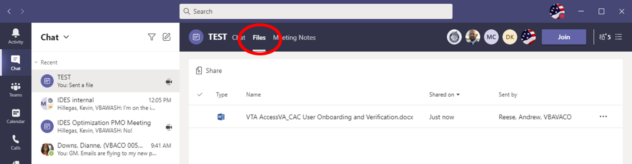

** After the call starts, the Teams Chat **will only** be used to ask questions. Call attendees **will not** make comments or respond to any of the questions. Please adhere to this request.

Ask questions over the phone or send an email to the appropriate staff corporate mailbox.

Please mute your microphone and turn off your camera by clicking on the appropriate icon. (See Figure 1)

Figure 1:

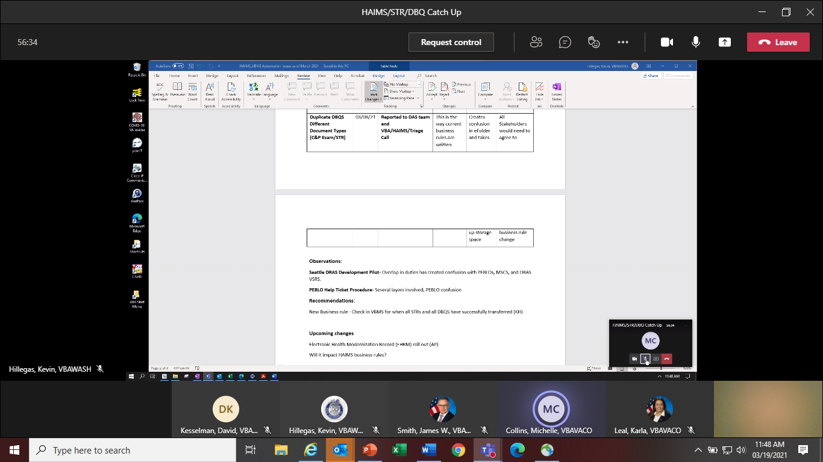

Below (Figure 2) is what your microphone and camera icons should look like when it is muted/turned off. Click the microphone icon to unmute if you need to ask a question (do not unmute if you do not need to speak). If you are dialed in via your phone, ensure your phone is muted.

Figure 2:

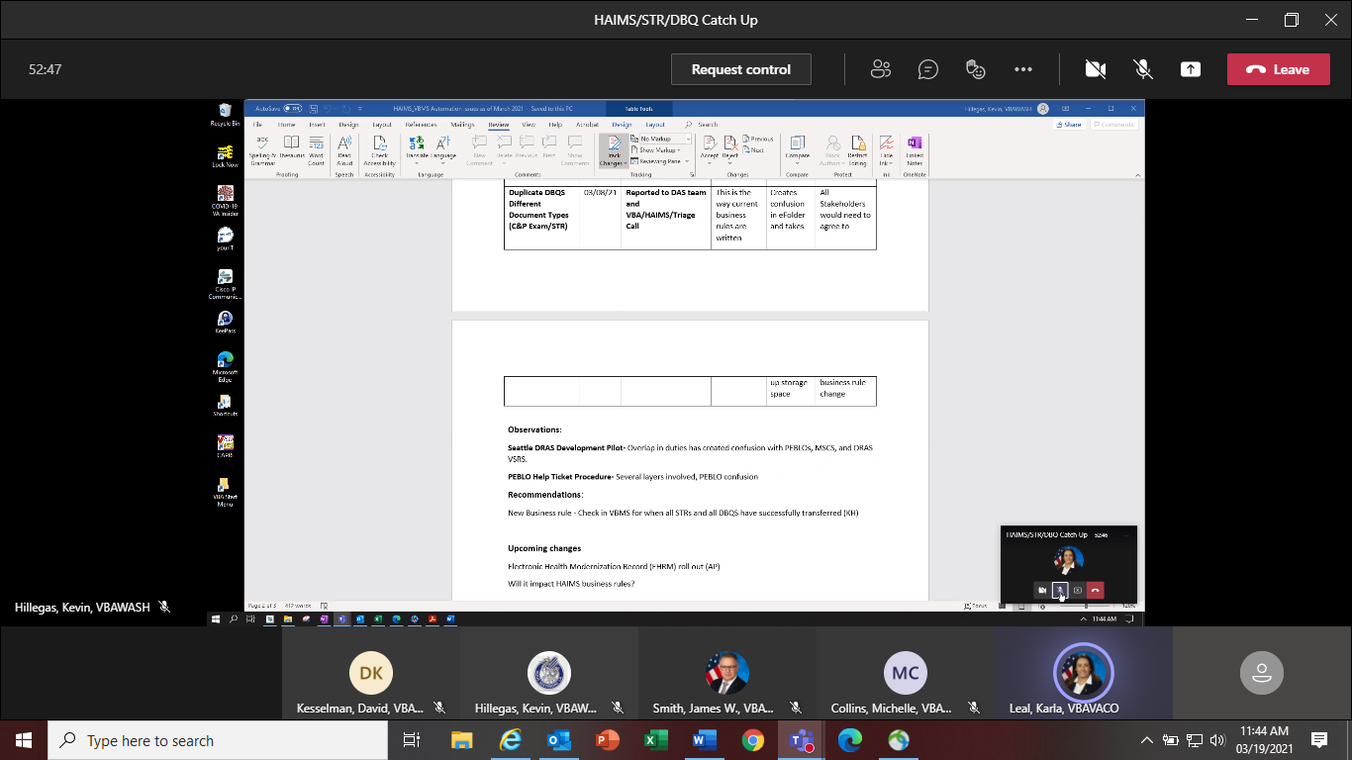

To ask a question, use the Raise your Hand option (click the hand and it will change color) in the Teams Meeting and you will be called upon for your question/comment. Once your question/comment is addressed lower your hand (click the hand again) (Figure 3). **Please do not talk/blurt out your question/comments unless called upon.**

Figure 3:



Please sign–up for the [C&P Calendar Subscription Service](http://vbacodmoint1.vba.va.gov/bl/21/calendar/cal_Subscribe.asp) to receive notification that the Read Ahead is available and for notification when the TMS number is active.

General Topic for Discussion

**Upcoming Guest Speakers**

Our staff is working to have some guest speakers present on upcoming calls as follows:

**Call Office Topic**

Nov 21 Acting Supv. for VR&E Outreach & Engagement VR&E transition assistance

Jan 22 VA Liaison Program National Program Manager VA Health Liaison Program

Feb 22 VHA Prosthetics (10P4RK) HISA Grant for transitioning SMs

Mar 22 Chief of Loan Policy LGY Funding Fee Waiver

**EP095 return and availability in VBMS**

During last month’s training event, we announced that End Product (EP) 336 with the Pre-Discharge Excluded claim label (EP336PDE) is available again in VBMS. On September 9, 2021, the Chief of Compensation Service Program Operations Staff informed us that [EP 095, Vocational Rehabilitation Eligibility Determination - Memorandum Rating Decision Required](https://vaww.vrm.km.va.gov/system/templates/selfservice/va_kanew/help/agent/locale/en-US/portal/554400000001034/content/554400000011474/Appendix%20B.%20End%20Product%20(EP)%20Codes#2), is also now in VBMS (Figure 1):

**Figure 1**



Please refer to [M21-1, X.i.6.D.1.a.](https://vaww.vrm.km.va.gov/system/templates/selfservice/va_kanew/help/agent/locale/en-US/portal/554400000001034/content/554400000177952/M21-1-Part-X-Subpart-i-Chapter-6-Section-D-Ancillary-Benefits-and-Other-Issues-Involving-Pre-Discharge-Claims#1a) and [M21-1, X.i.6.K.7.a.](https://vaww.vrm.km.va.gov/system/templates/selfservice/va_kanew/help/agent/locale/en-US/portal/554400000001034/content/554400000177960/M21-1,-Part-X,-Subpart-i,-Chapter-6,-Section-K---Special-Situations-Related-to-Integrated-Disability-Evaluation-System-(IDES)#7a) on handling VR&E claims/inquiries, and [M21-1, XIII.i.5.B.3.a](https://vaww.vrm.km.va.gov/system/templates/selfservice/va_kanew/help/agent/locale/en-US/portal/554400000001034/content/554400000173834/M21-1,-Part-XIII,-Subpart-i,-Chapter-5,-Section-B---Memorandum-Vocational-RehabilitationEmployment-(VR&E)-Ratings#3a) on preparation of VR&E memorandum ratings. If you are not aware of your Vocational Rehabilitation Counselor (VRC) serving your installation(s), or do not have current contact information for the VRCs, please see the [VR&E Office Directory](mailto:VR&E%20Office%20Directory) or contact [VREOUTREACH.VBACO@va.gov](mailto:VREOUTREACH.VBACO@va.gov) for this information. VR&E confirmed with our staff that both BDD and IDES participants may be assisted by the base VRCs or they will be directed how to obtain local VR&E assistance. VRCs provide service to all Service members (SMs) and Veterans that they may encounter.

**Identifying Evidence Info from Exam Staff**

Exam Staff will discuss Identifying Evidence.

In VBMS-EMS, claims processors are obligated to ensure that each piece of relevant evidence for the requested opinion is included in the Tabbed Evidence Description box as follows:

* *Tab Description*
* *Document Receipt Date*
* *Document Type*
* *Document ID*
* *Date of Record*

In VBMS, the ***Document ID***can be located in the following areas:

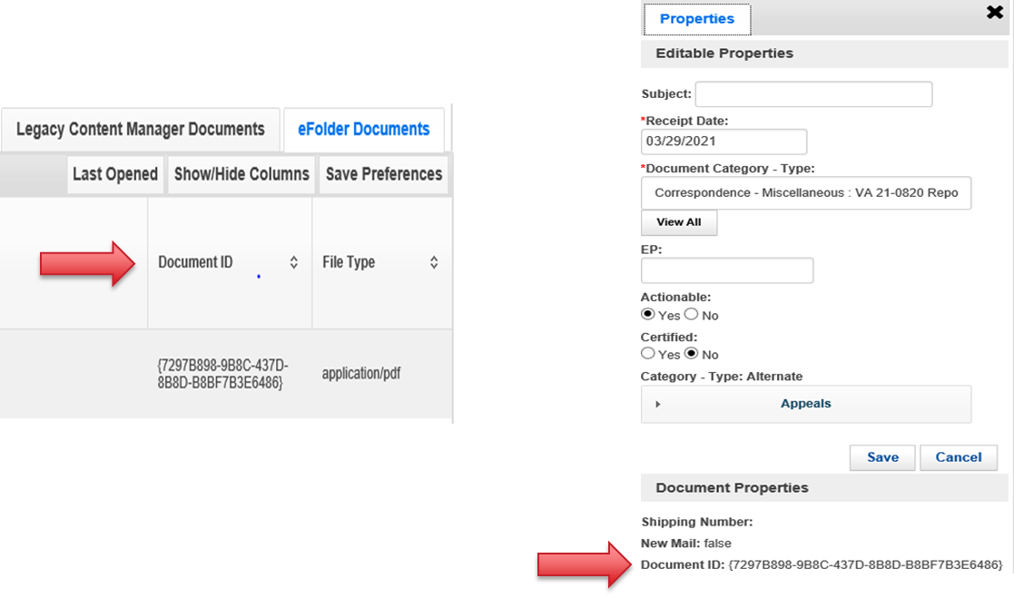

**Examples:**

Tab A: Asthma- pulmonary function test (PFT)

Document receipt date: 10/02/2000

Document type: CAPRI

Document ID: 2FB55D73-2F29-4808-99BD-F3F57D4367F3

Date of Record: 09/23/1999

Tab B: Pes planus- entrance exam

Document receipt date: 02/15/2019

Document type: STR

Document ID: F6A7389F-E257-4724-ADA3-66137CC86F76

Date of Record: 10/15/2020

IDES Specific Topics

**Public IDES Website Updated**

The Pre-Discharge IDES website was updated on August 10, 2021 and has a new URL of <https://www.benefits.va.gov/predischarge/ides.asp>. You may want to refresh old bookmarks, although the old URL should redirect to the new page. The previous site’s listing of Disability Benefits Questionnaires (DBQs) was removed. The public may use the resources found at <https://www.benefits.va.gov/compensation/dbq_publicdbqs.asp> for DBQ needs.

**MSC Actions if SM/MTF has a Complaint/Issue about a QTC Exam/Exam Provider**

MSCs are reminded that if they get a complaint/issue about a QTC or VES Exam/Exam Provider from a SM/MTF it should be sent to the Medical Disability Examination Office (MDEO) at [VAVBAWAS/CO/Contract Examination Inquiries](mailto:ContractExam.VBAVACO@va.gov) (cc [IDES Mailbox](mailto:VAVBAWAS/CO/IDES%20%3cIDES.VBACO@VA.GOV%3e)). It should not be sent directly to QTC. MDEO will research the issue/complaint and reply ASAP. For additional information on complaint steps to follow, see the [July 2021](https://vbaw.vba.va.gov/VBADOD/docs/IDES/July2021BDDIDESCallReadAheadFinal.docx) Monthly Conference Call.

**Handling IDES Cases Involving Employee-Veterans**

When an employee or relative of an employee of the MSC’s Regional Office (RO) is referred to IDES, MSC actions should be completed by an MSC at the RO’s sister station. Please note that the RACC does not process IDES claims. Sister stations are in Appendix 2.

When necessary, the IDES Staff will facilitate the process of reassigning the IDES case to the sister station MSC. When such facilitation is needed, or if the RO’s sister station does not support the IDES program, please contact the [IDES Mailbox](mailto:VAVBAWAS/CO/IDES%20%3cIDES.VBACO@VA.GOV%3e) for assistance.

**Completing Initial Meetings with IDES Service members**

[M21-1, X.i.6.E.4.d.](https://vaww.vrm.km.va.gov/system/templates/selfservice/va_kanew/help/agent/locale/en-US/portal/554400000001034/content/554400000177953/M21-1,-Part-X,-Subpart-i,-Chapter-6,-Section-E---Integrated-Disability-Evaluation-System-(IDES),-Referrals,-and-Initial-Processing#4) says “Whenever possible, the initial meeting between MSCs and IDES participants should be face-to-face. If such a meeting is not feasible, MSCs may hold the meeting by video conference or, as a last resort, by telephone.” During COVID and/or work at home, almost all interviews are/were via telephone. Some locations are now back in the office, and when possible, the interview should be in-person, however, if there are still COVID concerns or the SM prefers a telephonic interview we should try to accommodate.

**HAIMS/VBMS/STR/DBQ Update**

The IDES Program Office, in coordination with DoD, continues to track the HAIMS/VBMS/STRS/DBQ procedures implemented February 1, 2021.

* Challenges have been identified with some STR and DBQ transfers. The staff continues to work with VBMS, DAS and HAIMS to resolve
* NAD DBQ Business rule updated July 27, 2021
* HAIMS automation process has been published in the M21-1
* MSCs should not take any action on a case in VBMS and VTA until the PCS Date is entered in VTA by the PEBLO which indicates a case is ready for CEST
* If MTFs are having issues with uploading or not aware of the HAIMS/VBMS/DBQ transfer process, send details including VTA Case ID (if applicable) to the [IDES Mailbox](mailto:VAVBAWAS/CO/IDES%20%3cIDES.VBACO@VA.GOV%3e)

Holiday Leave and SM Availability during the Claims Development and Examination Phases

As we approach the holidays, MSCs are reminded to inquire about approved leave (non-emergency) during the initial interview that could interfere with the IDES process. If the SM indicates he or she has approved leave that would prevent the timely completion of exams, the MSC should return the referral to the PEBLO as an improper referral and remove the PCS Date. MSCs should confirm with the PEBLO that they are aware of the upcoming leave and see if something can be worked out (e.g. SM will attend exams while on leave, etc.). Do not accept a case or submit exam requests if you know the SM will not be available to report for exams.

Notes:

1. DoD policy allows commanders to grant leave to IDES SMs for the welfare or morale of the SM, provided that the leave does not prevent timely completion of IDES appointments.

2. Deferment should not be used by PEBLOs as a reason for cases where the SM is going on leave. If you hear of this being done, contact the [IDES Mailbox](mailto:VAVBAWAS/CO/IDES%20%3cIDES.VBACO@VA.GOV%3e).

Current IDES Program Timeliness

As outreach specialists and VA’s frontline contact with SMs and Veterans, it is vital that we are realistic in our communications regarding claims processing times. Current program timeliness data (ADC) for September 2021.

|  |  |  |
| --- | --- | --- |
| **Stage/Phase** | **IDES Goal (AD/NAD)** | **September 2021 (AD/NAD)** |
| **Claim Dev** | **5/11** | **5/7** |
| **Medical Stage** | **32** | **53/59** |
| **Proposed Ratings** | **20** | **8/17** |
| **Recon Ratings** | **4** | **8/16** |
| **Exit Interviews** | **14** | **7/7** |
| **Final Ratings** | **20/na** | **22/na** |

***Source:*** *VTA Completed Reports (Days to Complete Including Deferment) October 4, 2021 (3 ET).*

***Note:*** *VA using the goals from the 230-day process.*

Seattle DRAS VSC Development Pilot Info

The Pilot has been extended until October 15, 2021.

**BDD Specific Topics**

**Release from Active Duty (RAD) in VBMS**

The BDD team has submitted a VBMS Help Ticket for the below issue where VBMS has the Verified field prepopulated with, “Verified via VADS,” and users are unable to edit it. RVSRs have been unable to finalize the in-service BDD rating without the RAD entered in VBMS. We are working with the Quality Review staff to stop calling errors for this scenario where users are unable to remove the service verification from VBMS.

The Fort Carson intake site provided a workaround:

1) delete all periods of service in SHARE,

2) add the period(s) of service back into SHARE and select update,

3) delete the period(s) of service in VBMS, and

4) add the period(s) of service back in VBMS with the future RAD.

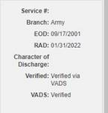

**Use of Tracked Items in VBMS**

Recently, we have received examples of delayed BDD claims due to unnecessary tracked items placed in VBMS. The use of a tracked item is essential to claims development; however, using tracked items such as “Awaiting STRs” and “Awaiting DD214” prior to discharge, has delayed BDD claims from advancing to the Ready for Decision (RFD) stage. In certain circumstances, these tracked item may be appropriate, but in only rare cases should they be used prior to discharge. Please ensure that all tracked items are reviewed carefully and close any unnecessary tracked items that could delay processing.

**Current BDD Program Timeliness**

As VA’s frontline contact with SMs and Veterans, it is vital that we are transparent in our communications regarding claims processing times. Below is the current program timeliness data as of October 7, 2021.

|  |  |  |
| --- | --- | --- |
| **BDD Timeliness Data** | | |
| **Data Points** | **Goal** | **October 7, 2021** |
| **Completed FYTD** |  | **1,215** |
| **Receipts FYTD** |  | **802** |
| **Pending** |  | **9,568** |
| **# Completed w/in 30 Days of Discharge** |  | **674** |
| **% Completed w/in 30 Days of Discharge** | **100%** | **55%** |
| **Avg. Days to Complete FYTD** | **30** | **67** |

***Source:*** *Tableau BDD History Report, October 8, 2021*

Upcoming Teleconferences

The next BDD/IDES Call is scheduled for Tuesday, November 9, 2021, at 2PM ET. Please submit IDES questions and proposed topics for discussion to the [IDES Mailbox](mailto:VAVBAWAS/CO/IDES%20%3cIDES.VBACO@VA.GOV%3e), and BDD questions and proposed topics for discussion to the [BDD Mailbox](mailto:VAVBAWAS/CO/PREDISCHARGE%20%3cPredischarge.VBACO@va.gov%3e) no later than close of business (COB), Monday, October 25, 2021.

The next BDD/IDES Coaches Call is scheduled for December 2, 2021, at 2PM ET. Please submit IDES questions and proposed topics for discussion to the [IDES Mailbox](mailto:VAVBAWAS/CO/IDES%20%3cIDES.VBACO@VA.GOV%3e), and BDD questions and proposed topics for discussion to the [BDD Mailbox](mailto:VAVBAWAS/CO/PREDISCHARGE%20%3cPredischarge.VBACO@va.gov%3e) no later than COB, Monday November 15, 2021.

Open Floor

**Appendix 1: Call Notes from the September,14 2021 MSC Training Event**

***Medical Exams Update presented by Medical Disability Evaluation Office (MDEO)***

**Question: QTC exams are delayed due to vendor quality review often adds 30 days when additional exams are requested. Are other people also experiencing issues with delays of quality reviews?**

**Answer:** Quality review process is common since the contractor cannot release an exam until it is certified adequate for VA purposes. The only option contractors have, is to reevaluate and conduct additional exams to ensure they are ready for VA.

**Question: For scheduling outside of the 100 miles limit, is permission required from the SM or from MDEO?**

**Answer:** The process is two-fold, before contractor can request the permission from MDEO they must know that the SM is willing to attend that examination.

**Question: A common problem is that exams are being schedule almost 100 miles away, regardless of the vast number of providers that are located in the city. Often, this issue generates frustration since SMs need to travel far away.**

**Answer:** The issue is about availability, as not all doctors and providers in metropolitan areas are accredited to conduct exams for the VA. MDEO Vendors are constantly recruiting accredited providers to expand their network.

**Question: Why cannot specialist exams, like TBI, be ordered through VHA after it reopened?**

**Answer:** Currently VA is not using VHA for IDES and BDD examinations. The situation is being discussed by VBA senior leadership to determine if this will become the policy moving forward. Given VHA internal policy concerning pandemic and health care related issues, examinations will be conducted by contractors until leadership decides otherwise.

**Question: VSOs are communicating to Veterans that they have the preference to choose where they want to get the exams for BDD claims and citing the M21-1. However, this guidance is opposite to the internal request to schedule all BDD exams with the contractors. VSOs are telling veterans to file complaints with the White House, causing additional scrutiny while trying to execute their job timely.**

**Answer:** MDEO has requested an update to the M21-1, but that is something that they do not have authority over.

Pre-Discharge Staff response: [M21-1, IV.i.2.A.2.b/c](https://vaww.vrm.km.va.gov/system/templates/selfservice/va_kanew/help/agent/locale/en-US/portal/554400000001034/content/554400000180498/M21-1-Part-IV-Subpart-i-Chapter-2-Section-A-Examination-Requests-Overview#2b) instructs when routing an examination request, take into account any claimant preferences, such as a preference that his/her examination be conducted at a VHA facility. These instructions only apply however to cases requiring ERRA. Currently Pre-Discharge examinations do not require ERRA.

**Question: Can SMs reschedule IDES exams with QTC directly or do they always need an approval and request from MSCs?**

**Answer:** QTC does not have the authority to reschedule exams. SMs must have approval from their PEBLOS and command for VA exams to be rescheduled. [M21-1, X.i.6.F.3.k.](https://vaww.vrm.km.va.gov/system/templates/selfservice/va_kanew/help/agent/locale/en-US/portal/554400000001034/content/554400000177955/M21-1-Part-X-Subpart-i-Chapter-6-Section-F-Integrated-Disability-Evaluation-System-IDES-Development-and-Examinations#3k)

**Question: QTC scheduling team is contacting MSCs to request authorization to schedule exams outside the permitted area. MSCs don’t have this authority and can that be communicated to QTC personnel.**

**Answer:** The authorization to schedule an exam outside the permitted area is the responsibility of MDEO. MDEO can approve a SM to schedule an appointment outside the area is they choose to. If anyone contacts MSCs with this matter, please refer them to MDEO since they have to authorize such change.

***Seattle DRAS Army Pilot Update***

**Question: With regards to the brokering goal of three days, when does Day-1 start for the claim, when the MSC receives a claim or the next day?**

**Answer:** Claim development complete starts when the Prepared Claim Start Date (PCSD) is entered in the system. The measure for claim development complete is from the prepared claim start date to the date the exams are ordered.

**Question: The brokerage goal of three calendar days is not beneficial for the process and that it should be three business days. Ex. If a claim is received on Friday, an MSC would not be able to work on it until Monday which will inherently be over the 3-day goal. Can the brokerage goal be changed from three calendar days to three business days?**

**Answer:** The 3-day goal is for the DRAS Army pilot only, the goal for the manual is still five days. In order to change the date from calendar days to business days, VA will have to agree to do so with DoD.

**Question: The M21-1 states SMs have five days to return the VA Form 21-526EZ. However, the goal for brokerage is three days. If VA sends the form by day three, they are doing a disservice to SM who only have two days to return the form. In addition, the manual says that MSCs cannot order exam until day six. What is the disconnect between the manual and the 3-day goal for brokerage?**

**Answer:** Participants have five days to return VA Form 21-526EZ form, but the M21-1 doesn’t limit requesting the application the same day it is provided in order to expedite the process. The idea is to communicate to SMs importance of application and to request form at their earliest convenience or before the 5-day time limit.

**Question: VSRs are having issues trying to follow-up with SMs after development. When VSRs do follow-up with SMs for pending documents, Service members either get upset or do not know who they are, since their primary contact is the MSCs. Are MSCs seeing this as well like VSRs?**

**Answer:** MSCs also experience same and there is no one-time solution to this issue. Rework happens in all phases of the process and DRASs are responsible for rework actions when claim is at their station. Our program permits SMs to add additional issues at any stage and often, not all evidence is submitted up front for various reasons. SMs should know who their MSC is, having been provided POC info and business card (when conducted in person).

**Question: Regarding rework caused by physicians, entries in Veterans Tracking Application (VTA) are commonly “Corrective Action is Due to MSC” even when error is attributable elsewhere, such as with VSR. There is no field for VSR.**

**Answer:** Although VTA does not have VSR fields, in terms of the Pilot, any case that has rework and a PCSD of February 1, 2021, onwards is attributable to VSRs rework and not MSCs rework.

**Question:** **Our site has executed exams and development timelines faster than the pilot; why is the data in the pilot showing a completion rate smaller than their previous success target?**

**Answer:** The data is correct because it is measuring Pilot data for all sites, not just high-performing sites. The improvement described in the pilot reports speaks to the IDES program entirely.

***Providence DRAS Update***

**Question: The notification letter to participants for claim solicitation involving additional conditions identified on exam, instructed them to communicate with their MSC to add condition(s) to the case. However, not all SMs are getting that information in their letter and they are going directly to eBenefits or VA.gov, which triggers a new claim and DRAS to order exams. Why are the letters not asking SMs to reach back to their MSCS for those particular cases?**

**Answer:** Previously, letters were created in Letter Creator (LC), which allowed more flexibility to add additional instructions to contact MSCs, when needed, to add additional claims. However, now automated letters are dispatched through VBMS-CORE which makes it harder to add those changes. Returning to LC usage will be considered.

**Question: We are getting a lot of subsequent VA Form 21-0819 with conditions that are identified by the PEB after the proposed rating is done. PEBLOS are sending subsequent VA Form 21-0819 with changes made to the referred name of the condition that was already identified and required additional actions when actions are not needed.**

**Answer:** If the condition was previously claimed, DRAS should evaluate according to standard procedure, no prescribed form is required, to include a new VA Form 21-0819. If added referred issue was not previously claimed, a new VA Form 21-0819 is required and PEB is directed accordingly. [M21-1, X.i.6.K.1.h.](https://vaww.vrm.km.va.gov/system/templates/selfservice/va_kanew/help/agent/locale/en-US/portal/554400000001034/content/554400000177960/M21-1,-Part-X,-Subpart-i,-Chapter-6,-Section-K---Special-Situations-Related-to-Integrated-Disability-Evaluation-System-(IDES)#1h)

***Tips for Improving***

**Question: Can we increase the timeout settings on VTA?**

**Answer:** Previously VTA’s timeout was set at 30 minutes and as a result of similar question from field a few years ago, the timeout was increased. VTA is currently set for an hour and is the maximum permitted by VTA IT. This duration is a balance between operational usage and security.

**Question: Is it important or not to fill out fields that are not considered mandatory. Example - the broker field in VTA.**

**Answer:** VTA fields that are not mandatory will not prevent MSCs to move forward with the claim if that data is not provided. However, all *available* data is required tobe entered into VTA. VTA notes are an excellent way to clarify data gaps.

**Question: Is the Electronic Data Interchange Personal Identifier (EDIPI) going to be similar to Social Security Number (SSN), needing protection because it is Personal Identifiable Information (PII)?**

**of if it can be shared as a VTA number that can be put in subject line and not be flagged for encryption.**

**Answer:** DoD considers the [EDIPI](https://www.google.com/url?sa=t&rct=j&q=&esrc=s&source=web&cd=&cad=rja&uact=8&ved=2ahUKEwjCvZKsqKnzAhVKMlkFHd0GCacQFnoECAIQAQ&url=https%3A%2F%2Fwww.esd.whs.mil%2FPortals%2F54%2FDocuments%2FDoD%2520Identification%2520Number_20180710.docx%3Fver%3D2018-07-10-121214-930&usg=AOvVaw0Vfw-YqVSqsDA5ZhhtlygR) to be PII and proper handling must be used. The EDIPI should not be placed into an email subject line.

**Question: Can you clarify about the CEST date having to match the PCSD in VTA?**

**Answer:** The CEST date is the date of the CEST action. [M21-1, X.i.6.E.3.c.](https://vaww.vrm.km.va.gov/system/templates/selfservice/va_kanew/help/agent/locale/en-US/portal/554400000001034/content/554400000177953/M21-1-Part-X-Subpart-i-Chapter-6-Section-E-Integrated-Disability-Evaluation-System-IDES-Referrals-and-Initial-Processing#3c)

**Question: BDD aspirants at TAP would like to get BDD information from the “horse’s mouth”, but OTED’s policies prevent our participation. Why are we not permitted to attend by their policies?**

**Answer:** We inquired with the Office of Transition and Economic Development (OTED) who confirmed, MSCs may introduce themselves at TAP sessions after proper coordination with the TAP manager and Benefits Advisor. We recommend intake sites leave contact information and BDD material ([Fact Sheet](https://benefits.va.gov/BENEFITS/factsheets/general/BDDFactSheet.pdf)/flyer) for attendees.

**Question: Is there a way to clean up contentions in VBMS or VA.gov?**

**Answer:** VA.gov currently has 834 available contentions that a user may select. These were chosen after field testing with actual claimants, being mindful of their understanding of medical terms.

**Question:** **Can we do some type of surveys in TAP sessions to assess SMs access to MSCs for BDD claims assistance?**

**Answer:** We will look into this option and feasibility.

**Question: Can we stipulate in our outreach material what qualifying STRs are? We are getting only TRICARE On-Line (TOL) records for example.**

**Answer:** We are currently updating our [BDD Fact Sheet](https://benefits.va.gov/BENEFITS/factsheets/general/BDDFactSheet.pdf) with additional STR descriptions. Four Military Treatment Facilities (MTFs) were identified as not providing AHLTA records to separating members. This staff contacted our DoD counterparts who in turn conducted site visits to enforce proper Release of Information guidance. DoD confirmed they have not made a change in policy on providing STRs.

**Question: Is there any other way to log onto VTA? I’m only able to log onto VTA by clearing my browser cookies and cache, which in turn logs me out of VBMS.**

**Answer:** Programmers recommend clearing cache periodically.

**Question: Unsure how to address BDD National Guard claimants requiring in-service ratings who have an IDES Proposed Rating already in VBMS-R and user is being requested “Do you want to override?”**

**Answer:** DRAS raters were reminded to not use Special Issue of “IDES Deferral” prior to being ready for release in order for claim to remain on station and prevent improper NWQ routing.

***Program Enhancements***

**Question: Is there any way a poster or communicational product with BDD information can be created?**

**Answer:** There are BDD communication products available on VA.gov and the BDD Intranet. Local reproduction/distribution is encouraged. All stations are provided reproduction funds to be used as directed by local leadership. Another resource may be the military installation, TAP office, or Military Treatment Facility (MTF) graphics shop.

**Question: SMs are getting confused about a memorandum that discusses medical records being submitted in the 90-180 days and delaying submitting STRs timely.**

**Answer:** SMs should not be able to see internal memos. Claims processors are encouraged to contact SMs and request any needed documents that are missing instead of waiting, especially about the importance of STR submission.

**Question: Is there a way to make the IDES participant POC information on VTA match what is on the VA Form 21-0819?**

**Answer:** DEERS populates IDES participant POC information into VTA. SMs must ensure DEERS is up to date. If VTA and VA Form 21-0819 information does not match, the VA Form 21-0819 data should be considered the most up to date.

**Question: We are getting PEBLOs who are backdating the PCSD, are they supposed to be able to do that?**

**Answer:** No, in these instances communicate to [VAVBAWAS/CO/IDES](mailto:ides.vbaco@va.gov) with case ID and we will contact DoD to have that corrected.

**Question: How long does the pilot program last?**

**Answer:** Pilot has been extended until October 15.

**Question: Can your office look into on what can be done about errors associated with service information that is system verified, so it does not show as verified service when the RAD is not in populated. It would be great for the coders to fix this error and alleviate so many errors being called.**

**Answer:** Our staff has put in a ticket to VBMS about this issue. While it is being addressed, we were told the following workaround is available

RAD VBMS Entry Workaround Steps:

1) delete all periods of service in SHARE, select save

2) add the period(s) of service back into SHARE and select update,

3) delete the period(s) of service in VBMS, select no in the Verified block for the current period

4) add the period(s) of service back in VBMS with the future RAD and

5) select the drop-down arrow under Verified and select “No”

**Question: Is there a way to reduce “unforced errors” such as what occurs when a Specialty Exam is simultaneously system selected along with the SHA Exam and associated with a contention?**

**Answer:** VBMS requires users to “Preview” prior to sending ESR and users are to review the ESR for accuracy prior to release.

**Appendix 2. Regional Office Sister Stations**

The table below contains the offices of jurisdiction for active employee-Veteran and National Service Officer (NSO) claims folders and related VA records.

| **Employing RO** | **Office of Jurisdiction** |
| --- | --- |
| Central Office | Baltimore, Maryland |
| Appeals Management Center | Baltimore, Maryland |
| Area Offices (see *Note*) | Baltimore, Maryland |
| Albuquerque, New Mexico | Waco, Texas |
| Anchorage, Alaska | Seattle, Washington |
| Atlanta, Georgia | Montgomery, Alabama |
| Baltimore, Maryland | Providence, Rhode Island |
| Boise, Idaho | Fort Harrison, Montana |
| Boston, Massachusetts | Manchester, New Hampshire |
| Buffalo, New York | New York, New York |
| Cheyenne, Wyoming | Salt Lake City, Utah |
| Chicago, Illinois | Milwaukee, Wisconsin |
| Cleveland, Ohio | Detroit, Michigan |
| Columbia, South Carolina | St. Petersburg, Florida |
| Denver, Colorado | Salt Lake City, Utah |
| Des Moines, Iowa | Chicago, Illinois |
| Detroit, Michigan | Pittsburgh, Pennsylvania |
| District of Columbia (WRO) | Wilmington, Delaware |
| Fargo, North Dakota | St. Paul, Minnesota |
| Fort Harrison, Montana | Seattle, Washington |
| Hartford, Connecticut | White River Junction, Vermont |
| Honolulu, Hawaii | San Diego, California |
| Houston, Texas | Phoenix, Arizona |
| Huntington, West Virginia | Winston-Salem, North Carolina |
| Indianapolis, Indiana | Louisville, Kentucky |
| Jackson, Mississippi | St. Louis, Missouri |
| Lincoln, Nebraska | New Orleans, Louisiana |
| Little Rock, Arkansas | Wichita, Kansas |
| Los Angeles, California | Oakland, California |
| Louisville, Kentucky | Nashville, Tennessee |
| Manchester, New Hampshire | Togus, Maine |
| Manila, Philippines | San Diego, California |
| Milwaukee, Wisconsin (including the Pension Maintenance Center (PMC)) | Des Moines, Iowa |
| Montgomery, Alabama | Columbia, South Carolina |
| Muskogee, Oklahoma | Little Rock, Arkansas |
| Nashville, Tennessee | Cleveland, Ohio |
| New Orleans, Louisiana | Jackson, Mississippi |
| New York, New York | Newark, New Jersey |
| Newark, New Jersey | Buffalo, New York |
| Oakland, California | Reno, Nevada |
| Philadelphia, Pennsylvania (including the PMC) | Indianapolis, Indiana |
| Phoenix, Arizona | Albuquerque, New Mexico |
| Pittsburgh, Pennsylvania | Philadelphia, Pennsylvania |
| Portland, Oregon | Boise, Idaho |
| Providence, Rhode Island | Hartford, Connecticut |
| Reno, Nevada | Sioux Falls, South Dakota |
| Roanoke, Virginia | Huntington, West Virginia (see ***Note***) |
| St. Louis, Missouri | Lincoln, Nebraska |
| St. Paul, Minnesota (including the PMC) | Denver, Colorado |
| St. Petersburg, Florida | Atlanta, Georgia |
| Salt Lake City, Utah | Seattle, Washington |
| San Diego, California | Los Angeles, California |
| San Juan, Puerto Rico | St. Petersburg, Florida |
| Seattle, Washington | Portland, Oregon |
| Sioux Falls, South Dakota | St. Paul, Minnesota |
| Togus, Maine | Boston, Massachusetts |
| Waco, Texas | Houston, Texas |
| White River Junction, Vermont | Togus, Maine |
| Wichita, Kansas | Muskogee, Oklahoma |
| Wilmington, Delaware | Indianapolis, Indiana |
| Winston-Salem, North Carolina | Roanoke, Virginia |

***Note:*** Eastern Area Veteran employee claims folders should be maintained at the Huntington Regional Office, not Baltimore.