Monthly Benefits Delivery at Discharge (BDD) and

Integrated Disability Evaluation System (IDES)

Conference Call Read Ahead

Compensation Service

BDD/IDES (212A)

July 13, 2021 — 2 PM ET

The Compensation Service BDD/IDES hosts this call to announce updates and address issues and questions related to the BDD/IDES Programs. All Military Services Coordinators (MSCs), Disability Rating Activity Sites (DRAS), Regional Offices and other VA personnel supporting BDD/IDES are invited to participate.

This read-ahead is provided to facilitate discussion during the conference call.

The Call Notes for the June call are in Appendix 1. The TMS # for this month’s call will be provided during the call and should be active within a week of the call’s completion. A Calendar Blast will notify the field when the TMS # is active.

**Call-in Information**

[Join Microsoft Teams Meeting](https://teams.microsoft.com/l/meetup-join/19%3ameeting_MzlhN2FlN2YtYTFhNS00NjExLWEwMzMtYWEwYjE0YzU1Y2Qx%40thread.v2/0?context=%7b%22Tid%22%3a%22e95f1b23-abaf-45ee-821d-b7ab251ab3bf%22%2c%22Oid%22%3a%22a0338b5c-0526-4e13-9809-5d0ecc8cdeb8%22%7d)

[+1 872-701-0185](tel:+1%20872-701-0185,,448196643# )  United States (Toll)

Conference ID: 448 196 643#

The Read Ahead and Slides will be attached to the Chat (may have to scroll up in the Chat) and can also be found in the Files link on the call. They are also located on the [IDES Homepage](https://vbaw.vba.va.gov/vbadod/IDES.asp) and on the [BDD Homepage.](https://vbaw.vba.va.gov/vbadod/predischarge.asp)

Note: The slides will not be available on the homepages until noon of call day.

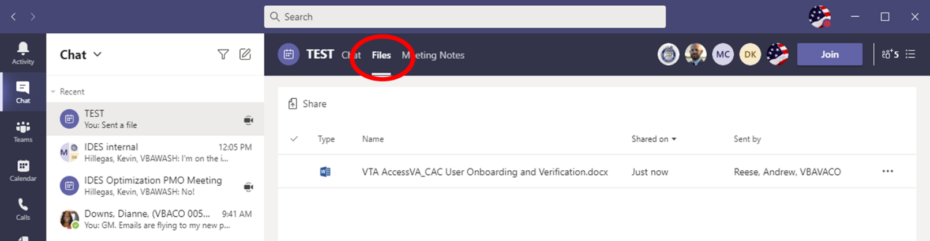

** After the call starts, the Teams Chat **will only** be used to ask questions. Call attendees **will not** make comments or respond to any of the questions. Please adhere to this request.

Ask questions over the phone or send an email to the appropriate staff corporate mailbox.

Please mute your microphone and turn off your camera by clicking on the appropriate icon. (See Figure 1)

Figure 1:

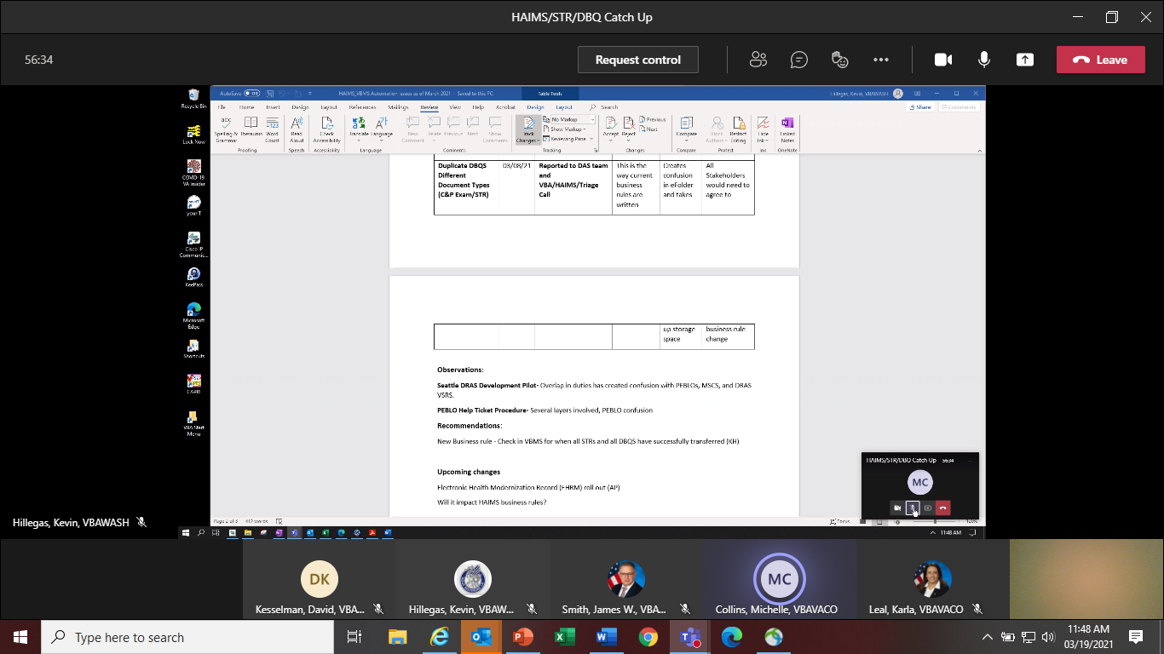

Below (Figure 2) is what your microphone and camera icons should look like when it is muted/turned off. Click the microphone icon to unmute if you need to ask a question (do not unmute if you do not need to speak). If you are dialed in via your phone, ensure your phone is muted.

Figure 2:

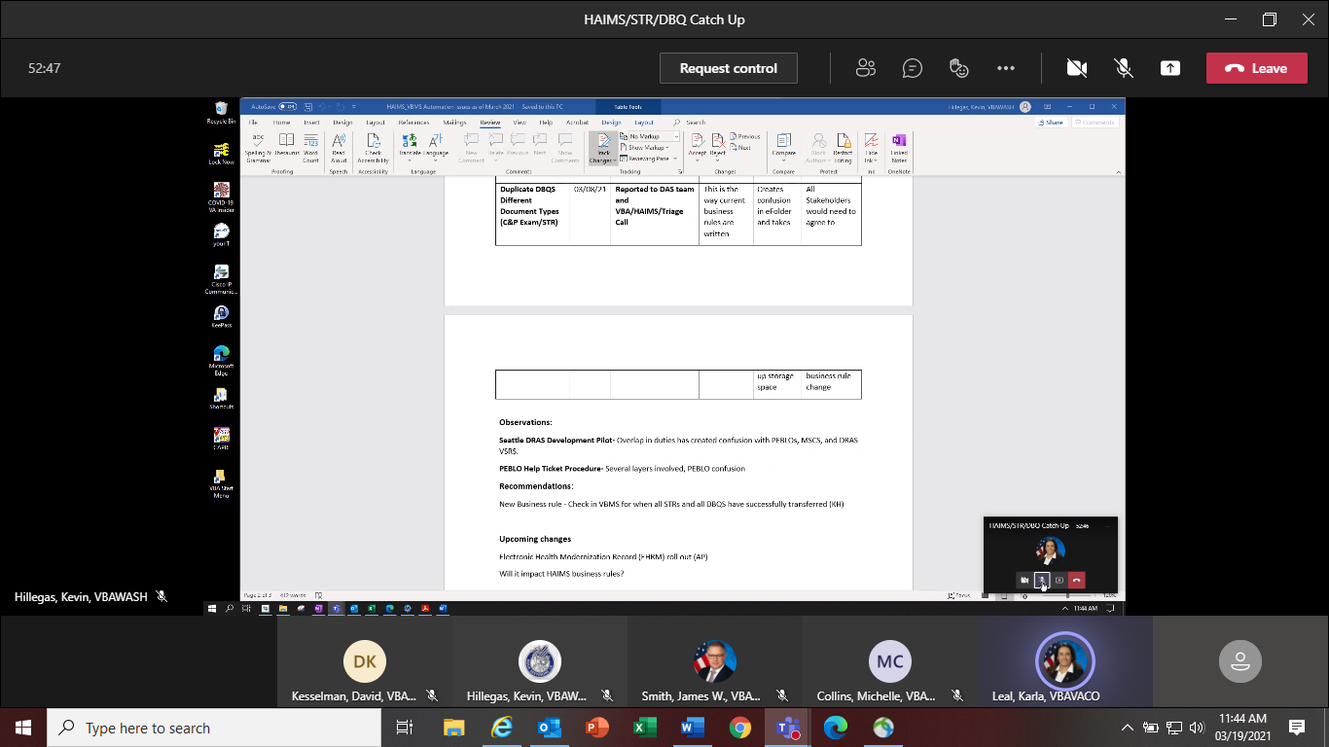

To ask a question, use the Raise your Hand option (click the hand and it will change color) in the Teams Meeting and you will be called upon for your question/comment. Once your question/comment is addressed lower your hand (click the hand again) (Figure 3). **Please do not talk/blurt out your question/comments unless called upon.**

Figure 3:



Please sign–up for the [C&P Calendar Subscription Service](http://vbacodmoint1.vba.va.gov/bl/21/calendar/cal_Subscribe.asp) to receive notification that the Read Ahead is available and for notification when the TMS number is active.

General Topic for Discussion

**Update to Military Sexual Trauma (MST) Language on Exam Requests**

Last month we stated effective immediately and until further notice, MSCs will add the language per [M21- I.IV.ii.1.D.6.c](https://vaww.vrm.km.va.gov/system/templates/selfservice/va_kanew/help/agent/locale/en-US/portal/554400000001034/content/554400000014906/M21-1,-Part-IV,-Subpart-ii,-Chapter-1,-Section-D---Claims-for-Service-Connection-(SC)-for-Post-Traumatic-Stress-Disorder-(PTSD)#6) to all exam requests (AD or NAD) that include a claim for PTSD due to MST.

**Update:** The MST opinion language has been removed from the Supplemental Language Matrix. The MST opinion language has been incorporated into exam management system (EMS) under "Is Specialty Language Needed?".

Please contact ContractExam.VBAVACO@va.gov for questions on supplemental language required for Medical Disability Examination (MDE) contract exams.

**Claimant’s Complaints Involving VA Exams**

In the [February 2021 Read Ahead](https://vbaw.vba.va.gov/VBADOD/docs/predischarge/Feb2021BDDIDESCallReadAheadFinal.docx) we discussed DoD Requesting Exam Clarifications. Along with that guidance, here are some additional recommendations if you receive a claimant’s complaint regarding a VA examination involving a Pre-Discharge claim:

1. Instruct Service member (SM)/claimant to record complaint (who, what, where, when) on a [VA Form 4138](https://www.va.gov/find-forms/about-form-21-4138) and to submit form using the [Upload evidence to support your claim](https://www.va.gov/disability/upload-supporting-evidence) link on VA.gov or secure email.
2. Assure SM that form will be available in our Veterans Benefits Management System (VBMS) for review.
3. Alert your station [Exam Liaison](https://vbaw.vba.va.gov/bl/21/contractexams/docs/Exam%20Liaison%20Directory.xlsx) and Coach as needed depending on complaint. Exam Liaisons will determine if complaint requires escalation to the [Medical Disability Examination Office (MDEO)](https://vbaw.vba.va.gov/bl/21/MDEO/default.htm). MDEO/vender will review and if something else is needed, reach back out to have whatever is needed done. Disagreements with the rating decision based on the examination results will not be routed to MDEO.
4. Remind claimant that contractors conduct a quality review after all Disability Benefits Questionnaires (DBQs) are signed off and prior to releasing exams to VA. Additionally, instruct SM that the VA Rating Board is the authority that determines sufficiency of examinations for evaluation purposes.
5. Vendors provide a satisfaction survey which claimants are encouraged to always complete.
6. Ensure complaint remediation actions are annotated in VBMS/Veterans Tracking Application (VTA) as appropriate.

**Updated Guidance On Submitting Audiological Exam And Medical Opinion Requests**

[M21-1 III.iv.3.A.7.h. Medical Opinions and the Hearing Loss and Tinnitus DBQ](https://vaww.vrm.km.va.gov/system/templates/selfservice/va_kanew/help/agent/locale/en-US/portal/554400000001034/content/554400000015809/M21-1,-Part-III,-Subpart-iv,-Chapter-3,-Section-A---Examination-Requests-Overview#7h) was recently updated. If tinnitus is not claimed, but reported during the course of the exam, examiners will provide an etiology opinion even when not solicited as long as tinnitus is not already service-connected (SC). For this reason, when preparing any audiological examination and/or opinion request, include a note/comment informing the examiner whether tinnitus is or is not SC.

IDES Specific Topics

**HAIMS/VBMS/STR/DBQ Update**

The IDES Program Office, in coordination with DoD, continues to track the HAIMS/VBMS/STRS/DBQ procedures implemented February 1, 2021.

* Challenges have been identified with some STR and DBQ transfers. The staff continues to work with VBMS, DAS and HAIMS to resolve
* NAD DBQ Business rule release date TBD
* HAIMS automation process has been published in the M21-1
* MSCs should not take any action on a case in VBMS and VTA until the PCS Date is entered in VTA by the PEBLO which indicates a case is ready for CEST
* If MTFs are having issues with uploading or not aware of the HAIMS/VBMS/DBQ transfer process, send details including VTA Case ID (if applicable) to the [IDES Mailbox](mailto:VAVBAWAS/CO/IDES%20%3cIDES.VBACO@VA.GOV%3e)

Cases when SM will not return forms/not available/not replying to MSC Contact

When a SM does not return forms, is not available and/or does not reply to MSC contact, and depending on the situation, the case should be returned to the PEBLO and the Prepare Claim Start Date removed, brokered to the DRAS (Army cases) or exams ordered for the referred conditions. We have been seeing too many cases with notes indicating “waiting on forms” or “waiting on a reply from SM” for more than 20-30 days. Please do what needs to be done and move the case along or return it.

Note: These are the types of cases that should be caught/addressed by running the Pending Claims Development Report.

**Needed Documents to PEBLO Immediately Following the Initial Interview**

Our office received communications through the Office of the Assistant Secretary of Defense

(Health Affairs) that PEBLOs are not receiving needed documents in some cases.

As described in M21-1 III.i.2.D.5.d., immediately following the initial meeting with an IDES SM, at minimum MSCs will provide the SM’s PEBLO:

* a copy of the completed VAF 21-526EZ, Application for Disability Compensation and Related Compensation Benefits, or a copy of the notice that the SM declined to submit a VA claim (if applicable), and

* a list of the examinations and/or medical opinions necessary to evaluate both the referred and claimed disabilities, with the exception of those disabilities that are not subject to examination for IDES purposes. The VAF 21-2507, Request for Physical Examination, or VBMS’s Exam Scheduling Request (ESR) for all referred/claimed disabilities will suffice for the needed list of examinations.

Current IDES Program Timeliness

As outreach specialists and VA’s frontline contact with SMs and Veterans, it is vital that we are realistic in our communications regarding claims processing times. Current program timeliness data (ADC) for June 2021.

|  |  |  |
| --- | --- | --- |
| **Stage/Phase** | **IDES Goal (AD/NAD)** | **June 2021 (AD/NAD)** |
| **Claim Dev** | **5/11** | **8/9** |
| **Medical Stage** | **32** | **69** |
| **Proposed Ratings** | **20** | **5** |
| **Recon Ratings** | **4** | **12** |
| **Exit Interviews** | **14** | **8** |
| **Final Ratings** | **20/na** | **22/na** |

***Source:*** *VTA Completed Reports (Days to Complete Including Deferment) July 6, 2021 (7:45am ET).*

***Note:*** *VA using the goals from the 230-day process.*

**BDD Specific Topics**

**Current BDD Program Timeliness**

As VA’s frontline contact with SMs and Veterans, it is vital that we are transparent in our communications regarding claims processing times. Below is the current program timeliness data as of July 7, 2021.

|  |  |  |
| --- | --- | --- |
| **BDD Timeliness Data** | | |
| **Data Points** | **Goal** | **July 7, 2021** |
| **Completed FYTD** |  | **19,080** |
| **Receipts FYTD** |  | **23,171** |
| **Pending** |  | **10,124** |
| **# Completed w/in 30 Days of Discharge** |  | **3,980** |
| **% Completed w/in 30 Days of Discharge** | **100%** | **20.9%** |
| **Avg. Days to Complete FYTD** | **30** | **119.0** |

***Source:*** *Tableau BDD History Report, July 7, 2021*

VTA Reminders

**VTA v.2.4.12**

VTA v.2.4.12 is scheduled for release late evening of June 21. A few of the changes/updates are shown below, and the complete list is in [Folder 6](https://vta.va.gov/VTA/secured/DES/View/HomepagePKCFileManager.aspx?FolderId=207) of the IDES Program Knowledge Center.

* No New Exams Ordered data field added to the MSC Tab
* Brokered to DRAS data field added to the MSC Tab
* Removed ‘Electronic STRs data field from the MSC Tab
* Update to definitions of Claims Establishment (CEST) Date, Exam End Date, SHA Exam Returned Date, Other Exam Returned Date and Other Exam Requested Date on MSC Tab

Seattle DRAS VSC Development Pilot

Seattle DRAS VSC Development Pilot Info and Reminders

The Pilot for all Army cases has been extended to at least 30 July.

Upcoming Teleconferences

The next BDD/IDES Call is scheduled for Tuesday, August 10, 2021, at 2PM ET. Please submit IDES questions and proposed topics for discussion to the [IDES Mailbox](mailto:VAVBAWAS/CO/IDES%20%3cIDES.VBACO@VA.GOV%3e), and BDD questions and proposed topics for discussion to the [BDD Mailbox](mailto:VAVBAWAS/CO/PREDISCHARGE%20%3cPredischarge.VBACO@va.gov%3e) no later than close of business (COB), Monday, July 26, 2021.

The next BDD/IDES Coaches Call is scheduled for September 2, 2021, at 2PM ET. Please submit IDES questions and proposed topics for discussion to the [IDES Mailbox](mailto:VAVBAWAS/CO/IDES%20%3cIDES.VBACO@VA.GOV%3e), and BDD questions and proposed topics for discussion to the [BDD Mailbox](mailto:VAVBAWAS/CO/PREDISCHARGE%20%3cPredischarge.VBACO@va.gov%3e) no later than COB, Monday August 16, 2021.

Open Floor

**Appendix 1: Call Notes from the June 2021 Comp Service BDD/IDES Conference Call**

**Question: For BDD claims, if a Service member claims sleep apnea and does not have a diagnosis or a sleep study of record, should a sleep study be requested?**

**Answer:** BDD claim processors are only required to request the SHA examination and any specialist exams (typically hearing, vision, dental, and psychiatric). Directed development (deferrals) should be followed and or discussed with the rating specialist or team coach.

[M21-1, III.i.2.B.2.b. Special Claims-Handling Procedures for BDD Claims](https://vaww.vrm.km.va.gov/system/templates/selfservice/va_kanew/help/agent/locale/en-US/portal/554400000001034/content/554400000014101/M21-1-Part-III-Subpart-i-Chapter-2-Section-B-Division-of-Responsibilities-for-Processing-Benefits-Delivery-at-Discharge-BDD-and-BDD-Excluded-Claims#2b)

[M21-1,III.iv.3.A.1.i. Definition: Specialist Examination](https://vaww.vrm.km.va.gov/system/templates/selfservice/va_kanew/help/agent/locale/en-US/portal/554400000001034/content/554400000015809/M21-1,-Part-III,-Subpart-iv,-Chapter-3,-Section-A---Examination-Requests-Overview)