Monthly Benefits Delivery at Discharge (BDD) and

Integrated Disability Evaluation System (IDES)

Conference Call Read Ahead

Compensation Service

BDD/IDES (212A)

June 8, 2021 — 2 PM ET

The Compensation Service BDD/IDES hosts this call to announce updates and address issues and questions related to the BDD/IDES Programs. All Military Services Coordinators (MSCs), Disability Rating Activity Sites (DRAS), Regional Offices and other VA personnel supporting BDD/IDES are invited to participate.

This read-ahead is provided to facilitate discussion during the conference call.

The Call Notes for the May call are in Appendix 1. The TMS # for this month’s call will be provided during the call and should be active within a week of the call’s completion. A Calendar Blast will notify the field when the TMS # is active.

**Call-in Information**

[Join Microsoft Teams Meeting](https://teams.microsoft.com/l/meetup-join/19%3ameeting_MzlhN2FlN2YtYTFhNS00NjExLWEwMzMtYWEwYjE0YzU1Y2Qx%40thread.v2/0?context=%7b%22Tid%22%3a%22e95f1b23-abaf-45ee-821d-b7ab251ab3bf%22%2c%22Oid%22%3a%22a0338b5c-0526-4e13-9809-5d0ecc8cdeb8%22%7d)

[+1 872-701-0185](tel:+1%20872-701-0185,,448196643# )  United States (Toll)

Conference ID: 448 196 643#

The Read Ahead and Slides will be attached to the Chat (may have to scroll up in the Chat) and can also be found in the Files link on the call. They are also located on the [IDES Homepage](https://vbaw.vba.va.gov/vbadod/IDES.asp) and on the [BDD Homepage.](https://vbaw.vba.va.gov/vbadod/predischarge.asp)

Note: The slides will not be available on the homepages until noon of call day.

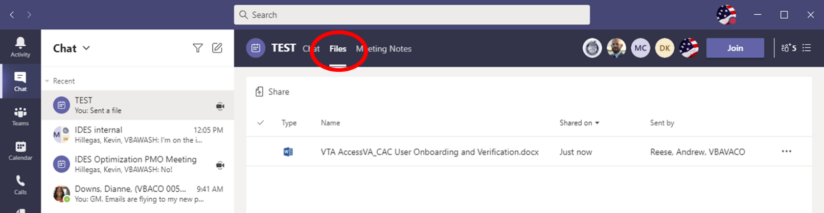

** After the call starts, the Teams Chat **will** only be used to ask questions. Call attendees **will not** make comments or respond to any of the questions. Please adhere to this request.

Ask questions over the phone or send an email to the appropriate staff corporate mailbox.

Please mute your microphone and turn off your camera by clicking on the appropriate icon. (See Figure 1)

Figure 1:

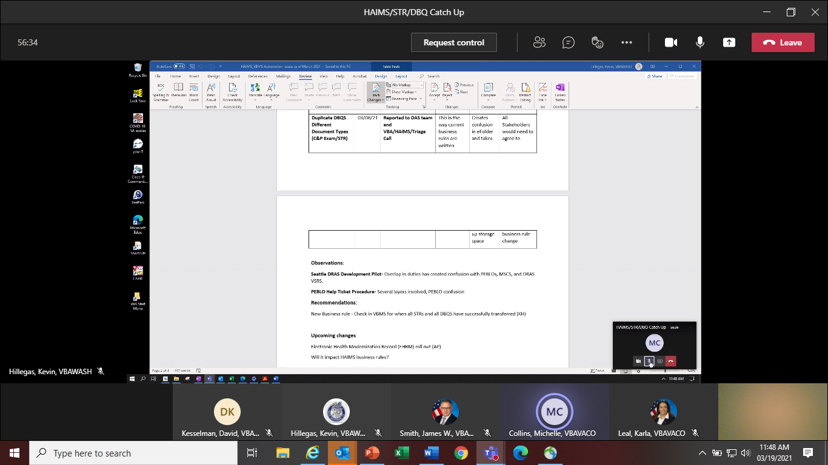

Below (Figure 2) is what your microphone and camera icons should look like when it is muted/turned off. Click the microphone icon to unmute if you need to ask a question (do not unmute if you do not need to speak). If you are dialed in via your phone, ensure your phone is muted.

Figure 2:

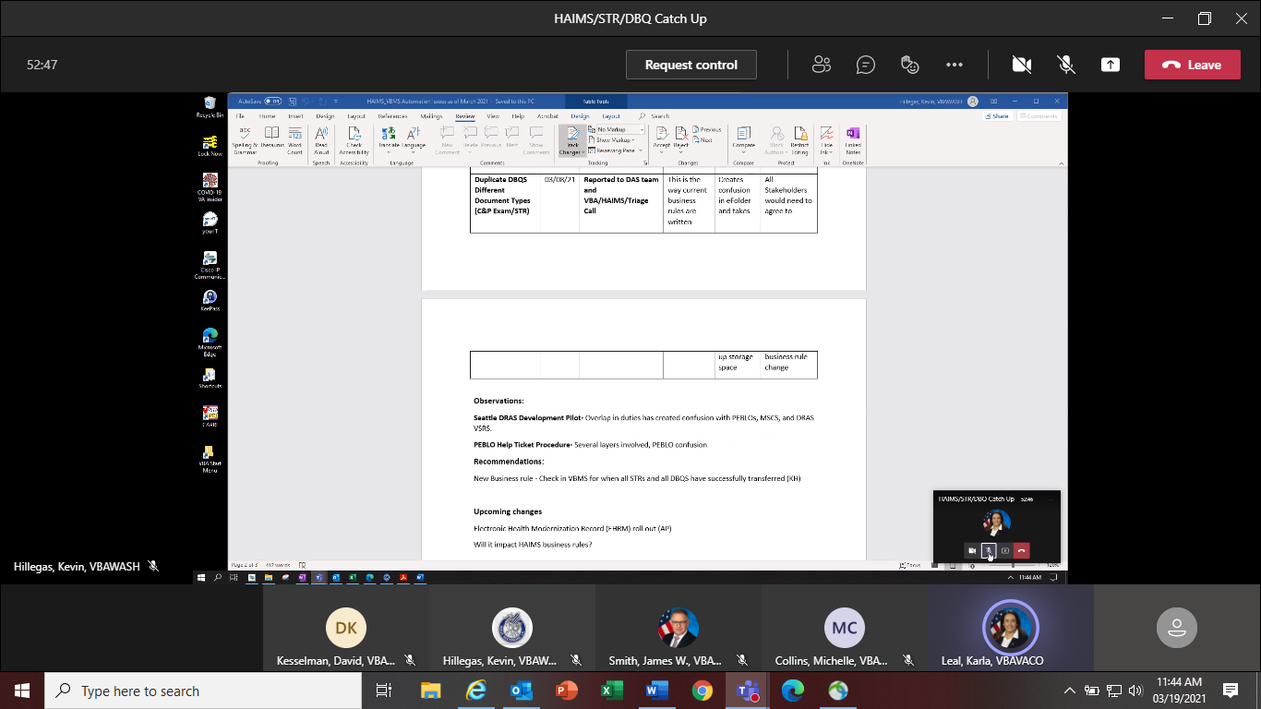

To ask a question, use the Raise your Hand option (click the hand and it will change color) in the Teams Meeting and you will be called upon for your question/comment. Once your question/comment is addressed lower your hand (click the hand again) (Figure 3). **Please do not ask questions or make comments unless called upon.**

Figure 3:



Please sign–up for the [C&P Calendar Subscription Service](http://vbacodmoint1.vba.va.gov/bl/21/calendar/cal_Subscribe.asp) to receive notification that the Read Ahead is available and for notification when the TMS number is active.

**Housekeeping Items**

* Tim Stephenson is no longer detailed as 212A Chief
* IDES Acting Chief: Alohalani.Bullock-Jones@va.gov
* BDD Acting Chief: Nancy.Hogan@va.gov

General Topic for Discussion

**BDD, IDES and Exam Staff Corporate Emails**

VA personnel are reminded that they are not to provide these VA Corporate emails to DoD (MTFs, PEBLOs, Service members, other).

**BDD:** [VAVBAWAS/CO/PREDISCHARGE](mailto:VAVBAWAS/CO/PREDISCHARGE)

**IDES:** [VAVBAWAS/CO/IDES](mailto:VAVBAWAS/CO/IDES%20%3cIDES.VBACO@VA.GOV%3e)

**Exam Staff:** [VAVBAWAS/CO/Contract Examination Inquiries](mailto:VAVBAWAS/CO/Contract%20Examination%20Inquiries)

**MST Language on Exam Requests**

Effective immediately and until further notice, MSCs will add the language per [M21 I.V.ii.1.D.6.c](https://gcc02.safelinks.protection.outlook.com/?url=https%3A%2F%2Fvaww.vrm.km.va.gov%2Fsystem%2Ftemplates%2Fselfservice%2Fva_kanew%2Fhelp%2Fagent%2Flocale%2Fen-US%2Fportal%2F554400000001034%2Fcontent%2F554400000014906%2FM21-1-Part-IV-Subpart-ii-Chapter-1-Section-D-Claims-for-Service-Connection-SC-for-Post-Traumatic-Stress-Disorder-PTSD%236&data=04%7C01%7C%7C69ee90889ab8411ac5c308d91b9c2330%7Ce95f1b23abaf45ee821db7ab251ab3bf%7C0%7C0%7C637571179678444495%7CUnknown%7CTWFpbGZsb3d8eyJWIjoiMC4wLjAwMDAiLCJQIjoiV2luMzIiLCJBTiI6Ik1haWwiLCJXVCI6Mn0%3D%7C1000&sdata=Yucro56k0Y%2FQEcE%2BRlm%2FCyt1gp7jt6qnZ8PNDjWyd14%3D&reserved=0) to all exam requests (AD or NAD) that include a claim for PTSD due to MST

**BDD and IDES Exams**

MSCs are reminded that all BDD/IDES exams will be ordered thru QTC or VES. There are no exceptions, other than those discussed in the [January 2021 Call](https://vbaw.vba.va.gov/vbadod/IDES.asp) (listed below) unless approved by this office. Contact the [IDES Mailbox](mailto:VAVBAWAS/CO/IDES%20%3cIDES.VBACO@VA.GOV%3e) or [BDD Mailbox](mailto:VAVBAWAS/CO/PREDISCHARGE%20%3cPredischarge.VBACO@va.gov%3e) as needed.

**Contract Examination Exclusions**

Circumstances under which contract examinations must not be requested include, but are not limited to, the following:

* Former Prisoner of War (FPOW) Protocol Examination is required
* Examination requires hospitalization or surgical evaluation, such as colonoscopy or laparoscopy
* Veteran is an inpatient at a Veterans Health Administration (VHA) facility, nursing home, extended care facility, or domiciliary (including state-operated Veterans' homes), or
* Veteran is an employee of the contract examination vendor scheduled to conduct the examination.

Contact [VAVBAWAS/CO/Contract Examination Inquiries](mailto:VAVBAWAS/CO/Contract%20Examination%20Inquiries) (and cc the [IDES Mailbox](mailto:VAVBAWAS/CO/IDES%20%3cIDES.VBACO@VA.GOV%3e) or [BDD Mailbox](mailto:VAVBAWAS/CO/PREDISCHARGE%20%3cPredischarge.VBACO@va.gov%3e)) for specific QTC/VES exam related questions

**BDD Specific Topics**

**BDD Claims Received without Service Treatment Records (STRs)**

If STRs are not received with the BDD claim, but the SM has 180 to 90 days still remaining on active duty and meets all other BDD requirements as shown in [M21-1, III.i.2.A.1.d](https://vaww.vrm.km.va.gov/system/templates/selfservice/va_kanew/help/agent/locale/en-US/portal/554400000001034/content/554400000014099/M21-1-Part-III-Subpart-i-Chapter-2-Section-A-General-Information-on-Pre-Discharge-Claims?query=pre-discharge), do not exclude the claim from the BDD program as directed in [M21-1, III.i.2.B.1.j](https://vaww.vrm.km.va.gov/system/templates/selfservice/va_kanew/help/agent/locale/en-US/portal/554400000001034/content/554400000014101/M21-1,-Part-III,-Subpart-i,-Chapter-2,-Section-B---Division-of-Responsibilities-for-Processing-Benefits-Delivery-at-Discharge-(BDD)-and-BDD-Excluded-Claims) and the [Questions and Answers (Q and A’s)](https://vbaw.vba.va.gov/VBADOD/docs/IDES/FY20MSCVirtualTrainingIMQandAsfor19and20AUG2020FINAL.pdf) from the MSC Virtual Training 2020. Per [M21-1, III.i.2.B.1.j](https://vaww.vrm.km.va.gov/system/templates/selfservice/va_kanew/help/agent/locale/en-US/portal/554400000001034/content/554400000014101/M21-1,-Part-III,-Subpart-i,-Chapter-2,-Section-B---Division-of-Responsibilities-for-Processing-Benefits-Delivery-at-Discharge-(BDD)-and-BDD-Excluded-Claims) the claim will not be excluded until the SM has less than 90 days before their future discharge date, and VA has not received the STRs.

Time permitting, you may download the STRs from the Joint Longitudinal Viewer (JLV) if they are complete for the last period of service. If you do not download the STRs from JLV, contact the SM by phone and letter to request STRs for their current period of service per [M21-1, III.i.2.B.1.j](https://vaww.vrm.km.va.gov/system/templates/selfservice/va_kanew/help/agent/locale/en-US/portal/554400000001034/content/554400000014101/M21-1,-Part-III,-Subpart-i,-Chapter-2,-Section-B---Division-of-Responsibilities-for-Processing-Benefits-Delivery-at-Discharge-(BDD)-and-BDD-Excluded-Claims). Once the SM reaches day 89 before their discharge date and the STRs have still not been received, then, the claim will be excluded from the BDD program on day 89.

**Current BDD Program Timeliness**

As VA’s frontline contact with SMs and Veterans, it is vital that we are transparent in our communications regarding claims processing times. Below is the current program timeliness data as of June 1, 2021.

|  |  |  |
| --- | --- | --- |
| **BDD Timeliness Data** | | |
| **Data Points** | **Goal** | **June 1, 2021** |
| **Completed FYTD** |  | **16,485** |
| **Receipts FYTD** |  | **20,095** |
| **Pending** |  | **9,400** |
| **# Completed w/in 30 Days of Discharge** |  | **3,354** |
| **% Completed w/in 30 Days of Discharge** | **100%** | **20.3%** |
| **Avg. Days to Complete FYTD** | **30** | **118.3** |

***Source:*** *Tableau BDD History Report, June 1, 2021*

IDES Specific Topics

**HAIMS/VBMS/STR/DBQ Update**

The IDES Program Office, in coordination with DoD, continues to track the HAIMS/VBMS/STRS/DBQ procedures implemented February 1, 2021. Please see reminders below:

* Challenges have been identified with some STR and DBQ transfers. The staff continues to work with VBMS, DAS and HAIMS to resolve
* NAD DBQ Business rule requirements session held last week
* HAIMS automation M21-1 guidance scheduled to be published soon
* MSCs should not take any action on a case in VBMS and VTA until the PCS Date is entered in VTA by the PEBLO which indicates a case is ready for CEST
* If MTFs are having issues with uploading or not aware of the HAIMS/VBMS/DBQ transfer process, send details including VTA Case ID (if applicable) to the [IDES Mailbox](mailto:VAVBAWAS/CO/IDES%20%3cIDES.VBACO@VA.GOV%3e)

**Seattle Pilot and MSC Errors in Army Cases**

Local Army MSCs should not perform any updates in VBMS that involve exams. These actions should be completed by the DRAS MSCs working the Pilot Program. When a local Army MSC conducts an exam input, updates an exam tracked item, etc., it creates a transaction for possible quality review. If the transaction is pulled for review and an issue is found with the exam, the local Army MSC could have an error cited on them (not the DRAS), based on the transaction they created.

Current IDES Program Timeliness

As outreach specialists and VA’s frontline contact with SMs and Veterans, it is vital that we are realistic in our communications regarding claims processing times. Current program timeliness data (ADC) for May 2021.

|  |  |  |
| --- | --- | --- |
| **Stage/Phase** | **IDES Goal (AD/NAD)** | **May 2021 (AD/NAD)** |
| **Claim Dev** | **5/11** | **8/10** |
| **Medical Stage** | **32** | **78/87** |
| **Proposed Ratings** | **20** | **4** |
| **Recon Ratings** | **4** | **10** |
| **Exit Interviews** | **14** | **8** |
| **Final Ratings** | **20/na** | **19/na** |

***Source:*** *VTA Completed Reports (Days to Complete Including Deferment) June 3, 2021 (7am ET).*

***Note:*** *VA using the goals from the 230-day process.*

VTA Reminders

**Pending Reports**

MSCs and Coaches are reminded to run their Pending CEST and Pending Claims Development Reports daily.

Seattle DRAS VSC Development Pilot

Seattle DRAS VSC Development Pilot Info and Reminders

* This Pilot has been extended to June 30
* MSCs for Army cases must broker the case to Seattle after verifying that VA Form 21-0819 and a Signed VA Form 21-526ez or VA Form 21-4138 documenting Veteran declines to file claim are available for viewing in VBMS

***MSCs are reminded that all exam actions for Army cases are currently handled by the Seattle DRAS. In Army cases, local MSCs must **not**:

* Order Exams
* Close out the Exam Returned Dates, the EED and the MEED in VTA
* Inform the PEBLO that exams have been completed
* Add notes in VTA regarding the completion of exams

When local MSCs indicate that exams have been completed prior to the DRAS entry of the MEED, it creates confusion and PEBLOs may move cases forward to the NARSUM prematurely.

Upcoming Teleconferences

The next BDD/IDES Call is scheduled for Tuesday, July 13, 2021, at 2PM ET. Please submit IDES questions and proposed topics for discussion to the [IDES Mailbox](mailto:VAVBAWAS/CO/IDES%20%3cIDES.VBACO@VA.GOV%3e), and BDD questions and proposed topics for discussion to the [BDD Mailbox](mailto:VAVBAWAS/CO/PREDISCHARGE%20%3cPredischarge.VBACO@va.gov%3e) no later than close of business (COB), Monday, June 28, 2021.

The next BDD/IDES Coaches Call is scheduled for September 2, 2021, at 2PM ET. Please submit IDES questions and proposed topics for discussion to the [IDES Mailbox](mailto:VAVBAWAS/CO/IDES%20%3cIDES.VBACO@VA.GOV%3e), and BDD questions and proposed topics for discussion to the [BDD Mailbox](mailto:VAVBAWAS/CO/PREDISCHARGE%20%3cPredischarge.VBACO@va.gov%3e) no later than COB, Monday August 16, 2021.

Open Floor

**Appendix 1: Call Notes from the May 2021 Comp Service BDD/IDES Conference Call**

**Miscellaneous**

**Question: If a Service member submits a signed VA Form 21-526EZ and an unsigned VA Form 21-4138 listing more contentions, do we need to get the 4138 signed?**

**Answer:** [M21-1, III.ii.2.B.1.f](https://vaww.vrm.km.va.gov/system/templates/selfservice/va_kanew/help/agent/locale/en-US/portal/554400000001034/content/554400000014119/M21-1-Part-III-Subpart-ii-Chapter-2-Section-B-Claims-for-Disability-Compensation-andor-Pension-and-Claims-for-Survivors-Benefits#1f) states that when a form requires a signature, the form must be signed without regard to other accompanying submitted forms bearing a signature. Therefore, a [VA Form 21-4138](https://vbaw.vba.va.gov/bl/20/cio/20s5/forms/VBA-21-4138-ARE.pdf) must be signed.

**Question: When we are developing to the Service member to clarify a condition they claimed and they return a 4138 with other conditions claimed on it that were not included on a 526EZ, is that a request for application?**

**Answer:** Yes, per [M21-1, III.ii.2.B.2.](https://vaww.vrm.km.va.gov/system/templates/selfservice/va_kanew/help/agent/locale/en-US/portal/554400000001034/content/554400000014119/M21-1-Part-III-Subpart-ii-Chapter-2-Section-B-Claims-for-Disability-Compensation-andor-Pension-and-Claims-for-Survivors-Benefits#2f)f, this is a request for application.

**Question: I have a BDD claim where the examinations are scheduled. However, the Service member submitted a DD 214 with an earlier discharge date than what was initially reported by the Service member, what should I do in this scenario?**

**Answer:** If the DD 214 is not signed or appears to be a draft, contact the Service member to clarify their anticipated discharge date. If the claim no longer meets the BDD requirements as shown in [M21-1, III.i.2.A.1.d](https://vaww.vrm.km.va.gov/system/templates/selfservice/va_kanew/help/agent/locale/en-US/portal/554400000001034/content/554400000014099/M21-1,-Part-III,-Subpart-i,-Chapter-2,-Section-A---General-Information-on-Pre-Discharge-Claims#1e), then, the claim will be excluded from the BDD program and the Service member must be informed as directed in [M21-1, III.i.2.B.3.a](https://vaww.vrm.km.va.gov/system/templates/selfservice/va_kanew/help/agent/locale/en-US/portal/554400000001034/content/554400000014101/M21-1-Part-III-Subpart-i-Chapter-2-Section-B-Division-of-Responsibilities-for-Processing-Benefits-Delivery-at-Discharge-BDD-and-BDD-Excluded-Claims#3a). The date of claim must be updated to reflect the correct day following the new discharge date per [M21-1, III.i.2.A.2.b](https://vaww.vrm.km.va.gov/system/templates/selfservice/va_kanew/help/agent/locale/en-US/portal/554400000001034/content/554400000014099/M21-1-Part-III-Subpart-i-Chapter-2-Section-A-General-Information-on-Pre-Discharge-Claims#2b).