Monthly Benefits Delivery at Discharge (BDD) and

Integrated Disability Evaluation System (IDES)

Conference Call Read Ahead

Compensation Service

BDD/IDES (212A)

May 11, 2021 — 2 PM ET

The Compensation Service BDD/IDES hosts this call to announce updates and address issues and questions related to the BDD/IDES Programs. All Military Services Coordinators (MSCs), Disability Rating Activity Sites (DRAS), Regional Offices and other VA personnel supporting BDD/IDES are invited to participate.

This read-ahead is provided to facilitate discussion during the conference call.

The Call Notes for the April call are in Appendix 1. The TMS # for this month’s call will be provided during the call and should be active within a week of the call’s completion. A Calendar Blast will notify the field when the TMS # is active.

**Call-in Information**

[Join Microsoft Teams Meeting](https://teams.microsoft.com/l/meetup-join/19%3ameeting_MzlhN2FlN2YtYTFhNS00NjExLWEwMzMtYWEwYjE0YzU1Y2Qx%40thread.v2/0?context=%7b%22Tid%22%3a%22e95f1b23-abaf-45ee-821d-b7ab251ab3bf%22%2c%22Oid%22%3a%22a0338b5c-0526-4e13-9809-5d0ecc8cdeb8%22%7d)

[+1 872-701-0185](tel:+1%20872-701-0185,,448196643# )  United States (Toll)

Conference ID: 448 196 643#

The Read Ahead and Slides will be attached to the Chat (may have to scroll up in the Chat) and can also be found in the Files link on the call. They are also located on the [IDES Homepage](https://vbaw.vba.va.gov/vbadod/IDES.asp) and on the [BDD Homepage.](https://vbaw.vba.va.gov/vbadod/predischarge.asp)

Note: The slides will not be available on the homepages until noon of call day.

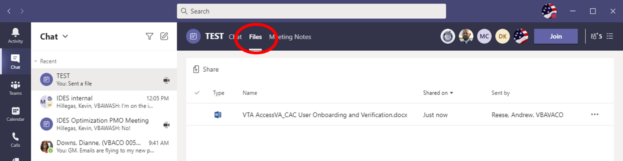

** After the call starts, the Teams Chat **will** only be used to ask questions. Call attendees **will not** make comments or respond to any of the questions. Please adhere to this request.

Ask questions over the phone or send an email to the appropriate staff corporate mailbox.

Please mute your microphone and turn off your camera by clicking on the appropriate icon. (See Figure 1)

Figure 1:

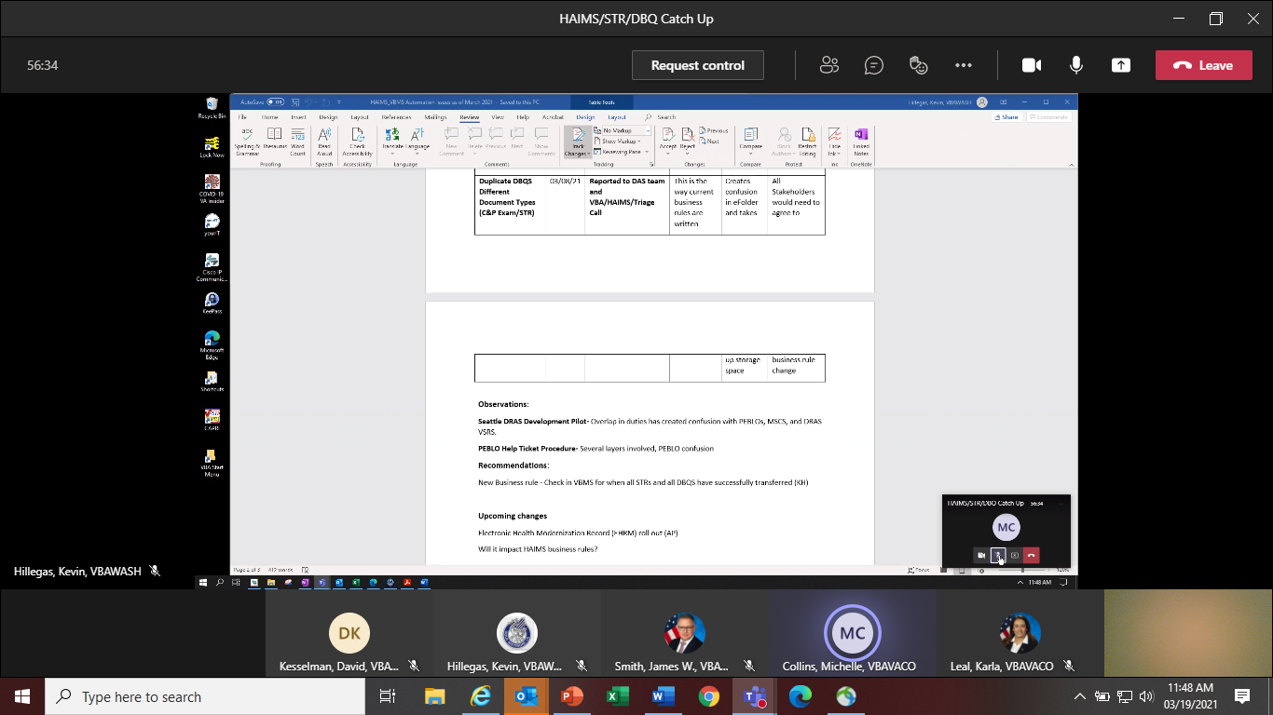

Below (Figure 2) is what your microphone and camera icons should look like when it is muted/turned off. Click the microphone icon to unmute if you need to ask a question (do not unmute if you do not need to speak). If you are dialed in via your phone, ensure your phone is muted.

Figure 2:

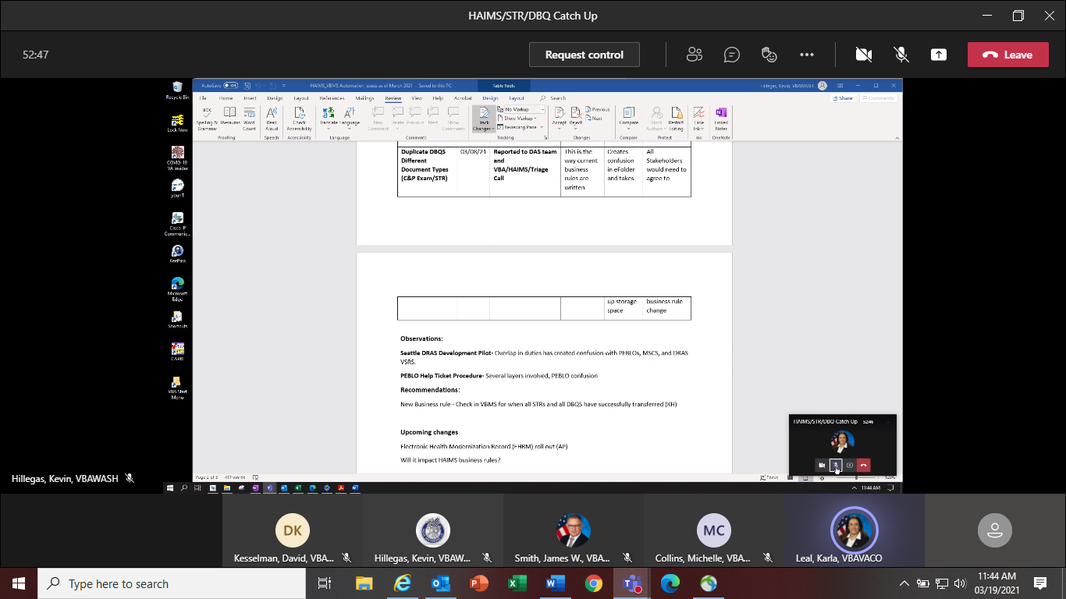

To ask a question, use the Raise your Hand option (click the hand and it will change color) in the Teams Meeting and you will be called upon for your question/comment. Once your question/comment is addressed lower your hand (click the hand again) (Figure 3). **Please do not talk/blurt out your question/comments unless called upon.**

Figure 3:



Please sign–up for the [C&P Calendar Subscription Service](http://vbacodmoint1.vba.va.gov/bl/21/calendar/cal_Subscribe.asp) to receive notification that the Read Ahead is available and for notification when the TMS number is active.

**Housekeeping Items**

212A Acting Chief

* Timothy Stephenson (Timothy.Stephenson@va.gov)

Call Format

Quality Training for MSCs will be the only topic covered during the call. All IDES, BDD and VTA topics will not be covered during the call. Send any IDES or VTA questions you may have to VAVBAWAS/CO/IDES or an IDES Analyst and BDD questions to VAVBAWAS/CO/PREDISCHARGE or an BDD Analyst.

General Topic for Discussion

**Quality Training for MSCs**

Quality review training material was distributed by the Office of Field Operations (OFO) to all Districts on May 7. Coaches will be informed of MSC common errors found and will be advised to discuss with all MSCs.

During the call today this same training material will be discussed in detail with all MSCs. The training will cover common errors seen in IDES and BDD MSC reviews. The training is intended to provide feedback and reminders regarding quality reviews. There will be an opportunity to discuss general quality topics and any related manual references, however specific errors that have been called will not be discussed during training. If there are questions about a specific error that has been called, MSCs should contact the reviewer per [M21-4 Chapter 6.5.h](https://vaww.vrm.km.va.gov/system/templates/selfservice/va_kanew/help/agent/locale/en-US/portal/554400000001034/content/554400000037939/Chapter-6.--Quality-Review-Team-(QRT)#5).

IDES Specific Topics

**HAIMS/VBMS/STR/DBQ Update**

The IDES Program Office, in coordination with DoD, continues to track the HAIMS/VBMS/STRS/DBQ procedures implemented February 1, 2021. Please see reminders below:

* Challenges have been identified with some STR and DBQ transfers. The staff continues to work with VBMS, DAS, HAIMS to resolve
* NAD DBQ Business rule is still being reviewed
* HAIMS automation Manual update should be published approximately mid May 2021
* MSCs should not enter help tickets through the VA IT portal-PEBLOs should enter trouble tickets for STRs and DBQs that have not transferred
* MSCs should not take any action on a case in VBMS and VTA until the PCS Date is entered in VTA by the PEBLO which indicates a case is ready for CEST
* If MTFs are having issues with uploading or not aware of the HAIMS/VBMS/DBQ transfer process, send details including VTA Case ID (if applicable) to the [IDES Mailbox](mailto:VAVBAWAS/CO/IDES%20%3cIDES.VBACO@VA.GOV%3e)

**QRT Reminder: CEST Transactions**

We recognize that the early CEST action represents a departure from the typical claims process, where claims are established after we are in possession of a VA claim, and all development action/system updates are to be taken upon CEST. We also recognize that this may seem particularly counterintuitive since AQRSs are still assigned MSC CEST transactions to review for quality. This concern was raised during the Comp Service/DRAS call on May 10, and we plan to engage the QRT Staff at Comp Service regarding this matter.

Note: At the time of claim establishment- it is not expected for MSCs to do a full file review. However, upon the initiation of development of the claim, after the initial interview, the MSC then is expected to complete a file review and make any additional necessary system updates to include military service, POA, etc.

**Use of New “IDES Non-AD” Claim Labels**

Effective Immediately, when DRAS claim processors establish final rating EPs in IDES claims involving participants who are not serving on active duty (NAD), they must select the appropriate “IDES Non-AD” claim label. Use of these new claim labels will provide work credit that is more reflective of the activity required in IDES claims involving NAD Veterans.

Note: No modification has been made to any process or procedure. NAD IDES cases must continue to be processed in accordance with current policy. The only change involves the selection of the new claim label in place of the standard IDES label in NAD IDES cases.

M21-1 III.i.2.F.2.d (which discusses establishing rating EPs in NAD cases) is currently being updated to reflect the new claim labels; until the change is published in M21-1, this message serves as interim guidance.

**Establishing Final Rating EPs in IDES Claims**

When establishing Rating EPs in IDES cases (as discussed in [M21-1 III.i.2.E.5.b](https://vaww.vrm.km.va.gov/system/templates/selfservice/va_kanew/help/agent/locale/en-US/portal/554400000001034/content/554400000046269/M21-1-Part-III-Subpart-i-Chapter-2-Section-E-Department-of-Veterans-Affairs-VA-Responsibilities-Based-on-Medical-Evaluation-Board-MEB-and-Physical-Evaluation-Board-PEB-Outcomes#5)), DRAS VSRs must not select the “Pre-Discharge” indicator. The Pre-Discharge indicator should be selected only when MSCs establish EP 689 at the onset of the IDES process (in accordance with [III.i.2.D.3.d](https://vaww.vrm.km.va.gov/system/templates/selfservice/va_kanew/help/agent/locale/en-US/portal/554400000001034/content/554400000033257/M21-1-Part-III-Subpart-i-Chapter-2-Section-D-Overview-of-the-Integrated-Disability-Evaluation-System-IDES-and-Initial-Claims-Development#3)).

Rationale: The Pre-discharge indicator at CEST serves to classify claims under District 6 contract. When this indication is misapplied to final IDES Rating EPs any post-IDES exams for deferred issues (including non-IDES issues raised after the initial interview) are counted as “IDES examinations” and complicate IDES exam inventory reduction efforts.

### Requesting Re-work Examinations

### When entering corrective examination requests, claims processors must consider [M21-1 III.iv.3.D.3](https://vaww.vrm.km.va.gov/system/templates/selfservice/va_kanew/help/agent/locale/en-US/portal/554400000001034/content/554400000015812/M21-1,-Part-III,-Subpart-iv,-Chapter-3,-Section-D---Examination-Reports#3) and a enter corrective exam requests as “re-work” in EMS when appropriate. This will typically be applicable to DRAS VSRs entering exam requests for deferred issues, but may also be applicable to MSCs who find incomplete exams (missed issues or missing DBQs) in their review for exam completeness.

### [M21-1 III.iv.3.D.3](https://vaww.vrm.km.va.gov/system/templates/selfservice/va_kanew/help/agent/locale/en-US/portal/554400000001034/content/554400000015812/M21-1,-Part-III,-Subpart-iv,-Chapter-3,-Section-D---Examination-Reports#3) discusses examination reports that must be considered insufficient and includes the following examples:

* The examination report is unsigned
* The examination report does not address all disabilities for which an examination was requested
* The required question(s) on the DBQ is/are unanswered
* The required review of the claims folder was not accomplished
* The report is missing information pertinent to the specific disability under review, such as the impact of musculoskeletal pain on the functional loss of an affected joint
* A medical opinion is not properly supported by a valid rationale and/or by the evidence of record
* A requested medical opinion was not furnished

### [M21-1 III.iv.3.D.3.c](https://vaww.vrm.km.va.gov/system/templates/selfservice/va_kanew/help/agent/locale/en-US/portal/554400000001034/content/554400000015812/M21-1,-Part-III,-Subpart-iv,-Chapter-3,-Section-D---Examination-Reports#3) discusses situations in which clarification must be requested, to include situation where exam results include ambiguous or conflicting information.

### [M21-1III.iv.3.D 3.f](https://vaww.vrm.km.va.gov/system/templates/selfservice/va_kanew/help/agent/locale/en-US/portal/554400000001034/content/554400000015812/M21-1,-Part-III,-Subpart-iv,-Chapter-3,-Section-D---Examination-Reports#3) requires that all insufficient exams and clarification requests be entered into EMS as “re-work” requests—not as new ESRs.

***Exception:*** [M21-1 III.iv.3.D.3.c](https://vaww.vrm.km.va.gov/system/templates/selfservice/va_kanew/help/agent/locale/en-US/portal/554400000001034/content/554400000015812/M21-1,-Part-III,-Subpart-iv,-Chapter-3,-Section-D---Examination-Reports#3) indicates that when further information is needed as a result of a rating change that took place after the examination was conducted a request for clarification is necessary. However, February 10, 2021 MDEO guidance, *Field Guidance for Utilizing Historical Language with New Musculoskeletal Disability Benefits Questionnaires (DBQ’s)* indicates that new ESRs must be entered if additional information is needed for rating purposes and the original request was submitted prior to January 18, 2021

***Important:*** if a required exam was cancelled and a valid reason was not indicated by the vendor, the exam should be considered insufficient and the corrective request must be entered in EMS as re-work.

Note: If a re-work request cannot be submitted because the original ESR was submitted under a an EP that is no longer pending, claims processors must use the cloning functionality described in the EMS Job Aid, [ESR Cloning Functionality](https://vbaw.vba.va.gov/bl/21/contractexams/docs/ESR%20Cloning%20Functionality_Job%20Aid_Concur.docx)

**Handling Requests from Vendors to Enter Re-work as New Requests**

IDES MSCs and DRAS VSRs must enter corrective ESRs as re-work requests as discussed above. If after a re-work request properly entered in EMS, a vendor returns a request to cancel the re-work item, and enter a new ESR, the claim processor must:

• Send notice to [IDES Mailbox](mailto:VAVBAWAS/CO/IDES%20%3cIDES.VBACO@VA.GOV%3e)

* Use the subject line: Vendor Requires New ESR for Re-Work Request
* Include the participant’s VTA Case ID
* a brief description of why the re-work request was entered

After submitting notice to the IDES mailbox, the MSC/VSR may proceed to enter the new request as requested by the vendor (do not delay action on IDES claims in these instances).

The IDES team at Compensation Service will compile these notices, review the cases, and engage the MDEO with any examples of erroneous vendor requests that may be identified.

**MSC Actions When SM Can’t be Contacted to Schedule Initial Interview**

[M21-1 III.i.2.D.3.d.](https://vaww.vrm.km.va.gov/system/templates/selfservice/va_kanew/help/agent/locale/en-US/portal/554400000001034/content/554400000033257/M21-1-Part-III-Subpart-i-Chapter-2-Section-D-Overview-of-the-Integrated-Disability-Evaluation-System-IDES-and-Initial-Claims-Development?query=ides#3g) discusses MSC actions when processing a referral package from a PEBLO. [M21-1 III.i.2.D.2.a.](https://vaww.vrm.km.va.gov/system/templates/selfservice/va_kanew/help/agent/locale/en-US/portal/554400000001034/content/554400000033257/M21-1-Part-III-Subpart-i-Chapter-2-Section-D-Overview-of-the-Integrated-Disability-Evaluation-System-IDES-and-Initial-Claims-Development?query=ides#2) -Stage 6 discusses SM availability and has a note that says in part “PEBLOs should not refer an individual to an MSC if the individual is unavailable to meet with the MSC within 5 days of the date the referral was made, …”.

Each week we run a Pending Claims Dev Report to see what cases have high ADP. Digging into the cases we find some with a reason of “Can’t get in contact with the SM.” We want to be accommodating to the SM especially during COVID or for other extenuating circumstances, but should not wait weeks on end for SM contact as Claim Development time runs. In the end, the MSC will make the decision to keep or return the case after the 5 days. If an MSC can’t reach a SM in 5 days (or however long the MSC decides to wait—we suggest no more than 10 days) and decides to return the case to the PEBLO the Prepare Claim Start Date should be removed.

**MSC Actions When a SM Does Not Immediately Return a Completed VA Form 21-526EZ**

This topic also deals with the Pending Claims Dev Report we run weekly to see what cases have high ADP. Digging into the cases we find some with a reason of “Waiting on 526”. MSCs are reminded that, per [M21-1 III.i.2.D.4.g](https://vaww.vrm.km.va.gov/system/templates/selfservice/va_kanew/help/agent/locale/en-US/portal/554400000001034/content/554400000033257/M21-1-Part-III-Subpart-i-Chapter-2-Section-D-Overview-of-the-Integrated-Disability-Evaluation-System-IDES-and-Initial-Claims-Development?query=IDES#4g), SMs have 5 days to return the 526, however, if extenuating circumstances exist that impact the SMs ability to return the form, the MSC may defer requesting exams beyond the five-day deadline.

We want to be accommodating to the SM especially during COVID or other unique situations, but we can’t wait weeks on end for the 526 to be returned as Claims Development time runs. In the end the MSC will make the decision on how many days to wait for the 526 (beyond the 5 days) and order exams for the referred conditions only or all conditions if 526 received. If MSCs do wait more than 5 days, we suggest waiting no more than 10 days.

Note: If exams are ordered for the referred conditions only, and the SM later submits the 526, please see [M21-1 III.i.2.D.4.h](https://vaww.vrm.km.va.gov/system/templates/selfservice/va_kanew/help/agent/locale/en-US/portal/554400000001034/content/554400000033257/M21-1-Part-III-Subpart-i-Chapter-2-Section-D-Overview-of-the-Integrated-Disability-Evaluation-System-IDES-and-Initial-Claims-Development?query=ides#4h)

**Secondary Action Required (SAR) Tracked Items**

The March 2021 Quality Bulletin notified field personnel that a Secondary Action Required (SAR) Tracked Item is required during the examination review process to prevent claims from going into an RFD status. ([M21-1, I.1.C.3.L](https://vaww.vrm.km.va.gov/system/templates/selfservice/va_kanew/help/agent/locale/en-US/portal/554400000001034/content/554400000014066/M21-1-Part-I-Chapter-1-Section-C-Duty-to-Assist-with-Obtaining-Records-and-a-Medical-Examination-or-Opinion?query=I.1.C.3.L#3)).

The SAR tracked item does not apply for IDES in the same way as it does for regular VSC claims. The IDES process is regimented in that the referral package should be complete with necessary records, the interview is completed for any additional claims and then exams are ordered. If there is some sort of delay due to additional records development, the MSC can reject the referral as incomplete. This is different than the regular non-IDES processing of claims.

The MSC should not be entering the SAR tracked item for IDES claims. This applies to the Seattle DRAS VSC Development Pilot as well as regular IDES processing for MSCs. If intake is completed and immediately brokered to the DRAS the exam review process has not started thus there is no need for a SAR tracked item.

Current IDES Program Timeliness

As outreach specialists and VA’s frontline contact with SMs and Veterans, it is vital that we are realistic in our communications regarding claims processing times. Current program timeliness data (ADC) for April 2021.

|  |  |  |
| --- | --- | --- |
| **Stage/Phase** | **IDES Goal (AD/NAD)** | **April 2021 (AD/NAD)** |
| **Claim Dev** | **5/11** | **9/9** |
| **Medical Stage** | **32** | **92** |
| **Proposed Ratings** | **20** | **5** |
| **Recon Ratings** | **4** | **7** |
| **Exit Interviews** | **14** | **7** |
| **Final Ratings** | **20/na** | **19/na** |

***Source:*** *VTA Completed Reports (Days to Complete Including Deferment) May 3, 2021 (1pm ET).*

***Note:*** *VA using the goals from the 230-day process.*

**BDD Specific Topics**

**BDD Claims Received without Service Treatment Records (STRs)**

If STRs are not received with the BDD claim, but the SM has 180 to 90 days still remaining on active duty and meets all other BDD requirements as shown in [M21-1, III.i.2.A.1.d](https://vaww.vrm.km.va.gov/system/templates/selfservice/va_kanew/help/agent/locale/en-US/portal/554400000001034/content/554400000014099/M21-1-Part-III-Subpart-i-Chapter-2-Section-A-General-Information-on-Pre-Discharge-Claims?query=pre-discharge), do not exclude the claim from the BDD program as directed in [M21-1, III.i.2.B.1.j](https://vaww.vrm.km.va.gov/system/templates/selfservice/va_kanew/help/agent/locale/en-US/portal/554400000001034/content/554400000014101/M21-1,-Part-III,-Subpart-i,-Chapter-2,-Section-B---Division-of-Responsibilities-for-Processing-Benefits-Delivery-at-Discharge-(BDD)-and-BDD-Excluded-Claims) and the Questions and Answers (Q and A’s) from the MSC Virtual Training 2020. Per [M21-1, III.i.2.B.1.j](https://vaww.vrm.km.va.gov/system/templates/selfservice/va_kanew/help/agent/locale/en-US/portal/554400000001034/content/554400000014101/M21-1,-Part-III,-Subpart-i,-Chapter-2,-Section-B---Division-of-Responsibilities-for-Processing-Benefits-Delivery-at-Discharge-(BDD)-and-BDD-Excluded-Claims) the claim will not be excluded until the SM has less than 90 days before their future discharge date, and VA has not received the STRs.

Do not download the STRs from the Joint Longitudinal Viewer (JLV). Contact the SM by phone and letter to request STRs for their current period of service per [M21-1, III.i.2.B.1.j](https://vaww.vrm.km.va.gov/system/templates/selfservice/va_kanew/help/agent/locale/en-US/portal/554400000001034/content/554400000014101/M21-1,-Part-III,-Subpart-i,-Chapter-2,-Section-B---Division-of-Responsibilities-for-Processing-Benefits-Delivery-at-Discharge-(BDD)-and-BDD-Excluded-Claims). Once the SM reaches day 89 before their discharge date and the STRs have still not been received, then, the claim will be excluded from the BDD program on day 89.

Normally, upon receipt of a BDD claim without STRs, an EP 336 with the *Pre-Discharge Excluded* claim label would be established. However, the *Pre-Discharge Excluded* was mistakenly deactivated in VBMS. We are working to reactivate the *Pre-Discharge Excluded* claim label for EP 336 in VBMS. Until this claim label is reactivated, establish the claim as an EP 336 with the *BDD* claim label until the STRs have been received or the claim reaches day 89 before discharge and the STRs have not been received. Select *BDD* as the Pre-Discharge type when establishing this type of claims. Once the STRs are received, examinations are requested and all other development is done, then, the EP 336 can be changed to the proper rating EP and claim label per [M21-1, III.i.2.A.2.d](https://vaww.vrm.km.va.gov/system/templates/selfservice/va_kanew/help/agent/locale/en-US/portal/554400000001034/content/554400000014099/M21-1-Part-III-Subpart-i-Chapter-2-Section-A-General-Information-on-Pre-Discharge-Claims?query=pre-discharge)

**Current BDD Program Timeliness**

As VA’s frontline contact with SMs and Veterans, it is vital that we are transparent in our communications regarding claims processing times. Below is the current program timeliness data as of May 6, 2021.

|  |  |  |
| --- | --- | --- |
| **BDD Timeliness Data** | | |
| **Data Points** | **Goal** | **May 5, 2021** |
| **Completed FYTD** |  | **14,024** |
| **Receipts FYTD** |  | **17,017** |
| **Pending** |  | **9,724** |
| **# Completed w/in 30 Days of Discharge** |  | **2,961** |
| **% Completed w/in 30 Days of Discharge** | **100%** | **21%** |
| **Avg. Days to Complete FYTD** | **30** | **115** |

***Source:*** *Tableau BDD History Report, May 6, 2021*

VTA Reminders

VTA Notes about Exams in Army Cases

Army MSCs who are not ordering and receiving exams are reminded that they should not enter notes that discuss exams. Any notes on exams will be entered by the MSCs at the Seattle DRAS.

**Pending CEST and Pending Claims Development (CD) Reports**

Coaches and MSCs are reminded of the importance of these two reports

* The Pending CEST Report should be run daily to see if there are any cases that need CESTing and other development
* The Pending Claims Development Report should be run daily (or at least every other day) to see what cases are pending in the CD Stage and need action/work

Note: These two reports can now be run by RO (VTA update), except for Providence and Hartford which still need to run the reports by New England Naval Health Clinic.

We track these pending #s weekly and are seeing too many cases with high pending days.

CD goal is 5 days for Active Duty and 11 days for Non-Active Duty. CD is the time from the Prepare Claim Start Date to the ordering of exams.

Note: During the Seattle Pilot Army MSCs do not order exams. Your last action in VTA is updating the 526 fields. You will broker the case to Seattle once all info/documents are in VBMS.

Seattle DRAS VSC Development Pilot

Seattle DRAS VSC Development Pilot Info and Reminders

* This Pilot has been extended to June 30
* MSCs for Army cases must broker the case to Seattle after verifying that VA Form 21-0819 and a Signed VA Form 21-526ez or VA Form 21-4138 documenting Veteran declines to file claim are available for viewing in VBMS

***MSCs are reminded that all exam actions for Army cases are currently handled by the Seattle DRAS. In Army cases, local MSCs must **not**:

* Order Exams
* Close out the Exam Returned Dates, the EED and the MEED in VTA
* Inform the PEBLO that exams have been completed
* Add notes in VTA regarding the completion of exams

When local MSCs indicate that exams have been completed prior to the DRAS entry of the MEED, it creates confusion and PEBLOs may move cases forward to the NARSUM prematurely.

Upcoming Teleconferences

The next BDD/IDES Call is scheduled for Tuesday, June 8, 2021, at 2PM ET. Please submit IDES questions and proposed topics for discussion to the [IDES Mailbox](mailto:VAVBAWAS/CO/IDES%20%3cIDES.VBACO@VA.GOV%3e), and BDD questions and proposed topics for discussion to the [BDD Mailbox](mailto:VAVBAWAS/CO/PREDISCHARGE%20%3cPredischarge.VBACO@va.gov%3e) no later than close of business (COB), Monday, May 24, 2021.

The next BDD/IDES Coaches Call is scheduled for June 3, 2021, at 2PM ET. Please submit IDES questions and proposed topics for discussion to the [IDES Mailbox](mailto:VAVBAWAS/CO/IDES%20%3cIDES.VBACO@VA.GOV%3e), and BDD questions and proposed topics for discussion to the [BDD Mailbox](mailto:VAVBAWAS/CO/PREDISCHARGE%20%3cPredischarge.VBACO@va.gov%3e) no later than COB, Monday May 17, 2021.

Open Floor

**Appendix 1: Call Notes from the April 2021 Comp Service BDD/IDES Conference Call**

**Quality Reviews for MSCs**

**Question: Why are multiple errors called on one review?**

**Answer:** Multiple errors can be called under different tasks. Please reach out to your local regional office quality team for additional details.

**Question: How soon are transactions pulled for quality reviews?**

**Answer:** Anytime an MSC creates a transaction it could be pulled for review. Quality review pulls should occur daily. Please reach out to your local regional office quality team for additional details.

**Question: Is there a list of what is considered a transaction for quality reviews?**

**Answer:** Yes; reach out to your local quality review team coach.

**Extension of Grace Period for Errors related to the HAIMS STR Transfer Process**

**Question: Who should we contact if an error was called regarding the HAIMS procedure?**

**Answer:** If there were any critical errors cited as a direct result of the HAIMS STR transfer process, and you believe they should be changed to comments for correction due to the extension of the grace period, MSCs should contact their coach.

Please include in your request specific details of the error that was cited (BID number, date, etc.) and explain why this was related to the HAIMS Transfer process and why it should now be cited as a comment. If the coach believes the request has merit, the coach will then contact the QRT coach at their station. The error will then be reviewed. If QRT coaches at the local stations have questions, please reach out to the QRT coaches at the Seattle and Providence DRAS sites for clarification regarding any specific error reconsideration request relating to this process.

**Question: Who should we contact with concerns regarding IDES/BDD Quality reviews?**

**Answer:** Any concerns regarding quality reviews should be coordinated with your Coach. Once coordinated, these concerns should be sent to the appropriate Predischarge Program Corporate Mailbox. [IDES Mailbox](mailto:VAVBAWAS/CO/IDES%20%3cIDES.VBACO@VA.GOV%3e) or [BDD Mailbox](mailto:VAVBAWAS/CO/PREDISCHARGE%20%3cPredischarge.VBACO@va.gov%3e)

**VA.gov File Upload Size Increased to 150 MB and Elimination of FDC question**

**Question: Why can’t I upload more than 150 MB in VBMS?**

**Answer:** Currently, Per VBMS only Veteran’s or DOD stakeholder are authorized to upload more than 150 MB.

**Updated IDES Claims Establishment/Referral Transfer Procedure**

**Comment: PEBLOs at my location have been sending IDES cases without entering a Prepare Claim Start Date in VTA**

**Response:** MSCs should not take action on cases before the PEBLO enters the Prepare Claim Start Date in VTA

**Question: When I complete the CEST action in VBMS what fields should be completed?**

**Answer:** At the time of the CEST action, MSCs must:

* assign the *IDES Participant* corporate flash in Share or Participant Profile.
* assign the claim to his/herself in VBMS, (or to the MSC who will be responsible for the case), and
* update the following fields on the MSC tab in VTA:
  + MSC ASSIGNED, and
  + VA REGIONAL OFFICE
  + CLAIMS ESTABLISHMENT (CEST) DATE

**Timely Identification of Completed Exams and MSC Admin Time**

**Comment: I will check VBMS for an exam and it has not been released, then a few days later I check VBMS and the exam has been released with a receipt date on or before the first time I checked.**

**Response:** This concern was reported to a VBMS Tech POC. It is believed to be an exam queuing issue. If this occurs, please provide additional examples immediately when identified. Please send concerns to the [IDES Mailbox](mailto:VAVBAWAS/CO/IDES%20%3cIDES.VBACO@VA.GOV%3e).

**Seattle DRAS VSC Development Pilot**

**Question: Will the Pilot end on May 1, 2021?**

**Answer:** The Pilot has been extended to June 30, 2021

**Comment: Our location has noticed a few Seattle DRAS VSRs are requesting duplicate exams. We have added notes in VBMS when a specialty exam is already of record, and these exams are being requested again.**

**Response:** The Seattle DRAS will take note and remind VSRs to check all notes before requesting exams that already of record.

**Comment: We have noticed Subsequent Development Letters in VBMS**.

**Response:** At this time the Seattle DRAS will continue to send subsequent development letters when appropriate. Rationale-To complete the development as early as possible

**Miscellaneous**

**Question: Can we get clarification on slide 23? It says MSCs for Army cases must broker the case to Seattle after verifying that VA Form 21-0819 and a Signed VA Form 21-526ez or VA Form 21-4138 documenting Veteran declines to file claim are available for viewing in VBMS**

**Answer:** Correction-If the 5 day time period expires without a signed VA Form 21-526 EZ (and there are no extenuating circumstances regarding SMs ability to return the form), the MSC can request the exams for the referred conditions only and broker to DRAS.

**Comment: There are still several instances where the Call Centers are releasing IDES Proposed Ratings to IDES Participants before they have been shared with the PEBLO.**

**Response:** The IDES staff has reported this concern to the Call Center management teams. Please continue to report any new instances and we will continue to work with the Call Center to resolve. Please send concerns to the [IDES Mailbox](mailto:VAVBAWAS/CO/IDES%20%3cIDES.VBACO@VA.GOV%3e).