Monthly Benefits Delivery at Discharge (BDD) and

Integrated Disability Evaluation System (IDES)

Conference Call Read Ahead

Compensation Service

BDD/IDES (212A)

April 13, 2021 — 2 PM ET

The Compensation Service BDD/IDES hosts this call to announce updates and address issues and questions related to the BDD/IDES Programs. All Military Services Coordinators (MSCs), Disability Rating Activity Sites (DRAS), Regional Offices and other VA personnel supporting BDD/IDES are invited to participate.

This read-ahead is provided to facilitate discussion during the conference call.

The Call Notes for the March Call are in Appendix 1. The TMS # for this month’s call will be provided during the call and should be active within a week of the call’s completion. A Calendar Blast will notify the field when the TMS # is active.

**Call-in Information**

[Join Microsoft Teams Meeting](https://teams.microsoft.com/l/meetup-join/19%3ameeting_MzlhN2FlN2YtYTFhNS00NjExLWEwMzMtYWEwYjE0YzU1Y2Qx%40thread.v2/0?context=%7b%22Tid%22%3a%22e95f1b23-abaf-45ee-821d-b7ab251ab3bf%22%2c%22Oid%22%3a%22a0338b5c-0526-4e13-9809-5d0ecc8cdeb8%22%7d)

[+1 872-701-0185](tel:+1%20872-701-0185,,448196643# )  United States (Toll)

Conference ID: 448 196 643#

The Read Ahead and Slides will be attached to the Chat (may have to scroll up in the Chat) and can also be found in the Files link on the call. They are also located on the [IDES Homepage](https://vbaw.vba.va.gov/vbadod/IDES.asp) and on the [BDD Homepage.](https://vbaw.vba.va.gov/vbadod/predischarge.asp)

Note: The slides will not be available on the homepages until noon of call day.

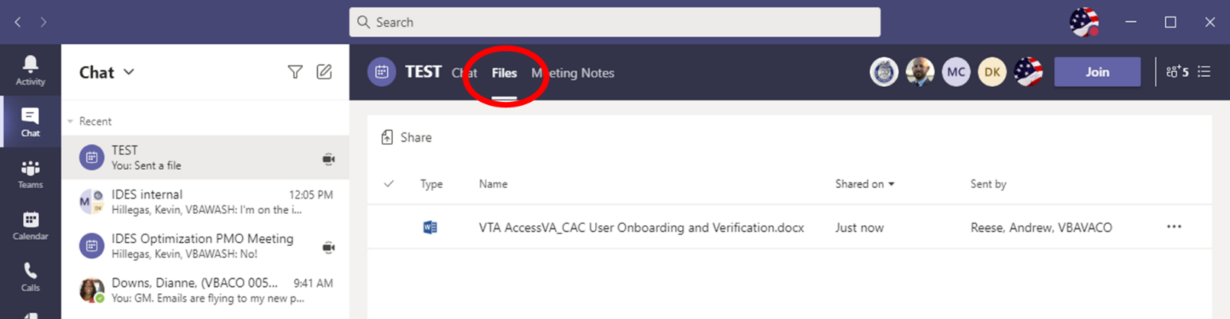

** After the call starts, the Teams Chat **will** only be used to ask questions. Call attendees **will not** make comments or respond to any of the questions. Please adhere to this request.

Ask questions over the phone or send an email to the appropriate staff corporate mailbox.

Please mute your microphone and turn off your camera by clicking on the appropriate icon. (See Figure 1)

Figure 1:

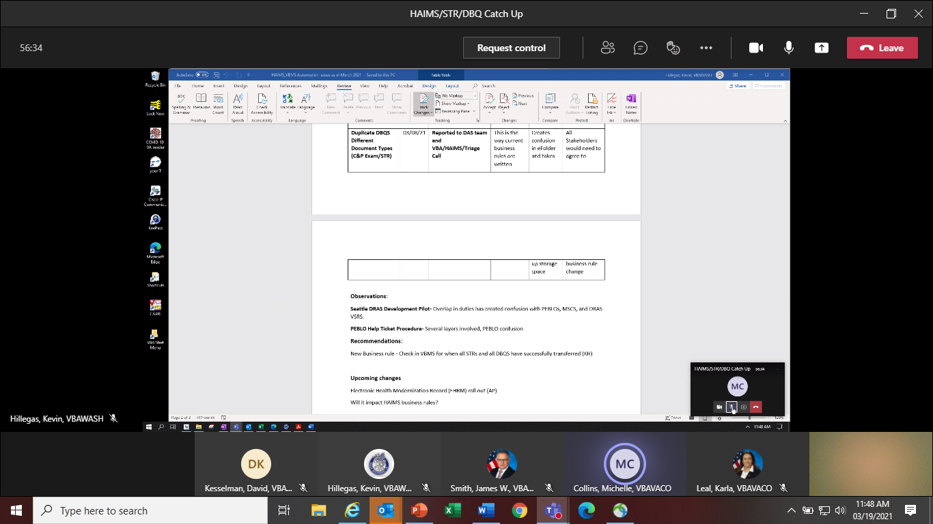

Below (Figure 2) is what your microphone and camera icons should look like when it is muted/turned off. Click the microphone icon to unmute if you need to ask a question (do not unmute if you do not need to speak). If you are dialed in via your phone, ensure your phone is muted.

Figure 2:

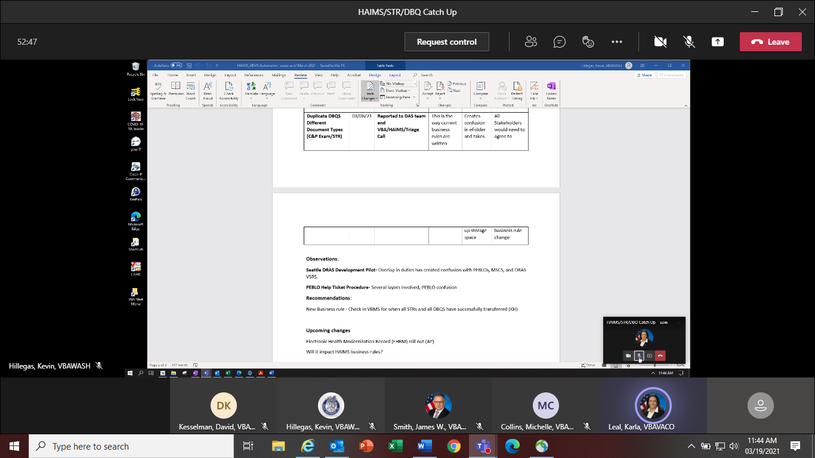

To ask a question, use the Raise your Hand option (click the hand and it will change color) in the Teams Meeting and you will be called upon for your question/comment. Once your question/comment is addressed lower your hand (click the hand again) (Figure 3). **Please do not talk/blurt out your question/comments unless called upon.**

Figure 3:



Please sign–up for the [C&P Calendar Subscription Service](http://vbacodmoint1.vba.va.gov/bl/21/calendar/cal_Subscribe.asp) to receive notification that the Read Ahead is available and for notification when the TMS number is active.

**Housekeeping Items**

Leads/Acting Chief until further notice:

* IDES: Alohalani.Bullock-Jones@va.gov
* BDD: Nancy.Hogan@va.gov

General Topics for Discussion

**Quality Reviews for MSCs**

This topic is intended to provide a reminder and information on how Quality Reviews for MSCs are pulled and conducted.

**We will NOT have discussions/answer questions on how/why errors are called and/or on specific errors.

Quality Reviews are selected on a random basis by the computer program known as the Quality Management System (QMS). This system controls what reviews are selected for each employee and distributes the reviews to Authorization Quality Review Specialists (AQRS). The QMS system randomly selects 5 transactions per month for each MSC and these transactions are reviewed for quality purposes.

The QMS system will sometimes select transactions that may be several months old. This can be for a variety of reasons. However, even though the transaction may be from several months ago, it is still valid for Quality Review purposes. The AQRS will review the claim and is required to cite any deficiencies found that are relevant to the transaction that is under review. Therefore, an MSC may see a review done for a transaction that is recent, and then also may see a review done for a transaction that they created in prior months. This is not unusual, as the QMS system may need to backfill the reviews for that MSC for a prior month.

Anytime a transaction is created by an MSC or any other VBA employee, it may be selected for Quality Review by the QMS system. Once selected by the system, it is sent to the Quality Review Specialist (QRS) for the quality review. The QRS and Quality Review Team (QRT) coaches have no control over what reviews are selected or the dates of the transactions under review. If you have questions or concerns about quality reviews and how they are selected by the QMS system, please direct that to your local management or QRT coach for further explanation or to elevate your question to the QMS staff, if necessary.

As always, if there are questions about why a specific error was cited, or if you believe the error was cited incorrectly and you would like to discuss, please reach out to the initial reviewer (AQRS) as instructed in [M21-4 Chapter 6.5.h](https://vaww.vrm.km.va.gov/system/templates/selfservice/va_kanew/help/agent/locale/en-US/portal/554400000001034/content/554400000037939/Chapter-6.--Quality-Review-Team-(QRT)#5). Please include any references that you may have to support your position. If you would like to request a formal reconsideration of the cited error, please use the link in the email notification you received and follow the instructions to submit your written reconsideration request. Again, please include all applicable references and regulations to support your request.

**Extension of Grace Period for Errors related to the HAIMS STR Transfer Process**

This serves as additional guidance regarding the HAIMS STR Transfer process and how quality reviews are conducted. There is a manual change pending regarding the new process that was fully implemented on February 1, 2021. We expect this guidance to be incorporated into the manual in mid-late April. Due to this pending update, we wanted to let the field know that the grace period for errors found related to this new change will be extended to 30 days after the date of the published manual changes. This is consistent with [M21-4 Chapter 6.4.d](https://vaww.vrm.km.va.gov/system/templates/selfservice/va_kanew/help/agent/locale/en-US/portal/554400000001034/content/554400000011649/Chapter-4.-Claims-and-Appeals-Processing) Grace Period for IQRs.

Additionally, if there were any critical errors cited as a direct result of the HAIMS STR transfer process, and you believe they should be changed to comments for correction due to the extension of the grace period, MSCs should contact their coach. Please include in your request specific details of the error that was cited (BID number, date, etc.) and explain why this was related to the HAIMS Transfer process and why it should now be cited as a comment. If the coach believes the request has merit, the coach would then contact the QRT coach at their station. The error will then be reviewed. If QRT coaches at the local stations have questions, please reach out to the QRT coaches at the Seattle and Providence DRAS sites for clarification regarding any specific error reconsideration request relating to this process.

Again, this grace period extension only applies to errors cited as a direct result of the HAIMS STR Transfer process. The grace period is in effect now and will continue until 30 days after the date of the published manual changes regarding this process.

**Quality Training for MSCs**

Quality review training material will be distributed by the Office of Field Operations (OFO) to all IDES/BDD Coaches during the first week of May 2021. Coaches will be informed of MSC common errors found and will be advised to discuss with all MSCs.

During the May IDES/BDD call this same training material will be discussed in detail with all MSCs. The training will cover common errors seen in IDES and BDD MSC reviews. The training is intended to provide feedback and reminders regarding quality reviews. There will be an opportunity to discuss general quality topics, and any related manual references, however specific errors that have been called will not be discussed during training. If there are questions about a specific error that has been called, MSCs should contact the reviewer per [M21-4 Chapter 6.5.h](https://vaww.vrm.km.va.gov/system/templates/selfservice/va_kanew/help/agent/locale/en-US/portal/554400000001034/content/554400000037939/Chapter-6.--Quality-Review-Team-(QRT)#5).

**Corporate Email Addresses**

MSCs and other VA personnel are reminded to contact the correct corporate email box when sending BDD or IDES inquiries/questions.

* BDD: [Predischarge.VBACO@va.gov](mailto:Predischarge.VBACO@va.gov)
* IDES: [IDES.VBACO@VA.GOV](mailto:IDES.VBACO@VA.GOV)

Note: These emails should not be given to non-VA personnel

BDD Specific Topics

**VA Fact Sheets for BDD and Separation Health Assessment (SHA)**

On the February Conference Call we announced that the [BDD Fact Sheet](https://www.benefits.va.gov/BENEFITS/factsheets/general/BDDFactSheet.pdf) and [SHA Fact Sheet](https://www.benefits.va.gov/BENEFITS/factsheets/serviceconnected/SeparationHealthAssessment.pdf) were revised and that the posted dates on the [VBA Fact Sheets](https://gcc01.safelinks.protection.outlook.com/?url=https%3A%2F%2Fbenefits.va.gov%2FBENEFITS%2Ffactsheets.asp&data=04%7C01%7C%7Cb2b9766cc2ce47fbc43308d8c93b9b28%7Ce95f1b23abaf45ee821db7ab251ab3bf%7C0%7C0%7C637480605124089671%7CUnknown%7CTWFpbGZsb3d8eyJWIjoiMC4wLjAwMDAiLCJQIjoiV2luMzIiLCJBTiI6Ik1haWwiLCJXVCI6Mn0%3D%7C1000&sdata=z8vAEXoOZ6hjJ3ghBOe%2FP4y28dnETkNhRVcPwKST6oI%3D&reserved=0) page would be updated once the Office of Strategic Engagement (OSE) Digital Media team received the Spanish versions of the fact sheets. The Spanish versions finalized translation in March. The January 2021 revision date for the English and Spanish versions of the BDD and SHA Fact Sheets may now be seen at the fact sheet library and on the last page of the fact sheets as well.

**BDD CEST Course TMS # 4486731**

The BDD staff are working with DoD to fully implement electronic availability of AHLTA Web Print (AWP) portion of Service Treatment Record (STR) to VA and completed SHA Disability Benefits Questionnaires (DBQs) to DoD via Health Artifact and Image Management Solution (HAIMS)-Data Access Service (DAS)-Veterans Benefits Management System (VBMS) exchange. During various stages of this effort, we found some errors in BDD claims establishment that severely impact our process. While we cover some of the issues and provide instruction to the MSCs on our regular monthly calls and other interactions, we realize there are other field employees that establish pre-discharge claims whom we are not as engaged with regularly. Therefore, we requested the FY 2021 National Training Curriculum’s BDD Cest Course in VA’s Training Management System (TMS) be mandatory training for those who have not taken it yet. This expected training was set up for April 1, 2021.

**VA.gov File Upload Size Increased to 150 MB and Elimination of FDC question**

The BDD team along with the Operational Innovation Staff have released functionality to allow claimants to upload files up to 150 MB on VA.gov. Service members (SMs) and Veterans may now upload files up to 150 MB with all claims submitted on VA.gov including BDD, BDD-Excluded and post-discharge claims. SMs and Veterans may also upload files up to 150 MB after they submit their claim on the [VA.gov claims status tool](https://www.va.gov/claim-or-appeal-status/).

Also, the below Fully Developed Claim (FDC) question was removed from VA.gov for BDD claims due to confusion that it caused the SM. If a BDD claim is excluded the local RO will handle that claim and the SMs claim will be in the FDC program unless the requirements are not met.

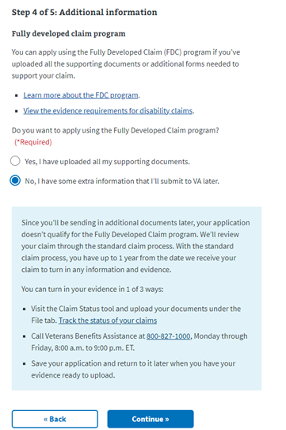

Current BDD Program Timeliness

As VA’s frontline contact with SMs and Veterans, it is vital that we are transparent in our communications regarding claims processing times. Below is the current program timeliness data as of April 6, 2021.

|  |  |  |
| --- | --- | --- |
| **BDD Timeliness Data** | | |
| **Data Points** | **Goal** | **April 6, 2021** |
| **Completed FYTD** |  | **11,514** |
| **Receipts FYTD** |  | **14,131** |
| **Pending** |  | **10,549** |
| **# Completed w/in 30 Days of Discharge** |  | **2,595** |
| **% Completed w/in 30 Days of Discharge** | **100%** | **22.8%** |
| **Avg. Days to Complete FYTD** | **30** | **110** |

***Source:*** *Tableau BDD History Report, April 7, 2021*

IDES Specific Topics

**HAIMS/VBMS/STR/DBQ Training Follow Up**

The IDES Program Office, in coordination with DoD, continues to track the HAIMS/VBMS/STRS/DBQ procedures implemented February 1, 2021. Please see reminders below:

* IT glitches have been identified and the staff is working with VBMS, DAS, HAIMS to resolve
* NAD DBQ Business rule is still being reviewed
* HAIMS automation Manual update should be published late April 2021
* MSCs should not enter help tickets through the VA IT portal-PEBLOs should enter trouble tickets for STRs and DBQs that have not transferred.
* If MTFs are having issues with uploading or not aware of the HAIMS/VBMS/DBQ transfer process, send details including VTA Case ID (if applicable) to the [IDES Mailbox](mailto:VAVBAWAS/CO/IDES%20%3cIDES.VBACO@VA.GOV%3e)

**Updated IDES Claims Establishment/Referral Transfer Procedure**

As initially announced during MSC training in January 2021 and discussed on each subsequent IDES/BDD Conference Call, IDES referrals are now transferred electronically to VA via an automated process. This process change has necessitated a change to IDES claim establishment procedures. The new IDES CEST procedure will be reflected in pending manual changes and will be published shortly. In the interim, the process for identifying and establishing EP control is fully outlined in Appendix 2, and is summarized as follows:

* MSCs must run the pending CEST report daily to identify new IDES referrals
* MSCs must CEST EP 689s using the Prepare Claim Start Date (PCSD) in VTA as the date of claim for the 689
* CEST of the EP 689 will initiate automated transfer of referral documents
* If the referral package fails to transfer from HAIMS to the VBMS eFolder within 24 hours of the EP 689 CEST, MSCs must:
* notify the PEBLO,
* obtain the referral package via SAFE, and
* update the PCSD to reflect when the referral was provided to VA

**Timely Identification of Completed Exams and MSC Admin Time**

As a result of the COVID-19 pandemic, Medical Evaluation (ME) stage time remains at an unprecedented high. These delays are largely out of the control of VBA or the MSC; however, MSCs can impact ME time through the timely delivery of examination reports to the PEBLO. The time between completion of VA exams and release to the PEBLO is considered “MSC admin time”. Nationally, MSC admin time for FY21 is over 7 days (vs. goal of 2 days). Further, DoD recently inquired about a list of cases with unusually high MSC admin time—over 400 cases had MSC admin times over 50 days, with some outliers as high as 1,000 days.

Most of the outliers were caused by data entry errors, where the month or year was keyed in incorrectly. MSCs must take care to ensure Exam End Date (EED) and Medical Evaluation End Date (MEED) are accurately entered in VTA.

While data entry errors accounted for many of the extreme outliers, high MSC admin times were often attributable to delays in the identification of completed examinations. MSCs must have an effective workload management system in place to ensure the identification of completed VA Exams. Available tools to track/identify completed exams include:

* the Pending Medical Evaluation Stage Report in VTA (discussed in [M21-1 III.i.2.D.7.a.](https://vaww.vrm.km.va.gov/system/templates/selfservice/va_kanew/help/agent/locale/en-US/portal/554400000001034/content/554400000033257/M21-1-Part-III-Subpart-i-Chapter-2-Section-D-Overview-of-the-Integrated-Disability-Evaluation-System-IDES-and-Initial-Claims-Development?query=ides#7))
* the Posted Cases report in Exam Track (discussed during [January 2021 IDES/BDD call](https://vbaw.vba.va.gov/VBADOD/docs/predischarge/Jan2021BDDIDESCallReadAheadFinal.pdf)), and
* new mail indicators for cases in the MSC’s VBMS work queue

Some cases with excessive MSC admin time involved instances in which no new exams were ordered (all required exams had been recently completed prior to the participants current IDES referral). In some cases, MSCs entered the EED in VTA as the date the *previous* exams were completed, erroneously exaggerating MSC admin time. When previously completed exams are used for IDES purposes, and no new examinations are ordered, MSCs must enter the current date as the ME Start and EED (the MEED will reflect the date the results are provided to the PEBLO).

Finally, high MSC admin time can be caused by MSCs closing out the EED before the examination results are deemed complete (per [M21-1 III.i.2.D.7.c and d](https://vaww.vrm.km.va.gov/system/templates/selfservice/va_kanew/help/agent/locale/en-US/portal/554400000001034/content/554400000033257/M21-1-Part-III-Subpart-i-Chapter-2-Section-D-Overview-of-the-Integrated-Disability-Evaluation-System-IDES-and-Initial-Claims-Development?query=ides#7)). When examination results are missing required information (to include requested medical opinions), the EED should not be entered until this missing information is provided.

Current IDES Program Timeliness

As outreach specialists and VA’s frontline contact with SMs and Veterans, it is vital that we are realistic in our communications regarding claims processing times. Below is the current program timeliness data (ADC) for March 2021.

|  |  |  |
| --- | --- | --- |
| **Stage/Phase** | **IDES Goal (AD/NAD)** | **March 2021 (AD/NAD)** |
| **Claim Dev** | **5/11** | **11/9** |
| **Medical Stage** | **32** | **113/144** |
| **Proposed Ratings** | **20** | **4/8** |
| **Recon Ratings** | **4** | **7/3** |
| **Exit Interviews** | **14** | **8/11** |
| **Final Ratings** | **20/na** | **18/na** |

***Source:*** *VTA Completed Reports (Days to Complete Including Deferment) April 5, 2021 (8am ET).*

***Note:*** *VA using the goals from the 230-day process.*

VTA Reminders

**Exit Interview Fields**

The Exit Interview fields and Return to Duty (RTD) Letter Date (discussed in next topic) will not become active until the Exit Interview Start Date is populated (this field is auto populated with the date the PEBLO/PEB enters the Final Disposition Date).

**VTA Notes**

The MSC and DRAS Tabs have a notes section where notes can be added. If you input a wrong note the system does not allow for you to delete/edit it. If a note was input in error and needs to be deleted you can send an email to [VRST@vba.va.gov](mailto:VRST@vba.va.gov) requesting a note be deleted (provide the note date and the first several words of the note).

**Return to Duty (RTD) Letter Date**

The definition of this VTA field is: “Date of the Returned to Duty Letter”. The field will only be active when one of the following exists and the Exit Interview Start Date is populated:

1. IPEB Referral (MEB Results) is No, Meets Standards, RTD.
2. Final Disposition = “Found fit & returned to duty”;
3. Final Disposition =“Unfit, but RTD”;
4. Final Disposition =“Non-disability retirement”:

When one of the above exists the RTD Letter Date data field has to be filled in before the Exit Interview fields become active. Even though the field is titled Return to Duty Letter Date, it also applies to cases with #4 from the above list as the Final Disposition.

**Changing/Updating/Manipulating VTA Data**

We received a report that Exit Interview fields are being changed/updated because DoD was changing dates on their tabs which resulted in negative ADCs on VA reports. The Exit Interview Start Date is auto populated with the date the PEBLO or PEB enters the Final Disposition Date (FDD). The MSC can then conduct the Exit Interview and enter VTA data. If the FDD is changed, this changes the Exit Interview Start Date, however, if the Exit Interview was already conducted and data entered, MSCs will NOT update/change the Exit Interview fields unless the Exit Interview is conducted again. The Exit Interview should only be conducted again to provide new/missed information. It should not be conducted again just to line up dates in VTA.

Note: This topic talks specifically about Exit Interview fields, but this rule also applies to other fields. Contact the [IDES Mailbox](mailto:VAVBAWAS/CO/IDES%20%3cIDES.VBACO@VA.GOV%3e) or an IDES analyst with any questions you may have about changing/updating data.

**VTA v.2.4.11**

VTA v.2.4.11 will be released the night of April 21. Below are some of the updates/changes. The complete list will be in Folder 6 of the VTA Knowledge Center after the release.

* A SMs Electronic Data Interchange Personal Identifier (EDIPI) will be displayed on the PEBLO Tab, Case Search, Case Summary, and reports that currently display SS# (except the DRAS reports, which will be done next release)
* Auto associate MEB MTFs with VA ROs: When a new Case is created, the VA RO will automatically be assigned based on the MEB MTF assignment. When an ineligible MEB MTF is selected, the Case will use the assigned MSC’s VA RO
* Date of Separation field will be disabled until the Secretarial Review End Date field is populated
* Users will only be able to load reports within a certain date range when selecting the ‘Date range’ option on the report filter. The ‘Cumulative’ option will be removed

Seattle DRAS VSC Development Pilot

Seattle DRAS VSC Development Pilot Info and Reminders

* This Pilot has been extended to June 30
* MSCs for Army cases must broker the case to Seattle after verifying that VA Form 21-0819 and a Signed VA Form 21-526ez or VA Form 21-4138 documenting Veteran declines to file claim are available for viewing in VBMS

MSCs are reminded that all exam actions for Army cases are currently handled by the Seattle DRAS. In Army cases, local MSCs must **not**:

* Order Exams
* Close out the SHA Exam Returned Date, the EED and the MEED in VTA
* Inform the PEBLO that exams have been completed
* Add notes in VTA regarding the completion of VA Examinations

When local MSCs indicate that exams have been completed prior to the DRAS entry of the MEED, it creates confusion and PEBLOs may move cases forward to the NARSUM prematurely.

Upcoming Teleconferences

The next BDD/IDES Call is scheduled for Tuesday, May 11, 2021, at 2PM ET. Please submit IDES questions and proposed topics for discussion to the [IDES Mailbox](mailto:VAVBAWAS/CO/IDES%20%3cIDES.VBACO@VA.GOV%3e), and BDD questions and proposed topics for discussion to the [BDD Mailbox](mailto:VAVBAWAS/CO/PREDISCHARGE%20%3cPredischarge.VBACO@va.gov%3e) no later than close of business (COB), Monday, April 26, 2021.

The next BDD/IDES Coaches Call is scheduled for June 3, 2021, at 2PM ET. Please submit IDES questions and proposed topics for discussion to the [IDES Mailbox](mailto:VAVBAWAS/CO/IDES%20%3cIDES.VBACO@VA.GOV%3e), and BDD questions and proposed topics for discussion to the [BDD Mailbox](mailto:VAVBAWAS/CO/PREDISCHARGE%20%3cPredischarge.VBACO@va.gov%3e) no later than COB, Monday May 17, 2021.

Open Floor

**Appendix 1: Call Notes from the March 2021 Comp Service BDD/IDES Conference Call**

**Entering the Medical Evaluation End Date (MEED) in VTA (Updated Procedure)**

**Question: What am I looking for in in VBMS regarding DBQ transfer?**

**Answer:** When records successfully transfer, a message will be shown on the Notes tab in VBMS (the same location where user notes are shown). The note will read, “SHA exam results successfully transferred to DoD (HAIMS)”

**Note:** There is a current IT issue in which the VBMS note is not populating even in instances where the records have successfully transferred to HAIMS. Until this issue is resolved, it is recommended that when the successful transfer note is not shown in VBMS, that MSCs/VSRs review the SMs record in Joint Legacy Viewer (JLV) before proceeding to request the SAFE link from the PEBLO. If the DBQs are in the JLV, it can be assumed that they were successfully transferred to HAIMS, and the MEED can be entered immediately.

**Question: Do I put the date of the VMBS Note as the ME End Date in VTA?**

**Answer:** No; when the note is found in VBMS, MSCs/VSRs must enter the current date as the ME End Date. The date of VBMS the note is immaterial. Entry of the ME End Date field in VTA serves to notify PEBLO that the exams are available as such no date earlier than the current date should be entered as the ME End Date.

**Question: Do I still need to review exams to ensure completeness?**

**Answer:** Yes; before proceeding to updating the ME End Date,MSCs must continue to review the exam results to ensure completeness. MSCs must first ensure that that all completed exams are in the eFolder, then check for the VBMS Note indicating that exams were transferred to HAIMS.

**Question: Are VSRs responsible for updating checking for the VBMS note?**

**Answer:** Yes; the employee who is processing the completed exam results (i.e., responsible for entering updating the ME End Date in VTA) must check for the note. In Army cases, this would be VSRs at the DRAS.

**Comment: I no longer have access to change the ME End Date.**

**Response:** The MSC assigned should always have access to update any field on the MSC Tab in VTA. The only known restriction would be if the *SHA Returned Date* has not yet been entered. If you are not able to enter/update the MEED in any cases with a completed *SHA Returned Date*, please send cases examples to the [IDES Mailbox](mailto:VAVBAWAS/CO/IDES%20%3cIDES.VBACO@VA.GOV%3e).

**Seattle DRAS VSC Development Pilot**

**Question:** Since Army MSCs are now brokering prior to the completion of development, are we still required to upload the MSC Development Checklist uploading?

**Answer:** For cases involved in the DRAS development Pilot, the MSC should upload the checklist at the time of brokering (indicating any development actions taken by the MSC). DRAS will upload and additional checklist to show subsequent development actions taken by the VSR.

**Comment:** PEBLOs are reporting that the DRAS has been non-responsive to inquiries.

**Response:** PEBLO interaction with DRAS should be limited to situations in which the DRAS VSR requests a SAFE link for exam transfer. Generally, all other PEBLO communications should be directed to the local MSC.

**Comment:** PEBLOs are reporting that DRAS is entering MEED on Saturdays.

**Response:** DRAS is working overtime and updating MEED with the current date in accordance with standard procedure.

**Automated Transfer of IDES Referral Documents**

**Question:** I am not receiving notification from my PEBLO (via email) until 2 days after the Prepared Claim Start Date (PCSD) has been entered, so I am losing 2 days of claim development time.

**Answer:** MSCs must run the pending CEST report on a daily basis to identify cases with PCSD dates. Cases will be shown on this report immediately upon entry of the PCSD. Since MSCs are not yet assigned to VTA cases, the report must be run for each intake site using the “MEB MTF” filter.

**Question:** Does the Prepared Claim Start Date (PCSD) count as day 1 in the Claim Development Stage?

**Answer:** No. When Claim Development (CD) time is calculated for reporting purposes, the Prepare Claim Start Date Counts as day zero. For example: if the exams are ordered (ME Start) on the same day as the PCSD, the reported CD time would be 0 days. If the ME Start Date is the day following the PCSD, CD time counted as 1 day.

**Question:** What is the timeframe for HAIMS transfer? I am typically seeing that it takes 4-7 days.

**Answer:** Referral documents typically to transfer within 24 hours, with limited exceptions. If you are finding that transfers routinely take over 24 hours (in all or most cases), please send cases examples to the [IDES Mailbox](mailto:VAVBAWAS/CO/IDES%20%3cIDES.VBACO@VA.GOV%3e), so the issue can be researched.

**Question:** If the documents arrive in the eFolder 2 days after the PCSD in VTA, should I change the date of receipt in the eFolder?

**Answer:** No; MSCs should not change the date of receipt shown in the eFolder when documents are automatically transferred via HAIMS. MSCs should only update the date of receipt of eFolder documents they upload themselves

**Question:** What am I supposed to do when records come into the eFolder a day or more after the PCSD in VTA? Unless I update the date of receipt of the 0819 in the eFolder, the date of receipt won’t match the DOC of the 689.

**Answer:** The DOC for the 689 must represent the date the referral was first initiated: this is the PCSD shown in VTA at the time of CEST. As a result of the new automated transfer process, the date of receipt of the 0819 will not always match the DOC. MSCs should **not** change the DOC of the EP 689 because of delays in the automated process. MSCs should **not** change the date of receipt for documents that were transferred via the automated process.

***Update:*** MSCs should include a VBMS note (as discussed in Appendix 2) at the time of CEST, indicating the date of referral (the PCSD at the time of CEST) to explain the DOC of the EP 689.

**Question:** PEBLOs are stating that DoD does not considering the VA Form 21-0819 “a medical document” and should not be uploaded to HAIMS. Can we get clarification?

**Answer:** DoD informed us that their PEBLOs are to upload the VA Form 21-0819 as the final document into HAIMS, using HAIMS Document Type "Administrative-Pre-Separation Record Statement". Please send to the IDES Corporate box any VTA cases where this is not happening so we may review and advise DoD as needed.

**Miscellaneous**

**Question:** DoD is requesting date stamps on Forms that we’ve received electronically (such as the 0819 or VA Form 21-0819). Are we required to date stamp forms that we’ve received electronically?

**Answer:** No; MSCs are not required to return the 21-0819 to the PEBLO. MSCs are not required to date stamp any form that is received electronically. MSCs should not print out any electronically document for the purposes of applying a wet ink date stamp. For documents that are received electronically (i.e., via email), the date of receipt will be entered by the MSC when the document is uploaded into the eFolder. Wet ink date stamps are required only when hard copy documents are presented to VA.

**Question:** Are we still required to apply to the CEST annotation on the 21-526 if the document was received electronically?

**Answer:** No; this annotation is only required if the 21-526 was provided in hard copy.

Automated Transfer of IDES Packages

**Question:** SM are finding examination results on Tricare Online and coming to MSCs with complaints/concerns about the exam—should the MSCs be ordering new exams in these cases?

**Answer:** No. DRAS RVSRs will determine the sufficiency of exams for VA rating purposes. When claimants bring concerns/complaints about VA exams to MSCs, the MSC should offer the participant a VA Form 21-4138 statement in support of claim. The 21-4138 should be uploaded to the participant’s eFolder so that it can be considered by the RVSR who will determine if new exams are necessary.

**Note:** Compensation Service is working with DoD regarding VA examination results on Tricare Online.

**Question:** What happens when the [VA Form 21-0819](https://www.vba.va.gov/pubs/forms/VBA-21-0819-ARE.pdf) does not have all of the correct information or missing information? Is the PEBLO required to correct and resubmit a revised 21-0819?

**Answer:** A properly completed VA Form 21-0819 is required as part of a complete IDES referral package (per [M21-1 III.i.2.D.3.d Step 4](https://vaww.vrm.km.va.gov/system/templates/selfservice/va_kanew/help/agent/locale/en-US/portal/554400000001034/content/554400000033257/M21-1-Part-III-Subpart-i-Chapter-2-Section-D-Overview-of-the-Integrated-Disability-Evaluation-System-IDES-and-Initial-Claims-Development" \l "3d)). However, the MSC has discretion to accept the referral and continue processing the claim, while concurrently working with the PEBLO to resolve any problems with the referral (per [M21-1 III.i.2.D.3.g](https://vaww.vrm.km.va.gov/system/templates/selfservice/va_kanew/help/agent/locale/en-US/portal/554400000001034/content/554400000033257/M21-1-Part-III-Subpart-i-Chapter-2-Section-D-Overview-of-the-Integrated-Disability-Evaluation-System-IDES-and-Initial-Claims-Development#3g)).

**Appendix 2. Updated IDES CEST and Automated Referral Transfer Procedures**

|  |  |
| --- | --- |
| i. Identifying new IDES Referrals | Each IDES intake site must run the *Pending CEST Report* in VTA to identify cases that have been referred to IDES and require MSC action.  **Important:** The *Pending CEST Report* must be run with sufficient regularity and frequency to ensure timely action on new IDES referrals. To the extent possible, the report should be run, at minimum, once daily. Site-specific circumstances may warrant running the report on a more frequent basis.    ***Notes:***   * The Pending CEST Report displays cases in which the PEBLO has entered the PREPARE CLAIM START DATE, but the MSC has not yet entered the CLAIMS ESTABLISHMENT (CEST) date in VTA * The report is available under VTA Operational Reports; MSC Pending Reports * Cases associated with a specific intake site are displayed via use of the filter, MEB MTF. |
| **ii. IDES Claims Establishment (CEST) and Initial System Updates.** | For each record that appears on the Pending CEST *Report*, the MSC must establish an end product (EP) in Veterans Benefits Management System (VBMS), according to the specifications in the table below.   |  |  | | --- | --- | | **For the…** | **Enter/Select…** | | EP | 689 | | date of claim | The PREPARE CLAIM START DATE (as shown in VTA) | | claim label | *Disability Evaluation System* | | claim type | PREDISCHARGE | | Pre-Discharge claim type | IDES | | Intake Site | MEB MTF (as shown in VTA) |   Additionally, at the time of the CEST action, MSCs must complete the system updates shown in the table below:   |  |  | | --- | --- | | **Step** | **Action** | |  | Assign the *IDES Participant* corporate flash in Share or Participant Profile. | |  | Update the following fields on the MSC tab in VTA:   * + MSC ASSIGNED, and   + VA REGIONAL OFFICE   + CLAIMS ESTABLISHMENT (CEST) DATE | |  | Add the following note in VBMS:  *EP 689 established for IDES case that was initially referred to VA on [MM/DD/YYYY]*  ***Notes:***   * The date shown in this note must reflect the PREPARE CLAIM START DATE shown in VTA at the time of CEST * This note serves to explain the date of claim of the EP 689. | |
| iii. Automated Transfer of IDES Referral Documents | Establishment of the EP 689 in VBMS will initiate an automated transfer of the IDES referral documents (that were uploaded by the PEBLO into HAIMs) into the participant’s VBMS eFolder.  ***Notes:***   * The automated transfer typically takes less than 60 minutes but may take several hours in some circumstances. * If the referral documents have not transferred within 24 hours after CEST, the MSC must take the actions outlined in M21-1, Part III, Subpart ii, 2.D.3.e   ***Important:*** At this time, PEBLOs should **not** provide MSCs with VA Forms 0819 or any other documents associated with IDES referrals via any other means, except in in instances in which the automated transfer process fails (as discussed in block iv below). |
| iv. Obtaining IDES Referral Packages When Automated Transfer Fails | If the referral package fails to transfer from HAIMS to the VBMS eFolder within 24 hours of the CEST the EP 689, the MSC take must the actions in the table below.   |  |  | | --- | --- | | Step | Action | | 1. | notify the PEBLO that referral package failed to transfer | | 2. | request that the PEBLO:   * submit a trouble ticket to their local HAIMS system administrator, and * provide the referral via on of the approved alternative means:   + encrypted email   + Safe Access File Exchange (SAFE) transfer, or   + shared local drives | | 3. | Upon receipt of the referral documents, the MSC must   * upload all documents associated with the referral into the VBMS eFolder, and * update the PREPARE CLAIM START DATE in VTA reflects the date that a proper referral was made available to VA | |