Monthly Benefits Delivery at Discharge (BDD) and

Integrated Disability Evaluation System (IDES)

Conference Call Read Ahead

Compensation Service

BDD/IDES (212A)

March 9, 2021 — 2 PM ET

The Compensation Service BDD/IDES hosts this call to announce updates and address issues and questions related to the BDD/IDES Programs. All Military Services Coordinators (MSCs), Disability Rating Activity Sites (DRAS), Regional Offices and other VA personnel supporting BDD/IDES are invited to participate.

This read-ahead is provided to facilitate discussion during the conference call.

The Call Notes from the previous month’s call will be an appendix to the current month’s Read Ahead (there is no longer a separate Call Notes document). The Call Notes for the February Call are in Appendix 1. The TMS # for this month’s call will be provided during the call and should be active within a week of the call’s completion. A Calendar Blast will notify the field when the TMS # is active.

**Call-in Information**

[Join Microsoft Teams Meeting](https://teams.microsoft.com/l/meetup-join/19%3ameeting_MzlhN2FlN2YtYTFhNS00NjExLWEwMzMtYWEwYjE0YzU1Y2Qx%40thread.v2/0?context=%7b%22Tid%22%3a%22e95f1b23-abaf-45ee-821d-b7ab251ab3bf%22%2c%22Oid%22%3a%22a0338b5c-0526-4e13-9809-5d0ecc8cdeb8%22%7d)

[+1 872-701-0185](tel:+1%20872-701-0185,,448196643# )  United States (Toll)

Conference ID: 448 196 643#

The Read Ahead and Slides will be attached to the Chat (may have to scroll up in the Chat) and can also be found in the Files link on the call. They are also located on the [IDES Homepage](https://vbaw.vba.va.gov/vbadod/IDES.asp) and on the [BDD Homepage.](https://vbaw.vba.va.gov/vbadod/predischarge.asp)

Note: The slides will not be available on the homepages until noon of call day.

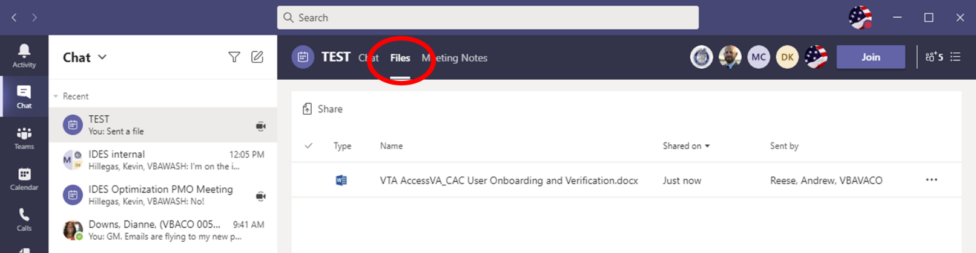

** After the call starts, the Teams Chat **will** only be used to ask questions. Call attendees **will not** make comments or respond to any of the questions. Please adhere to this request.

Ask questions over the phone or send an email to the appropriate staff corporate mailbox.

Please mute your microphone and turn off your camera by clicking on the appropriate icon. (See Figure 1)

Figure 1:

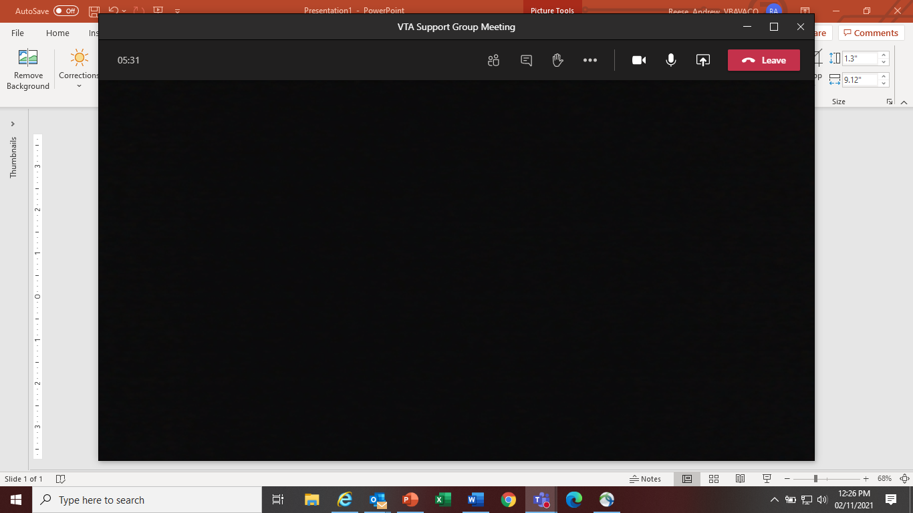

Below (Figure 2) is what your microphone and camera icons should look like when it is muted/turned off. Click the microphone icon to unmute if you need to ask a question (do not unmute if you do not need to speak). If you are dialed in via your phone, ensure your phone is muted.

Figure 2:



To ask a question, use the Raise your Hand option (click the hand and it will change color) in the Teams Meeting and you will be called upon for your question/comment. Once your question/comment is addressed lower your hand (click the hand again) (Figure 3). **Please do not talk/blurt out your question/comments unless called upon.**

Figure 3:



Please sign–up for the [C&P Calendar Subscription Service](http://vbacodmoint1.vba.va.gov/bl/21/calendar/cal_Subscribe.asp) to receive notification that the Read Ahead is available and for notification when the TMS number is active.

**Housekeeping Items**

* New Leadership
  + Mr. James Smith is the new Director for the Pre-Discharge & Interagency Collaboration Staff
  + New incoming Pre-Discharge Chief

General Topics for Discussion

**“Expiration Date” of Statement in Support of Claim, VAF 21-4138**

On a recent monthly call it was mentioned that the [VAF 21-4138](https://gcc01.safelinks.protection.outlook.com/?url=https%3A%2F%2Fwww.vba.va.gov%2Fpubs%2Fforms%2FVBA-21-4138-ARE.pdf&data=04%7C01%7C%7C0184e93492e5406a8cf008d8d35064af%7Ce95f1b23abaf45ee821db7ab251ab3bf%7C0%7C0%7C637491689518607510%7CUnknown%7CTWFpbGZsb3d8eyJWIjoiMC4wLjAwMDAiLCJQIjoiV2luMzIiLCJBTiI6Ik1haWwiLCJXVCI6Mn0%3D%7C1000&sdata=Xg95mkJwfGW4p5DnUb%2BvxPI0U4qPPCGWk2q3YUGY%2Bw0%3D&reserved=0) had “expired” as seen here:

[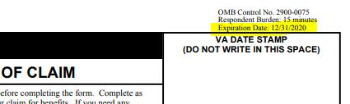](https://gcc01.safelinks.protection.outlook.com/?url=https%3A%2F%2Fapi.ams.gcc.teams.microsoft.com%2Fv1%2Fobjects%2F0-gccaz-d2-2a55ab52bb1874888eb036b24b02cbce%2Fviews%2Fimgo&data=04%7C01%7C%7C0184e93492e5406a8cf008d8d35064af%7Ce95f1b23abaf45ee821db7ab251ab3bf%7C0%7C0%7C637491689518617461%7CUnknown%7CTWFpbGZsb3d8eyJWIjoiMC4wLjAwMDAiLCJQIjoiV2luMzIiLCJBTiI6Ik1haWwiLCJXVCI6Mn0%3D%7C1000&sdata=4%2FeJMFcbsTz4RicEDP30fLrV%2BoUhsKX3gTMErFNFp0w%3D&reserved=0)

We reached out to the Compensation Service Form Manager who provided additional information. The expiration date at the top right refers to the Office of Management and Budget (OMB) Control number. This is the date by which VA must file for an extension. The VA has submitted the required extension notice to OMB. VA will continue to accept the current version of the form (available on our form websites) until OMB approves the extension and VA releases the new version to our form websites. Once the new form is released, the procedures as outlined in [M21-1 III.ii.1.C.8.b.](https://gcc01.safelinks.protection.outlook.com/?url=https%3A%2F%2Fvaww.vrm.km.va.gov%2Fsystem%2Ftemplates%2Fselfservice%2Fva_kanew%2Fhelp%2Fagent%2Flocale%2Fen-US%2Fportal%2F554400000001034%2Fcontent%2F554400000014112%2FM21-1-Part-III-Subpart-ii-Chapter-1-Section-C-Initial-Screening-Policies%238b&data=04%7C01%7C%7C0184e93492e5406a8cf008d8d35064af%7Ce95f1b23abaf45ee821db7ab251ab3bf%7C0%7C0%7C637491689518627415%7CUnknown%7CTWFpbGZsb3d8eyJWIjoiMC4wLjAwMDAiLCJQIjoiV2luMzIiLCJBTiI6Ik1haWwiLCJXVCI6Mn0%3D%7C1000&sdata=S4l3IuWd4E%2BE2lCuyvwyeXi%2Fvk3WwOkLtChVYpootP4%3D&reserved=0) will apply.

IDES Specific Topics

**HAIMS/VBMS/STR/DBQ Training Follow Up**

The IDES Program Office, in coordination with DoD, implemented new procedures for the HAIMS/VBMS/STR/DBQ automation on February 1, 2021. The staff continues to receive several questions and additional feedback. Please see topics below:

* Training Power Point slides have been updated and posted on the [IDES Homepage](https://vbaw.vba.va.gov/vbadod/IDES.asp)
* TMS ID has been activated; the recording and PPT have been added to TMS # 4563452
* Continue using Pending CEST Report in VTA, filter by your Military Treatment Facility (MTF)
* Please ensure Service is verified or open period of service is reflected in VBMS before requesting exams (See Appendix 1)
* Date of Claim=VTA Prepare Claim Start Date (See Appendix 1)
* No wet ink stamp or annotation needed (See Appendix 1)
* Duplicate 21-0819s- PEBLO must upload 21-0819 into HAIMS
* Seattle and Providence DRAS Quality Review Teams 30-day grace period has expired
* A few IT glitches have been identified and the staff is working with VBMS, DAS, HAIMS to resolve
* If MTFs are having issues with uploading or not aware of the HAIMS/VBMS/DBQ transfer process, send details including VTA Case ID (if applicable) to the [IDES Mailbox](mailto:VAVBAWAS/CO/IDES%20%3cIDES.VBACO@VA.GOV%3e)

**Traveling to Attend VES Medical Exams That Exceed Contractual Mileage Limits**

Last month we discussed the process used by QTC when exams exceed the 50/100-mile contractual rule for exams. The VES process is the same and is below.

* VES will contact SM with exam info and to schedule the exams after receiving the exam request from the MSC
* If the exam is beyond the 50/100-mile rule, VES will ask SM if traveling the distance is ok
* If SM accepts the distance, VES will submit a waiver to MDEO
* If waiver is approved, the exam will be scheduled and SM notified by VES via letter with time and place of appointments as the normal process of notification
* If waiver is disapproved, VES will contact the SM informing him/her of that decision and attempt to schedule the exam within limits or hold the exam request until a within limits examiner is found
* If SM has concerns/questions whether they are authorized to travel outside of the mileage limits, he/she should contact the PEBLO or Unit (not the MSC) about any travel restrictions
* Once the mileage concern/question is answered by the PEBLO or Command, SM should call VES with a yes or no on attending the exam(s)
* If the exams can be attended VES will finalize appointments
* If the exams can’t be attended, the exam will be put on hold until an examiner within the mileage limits is found
* VES will contact SM when an examiner within the miles limit is located/scheduled

Note: Turning down the exams will delay the IDES process.

Note: To reiterate: The MSC is not the SM’s POC about exams and mileage travel rules (restrictions/approval). SM should contact his/her Unit and/or PEBLO for clarification on their Chain of Command travel restrictions.

Note: Request MSCs inform the SM during the initial interview that there are no mileage payments by VES to attend exams.

Entering the Medical Evalution End Date (MEED) in VTA (Updated Procedure)

As a result of the automated DBQ transfer process that was implemented on February 1, 2021, claims processors with responsibility for entering the MEED in VTA must do so in accordance with the guidance shown in Appendix 2.

Note this guidance was also distributed via OFO email dated February 25, 2021, and is posted under *What’s New* on the [IDES Homepage](https://vbaw.vba.va.gov/vbadod/IDES.asp).

Current IDES Program Timeliness

As outreach specialists and VA’s frontline contact with SMs and Veterans, it is vital that we are realistic in our communications regarding claims processing times. Below is the current program timeliness data (ADC) for February 2021.

|  |  |  |
| --- | --- | --- |
| **Stage/Phase** | **IDES Goal (AD/NAD)** | **February 2021 (AD/NAD)** |
| **Claim Dev** | **5/11** | **10/16** |
| **Medical Stage** | **32** | **132/143** |
| **Proposed Ratings** | **20** | **7/11** |
| **Recon Ratings** | **4** | **9/6** |
| **Exit Interviews** | **14** | **10/10** |
| **Final Ratings** | **20/na** | **16/na** |

***Source:*** *VTA Completed Reports (Days to Complete Including Deferment) March 2, 2021 (8am ET).*

***Note:*** *VA using the goals from the 230-day process.*

BDD Specific Topics

Current BDD Program Timeliness

As VA’s frontline contact with SMs and Veterans, it is vital that we are transparent in our communications regarding claims processing times. Below is the current program timeliness data as of March 3, 2021.

|  |  |  |
| --- | --- | --- |
| **BDD Timeliness Data** | | |
| **Data Points** | **Goal** | **March 3, 2021** |
| **Completed FYTD** |  | **9,003** |
| **Receipts FYTD** |  | **9,543** |
| **Pending** |  | **11,424** |
| **# Completed w/in 30 Days of Discharge** |  | **2,241** |
| **% Completed w/in 30 Days of Discharge** | **100%** | **25%** |
| **Avg. Days to Complete FYTD** | **30** | **99** |

***Source:*** *Tableau BDD History Report, March 4, 2021*

Seattle DRAS VSC Development Pilot

Seattle DRAS VSC Development Pilot Exam Results Reminder

MSCs are reminded that all exam actions for Army cases are currently handled by the Seattle DRAS. In Army cases, local MSCs must **not**:

* Close out the MEED in VTA
* Inform the PEBLO that exams have been completed
* Add notes in VTA regarding the completion of VA Examinations

In Army cases, Seattle DRAS will enter the MEED in VTA once they have been deemed complete and ready for release to the PEBLO. When local MSCs indicate that exams have been completed prior to the DRAS entry of the MEED, it creates confusion and PEBLOs may move cases forward to the NARSUM prematurely.

Note**:** MSCs may provide copies of exam results to PEBLOs when HAIMS transfer fails—but should only do so after the DRAS has entered the MEED as discussed earlier.

MSCs are also reminded of the need to the IDES Development Special Issue Flash to all Army cases. The flash must be added prior to the brokering of the claim to DRAS.

Upcoming Teleconferences

The next BDD/IDES Call is scheduled for Tuesday, April 13, 2021, at 2PM ET. Please submit IDES questions and proposed topics for discussion to the [IDES Mailbox](mailto:VAVBAWAS/CO/IDES%20%3cIDES.VBACO@VA.GOV%3e), and BDD questions and proposed topics for discussion to the [BDD Mailbox](mailto:VAVBAWAS/CO/PREDISCHARGE%20%3cPredischarge.VBACO@va.gov%3e) no later than close of business (COB), Monday, March 29, 2021.

The next BDD/IDES Coaches Call is scheduled for June 3, 2021, at 2PM ET. Please submit IDES questions and proposed topics for discussion to the [IDES Mailbox](mailto:VAVBAWAS/CO/IDES%20%3cIDES.VBACO@VA.GOV%3e), and BDD questions and proposed topics for discussion to the [BDD Mailbox](mailto:VAVBAWAS/CO/PREDISCHARGE%20%3cPredischarge.VBACO@va.gov%3e) no later than COB, Monday May 17, 2021.

Open Floor

**Appendix 1: Call Notes from the February 2021 Comp Service BDD/IDES Conference Call**

**Military Service Verification**

**Question:** A Non-Active Duty (NAD) case when the Service member sometimes has an Active Duty for Training (ADT) period and it is not necessarily active duty, we will not know whether that is going to count as an active duty period of service until the rating is generated, so are you asking to put in a blank date?

**Answer:** extracted from[M21-1 III.ii.3.C.7.a](https://vaww.vrm.km.va.gov/system/templates/selfservice/va_kanew/help/agent/locale/en-US/portal/554400000001034/content/554400000014125/M21-1-Part-III-Subpart-ii-Chapter-3-Section-C-System-Updates#7a):

* Claims processors are responsible for ensuring that any unverified period of *active duty* is entered into VBMS as soon as VA is notified of the (unverified) period of active duty. The service will be marked as verified after VA receives all information required to verify military service.
* All periods of *active service* must be updated and verified in the systems by the rating activity prior to completion of the rating decision. Failure to do so will result in inaccurate or incomplete service displayed on the rating decision codesheet. However, the completion and authorization of a rating decision granting service connection based on a period of ADT or IADT is required before the service is considered active service. **Therefore, it is appropriate to enter the period of ADT or IADT into the systems after completion of the rating decision.**

As such, claims processors should not enter or verify any period (neither current or previous) of ADT or IADT, unless service-connection was previously granted for a condition relating to that period of service.

|  |  |  |
| --- | --- | --- |
| III.ii.3.C.7.a.  Military Service Verification |  | ***Important***:   * Claims processors are responsible for ensuring that any unverified period of active duty is entered into VBMS as soon as VA is notified of the (unverified) period of active duty. The service will be marked as verified after VA receives all information required to verify military service. * Each RO employee must check to ensure all periods of active service are updated and verified in VBMS when undertaking any claim action. Failure to ensure the period of service is marked verified may result in VBMS-Awards failing to process the award. * All periods of active service must be updated and verified in the systems by the rating activity prior to completion of the rating decision. Failure to do so will result in inaccurate or incomplete service displayed on the rating decision *Codesheet*.  However, the completion and authorization of a rating decision granting SC based on a period of active duty for training (ADT) or IADT is required before the service is considered active service.  Therefore, it is appropriate to enter the period of ADT or IADT into the systems after completion of the rating decision. |

**BDD Claims Received without Service Treatment Records (STRs)**

**Question:** When do we change the EP to a rating EP if we have the last 12 months of STRs, but not the entire STRs? Do we order the exam?

**Answer:** Yes, if you do not have the entire current period of service STRs, but you have the last 12 months of STRs, request the exams. Also, contact the SM to request all their current period of service STRs.

**Question:** If we are waiting on the STRs before the SM reaches 89 days before discharge and we can’t order the exam due to no current STRs, do we not change the EP 336 to a rating EP? If we leave the EP as a 336 it will stay in our work queue in VBMS.

**Answer:** You would immediately contact the SM to request their current period of service STRs. Since exams cannot be requested, the EP 336 cannot be changed until all development is completed including requesting all exams per [M21-1, III.i.2.A.2.d](https://vaww.vrm.km.va.gov/system/templates/selfservice/va_kanew/help/agent/locale/en-US/portal/554400000001034/content/554400000014099/M21-1-Part-III-Subpart-i-Chapter-2-Section-A-General-Information-on-Pre-Discharge-Claims#2d). The EP 336 diary EPs are not factored into the RO’s time in queue timeliness. Per NWQ, there is no time in queue timeliness requirement for diary EPs that have not matured past RAD+1.

**BDD YouTube Video and Fact Sheets**

**Question:** VA.gov claims contention list is very general and we must develop to clarify what conditions the SM is claiming when the SM enters just leg pain, arm, knee, shoulder, etc. Can the VA.gov team update this page on VA.gov to require SMs to specify the condition and which extremity, arm, knee, shoulder, wrists, elbows, etc. and the specific condition such as fracture, arthritis, pain with loss of motion, etc. If the SM enters joint or muscle pain, the SM would need to specify what extremity and any other symptoms beyond pain.

**Answer:** We have contacted the VA.gov team to see if this type of update is feasible and will advise when we receive a response.

**Date Stamps and Annotations**

**Question:** If we get an email from the PEBLO on Friday, but the documents don’t upload until Monday, do we change the date of the upload of the 0819 to reflect when the case was CEST’d?

**Answer:** The date of claim for the EP should equal the Prepare Claim Start Date, it is not connected to when we received the application since we moved to the HAIMS transfer process. The claim should be CEST’d before we receive the application, so it’s not tied to the date we received the application anymore. Unless the application was transferred on the day it is CEST’d, the application will be received subsequent to that date.

**HAIMS/VBMS/STR/DBQ Training Follow Up**

**Question:** If our DoD counterparts are not utilizing this process how do we proceed?

**Answer:** Provide the detail information to our corporate mailbox andwe will reach out to DoD Leadership to find out what the issues are and address appropriately.

**Temporary Early Retirement Authority (TERA) in USMC IDES Cases**

**Question:** Should an MSC upload the TERA approval letter and let the case move forward?

**Answer:** If the PEBLO does not take any actions, refrain from taking the Return to Duty actions until the case is disenrolled in VTA. If the case stays in VTA, it will proceed to the DRAS.

**Traveling to Attend QTC Medical Exams That Exceed Contractual Mileage Limits**

During the discussion of these two topics there were some comments on the call that the SM should be contacting QTC. To clarify and to make sure all are clear on the QTC procedure; SMs should not be contacting QTC to cancel an appointment. If the SM calls QTC to cancel an appointment, QTC will advise the SM that they will keep the appointment until they hear from the MSC or PEBLO to ensure the Command/PEBLO is informed and they truly need to reschedule, and are not delaying the process for non-approved reasons.

VES procedure is different.

VES: The SM should call VES to cancel an exam (re-schedule if possible). The SM does not need to have MSC/PEBLO approval to cancel an exam, however, as a courtesy the SM should inform their MSC.

**Appendix 2: Updated Guidance for Entering MEED in VTA (February 2021)**

As a result of the automated DBQ transfer process that was implemented on February 1, 2021, claims processors with responsibility for entering the MEED in VTA must do so in accordance with the guidance below.

When all exams are complete, the MSC/VSR responsible for entering the MEED must review VBMS Notes and/or JLV to confirm that the DBQs have transferred, and then take action in accordance with the table below.

|  |  |
| --- | --- |
| **If VBMS/JLV…** | **the MSC/VSR must:** |
| does not show that the DBQs have transferred | 1. Contact the PEBLO Assigned to request a SAFE link   **Notes:**   * if the case involves an Active Duty Service member, request the PEBLO enter a help ticket to document/determine the cause of the HAIMS transfer failure * if the PEBLO fails to provide a SAFE link by the end of the next business day, or the PEBLO responds stating that he or she is no longer assigned to the case, please notify [IDES.VBACO@VA.GOV](mailto:IDES.VBACO@VA.GOV)  1. Send the DBQs via SAFE 2. Enter the *MEED* in VTA to reflect the date the DBQs were sent in SAFE |
| shows the DBQs have transferred | enter the *MEED* immediately.  ***Note:*** If the PEBLO reports that the DBQs did not successfully transfer to HAIMS, the local MSC (the MSC Assigned in VTA) must:   * confirm that the PEBLO entered a help ticket, * provide the DBQs to the PEBLO via an approved alternative means, and * update the *MEED* to reflect the DBQs were provided |

Note: The guidance above is effectively immediately; the MEED must be updated in accordance with the table above in all cases point forward. Additionally, if a PEBLO reports that a *previously* entered MEED does not accurately represent the date the DBQs were made available, the claims processor that provided the DBQs to the PEBLO should review the case in VTA, and when appropriate, update the MEED to reflect the date the DBQs were provided.

*This guidance was distributed by OFO to all Districts on February 25, 2021.