Monthly Benefits Delivery at Discharge (BDD) and

Integrated Disability Evaluation System (IDES)

Conference Call Read Ahead

Compensation Service

BDD/IDES (212A)

November 10, 2020 — 2 PM ET

The Compensation Service BDD/IDES hosts this call to announce updates and address issues and questions related to the BDD/IDES Programs. All Military Services Coordinators (MSCs), Disability Rating Activity Sites (DRAS), Regional Offices and other VA personnel supporting BDD/IDES are invited to participate.

This read-ahead is provided to facilitate discussion during the conference call.

The Call Notes from the previous month’s call will be an appendix to the current month’s Read Ahead (there is no longer a separate Call Notes document). The Call Notes for the October Call are in Appendix 2. The TMS # for this month’s call will be provided during the call and should be active with-in a week of the call’s completion. A Calendar Blast will notify the field when the TMS # is active.

**Call-in Information**

[Join Microsoft Teams Meeting](https://teams.microsoft.com/l/meetup-join/19%3ameeting_MzlhN2FlN2YtYTFhNS00NjExLWEwMzMtYWEwYjE0YzU1Y2Qx%40thread.v2/0?context=%7b%22Tid%22%3a%22e95f1b23-abaf-45ee-821d-b7ab251ab3bf%22%2c%22Oid%22%3a%22a0338b5c-0526-4e13-9809-5d0ecc8cdeb8%22%7d)

[+1 872-701-0185](tel:+1%20872-701-0185,,448196643# )  United States (Toll)

Conference ID: 448 196 643#

The Read Ahead and Slides will be attached to the Chat (may have to scroll up in the Chat), can also be found in the Files link on the call and on the [IDES Homepage](https://vbaw.vba.va.gov/vbadod/IDES.asp) and on the [BDD Homepage.](https://vbaw.vba.va.gov/vbadod/predischarge.asp)

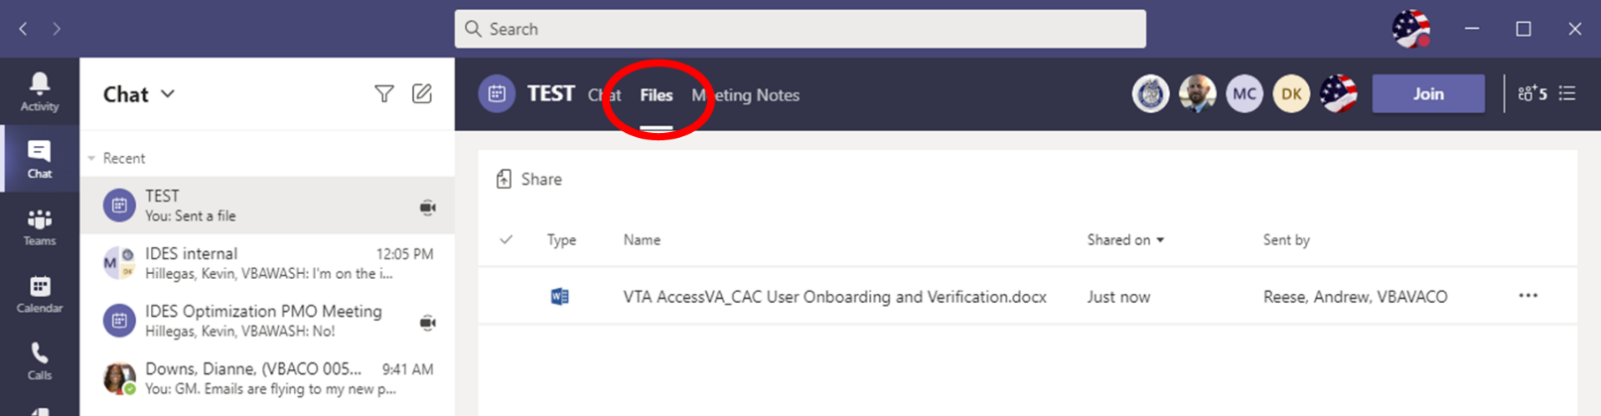

The Teams Chat will not be used for questions/comments after the call starts. Ask questions over the phone or send an email to the appropriate staff corporate mailbox.

Please mute your microphone and turn off your camera by clicking on the appropriate icon. (See Figure 1)

Figure 1: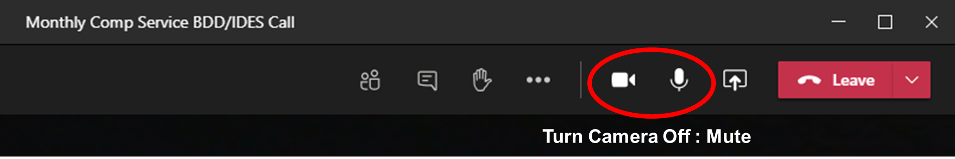

Below (Figure 2) is what your microphone icon should look like when it is muted and the camera is off. Click the microphone icon to unmute if you need to ask a question (do not unmute if you do not need to speak).

Figure 2:



If you are dialed in via your phone, ensure your phone is muted.

Please sign–up for the [C&P Calendar Subscription Service](http://vbacodmoint1.vba.va.gov/bl/21/calendar/cal_Subscribe.asp) to receive notification that the Read Ahead is available and for notification when the TMS number is active.

COVID-19 Topics for Discussion

**COVID-19**

This continues to be a very difficult time. Please remember that things are very fluid, and some changes/decisions are happening as we speak. We appreciate your patience, flexibility and support. Contact the [BDD Mailbox](mailto:VAVBAWAS/CO/PREDISCHARGE%20%3cPredischarge.VBACO@va.gov%3e) or [IDES Mailbox](mailto:VAVBAWAS/CO/IDES%20%3cIDES.VBACO@VA.GOV%3e) as needed.

Phase 3 Exam Resumption by QTC/VES and Other Exam Info

Below is a reminder of current exam info.

* Phase 1 – Out-patient C&P examinations can be completed that do not require the removal of PPE
* Phase 2 – Out-patient and in-patient C&P examinations can be completed that do not require the removal of PPE
* Phase 3 – All C&P examinations can be completed, and PPE removed

Most of the country is in Phase 3, however, COVID is fluid and changes may happen quickly based on state and/or local rules.

The most recent list of the Phase 3 locations is on the [IDES Homepage](https://vbaw.vba.va.gov/vbadod/IDES.asp).

<https://benefits.va.gov/compensation/claimexam.asp> can be used to see if exams have resumed in an area. Enter the zip code and it provides a status of that location. Overseas locations are also shown.

Notes:

1. VHA Executive in Charge and USB guidance remains that all BDD/IDES exams are to be ordered through QTC/VES. An email was sent from OFO to the Districts on October 21 in reference to this guidance. VHA will not be used, even if you have a pre-COVID local agreement with VHA. Any recent agreements between an RO and a VAMC are not allowed. Any concerns on pending QTC or VES exams should be submitted to [VAVBAWAS/CO/Contract Examination Inquiries](mailto:ContractExam.VBAVACO@va.gov) and cc the [IDES Mailbox](mailto:VAVBAWAS/CO/IDES%20%3cIDES.VBACO@VA.GOV%3e) or [BDD Mailbox](mailto:VAVBAWAS/CO/PREDISCHARGE%20%3cPredischarge.VBACO@va.gov%3e).
2. Any pending exam requests that are in CAPRI should be cancelled, to include those from before or the early days of COVID. If those exams have not been re-ordered through QTC/VES, they should be.
3. Keep your DoD counterparts informed on the latest exam guidance.

General Topics for Discussion

**Continuation Sheet for Claimed Disabilities**

[M21-1, III.ii.2.B.1.f](https://vaww.vrm.km.va.gov/system/templates/selfservice/va_kanew/help/agent/locale/en-US/portal/554400000001034/content/554400000014119/M21-1-Part-III-Subpart-ii-Chapter-2-Section-B-Claims-for-Disability-Compensation-and-or-Pension-and-Claims-for-Survivors-Benefits#1f) is the policy that applies to all claim submissions. If an individual submits a claim on the proper prescribed form and (because they run out of room, or for whatever reason) attaches “additional correspondence,” we can usually accept the contentions/statements on the “additional correspondence” as part of the claim. There is no expressed requirement that the attachment be a VA Form 21-4138, but MSCs should provide/encourage the use of VA Form 21-4138 for this purpose for any BDD/IDES applications submitted during in-person interviews. There are some notable exceptions outlined in that block: for instance, we can not accept freestanding medical evidence as indicative of intent to claim, and we can not do anything if only a POA (if any) signs the document attachment. It is also very important in these instances that the submissions be simultaneous. If we get a 526EZ and a 4138 with additional contentions on the same date, we can incorporate the 4138 contentions into the underlying claim. If we receive the 4138 one day later than the 526EZ, it becomes a request for application (RFA).

**Mental Health, PTSD and Audio Exam Requests**

There has been some confusion regarding exam requests. The Medical Disability Exam Office (MDE) has confirmed that if PTSD and another mental health condition is claimed that is not an eating disorder such as major depressive disorder, bipolar disorder, generalized anxiety disorder, etc. for BDD or BDD-Excluded claims and IDES referrals the PTSD DBQ should be selected in the exam request and not the [Mental Disorder DBQ](http://vbacoweb03.dva.va.gov/bl/21/DBQ/docs/InternalDBQs/Mental%20Disorders.pdf). The PTSD DBQ has instructions for the mental health examiner to determine if any other mental disorder diagnoses exist including any symptoms attributable to that mental disorder diagnosis.

Similarly, if hearing loss and tinnitus are claimed in BDD or BDD-Excluded claims and IDES referrals, the [Hearing Loss and Tinnitus](http://vbacoweb03.dva.va.gov/bl/21/DBQ/docs/InternalDBQs/HearingLoss_and_Tinnitus.pdf) DBQ should be selected in the exam request for the hearing loss and tinnitus contentions.

**Reducing Free Text Submissions on VAF 21-4138, Statement in Support of Claim and Enhancing Automation Capabilities**

Three new OMB approved forms are available in the VA’s [Find a VA form](https://www.va.gov/find-forms/) library and need to be used as applicable. These forms were created to address VAF 21-4138 free text submissions and to enhance automation capabilities.

* [VAF 21-0538-Mandatory Verification of Dependents](https://www.vba.va.gov/pubs/forms/VBA-21-0538-ARE.pdf); form to submit mandatory verification of dependents
* [VAF 20-10206-FOIA/PA Request](https://www.vba.va.gov/pubs/forms/VBA-20-10206-ARE.pdf); information and instructions on how to submit a Freedom of Information Act (FOIA) or Privacy Act (PA) request
* [VAF 20-10207-Priority Processing Request](https://www.vba.va.gov/pubs/forms/VBA-20-10207-ARE.pdf); form to submit a request for priority processing of a claim due to extreme financial hardship, terminally ill, ALS diagnosis, VSI/SI, >85 years old, FPOW, or MOH/PH
* [VAF 20-10208-Document/Evidence Submission](https://www.vba.va.gov/pubs/forms/VBA-20-10208-ARE.pdf); used for the submission of additional documentation or evidence in support of a claim

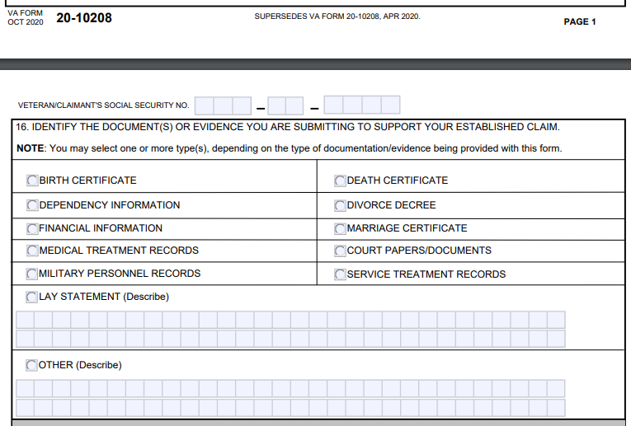

VA’s Under Secretary for Benefits (USB) plans to ***eventually*** increase the frequency with which Veterans must complete [*VAF 21-0538, Mandatory Status of Dependents*](https://www.vba.va.gov/pubs/forms/VBA-21-0538-ARE.pdf), from once every eight years to once every year. Effective September 19, 2020, the intake of VAF 21-0538 via the Centralized Mail (CM) process described in [M21-1 III.ii.1.E.1](https://vaww.vrm.km.va.gov/system/templates/selfservice/va_kanew/help/agent/locale/en-US/portal/554400000001034/content/554400000032384/M21-1,-Part-III,-Subpart-ii,-Chapter-1,-Section-E---Centralized-Mail-(CM)-Intake) triggers an automatic establishment of end product (EP) 330, *330DEPVER*. If VAF 21-0538 is received, please send to CM.

**Handling Supplemental Claims from Active Duty SMs**

MSCs have requested a review of the supplemental claim guidance discussed during the [October BDD/IDES Call](https://vbaw.vba.va.gov/VBADOD/docs/IDES/Oct2020BDDIDESCallReadAheadFinal1.docx). Additionally, it has been determined that the guidance is also applicable to supplemental claims submitted by BDD participants, as now reflected in Appendix 1. Compensation Service will provide a review of the current supplemental claim guidance and discuss related Q/As from the Call Notes (Appendix 2).

**Important:** Appendix 1 does **not** change any procedure discussed during the October Call relating to IDES claims. The updated guidance in Appendix 1 is only intended to indicate that the procedure is equally applicable in BDD claims.

IDES Specific Topics

Current IDES Program Timeliness

As outreach specialists and VA’s frontline contact with SMs and Veterans, it is vital that we are realistic in our communications regarding claims processing times. Below is the current program timeliness data (ADC) for October 2020.

|  |  |  |
| --- | --- | --- |
| **Stage/Phase** | **IDES Goal (AD/NAD)** | **October 2020 (AD/NAD)** |
| **Claim Dev** | **5/11** | **11/10** |
| **Medical Stage** | **32** | **133/132** |
| **Proposed Ratings** | **20** | **3/9** |
| **Recon Ratings** | **4** | **11/7** |
| **Exit Interviews** | **14** | **8/12** |
| **Final Ratings** | **20/na** | **16/na** |

***Source:*** *VTA Completed Reports (Days to Complete Including Deferment) November 2, 2020 (8am ET).*

***Note:*** *VA using the goals from the 230-day process.*

**VTA Specific Topics**

**VTA Announcements Section**

The VTA Announcements Section is on the right side of the VTA Homepage and is used to provide important info (announcements) to VTA users. You should look at the Announcement Section when you log-in, especially when you receive the pop-up below. Example: After the release of v.2.4.9 there was a “Save” issue along with an issue opening the MSC Tab. An announcement was added to the Announcements Section about this issue along with a work around (Clear Cache and/or use Chrome). We were receiving emails about the issue from MSCs 2-3 days after the announcement, which could have been prevented had the user read the annoucement.

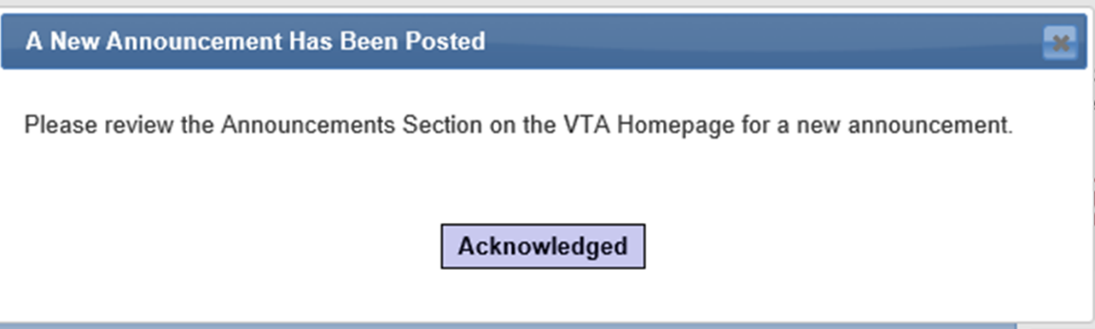

**Cases in VTA that Require New MSC Assigned**

MSC Coaches are responsible for reassigning cases in VTA when the MSC Assigned no longer supports IDES. The MSC coach should run the MSC Case Load Report, which is located under IDES Reports, Operation Reports. This report shows the Assigned MSC and the number of active cases. If the report shows active cases for an MSC that no longer supports IDES, those cases need to be reassigned. To find the cases that require reassignment, run a User Defined Report using the following selections:

|  |  |  |
| --- | --- | --- |
| **VTA Field Name** | **Column Options** | **Filter Options** |
| Case ID | X |  |
| Disenrollment Status | X | X |
| MSC Assigned | X | X |
| VA Regional Office | X |  |

Click Continue once all selections are made.

On next page (under filter options) select:

* Disenrollment Status: Enrollment Approved
* MSC Assigned: Select the MSC that is no longer supporting IDES

Click Run Report. The report generated will show the cases that need to be re-assigned. Cases should only be reassigned if the Exit Interview has not been completed.

BDD Specific Topics

**Selecting the Intake Site in VBMS**

[M21-1,III.i.2.A.2.a.](https://gcc01.safelinks.protection.outlook.com/?url=https%3A%2F%2Fvaww.vrm.km.va.gov%2Fsystem%2Ftemplates%2Fselfservice%2Fva_kanew%2Fhelp%2Fagent%2Flocale%2Fen-US%2Fportal%2F554400000001034%2Fcontent%2F554400000014099%2FM21-1-Part-III-Subpart-i-Chapter-2-Section-A-General-Information-on-Pre-Discharge-Claims&data=04%7C01%7C%7Cfddcaab16a1c4ccdb90008d880e70ad7%7Ce95f1b23abaf45ee821db7ab251ab3bf%7C0%7C0%7C637401077085987740%7CUnknown%7CTWFpbGZsb3d8eyJWIjoiMC4wLjAwMDAiLCJQIjoiV2luMzIiLCJBTiI6Ik1haWwiLCJXVCI6Mn0%3D%7C1000&sdata=MXQ966vlPXTsnZPTY9bBcdygaceYVF%2BiuSRwRVxR6i8%3D&reserved=0) **addresses the steps required for establishing BDD and BDD Excluded claims. It reminds the processor to “select the appropriate intake site” in VBMS.**

**The intake site is defined below as: (reference** [M21-1, III.i.2.B.1.a.**)**](https://vaww.vrm.km.va.gov/system/templates/selfservice/va_kanew/help/agent/locale/en-US/portal/554400000001034/content/554400000014101/M21-1-Part-III-Subpart-i-Chapter-2-Section-B-Division-of-Responsibilities-for-Processing-Benefits-Delivery-at-Discharge-BDD-and-BDD-Excluded-Claims#1a)

|  |  |  |
| --- | --- | --- |
| **Intake Site** |  | An ***intake site*** is any location where the Department of Veterans Affairs (VA) accepts claims. This includes:   * all regional offices (ROs) * demobilization sites with a VA presence * military installations with a VA presence, and * VA health care facilities.   A Benefits Delivery at Discharge (BDD) intake site is responsible for conducting outreach efforts, accepting claims, initiating development as appropriate, identifying points of contact for VA examinations, handling vocational rehabilitation and employment issues, and serving as a general liaison.    ***Note***:  Not all intake sites have the staffing or capability to perform the actions described in this topic. Under such circumstances, the parent RO of these sites bears the responsibility for taking these actions. |

If your intake site is not located in VBMS, please select your Regional Office when establishing BDD or BDD- Excluded claims. Email our BDD mailbox also to inform us of the missing intake site.

Current BDD Program Timeliness

As VA’s frontline contact with SMs and Veterans, it is vital that we are transparent in our communications regarding claims processing times. Below is the current program timeliness data as of November 3, 2020.

|  |  |  |
| --- | --- | --- |
| **BDD Timeliness Data** | | |
| **Data Points** | **Goal** | **November 3, 2020** |
| **Completed FYTD** |  | **2,100** |
| **Receipts FYTD** |  | **2,129** |
| **Pending** |  | **10,772** |
| **# Completed w/in 30 Days of Discharge** |  | **761** |
| **% Completed w/in 30 Days of Discharge** | **100%** | **36.2%** |
| **Avg. Days to Complete FYTD** | **30** | **73.1** |

***Source:*** *Tableau BDD History Report, November 4, 2020*

Upcoming Teleconferences

**There is no December Call.** We will send a Read Ahead if we have crucial information to provide.

The next BDD/IDES Call is scheduled for Tuesday, January 12, 2021, at 2PM ET. Please submit IDES questions and proposed topics for discussion to the [IDES Mailbox](mailto:VAVBAWAS/CO/IDES%20%3cIDES.VBACO@VA.GOV%3e), and BDD questions and proposed topics for discussion to the [BDD Mailbox](mailto:VAVBAWAS/CO/PREDISCHARGE%20%3cPredischarge.VBACO@va.gov%3e) no later than close of business (COB), Monday, December 28, 2020.

The next BDD/IDES Coaches Call is scheduled for December 3, 2020. Please submit IDES questions and proposed topics for discussion to the [IDES Mailbox](mailto:VAVBAWAS/CO/IDES%20%3cIDES.VBACO@VA.GOV%3e), and BDD questions and proposed topics for discussion to the [BDD Mailbox](mailto:VAVBAWAS/CO/PREDISCHARGE%20%3cPredischarge.VBACO@va.gov%3e) no later than COB, Monday November 16, 2020.

Open Floor

**Appendix 1:**

**Updated Guidance for Handling Supplemental Claims from Active Duty Service Members**

Previous Compensation Service guidance has indicated that supplemental claims from active duty service members must be processed outside of the IDES and BDD programs and according to standard supplemental claim procedure entirely. However, this has shown to be problematic as the standard supplemental claim process does not allow a means for these claims to be decided while the claimant is currently serving on active duty, resulting in unactionable EP 040s.

The guidance below updates and supersedes previous guidance and allows supplemental claim issues to be considered as part of IDES/BDD claims, and within IDES/BDD decisions. The requirement for VA Form 20-0996 remains in place, as does the requirement for EP 040. However, supplemental claim issues will now be controlled under the pending IDES/BDD EP while the participant is serving on active duty; establishment of the EP 040 will be deferred until the participant is discharged.

***Important:*** the guidance below is **not** applicable to higher level review (HLR) claims (filed on VA Form 20-0996), or to supplemental claims filed by IDES claimants who are not currently serving on active duty. In these scenarios, the standard HLR/supplemental claim processes are not impeded by the claimant’s duty status and as such, these applications must continue to be processed according to standard HLR/supplemental claim policy and procedure.

Continued Requirement for Prescribed Form

As indicated in previous guidance, supplemental claims must be submitted on VA Form 20-0995 to be considered a claim for benefits; this requirement remains unchanged. When previously denied conditions are indicated on a VA Form 21-526EZ, it cannot be considered a claim for benefits; rather, this must be handled as a “request for application” in accordance with M21-1 III.ii.2.C.6.a.

When pre-discharge claimants indicate their intent to claim a previously denied issue during an in-person interview, the MSC must explain the decision review options available (HLR vs. Supplemental claims) and associated application requirements. If a BDD/IDES participant wishes to pursue a supplemental claim, the MSC must provide a VA 20-0995 for this purpose.

Handling Supplemental Claim Applications from IDES/BDD Participants

When a VA Form 20-0995 is received from an active-duty Servicemember with a pending BDD or IDES claim, the claims processor who identifies the application must ensure that the issue is listed as a contention under the BDD (diary EP) or IDES EP (EP 689). The issue will remain controlled under the IDES/BDD EP while the participant remains on active duty. (An EP 040 will **not** be established upon the Servicemembers discharge as indicated below).

When active duty BDD/IDES participants submit VA Form 20-0995s, the supplemental claim issues must be developed in accordance with standard IDES/BDD procedure. The requirement for “potentially new evidence” is satisfied on the basis of the claimant’s current period of service and new STRs. When the evidence of record is sufficient to do so, the supplemental claim issue should be addressed in IDES proposed ratings, and BDD pre-discharge ratings.

Establishing EP 040

Upon discharge, an EP 040 must be established in Caseflow, with a date of claim representing the day following the participant’s discharge (i.e, RAD+1, in accordance with standard pre-discharge EP policy). In IDES claims, the EP 040 must be established by DRAS at the time the IDES Rating EP is established for the final rating. In BDD claims, the 040 must be established by the claim processor who first works the claim after the participant’s discharge.

Deciding Supplemental Claim Issues and Resolving EP 040

To the extent possible, supplemental claim issues should be addressed in final IDES/BDD ratings.

If the supplemental claim issue(s) were fully decided in the final IDES/BDD rating, the EP 040 must be cleared at the time the BDD/IDES rating is promulgation. If the supplemental claim issues were not resolved in the IDES/BDD rating, the EP 040 must remain pending to be processed in accordance with standard supplemental claim procedure.

**Appendix 2:** **Call Notes from the October 2020 Comp Service BDD/IDES Conference Call**

**Handling Supplemental Claims from Active Duty IDES SMs (DK)**

Please see Appendix 3 (October Read Ahead) for updated guidance on handling supplemental claims from active duty IDES SMs. Please note this guidance updates and supersedes all previous guidance on this issue.

**Question:** Is the DRAS supposed to address these issues on the proposed rating, defer these issues until the final?

**Answer:** Whenever the evidence of record is sufficient to do so, the supplemental claim issue should be addressed in IDES proposed ratings or the final IDES rating. If the supplemental claim issue(s) were not resolved in an IDES determination, the EP 040 must remain pending and will be processed outside of IDES IAW regular supplemental claim procedure.

**Question:** We take the 20-0995 from the SM and then we will also order the exam because the new POS is new & relevant, or are we not ordering the exams for those conditions?

**Answer:** A supplemental claim does not, by default or as a matter of general rule, automatically entitle a claimant to an examination (per M21-1 III.ii.2.D.1.j). However, for IDES participants who are currently serving on active duty, the fact of the new period of service, and the new STR, will nearly always constitute new and relevant evidence, and warrant examination.

When a complete 20-0995 is received during initial IDES interview, the MSC will include the supplemental claim issue(s) on the exam request. MSCs should make every attempt to obtain a completed 20-0995 during the initial interview so that the issue can be addressed as part of IDES exams and resolved within the IDES rating.

If an MSC receives a complete 20-0995 after the IDES interview, the supplemental claim issue(s) must be handled in accordance with M21-1 III.i.2.F.1.c., which stipulates that MSCs are not *obligated* to order exams for conditions claimed after the initial IDES interview (as VA is not obligated to consider these added issues as a part of IDES process). However, MSCs may elect to order exams for these issues if doing so does not impede the IDES process and does not interfere the MSC’s IDES responsibilities. MSCs are encouraged to order exams for new issues to the extent possible, as doing so is usually most efficient, and may provide the opportunity to resolve the issue as part of the IDES decision.

***Important***: Regardless of whether the MSC orders exams for supplemental claim issues, the MSC **must** ensure that the issues are listed under the EP 689 whenever he or she receives/identifies a complete VA Form 20-0995.

**Question:** “Is this guidance retroactive? So if we come across a 689 and it has an 040, should we be PCANing the 040 and putting it back under the 689, or is this point forward?”

**Answer:** The new guidance should be implemented immediately and is applicable to any active duty IDES/BDD participant with a supplemental claim, to include those with currently pending supplemental claims. While the participant remains on active duty, the EP 040 is unactionable, and should be cancelled. However, to ensure continuity of control, it is critical that the MSC ensure that the supplemental claim conditions are listed under the EP 689, prior to cancelling any pending EP 040.