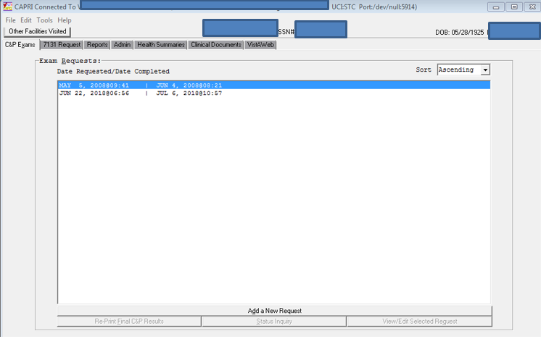

1. Select “Add a New Request”

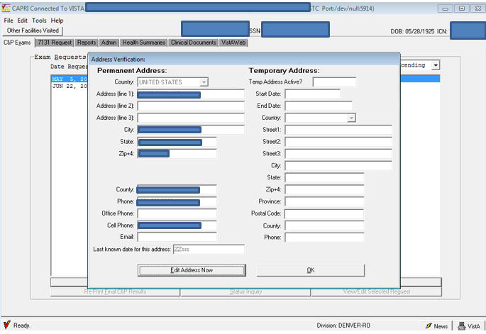

1. Review the address which the VA Medical Center has on record. If the address varies please review the “Last known date for this address” section near the bottom. If the address VBA has on file varies from VHA, then in Exam Request Builder ensure you include the address and the date of when we received the address.

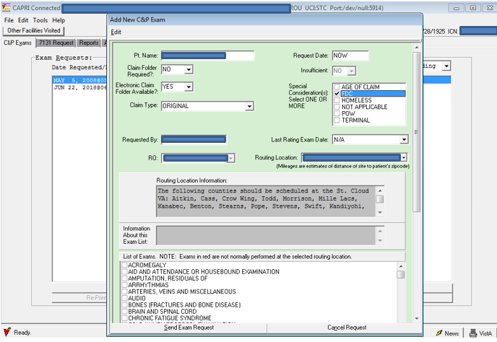

1. **Claim Folder Required** is asking if a physical claim file will be sent to the VA Medical Center. Majority of cases processed the proper selection will be “No”. One exception would include high level sensitive claims which are currently physically held as a Restrict Access Claims Center (RACC).
2. **Electronic Claims Folder Available** is asking if there is a claims file located within VBMS. Majority of cases processed the proper selection will be “Yes”.
3. **Claim Type** provides a drop down and select the most appropriate selection. Majority of cases processed will fall within “Original” or “Supplemental” selections. If the claim solely contains increase contentions, then “Increase” would be applicable. If it contains increase contentions and any other contentions which receive an examination, then default back to Original or Supplement.
4. **Special Consideration(s)** choose the option(s) which are applicable to the claim. If none are applicable, then do not select any.
5. **Routing location** will be selected based on results provided by Examination Request Routing Assistant (ERRA). Careful during this selection process; there are multiple Community Based Outpatient Clinics but not all clinics are equipped to provide Compensation and Pension (C&P) examination(s). Always refer to ERRA for the routing of C&P examination(s) and double check your selection.

Once a facility is selected, then the “List of Exams” will populate.

**Important: You will always select the body system which starts with “DBQ”.** This will ensure the Disability Benefits Questionnaire is completed. The body systems near the top do not attach a DBQ and are outdated.

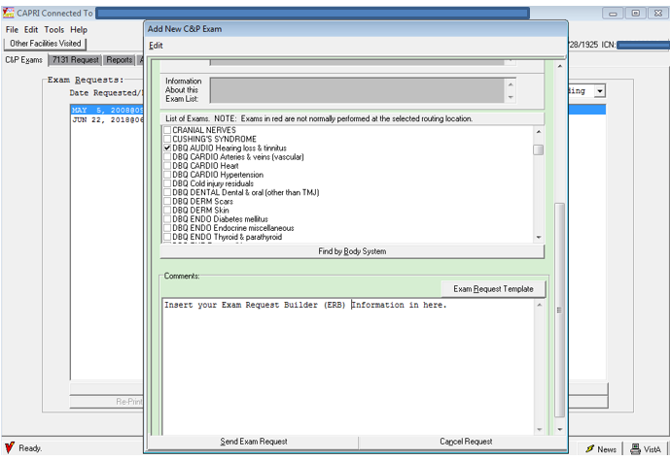

1. **Select all applicable DBQs.** If a medical opinion is required, then select the appropriate DBQ and DBQ Medical Opinion. There are a few exceptions where the opinion request is built into the DBQ. The most common is audio examination. If there is a question of if the medical opinion is built within the DBQ, please see the [DBQ Switchboard](http://vbacoweb03.dva.va.gov/bl/21/DBQ/default.asp) page located on the Compensation Intranet home page.
2. Enter the Exam Request Builder (ERB) data into the “Comments” section by copying and pasting functions.
3. Select “Send Exam Request” to submit the examination. Once the examination is submitted then it will be routed to the VA facility selected in the middle of the page.

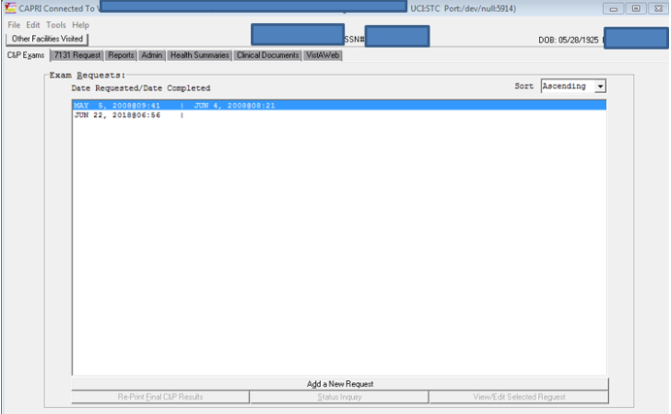

1. The current date will populate, and no additional date will be shown. This indicates an examination is pending. Once the examination is complete another date will populate to the right of the initial date.
2. A copy of the examination request should be uploaded into VBMS to document an examination was requested. Select the pending examination and double click the date. This will populate another window, then select “File” >> “Print” >> PDF. Save the PDF and upload into the VBMS electronic folder.