**Contention Classification Job Aid**

Effective March 21, 2016, the Contention Classification list has been reduced to include the following Contention Classifications. Selection of the appropriate Contention Classification will drive the selection of exams once exam automation functionality has been implemented.

**Important:** If the Contention Classification is incorrectly selected, it will send the incorrect data to the examiner and may cause the scheduling request to be return with clarification requests.

Use the table below as a guide for determining what contention classification to associate to a claimed contention/condition.

|  |  |
| --- | --- |
| Contention Classifications | Associate to the following contentions |
| Adhesions - Digestive | Adhesions of the digestive system |
| Adhesions - Gynecological | Adhesions of the gynecological system |
| Adhesions - Heart/Veins/Arteries | Adhesions of the cardiovascular system |
| Adhesions - Neurological other System | Adhesions of the neurological system |
| Adhesions - Respiratory | Adhesions of the respiratory system |
| Administrative Issue | Only non-rating issues such as dependency or drill pay |
| Aneurysm - Heart/Veins/Arteries | Aneurysm of the cardiovascular system |
| Aneurysm - Neurological other System | Aneurysm of the neurological system |
| Arm Condition - Heart/Veins/Arteries | Conditions of the cardiovascular system specific to the arm |
| Arm Condition - Neurological other System | Conditions of the neurological system specific to the arm |
| Birth Defect In Child | Birth defects in child |
| Caisson | Caisson sickness or disease |
| Cancer - Dental and Oral | Cancer of the mouth |
| Cancer - Digestive | Cancers of the digestive system such as colon cancer; esophageal cancer; liver cancer; and rectal cancer |
| Cancer - Endocrine | Cancers of the endocrine system such as pancreatic cancer |
| Cancer - Eye (Vision) | Cancers of the eye |
| Cancer - Genitourinary | Cancers of the genitourinary system such as kidney cancer and bladder cancer |
| Cancer - Gynecological | Cancers of the gynecological system such as ovarian cancer |
| Cancer - Heart/Veins/Arteries | Cancers of the cardiovascular system |
| Cancer - Hemic and Lymphatic | Cancers of the hemic and lymphatic system such as leukemia |
| Cancer - Musculoskeletal - Ankle | Cancers relating to the ankle |
| Cancer - Musculoskeletal - Elbow | Cancers relating to the elbow |
| Cancer - Musculoskeletal - Foot | Cancers relating to the foot |
| Cancer - Musculoskeletal - Hand | Cancers relating to the hand |
| Cancer - Musculoskeletal - Hip | Cancers relating to the hip |
| Cancer - Musculoskeletal - Knee | Cancers relating to the knee |
| Cancer - Musculoskeletal - Mid/Lower Back (Thoracolumbar Spine) | Cancers relating to the mid and lower back |
| Cancer - Musculoskeletal - Neck/Upper Back (Cervical Spine) | Cancers relating to the neck and upper back |
| Cancer - Musculoskeletal - Shoulder | Cancers relating to the shoulder |
| Cancer - Musculoskeletal - Wrist | Cancers relating to the wrist |
| Cancer - Musculoskeletal - Other | Avoid the use of this classification unless no other possible classification is appropriate |
| Cancer - Musculoskeletal and Muscle Injuries | Cancers of the musculoskeletal system such rhabdomyosarcoma |
| Cancer - Neurological other System | Cancers of the neurological system such as brain cancer |
| Cancer - Respiratory | Cancers of the respiratory system such as lung cancer |
| Cancer - Skin | Cancers of the skin such as skin cancer |
| Cold Injury Residuals | Cold injury residuals |
| Competency | Competency and incompetency |
| Cyst/Benign Growth - Dental and Oral | Cysts or growths of the mouth |
| Cyst/Benign Growth - Digestive | Cysts or growths on the digestive system |
| Cyst/Benign Growth - Ear Disease and Other Sense Organs | Cysts or benign growths on the ear or other sense organs |
| Cyst/Benign Growth - Endocrine | Cysts or benign growths on the endocrine system |
| Cyst/Benign Growth - Eye (Vision) | Cysts or benign growths on the eyes |
| Cyst/Benign Growth - Genitourinary | Cysts or benign growths on the genitourinary system such as kidneys or bladder |
| Cyst/Benign Growth - Gynecological | Cysts or benign growths on the gynecological system such as ovaries |
| Cyst/Benign Growth - Heart/Veins/Arteries | Cysts or benign growths on the cardiovascular system |
| Cyst/Benign Growth - Hemic and Lymphatic | Cysts or benign growths on the hemic and lymphatic system |
| Cyst/Benign Growth - Musculoskeletal - Ankle | Cysts or benign growths on ankle |
| Cyst/Benign Growth - Musculoskeletal - Elbow | Cysts or benign growths on elbow |
| Cyst/Benign Growth - Musculoskeletal - Foot | Cysts or benign growths on foot |
| Cyst/Benign Growth - Musculoskeletal - Hand | Cysts or benign growths on hand |
| Cyst/Benign Growth - Musculoskeletal - Hip | Cysts or benign growths on hip |
| Cyst/Benign Growth - Musculoskeletal - Knee | Cysts or benign growths on knee |
| Cyst/Benign Growth - Musculoskeletal - Mid/Lower Back (Thoracolumbar Spine) | Cysts or benign growths on mid/lower back |
| Cyst/Benign Growth - Musculoskeletal - Neck/Upper Back (Cervical Spine) | Cysts or benign growths on neck/upper back |
| Cyst/Benign Growth - Musculoskeletal - Other | Avoid the use of this classification unless no other possible classification is appropriate |
| Cyst/Benign Growth - Musculoskeletal - Shoulder | Cysts or benign growths on shoulder |
| Cyst/Benign Growth - Musculoskeletal - Wrist | Cysts or benign growths on wrist |
| Cyst/Benign Growth - Musculoskeletal and Muscle Injuries | Cysts or benign growths on muscles |
| Cyst/Benign Growth - Neurological other System | Cysts or benign growths on neurological system |
| Cyst/Benign Growth - Respiratory | Cysts or benign growths on respiratory system such as lungs |
| Cyst/Benign Growth - Skin | Cysts or benign growths on skin |
| Dental and Oral | Any dental or oral conditions not related to the temporomandibular joint (TMJ) |
| Dental and Oral - Musculoskeletal | Any condition related to TMJ; Fracture of jaw |
| Digestive | Conditions of the digestive system such as esophagus; stomach; intestines; gastroesophageal reflux disorder (GERD); irritable bowel syndrome (IBS); hemorrhoids |
| Ear Disease and Other Sense Organs | Ear infections; vertigo; Meniere’s disease; dizziness |
| Eating Disorders | Anorexia; bulimia; binge eating |
| Embolism/Infarction - Heart/Veins/Arteries | Embolism of the cardiovascular system such as pulmonary embolism |
| Embolism/Infarction - Neurological other System | Embolism of the neurological system |
| Endocrine | Conditions of the endocrine system such as thyroid; parathyroid; pancreas; pituitary gland; and Cushing’s syndrome |
| Eye (Vision) | Macular degeneration; glaucoma; herpes on eye(s); other vision related conditions |
| Genitourinary | Conditions of the genitourinary system such as kidney (nephropathy) and bladder |
| Gulf War Unexplained Chronic Multi-Symptom Illness | Gulf War unexplained chronic multi system illnesses such as fibromyalgia and chronic fatigue |
| Gulf War Undiagnosed Illness | Undiagnosed illness Gulf war |
| Gynecological | Any gynecological conditions such as menstrual disorders and hysterectomy |
| Hearing Loss | Hearing loss; tinnitus |
| Heart/Veins/Arteries | Conditions of the cardiovascular system such as heart and hypertension |
| Helpless Child | Helpless child |
| Hemic and Lymphatic | Conditions of the hemic and lymphatic system such as spleen; bone marrow; lymph nodes |
| Hemorrhage - Eye (Vision) | Hemorrhage of eye |
| Hemorrhage - Neurological other System | Hemorrhage of neurological system such as a cerebral hemorrhage and stroke |
| Infectious Diseases, Immune Disorders & Nutritional Deficiencies | Malaria; leprosy; HIV/AIDS; pellagra; beriberi; lupus |
| Leg Condition - Heart/Veins/Arteries | Conditions of the cardiovascular system specific to the leg such as varicose veins |
| Leg Condition - Neurological other System | Conditions of the neurological system specific to the leg |
| Mental Disorders | Depression; anxiety; insomnia; and other mental health conditions |
| Musculoskeletal - Amputations | Amputations other than toe amputations |
| Musculoskeletal - Ankle | Ankle conditions such as Ankle sprain and ankle strain |
| Musculoskeletal - Arthritis | Arthritis |
| Musculoskeletal - Elbow | Elbow conditions; Tendonitis of elbow; Tennis elbow |
| Musculoskeletal - Foot | Pes planus (flatfoot); plantar fasciitis; heel spur; other foot related conditions |
| Musculoskeletal - Hand | Any finger conditions; any hand conditions |
| Musculoskeletal - Hip | Hip bursitis; hip strain; thigh strain; other hip and thigh conditions |
| Musculoskeletal - Knee | Patellofemoral syndrome (PFS); anterior cruciate ligament (ACL); meniscus tear; other knee related conditions |
| Musculoskeletal - Mid/Lower Back (Thoracolumbar Spine) | Mid/low back conditions such as lumbosacral pain; degenerative disc disease; low or mid back pain |
| Musculoskeletal - Neck/Upper Back (Cervical Spine) | Upper back pain; cervical spine; degenerative disc disease |
| Musculoskeletal - Osteomyelitis | Bone conditions such as osteomyelitis; bone infection; and inflammation of bone |
| Musculoskeletal - Other | Avoid the use of this classification unless no other possible classification is appropriate |
| Musculoskeletal - Shoulder | Shoulder bursitis; shoulder tendonitis; Rotator cuff; other shoulder conditions |
| Musculoskeletal - Toe Amputations | Amputations of toes |
| Musculoskeletal - Wrist | Sprained wrist; strained wrist; tendonitis of wrist; other wrist conditions |
| Musculoskeletal and Muscle Injuries | Weakness of muscles; bruising or contusion of muscle |
| Neurological - Cranial/Peripheral Nerves | Facial nerve disorders; carpal tunnel; peripheral neuropathy |
| Neurological other System | Amyotrophic lateral sclerosis (ALS); multiple sclerosis (MS) |
| Pension | Live pension and death pension |
| Pension - Aid and Attendance/Housebound | Special monthly pension (SMP); pension aid and attendance; pension housebound |
| Post Traumatic Stress Disorder (PTSD) Combat - Mental Disorders | Combat related PTSD |

|  |  |
| --- | --- |
| Post Traumatic Stress Disorder (PTSD) Personal Trauma - Mental Disorders | Personal trauma related PTSD; military sexual trauma (MST) |
| Respiratory | Asthma, bronchitis, asbestosis; sinusitis; rhinitis; and other respiratory conditions |
| Scars (Extremities and Trunk) | Scars on extremities and trunk |
| Scars (Head, Face, Or Neck) | Scars on head, face, or neck |
| Service Connected Death | Service connected death |
| Skin | Dermatitis; rosecea; pseudofolliculitis barbae (PFB); herpes; acne; and other skin related conditions |
| Special Monthly Compensation - Aid and Attendance/Housebound | Aid and attendance; housebound; special monthly compensation (SMC) |
| Special Monthly Compensation - Anatomical Loss/Loss Of Use | Erectile dysfunction |
| Spina Bifida | Spina Bifida |
| Traumatic Brain Injury | Traumatic brain injury (TBI) |
| Tuberculosis | Tuberculosis (TB) |
| Unemployability | Individual unemployability (IU) |
| Wound, Bullet/Shell Fragment | Gunshot wound (GSW); shrapnel wound; bullet wound |

Whenever in doubt about which contention classification to select for a condition, you may use the following resources:

* [Index of DBQ/Exams by Disability](http://vbacodmoint1.vba.va.gov/bl/21/DBQ/DBQByDisab.asp)

**Example**: You received a claim from a veteran claiming service connection for *diabetes mellitus.* The claimed condition of “diabetes” can be typed into the search criteria. After the condition has been entered, the following results will be provided. Please note the name of the DBQ will be provided in the third column “Required DBQ”. Reviewing the results provided, you know to choose “Endocrine” as the classification for the claimed condition.

**Image 4**: Index of DBQ/Exams by Disability

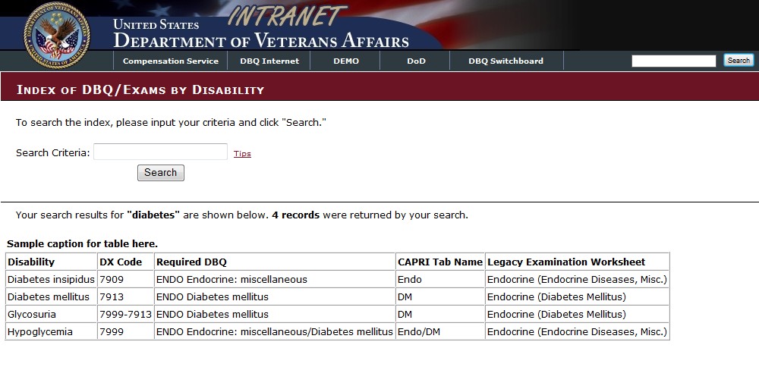

* [Medical Electronic Performance Support System (Medical EPSS)](http://cptraining.vba.va.gov/C&P_Training/Job_Aids/Medical_EPSS.htm)

Both resources can be located on the [VA Compensation Service Intranet Rating Job Aids](http://vbaw.vba.va.gov/bl/21/rating/rat00.htm). Both resources are search engines that allow you to determine what body system and DBQ is warranted; which will assist in selecting the correct contention classification.

**Contention Classification Scenarios**

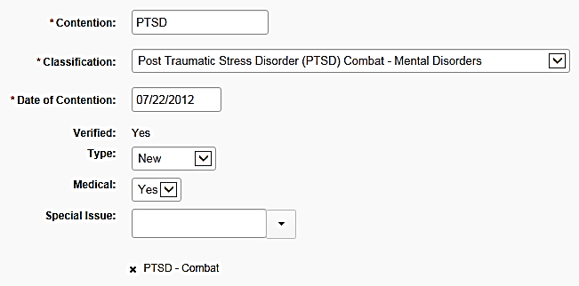**Image 1 - Contention List Screen**: This shows the **correct** selection of the ‘Contention Classification’ of *Post Traumatic Stress Disorder (PTSD) – Mental Disorders*. 

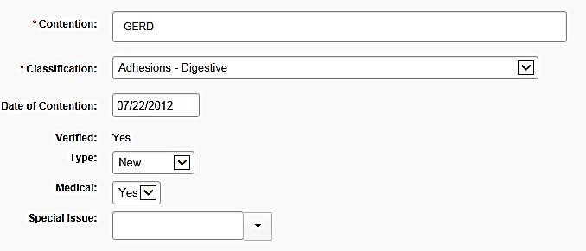**Image 2A - Contention List Screen**: This shows an **incorrect** selection of the ‘Contention Classification’. *Adhesions – Digestive* is not the correct selection for a disability or symptoms related to “GERD”. The ‘Contention Classification’ **must be** **corrected** if an incorrect selection is made.

****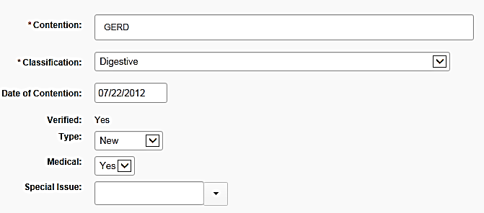**Image 2B - Contention List Screen**: The ‘Contention Classification’ has been **corrected** to display *Digestive* for the disability/symptoms related to “GERD”.

**Contention Classifications followed by “Other”**

Avoid the use of the following contention classifications unless absolutely necessary

* Cyst/benign growth – Musculoskeletal – Other
* Musculoskeletal – Other
* Cancer - Musculoskeletal - Other

An incorrect selection of these contention classifications can potentially result in an incorrect exam request and undue delay to resolution of a claim.

**Administrative Issue**

Please note “Administrative Issue” replaces the previous “miscellaneous” selection, which has now been removed. Previously, “miscellaneous” was used, sometimes incorrectly, as a catch-all for any contention. “Administrative Issue” is to be used from this point forward for **only** non-rating issues, such as dependency or drill pay. If the contention is incorrectly classified as Administrative, when it should be medical, the system will not allow for a selection of an exam scheduling request, and the user will be required to correct the classification.

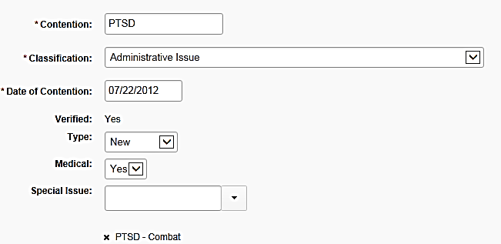**Image 3A – Contention List Screen**: This shows an **incorrect** selection of the *Administrative Issue* contention classification.



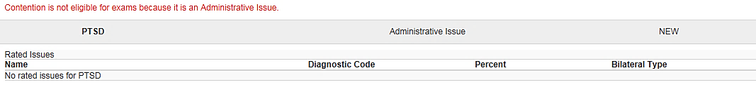**Image 3B** **– Exams: Select Contentions Screen**: When the **incorrect** selection of *Administrative Issue* is made, users are notified the “*contention is not eligible for exams because it is an Administrative Issue*”. Users **must make a correction** to the contention classification on the Contention List Screen.

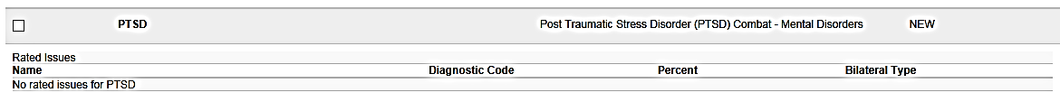**Image 3C – Exams: Select Contentions Screen**: When an appropriate medical classification is selected, Users will be able to select the contention to make an exam scheduling request.