## SETUP STAGE

* VSOs will submit ITFs, 21-22s, and email your IPC coach to request paper claim folders as required
* Process these as normal, making sure to update POA authorization and change of address correctly
* **IMPORTANT**: these will not be identified as DRC related, so request any paper claim folders to be scanned if processing these

## EVIDENCE SUBMISSION STAGE

* VSOs might submit evidence via Direct Upload prior to either a DRC exam request or DRC submission
* **IMPORTANT:** If DRC is mentioned or a DRC Evidence Coversheet exists, do not send an RFA letter or establish an EP. This is for a future claim and update systems as normal.

## DRC EXAM REQUEST

* VSOs will submit a DRC Evidence Coversheet, 21-4138, and other evidence as a packet via Direct Upload. Ensure proper POA system updates and request paper claim folder if it hasn’t been done.
* Establish an EP 400 – DRC Exam Request (or 401, 402, if needed) using Express Lane and DOC of receipt of 21-4138
* **IMPORTANT:** 
  1. Do not use EP 400 – Correspondence
  2. Do not clear EP 400 – DRC Exam Request at this time
  3. Add Special Issue – Decision Ready Claim

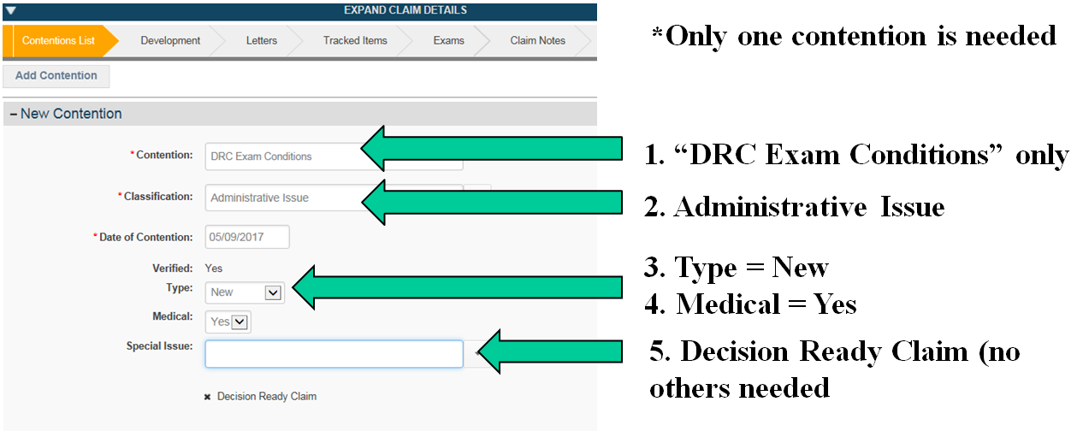

## DRC SUBMISSION

Your DRC Centralized Mail Queue will contain a DRC Coversheet, 21-526ez signed by Veteran, DBQs for each contention (or just medical evidence for Paragraph 29/30 claims), and optional evidence (like medical evidence, 21-686c, etc.)

## **DRC** EXCLUSIONS

|  |  |  |
| --- | --- | --- |
| 21-526ez not signed by claimant (only VSO) | Claims with a pending disability claim (not EP 400) | * Individual Unemployability * Stand-alone special monthly compensation (only 21-526ez and 21-2680) |
| Claims for conditions already at scheduler maximum   * Tinnitus at 10% * any condition at 100% | DRC conditions currently on appeal | * Pregnant * Pre-discharge * Foreign address * Incarcerated * Restricted access (RACC) |
| Dependent child birth defect and spina bifida claims (Chapter 18) | Pension, dual claim, and special monthly pension | In-Service Death, Parent DIC, DIC claims involving accrued benefits (claim or appeal pending at time of death) |

## PROCESSING DRC EXCLUSIONS

|  |  |
| --- | --- |
| If… | Then… |
| If there is not a pending rating EP or appeal for the DRC issues claimed | * Establish the appropriate EP, * Enter in the associated contentions, * Add the “Decision Ready Claim” Special Issue to the claim, * Open and close a custom tracked item, labeled “DRC” to trigger the auto-RFD feature, and * PCLR the EP 400 used to control the DRC contract exam request (if pending) |
| If there is not a pending rating EP or appeal for the DRC issues claimed AND the submission is on the exclusion list | * Return the claim to the normal queue for processing * Send “DRC exclusion letter” to the Veteran using the letter creator tool, citing “one or more claimed conditions is on the DRC exclusion list” as the exclusion reason |

## DRC CEST

1. Establish 020 – Increase with DOC of receipt of 21-526ez
2. **CRITICAL**: add “Decision Ready Claim” special issue to one contention
3. Create a custom tracked item labeled “DRC” with 1 day suspense and close the tracked item to route to RVSR

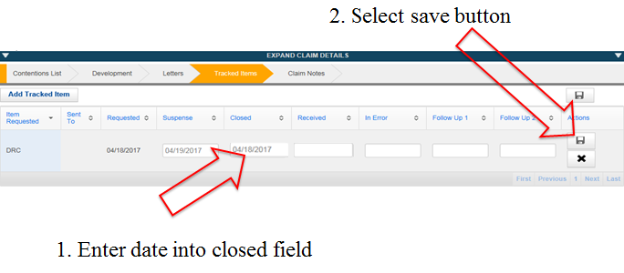

## IMPORTANT REMINDERS

* Ensure paper claim folders are requested for scanning ASAP
* Do not send 5103 letters
* Do not send RFA letters when evidence is submitted with a DRC Evidence Coversheet
* Establish EP 400 – DRC Exam Request, not EP 400 - Correspondence
* Use the Decision Ready Claim special issue for EP 400 and EP 020