- Please “translate” SOAP, abbreviations & acronyms on the left side.
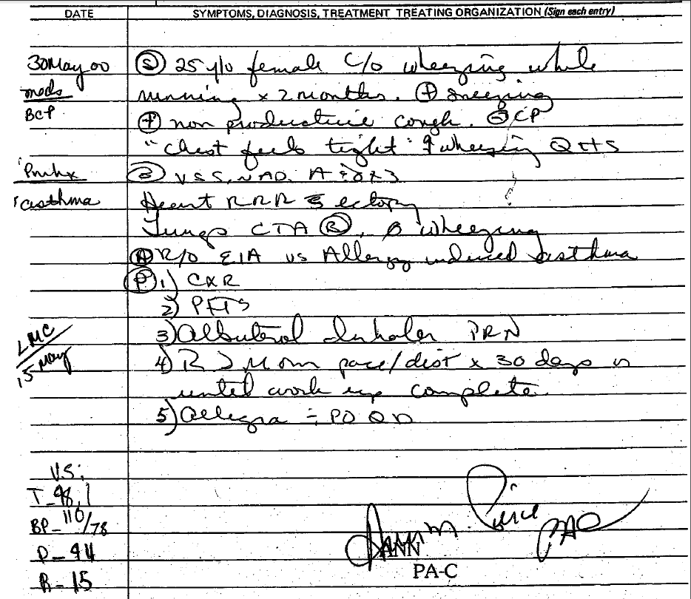
S:____________________________________________________________________________________________________________________________________O:____________________________________________________________________________________________________________________________________A:____________________________________________________________________________________________________________________________________P:____________________________________________________________________________________________________________________________________ Left:__________________________________________________________________________________________________________________________________
- Please “translate” SOAP.
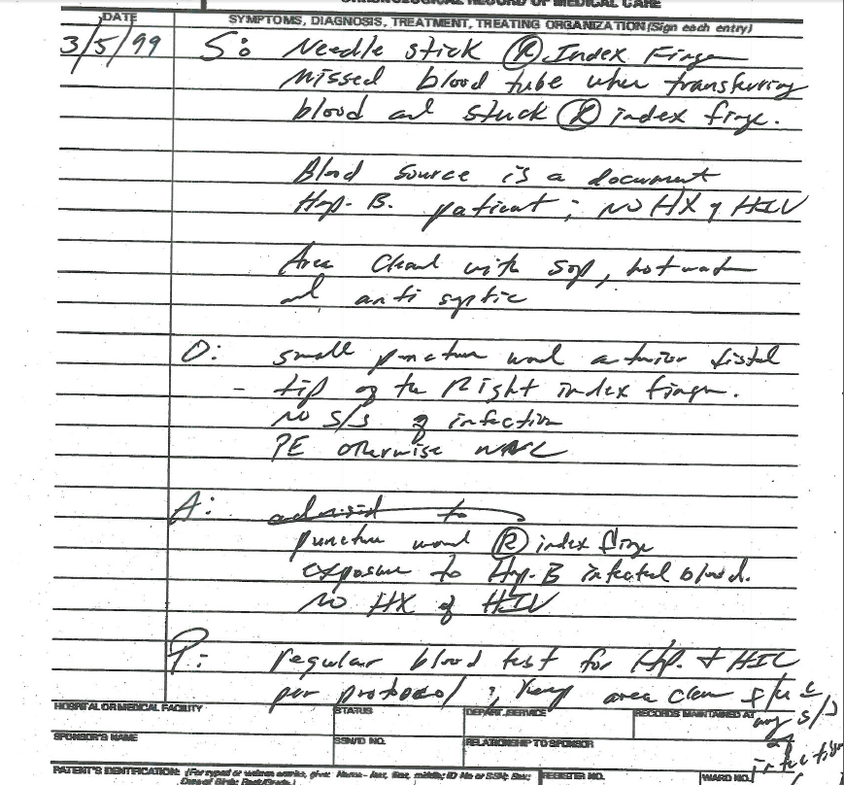
S:____________________________________________________________________________________________________________________________________O:____________________________________________________________________________________________________________________________________A:____________________________________________________________________________________________________________________________________P:____________________________________________________________________________________________________________________________________
- Please “translate” SOAP.
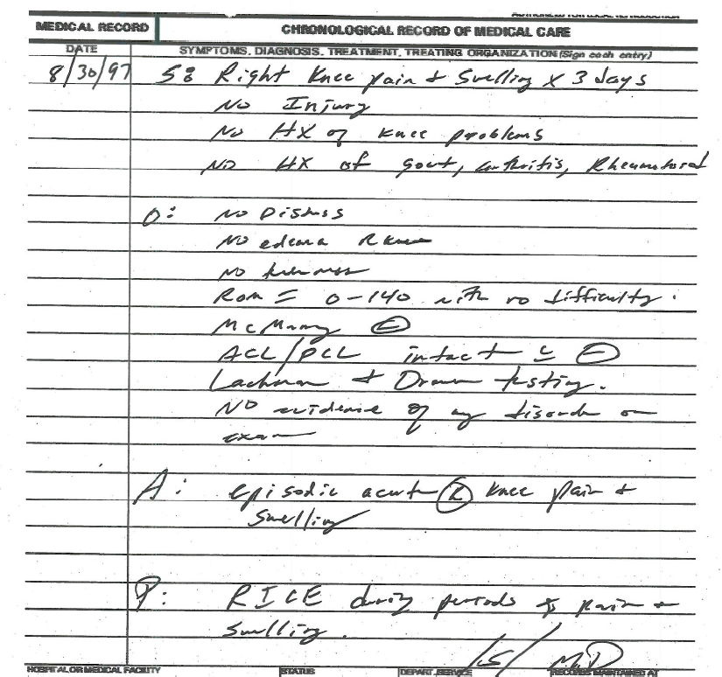
S:____________________________________________________________________________________________________________________________________O:____________________________________________________________________________________________________________________________________A:____________________________________________________________________________________________________________________________________P:____________________________________________________________________________________________________________________________________

