This job aid provides Training Managers and VBA TMS Admins* with instructions on adding employees to (and removing them from) FY17 Compensation Service classes in TMS. Section 2 lists the proper actions to take when employees change job positions.

**\* In order obtain access to edit Compensation Service’s classes, TMS Admins must ask their RO Training Manager to contact the VBA Domain Manager at** [**Arthur.Edmonds@va.gov**](mailto:Arthur.Edmonds@va.gov)

**Section I: Add or remove employees to/from a FY17 Compensation Service class**

1. Select **Learning** from the TMS Admin home screen.
2. Select **Classes** from the left-hand menu.
3. Input the desired Class ID in the **Class ID** field and select **Search.**

* **VBA-262** – VSR Primary Class
* **VBA-263** – PCT VSR Specialized Class
* **VBA-264** – Pre-Discharge MSC Primary Class
* **VBA-265** – AQRS Specialized Class
* **VBA-266** – RVSR/DRO Primary Class
* **VBA-267** – RQRS Specialized Class
* **VBA-268** – CA Primary Class
* **VBA-316** – Special Ops RVSR Class
* **VBA-317** – Special Ops VSR Class
* **VBA-318** – DRO Specialized Class
* **VBA-369** – VSR-Skilled Coach Class
* **VBA-371** – Rating-Skilled Coach Class
* **VBA-372** – Non-Adjudication-Skilled Coach Class
* **VBA-387** – WARTAC Graduate Hires
* **VBA**-**417** – Compensation Service IPC Class

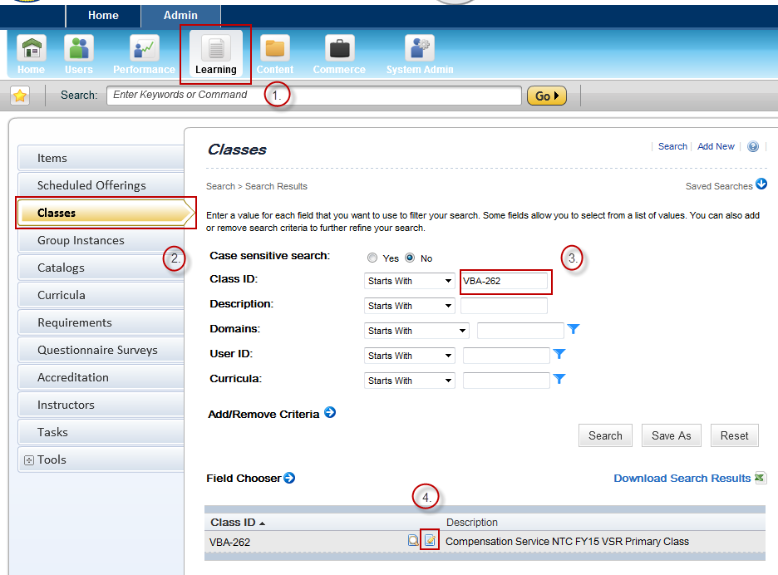

1. Once the initial class record appears in the search results, select the **Edit** icon.
2. Within the main class record, select **Users** from the left-hand menu.
3. To add an employee to the class, input the employee’s TMS User ID and select **Add**. To add multiple employees, select ‘add one or more from list’.
4. To remove an employee from the class, mark the ‘Remove’ check box next to the employee’s TMS User ID and select **Apply Changes.**

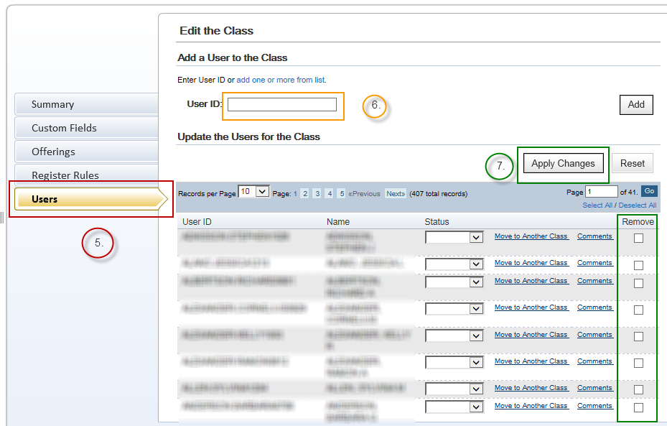

**Section 2: Class Change Scenarios**

* **Scenario 1**: *A VSR employee becomes an RVSR*. In this situation, the local TMS Admin will need to remove the employee from the VSR Primary class (VBA-262). The appropriate RVSR curricula will be centrally assigned to the employee once he or she completes RVSR Challenge training.
* **Scenario 2**: *A VSR or RVSR moves into a supervisory position and is no longer a production employee*. This situation requires the local TMS Admin to remove the employee from the VSR or RVSR Primary class (VBA-262 or VBA-266 respectively), as non-production employees are not part of the target audience for the Compensation Service NTC. The Admin should ensure the appropriate supervisory curricula, such as the ‘New Supervisors Soft Skills Training’ curriculum, are added to the employee’s learning plan. If the employee has moved to a Coach position, add them to the appropriate skilled coach class.
* **Scenario 3**: *A Compensation Service employee accepts a VBA position outside of Compensation Service*. In this circumstance, the employee should be removed from all Compensation Service classes. The employee’s new required training curricula should be added.
* **Scenario 4**: *A VSR or RVSR moves to a specialized position or team*. In this situation the employee remains in the VSR or RVSR Primary class (VBA-262 or VBA-266 respectively), and should be added to the class created for the specialized position or team (e.g., Special Ops VSR class).
* **Scenario 5**: *An RVSR moves to the VSR position*. If the employee will be attending VSR Challenge, the employee will be considered a ‘trainee’ and should be removed from all NTC-related and One-Time Mandated curriculum in TMS. Once the employee graduates from VSR Challenge, he or she will be centrally added to the appropriate TMS class and will be assigned the appropriate curricula.

**For questions regarding this job aid, please contact the VBA Curriculum Support Team at** [**VBACurriculumSupport@Camber.com**](mailto:VBACurriculumSupport@Camber.com)**. For policy-related questions, contact the Compensation Service Training Staff at** [**CPTraining.VBACO@va.gov**](mailto:CPTraining.VBACO@va.gov)**.**