This job aid provides Training Managers and VBA TMS Admins* with instructions on adding employees to (and removing them from) FY17 BAS classes in TMS.

**\* In order obtain access to edit BAS classes, TMS Admins must ask their RO Training Manager to contact the VBA Domain Manager at** [**Arthur.Edmonds@va.gov**](mailto:Arthur.Edmonds@va.gov)

**Section I: Add or remove employees to/from a FY17 BAS class**

1. Select **Learning** from the TMS Admin home screen.
2. Select **Classes** from the left-hand menu.
3. Input the desired Class ID in the **Class ID** field and select **Search.**

* **VBA-478** – BAS Public Contact Representatives - New (NCC/NPCC) Class
* **VBA-479** – BAS Public Contact Representatives - New (NIRC) Class
* **VBA-480** – BAS Public Contact Representatives - Experienced Class
* **VBA-481** – BAS PCR Manager and Coach - New Class
* **VBA-482** – BAS PCR Manager and Coach - Experienced Class
* **VBA-483** – BAS PCR Training Coordinator - New Class
* **VBA-484** – BAS PCR Training Coordinator - Experienced Class
* **VBA-485** – BAS PCR Lead Class
* **VBA-486** – BAS PCR Management Analyst Class
* **VBA-487** – BAS PCR Program Support Assistant Class
* **VBA-488** – BAS Quality Review Specialist - New Class
* **VBA-489** – BAS Quality Review Specialist - Experienced Class
* **VBA-490** – BAS VACO Front Office (Non-Management) Class
* **VBA-491** – BAS VACO Quality Staff Class
* **VBA-492** – BAS VACO Training Staff Class
* **VBA-493** – BAS VACO Site Visit Staff Class
* **VBA-494** – BAS VACO Web Communications Staff Class
* **VBA-495** – BAS VACO Access & Business Application Staff Class
* **VBA-496** – BAS Field Outreach Coordinator Class
* **VBA-497** – BAS VACO Outreach Staff Class
* **VBA-498** – BAS PCT LAS/PCT Class
* **VBA-499** – BAS PCT Coach Class

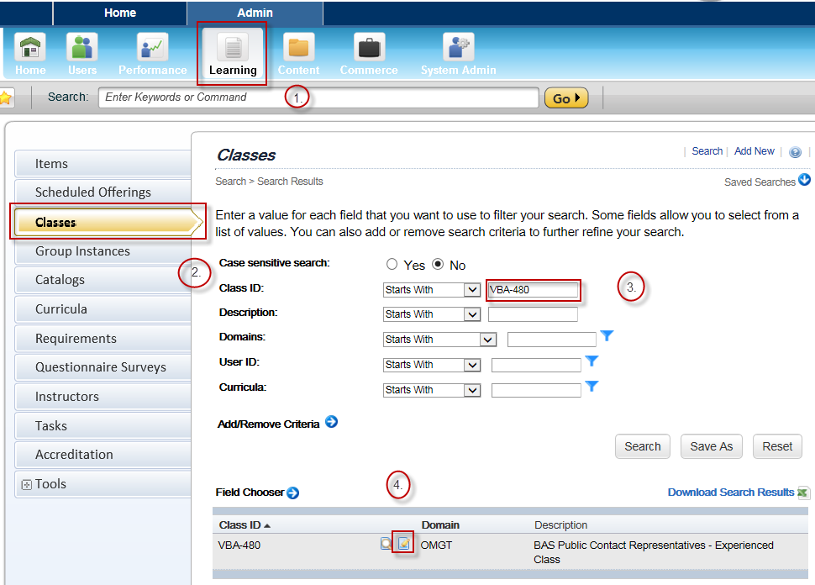

1. Once the initial class record appears in the search results, select the **Edit** icon.
2. Within the main class record, select **Users** from the left-hand menu.
3. To add an employee to the class, input the employee’s TMS User ID and select **Add**. To add multiple employees, select ‘add one or more from list’.
4. To remove an employee from the class, mark the ‘Remove’ check box next to the employee’s TMS User ID and select **Apply Changes.**

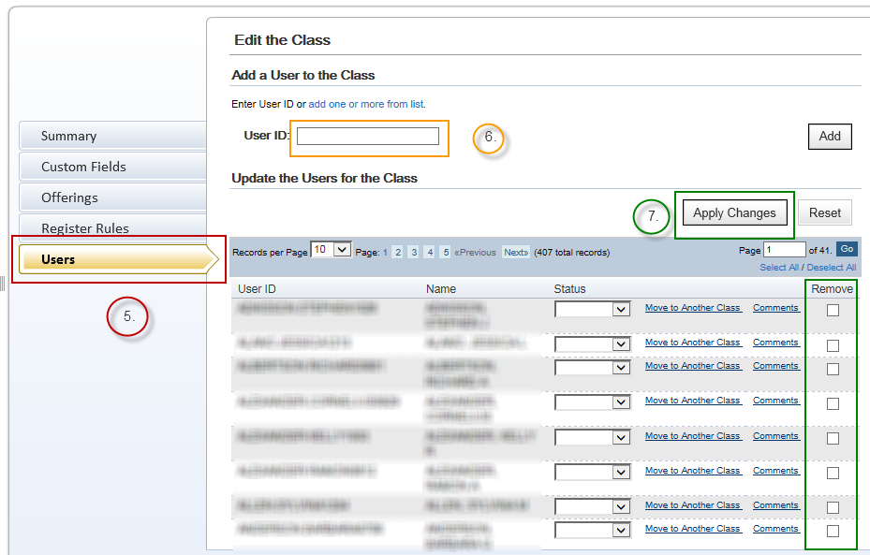

**For questions regarding this job aid, please contact the VBA Curriculum Support Team at** [**VBACurriculumSupport@Camber.com**](mailto:VBACurriculumSupport@Camber.com)**. For policy-related questions, contact the BAS Training Staff at Regina Yount (**[**Regina.Yount@va.gov**](mailto:Regina.Yount@va.gov)**).**