This job aid provides Training Managers and VBA TMS Admins with instructions on adding employees to (and removing them from) FY15 Compensation Service classes in TMS. Section 2 lists the proper actions to take when employees change job positions.

Section I: Add or remove employees to/from a FY15 Compensation Service class

- Select Learning from the TMS Admin home screen.

- Select Classes from the left-hand menu.

- Input the desired Class ID in the Class ID field and select Search.
- VBA-262 – VSR Primary Class
- VBA-263 – PCT VSR Specialized Class
- VBA-264 – IDES MSC Specialized Class
- VBA-265 – AQRS Specialized Class
- VBA-266 – RVSR/DRO Primary Class
- VBA-267 – RQRS Specialized Class
- VBA-268 – CA Primary Class
- VBA-316 – Special Ops RVSR Class
- VBA-317 – Special Ops VSR Class
- VBA-318 – DRO Specialized Class

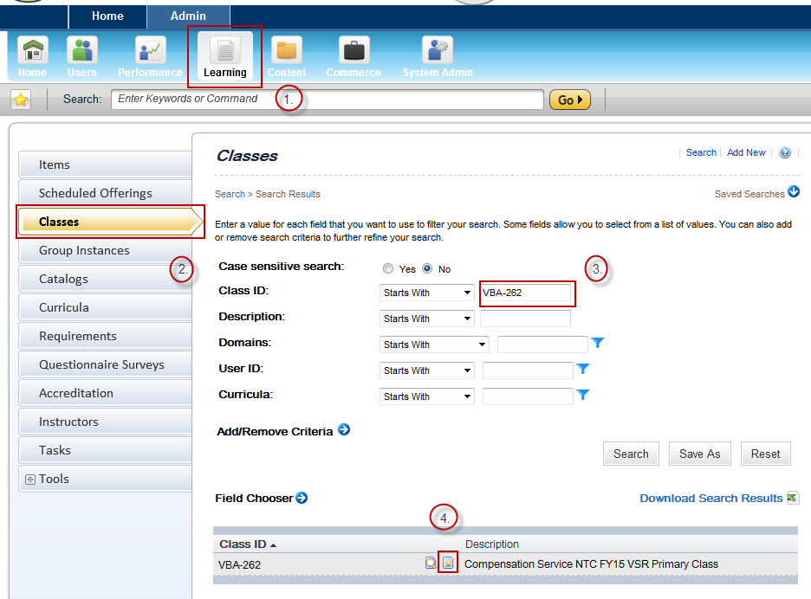

- Once the initial class record appears in the search results, select the Edit icon.

- Within the main class record, select Users from the left-hand menu.

- To add an employee to the class, input the employee’s TMS User ID and select Add. To add multiple employees, select ‘add one or more from list’.

- To remove an employee from the class, mark the ‘Remove’ check box next to the employee’s TMS User ID and select Apply Changes.
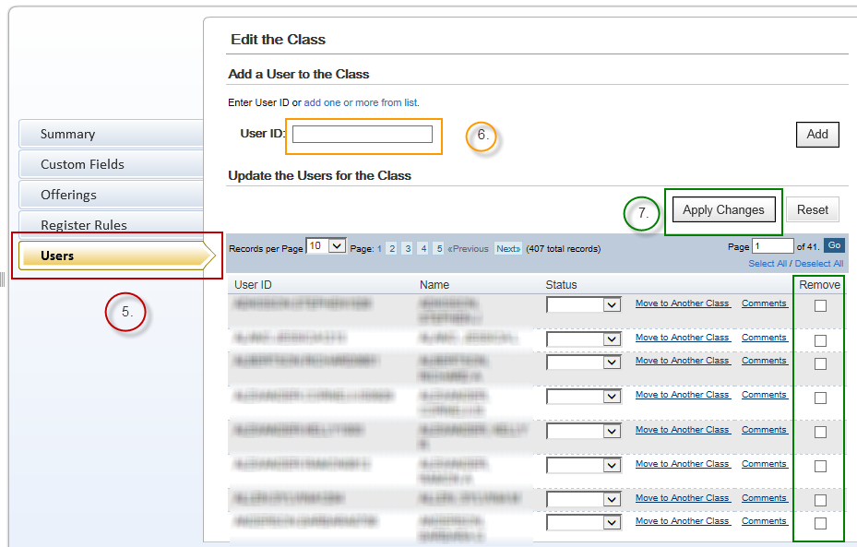

Section 2: Class Change Scenarios
- Scenario 1: A VSR employee becomes an RVSR. In this situation, the local TMS Admin will need to remove the employee from the VSR Primary class (VBA-262). The appropriate RVSR curricula will be centrally assigned to the employee once he or she completes RVSR Challenge training.
- Scenario 2: A VSR or RVSR moves into a supervisory position and is no longer a production employee. This situation requires the local TMS Admin to remove the employee from the VSR or RVSR Primary class (VBA-262 or VBA-266 respectively), as non-production employees are not part of the target audience for the Compensation Service NTC. The Admin should ensure the appropriate supervisory curricula, such as the ‘New Supervisors Soft Skills Training’ curriculum, are added to the employee’s learning plan.
- Scenario 3: A Compensation Service employee accepts a VBA position outside of Compensation Service. In this circumstance, the employee should be removed from all Compensation Service classes. The employee’s new required training curricula should be added.
- Scenario 4: A VSR or RVSR moves to a specialized position or team. In this situation the employee remains in the VSR or RVSR Primary class (VBA-262 or VBA-266 respectively), and should be added to the class created for the specialized position or team (e.g., Special Ops VSR class).
- Scenario 5: An RVSR moves to the VSR position. If the employee will be attending VSR Challenge, the employee will be considered a ‘trainee’ and should be removed from all NTC-related and One-Time Mandated curriculum in TMS. Once the employee graduates from VSR Challenge, he or she will be centrally added to the appropriate TMS class and will be assigned the appropriate curricula.

For questions regarding this job aid, please contact the VBA Curriculum Support Team at VBACurriculumSupport@Camber.com. For policy-related questions, contact the Compensation Service Training Staff at CPTraining.VBACO@va.gov.

