PMC INTRODUCTION to Dependency
TRAINEE HANDOUTS

PREQUISITE TRAINING | Prior to this training, you must have completed VSR TPSS Modules on Compensation, Dependency Benefits, and Pension.
PURPOSE OF LESSON | The purpose of this lesson is to provide you with an opportunity to describe the evidence necessary to verify dependency on an Improved Pension award. In addition, you will be provided an opportunity to indicate the steps necessary to accurately request this evidence.  Note: Income issues will be handled in later lessons.
Time Required | 4 hours
Instructional Method | Participatory discussion and a practical exercise.
Materials/ Training Aids | Classroom or private area where a discussion may be held. Chairs and writing surfaces are required.  Large writing surface such as—easel pad, chalkboard, dry erase board, overhead projector, etc., with appropriate markers, or computer with projection equipment and PowerPoint software.  Improved Pension, Dependency Issues and Development trainee handouts  Copies of the following reference materials (Or if possible, access the appropriate reference on the computer.)  - 38 CFR §3.1(j)  - 38 CFR §3.3(a)  - 38 CFR 3.23  - 38 CFR §3.50  - 38 CFR §3.57-3.58  - 38 CFR §3.204-3.211  - 38 CFR §3.356  - 38 CFR §3.667  - M21-1, Part III, Chapter 6, Topics 06–10 and 20–21  - M21-1, Part III, Chapter 11, Topic 17  - M21-1 MR, Part III, Subpart iii  - M21-1, Part IV, Chapters 12, 14, and 15 (portions only—see lesson)  - M21-1, Part V, Chapter 17, Topic 07  - Blank VA Form 21-686c  - Blank VA Form 21-674

Table of Contents

References 4
The ABCs of Improved Pension Dependents Handout 5
When Is a Birth or Marriage Document not Required? 6
Who Is a Dependent for VA Purposes? Handout 7
Who Is a Dependent for VA Purposes? Exercise 8
Dependency Development Job Aid 2
Dependents for Improved Pension Scenarios 12
Review Exercise 13

References

- 38 CFR
3.1(j)
3.3(a)
3.50
3.57-3.59
3.204-3.211
3.356
3.667

- M21-1
Part III, Chapters 2 & 6
Part IV, Chapters 12-15
Part V, Chapter 5, 17 & 23

- M21-1 MR
Part III, Subpart iii
The ABCs of Improved Pension Dependents Handout

A. | When does a veteran, who is entitled to improved pension, qualify for dependents?

B. | Must a veteran claim a dependent for improved pension purposes?

C. | Which classes of dependents can the veteran claim as dependents?

When Is a Birth or Marriage Document not Required?

(38 CFR 3.204, 3.205[a])

Answer:

What information must be provided in order to accept a statement of dependency at face value?

- (month/year) of the event.

- of the event.

- Full and of the dependent of the .

- Dependent’s number.

- Name and address of the person who when

the veteran’s child does not reside with .

Who Is a Dependent for VA Purposes? Handout
Who Is a Dependent for VA Purposes? Exercise

Give the correct citation(s) for: Spouse

Spouse: 38 CFR

Complete the following: Spouse

- A marriage is based on law.
[Federal, State, County, Parish]

- If no other evidence exists, you can accept an from two or more witnesses to the veteran’s marriage ceremony.

- You would look for the list of states that recognize common-law marriages in
M21-1, Part

- 38 CFR governs void or annulled marriages.

- A divorce is established for VA purposes by
.

Give the correct citation(s) for: Child

Biological child (legitimate): 38 CFR

Biological child (illegitimate): 38 CFR

Stepchild: 38 CFR

Adopted child (domestic): 38 CFR

Adopted child (foreign): 38 CFR

School child: 38 CFR

Helpless child: 38 CFR

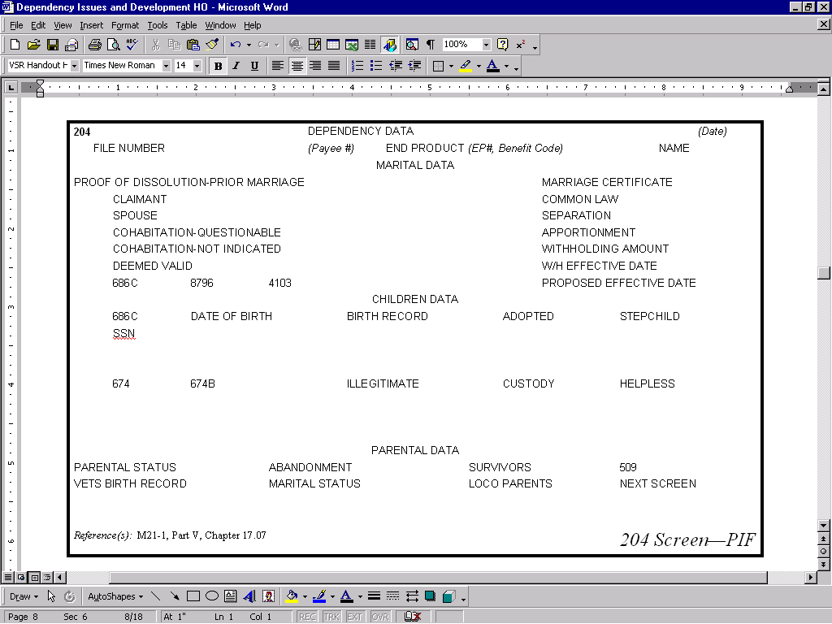
Dependency Development Job Aid
Dependency Development
Any necessary
data missing?
Received
VAF 21-526,
21-686c,
21-4138
or Letter
No
No
Yes
Establish dependent,
pay for or deny
Data without
conflict with
claims file?
Yes
Develop for
missing data
Marriage
Dissolution
of Marriage
Birth
What conflicts?
•
Valid marriage
•
Common-law
•
Other,e.g., tribal
•
Death
•
Divorce
•
Annulment
•
Evidence/Relationship
Biological
Adopted
Stepchild
•
Age question?
Under18
18-23 (in-school)
Over 18 (helpless)
Determine
what conflicts.
Develop. Inform
veteran how to
resolve
conflict.

Dependents for Improved Pension Scenarios

Carefully read the following scenarios. Briefly explain if the evidence of record is complete and acceptable. If not, how would you develop for the proper evidence to add or remove a dependent?

Scenarios

- Jeb Tummer filed an original pension claim. He attached a copy of his marriage certificate. He completed the dependency segment on his VA Form 21-526 by showing neither he nor his spouse had married any one else before they wed and that they arecurrently living together. He has also completed the income and net worth section showing she has no income or net worth.

- Shirley Lowe filed an original pension claim. She completed the dependency segment on VA Form 21-526 by showing that she and her husband had never married anyone else before they wed. The date and place of the wedding was omitted. In addition, no income or net worth for the spouse was submitted.

- Jim Zigler has a running improved pension award. He is being paid benefits for his wife, Theresa. He stated that his wife gave birth to a healthy son and that he wants the child to be added to his award as soon as possible.

- Wally Winslow has a running improved pension award. He states that he has married Trudy Evans on March 17, 1998, and that neither she nor he has ever been married before. Wally provides the Social Security number for his new bride. He indicates that they live apart due to his medical conditions and has provided completed income and net worth information.

- Joe Sikorsky has a running improved pension award and submits a death certificate to your office which shows that his wife of 50 years passed away the other day.

Review Exercise

Please complete the following review exercise. It should take you approximately 5 to 7 minutes to complete the exercise.

Instructions: Attached are forms for the following three scenarios. Read the scenario and form and then describe the evidence necessary to verify dependency on an improved pension award and indicate what steps are necessary to accurately request this evidence.

- Wayne Williams. VA Form 21-4138. M11 screen shows an improved pension award. Veteran has no dependents of record.

- Doris Yarborough. VA Form 21-686c. M11 screen shows an improved pension award. A spouse was already added 4/1/1990.

- Wendall Danforth. VA Form 21-4138. M11 screen shows an improved pension award. A spouse was added 4/1/1997.

Department of Veterans Affairs |  |  |  |  |  | STATEMENT IN SUPPORT OF CLAIM
PRIVACY ACT INFORMATION: The law authorizes us to request the information we are asking you to provide on this form. (38 U.S.C. 210(c)(1)) The responses you submit are considered confidential. (38 U.S.C. 3301) They may be disclosed outside the Department of Veteran Affairs (VA) only if the disclosure is authorized by the Privacy Act, including the routine uses identified in the system of records, 58VA21/22, Compensation, Pension, Education and Rehabilitation Records-VA, published in the Federal Register. The requested information is considered relevant and necessary to determine maximum benefits under the law. Information submitted is subject to verification through computer matching programs with other agencies.
RESPONDENT BURDEN: Public reporting burden for this collection of information is estimated to average 1/4 hour per response, including the time for reviewing instructions, searching existing data sources, gathering and maintaining the data needed, and completing and reviewing the collection of information. Send comments regarding this burden estimate or any other aspect of this collection of information, including suggestions for reducing this burden, to the VA Clearance Officer (732), 810 Vermont Ave., NW, Washington, DC 20420; and to the Office of Management and Budget, Paperwork Reduction Project (2900-0075) Washington, DC 20503. Do not send requests for benefits to these addresses.
FIRST NAME - MIDDLE NAME - LAST NAME OF VETERAN (Type or print) |  |  |  |  |  |  |  |  | SOCIAL SECURITY NO. |  |  |  |  |  |  |  |  | VA FILE NO.
Wayne Williams |  |  |  |  |  |  |  |  | 700-XX-9981 |  |  |  |  |  |  |  |  | 700XX9981
The following statement is made in connection with a claim for benefits in the case of the above named veteran:
I want to claim my wife, Nora, as my dependent.
What do I need to do to claim her?
(CONTINUE ON REVERSE)
I CERTIFY THAT the statements on this form are true and correct to the best of my knowledge and belief.
SIGNATURE |  |  |  |  |  |  |  |  |  |  |  |  |  | DATE SIGNED
Wayne Williams |  |  |  |  |  |  |  |  |  |  |  |  |  | 5/28/2005
ADDRESS
White River Junction
New Hampshire
PENALTY - The law provides severe penalties which include fine or imprisonment, or both, for the willful submission of any statement or evidence of a material
fact, knowing it to be false.
VA FORM SEP 1989 |  | 21-4138 |  |  | EXISTING STOCKS OF VA FORM 21-4138, MAY 1987, WILL BE USED |  |  |  |  |  |  | For Training Only
Department of Veterans Affairs |  |  |  |  |  | DECLARATION OF STATUS OF DEPENDENTS
PRIVACY ACT INFORMATION: The law authorizes us to request the information we are asking you to provide on this form. (38 U.S.C. 210(c)(1)) The responses you submit are considered confidential. (38 U.S.C. 3301) They may be disclosed outside the Department of Veteran Affairs (VA) only if the disclosure is authorized by the Privacy Act, including the routine uses identified in the system of records, 58VA21/22, Compensation, Pension, Education and Rehabilitation Records-VA, published in the Federal Register. The requested information is considered relevant and necessary to determine maximum benefits under the law. Information submitted is subject to verification through computer matching programs with other agencies.
RESPONDENT BURDEN: Public reporting burden for this collection of information is estimated to average 1/4 hour per response, including the time for reviewing instructions, searching existing data sources, gathering and maintaining the data needed, and completing and reviewing the collection of information. Send comments regarding this burden estimate or any other aspect of this collection of information, including suggestions for reducing this burden, to the VA Clearance Officer (732), 810 Vermont Ave., NW, Washington, DC 20420; and to the Office of Management and Budget, Paperwork Reduction Project (2900-0075) Washington, DC 20503. Do not send requests for benefits to these addresses.
INSTRUCTIONS: This form must be completed and returned to VA. Certified copies of public records may be obtained free in some jurisdictions if the county clerk or similar custodian of such records is informed that they are required by VA in determining eligibility for benefits. If you previously submitted a certified copy of a birth or marriage record, you need not furnish another certified copy.
1A. FIRST - MIDDLE - LAST NAME OF VETERAN |  |  |  |  |  |  | 2A. NAME OF CLAIMANT (If other than veteran) |  |  |  |  |  | 3. |  | FILE NO.
Doris Yarborough
1B. VETERAN’S SOCIAL SECURITY NUMBER |  |  |  |  |  |  | 2B. CLAIMANT’S SOCIAL SECURITY NUMBER
701-XX-3014 |  |  |  |  |  |  |  |  |  |  |  |  | C- |  | 701-XX-3014
4. ADDRESS OF CLAIMANT (No. and street or rural route, city or PO, State and Zip Code)
2932 Kellogg St.
San Diego, CA 92108
5. MARITAL STATUS (Check one)
 MARRIED  □ WIDOWED |  |  | □ DIVORCED  □ SEPARATED |  |  |  |  |  | - NEVER MARRIED (If checked, do not complete  Items 6 thru 10)
NOTE: Furnish the following information about each of your previous marriages including your current marriage. A certified copy of the public or church record of your current marriage is required unless previously submitted. Begin with your current marriage.
6A. DATE AND PLACE OF MARRIAGE |  |  | 6B. TO WHOM MARRIED (First, middle, last name) |  |  |  |  | 6C. SOCIAL SECURITY NUMBER |  |  | 6D. HOW MARRIAGE TERMINATED (Death, divorce) |  |  |  |  | 6E. DATE AND PLACE TERMINATED
3/11/1990  Lisbon, Peru |  |  | Stan Yarborough |  |  |  |  | 773-XX |  |  | -1230
NOTE: Furnish the following information about each previous marriage OF YOUR CURRENT SPOUSE.
7A. DATE AND PLACE OF MARRIAGE |  |  |  | 7B. TO WHOM MARRIED (First, middle, last name) |  |  |  |  |  |  | 7C. HOW MARRIAGE TERMINATED (Death, divorce) |  |  |  |  | 7D. DATE AND PLACE TERMINATED
none
VA FORM JAN 1992 | 21-686C |  |  | EXISTING STOCKS OF VA FORM 21-686C, JUL 1989, WILL BE USED |  |  |  |  |  | For Training Only |  |  |  |  |  |  | (Continued on Reverse)

8. DO YOU LIVE TOGETHER? (Answer only if married) |  |  |  | 9. AMOUNT YOU CONTRIBUTE TO YOUR SPOUSE’S SUPPORT MONTHLY
 YES □ NO (If No, complete Item 9) |  |  |  | none
10. ADDRESS OF PRESENT SPOUSE (If different than Item 4)
11. IDENTIFICATION OF VETERAN’S UNMARRIED CHILD(REN) (Check) |  |  UNDER 18  YEARS OF AGE |  |  |  | □ OVER 18 AND UNDER  23, AND ATTENDING  SCHOOL |  |  | □ OF ANY AGE PERMANENTLY  HELPLESS FOR MENTAL OR  PHYSICAL REASONS
NOTE: If any box in Item 11 is checked, furnish the following information for each child and submit a certified copy of the public or church record of birth or a copy of the court record of adoption or adoption agreement.
12A. FULL NAME OF EACH CHILD | 12B. DATE OF BIRTH (Mo., day, yr.) |  | 12C. SOCIAL SECURITY NUMBER |  |  |  | 12D. NAME AND ADDRESS OF PERSON  HAVING CUSTODY OF CHILD  (If child is not in custody of person  claiming dependency allowance)
Heather Yarborough | 5/31/ 2005 |  | none |  |  |  | with parents
13. REMARKS
I HEREBY CERTIFY THAT the information I have given above is true and correct to the best of my knowledge and belief.
14. SIGNATURE OF CLAIMANT |  |  |  |  | 15. DATE |  |  | 16. DAYTIME TELEPHONE NUMBER (Include Area Code)
Doris Yarborough |  |  |  |  | 6/1/2005 |  |  | 1-800-827-1000
PENALTY - The law provides severe penalties which include fine or imprisonment, or both, for the willful submission of any statement or evidence of a material fact, knowing it to be false, or for the fraudulent acceptance of any payment to which you are not entitled.

Department of Veterans Affairs |  |  | STATEMENT IN SUPPORT OF CLAIM
PRIVACY ACT INFORMATION: The law authorizes us to request the information we are asking you to provide on this form. (38 U.S.C. 210(c)(1)) The responses you submit are considered confidential. (38 U.S.C. 3301) They may be disclosed outside the Department of Veteran Affairs (VA) only if the disclosure is authorized by the Privacy Act, including the routine uses identified in the system of records, 58VA21/22, Compensation, Pension, Education and Rehabilitation Records-VA, published in the Federal Register. The requested information is considered relevant and necessary to determine maximum benefits under the law. Information submitted is subject to verification through computer matching programs with other agencies.
RESPONDENT BURDEN: Public reporting burden for this collection of information is estimated to average 1/4 hour per response, including the time for reviewing instructions, searching existing data sources, gathering and maintaining the data needed, and completing and reviewing the collection of information. Send comments regarding this burden estimate or any other aspect of this collection of information, including suggestions for reducing this burden, to the VA Clearance Officer (732), 810 Vermont Ave., NW, Washington, DC 20420; and to the Office of Management and Budget, Paperwork Reduction Project (2900-0075) Washington, DC 20503. Do not send requests for benefits to these addresses.
FIRST NAME - MIDDLE NAME - LAST NAME OF VETERAN (Type or print) |  |  |  | SOCIAL SECURITY NO. |  |  | VA FILE NO.
Wendall Danforth |  |  |  | 717-XX-9981 |  |  | 717XX9981
The following statement is made in connection with a claim for benefits in the case of the above named veteran:
I married Julia on March 16, 1997 in St. Paul’s
Cathedral in Manchester, New Hampshire.
The marriage didn’t work out. Our divorce is final today.
(CONTINUE ON REVERSE)
I CERTIFY THAT the statements on this form are true and correct to the best of my knowledge and belief.
SIGNATURE |  |  |  |  |  | DATE SIGNED
Wendall Danforth |  |  |  |  |  | 5/28/2005
ADDRESS
Manchester
New Hampshire
PENALTY - The law provides severe penalties which include fine or imprisonment, or both, for the willful submission of any statement or evidence of a material
fact, knowing it to be false.
VA FORM SEP 1989 | 21-4138 | EXISTING STOCKS OF VA FORM 21-4138, MAY 1987, WILL BE USED |  |  | For Training Only

