(VSR VIP Pre-D)

Introduction to End Product Controls and Claims Establishment

Trainee Handout

**Table of Contents**

Objectives 2

References 3

Topic 1: End Products 4

Topic 2: Claims Establishment (CEST) in VBMS Core 6

Attachment A: End Product Codes 16

Review Exercise: CEST and EP Control 17

Practical Exercise 18

Objectives

Upon completion of this lesson, you will be able to:

* Identify how End Product (EP) controls affect claim management, productivity, and staffing
* Demonstrate how to establish a claim using Veteran Benefits Management System Core (VBMS Core)
* Describe procedures for adding contentions and special issues into VBMS Core
* Define procedures for creating Corporate Flashes (RO Flashes and VACO Flashes)

References

* [M21-1, Part III, Subpart ii, Chapter 1. Section C,](https://vaww.vrm.km.va.gov/system/templates/selfservice/va_kanew/help/agent/locale/en-US/portal/554400000001034/content/554400000014112/M21-1-Part-III-Subpart-ii-Chapter-1-Section-C-Initial-Screening-Policies) Initial Screening Policies
* [M21-1, Part III, Subpart ii, Chapter 3. Section B,](https://vaww.vrm.km.va.gov/system/templates/selfservice/va_kanew/help/agent/locale/en-US/portal/554400000001034/content/554400000014123/M21-1-Part-III-Subpart-ii-Chapter-3-Section-B-Claims-Establishment) Claims Establishment
* [M21-1, Part III, Subpart iii, Chapter 1. Section F,](https://vaww.vrm.km.va.gov/system/templates/selfservice/va_kanew/help/agent/locale/en-US/portal/554400000001034/content/554400000071983/M21-1-Part-III-Subpart-iii-Chapter-1-Section-F-Record-Maintenance-During-the-Development-Process) Record Maintenance During the Development Process
* [M21-1, Part III, Subpart iii, Chapter 5,](https://vaww.vrm.km.va.gov/system/templates/selfservice/va_kanew/help/agent/locale/en-US/portal/554400000001034/topic/554400000003089/Chapter-05-Relationship-and-Dependency) Relationship and Dependency
* [M21-4, Appendix B](https://vaww.vrm.km.va.gov/system/templates/selfservice/va_kanew/help/agent/locale/en-US/portal/554400000001034/content/554400000011474/Appendix%20B.%20End%20Product%20Codes%20and%20Work-Rate%20Standards%20for%20Quantitative%20Measurements), End Product Codes and Work Rate Standards for Quantitative Measurements
* [M21-4, Appendix C](https://vaww.vrm.km.va.gov/system/templates/selfservice/va_kanew/help/agent/locale/en-US/portal/554400000001034/content/554400000036570/Appendix%20C.%20Index%20of%20Claim%20Attributes), Index of Claim Attributes
* [Share User’s Guide](http://css.vba.va.gov/SHARE/)
* [VBMS Core User Guide](http://vbaw.vba.va.gov/VBMS/Resources_Technical_Information.asp)
* [VBMS Core Online Help](https://www.vbms.vba.va.gov/vbmsp2/resources_p4/webhelp/index.htm)

Topic 1: End Products

**End Products**

* The End Product (EP) system is the primary Veterans Service Center (VSC) workload monitoring and management tool.
* Correct use of the EP system facilitates proper control of pending workloads and appropriate work measurement credit.
* Correct work measurement is also essential to substantiate proper staffing requirements and determine productive capacity.
* Received and completed EPs are also used to formulate the annual budget submission to the Secretary, Office of Management and Budget OMB, the President, and Congress.

**Establishing and Maintaining EP Controls**

A claim should be promptly placed under EP control when received. The EP should remain pending until all required actions on that claim have been completed.

* EP code 010 Initial disability compensation claim containing 8 issues or more
* EP codes 110 Initial disability compensation claim containing 7 issues or less
* EP codes 010 and 110 are for original claims. The Veteran will only have one of this type of claim ever in a lifetime.
* EP code 020 is used for non-original initial rating and increase claims regardless of the number of contentions
* EP code 030 is used for higher level review claims
* EP code 040 is used for supplemental claims for claims previously denied. These claims were previously referred to as reconsideration if filed within a year of the decision and reopened if filed more than a year after the decision.
* EP code 130 is used for dependency claims (not accompanying an original claim).
* EP 400 is used when the action is independent and involves correspondence action on a letter, e-mail, inquiry, form, document, official notice, etc., which can usually be handled on the basis of existing records and decisions, and a rating or authorization determination is not required for final disposition of the issue created.

Generally, multiple EPs of the same type must not be pending at the same time, even though the casework may involve multiple actions that could have resulted in separate EPs had they been received and/or worked at different times. The EP should not be cleared until all issues have been decided.

An original claim may not have an accompanying EP 130. If a claim for dependents accompanies an original claim (010 or 110) *do not* establish an EP 130. Instead, add the dependency contentions to the original claim. If the claim is an original claim and a decision was rendered granting, at a minimum, 30% service connection, and we receive a dependency claim after notifying the claimant of our decision, an EP 130 must simultaneously be established while the original claim is pending. See [M21-1 III.iii.5.L.1.e](https://vaww.vrm.km.va.gov/system/templates/selfservice/va_kanew/help/agent/locale/en-US/portal/554400000001034/content/554400000032212/M21-1-Part-III-Subpart-iii-Chapter-5-Section-L-Adjusting-Awards-for-Dependents#1) for additional detail. If the claim *is not* an original claim, then establish a separate EP 130 for tracking and control purposes.

See Attachment A for a list of commonly used EPs. A more thorough list of EPs can be found at [M21-4, Appendix B](https://vaww.vrm.km.va.gov/system/templates/selfservice/va_kanew/help/agent/locale/en-US/portal/554400000001034/content/554400000011474/Appendix%20B.%20End%20Product%20Codes%20and%20Work-Rate%20Standards%20for%20Quantitative%20Measurements#S1).

Topic 2: Claims Establishment (CEST) in VBMS Core

**Common Terms**

**VBMS Core**

Veterans Benefits Management System Core (VBMS Core) is the system used to review the Veteran’s profile, establish claims, add contentions to include dependents, and develop claims. VBMS Core is the primary system used to establish:

* All initial compensation claims both original and non-original
* Pension and survivor claims
* Claim or Work Item for which the claimant has a VA appointed fiduciary
* Most claim types for which a VBMS record already exists

VBMS Core is used to establish almost all claims; however, Share is still used in some cases for Claims Establishment and for adding flashes.

**Share**

Share is a legacy application used by Regional Offices (ROs) to interface with other VBA systems and databases to retrieve Veteran information, establish end products, add corporate flashes, and update systems.

*Note:* Although Share will be discussed for supplemental purposes, claims establishment in Share will not be a topic of this class. For more information on claims establishment in Share, please review the [Share User’s Guide](http://css.vba.va.gov/SHARE/).

***Exceptions to CESTING in VBMS Core***:  The following claims must be established using Share:

* any claim where the claimant is an organization, unless the organization is a state cemetery
* Discovered legacy appeals where the appellant is not a child, spouse, or parent of the Veteran
* accrued claims upon the death of a surviving spouse or child, as listed in [M21-1, Part VIII, 1.5.c](https://vaww.vrm.km.va.gov/system/templates/selfservice/va_kanew/help/agent/locale/en-US/portal/554400000001034/content/554400000015017/M21-1,-Part-VIII,-Chapter-1---Entitlement-to-Accrued-Benefits-Under-38-U.S.C.-5121)

**Caseflow**

Caseflow is a process used to assess Higher Level Review (HLR) and Supplemental Claims.

When VA receives an HLR and/or a supplemental claim for compensation in the CM portal, the intake team at the DROC will take the steps to place it under control.  Generally, DROCs will follow the Case-flow instructions to properly intake an election. See [M21-1 I.7.2.e](https://vaww.vrm.km.va.gov/system/templates/selfservice/va_kanew/help/agent/locale/en-US/portal/554400000001034/content/554400000102907/M21-1,%20Part%20I,%20Chapter%207,%20Appeals%20Modernization%20Act%20(AMA)%20Controls%20and%20Other%20Activities#2) for specific details.

**Preparing for Claims Establishment (CEST)**

Prior to establishing a claim:

* Check for a previously established claims folder number per [M21-1, Part III, Subpart ii, 3.A.1.d](https://vaww.vrm.km.va.gov/system/templates/selfservice/va_kanew/help/agent/locale/en-US/portal/554400000001034/content/554400000014122/M21-1-Part-III-Subpart-ii-Chapter-3-Section-A-Assignment-of-Claims-Folder-Numbers#1d)
* Establish a claims folder in VA systems (if necessary)
* Determine the current claims folder format and request scanning of paper claims folder
* Review the VBMS exclusions to determine the system in which to place the claim under control
* Place EP under control using the appropriate system.

*Reminder:* SSNs were not always used as the Veteran’s file number for VA purposes. VA used to use separately established claims file number. Therefore, checking for a previously established claims folder number, per [M21-1, Part III, Subpart ii, 3.A.1.d](https://vaww.vrm.km.va.gov/system/templates/selfservice/va_kanew/help/agent/locale/en-US/portal/554400000001034/content/554400000014122/M21-1-Part-III-Subpart-ii-Chapter-3-Section-A-Assignment-of-Claims-Folder-Numbers#1d), is extremely important in avoiding duplicate claims files for the same Veteran (DUPCs).

**Establishing a New End Product in VBMS Core**

* Complete the entries beginning with the New Claim Screen
* Verify Veteran’s contact information and check for open claims in the existing claims field
* Add Contentions and corresponding information
* Click “Save and add” or “Save”

**Veteran’s Profile Screen**

Prior to establishing a new claim, verification of the Veteran’s profile must be completed. Pull up the Veteran’s profile by entering the claim number or Social Security number in the search box, review the profile, then determine if a new claim is warranted.

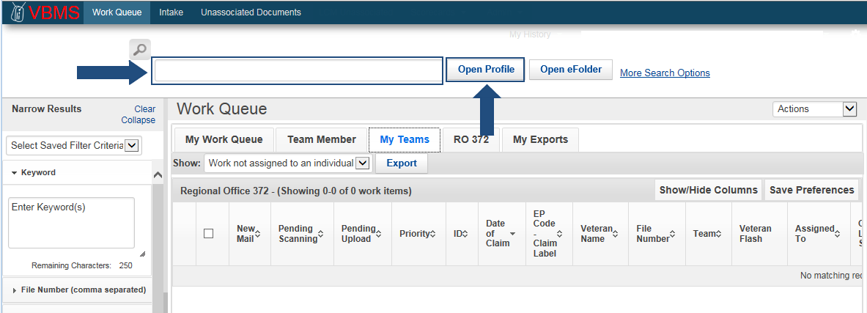

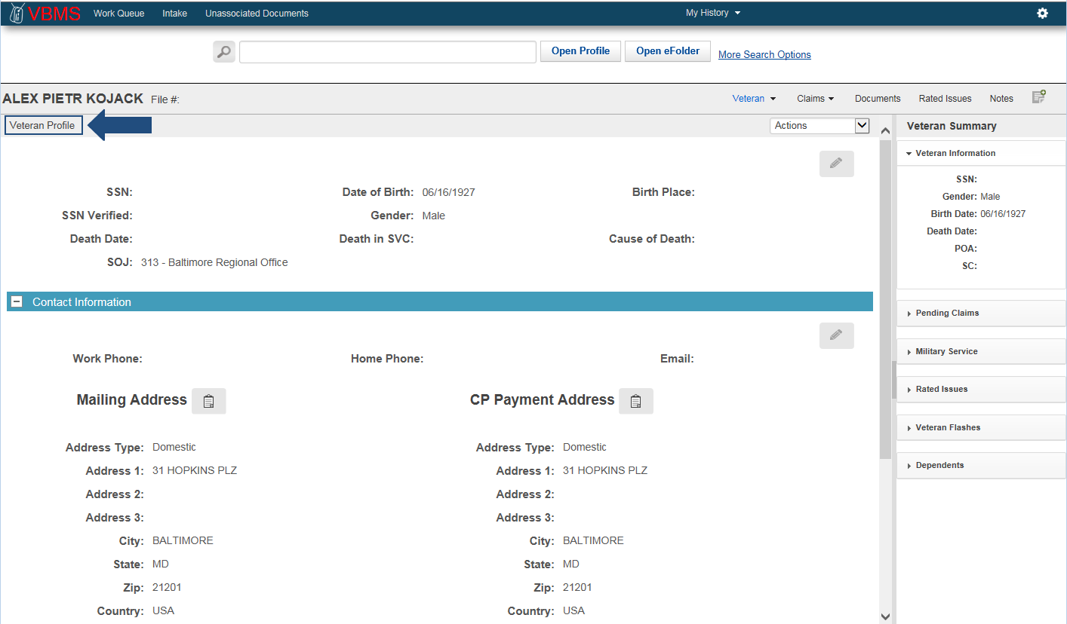

**The Date of Claim** is a required entry when establishing a claim and serves as the basis for determining processing timeliness. For CEST purposes, it is the earliest date the claim was received by a VA facility. The term “VA facility” includes, but is not limited to:

* eBenefits
* VA Regional Office
* VA Centralized Mail Facility
* VA employee at an outreach event
* VA Public Contact team
* VA Call Center
* VA Medical Center

VA requires a manual or electronic date stamp on all incoming documents received at a VA facility. The “received date” on a fax is an acceptable date stamp for documents faxed and directly indexed into the electronic claims folder (eFolder).

**Establishing a New Claim**

After verifying the Veteran’s personal information and ensuring this is the Veteran for which the claim is being established. Click **Actions** and then select **New Claim**. The Claim Establishment page opens to the New Claim Information section.

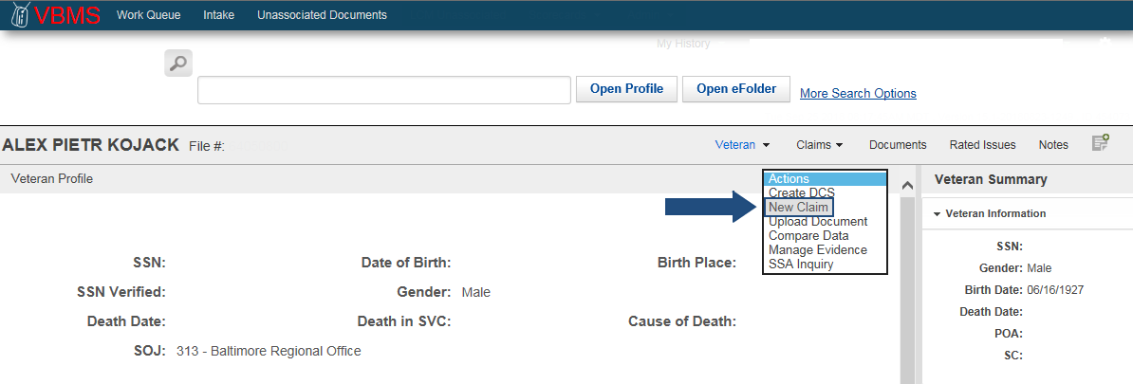

**New Claim Information Screen**

Once all pertinent information has been verified proceed to the New Claim Information Screen.

1. Complete all the entries required noted by the red asterisk in VBMS Core.

* Payee Code
* EP & Claim Label
* Modifier
* Date of Claim
* Segmented Lane
* Station

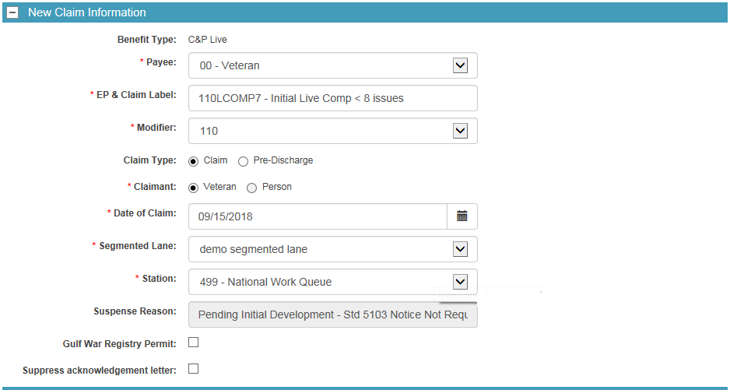

1. Verify Veteran’s Contact Information and update the information as needed.

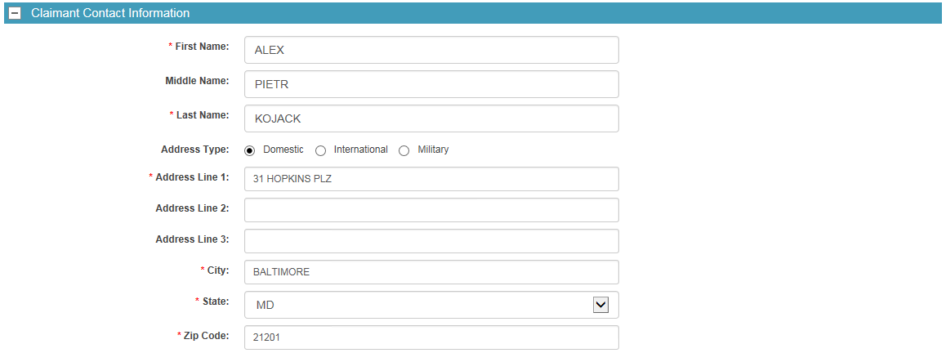

1. Choose appropriate Power of Attorney selection, then choose the appropriate “General POA Code”

* None: The claimant has not identified a POA or POA information is not available
* VSO: The Veterans Service organization or Officer acts as POA for the claimant
* Private: The claimant retains a private attorney to act as POA

1. Select “Assign a limited POA for this claim” check box to indicate if the claimant has authorized the VSO or other POA limited access to eFolder only.
2. If not limited access, check both “Allow eFolder Access” and “Chg of Addr Auth”.

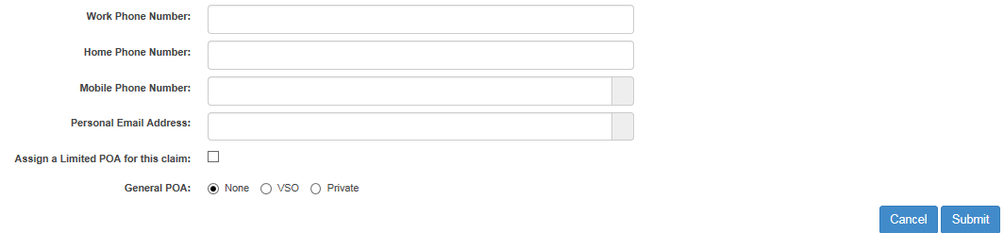

1. Select **Submit**

The process of establishing a New EP in VBMS Core is complete. The system will now direct the VSR automatically to the Development Plan task bar and should default to the *Contentions* list.

**Establishing Contentions**

**New Contentions at Claims Establishment**

Use of contentions for each claim is mandatory and should be entered as soon as they are identified. All claimed issues must be entered as contentions **as they are claimed** by the Veteran on the application for benefits. Each claimed issue, including non-rating issues, must be entered as a separate contention.  Non-rating contentions must relate to the specific benefit being sought.

1. If not already there, click **Contentions** list
2. Click **Add Contention**



1. Click the **Contention** box and enter the contention as it is claimed by the Veteran/claimant
2. Click the **Classification** box and choose from the classification list. You can narrow down the results by typing in the box, but ensure you choose the appropriate one from the list.
3. The contentions date is set to the date of claim by default. If needed (in the case of additional claims after the first is established), click **Date of Contention** and select date from calendar. The contentions date cannot be before the date of claim.

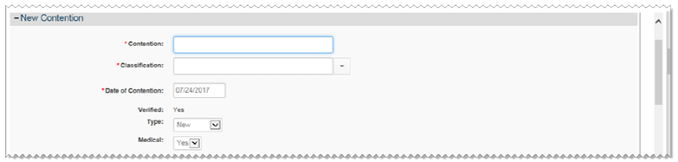

1. The **Verified box** is automatically populated with a yes or no value, once you save the contention. The Verified box indicates that the contention has been reviewed and it is correct.
   1. Scanned contentions will show *No* until a classification and type are entered.
   2. Contentions that have been manually entered will always show *Yes*.
2. Click **Type** and choose the type from the list: New; Reopen, Increase, Secondary or Request for Examination (RFE).
3. Click **Medical** and select *Yes* or *No.*

Non-rating contentions should relate to the specific benefit being sought and appropriate naming conventions must be followed. *See below for an example.*

*Example of Appropriate Naming*

A Veteran submits an *initial claim* for service connected compensation for hearing loss due to acoustic trauma and ringing in the ears, along with a claim to add a spouse and a child. Create separate contentions for the spouse and child as well as each medical contention as follows:

* dependency claim for **[name of spouse]**
* dependency claim for **[name of child]**
* hearing loss due to acoustic trauma ***(exactly how Veteran stated)***
* ringing in the ears ***(even though the medical term for this is tinnitus, we list the contention as it was claimed)***

*Special Issues*

1. If applicable, click in the **Special Issue** boxand select an issue from the drop-down list; or typing in the box will narrow down the list of items to choose from. *Note:* Not every claim/contention will require a special issue.

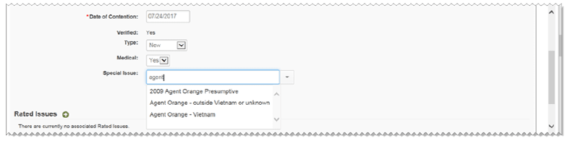

1. The special issue you selected is shown below the Special Issue list. You can click

**[X]** to remove a special issue from the contention, if necessary.



*Rated Issues*

Contentions with a claim type of secondary or increase are often associated with issues that have been previously determined. When working with these types of contentions review previously rated issues and associate them to the contention, if appropriate. If there are no rated issues that apply to the specific claim being worked, no action is needed.

Contentions with a type of *Increase* or *RFE* must be associated to a rated issue before you can add them to an exam scheduling request.

1. Click the green add icon next to the Rated Issues. The Associate Rated Issues dialog opens.

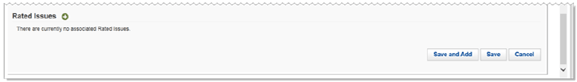

1. Select the check boxes next to the Associate Rated Issues you want to associate to the contention and click the **Add** button.

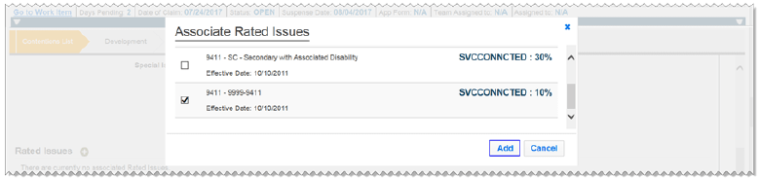

1. The issues that have been selected to associate are listed in the **Rated Issues** list.

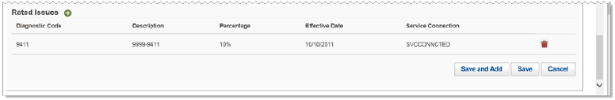

1. Click **Save** to save the contention or click **Save and Add t**o save the contention and add another.

**Reviewing Established Contentions**

Contentions that have been entered into the system electronically (eBeneftis, Stakeholder Enterprise Portal (SEP), etc.) must be verified upon review and are marked with a yellow alert icon in the Contentions List.



After the contention is completed and verified the yellow alert icon will disappear. All contentions must be verified in order to be available for viewing via eBenefits.

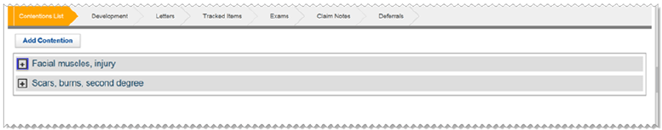

1. Click the plus sign [+] next to the contention to view or edit the contentions
2. To add additional contentions, follow **New Contentions at Claims Establishment** procedures 2-14

**Adding Flashes in Share**

*For the purposes of this training Share will only be utilized to add flashes to the record. If more detail is required please refer to the Share User’s Guide. Most claims are not to be established in Share.*

Claimant flashes are claimant-specific indicators that represent an attribute, fact, or status that may occasionally change (e.g. Former Prisoner of War (FPOW), blind Veteran, homeless, etc.).  Regional offices (ROs) are responsible for:

* identifying claimant’s records that require flashes
* inputting the flashes when required, and
* promptly removing the flash when it no longer applies

Claimant flashes must be entered in the corporate record once the need is identified.  Most flashes are added by the end user, but some are generated by the system.  Flashes will exist on a claimant’s record until the flash is manually removed.

***Note:*** Claimant flashes may be reviewed on the VBMS Core profile screen; however, they cannot be added in VBMS Core. They must be added and updated in Share.

*How to Add a Flash in* Share

1. Open Share from your Start menu
2. Select *Corporate Flashes* from the *Available Processes* list
3. Under *Search Criteria*, enter the File Number
4. Select the **Submit** button

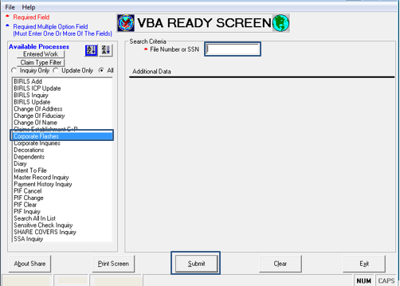

1. Select desired flashes from the Available RO Flashes or Available VACO Flashes. Use the **>** button to add the flashes to the Selected boxes. When all flashes are selected, click the **Submit** button. A message will be displayed stating the updates are complete.

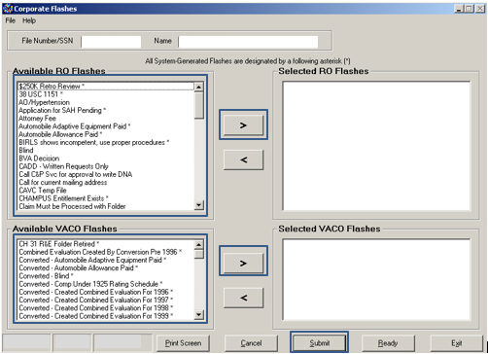

Additional guidance on the use of Share can be found in the Share User’s Guide.

Attachment A: End Product Codes

|  |  |
| --- | --- |
| 010 Initial Disability Compensation, 8 Issues or More  020 Compensation Claims Received After the Initial Eligibility Decision  030 Higher level Review  040 Supplemental Claims  070 Post-Certification Control  095 Vocational-Rehabilitation Eligibility Determination – Memorandum Rating Decision Required  110 Initial Disability compensation, 7 Issues or Less  120 Pension Claims Received After the Initial Eligibility Decision  130 Disability and Death Dependency  135 Hospitalization Adjustments or Resumptions  140 Initial Death Compensation and DIC Claims  150 Income, Estate, and Election Issues  154 IVM Match Cases – Pension & Parents’ DIC  155 EVR Referrals  160 Burial, Plot, Headstone Marker, Engraving Claims  165 (EP 163, 164, 165) Accrued by Reimbursement or Accrued by Relationship Claims  170 Pre-Certification Appeal Control  172 Statement of the Case\/Grant of Benefits – Historical *(prior to May 15, 2017)*  173 Hearing – Conducted by an Employee Other Than a Decision Review Officer (DRO)/Informal DRO Hearings - Historical *(prior to April 27, 2017)*  174 Hearings Conducted by DRO/Decisions – Historical *(prior to April 27, 2017)*  180 Initial Disability Pension Claims  190 Initial Survivors Pension Claims  290 Eligibility Determinations - Other  293 COWC Decisions | 295 Vocational Rehabilitation Eligibility Determination, Memorandum Rating – Decision Not Required - Historical  298 CRSC/CRDP Awards  310 Routine Future Examinations  314 Income Verification Match – Service-Connected Individual Unemployability  320 Reviews Due to Hospitalization  330 Reviews – Regulatory & Procedural  336 Pre-Discharge Claims – BDD  337 Pre-Discharge Claims – QS *(Historical)*  400 Correspondence & Information Actions  410 Original Claim Spina Bifida  420 Reopened Claim Spina Bifida  450 BVA – Spina Bifida  470 NOD – Spina Bifida  500 Special Controlled Correspondence   1. FOIA and Privacy Act Requests   590 Due Process for Incompetency   1. Predetermination Notice 2. Reviews, Ratings Involved   690 Reviews, Authorization Review Only  699 Unassociated STRs   1. Reviews, Referrals, Other   960 Administrative Error, Codesheet, and Master Record Corrections |

For additional EPs and information on EPs, refer to [M21-4, Appendix B, Topic II](https://vaww.vrm.km.va.gov/system/templates/selfservice/va_kanew/help/agent/locale/en-US/portal/554400000001034/content/554400000011474/Appendix%20B.%20End%20Product%20Codes%20and%20Work-Rate%20Standards%20for%20Quantitative%20Measurements#S2).

Review Exercise: CEST and EP Control

**Instructions:** Use all references that are available to complete the following:

1. What is an end product (EP) and why is it important?
2. What is the difference between EP 010 and EP 110?
3. Which EP is used for dependency claims?
4. What is CEST and for what is it used?
5. How is the date of claim established?
6. What are the steps necessary to establish a new claim in VBMS Core?
7. How should contentions be entered into VBMS Core?
8. What is the proper way to enter a “dependency” contention?
9. What are flashes and how are they added to the system?
10. What does the icon mean on the contention?

Practical Exercise

This practical exercise will give you an opportunity to practice establishing a claim. Once the instructor has provided you with an e-case, complete the following:

1. Review the assigned eCase
2. Access the VBMS Core Demo System
3. Complete new claim procedures to establish the claim