Claims Based on Service in Southwest Asia
Instructor Lesson Plan
Time Required: 3 Hours

Table of Contents

Lesson Description 2
Claims Based on Service in Southwest Asia 4
Topic 1: Presumptive SC for Undiagnosed Illness and MUCMIs Under §3.317(a&b) 6
Topic 2: Presumptive SC for Infectious Diseases Under §3.317(c) 12
Topic 3: Developing Southwest Asia Claims 14
Lesson Review, Assessment, and Wrap-up 23

Lesson Description
The information below provides the instructor with an overview of the lesson and the materials that are required to effectively present this instruction.
TMS # | 61839
Prerequisites | Prior to this lesson, the Veteran Service Representatives (VSRs), Rating Veteran Service Representatives (RVSRs), Decision Review Officers (DROs), Authorization Quality Review Specialists (AQRSs), and Rating Quality Review Specialists (RQRSs) should have completed Challenge training.
target audience | The target audience for Claims Based on Service in Southwest Asia  (Post Challenge VSR & RVSR) is for VSRs and RVSRs who have completed Challenge training, DROs, and A/RQRSs. Although in most instances the VSR will be undertaking the necessary development actions, an RVSR/DRO must also know what information is required before they can appropriately decide a claim. The A/RQRSs must also know this information in order to properly review claims for quality.
Time Required | 3 hours
Materials/  TRAINING AIDS | Lesson materials:  - Claims Based on Service in Southwest Asia PowerPoint Presentation  - Claims Based on Service in Southwest Asia Trainee Handout
Training Area/Tools | The following are required to ensure the trainees are able to meet the lesson objectives:  - Classroom or private area suitable for participatory discussions  - Seating, writing materials, and writing surfaces for trainee note taking and participation  - Handouts, which include a practical exercise  - Large writing surface (easel pad, chalkboard, dry erase board, overhead projector, etc.) with appropriate writing materials  - Computer with PowerPoint software to present the lesson material  Trainees require access to the following tools:  - VA TMS to complete the assessment  - Compensation Service Intranet: Rating Job Aids  - Internet acces for Compensation Pension Knowledge Management (CPKM)  - Internet acces for Electronic Code of Federal Regulations
Pre-Planning | - Become familiar with all training materials by reading the Instructor Lesson Plan while simultaneously reviewing the corresponding PowerPoint slides. This will provide you the opportunity to see the connection between the Lesson Plan and the slides, which will allow for a more structured presentation during the training session.  - Become familiar with the content of the trainee handouts and their association to the Lesson Plan.  - Practice is the best guarantee of providing a quality presentation. At a minimum, do a complete walkthrough of the presentation to practice coordination between this Lesson Plan, the trainee handouts, and the PowerPoint slides and ensure your timing is on track with the length of the lesson.  - Ensure that there are copies of all handouts before the training session.  - When required, reserve the training room.  - Arrange for equipment such as flip charts, an overhead projector, and any other equipment (as needed).  - Talk to people in your office who are most familiar with this topic to collect experiences that you can include as examples in the lesson.  - This lesson plan belongs to you. Feel free to highlight headings, key phrases, or other information to help the instruction flow smoothly. Feel free to add any notes or information that you need in the margins.
Training Day | - Arrive as early as possible to ensure access to the facility and computers.  - Become familiar with the location of restrooms and other facilities that the trainees will require.  - Test the computer and projector to ensure they are working properly.  - Before class begins, open the PowerPoint presentation to the first slide. This will help to ensure the presentation is functioning properly.  - Make sure that a whiteboard or flip chart and the associated markers are available.  - The instructor completes a roll call attendance sheet or provides a sign-in sheet to the students. The attendance records are forwarded to the Regional Office Training Managers.

 | Claims Based on Service in Southwest Asia
 | INSTRUCTOR INTRODUCTION |  | Complete the following:  - Introduce yourself  - Orient learners to the facilities  - Ensure that all learners have the required handouts
 | time required |  | 0.5 hours
 | Purpose of Lesson |  | This lesson provides the trainee with a comprehensive understanding of developing claims for disabilities based on the provisions of 38 CFR §3.317, to include undiagnosed illness, medically unexplained chronic multi-symptom illnesses (MUCMI), and presumptive infectious diseases.
 | Lesson Objectives  Slide 2 | In order to accomplish the purpose of this lesson, the trainee will be required to accomplish the following lesson objectives.  The trainee will be able to:  - Demonstrate a comprehensive understanding of developing claims for disabilities based on the provisions of 38 CFR §3.317, to include:  - undiagnosed illness,  - medically unexplained chronic multi-symptom illness (MUCMI), and  - presumptive infectious diseases
 |  | Stress that the topic does not cover specific Gulf War environmental hazards such as burn pits, particulate matter, sulfur fire, or Chromium VI. For more information on those topics, see the training titled “Claims Based on Exposure to Environmental Hazards in Iraq, Afghanistan, and Djibouti”
 | References  Slide 3 | All M21-1 references are found in the Live Manual Website.  - 38 CFR 3.317, Compensation for certain disabilities occurring in Persian Gulf veterans  - M21-1, Part IV, Subpart ii.1.E, Claims Based on Service in Southwest Asia  - M21-1, Part IV, Subpart ii.2.D, Service Connection (SC) for Qualifying Disabilities Associated with Service in Southwest Asia
 | APPLICATION IN THE WORKPLACE  Slide 4 | Gaining knowledge in this area will improve your quality, your office’s quality, and most importantly; ensure the accuracy of decisions made in regards to service connection for claims for disabilities resulting from service in Southwest Asia. Proper development prevents unneccesary delay in claims which may result from over, or under development. This not only impacts the timeliness in which a Veteran receives a decision, and potentially payment, but it also is a quality error.
 | STAR Error code(s) | B1: Failing to provide GW special issue paragraph prior to denial.  B2: Failing to provide medical examination/opinion when required.
 | Provisions of the Persian Gulf War Veterans’ Benefits Act of 1994  Slide 5 | Authorized the Department of Veterans Affairs (VA) to compensate any Gulf War (GW) Veteran suffering from a chronic disability resulting from an undiagnosed illness or combination of undiagnosed illnesses which manifested either  - during active duty in the Southwest Asia theater of operations during the GW, or  - to a degree of 10 percent or more within a presumptive period following service in the Southwest Asia theater of operations during the GW.
 | Provisions of 38 CFR §3.317  Slide 6 | Defines certain key terms and provides for presumptive SC for  - undiagnosed illness or MUCMIs, and  - a list of infectious diseases
 | Provisions of the Persian Gulf War Veterans’ Act of 1998  Slide 7 | Authorized the VA to compensate GW Veterans for diagnosed or undiagnosed disabilities that are determined by VA regulation to warrant a presumption of service connection based on a positive association with exposure to one of the following as a result of GW service  - a toxic agent  - an environmental or wartime hazard, or  - a preventive medication or vaccine.
 | Provisions of the Veterans Education and Benefits Expansion Act of 2001  Slide 8  Knowledge Check  Slide 9 | Effective March 1, 2002, this provision expanded the definition of “qualifying chronic disability” to include, not only a disability resulting from an undiagnosed illness but also  - a medically unexplained chronic multi-symptom illness (MUCMI) that is defined by a cluster of signs and symptoms, and  - any diagnosed illness that is determined by VA regulation to warrant presumption of SC.  What are the provisions of 38 CFR 3.317?  Answer: Defines certain key terms and provides for presumptive service connection for undiagnosed illness or MUCMI and a list of infectious diseases.

Topic 1: Presumptive SC for Undiagnosed Illness and MUCMIs Under §3.317(a&b)
Introduction |  |  |  | This topic will define who is a qualifying Veteran and what constitute undiagnosed illness and medically unexplained chronic multi-symptom illness.
Time Required |  |  |  | 1 hour
OBJECTIVES/  Teaching Points |  |  |  | Topic objectives and teaching points to support the topic objectives:  - Defines:  - Qualifying Veteran for Undiagnosed Illness and MUCMIs  - Southwest Asia Theater of Operations  - Presumptive Period for Manifestation of Disability  - Qualifying Chronic Disability  - Signs, symptoms, and characteristics of:  - Undiagnosed Illness  - MUCMI  - FGID
Presumptive SC for Undiagnosed Illness and MUCMIs under §3.317  Slide 10 |  |  |  | Explain that the focus of this lesson will be on Gulf War presumptive conditions as defined by §3.317.  (Reiterate that the topic does not cover specific Gulf War environmental hazards such as burn pits, particulate matter, sulfur fire, or Chromium VI. For more information on those topics, see the training titled “Claims Based on Exposure to Environmental Hazards in Iraq, Afghanistan, and Djibouti.” Or other (non-GW) enivornmental hazards, such as Camp Lejeune and Atsugi.)
Qualifying Veteran for Undiagnosed Illness and MUCMIs  Slide 11 |  |  |  | A Veteran who served on active military, naval, or air service in the Southwest Asia theater of operations during the GW period.  - The GW period extends from August 2, 1990, through a date yet to be determined by law or Presidential proclamation.  Explain that the only Veterans who are eligible for consideration of service connection for Undiagnosed Illness and MUCMIs are those who have qualifying service. First step when you receive one of these claims is to develop for verification of qualifying service.
Definition: Southwest Asia Theater of Operations  Slide 12 |  |  |  | The Southwest Asia theater of operations includes the following locations and the airspace above them  Iraq  Kuwait  Saudi Arabia  the neutral zone between Iraq and Saudi Arabia  United Arab Emirates  Bahrain  Qatar  Oman  the Gulf of Aden  the Gulf of Oman  the Persian Gulf  the Arabian Sea  the Red Sea  Explain this is an inclusive list of the areas that the Veteran must have served in to qualify for service connection for Undiagnosed Illness and MUCMIs.  Ask: is there any country that stands out to you as not being included on this list?  Answer: Afghanistan.  Reiterate the first thing you want to do in these cases, is verify service in one these locations. (We will cover development after we discuss what conditions qualify.)
Presumptive Period for Manifestation of Disability  Slide 13 |  |  |  | The date following last performance of active military, naval, or air service in the Southwest Asia theater of operations during the GW through December 31, 2021.  Explain that this date might be extended, but until (or unless) it is, this is what the regulation states.
Qualifying Chronic Disability  Slide 14 |  |  |  | A chronic disability resulting from any of the following or any combination of the following  - an undiagnosed illness, or  - a MUCMI.  Explain The Veteran does not have to identify a claimed disability as due to Gulf War service. It is our duty to recognize the potential entitlement based on the criteria being met. If you see a Veteran has qualifying Southwest Asia service, and claims anything that could possibly be considered under this regulation, we must pursue appropriate development.
Signs and Symptoms of Undiagnosed Illnesses or MUCMIs  Slide 15 |  |  |  | - joint pain  - muscle pain  - neurological signs or symptoms  - headache  - neuropsychological signs or symptoms  - gastrointestinal signs or symptoms  - abnormal weight loss  - fatigue  - sleep disturbances  - respiratory signs and symptoms (upper or lower)  - cardiovascular signs or symptoms  - skin signs and symptoms  - menstrual disorders  Note: The list of categories is not exclusive; signs or symptoms not represented by one of the listed categories may also qualify.  Explain Whenever you see a claim for service connection for any of these types of conditions from a Veteran who has qualifying service, order a GW general medical examination. (AND any applicable specialty examinations that might also be necessary.)
Definition: Undiagnosed Illness  Slide 16 |  |  |  | A type of chronic qualifying disability where qualifying signs and/or symptoms cannot be attributed to any known clinical diagnosis by history, physical examination and laboratory tests.  Note: The existence of a clinical diagnosis with specific etiology, which may weigh against §3.317 entitlement, does not preclude the ordering of a Gulf War examination unless all symptoms claimed by the Veteran are clearly attributable to the diagnosis, such as a condition like sleep apnea that is definitely diagnosed via sleep study.
Definition: MUCMI  Slide 17 |  |  |  | A type of chronic qualifying disability in which there is a diagnosed illness that has  - An inconclusive pathophysiology and etiology,  - overlapping symptoms and signs, and  - features such as  - fatigue and pain  - disability out of proportion to physical findings, and  - inconsistent demonstration of laboratory abnormalities.  Explain It will be the examiner’s job to make the determination if what the Veteran has is considered undiagnosed versus MUCMI, versus a diagnosable condition with a known etioliogy, etc. It is all a part of the GW general medical examination.
MUCMIs include, but are not limited to  Slide 18 |  |  |  | - chronic fatigue syndrome  - fibromyalgia, or  - functional gastrointestinal disorders (FGIDs), excluding structural gastrointestinal diseases.  Explain These specifically identified MUCMIs are presumptive, but that does not mean that ones that are not cited here could not also be service connected.  Stress as the title states, this list is not limited to just these conditions as this is not an all exclusive list.
Definition: FGIDs  Slide 19 |  |  |  | A group of diagnosed conditions that are a type of MUCMI. They are characterized by chronic or recurrent symptoms that are  - unexplained by any structural, endoscopic, laboratory, or other objective signs of injury or disease, and  - may be related to any part of the gastrointestinal tract.  Explain The regulation used to just specify irritable bowel syndrome, but it has been amended to broaden the scope and now defines such conditions as FGIDs.
Characteristic FGID symptoms include  Slide 20 |  |  |  | - abdominal pain  - substernal burning or pain  - nausea  - vomiting  - altered bowel habits (including diarrhea, constipation)  - indigestion  - bloating  - postprandial fullness  - painful or difficult swallowing  Explain again, any time a Veteran claims any of these type of symptoms, and has qualifying service, we will order the GW general medical examination. It is up to you to recognize the signs/symptoms that might be associated to GW service.
FGID Continued  Slide 21 |  |  |  | Diagnosis of a FGID under generally accepted medical principles normally requires  - symptom onset at least six months prior to diagnosis, and  - the presence of symptoms sufficient to diagnose the specific disorder at least three months prior to diagnosis.  FGID diagnoses include but are not limited to  - irritable bowel syndrome, and  - functional  - dyspepsia,  - vomiting,  - constipation,  - bloating,  - abdominal pain syndrome, or  - dysphagia.  Explain again, this will be the doctor’s determination. Not the VSR or RVSR.
FGID Continued  Slide 22 |  |  |  | Important: FGIDs do not include structural gastrointestinal diseases, such as  - inflammatory bowel disease (such as ulcerative colitis or Crohn's disease), and  - gastroesophageal reflux disease,  as these conditions are considered to be organic or structural diseases characterized by abnormalities seen on x-ray, endoscopy, or through laboratory tests.  Reiterate: Keep in mind that just because a Veteran claims, or has a diagnaosis of GERD, you do not want to just discount their claim (under §3.317) based on the existence of that diagnosis. The symptoms of GERD can also be consistent with those under FGIDs. It is common for a doctor to document a diagnosis based on the symptoms, however unless there is evidence that there has been comprehensive testing (as noted on the slide) conducted which resulted in the clinical diagnosis with specific etiology, order the GW general medical examination so that a VA doctor can review all evidence and make the determination.
Partially Understood Chronic Multi-symptom Illnesses  Slide 23  Knowledge Check  Slide 24  Knowledge Check (cont.)  Slide 25 |  |  |  | Chronic multi-symptom illnesses of partially explained etiology and pathophysiology, such as  - diabetes and  - multiple sclerosis,  are not considered medically unexplained and cannot be considered a qualifying chronic disability for purposes of 38 CFR §3.317.  Explain keep in mind that these are §3.309(a) conditions, so consideration under presumptive service connection still may apply, just not under §3.317.  How does a Veteran qualify to be considered for an Undiagnosed Illness and/or MUCMI?  Answer: The Veteran must have served on active military, naval, or air service in the Southwest Asia theater of operations during the GW period from August 2, 1990, through a date yet to be determined.  The Southwest Asia theatre of Operations include what locations?  Answer:  - Iraq - Kuwait - Saudi Arabia - the neutral zone between Iraq and Saudi Arabia - United Arab Emirates - Bahrain - Qatar - Oman - the Gulf of Aden - the Gulf of Oman - the Persian Gulf - the Arabian Sea - the Red Sea

Topic 2: Presumptive SC for Infectious Diseases Under §3.317(c)
Introduction |  |  |  | This topic will outline specific development procedures and requirements.
Time Required |  |  |  | 0.25 hours
OBJECTIVES/  Teaching Points |  |  |  | Topic objectives and teaching points to support the topic objectives:  - Defines:  - Qualifying Veteran for Infectious Diseases  - Qualifying Infectious Diseases  - Long-Term Health Effects Potentially Associated with Infectious Diseases
Presumptive SC for Infectious Diseases Under §3.317(c)  Slide 26 |  |  |  | Explain that although the infectious diseases are also listed under §3.317, they are separate and distinct from the undiagnosed illness and MUCMIs.
Qualifying Veteran for Infectious Diseases  Slide 27 |  |  |  | The Veteran served on active duty  - in the Southwest Asia theater of operations during the GW (as previously defined), OR  - in Afghanistan on or after September 19, 2001  Important: Notice the inclusion of Afghanistan!!!
Qualifying Infectious Diseases  Slide 28 |  |  |  | 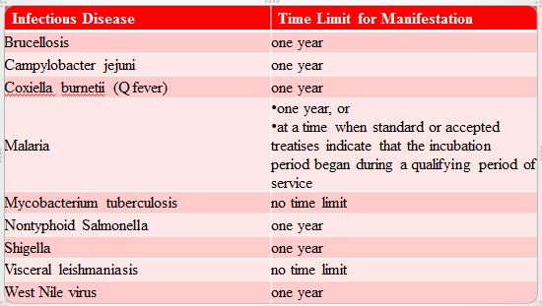  - The disease must manifest to a compensable degree within the time limit specified in the table.  Note: There must be actual clinical/medical evidence of a diagnosis of one of the above. Immunization for infectious diseases, or tests for them, are not the same as actually having/contracting them.  Emphasize: The one year time period specified in the table means within one year from the date of separation from a qualifying period of service as specified in 38 CFR 3.317 (c)(3)(ii).
Long-Term Health Effects Potentially Associated with Infectious Diseases  Slide 29  Knowledge Check  Slide 30 |  |  |  | The Institute of Medicine of the National Academy of Sciences has identified the conditions listed in column B in the table below as potential long-term health effects associated with the infectious diseases (column A). (See §3.317 and M21-1 IV.ii.2.D.1.q. for complete table.)  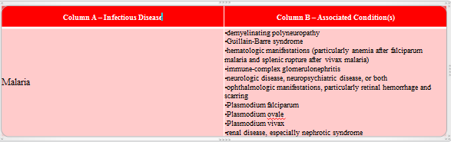  If a Veteran who is presumed SC for a disease listed in column A is diagnosed with a disease in column B within the time period specified in the table (if no time period is specified, at any time), VA will request a medical opinion as to whether it is at least as likely as not that the condition was caused by the Veteran having had the associated disease in column A.  Explain: If the evidence shows that a Veteran actually did contract an infectious disease, this could lead to a plethora of secondary conditions. As noted on the slide, there is an extensive chart located in the Manual, that should be referred to any/every time this type of claim is being processed. You would need to locate the specific disease the Veteran had (in column A) and then consider all potentially associated conditions shown (in column B) as possibly service connected on a secondary basis.  Veterans who served on active duty in Afghanistan can qualify for presumption of what type of disease under §3.317 (c)?  Answer: Infectious

Topic 3: Developing Southwest Asia Claims
Introduction |  |  |  | This topic will define who is a qualifying Veteran and what constitute undiagnosed illness and medically unexplained chronic multi-symptom illness.
Time Required |  |  |  | 1 hour
OBJECTIVES/  Teaching Points |  |  |  | Topic objectives and teaching points to support the topic objectives:  - Outline necessary development actions and considerations
Developing Southwest Asia Claims  Slide 31 |  |  |  | Explain that development for claims based on service in Southwest Asia is not significantly different than developing other types of claims. If anything, they should be handled with as liberal of an approach as possible.
Claim for Exposure to Environmental Hazards  Slide 32 |  |  |  | A claim is not substantially complete if a Veteran alleges exposure to environmental hazards during service, but does not identify the medical condition or symptom for which service connection (SC) is claimed.  In cases such as these  - inform the Veteran that he/she must identify a specific disability, since exposure in and of itself is not a disability, and  - ask the Veteran to identify the disability(ies) that resulted from exposure to environmental hazards during service.  Important: Whenever possible, telephone the Veteran to obtain the information needed to substantiate the claim. Do not establish a pending EP until the Veteran has identified a disability that has resulted from exposure to the environmental hazard. Do not process the claim as a denial. (There is NO rating jurisdiction without a disability identified!) M21-1 Part IV, Subpart ii.1.E.1.a
Initial Development Action  Slide 33 |  |  |  | There is no requirement for a specialized Section 5103 notice.  Important: Send a standard Section 5103 notice if the Veteran files a substantially complete application on a non-EZ form.  Explain For any new claim for SC for a qualifying disability under 38 CFR 3.317 resulting from service in Southwest Asia, additional development to the Veteran is not required as the evidence requirements are covered under the Disability Service Connection evidence table of the VA Form 21-526EZ, Application for Disability Compensation and Related Compensation Benefits.  Note: If multiple joint and/or muscle pain is alleged, request that the Veteran specify the joints and/or area(s) affected. M21-1 Part IV, Subpart ii.1.E.1.b & c  Reiterate: Whenever possible, telephone the Veteran to obtain the information needed to substantiate the claim.
Verifying Southwest Asia Service Using DD Form 214  Slide 34 |  |  |  | 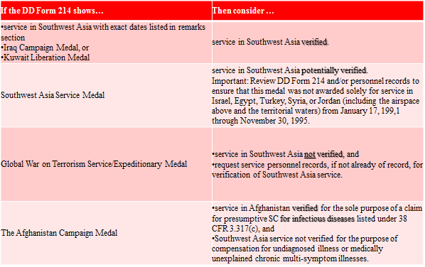  Important: Look at the DD214, personnel records, and STRs for service in any of the qualifying locations.  Note: Table located M21-1 Part IV, Subpart ii.1.E.1.d
Requesting Service Department Records  Slide 35 |  |  |  | In addition to service treatment records (STRs), request  - clinical records, if the Veteran furnishes information on the application about specific inpatient treatment, and  - service personnel records, if the dates of service in Southwest Asia during the Gulf War period that began on August 2, 1990, are not already of record.  Note: Concurrently request clinical records, service personnel records, and STRs, if all are needed.
Knowledge Check  Slide 36 |  |  |  | Have the students read and complete the Knowledge Check found in the PowerPoint. Have them discuss their responses.
Considering VHA Persian Gulf Health Registry Examinations  Slide 37 |  |  |  | - In all cases when the Veteran has been examined as part of the Veterans Heath Administration (VHA) Persian Gulf Health Registry, ensure those results have been obtained.  Important: Check the box in the GULF WAR REGISTRY PERMIT field (in VBMS) when claimants indicate they were included in the Veterans Heath Administration (VHA) Persian Gulf Health Registry. If you are unsure whether the Veteran had one, there is a pick in VBMS (Special Issues: GW-registry exam?) providing language asking the Veteran. (Do not send a development letter solely for this information, this is merely something you should add to your letter if you have to develop for other necessary information.)
When an Examination is Necessary  Slide 38 |  |  |  | An examination is necessary in cases falling under §3.317 when there is  - competent lay or medical evidence of a chronic disease (or chronic signs or symptoms of a disease) listed in §3.317 manifesting within the period specified in §3.317, and  - service required by §3.317  Important:  - The threshold for requiring an examination is low.  - The Veteran does not have to identify a claimed disability as due to Gulf War service.  Important: A claimant’s own statement, covering in sufficient detail a condition that is within his/her ability to describe, such as his/her own symptoms, may to that extent constitute evidence. The claimant is often the most qualified source to describe the circumstances of the disabling effects of the disease or injury. M21-1 Part III, Subpart ii.2.D.3.g  Important: As a matter of policy, VA decision makers should accept evidence at face value unless called into question by other evidence of record or sound medical or legal principles. M21-1 Part III, Subpart iv.5.2.b
Gulf War General Medical  Slide 39 |  |  |  | - Identifies what signs and symptoms the Veteran has, what other examinations are needed, and provides a medical statement explaining whether the Veteran’s disability pattern is:  - (1) an undiagnosed illness  - (2) a diagnosable but medically unexplained chronic multi-symptom illness of unknown etiology  - (3) a diagnosable chronic multi-symptom illness with a partially explained etiology, or  - (4) a disease with a clear and specific etiology and diagnosis.  - Important: There is no limit on the number of Gulf War General Medical examinations that we may order. You will need to determine based on the facts of the case whether a Gulf War General Medical examination is appropriate, or if a speciality examination based on the specific body system would be sufficient.
When a Gulf War Examination is not Necessary  Slide 40 |  |  |  | - Do not order a Gulf War examination when the evidence is adequate to substantiate the claim under §3.317 or on another basis– even if the threshold for an examination is met.  - Example: A Veteran has qualifying service in the Southwest Asia theater of operations and the claims folder contains a competent medical assessment of chronic fatigue syndrome. (The evidence shows that this developed to a compensable degree after service but before December 31, 2021.)  Explain: A Chronic Fatigue Syndrome DBQ (21-0960Q-1) would be ordered, if the evidence of record does not contain enough information to assign an evaluation for chronic fatigue syndrome. But regardless, the GW gen med would not be necessary.
When a Gulf War Examination is not Necessary (cont.)  Slide 41 |  |  |  | - Do not order a Gulf War examination if one has been completed in response to a pending claim or a decision that has not yet become final. In these cases, only order the specialty DBQ specific to the claimed condition.  - Do not request a Gulf War examination when the claim is for a single joint injury – not an undiagnosed illness or medically explained multi-symptom illness – and the evidence shows  - trauma to the joint in service or thereafter, and  - a known clinical diagnosis such as traumatic arthritis or meniscal tear indicating an injury etiology.  Explain Specific language will need to be included in the non-GW gen med, which will be addressed later in this presentation.  Note: For the joint injury, it is the same concept as the previous slide, where there is no potential entitlement under §3.317. There is potential entitlement to service connection on a direct and/or secondary basis, and that is how the claim should be processed.
When an Examination is not Necessary  Slide 42 |  |  |  | An examination is not necessary in a limited variety of cases where there is no potential entitlement under §3.317.  - Do not order an examination when a Southwest Asia Veteran claims neurological symptoms manifesting within the period specified in §3.317 but there is a competent medical diagnosis of multiple sclerosis (MS) and competent medical evidence attributing the symptoms to MS.  - Do not order an examination for obstructive sleep apnea diagnosed by sleep study, as this is not a recognized qualifying chronic disability under the provisions of §3.317.  Explain: MS is listed in §3.317(a)(2)(ii) as a chronic multi-symptom illness of partially understood etiology and pathophysiology that cannot be considered medically unexplained. The same goes for diabetes, as explained on slide 21.  Explain Sleep apnea cannot be presumptively service-connected (SC) under the provisions of 38 CFR 3.317 since it is a diagnosable condition. If claimed, sleep apnea must be considered on a non-presumptive SC basis. (M21-1 IV.ii.2.D.1.n.)
KNOWLEDGE CHECK  Slide 43 - 44 |  |  |  | Have the students read and complete the Knowledge Check found in the PowerPoint. Have them discuss their responses.
Impact of Known Clinical Diagnoses  Slide 45 |  |  |  | - The existence of a clinical diagnosis with specific etiology, which may weigh against §3.317 entitlement, does not preclude the ordering of a Gulf War examination unless all symptoms claimed by the Veteran are clearly attributable to the diagnosis.  - If there is a question as to whether the claimed signs and symptoms are attributable to an established clinical diagnosis, a Gulf War examination is necessary.  Note: As discussed on slide 14…
Requesting an Examination in a Southwest Asia Claim  Slide 46 |  |  |  | When an examination is necessary  - Request a Gulf War General Medical Examination DBQ or specific specialty examination (whichever is appropriate), AND any required specialist DBQs  - Plus, request a South West Asia Infectious diseases DBQ (if applicable)  - Send the claims folder to the examiner to review.  Note: Do not prepare a separate medical opinion DBQ. The exam request builder provides the required language.  Ask: What examinations must be performed by specialists?  Answer: hearing, vision, dental, and psychiatric. (M21-1 Part III, Subpart iv.3.A.6.a.) (I find it easy to remember this as eyes, ears, mental, dental.)
Exam Request Builder  Slide 47 |  |  |  | 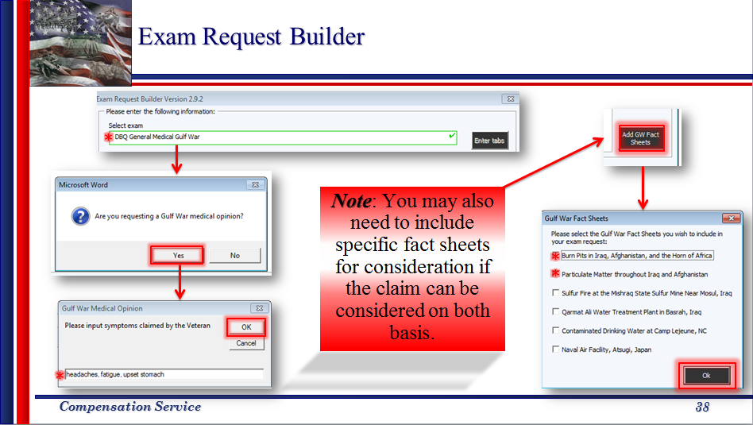  Explain: Always ensure to develop for all applicable theories of entitlement (i.e. direct, presumptive, etc.). For more information on service connection based on exposure to specific Gulf War environmental hazards, see training titled “Claims Based on Exposure to Environmental Hazards in Iraq, Afghanistan, and Djibouti.”  Example: Veterans who served in Iraq have service location which qualifies them for consideration under §3.317, but they also may be considered based on Burn Pit and Particulate Matter exposures, which require the attachment of the Fact Sheets. (Iraq is just an example, consideration under both basis is not limited to Veterans with service in Iraq, but is limited to Veterans with service in the SWA theatre of operations with the specific location identified to also have exposure based on specific environmental hazards.)
Exam Request Builder  for Gulf War Examination  Slide 48 |  |  |  | 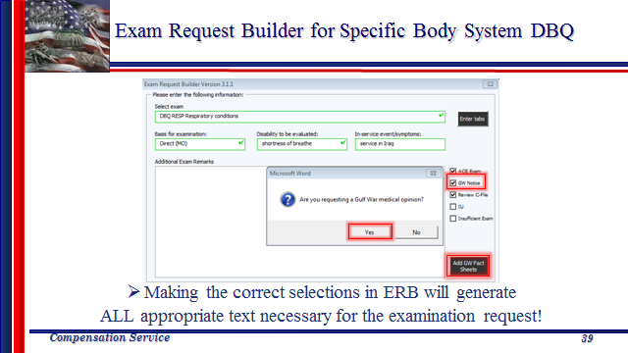  Explain: Checking the GW Notice box generates all of the wording shown/required in M21-1 IV.ii.1.E.2.m & n.
Special Issue Indicators  Slide 49 |  |  |  | - Gulf War Presumptive  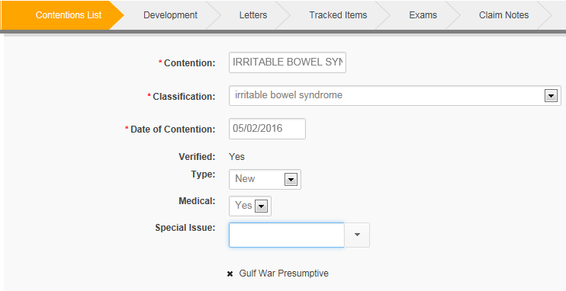

PRACTICAL EXERCISE

Lesson Review, Assessment, and Wrap-up
Introduction  Discuss the following: | The Claims Based on Service in Southwest Asia (Post Challenge VSR & RVSR) lesson is complete.  Review each lesson objective and ask the trainees for any questions or comments.
Time Required | 0.25 hours
Lesson Objectives | You have completed the Claims Based on Service in Southwest Asia (Post Challenge VSR & RVSR) lesson.  The trainee should be able to: .25+  - Demonstrate a comprehensive understanding of developing claims for disabilities based on the provisions of 38 CFR §3.317, to include:  - undiagnosed illness,  - medically unexplained chronic multi-symptom illness (MUCMI), and  - presumptive infectious diseases
Assessment | Remind the trainees to complete the online assessment in TMS to receive credit for completion of the course.  The assessment will allow the participants to demonstrate their understanding of the information presented in this lesson.

