Power of Attorneys (POAs)/Service Organizations

Trainee Handout

**Table of Contents**

Objectives 2

References 2

Types of Power of Attorneys (POAs) and Their Authority 3

Processing VA Form 21-22 and VA Form 21-22a 4

Exclusive Contact 8

Revoking and Terminating Representation 9

When Paper Copies of Notification Letters MUST be Mailed to the POA 10

Attachment A: VA Form 21-22 11

Attachment B: VA Form 21-22a 13

Attachment C: National Organization POA Codes 15

Attachment D: State Organizations POA Codes 16

Attachment E: Topic 2 Exercise 17

Practical Exercise 17

Objectives

* Identify types of POAs that may be appointed by claimants for VA purposes and their authority
* Describe the requirements when processing VA Form 21-22 and VA Form 21-22a
* Discuss the requirements for exclusive contact, revocation, or termination of a POA
* Determine when paper copies of notification letters must be mailed to the POA

References

* [38 U.S.C. 7332, Confidentiality of Certain Medical Records](https://www.law.cornell.edu/uscode/text/38/7332)
* [38 CFR 14.628, Recognition of Organizations](http://www.ecfr.gov/cgi-bin/text-idx?SID=204797488e6ebe2c75e729e0243708b3&mc=true&node=se38.1.14_1628&rgn=div8)
* [38 CFR 14.630, Authorization for a particular claim](http://www.ecfr.gov/cgi-bin/retrieveECFR?gp=&SID=204797488e6ebe2c75e729e0243708b3&mc=true&n=pt38.1.14&r=PART&ty=HTML#se38.1.14_1630)
* [38 CFR 14.631, Powers of Attorney; Disclosure of Claimant Information](http://www.ecfr.gov/cgi-bin/retrieveECFR?gp=&SID=204797488e6ebe2c75e729e0243708b3&mc=true&n=pt38.1.14&r=PART&ty=HTML#se38.1.14_1631)
* [38 CFR 14.633, Termination of accreditation or authority to provide representation under §14.630](http://www.ecfr.gov/cgi-bin/retrieveECFR?gp=&SID=204797488e6ebe2c75e729e0243708b3&mc=true&n=pt38.1.14&r=PART&ty=HTML#se38.1.14_1633)
* [38 CFR 20.204, Rule 204. Withdrawal of Appeal](http://www.ecfr.gov/cgi-bin/text-idx?SID=204797488e6ebe2c75e729e0243708b3&mc=true&node=se38.2.20_1204&rgn=div8)
* [M21-1, Part I, Chapter 3, Section A, General Information on Power of Attorney](https://vaww.vrm.km.va.gov/system/templates/selfservice/va_kanew/help/agent/locale/en-US/portal/554400000001034/content/554400000014076/M21-1-Part-I-Chapter-3-Section-A-General-Information-on-Power-of-Attorney-POA)
* [M21-1, Part I, Chapter 3, Section B, Power of Attorney (POA) Rights to Notification and Review of Records](https://vaww.vrm.km.va.gov/system/templates/selfservice/va_kanew/help/agent/locale/en-US/portal/554400000001034/content/554400000014077/M21-1-Part-I-Chapter-3-Section-B-A-Representatives-Right-to-Notification-and-Review-of-Records?query=Power%20of%20Attorney%20(POA)%20Rights%20to%20Notification%20and%20Review%20of%20Records)
* [M21-1, Part III, Subpart i, Chapter 4, Section B, The Stakeholder Enterprise Portal (SEP) Role in the Veterans Online Application (VONAPP) Direct Connect (VDC) Process](https://vaww.vrm.km.va.gov/system/templates/selfservice/va_kanew/help/agent/locale/en-US/portal/554400000001034/content/554400000031400/M21-1-Part-III-Subpart-i-Chapter-4-Section-B-The-Stakeholder-Enterprise-Portal-SEP-Role-in-the-Veterans-Online-Application-VONAPP-Direct-Connect-VDC-Process#1)
* [M21-1, Part III, Subpart i, Chapter 4, Section B, Overview of Original Claims Submission Through SEP](https://vaww.vrm.km.va.gov/system/templates/selfservice/va_kanew/help/agent/locale/en-US/portal/554400000001034/content/554400000031400/M21-1-Part-III-Subpart-i-Chapter-4-Section-B-The-Stakeholder-Enterprise-Portal-SEP-Role-in-the-Veterans-Online-Application-VONAPP-Direct-Connect-VDC-Process%20-%201%20-%202)
* [M21-1, Part III, Subpart ii, Chapter 1, Section A, Process Overview](https://vaww.vrm.km.va.gov/system/templates/selfservice/va_kanew/help/agent/locale/en-US/portal/554400000001034/content/554400000014108/M21-1-Part-III-Subpart-ii-Chapter-1-Section-A-Process-Overview)
* [M21-1, Part III, Subpart ii, Chapter 3, Section C, System Updates](https://vaww.vrm.km.va.gov/system/templates/selfservice/va_kanew/help/agent/locale/en-US/portal/554400000001034/content/554400000014125/M21-1-Part-III-Subpart-ii-Chapter-3-Section-C-System-Updates?query=updating%20POA)
* [M21-1, Part III, Subpart ii, Chapter 1, Section C, Handling Outdated Forms](https://vaww.vrm.km.va.gov/system/templates/selfservice/va_kanew/help/agent/locale/en-US/portal/554400000001034/content/554400000014112/M21-1-Part-III-Subpart-ii-Chapter-1-Section-C-Initial-Screening-Policies)

Types of Power of Attorneys (POAs) and Their Authority

Types of POAs

There are four types of POAs:

* Accredited representative of a service organization – Service organizations must obtain recognition from the VA in order to represent claimants
* Non-licensed individual – A non-licensed individual can represent a claimant on a one-time, one-claim basis per the provisions of 38 CFR 14.630. A non-licensed individual may only represent one VA claimant (unless a request is made to the VA’s General Counsel)
* Accredited Agent – Agents must obtain recognition from the VA in order to represent claimants
* Attorney – An attorney needs to be a member in good standing of a state bar and obtain recognition from the VA in order to represent claimants

Note: Claimants may enter into a fee agreement with an attorney POA representative who represents them in the preparation, presentation, and prosecution of their claim with the VA. These types of POA are handled by an *attorney fee coordinator* in each specific office.

POA Authority and Limitations

A POA is authorized to prepare, present, and prosecute a claimant’s claim. A POA has the authority to:

* review the claimant’s records
* present evidence on behalf of the claimant
* submit an intent to file, non-original claim, a notice of disagreement (NOD), or a substantive appeal on behalf of the claimant, and
* withdraw an appeal

While POAs can submit, request, and present certain information on behalf of the claimant, there are also limitations that govern the POAs ability to sign documentation. Here are some limitations of what a recognized POA cannot do.

A POA cannot:

* Sign an original, formal claim for benefits *
* ***original*** applications for Veterans benefits
* forms ***requiring claimant certification***, such as eligibility verification reports to include
  + [***VA Form 21-4140, Employment Questionnaire***](http://www.vba.va.gov/pubs/forms/VBA-21-4140-1-ARE.PDF)
  + [VA Form 21-8940, Veteran’s Application for Increased Compensation Based on Unemployability](http://www.vba.va.gov/pubs/forms/VBA-21-8940-ARE.pdf)
  + [VA Form 21-4142, Authorization to Disclose Information to the Department of Veterans Affairs (VA)](http://www.vba.va.gov/pubs/forms/VBA-21-4142-ARE.pdf)
  + [VA Form 21-4192, Request for Employment Information in Connection With Claim for Disability Benefits](http://www.vba.va.gov/pubs/forms/VBA-21-4192-ARE.pdf)
  + [***VA Form 21-0538, Status of Dependents Questionnaire***](http://vbaw.vba.va.gov/bl/20/cio/20s5/forms/VBA-21-0538-ARE.pdf)
  + [VA Form 21-8951-2, Notice of Waiver of VA Compensation to Receive Military Pay and Allowances](http://www.vba.va.gov/pubs/forms/VBA-21-8951-2-ARE.pdf), and
  + [VA Form 21-651, Election of Compensation in Lieu of Retired Pay or Waiver of Retired Pay to Secure Compensation from Department of Veterans Affairs](http://www.vba.va.gov/pubs/forms/VBA-21-651-ARE.pdf).
* Sign any forms requested in a development letter
* Sign a claim or other form which requires claimant certification
* Sign a VA Form 20-572, Request for Change of Address/Cancellation of Direct Deposit, VA Form 24-0296, Direct Deposit Enrollment

\****Exception***: *Claims may be submitted by powers of attorney (POAs) through the Stakeholder Enterprise Portal (SEP). Original claims submitted through SEP involve additional signature requirements to be substantially complete.* **III.ii.1.A.** (For additional information, see **III.i.4.B**)

***Note***: The representative is furnished copies of all correspondence sent to the claimant. POAs with access to view an eFolder do not receive a paper copy of correspondence, but attorneys, agent, and individuals under 38 CFR 14.630 receive paper copies of all correspondence.

Processing VA Form 21-22 and VA Form 21-22a

Process POA requests as soon as they are received from the claimant and/or representative.

Forms to Establish POAs

The following forms are used to establish a POA for VA purposes:

* **VA Form 21-22**, Appointment of Veterans Service Organization as Claimant’s Representative. VA Form 21-22 identifies the service organization the claimant has chosen to represent him/her. VA Form 21-22 needs to be signed and dated by both the claimant and the representative.
* **VA Form 21-22a**, Appointment of Individual as Claimant’s Representative. VA Form 21-22a identifies the agent, attorney, or non-licensed individual the claimant has chosen to represent him/her. VA Form 21-22a needs to be signed and dated by both the claimant and the agent or attorney.

***Note***: *These forms are not interchangeable; VA Form 21-22 is for representatives from Veterans Service Organizations (VSOs,) all others must use VA Form 21-22a.*

Restricted Information

In certain cases, access to information is restricted. VA must obtain consent from the claimant prior to disclosing any restricted information that is protected under 38 U.S.C. 7332.

Blocks 12, 13, and 14 on VA Form 21-22 authorize or limit certain authorizations to the appointed POA.

Blocks 12-14 of VA Form 21-22

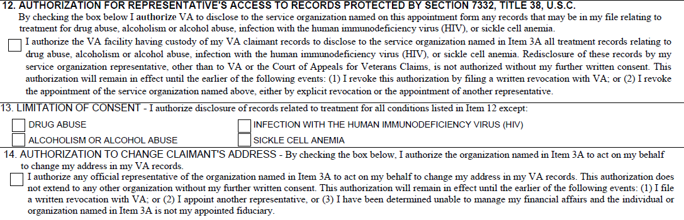

Blocks 9-11 of VA Form 21-22a

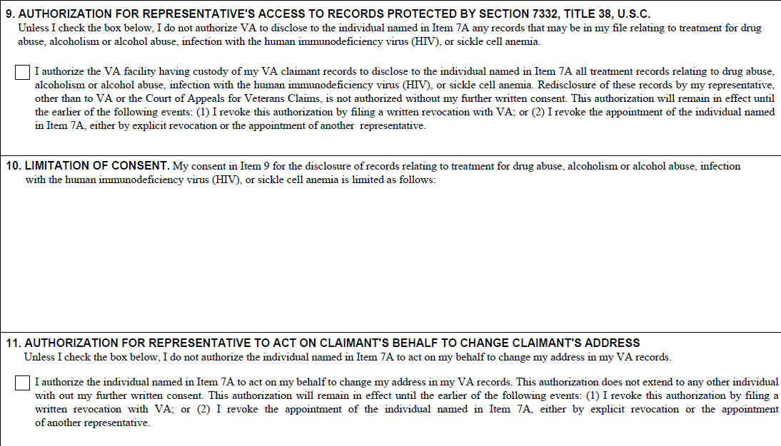

Block 12 on the VA form 21-22 or Block 9 on the VA Form 21-22a: When this box is checked the claimant is authorizing the representative access to protected records related to drug abuse, alcoholism or alcohol abuse, infection with the human immunodeficiency virus (HIV), or sickle cell anemia.

Block 13 on the VA form 21-22 or Block 10 on the VA Form 21-22a: If one or more box is checked on the 21-22 or a condition is listed on the 21-22a the claimant is limiting disclosure of the records related to that condition.

Note:

* If the block in box 12 is NOT checked, or if any box in block 13 IS checked on VA Form 21-22 you cannot allow access to VBMS for the POA.
* If Block 9 is NOT checked, or if there is anything listed in Block 10 on the VA Form 21-22a limiting consent you cannot allow access to VBMS for the POA.

Block 14 on the VA form 21-22 or Block 11 on the VA Form 21-22a: If this block is checked the claimant is authorizing the POA to change the address on the claimant’s behalf. This is also known as “CADD Authorization”

CADD updates are done during a PIF change within the SHARE application.

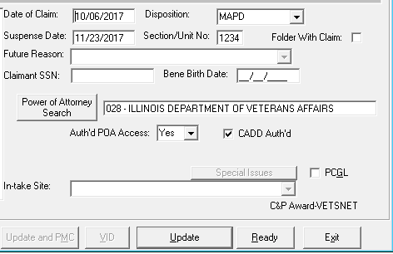



How to Process VA Form 21-22 and VA Form 21-22a

When in receipt of VA Form 21-22 or VA Form 21-22a, and before updating VBMS or SHARE, you must ensure the form is complete and current.

In order for the [VA Form 21-22](http://www.vba.va.gov/pubs/forms/VBA-21-22-ARE.pdf) to be considered complete, it must contain the following information:

* Enough information to identify the Veteran/claimant
* The name of the service organization,
* Signature of the Veteran/claimant with a corresponding date of signature, and
* Signature of the representative acting on behalf of the service organization with a corresponding date of signature.

***Important:*** ROs are required to accept a [***VA Form 21-22***](http://www.vba.va.gov/pubs/forms/VBA-21-22-ARE.pdf) with or without the VSO's signature if received between June 19, 2012 (the date the first revision of the form containing a VSO signature block was released to the public), and April 21, 2013 (the date the first revision of the form containing the VSO signature block was made available in SEP/VDC).

In order for the [VA Form 21-22a](http://www.vba.va.gov/pubs/forms/VBA-21-22a-ARE.pdf) to be considered complete, it must contain the following information:

* Enough information to identify the Veteran/claimant,
* The name of the individual appointed as the Veteran/claimant’s representative,
* Identification of the type of representation
  + attorney, agent, individual providing representation under section 14.630 (claimant and representative signatures and the address of the representative must be provided), or an *individual representative* of a service organization
* Signature of the Veteran/claimant with a corresponding date of signature, and signature of the individual providing representation on a one time basis, representative of an accredited veteran’s service organization, agent, or attorney with a corresponding date of signature.

Assume representation by an accredited representative of a service organization, agent, or attorney is unlimited, meaning the representative represents the claimant for all VA claims, unless VA Form 21-22, VA Form 21-22a, or the declaration of representation shows otherwise. A declaration of representation by a non-accredited individual per the provisions of [38 CFR 14.630](http://www.ecfr.gov/cgi-bin/text-idx?SID=416f8761b1794582fb3ab81547dec7ec&node=se38.1.14_1630&rgn=div8) is limited to one claim by its very nature.

***Important:*** A limited declaration of representation does not automatically terminate or revoke an unlimited declaration held by another party.

***Important:*** Due to a technical issue, [VA Forms 21-22](http://www.vba.va.gov/pubs/forms/VBA-21-22-ARE.pdf) submitted through SEP/VDC between March 22, 2015, and May 3, 2015, do not show an electronic signature from the Veteran. The forms without an electronic signature from this period remain valid for VA purposes.

**Outdated Forms**

VA ***can*** accept older versions of [*VA Form 21-*22](http://www.vba.va.gov/pubs/forms/VBA-21-22-ARE.pdf) until depletion of existing stock in accordance with [M21-1, Part III, Subpart ii, 1.C](https://vaww.vrm.km.va.gov/system/templates/selfservice/va_kanew/help/agent/locale/en-US/portal/554400000001034/content/554400000014112/M21-1,-Part-III,-Subpart-ii,-Chapter-1,-Section-C---Initial-Screening-Policies)

An outdated 21-22 can be accepted under the following guidelines.

* when generated through a VA electronic claims submission system
* at any time when submitted by an authorized VSO representative whether submitted electronically or via paper
* for 12 months after a revision of a form if not submitted by a VSO representative
* Acceptable versions of VA Form 21-22 include boxes to limit access to sensitive records under 38 U.S. Code 7332 and a box to authorize the POA to change the claimant’s address. The form must also be signed by the veteran and POA. If the outdated form does not contain this information the form is not considered complete.

If an outdated 21-22 is received follow the guidance in M21-1, Part III, Subpart ii, 3.C

* Send a development letter requesting completion of the current version of the [*VA Form 21-22*](http://www.vba.va.gov/pubs/forms/VBA-21-22-ARE.pdf) or [*VA Form 21-22a*](http://www.vba.va.gov/pubs/forms/VBA-21-22a-ARE.pdf)
  + provide the current version of the form for completion, and
  + return the outdated form.

**Updating Systems**

Once a complete [VA Form 21-22](http://www.vba.va.gov/pubs/forms/VBA-21-22-ARE.pdf) or [VA Form 21-22a](http://www.vba.va.gov/pubs/forms/VBA-21-22a-ARE.pdf) in a version date that we are able to accept has been received, follow the steps in the table below to update the appointment of a representative.

The following system updates are required when a claimant appoints a new representative or revokes a current representative:

* SHARE
* update the Beneficiary Identification and Records Locator Subsystem (BIRLS)
* perform a pending issue file (PIF) update to provide POA
  + access to the eFolder, and
  + change of address authority.
* Veterans Appeals Control and Locator System (VACOLS) (if there is an active appeal pending at the RO).

***Note***:  If the only update needed is POA access to the eFolder, this can be performed through VBMS, as described in [M21-1, Part III, Subpart ii, Chapter 3, Section C](https://vaww.vrm.km.va.gov/system/templates/selfservice/va_kanew/help/agent/locale/en-US/portal/554400000001034/content/554400000014125/M21-1-Part-III-Subpart-ii-Chapter-3-Section-C-System-Updates).

**Updating BIRLS**

| **Step** | **Action** |
| --- | --- |
| 1 | Open the claimant’s profile by opening SHARE and   * selecting the BIRLS UPDATE command * entering the claimant’s claims folder number in the FILE NUMBER OR SSN field, and * selecting SUBMIT. |

|  |  |  |  |  |  |  |  |  |  |
| --- | --- | --- | --- | --- | --- | --- | --- | --- | --- |
| 2 | Review the POWER OF ATTORNEY field and determine if the POA needs to be updated in BIRLS.     | **If an update is ...** | **Then ...** | | --- | --- | | needed | * use the LOCATE field under the POWER OF ATTORNEY SEARCH to find the POA * select the POA * select UPDATE * perform the PIF INQUIRY command, and * proceed to Step 4 if there are any active EPs.  They will require additional steps to reflect the POA update.   ***Note***:  Proceed directly to Step 5 if there are no active EPs, or the active EPs do not need a POA update. | | needed but the POA could not be located in the POWER OF ATTORNEY SEARCH | proceed to the next step. | | not needed | * select CANCEL * perform the PIF INQUIRY command, and * proceed to Step 4 if there are any active EPs.  They will require additional steps to reflect the POA update.   ***Note***:  Proceed directly to Step 5 if there are no active EPs, or the active EPs do not need a POA update. | |

|  |  |  |  |  |  |  |  |
| --- | --- | --- | --- | --- | --- | --- | --- |
| 3 | Locate the POA using the [**Office of General Counsel (OGC) Accreditation Search**](http://www.va.gov/ogc/apps/accreditation/index.asp).   | **If the POA was ...** | **Then ...** | | --- | --- | | found | * select POWER OF ATTORNEY SEARCH * select POA code 099 in the LOCATE field * select UPDATE * follow the procedure in [M21-1, Part III, Subpart ii, Chapter 3, Section C](https://vaww.vrm.km.va.gov/system/templates/selfservice/va_kanew/help/agent/locale/en-US/portal/554400000001034/content/554400000014125/M21-1-Part-III-Subpart-ii-Chapter-3-Section-C-System-Updates) to have the POA added to the corporate database * add a VBMS or MAP-D note explaining the situation and actions taken, and * proceed to the next step. | | not found | * add a VBMS or MAP-D note explaining why the POA could not be updated, and * forward the information to the Agent and Attorney Fee Coordinator (AAFC) for follow-up with the POA.  No further action is required. | |
| 4 | Follow the steps in the table below to update the POA on a pending EP.   | **Step** | **Action** | | --- | --- | | 1 | Make note of specific EP(s) and claim label(s) of any active EP(s) pending after performing the PIF INQUIRY command. | | 2 | Select the PIF CHANGE command and complete the following fields based on the pending EP:   * BENEFIT TYPE * PAYEE NUMBER, and * CLAIM TYPE. | | 4 | Update the POA using the POWER OF ATTORNEY SEARCH command to locate the POA code and select UPDATE. | | 5 | Update the AUTH’D POA ACCESS drop-down to grant or deny POA access to the claims folder based on the guidance provided in [M21-1, Part III, Subpart ii, 3.C](https://vaww.vrm.km.va.gov/system/templates/selfservice/va_kanew/help/agent/locale/en-US/portal/554400000001034/content/554400000014125/M21-1-Part-III-Subpart-ii-Chapter-3-Section-C-System-Updates?query=private%20attorney#5d). | | 6 | Checkmark the CADD AUTH’D radio button to allow a POA to change the claimant’s address if the   * Authorization to Change Claimant’s Address box on [VA Form 21-22](http://www.vba.va.gov/pubs/forms/VBA-21-22-ARE.pdf), or * Authorization for Representative to Act on Claimant’s Behalf to Change Claimant’s Address box on [VA Form 21-22a](http://www.vba.va.gov/pubs/forms/VBA-21-22a-ARE.pdf) is marked. | | 7 | Select UPDATE. | |
| 5 | Determine if the POA is a private attorney or agent.    Notify the AAFC that the appointment should be reviewed for fee agreements or additional development if the POA is identified as a private attorney or agent.  Otherwise, no further action is needed. |

**Updating a Pending Issue File (PIF)**

|  |  |  |  |  |  |  |  |  |  |  |  |  |  |  |  |  |
| --- | --- | --- | --- | --- | --- | --- | --- | --- | --- | --- | --- | --- | --- | --- | --- | --- |
| | **Step** | **Action** | | --- | --- | | 1 | Make note of specific EP(s) and claim label(s) of any active EP(s) pending after performing the PIF INQUIRY command. | | 2 | Select the PIF CHANGE command and complete the following fields based on the pending EP:   * BENEFIT TYPE * PAYEE NUMBER, and * CLAIM TYPE. | | 4 | Update the POA using the POWER OF ATTORNEY SEARCH command to locate the POA code and select UPDATE. | | 5 | Update the AUTH’D POA ACCESS drop-down to grant or deny POA access to the claims folder based on the guidance provided in [M21-1, Part III, Subpart ii, Chapter 3, Section C](https://vaww.vrm.km.va.gov/system/templates/selfservice/va_kanew/help/agent/locale/en-US/portal/554400000001034/content/554400000014125/M21-1-Part-III-Subpart-ii-Chapter-3-Section-C-System-Updates). | | 6 | Checkmark the CADD AUTH’D radio button to allow a POA to change the claimant’s address if the   * *Authorization to Change Claimant’s Address* box on [***VA Form 21-22***](http://www.vba.va.gov/pubs/forms/VBA-21-22-ARE.pdf)*,* or * *Authorization for Representative to Act on Claimant’s Behalf to Change Claimant’s Address* box on [***VA Form 21-22a***](http://www.vba.va.gov/pubs/forms/VBA-21-22a-ARE.pdf) is marked. | | 7 | Select UPDATE. | | 8 | Determine if the POA is a private attorney or agent.    Notify the AAFC that the appointment should be reviewed for fee agreements or additional development if | |

Under the **PIF change** function in SHARE – input Veteran as 00 and EP with proper Claim Type.

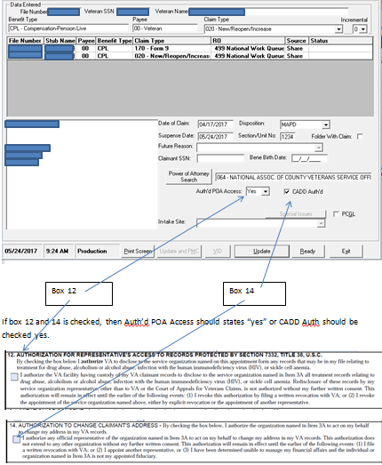

If box 12 and 14 is checked, then Auth’d POA Access should states “yes” and CADD Auth should be checked yes.

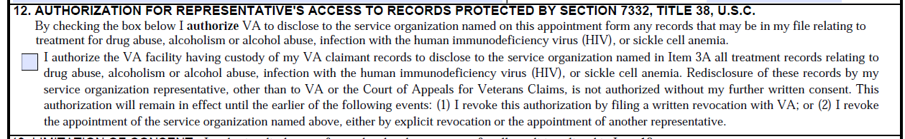

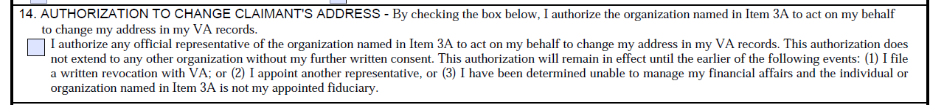

In SHARE under Corporate Update on the “All Relationships”, click “POA History”.

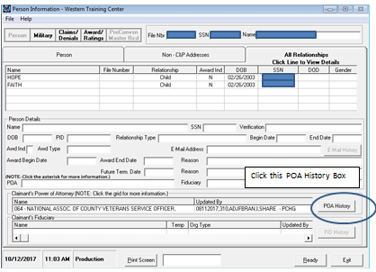

The table will expand to show the Auth’d POA Access and CADD Auth’d field. Ensure these two areas accurately reflect Box 12 and Box 14 on the VA Form 21-22.

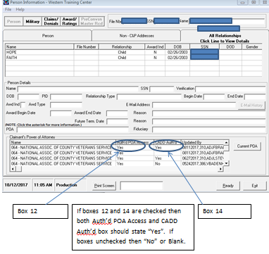

**Updating VACOLS**

To update the POA in VACOLS, see the [***VACOLS User Guide***](http://vbaw.vba.va.gov/bl/21/publicat/Users/Index.htm#bmv),.

Exclusive Contact

What is Exclusive Contact?

The term exclusive contact refers to sending communications with the claimant directly to a representative and generally not communicating directly with the claimant. *** VA no longer honors requests for exclusive contact to restrict the communication between VA and the claimant.

Processing a Request for Exclusive Contact

In any case where an attorney requests exclusive contact in writing, send the attorney a letter incorporating the following notice:

*We are unable to comply with your request that we correspond exclusively with you and not with the VA claimant you represent.*

*While VA has attempted in the past to accommodate exclusive contact requests, the agency has found that our attempts to comply with these requests adversely impacted the timely completion of essential ministerial functions, such as responding to phone inquiries from claimants and the issuance of standard benefit information letters. Rather, as required by regulatory and statutory provisions, we have determined that corresponding directly with the VA claimant with a copy of each and every communication to the representative is the best means for keeping all interested persons up-to-date about VA’s actions regarding a particular claimant. This course of action is consistent with the non-adversarial nature of the VA benefits adjudication system and with VA statutes and regulations.*

*To this end, section 5104(a) of title 38, United States Code, and its implementing regulation, 38 C.F.R. § 3.103, provide that VA must send notice of any decision to the claimant with a copy to the claimant's representative. VA statutes and regulations do not require a process whereby VA maintains "exclusive contact" with a representative in lieu of the VA claimant. At the same time, despite any request for exclusive contact with a representative, VA has always sent automatically generated correspondence to VA claimants and has responded to claimants who seek information directly from VA. As a result of our careful review of relevant VA statutes, regulations and procedures, we have determined that prohibiting claimants from receiving information, any information, about their claims, or limiting it in some fashion, is not a process that is beneficial to Veterans, their dependents or survivors. We can assure you, however, that as long as you represent a VA claimant, you will be sent copies of any and all notices, decisions or other written communications at the same time as the claimant is sent such notice, decision or communication.*

Revoking and Terminating Representation

The relationship between a claimant and a POA can be revoked or terminated by either party.

* A claimant, claimant’s guardian, or VA fiduciary may revoke or terminate his/her relationship with a representative at any time by informing VA.
* A representative may revoke or terminate the representation by notifying the claimant and VA in writing, if doing so would not adversely impact the claimant’s interests.
  + **Note:** If the Board of Veterans’ Appeals (BVA) has jurisdiction over the claims folder, the representative must obtain permission from BVA to revoke or terminate his/her representation.
* Representation is automatically revoked if
  + a new unlimited declaration of representation is received, or
  + the claimant dies.

VA must notify the representative of the withdrawal of representation by sending them a copy of the annotated declaration of representation. This applies to declarations of representation in both paper claims folders and eFolders.

When Paper Copies of Notification Letters MUST be Mailed to the POA

The representative/POA is to be furnished copies of all correspondence sent to the claimant when no restrictions are noted on the appointment form.

* VSOs with eFolder access will review documents in the eFolder and do not require paper copies of correspondence.

* VSOs (with restricted access shown on VA Form 21-22), Non-licensed individuals (representing claimants under 38 CFR 14.630), Attorneys, and Agents will be mailed paper copies of correspondence not addressing restricted issues if they do not have access to view eFolders. **Please note most non-VSO representatives do not normally have eFolder access.**

Unless representation is limited by the claimant, power of attorney (POA) representatives are entitled to notice of any VA decisions affecting the payment of benefits or relief sought by claimants whom they represent. Representatives also must receive other forms of correspondence sent to claimants. These include:

* decision notices
* statements of the case and supplemental statements of the case
* notice of certification and transfer of appeals to the Board of Veterans’ Appeals (BVA)
* intent to file a claim notices
* incomplete application notices, and
* requests for information and evidence needed to substantiate a claim (e.g. development letters).

When RO personnel generate correspondence associated with a claimant represented by a private attorney or claims agent, they must include the address of the private attorney or claims agent in the carbon copy (cc) line of the correspondence.

* Including the full address in the cc line will allow mail processors to quickly and accurately address outgoing private attorney or claims agent copies of correspondence.

Best Practice Tips to ensure POAs are properly notified:

1. Always double check the VAF 21-22/21-22a prior to finalizing any correspondence to avoid missing correspondence
2. Use a “Working Notes” bookmark in VBMS to indicate the *POA must receive paper copies of correspondence*
3. Use the subject line in VBMS to indicate that correspondence has been mailed
4. When in doubt – refer to M21-1 Part I, 3.B for clarification

Attachment A: VA Form 21-22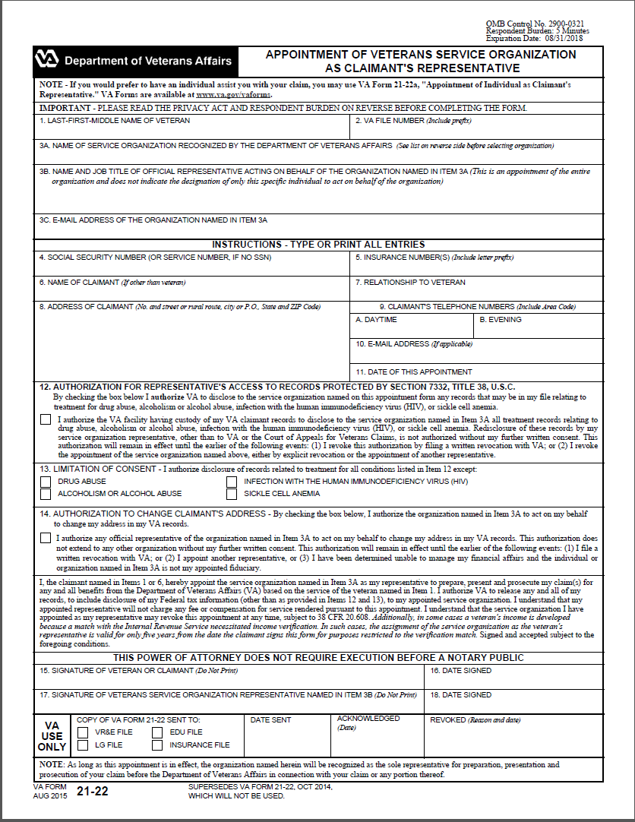

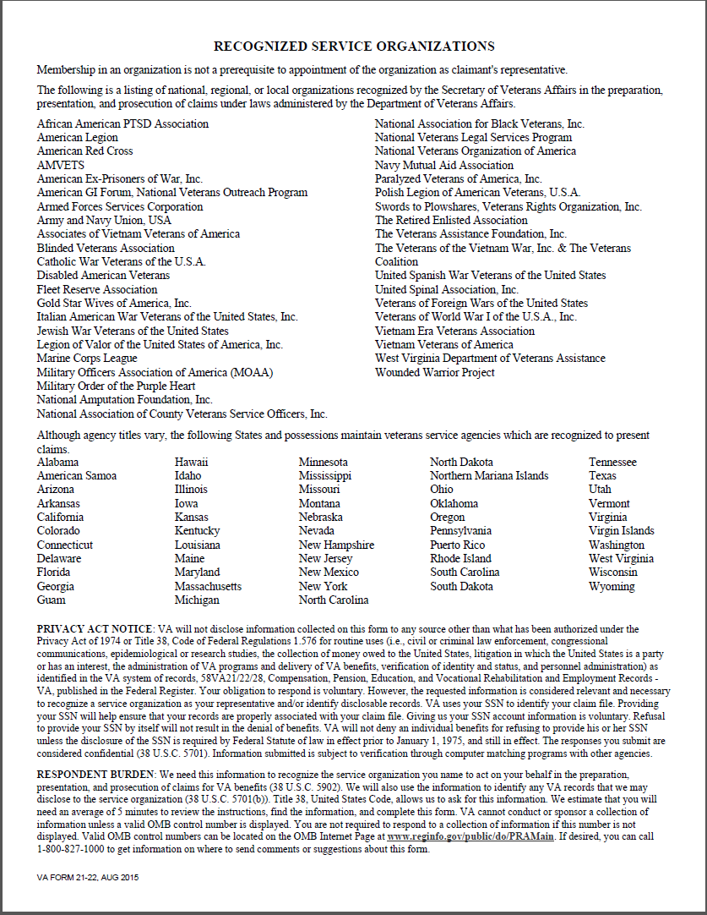

Attachment B: VA Form 21-22a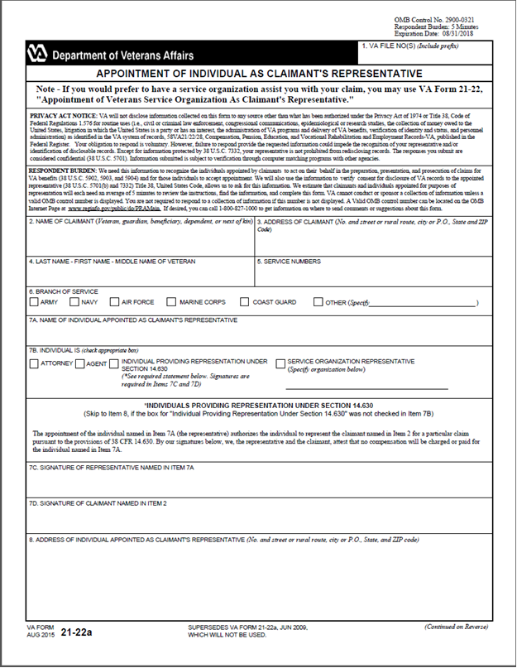

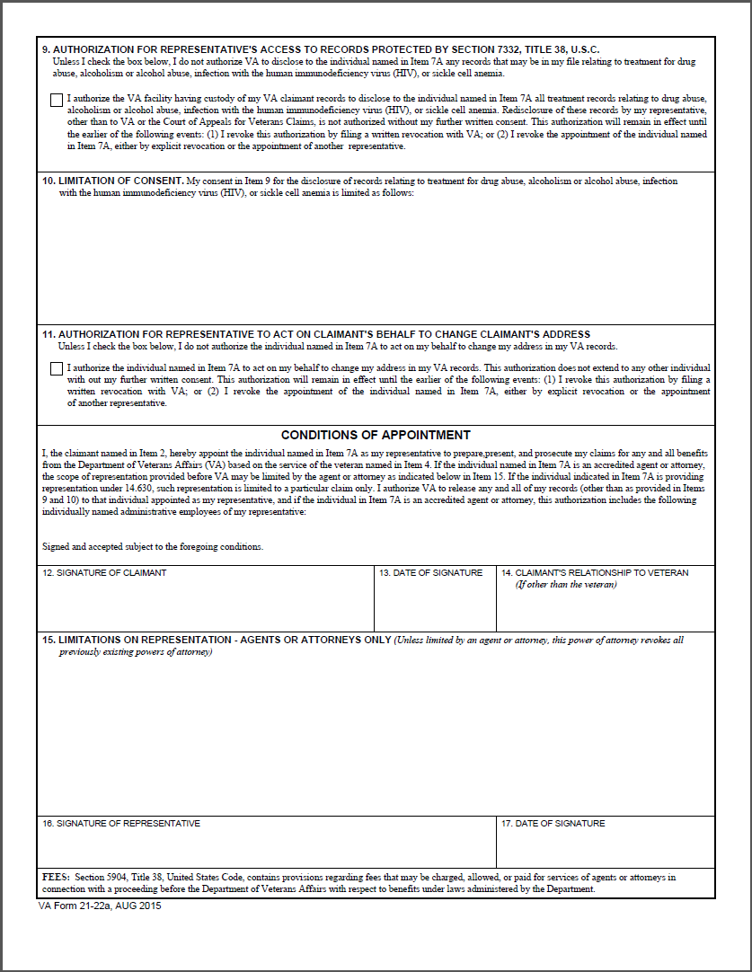

Attachment C: National Organization POA Codes

|  |  |
| --- | --- |
| **POA Code** | **National Organization Name** |
| A21 | Military Officers Association of America |
| 00V | The Wounded Warrior Project |
| 007 | The Retired Enlisted Association |
| 011 | Associates of Vietnam Veterans of America |
| 012 | Gold Star Wives of America, Inc. |
| 024 | National Amputation Foundation, Inc. |
| 029 | Vietnam Era Veterans Association |
| 043 | Swords to Plowshares, Veterans Rights Organization, Inc. |
| 062 | Non-commissioned Officers Association of the U.S.A. |
| 064 | National Association of County Veterans Service Officers |
| 065 | American Ex-Prisoners of War, Inc. |
| 068 | American GI Forum, National Veterans Outreach Program |
| 070 | Vietnam Veterans of America |
| 071 | Paralyzed Veterans of America, Inc. |
| 074 | American Legion |
| 075 | American Red Cross |
| 077 | American Veterans/AMVETS |
| 078 | Armed Forces Services Corporation |
| 079 | Army and Navy Union, USA |
| 080 | Blinded Veterans Association |
| 081 | Catholic War Veterans of the U.S.A. |
| 082 | National Veterans Legal Services Program |
| 083 | Disabled American Veterans |
| 084 | National Association for Black Veterans, Inc. |
| 085 | Fleet Reserve Association |
| 086 | Jewish War Veterans of the United States |
| 087 | Legion of Valor of the United States of America, Inc. |
| 088 | Marine Corps League |
| 089 | Military Order of the Purple Heart |
| 090 | United Spinal Association, Inc. |
| 091 | African American PTSD Association |
| 092 | The Veterans of the Vietnam War, Inc. & The Veterans Coalition |
| 093 | Navy Mutual Aid Association |
| 094 | National Veterans Organization of America |
| 095 | Italian American War Veterans of the United States, Inc. |
| 096 | United Spanish War Veterans of the United States |
| 097 | Veterans of Foreign Wars of the United States |
| 098 | Veterans of World War I of the U.S.A., Inc. |

Attachment D: State Organizations POA Codes

| State | State Organization Name | POA Code |
| --- | --- | --- |
| Alabama | Department of Veterans Affairs | 022 |
| American Samoa | Veterans Affairs Office | 067 |
| Arizona | Veterans Service Commission | 045 |
| Arkansas | Department of Veterans Affairs | 050 |
| California | Department of Veterans Affairs | 044 |
| Colorado | Division of Veterans Affairs | 039 |
| Connecticut | Department of Veterans' Affairs | 008 |
| Delaware | Commission of Veterans Affairs | 060 |
| Florida | Department of Veterans Affairs | 017 |
| Georgia | Department of Veterans Service | 016 |
| Guam | Office of Veterans Affairs | 056 |
| Hawaii | Office of Veterans Services | 059 |
| Idaho | Division of Veterans Services | 047 |
| Illinois | Department of Veterans Affairs | 028 |
| Iowa | Department of Veterans Affairs | 033 |
| Kansas | Commission on Veterans Affairs | 052 |
| Kentucky | Center for Veterans Affairs | 027 |
| Louisiana | Department of Veterans' Affairs | 021 |
| Maine | Department of Veterans Services | 002 |
| Maryland | Veterans' Service Commission | 013 |
| Massachusetts | Department of Veterans Service | 001 |
| Michigan | Michigan Veterans Affairs Agency | 8FE |
| Minnesota | Department of Veterans Affairs | 035 |
| Mississippi | Veterans Affairs Board | 023 |
| Missouri | Veterans Commission | 031 |
| Montana | Veterans Affairs Division | 036 |
| Nebraska | Department of Veterans' Affairs | 034 |
| Nevada | Commission for Veterans Affairs | 054 |
| New Hampshire | State Veterans Council | 073 |
| New Jersey | Department of Military and Veterans' Affairs | 009 |
| New Mexico | Veterans' Service Commission | 040 |
| New York | Division of Veterans' Affairs | 006 |
| Northern Mariana Islands | Veterans Affairs Office | 053 |
| North Carolina | Division of Veterans Affairs | 018 |
| North Dakota | Department of Veterans Affairs | 037 |
| Ohio | Department of Veterans Services | 025 |
| Oklahoma | Department of Veterans Affairs | 051 |

| State | State Organization Name | POA Code |
| --- | --- | --- |
| Oregon | Department of Veterans' Affairs | 048 |
| Pennsylvania | Department of Military Affairs Bureau for Veterans Affairs | 010 |
| Puerto Rico | Public Advocate for Veterans Affairs | 055 |
| Rhode Island | Division of Veterans Affairs | 004 |
| South Carolina | Division of Veterans Affairs | 019 |
| South Dakota | Division of Veterans Affairs | 038 |
| Tennessee | Department of Veterans' Affairs | 020 |
| Texas | Veterans Commission | 049 |
| Utah | Office of Veterans Affairs | 041 |
| Vermont | Veterans Affairs Section, Military Department | 005 |
| Virgin Islands | Office of Veterans Affairs | 032 |
| Virginia | Department of Veterans Affairs | 014 |
| Washington | Department of Veterans Affairs | 046 |
| West Virginia | Department of Veterans Assistance | 015 |
| Wisconsin | Department of Veterans Affairs | 030 |
| Wyoming | Wyoming Veterans Affairs Commission | 869 |

Attachment E: Topic 2 Exercise

**Instructions:** Circle the VA Form number that would be used to request a POA for each type of POA listed below.

|  |  |
| --- | --- |
| **Type of POA** | **VA Form (circle one)** |
| Agent | 21-22 / 21-22a |
| Attorney | 21-22 / 21-22a |
| Veterans Service Organization | 21-22 / 21-22a |
| Non-licensed individual | 21-22 / 21-22a |

Practical Exercise

**Instructions:** Read through the following scenarios and select the correct answer.

**Scenario 1**

You receive a VA Form 21-22a from claimant, Kyle Albright. This is a limited declaration for representation, for the appeal issue only, related to processing an appeal on an award for compensation benefits. The representative on the request is identified as Carlos Medina, an agent. Upon review of Mr. Albright’s file, you see he already has an unlimited declaration of representation on file with the VFW listed as his representative. You see that the VFW represented Mr. Albright on the original decision is now being appealed. Neither declaration limits access to documents under 38 USC 7332.

1. What actions do you take to file the VA Form 21-22a requesting Carlos Medina as the agent to represent this appeal?
2. How does the new request for representation affect the existing POA with the VFW?
3. When correspondence is sent to the Veteran for the appeal issue which additional action must be taken with respect to Mr. Medina?
4. When correspondence is sent to the Veteran for claims other than the appeal issue, which additional action must be taken with respect to VFW?

**Scenario 2**

You receive a request for Exclusive Contact from Martin Ringer, an attorney, relating to the case file for a Veteran, Vanessa Muldrow. A review of Ms. Muldrow’s file indicates she has applied for compensation benefits and the rating is pending. You also see Martin Ringer is listed as her representative and the VA Form 21-22a has been filed appropriately in her claims folder.

1. How did you determine the VA Form 21-22a for Martin Ringer had been filed appropriately?
2. What consideration(s) do you need to take into account regarding the fact that Ms. Muldrow is being represented by an attorney?
3. What consideration(s) do you need to take into account regarding the request for Exclusive Contact?

**Scenario 3**

You receive a VA Form 21-22 from claimant Ben Freindly. The representative on the request is identified as Dan Benson, a VSO for DAV. Upon review of Mr. Albright’s file, you see he already has an unlimited declaration of representation on file with the New York State Division of Veterans' Affairs listed as his representative. The declaration limits access to documents under 38 USC 7332.

1. What POA code will you use when you update VBMS?
2. How does a new request for representation affect the existing POA with New York State?
3. When correspondence is sent to the Veteran for claimed issues what additional action must be taken with respect to DAV.