RECORDS MANAGEMENT
Trainee Handouts

PREREQUISITE TRAINING | Prior to this training you must have completed VSR prerequisite lessons on MAP-D, Share, and the C&P Publications Page.
PURPOSE OF LESSON | The purpose of this lesson is to teach you the process of reviewing a file to determine if records are required to adjudicate the claim and how to request the required records.  At the completion of this training (provided with the appropriate manual and regulatory references, and handouts) you will be able to:  - Identify the three types of service records and describe how to retrieve them  - Identify the different types of VA treatment records and describe how to retrieve them  - Identify the two categories of non-federal records and describe how to retrieve them.
Time Required | 1 hour 30 minutes classroom; 30 minutes review exercise
Instructional Method | Participatory discussion and practical exercise
Materials/ Training Aids | - Records Management Trainee Handouts  - Records Management PowerPoint Presentation

Table of Contents

References 3
Service Treatment Records 4
BIRLS LOC Screen 5
Records Management Center Service Treatment Record Requests 6
Sample of Reserve or National Guard Letter 7
MILITARY ACADEMIES 8
Records management 9
Review Exercise 9

References

38 CFR 3.159
M21-1MR III.iii.1.C.13 & 14
M21-1MR III.iii.2
M21-1MR IV.ii.1.A
PIES Participant Guide
CAPRI Users Guide
Share Users Guide

Service Treatment Records

Current Workflow of Incoming Service Treatment Records
At the Records Management Center

References: | PIES Participant Guide  M21-1MR III.iii.2

BIRLS LOC Screen

Reference: Share Users Guide, Page 18

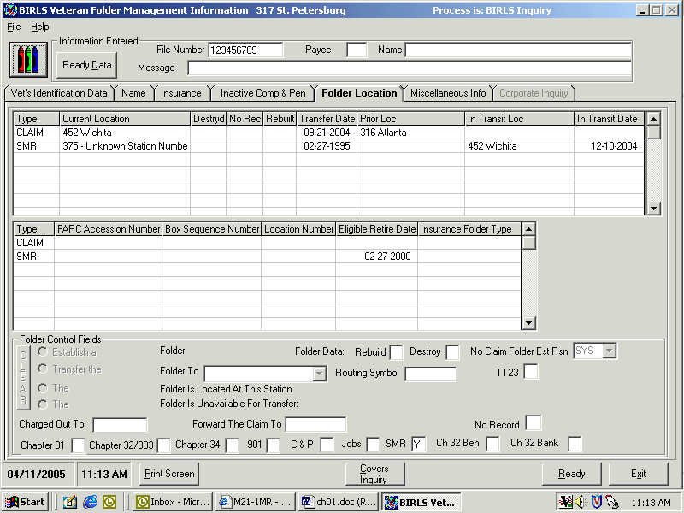

Records Management Center Service Treatment Record Requests

Sample of Reserve or National Guard Letter
Development Letter for Records Expected to be in the Custody of the Reserves or National Guard
 | In Reply Refer To:
Reserve Unit  National Guard | XXX/21XXX  VA file number  VETERAN’S LAST NAME, First Name  Veteran’s Social Security No.  Veteran’s Date of Birth
To Whom It May Concern:
We have received a claim for benefits from the veteran named above. We have information that this veteran is or was assigned to your unit. This letter requests copies of any service records which you may have, or information about the location of these records.
What We Need
Before we can process the claim, we must try to obtain information from the veteran’s service records. We would appreciate your forwarding the information listed below:
- A copy of all physical examinations, to include the EOD and RAD examinations, if available.
- A complete copy of all service medical treatment records of the veteran.
- A copy of any line of duty determinations which may have been made because of any injury.
- Verification of all periods of service. Show which dates are active duty and which are active duty for training. Provide the character of service for any period of active duty.
If You Do Not Have Service Records
If you do not have this veteran’s service records, we would appreciate any information you may have that will help us locate them. If known, please provide the name and complete mailing address of the organization which does have these records. If you transferred the service records to another organization, please provide the date when the records were transferred.
Your prompt attention to this matter will be appreciated.
This letter is being sent in duplicate so that you may retain a copy. Attach the other copy of our letter to your reply to ensure proper identification.
Sincerely yours,
Veterans Service Center Manager
Enclosure

MILITARY ACADEMIES

In your letter to all of the academies please provide the following information:
Name
Social Security Number
Date of Birth
Dates of attendance or at least the date of graduation (if known).

Note: You can usually get this information off the DD214 for active service. The date of entry is the date they graduate or take their oath of office. Per someone at the Academy, the date or even year is really all they need.

Records management
Review Exercise

Please complete the following review questions. You may use your reference material.
Allow 1 hour to complete the exercise and discuss the answers.

- List the three major types of service records.

- What are the two main facilities that house service records?

- What is the manual reference that deals with developing for service records?

- Under whose jurisdiction does the NPRC fall?

- True or False? The NPRC only stores records for VA.

- Under whose jurisdiction does the RMC fall?

- Generally speaking, where are service members’ service treatment records automatically sent upon their discharge?

- As a VSR if you wanted to know if the RMC has a service treatment record file for a veteran, where would you look?

- True or False? Station locations 375, 376, St. Louis RMC, RPC and SMRC are all the same facility.

- A completed PIES request is sent to what facility?

- When requesting financial records from Finance Centers, what must the VSR do to the PIES request to ensure the request goes to the correct location?

- Can you submit a request for financial information on the same PIES request that you are submitting for service and medical information?

- Refer to your answer to question #12. Why or why not?

- Do the service treatment records routinely contain inpatient treatment records (clinical)?

- True or False? If a Regional Office establishes a claim through Share, and a claims folder exists at 376, the claims folder will automatically be sent to the Regional Office.

- True or False? If a Regional Office establishes a clams folder through BIRLS when establishing an end product and the service treatment records are located at the RMC, then the service treatment records will automatically be sent to the Regional Office.

- Who is ultimately responsible for obtaining private treatment records?

- True or False? The “in-transit date” on the BIRLS LOC screen is the date the files left the RMC.

- What is the system used to request treatment records from a VA Hospital?

- If records cannot be retrieved from a VA facility using that system, what form is used to make the request?

- List five categories of VA medical records.

- What does the acronym HIPAA stand for?

- What is a VA Form 21-4142?

- When is this form used?

- True or False? VA will pay for copies of private treatment records.

