DPRIS Web
(Defense Personnel Records Information Retrieval System)
Manager Handout
Trainee Handout

Table of Contents

Objectives 2
References 3
DPRIS Web Advantages 4
Using Dpris Web 14
Account Management 24
DPRIS Web Help 39

Objectives
- Given the instructor’s lecture, class discussions, and practical exercises, you will:
- Become familiar with DPRIS Website,
- Understand your role and responsibilities as a DPRIS Web Manager,
- Become a registered user of DPRIS Web,
- Become familiar with how you can submit requests and review responses using DPRIS Web,
- Know how to manage user accounts, and
- Know how to request assistance if needed.
References

DPRIS Website User Guide

DPRIS Web Advantages

The Defense Personnel Records Information Retrieval System (DPRIS) Website provides authorized users with access to digital electronic images to Official Military Personnel Files (OMPF). DPRIS Web is now the primary Internet portal supporting external electronic access by authorized government agencies to any of the military services’ digital OMPF repositories. In the past, information from these records was typically provided via hardcopy, with requests for information and responses to such requests mailed through the U.S. Postal Service. Regardless of the form in which the information is obtained, all users are required by law to safeguard the information contained in the OMPF, as directed by the Privacy Act of 1974 and HIPAA. Some advantages of DPRIS Web over other systems include:

- Through a single secure internet sign-on, allows access to OMPF images contained in the military services’ repositories,
- On average, images are received in less than 48 hours,
- Many images are received within minutes,
- Provides a standard index of all images contained in each of the Services’ OMPF systems,
- Includes a Follow-up Message capability. This enables the user to gain additional information directly from the Services’ action officer (except Army).

VA-Services Interface

Without DPRIS Web, submitting a request to a service’s image repository would be much more cumbersome. If you needed images from the Army’s image repository, for example, you would have to log into the repository, submit the request, and then log out. At some point later on, you would have to go back to see if the request for images has been processed, and if so, then download the images. You would have to do this for each military service’s repository (Army, Navy, Air Force, or Marines). Therefore, you would have to maintain several separate log-ons.
In addition, if one of the Services needed to change some of the programming for their record system, VA would possibly need to change their programming to ensure users would have continued access. VA would have to do this every time for a military service that changed the programming to their personnel records system. This would result in delays in retrieving images from these repositories, which is not an efficient way to conduct business. This is why the Office of the Under Secretary of Defense, Personnel and Readiness Information Management, sponsored the creation of DPRIS Web.
By having DPRIS Web, you will only need to maintain one login in order to submit requests. When you submit the request, DPRIS Web will route the request to the correct image repository. When the image is available for viewing, DPRIS Web will advise you via email.
DPRIS Web standard indexing scheme

Each of the military services manages their OMPF digital records systems differently. Rather than requiring users to learn each indexing system, DPRIS Web has developed a standard index. Each document within the four military services’ OMPF systems has been mapped to the DPRIS Web standard indexing scheme. The complete DPRIS Web Standard OMPF Document Indexing Scheme is depicted in Table 2-1 below. It shows the four major functional document groupings.
Table 2-1. DPRIS Web Standard OMPF Document Indexing Scheme

DPRIS Web Groups and Subgroups
All documents in the digital OMPF inventory can intuitively be assigned to one of the following four major functional groupings:
- Service Computation: Documents that record service entry and discharge, length of service, service agreements, appointments, commissions, statements of cumulative service, and other similar time specific data.
- Performance: Documents that record a service member’s performance including evaluations, fitness reports, effectiveness reports, commendatory or derogatory items, and other performance-specific data.
- Professional History: Documents that record promotions, education, training, chronological listings of assignments, qualifications, and similar historical data.
- Administrative: Documents that record administrative actions or personal information regarding dependents, tuition assistance, medical and dental reports, insurance, and other miscellaneous administrative data.
The Consolidated OMPF Document Mapping Report published July 24, 1998 assigned each of the individual document types contained in the military services’ digital OMPF systems to one or more of the DPRIS Web Standard Index subgroups. Building on this, DPRIS Web can support standard requests and retrieval of OMPF document images from any of the four OMPF systems, by another military service or authorized agency, using a single functional methodology.

PERSONNEL RECORDS AVAILABLE THROUGH DPRIS WEB
Not every Veteran’s OMPF is available through DPRIS Web. There are specific dates associated with each branch of service as to when each branch of service began retaining Veterans’ OMPFS into their imaging system.
The Veteran’s OMPF should be available through DPRIS Web if his/her service obligation ended on or after the following dates:
Army: October 1, 1994*
Navy: January 1, 1995
Marine Corp: January 1, 1999
Air Force: October 01, 2004
There are no Coast Guard records currently available in DPRIS Web.
*Army service that ended between October 1, 1994, and September 30, 2002; OMPFs should be stored electronically as image files in iPerms, and ROs may request copies of them through the Defense Personnel Records Image Retrieval System (DPRIS).
Important: If DPRIS returns a response indicating there is no information for the Veteran; then ROs may request copies of the OMPF through PIES.
National Guard and Reserves Service
When determining if the OMPF records are available through DPRIS Web, you must take Reserves and National Guard duty into consideration as well. The easiest way to think about this is the word obligation. It does not matter if the person served on Active Duty, Reserves, National Guard, or in all three. It is the date of release when there is no further obligation that matters. That is the information you need to consider in your inquiry.
Two Periods of Active Duty Service (before and after DPRIS dates)
Example: The Veteran served in the Marine Corp from 1980 to 1988. The Veteran had no other obligated service after 1988. However, the Veteran reenlisted in 2001 and served on active duty until 2005. Would the Veteran’s OMPF be available through DPRIS Web?
Answer: You would begin your search for the OMPF records by first going to DPRIS Web. The 2001 through 2005 records will be available through DPRIS Web. Also, there may be OMPF images from the 1980 through 1988 period because the Veteran served after December 31, 1997. However, if the records from the first period of service were not part of the imaged OMPF (in this case, the 1980 to 1988 period), then you need to try alternate sources for those particular records.
Note: If the OMPF records for this Veteran’s first period of service were not available through DPRIS Web, than a request for OMPF records should be sent to the National Personnel Records Center (NPRC) through the Personnel Information Exchange System (PIES) application for the first period of service. If the Veteran only served from 1980 to1988, and had no service obligation to, or after, December 31, 1997, then a request for OMPF records should be submitted to NPRC, through the PIES application, and not through DPRIS Web.

ROLES & RESPONSIBILITIES
As a DPRIS Web Manager, there are several roles and responsibilities associated with this assigned duty:
- Communicate with local users, DPRIS Web staff via User Assistance Forms, and Central Office to solve problems.
- Prior to approving each request for access to DPRIS Web, Web Manager must ensure information contained on the registration form is complete and accurate. (Review User ID and email address against information in Outlook.)
- Approve/disapprove Level 3 User access for only individuals that you directly administer.
- Re-set passwords for Level 3 Users that you directly administer.
- Assign DPRIS Web Standard Index subgroup document and DPRIS Web Report access for those Level 3 Users that you directly administer.
- Promptly deactivate any level 3 Users that you directly administer, who no longer require DPRIS Web access in the performance of their duties.
- Review, as warranted, retrieved personnel record information and follow-up exchanges for all agency Authorized Users that you directly administer.
- Initiate secure DPRIS Web follow-up messages.
- Initiate DPRIS Web requests for military personnel records.
- Initiate requests for approved DPRIS Web Standard Reports.
- Manage own personal DPRIS Web user account information.
- Access DPRIS Web Information, Help Website Modules, and submit automated User Requests for assistance using the Assistance Form.

THE REGISTRATION PROCESS

The normal means of entry to the Website is through its home page at https://www.dpris.dod.mil, which includes a public area open to all Internet users. Type in the website address in your browser and hit enter. The DPRIS Web homepage will be displayed. It is recommended that this website address be added to your Favorites list.

DPRIS Web Home Page
In order to register as a DPRIS Web user, click on New Users Registration.
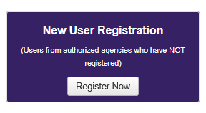

New User Registration

Read the privacy and security statement and click Accept.

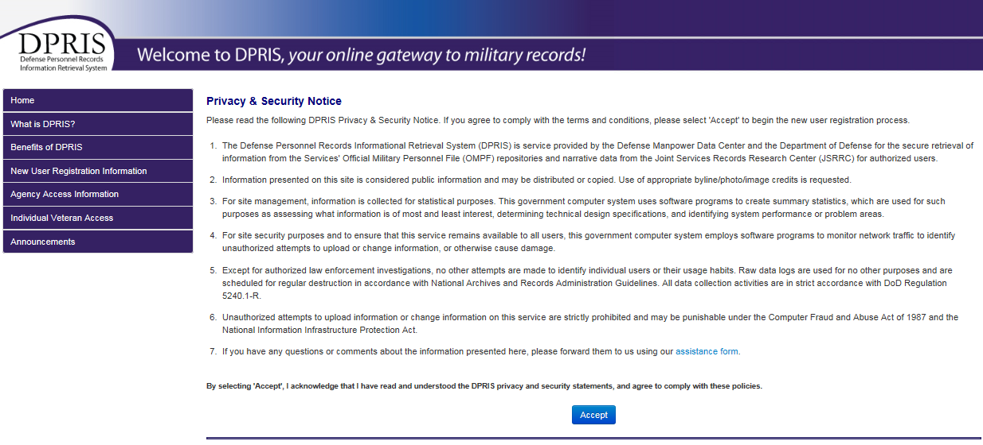

Enter the provided Agency ID.

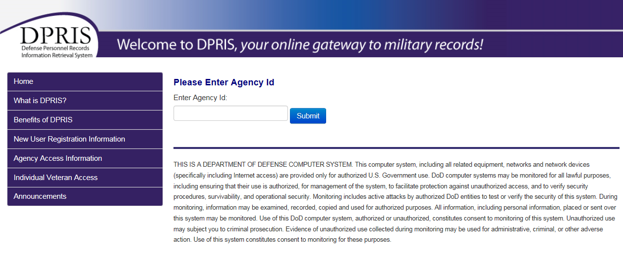

Agency Information
The Agency Identification Code (AIC) will be provided to you prior to attempting registration into DPRIS Web. This Agency Identification Code (AIC) is specific to a regional office. It will not change, and everyone that works at that regional office will use that regional office’s identification code.

Completing the Registration Form

In order to complete the new user registration form (shown below), the first thing is to input personal information. Input your first name and last name (your middle name is optional). Then, input the User ID from the printout of your VA email address. Input a strong password. Confirm the password by inputting it a second time. Then select a secret question using the drop-down menu. Input the answer to the secret question. The answer to the secret question is case sensitive. Remember how you typed in the answer. Input your VA email address. Again, this can be taken directly from the printout of your VA email address. Finally, input your phone number.
For selecting a manager, select your DPRIS Web Super User. Now that the correct DPRIS Web manager has been selected, DPRIS Web automatically populates the fields for name, phone number, email address, the full agency name, and the office code or symbol, if one was entered. These fields are read-only, and cannot be changed by the user when entering information on the registration form. Now that the form has been completed, you just need to click on submit.
Note: The DPRIS Web Super User that was selected will receive an email stating that there is a pending request for access to the DPRIS website. The request will be reviewed. If the request is approved, you will receive an email stating that the account has been approved, and you can simply begin requesting DPRIS OMPF records. If the request is disapproved, you will receive an email stating that the request was disapproved, and an explanation will be provided as to why. You will need to complete the entire registration form again if you receive an email that the registration form was rejected because you selected either the incorrect User ID or the wrong manager.
If the reason for the form being rejected was for any other reason, you can go back to the DPRIS Web homepage and click on New User Registration. Then, select the Pending User link. Log-in as a pending user, and correct the error as indicated in the email. Then, once again, select submit. The DPRIS Web Super User that was selected will get an email advising that there is new user registration forms awaiting his/her review.

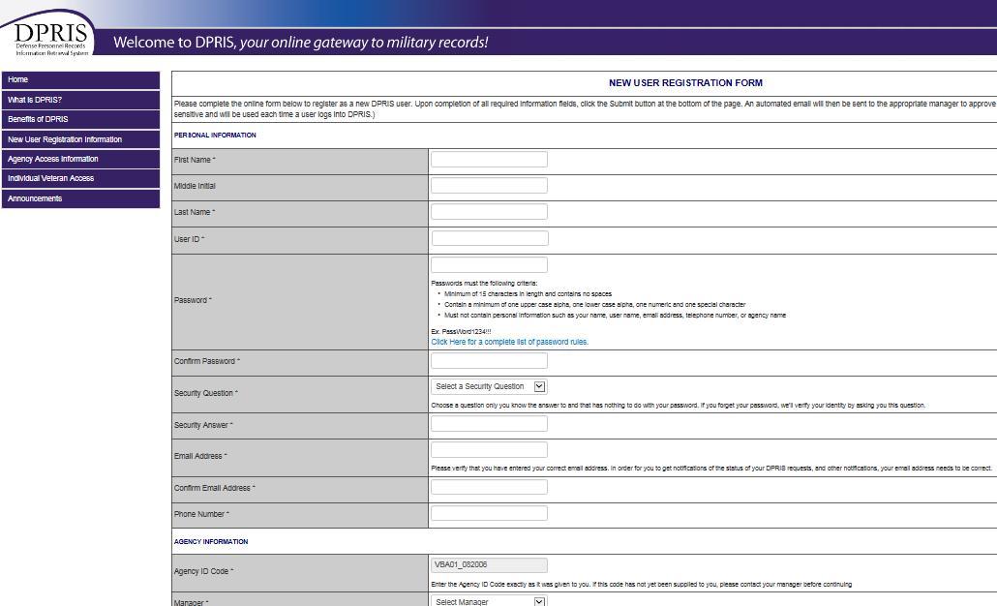

Using DPRIS Web

Log-in using your User ID and Password. This is the first screen you see once you have successfully logged into DPRIS Web.

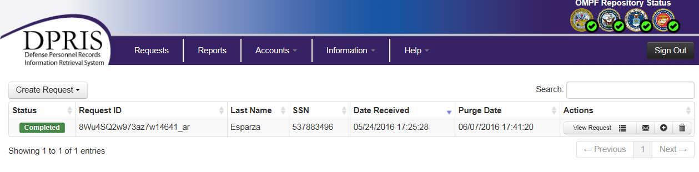

DPRIS Web Response Page
- Responses: Link to the Responses via a list of your requests for which responses have been received from one or more of the military service OMPF systems or from JSRRC. This is the default page that opens after a successful user login. It is often useful to return to this screen from other pages within the secure area of the Website via this link.
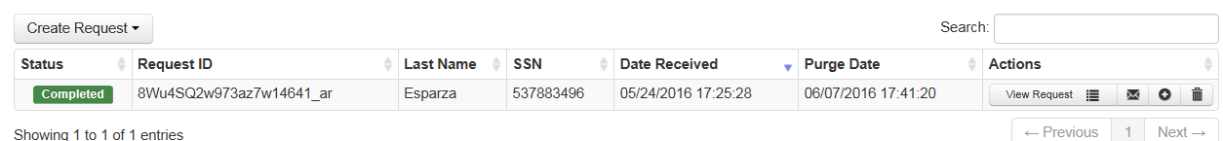
- Create Request: Link to the Create Request Form, where you can create a new query for information from a digital OMPF record maintained by one of the military services or submit a request to JSRRC.
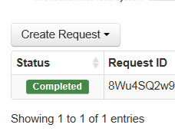
- Reports: Link to a page where a variety of DPRIS Web reports can be requested. The reports available to you are determined by your access level within DPRIS Web.

- Accounts: Link to a page that allows you to modify your profile or change your password.
- Information: Link to a page with background information about the DPRIS Web initiative and the DPRIS Web Standard Indexing Scheme.
- Help: Link to the DPRIS Web Assistance Form, which allows you to submit suggestions or feedback, or request assistance for using DPRIS Web.
- Request ID: This column lists Request IDs that have received a response from an OMPF repository or JSRRC. If multiple requests are displayed, they are initially sorted by the Request ID. However, multiple requests can be sorted in a different order by clicking on the arrow in either the Social Security Number (SSN) or Date column headings.
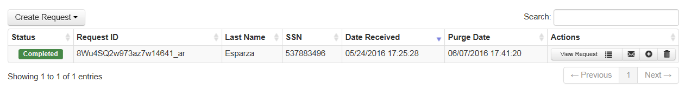
- SSN: Lists the SSNs associated with each of your active requests.
- Date Received: This column lists the date and time each set of images was received by DPRIS Web from the OMPF repository, or information was received from JSRRC.
- Purge Date: This column displays the date the response will be purged from the DPRIS Web system. After a response is purged, non-image data pertaining to the request remains available via the Reports option, but the response is no longer displayed on the Responses page.
- Extend Purge Date: This link allows you to extend the purge date for a request.
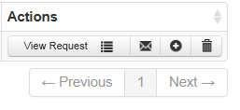
- Purge Requests: This link allows you to purge requests prior to the purge date. A popup message will be displayed, requiring you to confirm the purge process. If you click the OK button on the confirmation message, selected request will be permanently removed from your list of active requests. If you click the Cancel button on the confirmation message, the selected request will not be purged and will remain in the users list until the purge date has expired.
- Follow-Up Message: Links to a page from which a secure follow-up message can be generated to a Military Service Action Officer, with regard to the related request. Once created, the message is stored in the DPRIS Web database and the Action Officer for the appropriate military service branch is notified of the message. You will be able to submit follow-up messages for review by the Action Officer, as well as review the secure electronic responses from the Action Officer. When the Action Officer has responded to a follow-up message, you will receive an email notification that a response is available for review.
Important: If it becomes necessary to follow up on a DPRIS request for Army records, send an unencrypted email to the Army Human Resources Command (HRC) at askhrc.army@us.army.mil, and associate a copy of the email with the claims folder. (Because the email is unencrypted, users must not include personally identifiable information in the subject line of the email.)
The email to HRC must contain the following information
- Veteran’s full name
- Veteran’s dates of service
- last four numbers of the Veteran’s SSN, and
- a description of the specific records the user is seeking.

- Navigation (Item 16): If you have more than one page of returned requests, navigational links will be visible to enable you to go from page to page.

Viewing Responses to Request

Clicking on View Request brings up a list of documents available for viewing.

Select the images to be viewed by checking the box (1). Then, click Display Selected Files (2).

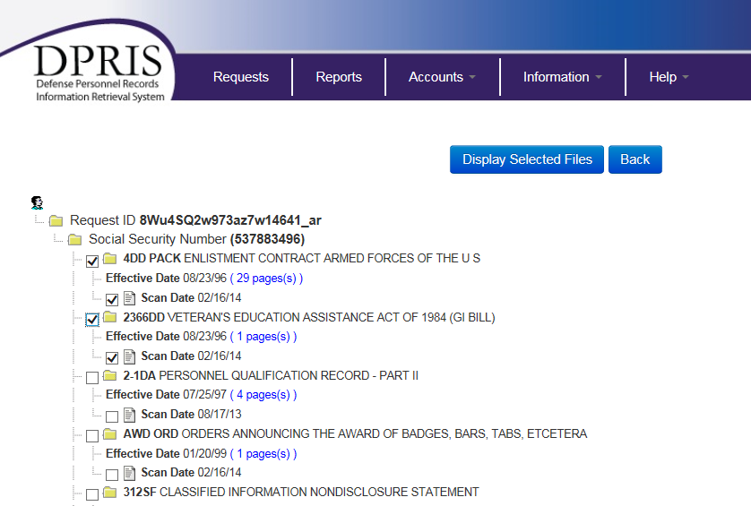

Submitting OMPF and JSRRC Request

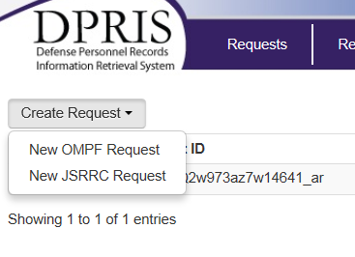
When the Create Request link is selected, the dropdown shown above is displayed. When the OMPF Request link on this page is selected, the OMPF Request Form is displayed as shown in Figure 3-9 on the following page. The OMPF repositories that are displayed in Item 1 in Figure 3-9 will vary, based upon the authorization approved for the agency. For example, if an agency is only authorized to submit requests to the Navy and Army repositories, only the checkboxes for the Navy and Army would be displayed on this form. The Air Force and Marine Corp checkboxes would not be visible on the form. The Document Index codes that are displayed in Item 2 in Figure 3-9 will also vary, based upon the access level approved for the user. To create an OMPF request, you need to complete the form and click the Submit button.
Your authorization level is pre-established by your DPRIS Web Super User during the registration process. This process determines the types of documents (i.e., groups and subgroups of the DPRIS Web Standard Index) that will be visible to you on the OMPF Request Form and that can be used in a request to the military service OMPF repositories. For example, a user viewing the screen in Figure 3-9 is only authorized to request document images associated with the DPRIS Web Service Computation Group and some of the subgroups from the DPRIS Web Professional History Group.

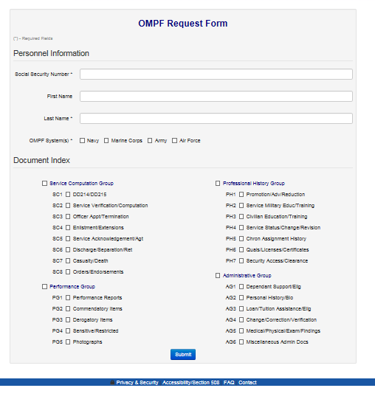
Figure 3-9. OMPF Request Form

Submitting JSRRC Request
When the JSRRC Request link on the Create Request page is selected, the main JSRRC Request Form is displayed as shown in Figure 3-10 on the following page. To create a JSRRC request, the user first enters the mandatory information in the Personnel Information section (Item 1 in Figure 3-10).

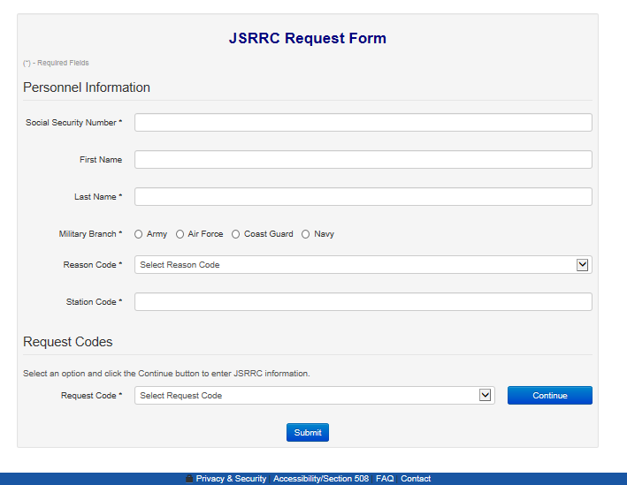
Figure 3-10. JSRRC Request Form
A JSRRC request must contain the information for at least one of the Post Traumatic Stress Disorder (PTSD) Stressor codes or the Agent Orange code. It can contain up to four codes if needed. To enter the request code information, you must select from the dropdown menu and then click the Continue button. If one of the PTSD Stressor codes was selected, the PTSD Stressor form will be displayed as shown in Figure 3-11 on the following page. You would enter the mandatory information on this form and click the Continue button to return to the main JSRRC Request Form.

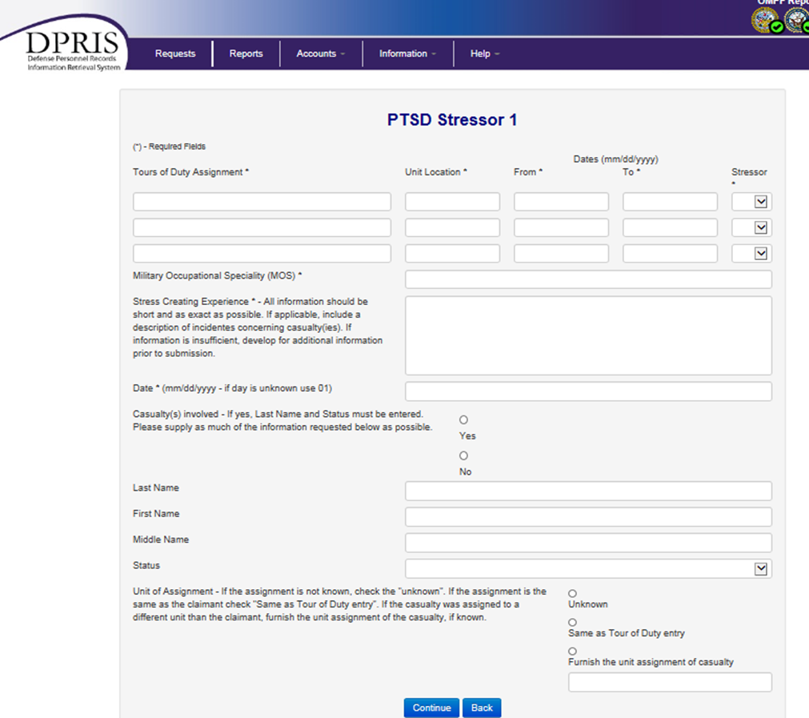

Figure 3-11. PTSD Stressor Form

If the Agent Orange code was selected, the Agent Orange Claim form will be displayed as shown in Figure 3-12 below. You would enter Ship From and Ship To dates for up to five shipments. Each shipment can have up to 25 pairs of dates. To add another date to a shipment (i.e., Unit assignment), you must click the Add Date button for the shipment. Once all shipment information is entered, you would click the Continue button to return to the main JSRRC Request Form.

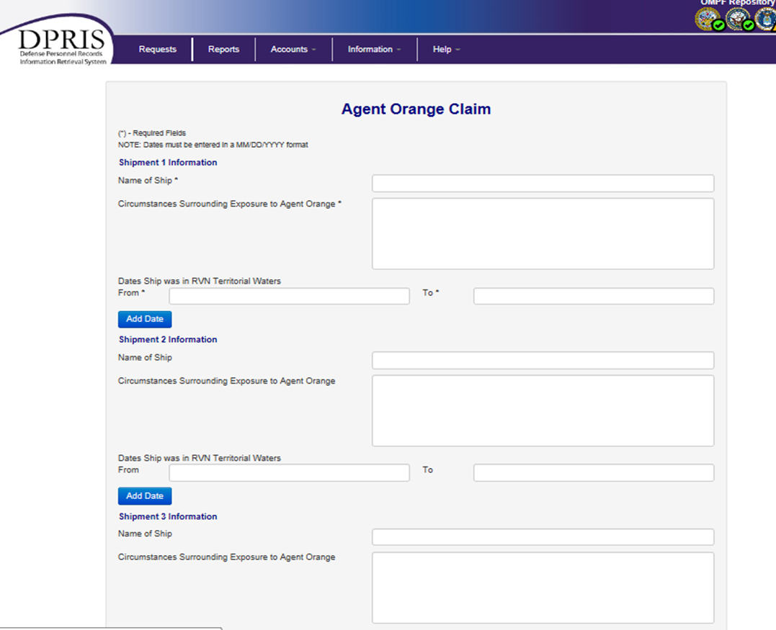

Figure 3-12. Agent Orange Claim Form

Viewing User Reports
Figure 3-13 below displays an example of what the Reports page could look like. The names and types of reports shown are subject to change as DPRIS Web’s development continues and as information reporting requirements become more refined for the various military services and government agencies.

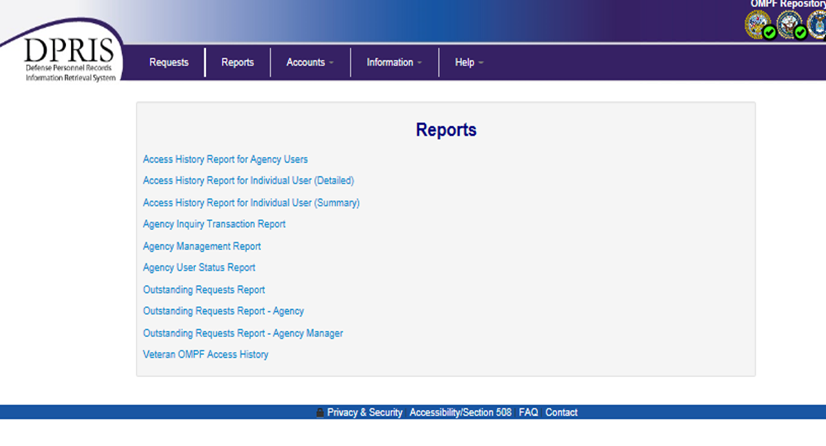
Figure 3-13. Sample Listing of Available Reports

Types of Reports
The collection and organization of data into reports, tailored toward different users and administrators, represents an important DPRIS Web capability. Examples of the type of management information that should be available are: the total number of OMPF queries made by the external customer base; the types of information requested; and a listing of the documents or exception status returned in response to these queries. DPRIS Web has been designed to routinely collect such data and facilitate on-demand generation of detailed reports about DPRIS Web OMPF records management system usage.
The scope of reports includes: details of a single request; summaries of all requests from an entire external agency; and all requests directed to a specific Service OMPF repository. Collection and reporting of DPRIS Web metrics data provides OMPF Records Managers a greater understanding of the external customer base and their OMPF information needs. It also provides the external customer base specific information concerning requests to the military services’ OMPF repositories and to JSRRC. User needs for DPRIS Web metrics reports have been segregated; the following is an example category:
- Information pertaining to access to a specified individual’s OMPF record.
This category reports on requests to one individual’s OMPF record and the information returned. The OMPF Access History Report, for instance, summarizes requests for records associated with one SSN. This audit trail enables OMPF record managers to determine who has accessed a particular OMPF record and what information was provided in response to the query.

Account Management

The DPRIS Web Responses page, that appears for all users immediately following successful login, displays an Accounts option on the bar near the top (Item 4 of Figure 3-6). This is a link to the Account Management page shown in Figure 3-16 below. From the Account Management page, you can access links to modify your profile or change your password.

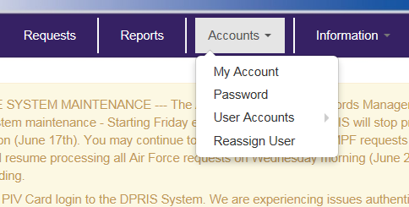

Figure 3-16. Account Management Options

My Account Option

Item 1 of Figure 3-16 is the My Account option. It provides a link to the page that allows you to update or change your personal account information, as shown in Figure 3-17 below. The fields and options in this form are fairly intuitive and self-explanatory.

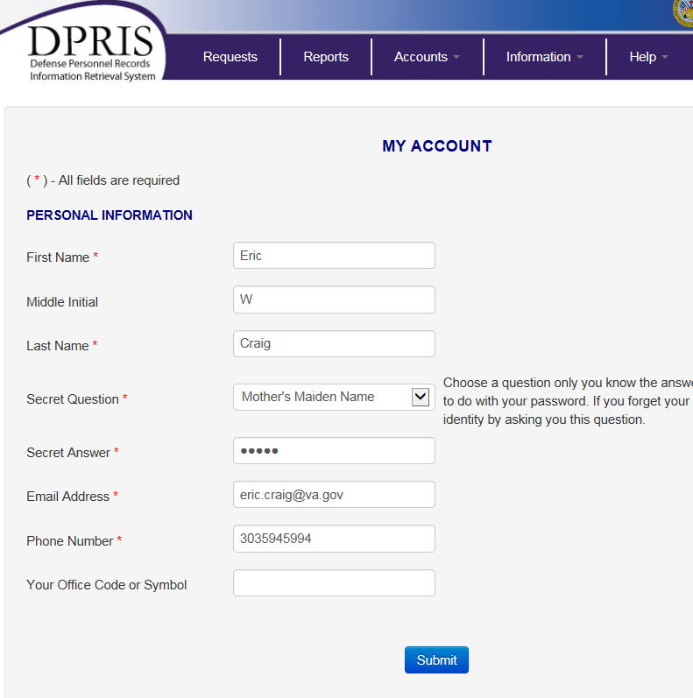

Figure 3-17. My Account Option

Password Option

Item 2 of Figure 3-16 permits you to change your personal password. It links the page shown in Figure 3-18 below.
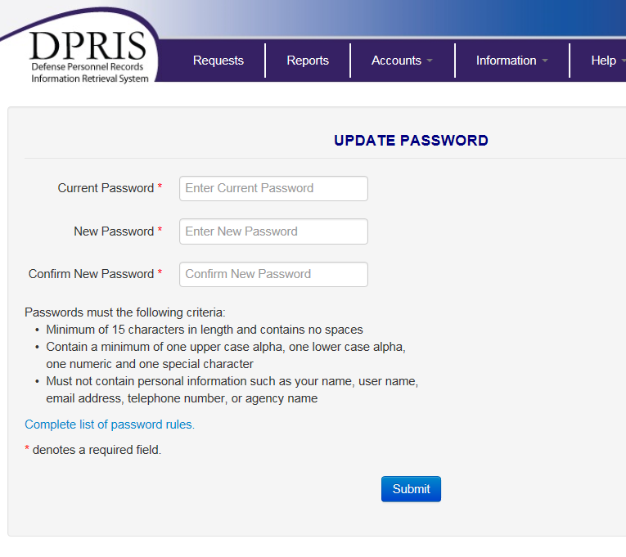

Figure 3-18. Password Option

User Accounts Option

Agency managers have the responsibility of managing DPRIS Web accounts for their subordinate users through the DPRIS Website. The roles associated with this activity are assigned as part of the user approval process and are recognized by the DPRIS Web system when a user logs in. Agency managers are authorized to approve new user registration requests, change the document assignment and authority role of their active subordinate users, and temporarily and permanently deactivate subordinate users. Item 3 of Figure 3-16 is the User Accounts option, linking to the User Accounts page shown in Figure 3-20 on the following page. This link is available only to users in a managerial role. It is not available for individuals in a non-managerial role.

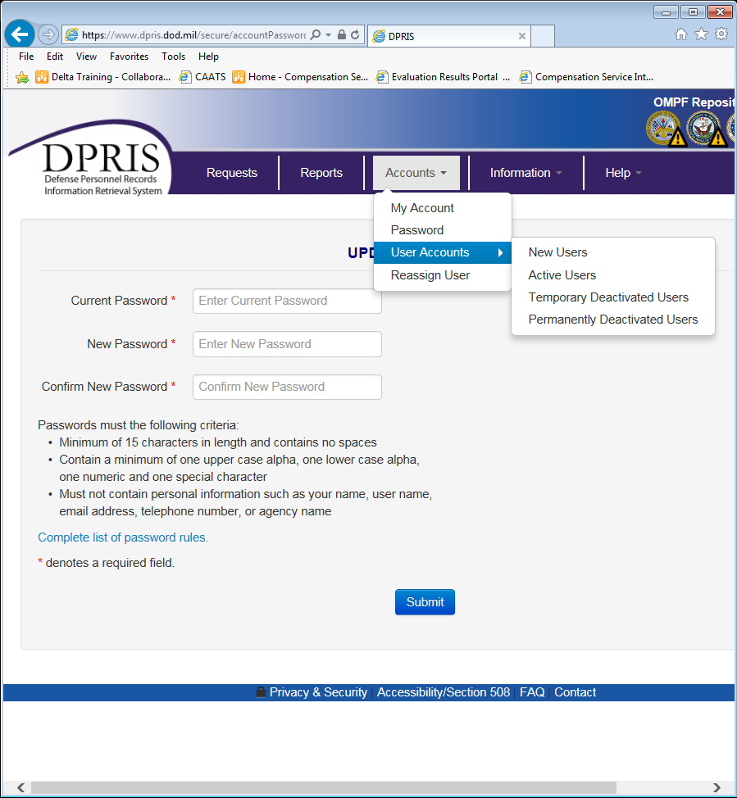
Figure 3-20. User Accounts

When a new user submits a New User Registration, an email is automatically sent to the manager, selected by the user, notifying him/her that a new user has requested access to DPRIS Web. The manager must then log into DPRIS Web to approve or reject the registration request by clicking the New Users link on the Users Account page (Displayed list of Figure 3-20). A list of users who have requested access, and are pending approval, will be displayed as show in Figure 3-21

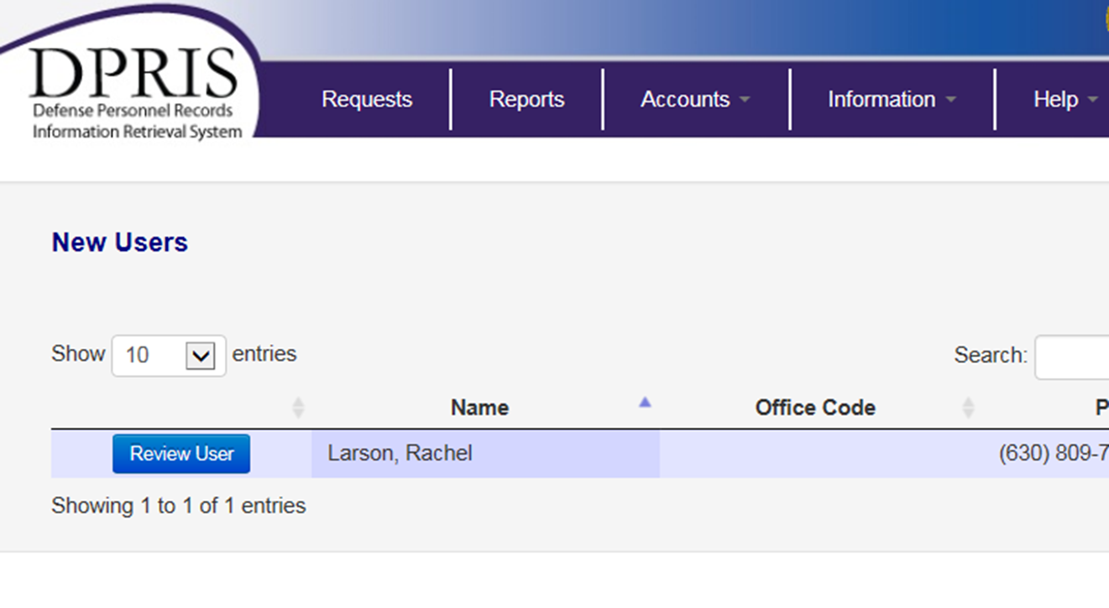
Figure 3-21. Listing of New Users

To select and review a registration request, click on Review User.

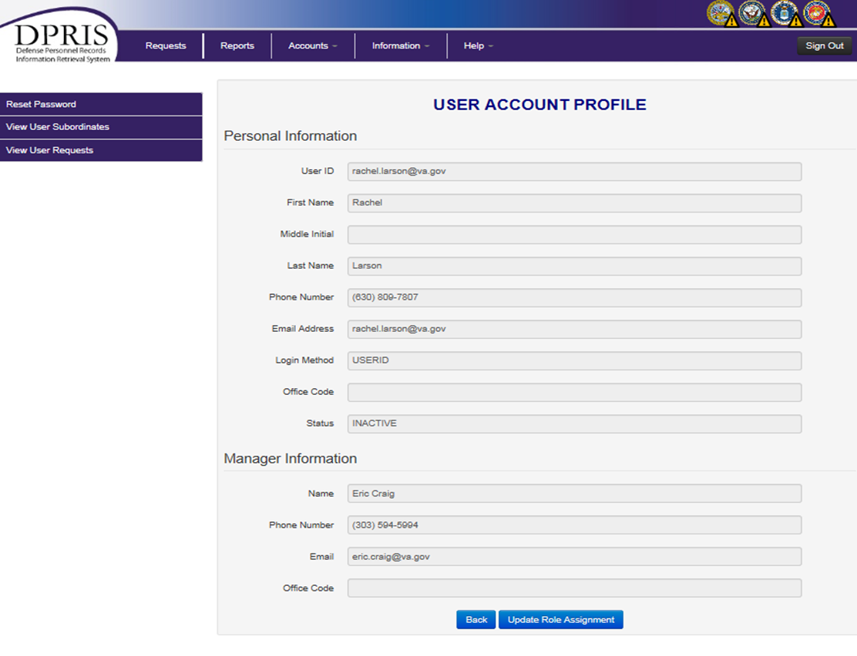

Figure 3-22. Profile of New User

Activation of New DPRIS Web User’s Registration Form
Selecting the Continue button of the Account Management page enables you to assign a role and document types that will be viewable. In addition, it provides the option of approving or rejecting the request, as depicted in Figure 3-23 on the following page.
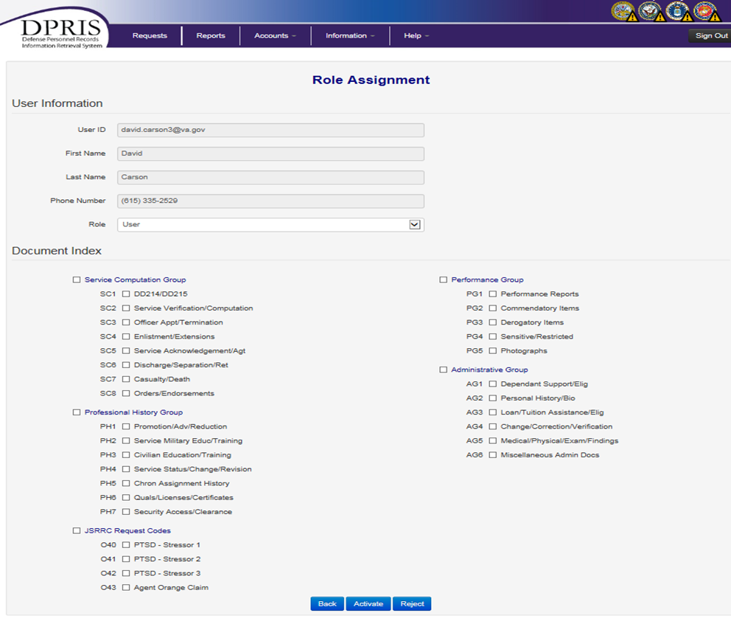
Figure 3-23. New User Approval / Rejection Screen
Assign the appropriate role to the new user. Only roles lower in authority than yours will be displayed. For this sample, the agency has three levels of authority: Super User, Manager, and User. The manager who logged in has the highest level of authority, i.e., Super User role. Consequently, the roles displays for the manager to choose are the “Manager” and “User” roles, which are both at a lower level than the Super User level.
You, as the manager, determine which types of OMPF and JSRRC documents the new user will be allowed to request. This form allows assignment of any or all of the DPRIS Web groups or subgroups to you have been authorized access. Documents that you have not been given access to will not be displayed on this page.

If the registration request is approved, and the form is completed, the Activate button should be clicked. If you determine that the new user has entered invalid or incorrect information, should not be authorized access to use the DPRIS Web system, or has not registered in the proper organization, you should select the Reject button. Once the form is accurately completed, submitted, and accepted by the DPRIS Web Super User, an email is automatically sent to the new user, notifying the user of his approval or rejection as a DPRIS Web User. After receipt of this notification, the user can begin using DPRIS Web.

Rejection of New DPRIS Web User’s Registration Form
If the Reject button (Item 3 in Figure 3-23) is used, another screen will be displayed that gives you the opportunity to provide information to explain the rejection. This screen is shown in Figure 3-24 below.
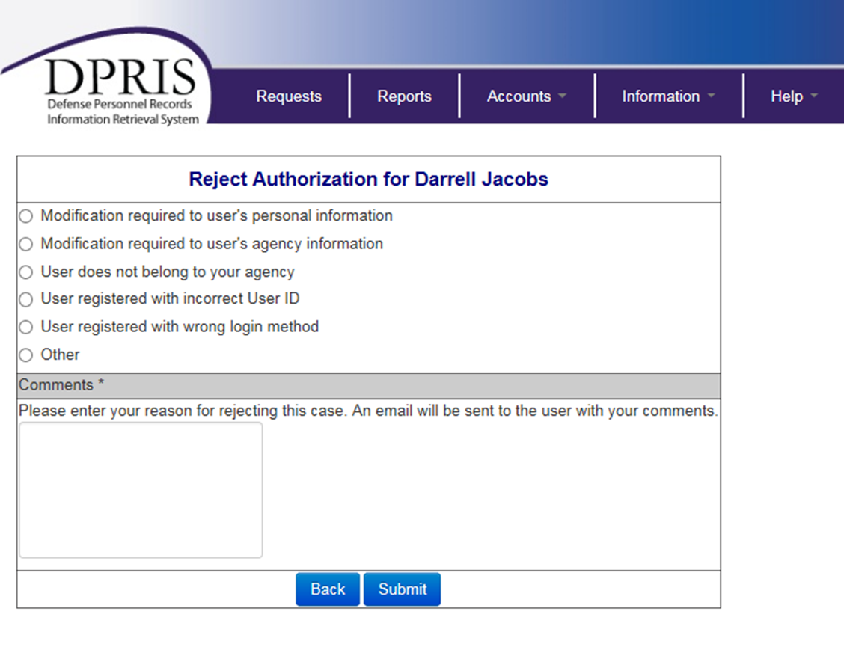Figure 3-24. New User Rejection Comments Screen

You should select the reason that best describes why the request has been rejected and elaborate as necessary in the Comments section. If any of the reasons indicated as Item 1 of Figure 3-24 are selected, an email will automatically be sent to the applicant specifying what changes are required on the registration form. The email also gives the applicant instructions for accessing the previously submitted registration form to make the changes. The existing registration information is retained in the DPRIS Web database until satisfactorily updated and approved by you, the manager.
In cases where the registration form is rejected because the user does not belong to the designated agency, the user did not enter a correct User ID value, or because the user did not indicate the correct login method (Item 2 in Figure 3-24), the applicant will be sent an email with notification of the rejection and instructions to recreate the registration form with the correct information specified. In this case, DPRIS Web deletes the rejected registration information from the DPRIS Web database.

Updating of Existing DPRIS Web Users
Managers will use the Active Users link on the Users Account page (Item 3 of Figure 3-20) to periodically review and update active users’ accounts. To select and review the account of an active user, click on an individual user’s name, as shown in Figure 3-25 below.
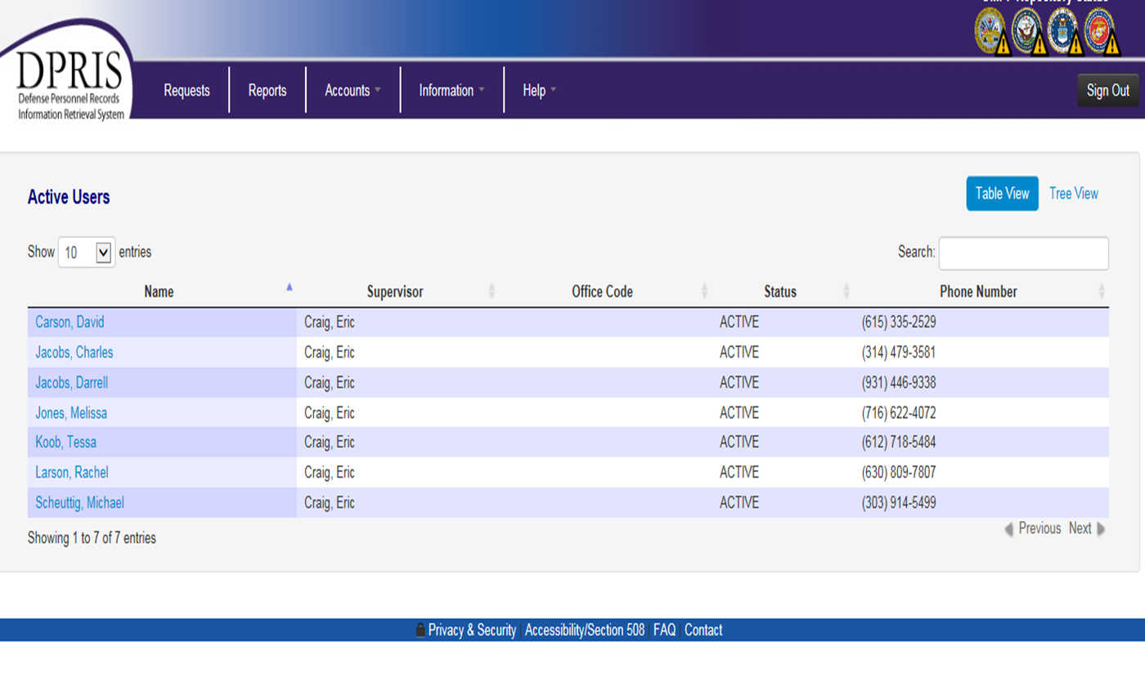
Figure 3-25. Listing of Existing DPRIS Web Users
Each name in Figure 3-25 links to separate pages that displays information about that specific user, as shown in Figures 3-26 and 3-27 on the following pages.

Figure 3-26. Existing DPRIS Web User Profile
As shown in Figure 3-26 above, you can change a user’s role level and/or modify the viewable documents that the user has access to. To save the changes to the user’s account, the Continue button (at the bottom of the screen in Figure 3-26) and then the Update button (Item 1 in Figure 3-27) must be clicked. However, if the user being modified is currently in a managerial role and has subordinate users assigned to them, the user’s role cannot be changed to a lower authority level without the subordinate users first being reassigned to another authorized manager.

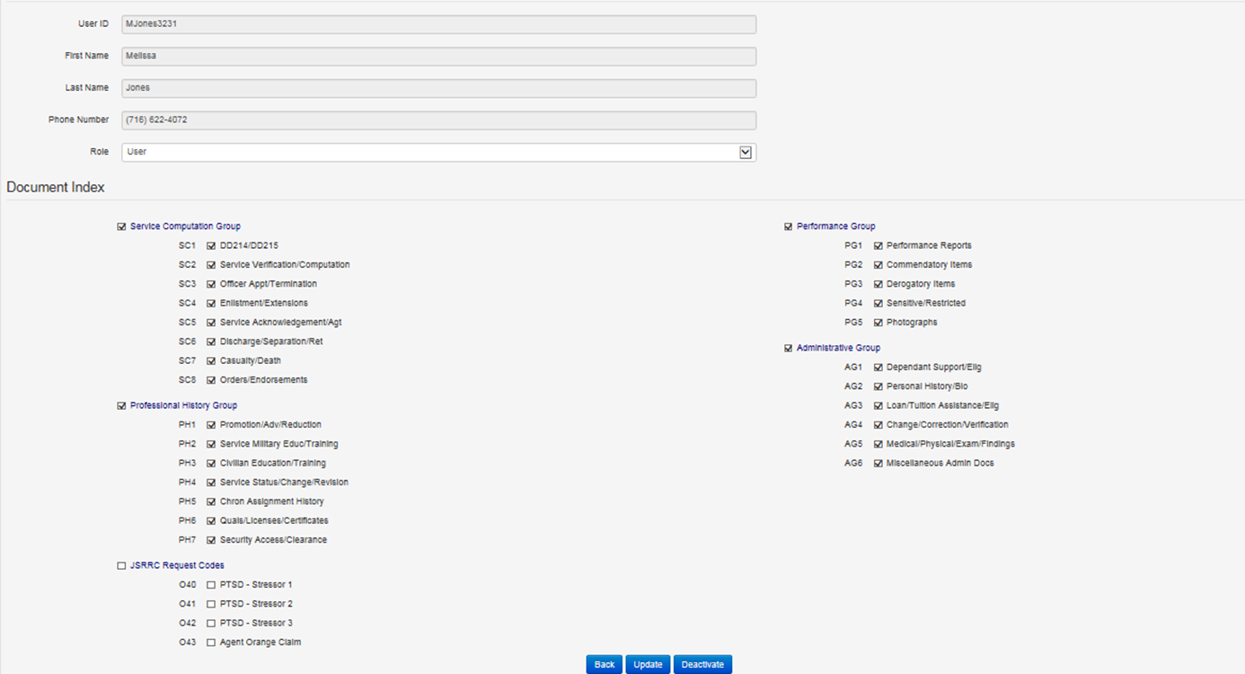Figure 3-27. Existing User Deactivation / Update Screen

Deactivation of Existing DPRIS Web Users
A manager in an agency can permanently deactivate an existing user for reasons such as the user has resigned, has been transferred from the agency, has moved to a different division / position, or no longer requires DPRIS Website access. The manager can also deactivate an existing user temporarily if the user will be away from her position for a finite time period, but will be returning, such as with maternity leave. To deactivate a user, click on the name of the user in the User Accounts page, as depicted in Figure 3-25, which will lead to the page shown in Figure 3-27.
By selecting the Deactivate button (Item 2 in Figure 3-27), you can deactivate the user. When the button is clicked, a check is made to see if the user being deactivated has active subordinate users. If this is the case, a message will be displayed stating that the subordinate users will need to be reassigned to another manager in the agency before the user can be deactivated. If no subordinate users were found for the user, another screen will be displayed requesting additional information, as shown in Figure 3-28 on the following page.
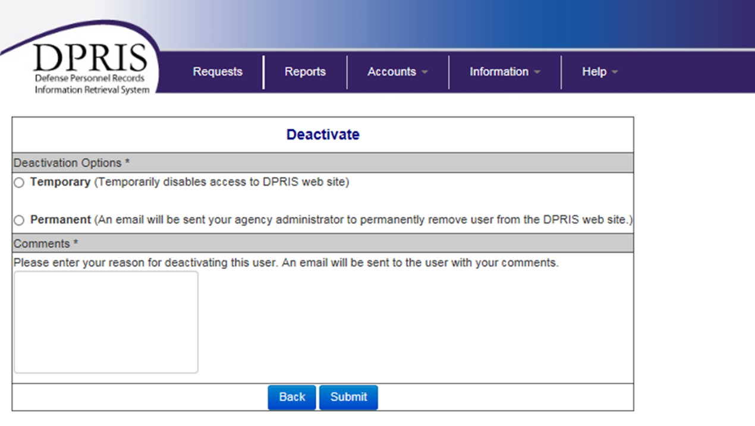
Figure 3-28. User Deactivation Screen

In Figure 3-28, the manager selects either Temporary or Permanent deactivation, adds comments, and selects the Submit button. An email will be sent to the user confirming the deactivation with the body of the email containing the comments the manager entered in the Comments field. At this point, the user’s ability to access and use the website is temporarily or permanently deactivated. If temporarily deactivated, the user is not removed from the DPRIS Web system, but will be displayed in the Temporary Deactivated User list on the User Accounts page, as depicted at Item 4 in Figure 3-20. When there is a need to reactivate a temporarily deactivated user, you can re-approve the user following the steps used for new user approval. If the user is permanently deactivated, the user’s account information is deleted from the DPRIS Web system. Permanently deactivated user accounts may be viewed by selecting the Permanently Deactivate Users link on the User Accounts page, as depicted at Item 5 in Figure 3-20.

Resetting Passwords

To reset passwords, access the Active Users on the Users Account page. Usually the user that is locked-out can be found in the ‘Active Users’ list. Users in a pending status can also be locked-out for exceeding the number of invalid login attempts.
Locate the user that was indicated to be locked-out in the email sent to you by the DPRIS Web system and select the user by clicking his/her name. The ‘User Profile’ page will be displayed with the user’s information displayed as shown in the figure below. There will be a ‘Reset Password’ link in the ‘Quick Links’ section. Select this link.

The ‘Reset Password’ page will be displayed as shown in figure below. Enter a New Password value and then type that same value into the Confirm New Password field. The password you choose must pass the strong password rules. This password can be regarded as a temporary password since the user will have to change to a new password the first time they try to login to DPRIS Web after you have reset the password. Therefore, you can choose a password that is easy for you to remember and use it whenever you reset users’ passwords. Select the Submit button to update the password. If all validations pass, a confirmation page will be displayed and the user will receive an email with the temporary password.

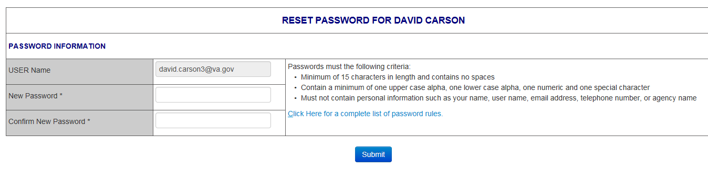

Reset Password Screen

DPRIS Web Information

The Information page (shown below) provides historical and background information on DPRIS Web and the OMPF Environment.

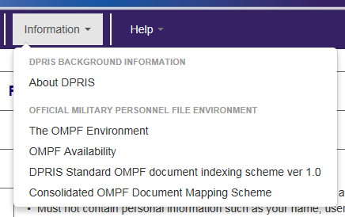

DPRIS Web Help

The DPRIS Web Help Desk can be contacted from most of the DPRIS Web pages by clicking on the Help link located on the bar near the top of each page. After clicking the link, you are taken to the Help area of the Website. Figure 3-14 shows the links provided at the secure area Help link.
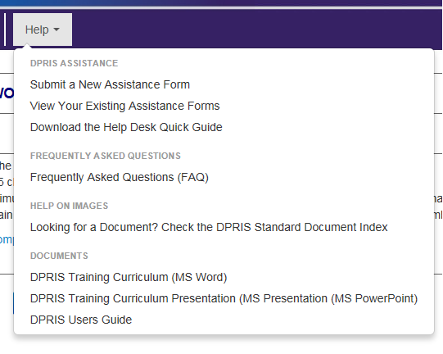

Figure 3-14. DPRIS Web Secure Area Help Options

The Assistance Form link will take you to the DPRIS Web Assistance Form. The Frequently Asked Questions link will provide you with regularly asked questions and answers concerning DPRIS Web. The Help On Images link provides you with information concerning documents available in the Services’ OMPF systems. The Downloads links give you the capability to download the most recent versions of the DPRIS Website Users Guide, DPRIS Training Curriculum, and the MS PowerPoint slides used in conjunction with the training curriculum.

To communicate with the DPRIS Web Help Desk, you would initially click on the Assistance Form option. A screen will be displayed containing the Assistance Form. This form is designed both for routine DPRIS Web users and for managers and systems administrators. It allows you to:
- Submit suggestions to improve the DPRIS Web user interface and functional design.
- Report deficiencies and problems encountered with the performance of DPRIS Web.
- Request technical or operational assistance.

Assistance Form. You are required to select options in the top sections of the form to specify the general nature and urgency of the communication.

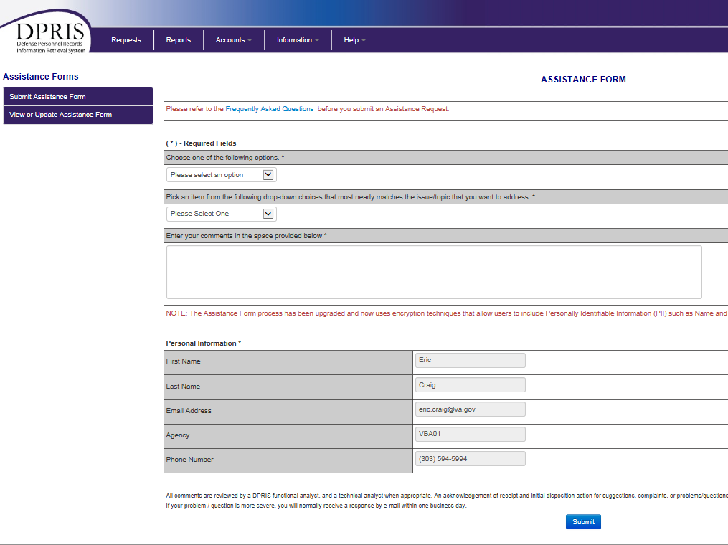

Figure 3-15. DPRIS Web User Assistance Form

A Comment section on the User Assistance Form allows you to type up to 500 characters of pertinent information pertaining to their comment or question. Once the form has been completed, it can be submitted by clicking the Submit button at the bottom of the form.
If the submitted form is a request for assistance, a DPRIS Web functional or technical specialist will attempt to contact you within 24 hours. If the form is used to provide feedback or a suggested system change, you will be contacted via email or phone by a member of the DPRIS Web Support Team to acknowledge you submission. A Software Problem Report (SPR) will be generated if appropriate. Otherwise, the suggestion will be evaluated and considered for future DPRIS Web upgrades.

VBA Central Office Contact

If any other issues arise with DPRIS Web that does not fall into any of the previous categories, then please contact the VBA Central Office for assistance at the following email address: VAVBAWAS/CO/PIES.

