Slide 1 - Fund Usage Reviews
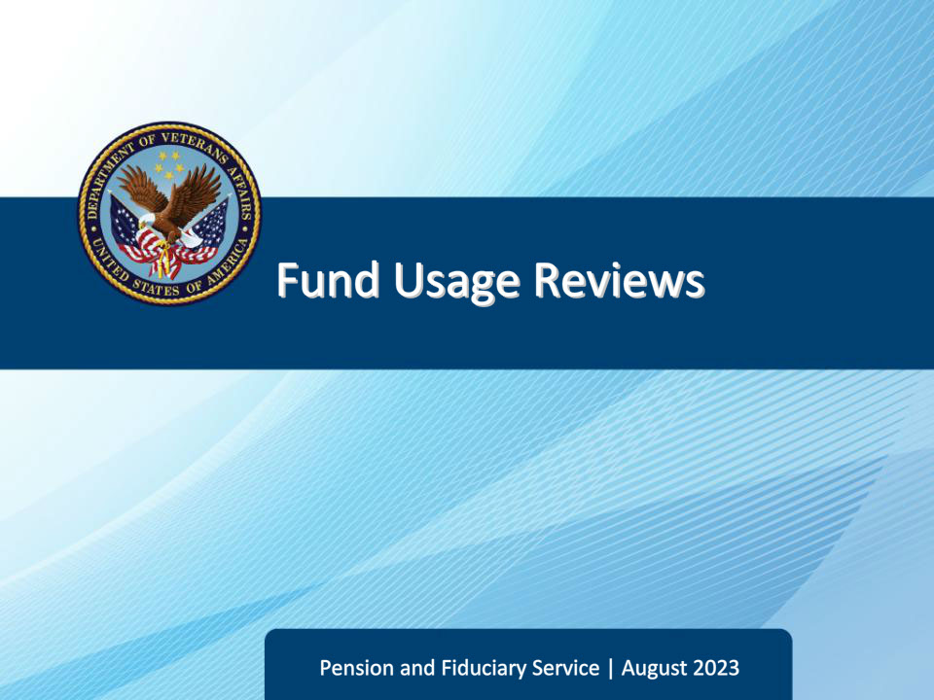
Slide notes

Course Description:

This course teaches learners about the fund usage review process.

Slide 2 - Navigation
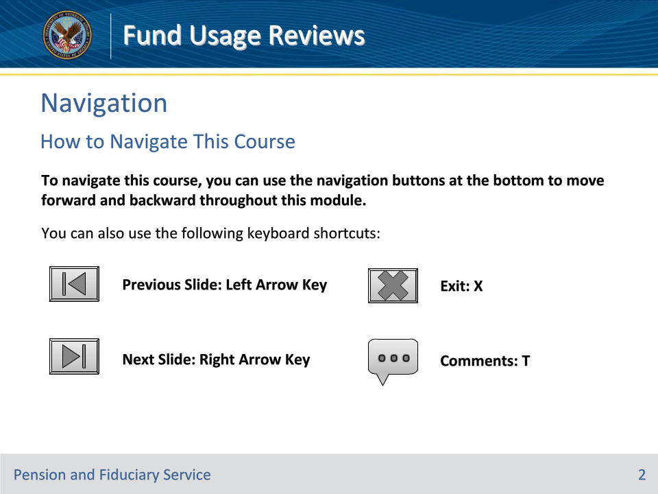
Slide notes

To navigate this course, you can use the navigation buttons at the bottom to move forward and backward throughout this module.

You can also use the following keyboard shortcuts:

• Previous Slide: Left Arrow Key

• Next Slide: Right Arrow Key

• Exit: X

• Comments: T

Slide 3 - Objectives
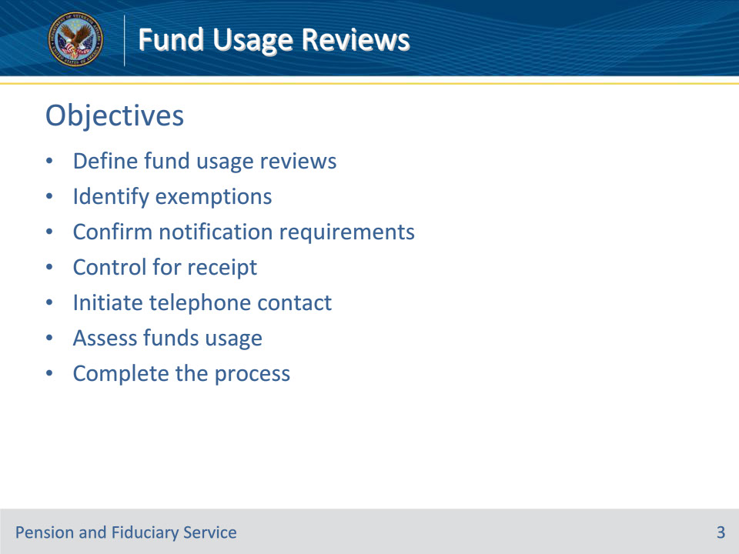
Slide notes

Instructor Notes:

At the end of this lesson, given the training and references, the learner will be able to do the following:

• Define fund usage reviews

• Identify exemptions

• Confirm notification requirements

• Control for receipt

• Initiate telephone contact

• Assess funds usage

• Complete the process

Slide 4 - References
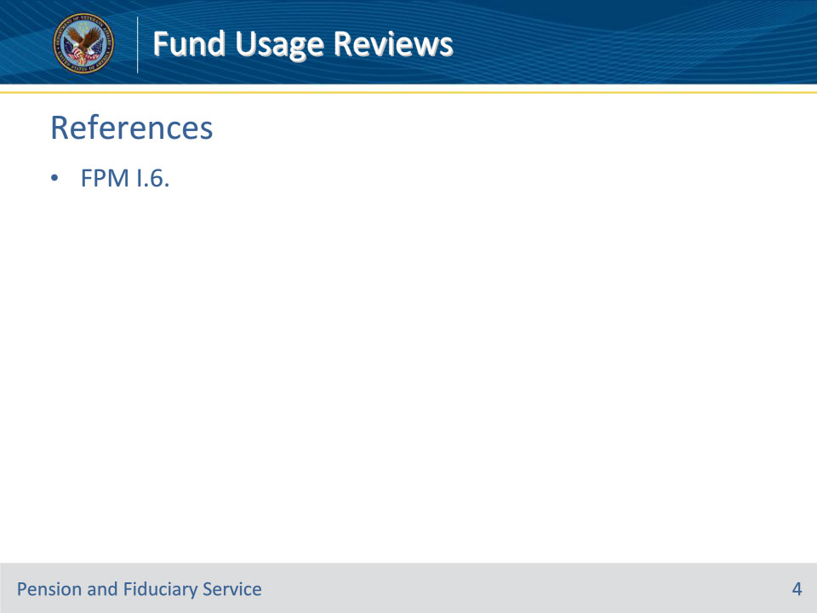
Slide notes

Instructor Notes:

These are the relevant references pertaining to this course:

• FPM I.6. Fund Usage Oversight

Slide 5 - Definition
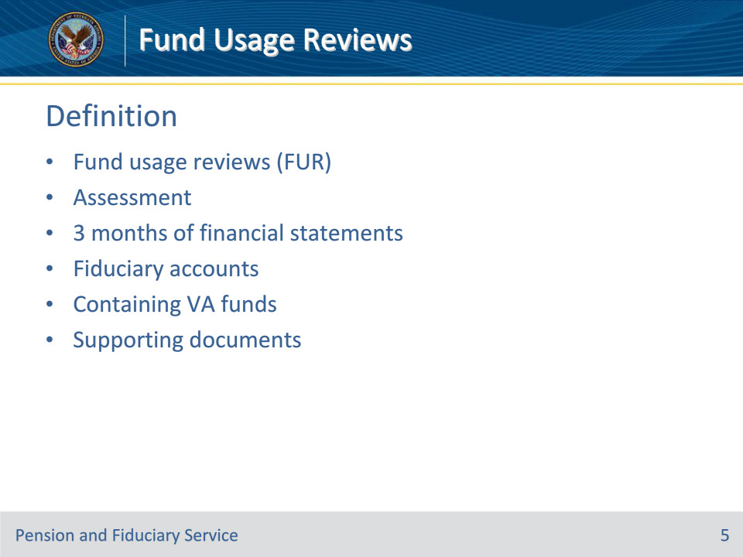
Slide notes

Policy Reference(s): FPM I.6.A.1.a.

Instructor Notes:

A fund usage report consists of three months of all financial statements containing VA funds for each beneficiary that the fiduciary manages.

The fund usage report may also include any supporting documents (receipts, invoices, etc.) that show irregular purchases so that VA can confirm the funds are being spent in the beneficiary’s best interest.

Slide 6 - Purpose
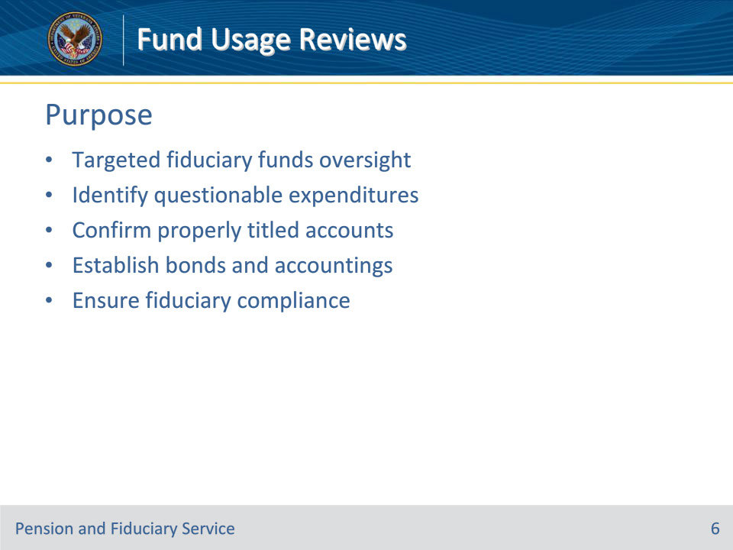
Slide notes

Policy Reference(s): FPM I.6.A.1.a.

Instructor Notes:

Fund usage reviews are completed by hub personnel and are an assessment of the three months of financial statements and supporting documentation. The purpose of the review is to provide targeted oversight of fiduciary use and management of VA beneficiary funds by:

• identifying expenditures that may not be for the use and benefit of the beneficiary and their dependents

• confirming that VA-appointed fiduciaries maintain properly titled accounts when required

• establishing bond and accounting requirements when necessary, and

• ensuring fiduciary compliance with VA responsibilities

Slide 7 - Submission Methods
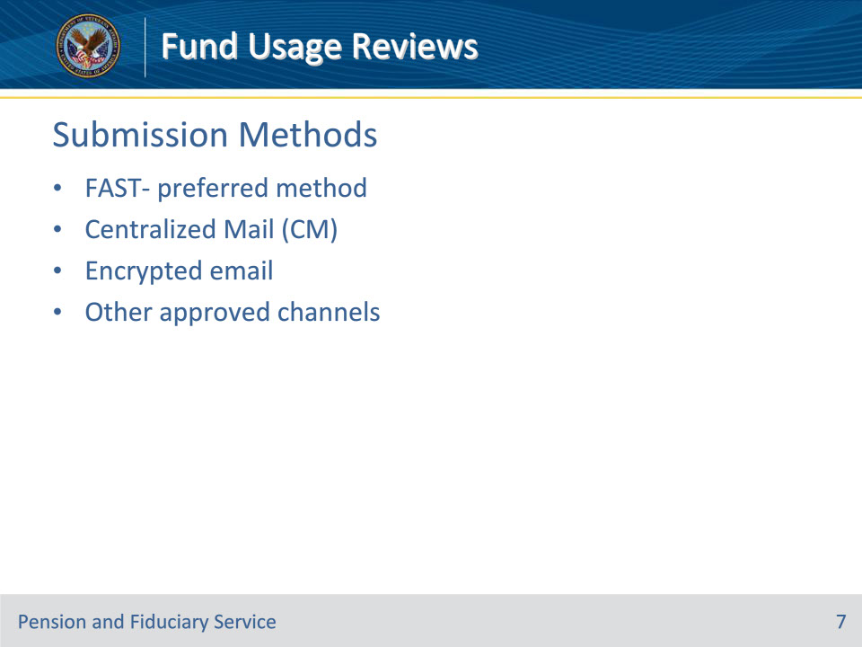
Slide notes

Policy Reference(s): FPM I.6.A.1.a.

Instructor Notes:

While the Fiduciary Accountings Submission Tool (FAST) is the preferred method for fiduciaries to submit fund usage reports, fiduciaries may also provide their reports through the Centralized Mail (CM) portal, encrypted email, or by other approved channels.

Slide 8 - Requirements
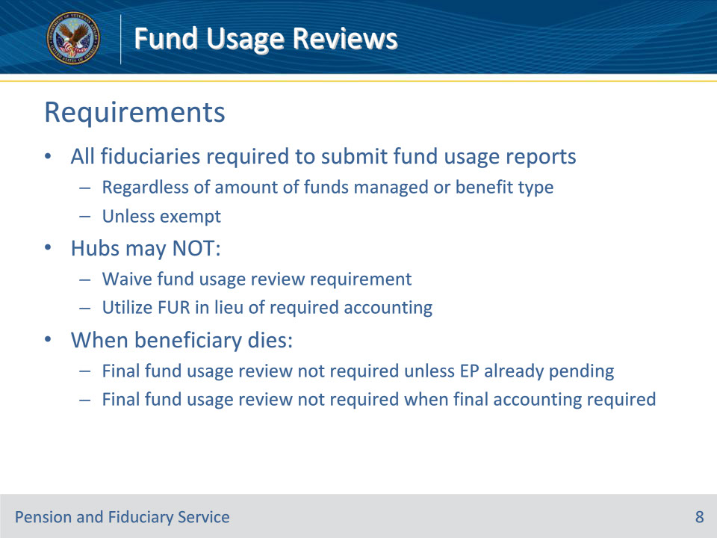
Slide notes

Policy Reference(s): FPM I.6.A.1.b.

Instructor Notes:

All fiduciaries are required to submit fund usage reports regardless of the amount of the VA benefit funds they manage or the type of benefit that the fiduciary receives, unless they meet one of the exemptions on the next slide.

Hubs may not choose to perform less oversight than the situation dictates. Due to this, hubs may not

• waive the fund usage review requirement, or

• utilize the fund usage review in lieu of an accounting when a fiduciary is required to account.

• When a beneficiary dies, a final fund usage review is not required unless an end product (EP) for fund usage review was pending at the time of the beneficiary’s death.

• When a beneficiary dies without heirs or a will, and the funds would escheat to the State, the fiduciary must submit a final accounting. When a final accounting is required, a final fund usage report will not be required.
Slide 9 - Exemptions
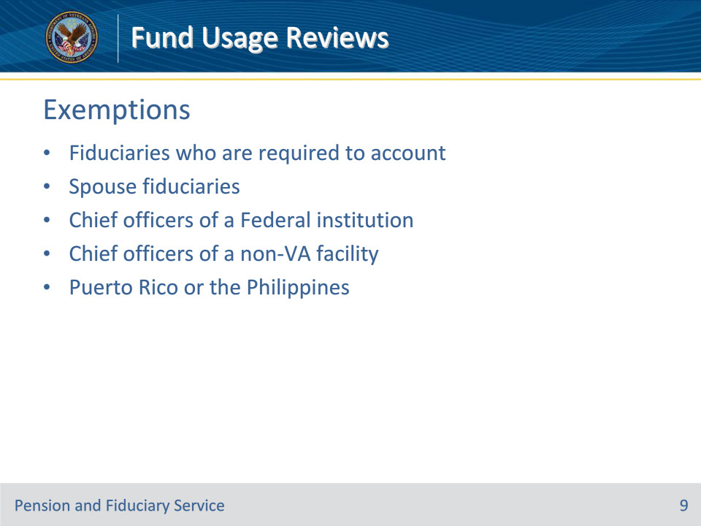
Slide notes

Policy Reference(s): FPM I.6.A.1.c.

Instructor Notes:

Fiduciaries excepted from the fund usage report submission requirement include

• fiduciaries who are required to submit an annual accounting

• VA appointed

• spouse fiduciary

• fiduciary who is the chief officer of a Federal institution, or

• fiduciary who is the chief officer of a non-VA facility receiving benefits for a beneficiary residing in the facility, or

• fiduciaries who were appointed outside of the U.S., in the Commonwealth of Puerto Rico or the Republic of the Philippines, and both the beneficiary and fiduciary permanently resides outside of the U.S., in the Commonwealth of Puerto Rico or the Republic of the Philippines.

• Hubs will not establish a date in the FUND USAGE REVIEW DATE field for exempted fiduciaries.

• Chief officer is a position within an institution that is filled by an individual for the purpose of representing that institution in a legal capacity. As such, the individual in that position is not the fiduciary, but rather acts as a representative of the entity that is their institution. The institution’s Federal Employer Identification number would be used to represent the institution and not the chief officer’s Social Security number.

Slide 10 - Notification
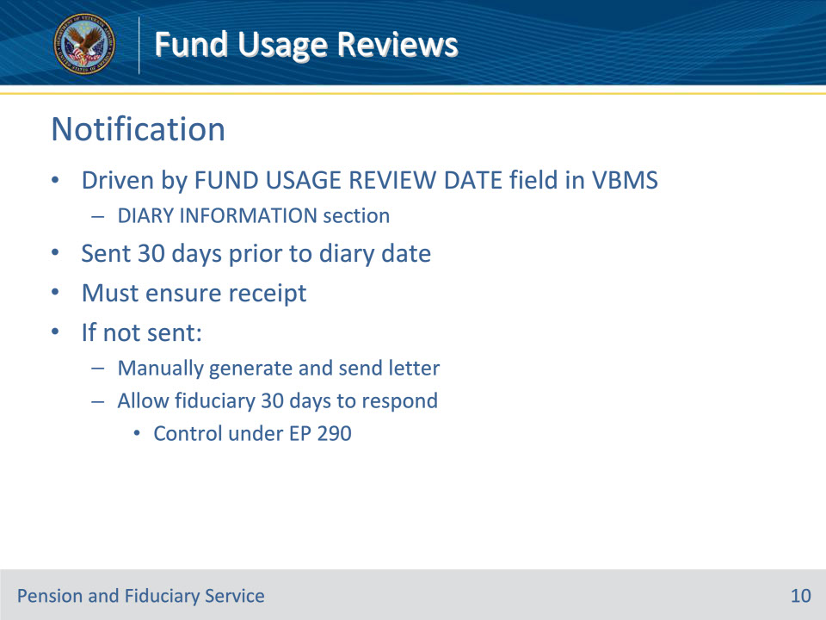
Slide notes

Policy Reference(s): FPM I.6.B.1.a.

Instructor Notes:

The fund usage reports are required within regular intervals, but the review period is unique to each fiduciary. Notification of the fund usage report is required and driven by the FUND USAGE REVIEW DATE field in the DIARY INFORMATION section in VBMS.

• The system will automatically generate and send the Fund Usage Due Letter and establish end product (EP) 290, Fund Usage Review, 30 days prior to the fund usage review diary date.

Hubs must ensure the fiduciary receives notification that the fund usage report is due prior to the review due date.

• If the hub determines that the Fund Usage Due Letter was not sent, manually generate and send the notification letter allowing the fiduciary 30 days to respond from the date of the manually generated letter. Control the 30-day response time under the EP 290.

Slide 11 - Notification (Cont.)
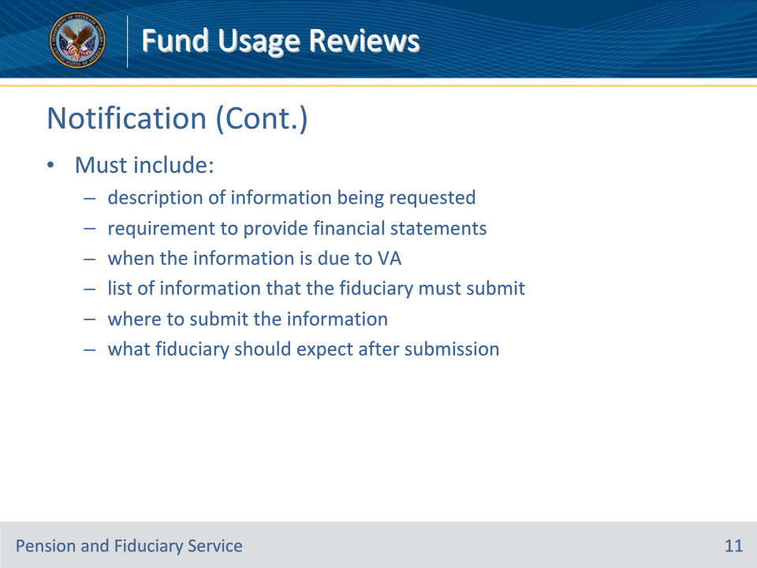
Slide notes

Policy Reference(s): FPM I.6.B.1.a.

Instructor Notes:

The notification must include

• a description of what is being requested

• requirement to provide financial statements for the three-month period prior to the date of notification

• when the information is due to VA

• a list of information that the fiduciary must submit

• where the fiduciary must submit the information, and

• what the fiduciary should expect after the submission of the information.

Slide 12 - Past Due
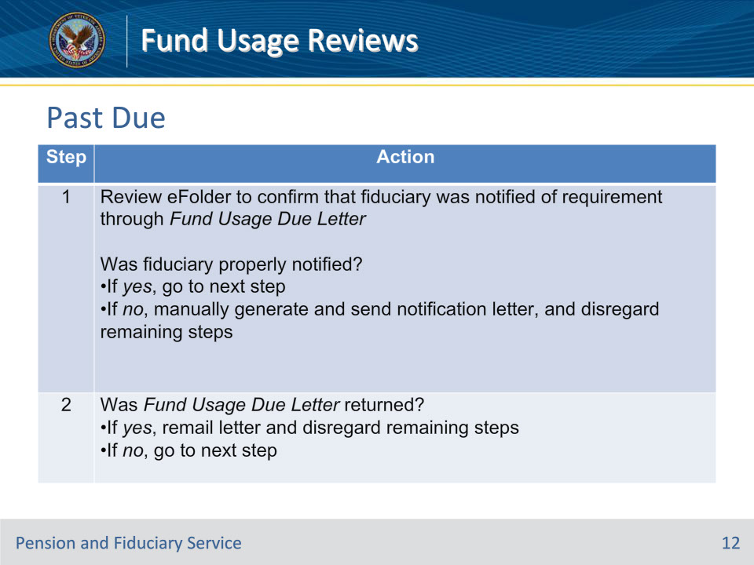
Slide notes

Policy Reference(s): FPM I.6.B.1.b.

Instructor Notes:

The fund usage report becomes past due on the first day following the due date for the period under review.

When VA is not in receipt of a fund usage report that is past due, hubs must take immediate action to ensure timely oversight of the beneficiary’s VA funds. Follow the steps in this table to determine the necessary action(s) for a past due report.

Slide 13 - Past Due (Cont.)
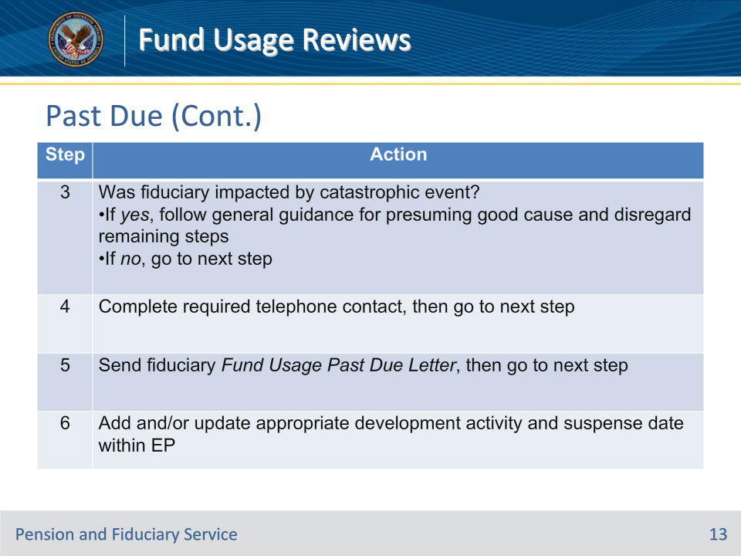
Slide notes

Policy Reference(s): FPM I.6.B.1.b.

Instructor Notes:

Follow the steps in this table to determine the necessary action(s) for a past due report.

Slide 14 - Past Due (Cont.)
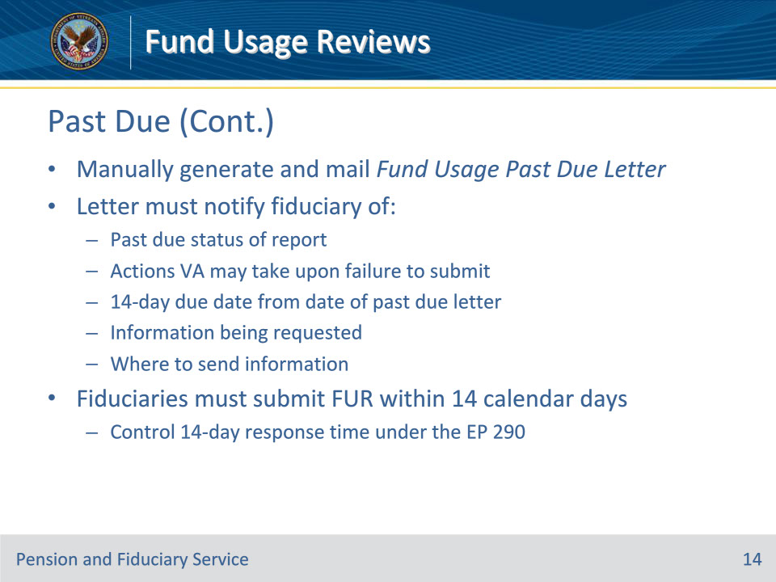
Slide notes

Policy Reference(s): FPM I.6.B.1.b.

Instructor Notes:

Hubs must manually generate and mail the Fund Usage Past Due Letter in the system. The letter must notify the fiduciary of

• the past due status of the report

• actions that the VA may take upon failure to submit financial statements

• the 14-day due date from the date of the past due letter

• the information being requested, and

• where to send the information.

Fiduciaries must submit a completed fund usage report within 14 calendar days of the date of the past due notification. Control the 14-day response time under the EP 290.

Slide 15 - Extensions
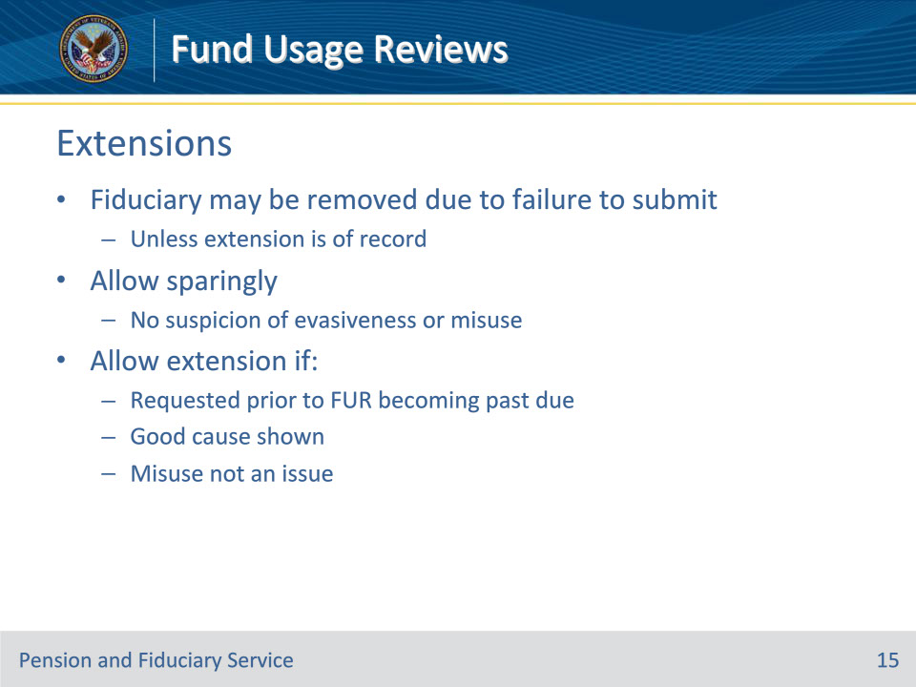
Slide notes

Policy Reference(s): FPM I.6.B.1.c.

Instructor Notes:

Fiduciaries are provided with notification to submit the fund usage report 30 days prior to the fund usage review date. The fiduciary is also given 14 additional days from the date of the Fund Usage Past Due Letter to provide hubs with the fund usage report if response to the original request is past due.

A fiduciary who fails to respond to VA’s request for information within 30 days after a request is made may be removed from service, unless an extension is of record. As a result, the hub should allow fund usage report extensions sparingly, and only in circumstances when there is no suspicion that the fiduciary is being intentionally evasive or misusing beneficiary funds.

Unless presuming good cause, the hub may allow an extension of the fund usage report due date if:

• the fiduciary

• provides a written or telephonic request for an extension prior to the fund usage request becoming past due, and

• shows good cause for not submitting the report, and

• misuse is not at issue.

Slide 16 - Extensions (Cont.)
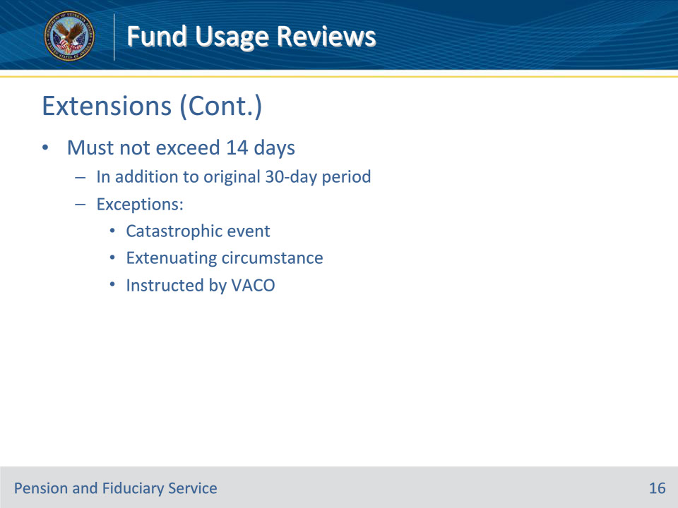
Slide notes

Policy Reference(s): FPM I.6.B.1.c.

Instructor Notes:

A good cause extension for submission of a fund usage report must not exceed 14 days and the time granted will be in addition to the original 30-day submission period.

Exception: A good cause extension may be greater than 14 days when the fiduciary is impacted by a catastrophic event, a documented extenuating circumstance exists beyond the fiduciary’s control, or as instructed by VA Central Office.

Slide 17 - Extensions (Cont.)
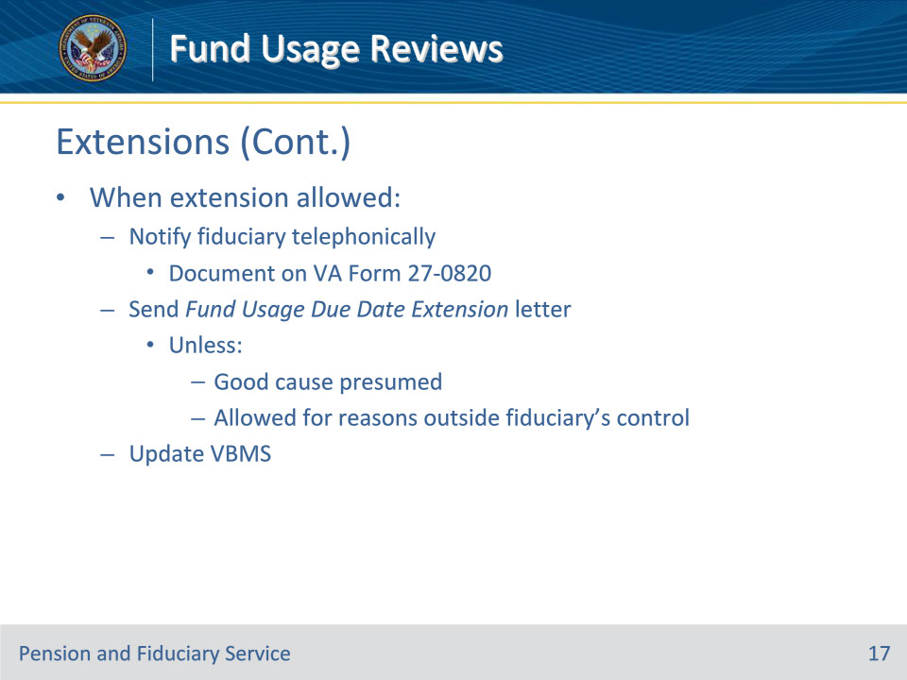
Slide notes

Policy Reference(s): FPM I.6.B.1.c.

Instructor Notes:

When the hub allows an extension of the fund usage report due date:

• contact the fiduciary telephonically to confirm that the fund usage report due date extension was granted, and document the contact on a VA Form 27-0820, Report of General Information

• send the Fund Usage Due Date Extension letter, unless good cause is presumed, or allowed for reasons outside of the fiduciary’s control, and

• update VBMS

Unless presuming good cause, do not allow an extension of the fund usage report due date if good cause is not shown, or if the report is already past due.

Slide 18 - Telephone Contact
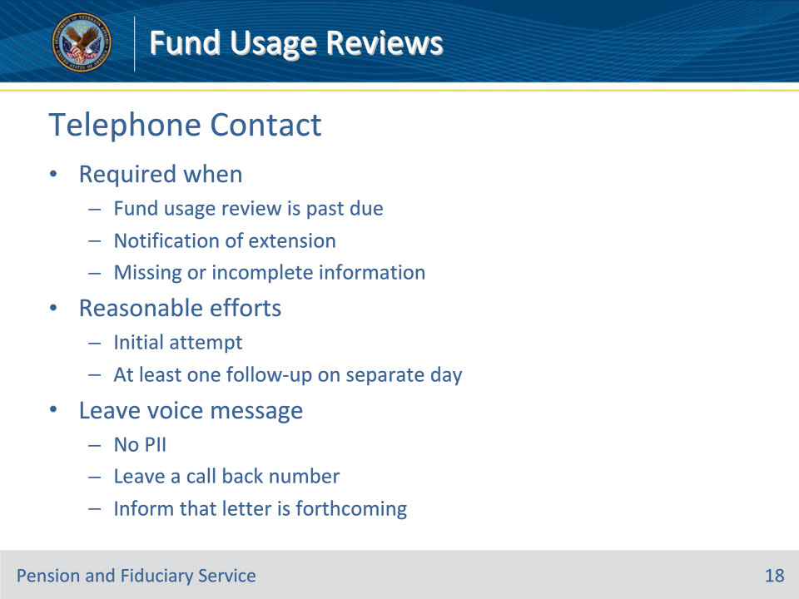
Slide notes

Policy Reference(s): FPM I.6.B.1.d.

Instructor Notes:

The hub must make reasonable efforts to contact the fiduciary telephonically at least one time when

• the fund usage report is past due

• it is necessary to notify the fiduciary of an extension of the fund usage due date, or

• the hub is unable to complete the fund usage review due to missing or incomplete information.

Reasonable efforts generally consist of

• an initial attempt to contact the fiduciary by telephone, using the most current telephone number(s) of record, and

• at least one follow-up on a separate day if the initial attempt is unsuccessful.

If the individual does not respond to the telephone call, the hub must attempt to leave a voice message. When leaving a voice message, do not provide any personally identifiable information on the recording. Leave a call back number for the fiduciary and inform the fiduciary that VA is also sending a follow-up letter detailing the information needed to approve the fund usage report.

Do not make more than two telephone attempts to contact the fiduciary to request fund usage review information before sending a written request for information.

Slide 19 - Telephone Contact (Cont.)
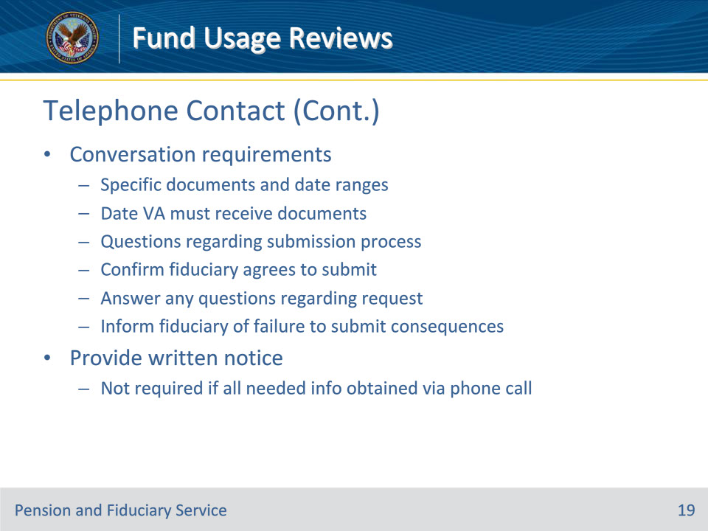
Slide notes

Policy Reference(s): FPM I.6.B.1.d.

Instructor Notes:

The conversation with the fiduciary must

• detail the specific documents and any applicable date ranges for the documents that the fiduciary must provide VA for fund usage approval

• identify the date that VA must receive the documents and/or information being requested

• ask the fiduciary if they have any questions regarding the submission process

• confirm that the fiduciary agrees to submit the requested information by the due date

• answer any questions regarding the request during the phone call, and

• inform the fiduciary that if VA does not receive the information, VA may take actions to protect the beneficiary to include

• appointing a successor fiduciary, and

• complete an investigation to determine if the funds were used in the interest of the beneficiary.

In addition to telephone contact, the hub must provide the fiduciary with written notice outlining the information VA requires when attempting to obtain the information.

A letter is not required when the information needed to complete the fund usage review is obtained telephonically and documented on a VA Form 27-0820, Report of General Information.

Slide 20 - Telephone Contact (Cont.)
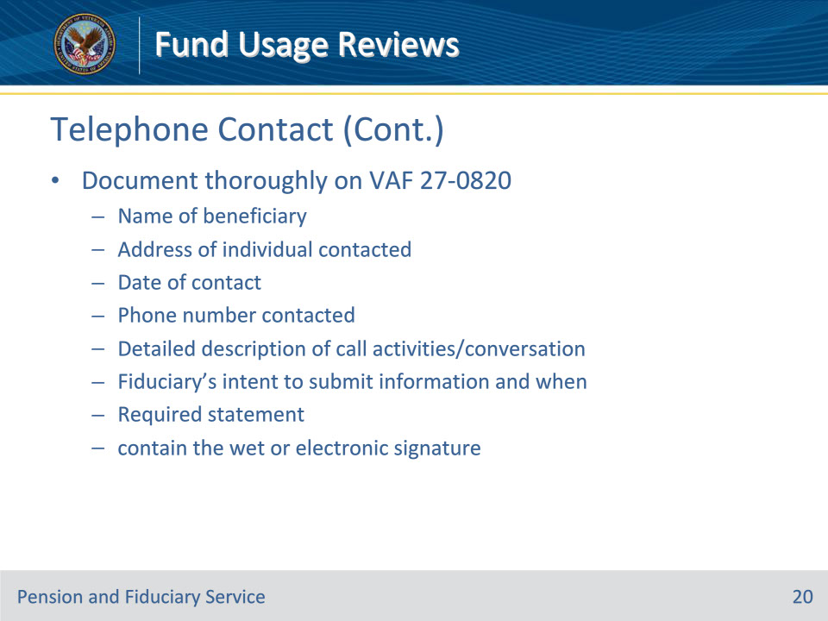

Slide notes

Policy Reference(s): FPM I.6.B.1.e.

Instructor Notes:

Document all successful and unsuccessful phone call contact with fiduciaries, beneficiaries, or other parties on a VA Form 27-0820. An individual VA Form 27-0820 must be generated for each contact and uploaded to the eFolder.

Documentation must include the:

• name of the beneficiary

• address of the individual contacted

• date of the contact

• phone number contacted, and

• wet or electronic signature of the individual completing the VA Form 27-0820.

When contact with the fiduciary is successful, the VA Form 27-0820 must also include

• a detailed description of the call activities and/or conversation

• the fiduciary’s intent to submit the fund usage report information and when they plan to do so, and

• a statement that the caller advised the fiduciary that their statement would be documented and used in the fiduciary fund usage review process.

Conversations must be thoroughly documented including specific amounts, dates, individuals involved, and circumstances as the information gathered during the call may be subject to appeal, if misuse is found.

Slide 21 - Returned Mail
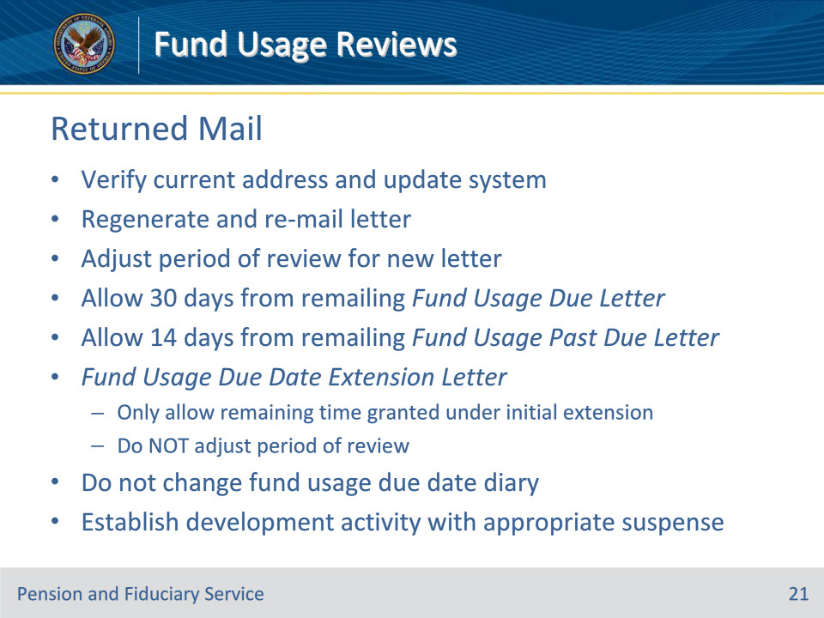
Slide notes

Policy Reference(s): FPM I.6.B.1.f.

Instructor Notes:

When the hub receives a fund usage request letter as undeliverable, verify the fiduciary’s current address and update the system.

If the fiduciary’s address is verified, regenerate and re-mail the letter. When re-generating the letter, the period of review must be adjusted to show the three-month period prior to the date of the new notification letter.

Allow the fiduciary 30 days from the date of the Fund Usage Due Letter and 14 days from the Fund Usage Past Due Letter to provide the fund usage report when the letter had to be remailed due to an incorrect address. Control the new suspense time through a development activity under the EP 290.

If the fiduciary’s address cannot be verified, follow the due diligence guidance.

When remailing the Fund Usage Due Date Extension letter, only allow the fiduciary the remaining time granted under the initial extension, and do not readjust the period of review as described above.

Do not change the fund usage due date diary when re-mailing returned mail. Establish a development activity with the appropriate suspense.
Slide 22 - Control
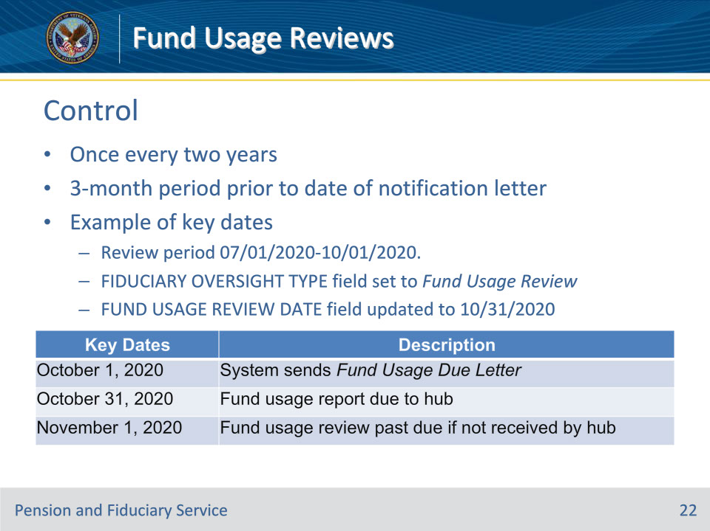
Slide notes

Policy Reference(s): FPM I.6.A.1.d.

Instructor Notes:

When required, VA-appointed fiduciaries must submit fund usage reports for review by the hub once every two years. The funds to be reviewed will incorporate the three-month period prior to the date of the notification letter.

This table is an example of a fund usage review period from July 1‎, ‎2020, through October 1, 2020. The example illustrates key dates for a fund usage review period when the FIDUCIARY OVERSIGHT TYPE field is set to Fund Usage Review with a FUND USAGE REVIEW DATE field updated with October 31, 2020.

Slide 23 - Control (Cont.)
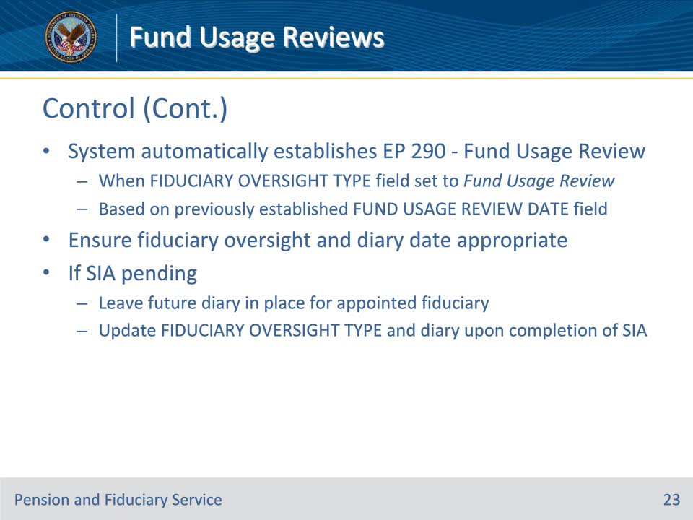
Slide notes

Policy Reference(s): FPM I.6.B.3.a.

Instructor Notes:

The system automatically establishes the EP 290 - Fund Usage Review when the FIDUCIARY OVERSIGHT TYPE field is set to Fund Usage Review based on the previously established FUND USAGE REVIEW DATE field diary information.

The hub must ensure the fiduciary oversight types and diary date entered in VBMS accurately reflects the appropriate future type and diary for the appointed fiduciary. If a successor initial appointment (SIA) is pending, leave the future diary in place for the appointed fiduciary and update the FIDUCIARY OVERSIGHT TYPE field and diary date upon completion of the SIA.

Slide 24 - Control (Cont.)
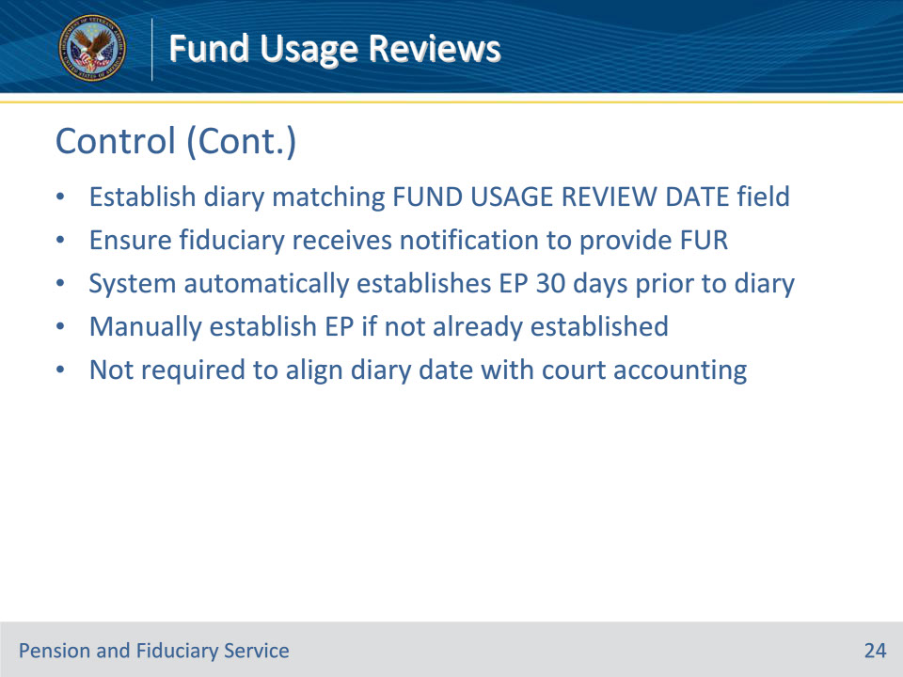
Slide notes

Policy Reference(s): FPM I.6.B.3.b.

Instructor Notes:

The hub must establish a diary with a date entered in the FUND USAGE REVIEW DATE field to ensure that the fiduciary receives notification to provide the fund usage report to VA. The system will automatically establish the fund usage review EP 30-days prior to the fund usage review diary date. Users must manually establish the EP if a fund usage review is required and the EP control was not already established.

Hubs are not required to align a diary date for a fund usage report for VA-appointed fiduciaries who are also court-appointed with a court accounting period if the fiduciary is required to provide an accounting to the court.

Slide 25 - Initial Diary
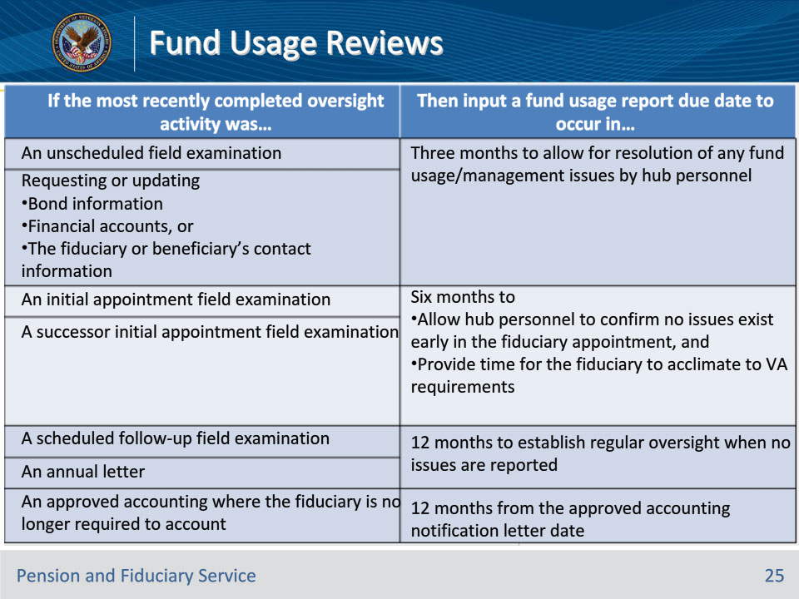
Slide notes

Policy Reference(s): FPM I.6.B.3.c.

Instructor Notes:

When a fiduciary is required to provide an initial fund usage report for a beneficiary for whom they have not provided a fund usage report in the past, the hub must establish an initial fund usage review date.

Use this table to establish the initial fund usage diary date.

Instructor Actions: Go over the table with the class.

Slide 26 - Subsequent Diaries
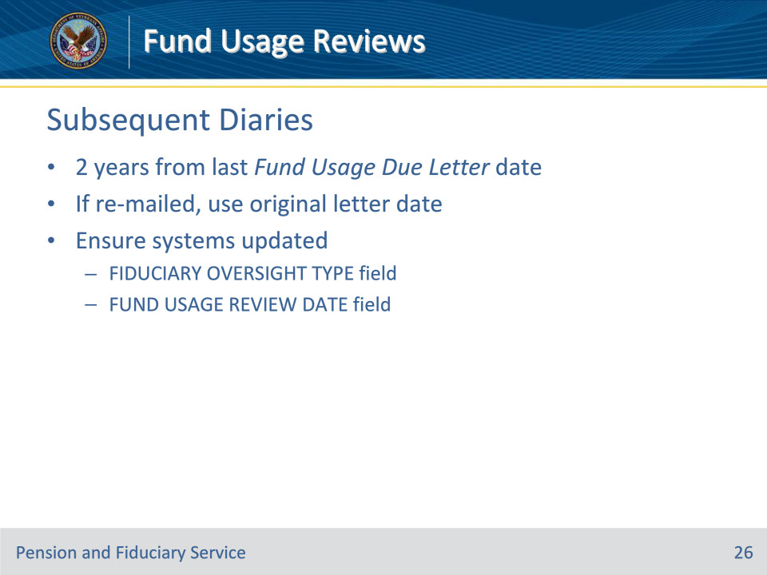
Slide notes

Policy Reference(s): FPM I.6.B.3.d.

Instructor Notes:
Establish a subsequent fund usage diary date to occur two years from the date of the Fund Usage Due Letter sent for the most recent fund usage review. The date that the letter is sent is the date listed on the Fund Usage Due Letter.

If the Fund Usage Due Letter is re-mailed because the letter was undeliverable, hubs must not use the date of the re-mailed letter to establish the future fund usage diary. Instead, hubs must utilize the date of the initial request for the fund usage review period that was most recently completed.

Hubs must ensure that the FIDUCIARY OVERSIGHT TYPE field is set to Fund Usage Review and a date is entered in the FUND USAGE REVIEW DATE field when establishing a future fund usage review diary.

Slide 27 - Subsequent Diaries (Cont.)
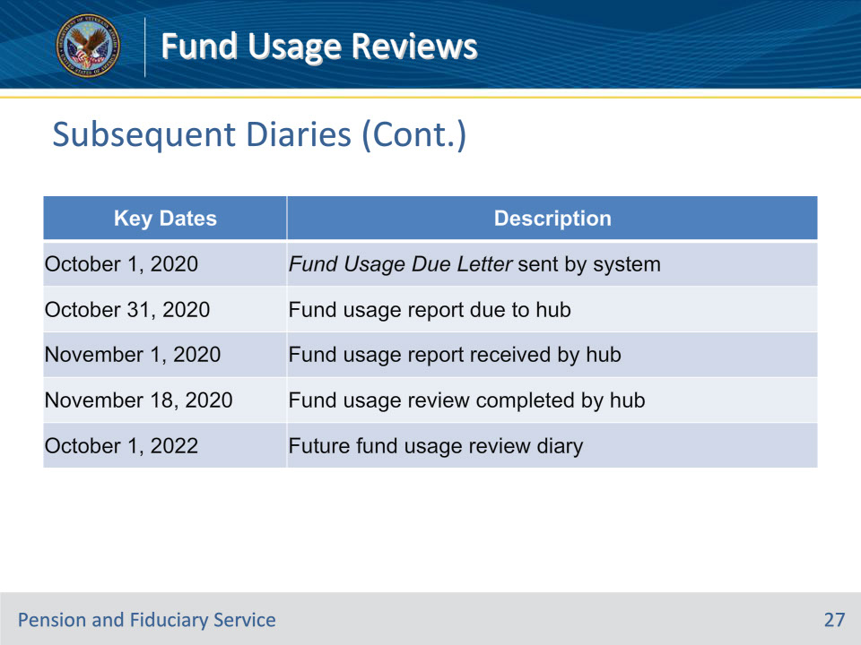
Slide notes

Policy Reference(s): FPM I.6.B.3.d.

Instructor Notes:

Examples:

• The Fund Usage Due Letter was sent on October 1, 2020. The fund usage review was completed on November 16, 2020, for the period of July 1‎, ‎2020, through October 1, 2020. The FIDUCIARY OVERSIGHT TYPE field is set to Fund Usage Review with a review date of October 1, 2022.

• The Fund Usage Due Letter was sent on October 1, 2020. The Fund Usage Due Letter was returned to VA undeliverable on October 29, 2020. The hub regenerated and re-mailed the Fund Usage Due Letter on November 1, 2020. The fund usage review was completed on November 30, 2020, for the period of August 1‎, ‎2020, through November 1, 2020 (the new three-month review period to correspond with the new notification letter). The FIDUCIARY OVERSIGHT TYPE field is set to Fund Usage Review with a review date of October 1, 2022.

This table describes key dates in detail.

Slide 28 - Assessing Fund Usage
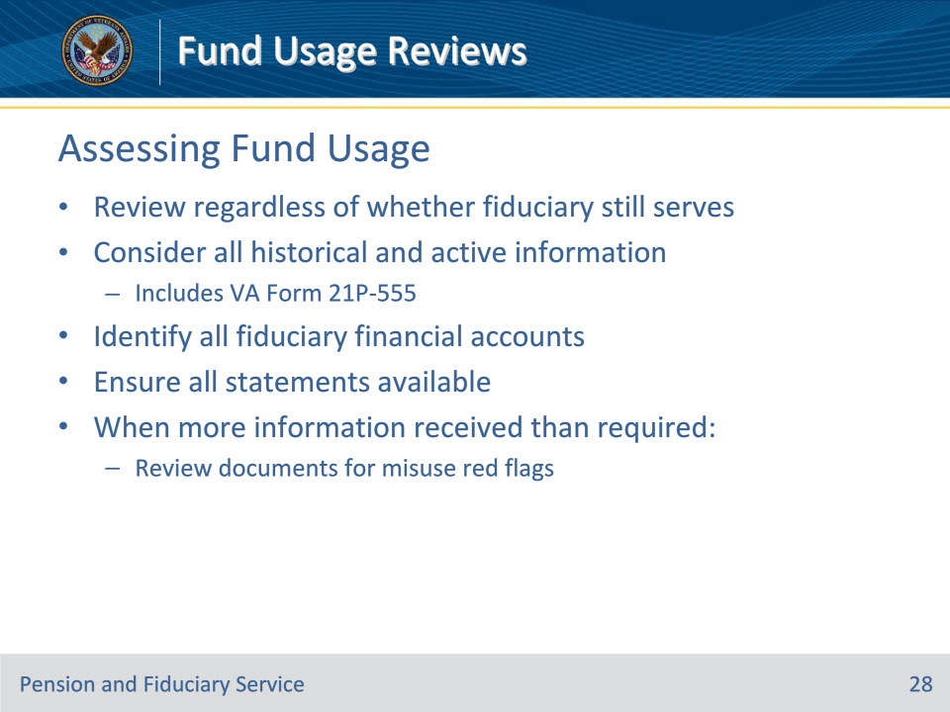
Slide notes

Policy Reference(s): FPM I.6.B.2.a.

Instructor Notes:

Hubs must take timely action to review all fund usage reports it receives and address non-receipt of fund usage reports regardless of whether the fiduciary who submitted the report is actively serving the beneficiary.

During the process of completing the fund usage review, consider all historical and active information relating to the beneficiary and fiduciary in the system and eFolder. When considering available information, identify all financial accounts that the fiduciary may manage and ensure that the financial statements are available for the period under review.

• Consideration of all historical and active information includes the VA Form 21P-555. Follow the guidance in FPM, Part I, 1.B.3.d if a VA Form 21P-555 is not of record at the time of the fund usage review.

• When a fiduciary submits more information than required for the fund usage review period, the hub must review the financial documents for red flags of misuse. This includes any financial statements that fall outside of the financial review period.

Slide 29 - Elements
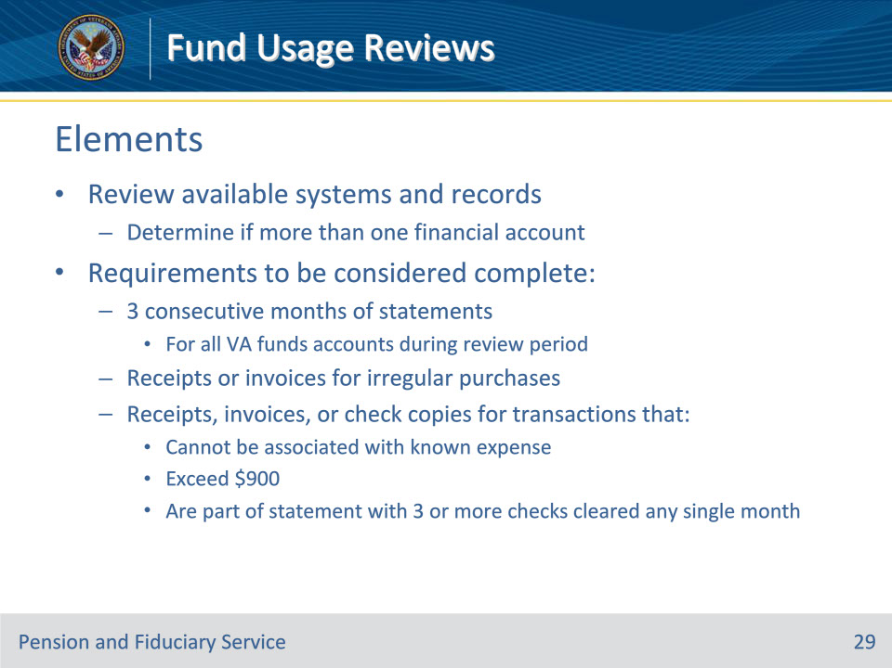
Slide notes

Policy Reference(s): FPM I.6.B.2.b.

Instructor Notes:

Review all available systems and records to determine if the fiduciary manages VA funds in more than one financial account for the same beneficiary such as a dividend paying account. In order for a fund usage report submission to be considered complete, the fiduciary must submit:

• three consecutive months of financial statements for all accounts containing VA funds for the prescribed fund usage review period

• receipts or invoices for irregular purchases, when needed to verify fund usage, and

• receipts, invoices, or copies of checks for any check transactions that

• cannot be associated with a known expense of record

• exceed $900.00, or

• are part of a financial statement in which three or more checks were cleared in any single month.

Slide 30 - Elements (Cont.)
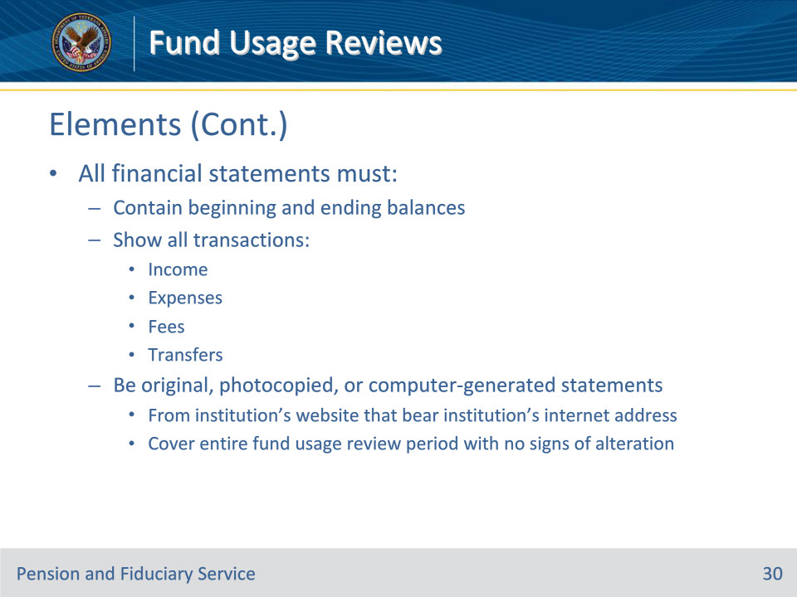
Slide notes

Policy Reference(s): FPM I.6.B.2.b.

Instructor Notes:

For the entire period under review, all financial statements must:

• contain the beginning and ending balances, generally identified by a month, quarter, or year

• show all transactions to include

• income

• expenses

• fees, and

• transfers, and

• be original, photocopied, or computer-generated statements from the financial institution’s website that bear the institution’s internet address covering the entire fund usage review period with no signs of alteration.

Slide 31 - Elements (Cont.)
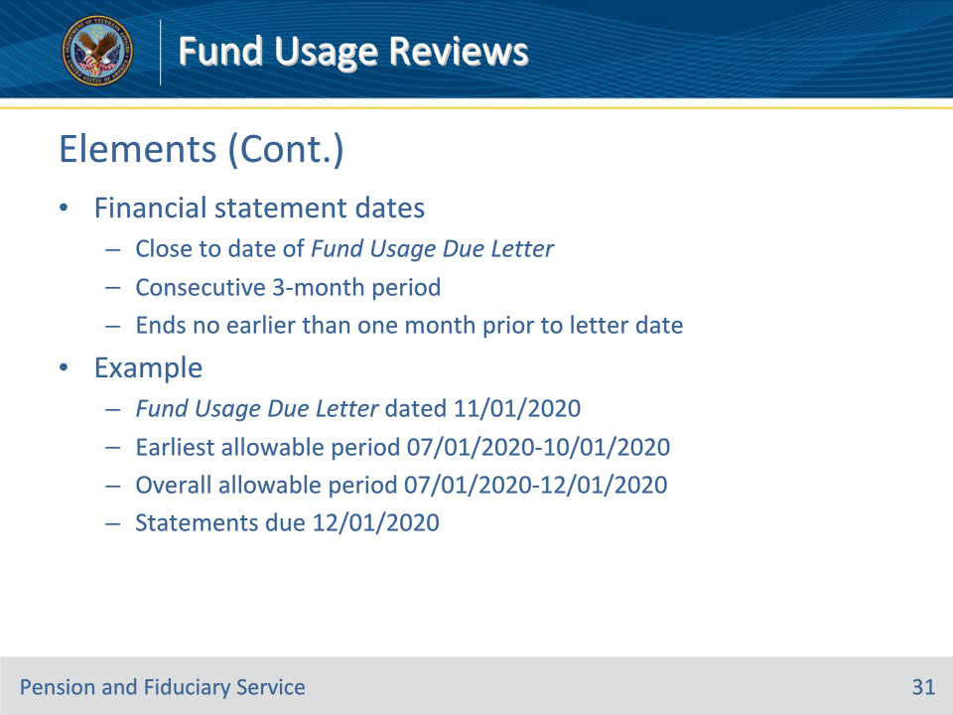
Slide notes

Policy Reference(s): FPM I.6.B.2.b.

Instructor Notes:

The period covered by the financial documentation should be close to the date of the Fund Usage Due Letter to fulfill the requirement of being within the three-month period prior to the date of the letter. The dates do not need to be the period exactly preceding the date of that letter if they cover a consecutive three-month period that ends no earlier than one month prior to the date of the Fund Usage Due Letter.

Example: If the Fund Usage Due Letter is dated November 1, 2020, the earliest three-month financial statement transaction period allowable would be July 1, 2020, to October 1, 2020. The statement transaction dates may cover any consecutive three-month period between July 1, 2020, and December 1, 2020. The due date for submitting these financial statements is December 1, 2020.

Slide 32 - Elements (Cont.)
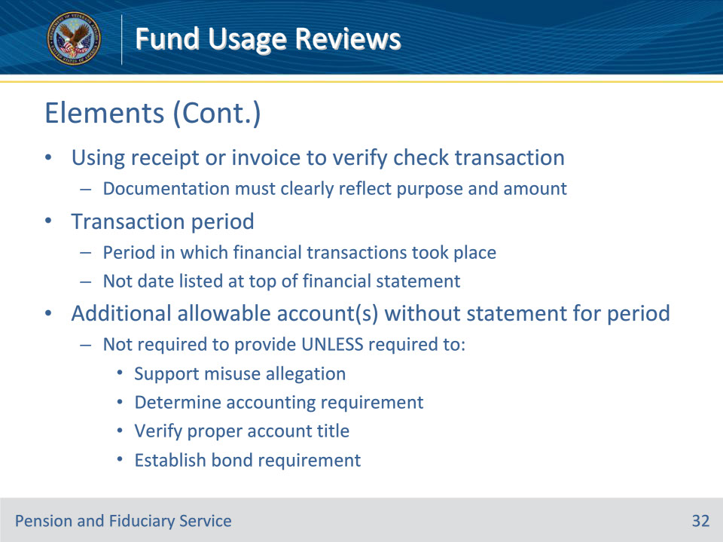
Slide notes

Policy Reference(s): FPM I.6.B.2.b.

Instructor Notes:

• When using a receipt or invoice to verify a check transaction, the documentation must clearly reflect the purpose and amount of the check(s) in question.

• Transaction period refers to the period in which the financial transactions took place and not the date listed at the top of the financial statement.

• There may be instances where fiduciaries use additional financial accounts for actions such as allowable investments and do not receive an account statement for the period under review (e.g., the three-month period prior to the date of the Fund Usage Due Letter). In this situation, the fiduciary is not required to provide the statement for that account, unless the hub requires the information to

• support an allegation of misuse

• determine if a fiduciary must account

• verify proper titling of an account, or

• establish a bond requirement.

Slide 33 - Elements (Cont.)
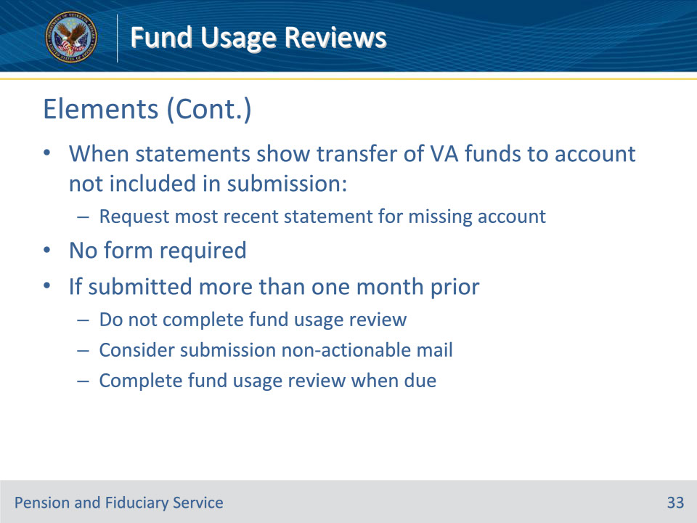
Slide notes

Policy Reference(s): FPM I.6.B.2.b.

Instructor Notes:

If the financial statements for the account in which monthly VA benefit payments are deposited show transfers of the VA funds to an account that was not included in the submission, the hub must request the most recent financial statement for the account to which the funds were transferred.

• Fiduciaries are not required to submit a form with the fund usage report.

• If the fiduciary submits the fund usage report more than one month prior to the date of the fund usage due notification letter, do not complete the fund usage review. Instead, consider the submission non-actionable mail and complete the fund usage review when it is due.

Slide 34 - Follow Up Requests
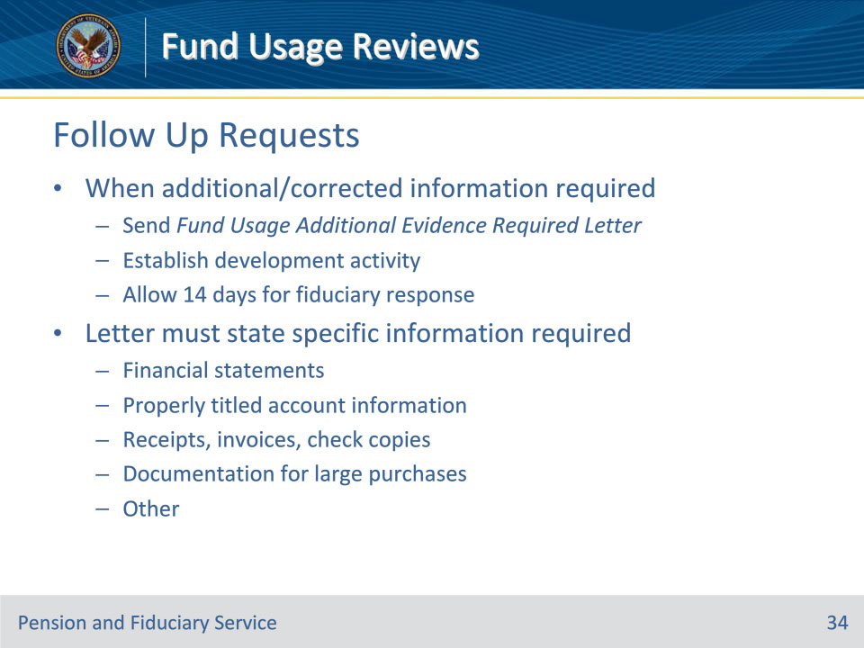
Slide notes

Policy Reference(s): FPM I.6.B.1.g.

Instructor Notes:

To ensure the beneficiary’s funds are being used for the use and benefit of the beneficiary and the beneficiary’s dependents, a full and accurate report of fund usage must be provided by the fiduciary.

Additional and/or corrected information relating to fund usage must be requested when not of record and fiduciaries must receive a written notification letter of the request. The fiduciary must provide the additional and/or corrected information within 14 days of VA’s request. Establish a development activity for the request of the corrected information and send the Fund Usage Additional Evidence Required Letter.

The notification letter must specifically state the information the hub needs to complete the fund usage review including (but not limited to)

• financial statements

• properly titled account information

• receipts, invoices, or copies of checks
• documentation or receipts for large purchases

Slide 35 - Follow Up Requests (Cont.)
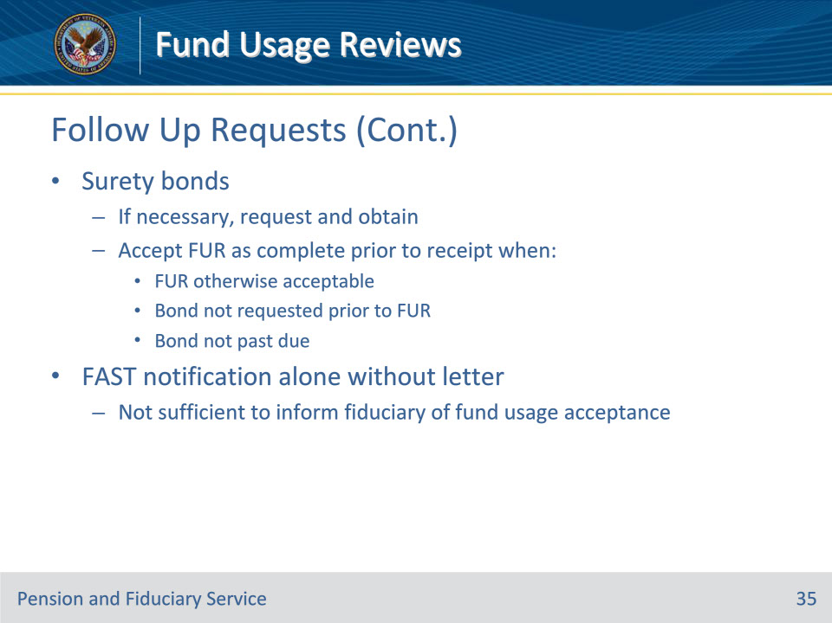
Slide notes

Policy Reference(s): FPM I.6.B.1.g.

Instructor Notes:

If necessary, request and obtain a bond. The hub may accept the fund usage report as complete prior to receiving evidence of the surety bond if the report is otherwise acceptable and the

• bond was not requested from the fiduciary prior to the fund usage review, or

• fiduciary’s bond submission is not past due

When a bond is required and the situation meets the criteria described above, complete the fund usage review.

Electronic notification through FAST alone without the appropriate notification letter is not sufficient to inform the fiduciary of fund usage acceptance.

Slide 36 - Evaluating Statements
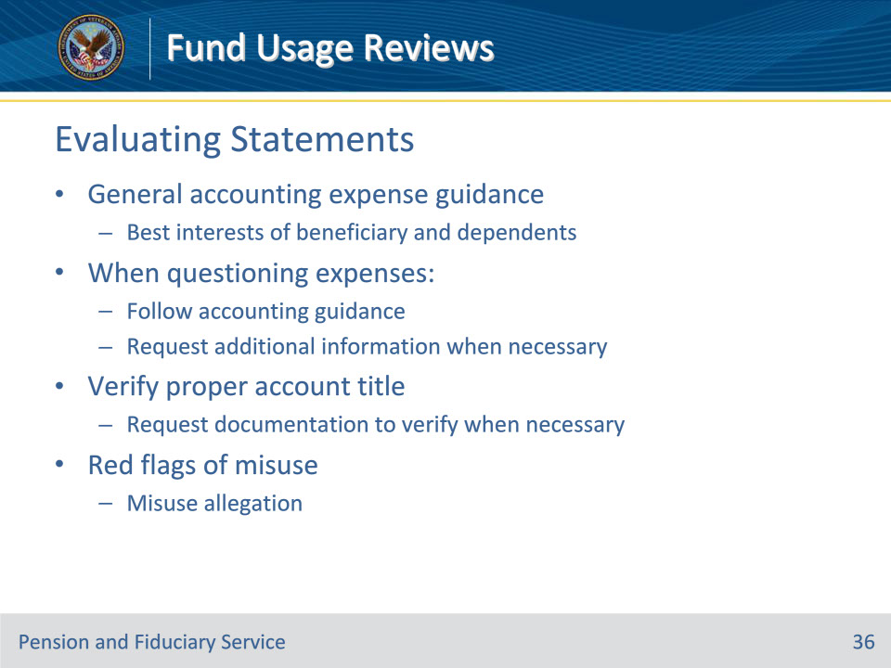
Slide notes

Policy Reference(s): FPM I.6.B.2.c.

Instructor Notes:

Follow the general accounting guidance on fiduciary expenses to determine if expenses on the fiduciary’s fund usage report are questionable when reviewing all financial statements.

When questioning expenditures, follow accounting guidance. Request additional information when necessary.

Verify that accounts are properly titled. If there is evidence to suggest that the accounts are not properly titled, request documentation to verify.

To satisfy the purpose of the fund usage review, hubs must review all financial statements that contain VA beneficiary funds to determine if red flags of misuse exist in the fiduciaries fund usage statements.

If red flags of misuse are identified, the hub must take immediate action to establish an allegation of misuse.

Slide 37 - Review Completion
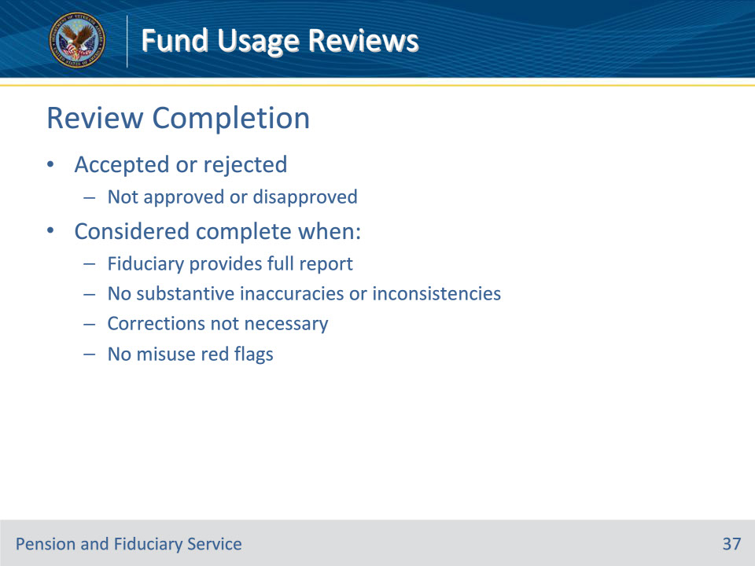
Slide notes

Policy Reference(s): FPM I.6.A.2.a.

Instructor Notes:

Fund usage reviews are not approved or disapproved. Instead, the review is considered either accepted or rejected. Accepted fund usage reviews are considered complete when

• the fiduciary provides a full report

• no substantive inaccuracies or inconsistencies in reported fund usage exist

• corrections are not necessary, and

• no red flags of misuse exist.

Slide 38 - Review Completion (Cont.)
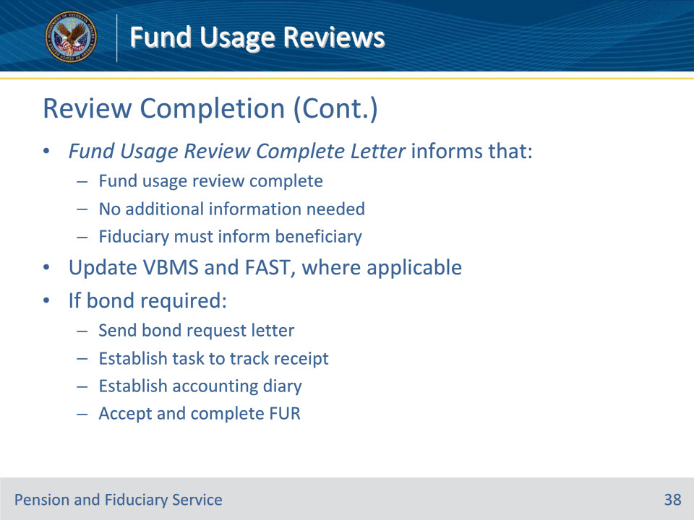
Slide notes

Policy Reference(s): FPM I.6.A.2.a.

Instructor Notes:

Upon successful completion and acceptance of the fund usage review, send the fiduciary the Fund Usage Review Complete Letter. The notification letter must inform the fiduciary that

• the fund usage report for the period under review is complete

• no additional information is needed regarding the fund usage review at this time, and

• the fiduciary must contact the beneficiary to confirm the completion of the periodic review.

If the fund usage review is accepted, the hub must also update VBMS and, as applicable, FAST to ensure that the system reflects the correct review status.

If the fiduciary submits fund usage documents in FAST and through other approved modes (for example, CM, fax, etc.), the hub must resolve the FAST submission.

If a bond is required and no other information is needed to accept the fund usage review:

• send a bond request letter

• establish the appropriate administrative task to track for receipt of the bond

• establish an accounting diary

• accept and complete the fund usage review

Slide 39 - Incomplete Review
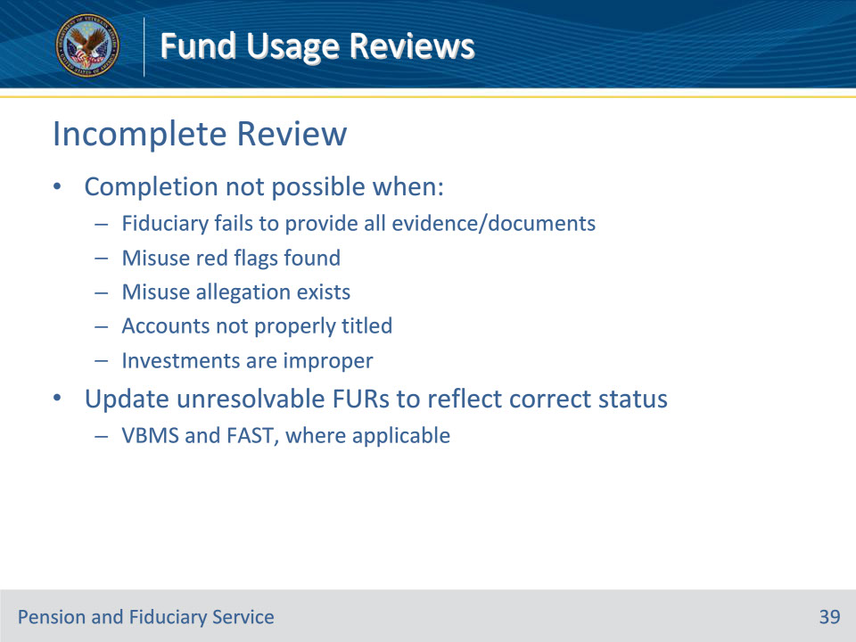
Slide notes

Policy Reference(s): FPM I.6.A.2.b.

Instructor Notes:

Completion of the fund usage review is not possible when

• the fiduciary fails to provide all fund usage documents or evidence VA requests

• red flags of misuse are found

• an allegation of misuse exists

• all accounts are not properly titled, or

• investments are improper

When fund usage reviews cannot be completed, VBMS and, as applicable, FAST must be updated to reflect the correct system status.

Slide 40 - Incomplete Review: When completion is not possible:
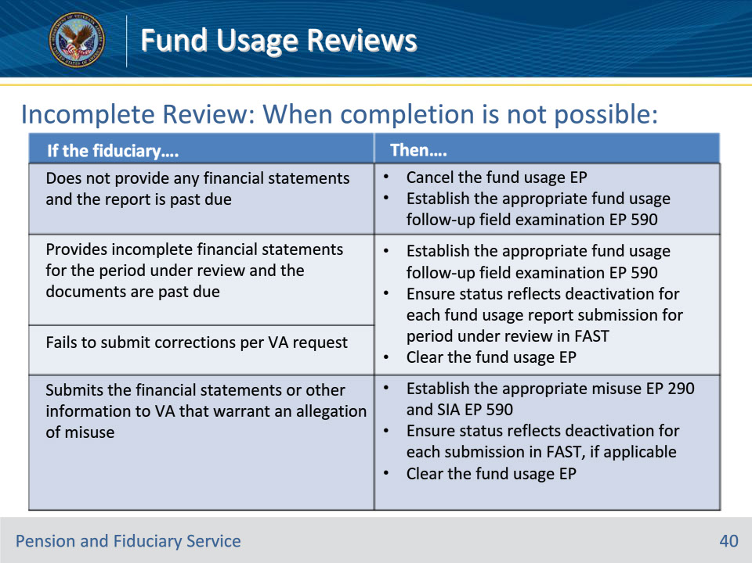
Slide notes

Policy Reference(s): FPM I.6.A.2.c.

Instructor Notes:

When completion of the fund usage review is not possible because the fiduciary failed to provide the information necessary to complete the review, as requested, the hub must take immediate action to move the case to the next stage of processing.

Use this table to determine the action required when a fund usage review cannot be completed.

• Consider if the fiduciary’s actions demonstrate willful neglect or refusal during the fund usage review process.
• Do not update the future fund usage diary date when completing the actions in the table above. The FE must update the fund usage future diary date after completing the appropriate field examination.

• If the fiduciary states that they will not comply with any element of VA’s required fund usage review process at any time, regardless of whether VA has notified the fiduciary to submit the fund usage report, the hub must treat the statement as prima facie evidence of misuse.

• Do not routinely suspend benefit payments because the fiduciary does not respond to VA’s request for the fund usage report.

Slide 41 - Incorrect FAST Submission
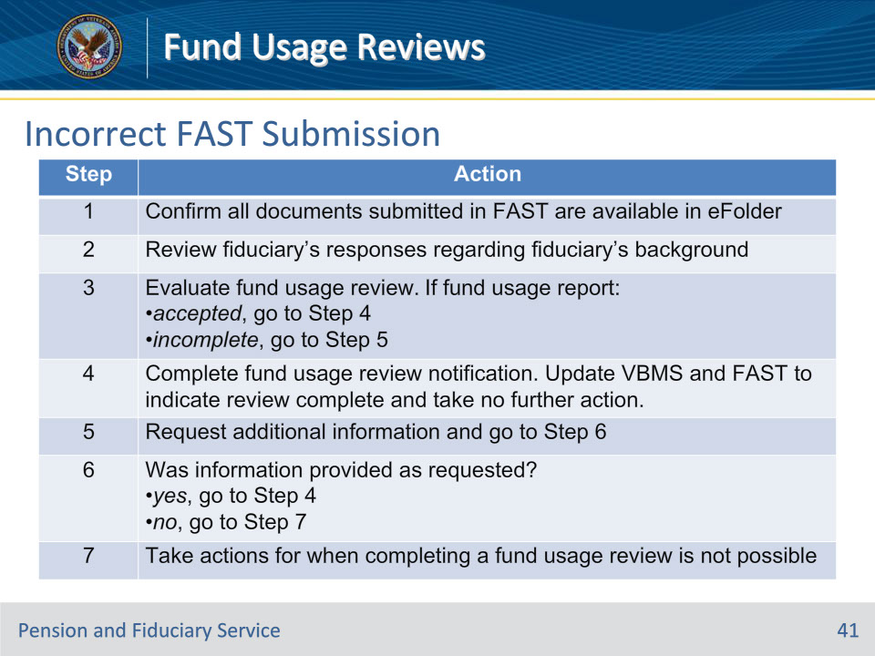
Slide notes

Policy Reference(s): FPM I.6.A.2.d.

Instructor Notes:

To comply with VA’s request for information relating to the management of VA beneficiary funds, the fiduciary may submit the incorrect type of report in FAST.

Follow the steps in this table when the fiduciary uses the accounting submission option in FAST to submit a fund usage report.

Note for step 2: If the responses indicate a bar to service exists, complete the fund usage review and establish a successor initial appointment field exam EP.

Note for step 5: Update both VBMS and FAST appropriately.

Slide 42 - Questions?
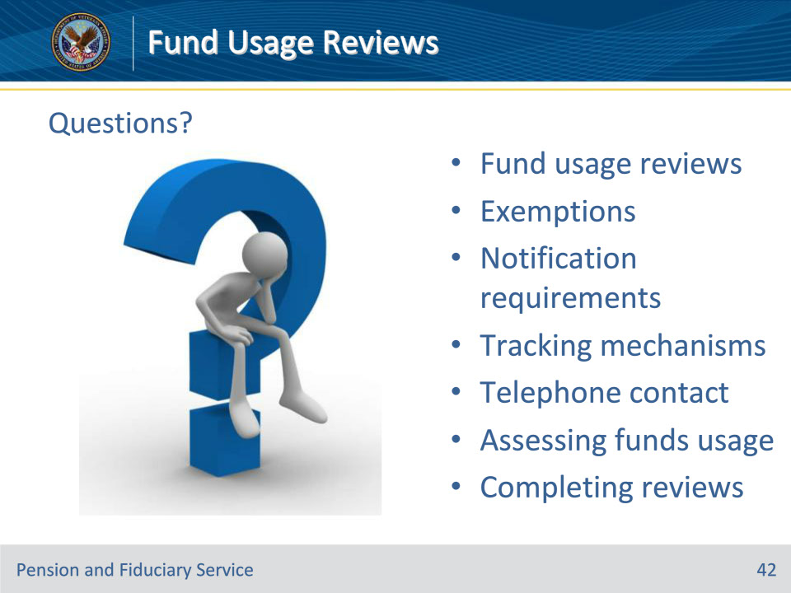
Slide notes

Instructor Notes:

We discussed the following topics today:

• fund usage reviews

• exemptions

• notification requirements

• Tracking mechanisms

• telephone contact

• Assessing funds usage

• Completing reviews

Are there any questions?

Slide 43 - TMS Survey
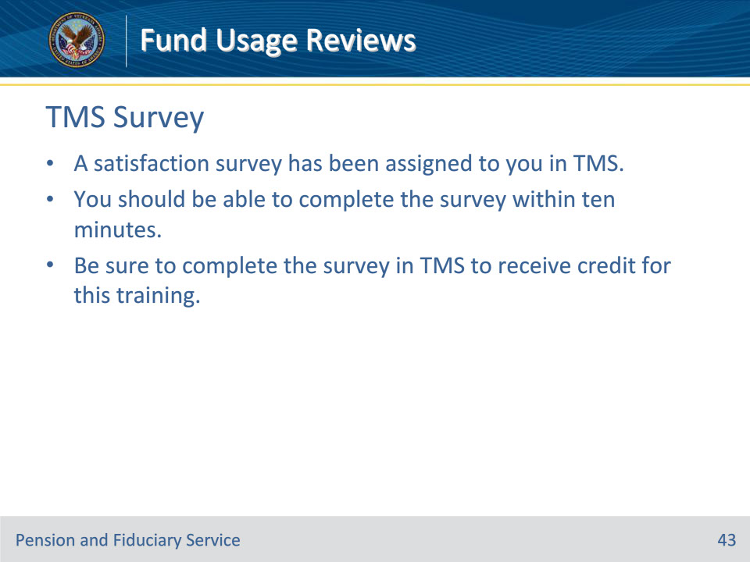
Slide notes

Instructor Notes:

A satisfaction survey has been assigned to you in TMS. You should be able to complete the survey within ten minutes. Completing the survey will allow you to receive credit for this training.

