Education Service
Veterans Appeals Improvement and Modernization Act of 2017
Processing Supplemental Claims – AMA
(Refresher Training)
Lesson Plan

August 2022
Version 2.0

Lesson Overview
Topic |  | Description
Time Estimate: |  | 1.5 hour
Purpose of the Lesson: |  | The purpose of this lesson is to provide refresher training on processing requests under the Appeals Modernization Act (AMA) Supplemental Claim - AMA (AMA–SC)
Prerequisite Training Requirements: |  | None
Target Audience: |  | This lesson is designed for the following audiences:  - Veterans Claims Examiners (VCEs)  - Senior Veterans Claims Examiners (SVCEs)  - Education Quality Training Specialists (EQTS)
Lesson References: |  | - Veterans Appeals Improvement and Modernization Act of 2017  - M22-4 Part 3: Chapter 2.04 Appeals  - Veterans Benefits Administration (Appeals Modernization)
Lesson Objectives: |  | After you have completed the Processing Procedures for Higher Level Reviews (Refresher Training), you will be able to:  - Differentiate between the three AMA lanes/review options  - Establish appropriate end-product (EP) for AMA - SC requests  - Review and process an AMA - SC request
What You Need: |  | Processing Procedures for Supplemental Claim - AMA (AMA - SC) (Refresher Training)
Post Training Requirements: |  | Upon completion of the of the lesson, participants are required to complete an online lesson assessment and survey in Talent Management System (TMS).  To demonstrate successful completion of the lesson participants must pass the assessment with a score of at least 80%.  Participants must also complete the online survey to earn credit for completion of the lesson.
 | PowerPoint Slides |  | Instructor Activities
 | 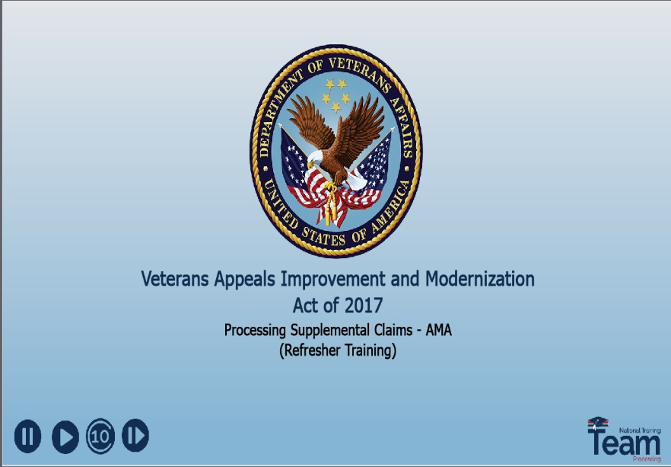 |  | Display Slide 1  In this training, I will be discussing Supplemental Claims under the Appeals Modernization Act (AMA) to be referred to as AMA-SC throughout the remainder of the training. This AMA option was previously known as Reconsideration of Supplemental Claims (RSC).  This is a refresher training for those individuals who already process AMA-SC requests.
 | 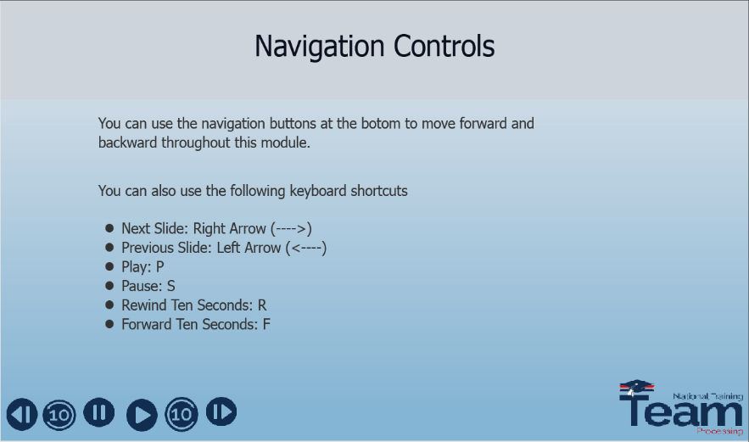 |  | Display Slide 2 “Navigation Controls”  To move throughout the presentation, you may use the navigation buttons at the bottom of the screen, or the keyboard shortcuts shown on the screen to move forwards and backwards throughout the presentation.
 | 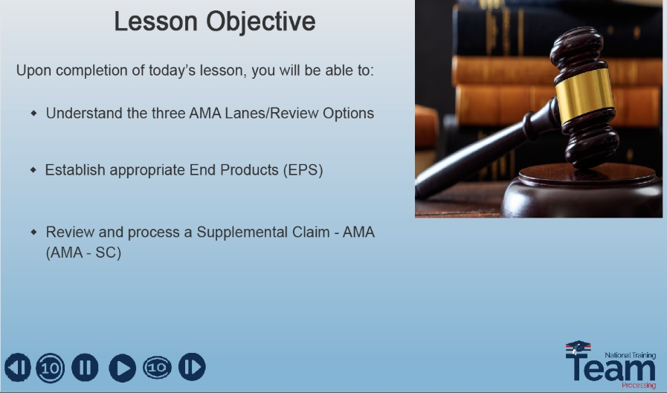 |  | Display Slide 3 “Lesson Objective”  By the end of this lesson, you will be able to:  - Understand the 3 AMA lanes, also known as review options  - Establish appropriate End Products for AMA-SC requests  - and Review and process an AMA Supplemental Claim
 | 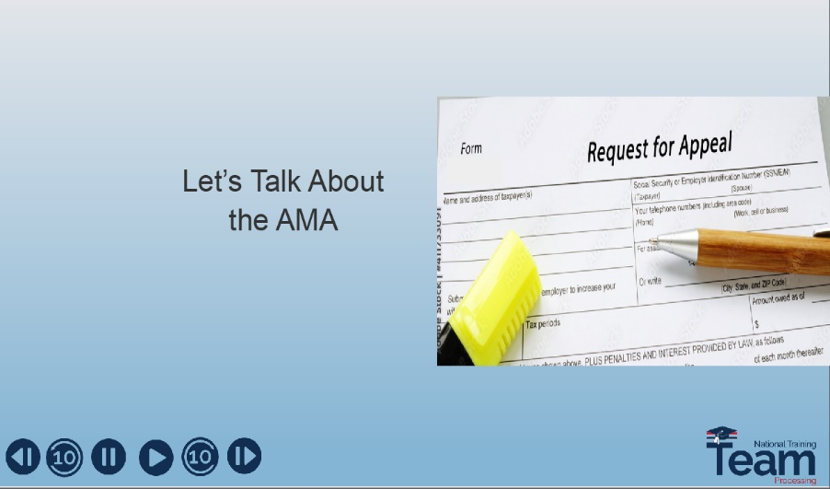 |  | Display Slide 4 “Let’s Talk about the AMA”  Before we go into detail about the AMA-SC process, let’s first discuss the origin of the AMA and the three lanes
 | 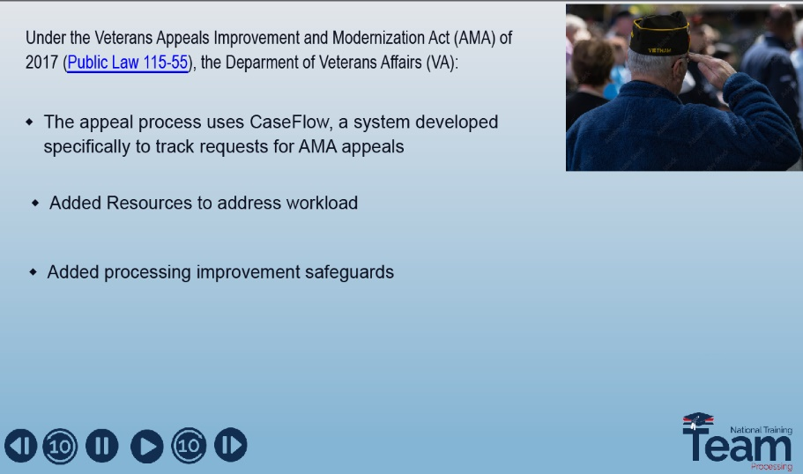 |  | Display Slide 5  The AMA modernized the appeals process by making it more user- friendly for veterans and their dependents.  - A system called CaseFlow was developed specifically to track requests for AMA appeals  - The AMA added resources to assist with workload  - Improvement safeguards were added to ensure claimants receive the earliest effective date possible for their claims, and;  - AMA Facilitates more timely decisions
 | 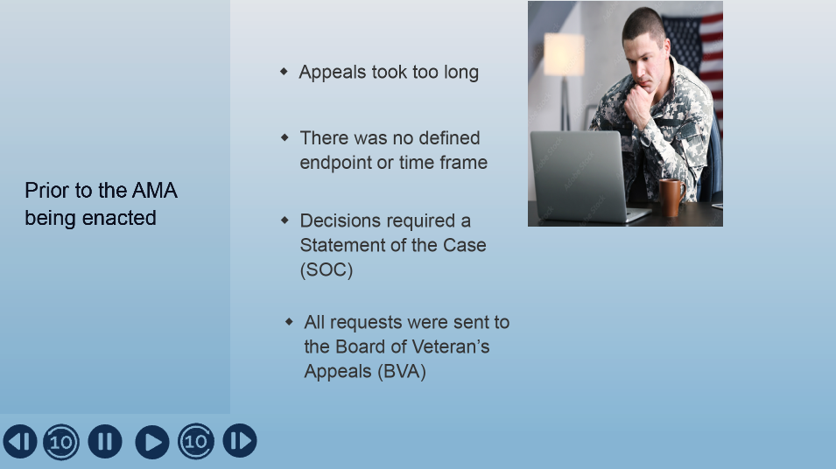 |  | Display Slide 6  Prior to the AMA being enacted:  - Appeals could take years before a final decision would be reached  - There was no defined endpoint or timeframe  - Decisions required a Statement of the Case (SOC) which added additional time to the appellate process  - All requests were required to be sent to BVA and this led to a backlog of cases and additional time to process requests
 | 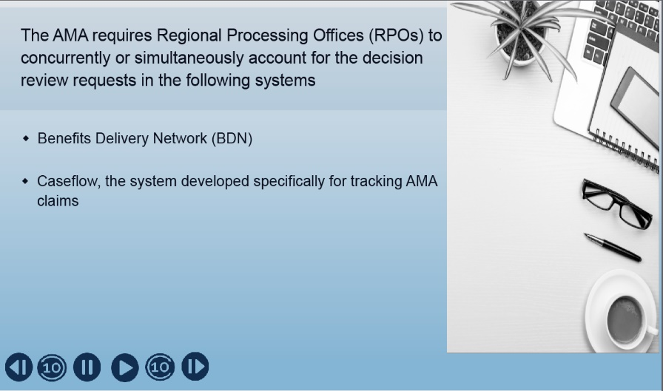 |  | Display Slide 7  Before the AMA was enacted, it was difficult to track an appeal’s status after the initial SOC, as there was no consistency in how appeals were tracked.  In order to combat these issues, Caseflow, uniform BDN end products, and TIMS document names were created.  BDN and Caseflow are used to account for the notice of decision review requests either concurrently or simultaneously.
 | 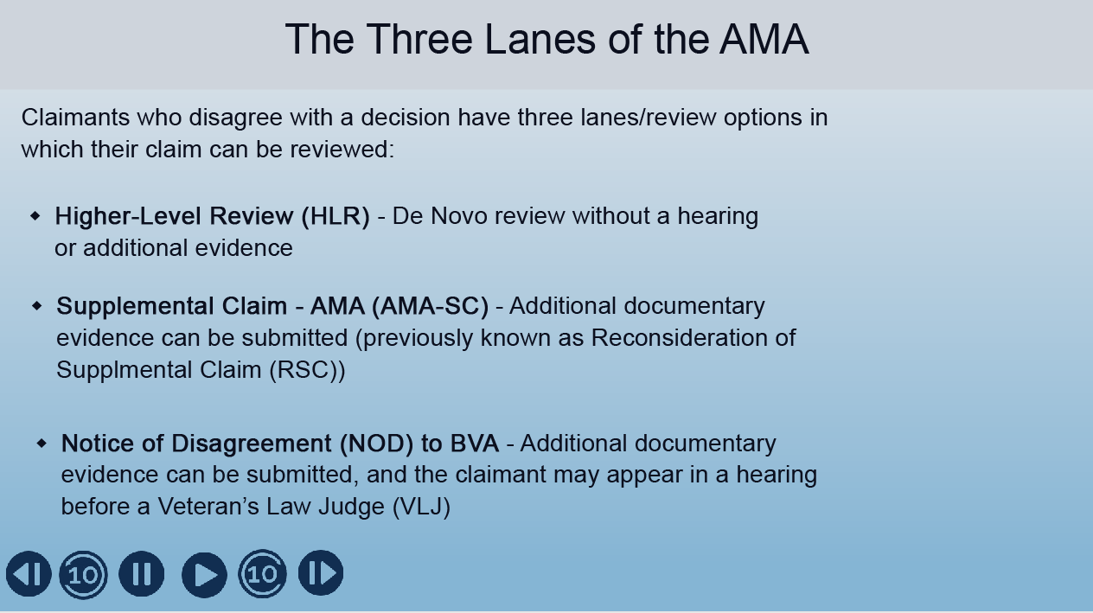 |  | Display Slide 8 “The Three Lanes of the AMA”  I will now give you a brief overview of the 3 different lanes/options available under the AMA  - The first lane/review option available is Higher-Level Review (HLR). This option is for claimants who feel a processing mistake was made during the processing of their claim and they would like a second review by a different official to catch the error and grant their request. Under this lane, we mention De Novo review. This means the decision on appeal is made by reviewing all available evidence which was in the file at the time the original decision was made, without deference to a previous decision, or taking a “new look” at an issue with fresh eyes, without bias to a previous decision made. No additional evidence is considered under this lane.  - The next lane/review option is the Supplemental Claims – AMA (AMA-SC) option. As mentioned earlier in the presentation, this was previously called Reconsideration of Supplemental Claim (RSC). This option allows for new evidence and works best for claimants who feel their original claim was missing relevant information and they feel new evidence could influence the outcome of their appeal.
 |  |  | - The final lane/review option is for claimants who would like to send their appeal directly to the Board of Veterans Appeals (BVA). It’s often used after a claimant has received a decision from either an HLR or AMA-SC and they still are not satisfied with the decision.
 | 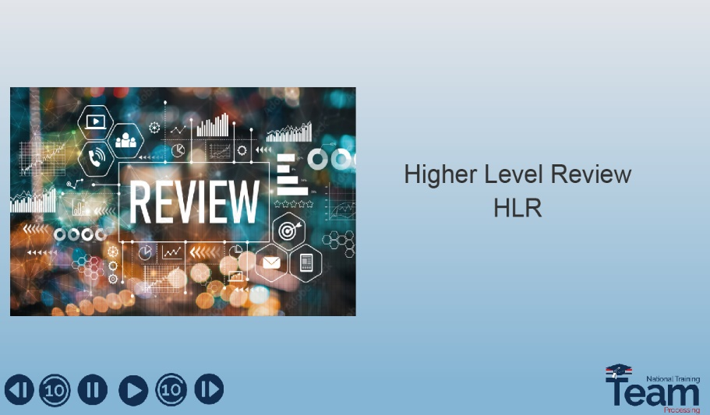 |  | Display Slide 9 “Higher Level Review (HLR)”  Now that I’ve explained the three AMA lane/review options, I’d like to provide more information on each. Remember, this training is for the AMA-SC lane/review option so I will be going into greater detail on AMA-SC later in this presentation.  But first, let’s discuss the Higher-Level Review (HLR) option.
 | 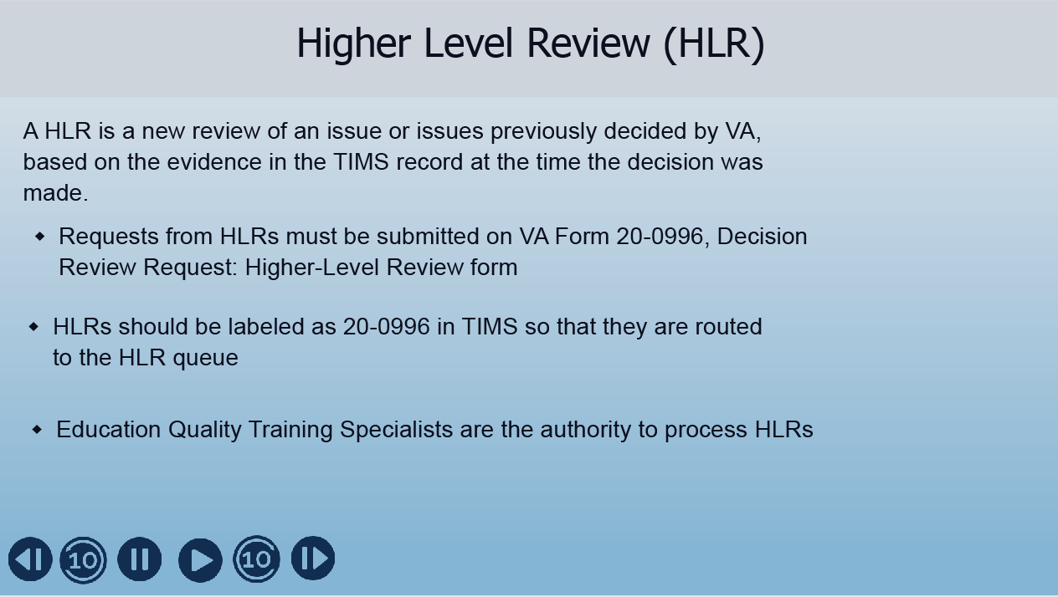 |  | Display Slide 10 “Higher Level Review (HLR)”  HLRs are a new review of an issue previously decided by VA based on evidence already in the claims folder at the time the original decision was made.  Some important things to know about HLRs:  - They must be submitted on a VA Form 20-0996  - They should be labeled as a 20-0996 in TIMS, so that they are routed to the correct queue  - HLRs are processed by Education Quality Training Specialists
 |  |  | Please note that claimants also have the option of requesting a different RPO review their claim. However, if it is a specialized claim only processed by one office, those requests will be reviewed by the same office who issued the original decision that is being appealed.
 | 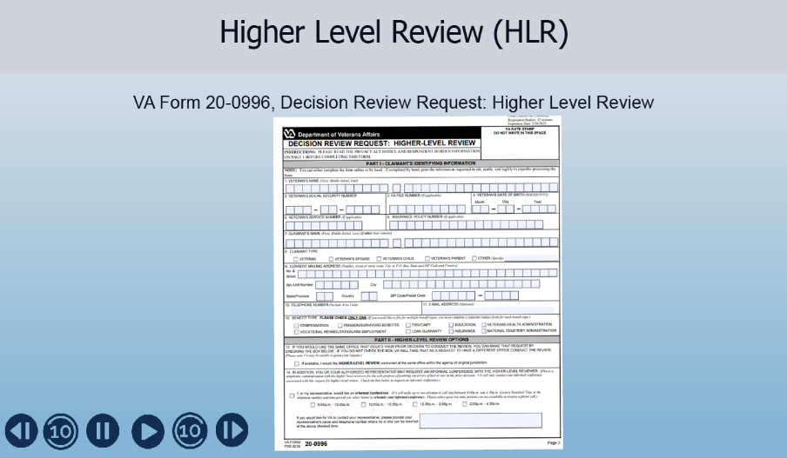 |  | Display Slide 11 “Higher Level Review (HLR)”  On this slide is an image of the VA Form 20-0996. This is the form used for Higher Level review requests and it must be on file before the processing of the HLR. Remember, if the request is not on this form, it will not be considered an HLR.
 | 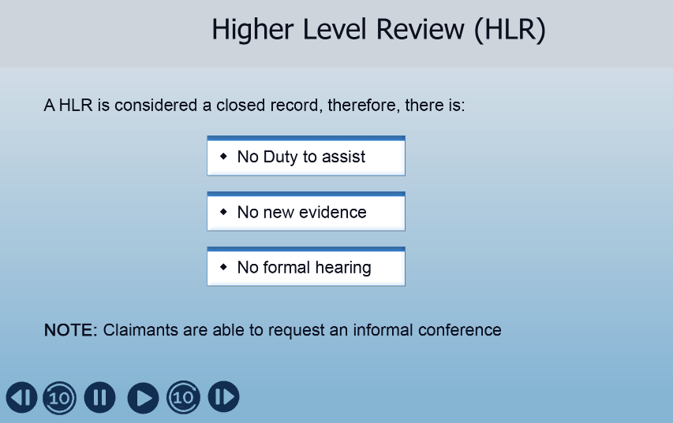 |  | Display Slide 12 “Higher Level Review (HLR)”  Because an HLR is considered a closed record, there is:  - No duty to assist  - No new evidence  - No formal hearing  However, claimants can request an informal conference. This informal conference allows the claimant to discuss the decision previously made. They can only argue their case based on the information already on file. These informal conferences are done over the phone and no new evidence will be accepted.
 | 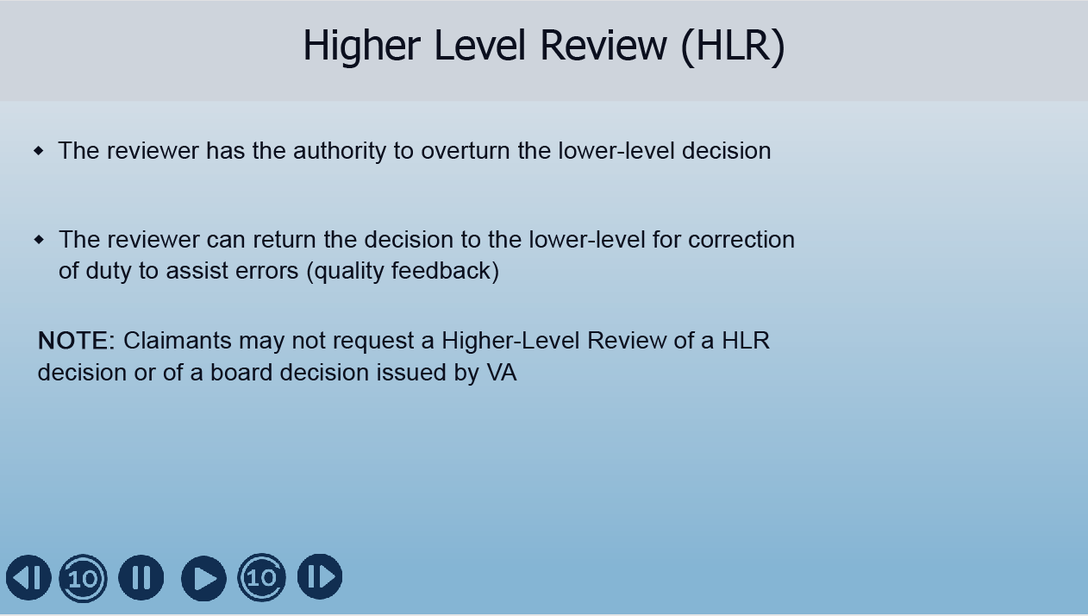 |  | Display Slide 13 “Higher Level Review (HLR)”  Upon review of the evidence of record, the reviewer does have the authority to overturn the lower-level decision. The reviewer can also return the case back to the lower level for correction of any duty to assist error. This could include inadequate development errors or failure to request additional information the first time around.  It's important to note the claimant may not have an HLR review if a previous HLR or BVA decision had been made on the initial claim.
 | 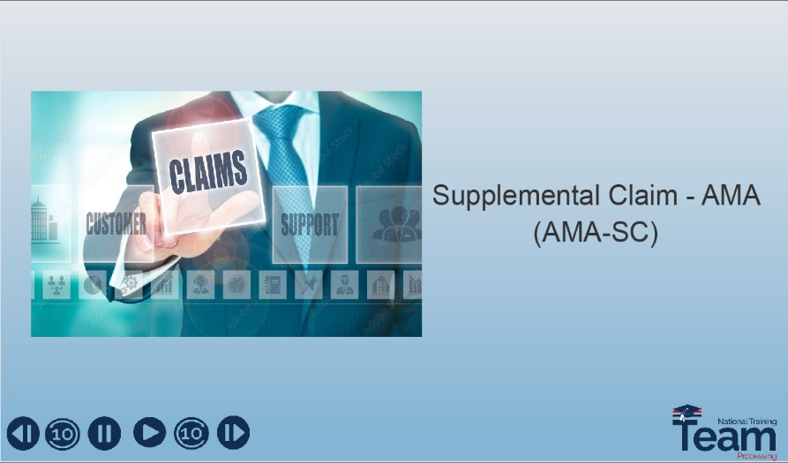 |  | Display Slide 14 “Supplemental Claim – AMA (AMA-SC)”  Okay, we have discussed HLRs, now let’s talk about the next lane, which is the Supplemental Claim – AMA
 | 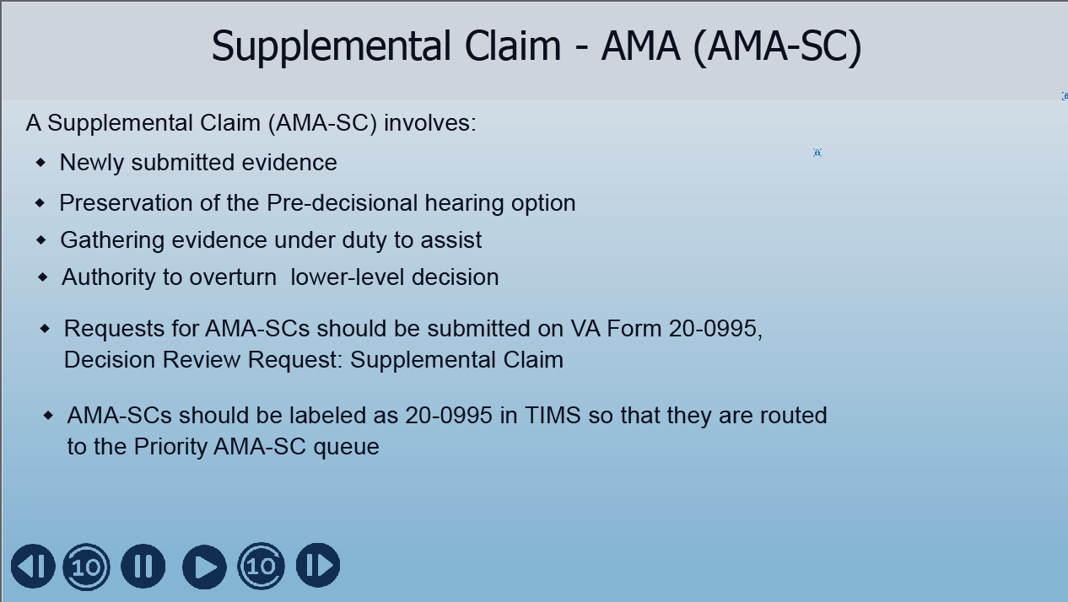 |  | Display Slide 15 “Supplemental Claim – AMA (AMA-SC)”  Unlike HLRs, the AMA-SC allows the claimant to submit new evidence  All AMA-SC requests are submitted on a VA Form 20-0995.  When these requests are received, they are labeled as 20-0995 so that they are routed to the correct queue in TIMS.
 | 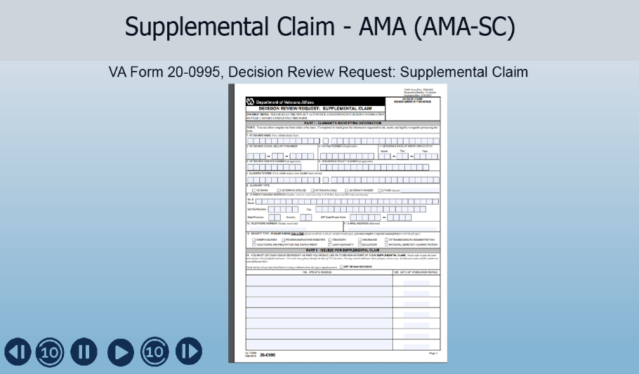 |  | Display Slide 16 “Supplemental Claim – AMA (AMA-SC)”  On this slide is an image of the VA form 20-0995. This is the form used for AMA-SC review requests and must be on file before the processing of an AMA-SC.  If the proper form is not on file, the request will not be considered an AMA-SC.
 | 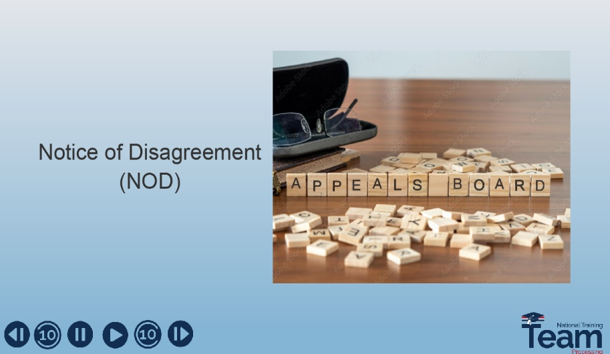 |  | Display Slide 17 “Notice of Disagreement (NOD)”  The final AMA lane/review option available is Notice of Disagreement or NOD  Let’s talk about this option
 | 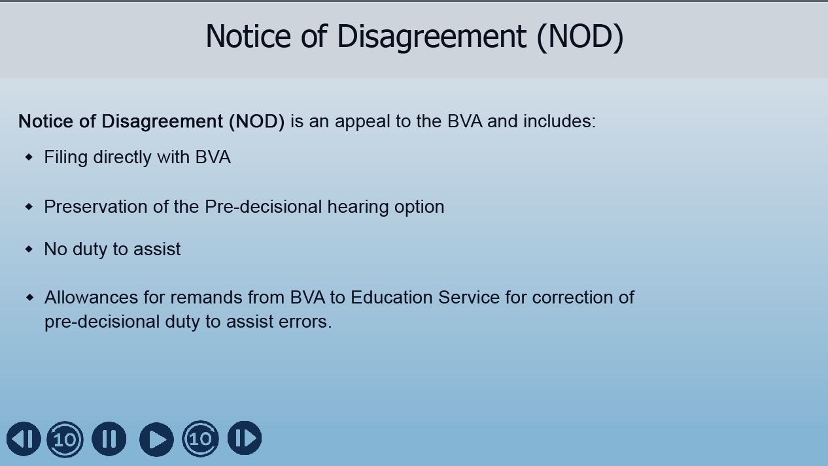 |  | Display Slide 18 “Notice of Disagreement (NOD)”  A Notice of Disagreement must be submitted on a VA Form 10182.  This option includes a choice of three additional dockets:  - Direct Review  - Evidence Submission  - Hearing  There is no duty to assist the claimant by BVA. BVA does have the option to remand the appeal to the RPO for corrections or additional evidence gathering
 | 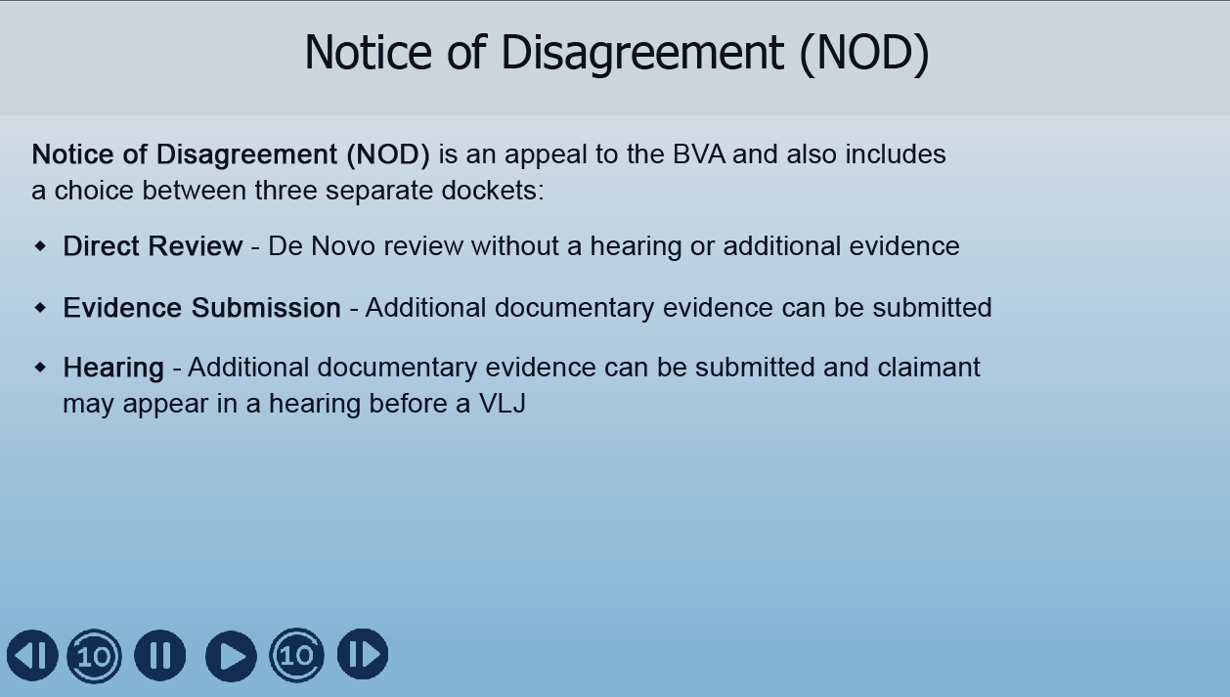 |  | Display Slide 19 “Notice of Disagreement (NOD)”  As mentioned in the previous slide, a Notice of Disagreement has the choice of three additional dockets  - Direct Review, which is a De Novo review without a hearing or additional evidence,  - Evidence Submission, which allows the claimant to submit additional documentary evidence, or:  - Hearing in which the claimant may appear in a hearing before a Veterans Law Judge (VLJ) as well as submit additional documentary evidence.
 | 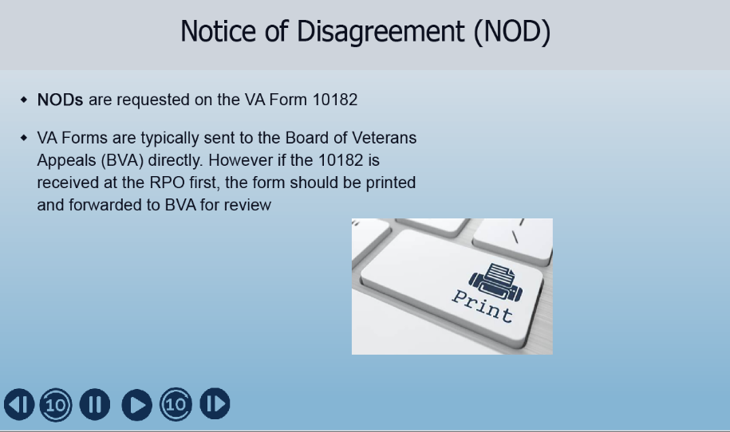 |  | Display Slide 20 “Notice of Disagreement (NOD)”  Remember, NODs should be requested on VA Form 10182 and the claimant should send them directly to BVA. However, if the RPO receives the form, it should be printed and forwarded to BVA for review.
 | 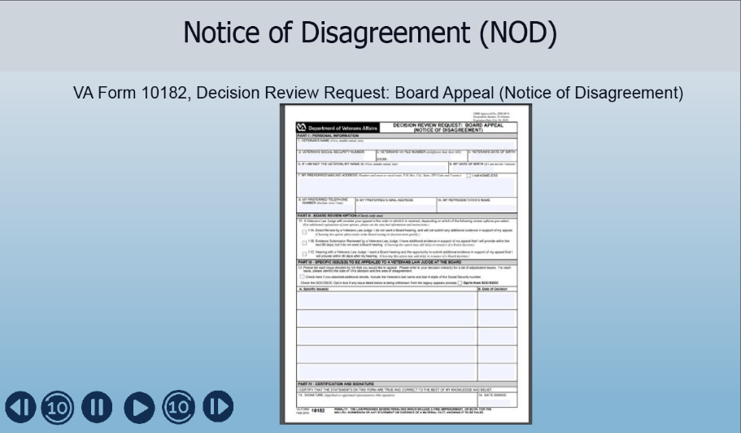 |  | Display Slide 21 “Notice of Disagreement (NOD)”  On this slide is an image of VA form 10182. This is the form used for NOD requests and all requests for a review by BVA must be submitted on this form.  If an NOD is received at the RPO and it is not on this form, but on either a 4138 or written correspondence, send the claimant a courtesy letter informing them that NODs must be received on the VA Form 10182
 | 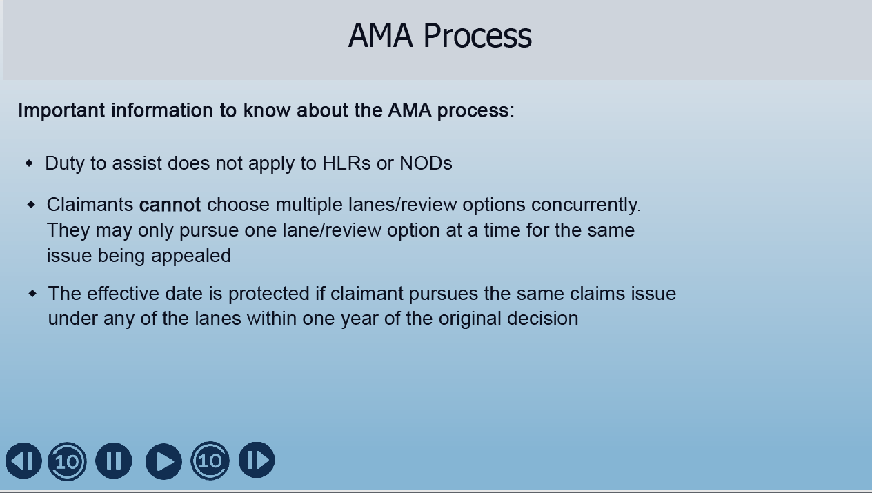 |  | Display Slide 22 “AMA Process”  Before we go into detail about AMA-SCs, here are some final thoughts on the AMA process:  - Duty to assist does not apply to either HLRs or NODs  - Claimants cannot choose multiple lanes/review options concurrently. They can only pursue one lane/review option at a time for the same issue being appealed  - The effective date is protected if the claimant pursues the same claims issue under any of the lanes within one year of the original decision
 | 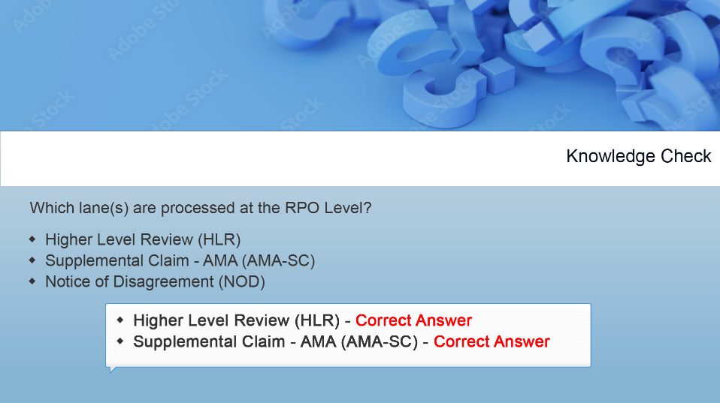 |  | Display Slide 23 “Knowledge Check”  Let’s do a quick knowledge check before we proceed.  Which of the following lane(s) are processed at the RPO level?  A. Higher Level Reviews  B. Supplemental Claim – AMA  C. Notice of Disagreements  There are 2 correct answers, both HLRs and AMA-SCs are processed at the RPO level
 | 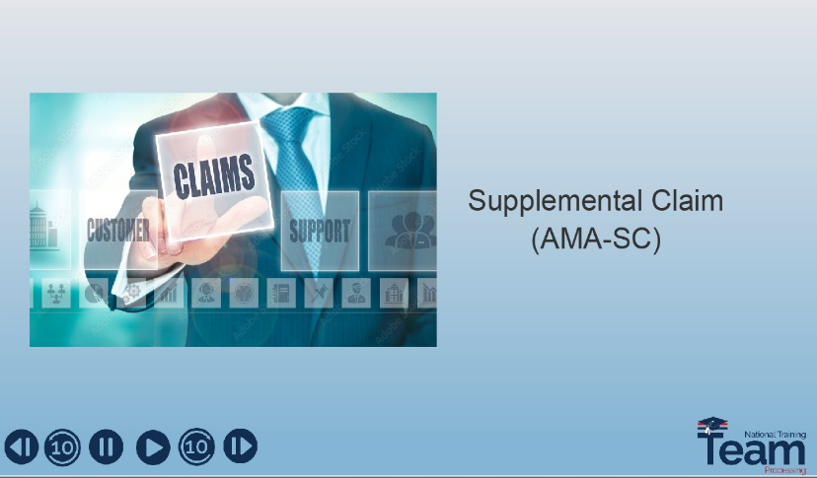 |  | Display Slide 24 “Supplemental Claim - AMA (AMA-SC)”  Now it’s time to dive into more detail about the Supplemental Claim (AMA-SC)
 | 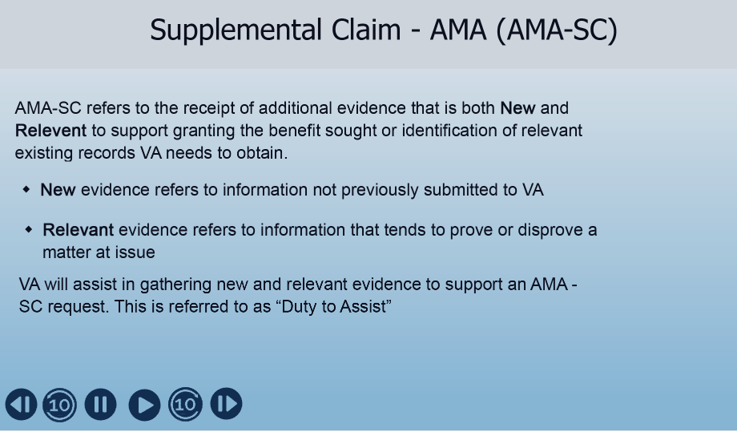 |  | Display Slide 25 “Supplemental Claim - AMA (AMA-SC)”  An AMA-SC refers to the receipt of additional evidence, both New and Relevant, to support granting the benefit sought or identification of relevant existing records VA needs to obtain.  - New evidence refers to information not previously submitted to VA  - Relevant evidence refers to information which tends to prove or disprove a matter at issue  Under Duty to assist, the VA will help in gathering new and relevant evidence to support an AMA-SC.
 | 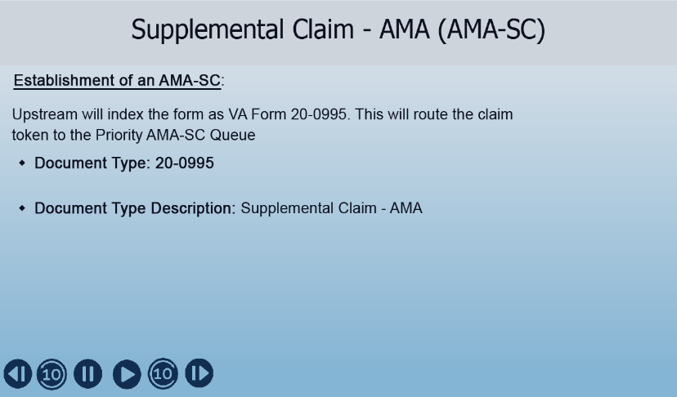 |  | Display Slide 26 “Supplemental Claim - AMA (AMA-SC)”  As mentioned earlier, the claimant must submit an AMA-SC request on VA Form 20-0995. Upon receipt of this form at the VA, Upstream should index the document using the document type and document type description shown on screen. This will create a claim token to the Priority AMA-SC Queue.
 | 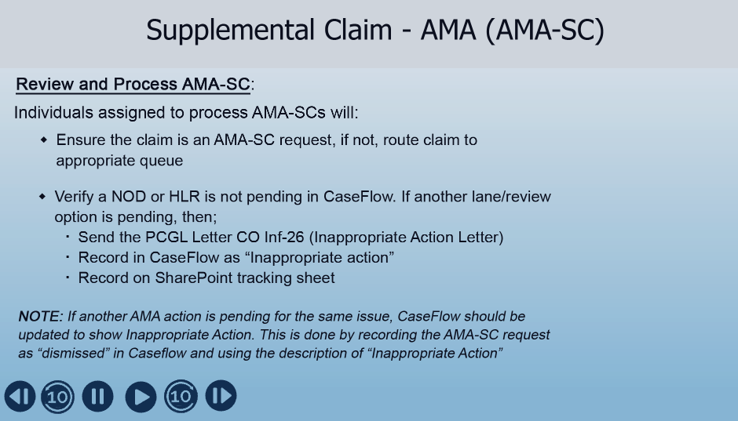 |  | Display Slide 27 “Supplemental Claim - AMA (AMA-SC)”  Each RPO determines who processes these claims and the number of individuals assigned to process them.  The individual assigned to work the AMA-SC will:  - Ensure the claim is an AMA-SC request, if not then route the claim to appropriate queue  - Verify an NOD or HLR is not already pending in Caseflow for the same issue. If there is one pending, then they will.  - Send Inappropriate Action Letter (PCGL CO Inf-26)  - Record in Caseflow as “Inappropriate action”  - Record on SharePoint tracking sheet  Note: If another AMA action is pending for the same issue, Caseflow should be updated to show Inappropriate Action. This is done by recording the AMA-SC request as “dismissed” in Caseflow and using the description of “Inappropriate Action”
 | 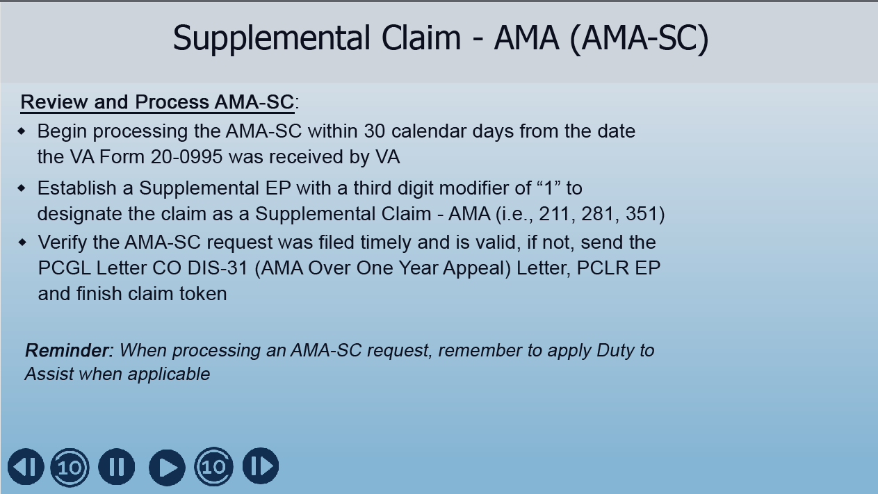 |  | Display Slide 28 “Supplemental Claim - AMA (AMA-SC)”  When processing an AMA-SC also ensure:  - RPOs begin processing these requests within 30 calendar days from the date the 20-0995 was received by VA. They don’t have to be completed within that 30 day window but processing must have begun. Claims over 30 days should be tracked  - Ensure that the correct Supplemental EP with a third digit modifier of “1” and date of claim has been established  - Verify the AMA-SC request was filed timely and is valid.  Timely means that the claim is received within 1 year of the decision. If received after 1 year send the “AMA Over One Year Appeal” letter, PCLR EP and finish claim token. Do Not Enter into Caseflow  Valid means that the AMA-SC sent in by the claimant is regarding a decision that VA previously made. If not valid, we’ll use the inappropriate action letter and modify it to what we need to say, stating why we can’t accept the appeal. PLCR EP and finish claim token. Do not enter into Caseflow  - AMA-SCs should be processed next in group.  Just a reminder that Duty to assist applies when required, and this means we must assist the veteran in obtaining evidence needed to support the claim. We have an especially high obligation to assist when it comes to federal records. If we need federal records (i.e., DD214, Kicker evidence, proof of contribution, etc.) we must continue our attempts to obtain these records “unless it is reasonably certain such records do not exist or that further efforts to obtain the records would be futile.”
 | 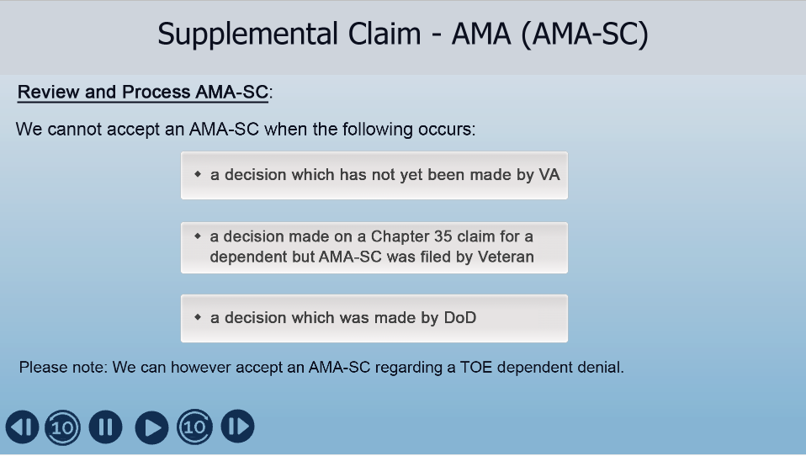 |  | Display Slide 29 “Supplemental Claim - AMA (AMA-SC)”  - cannot accept an AMA-SC for a decision which has not yet been made by VA. For instance, the request was received before the denial was processed.  - We cannot accept an AMA-SC from a veteran regarding a decision on a chapter 35 claim for a dependent.  - We cannot accept an AMA-SC for a decision which was made by DOD. This goes for a DoD denial of a TOE transfer.  Please note: We can however accept an AMA-SC regarding a TOE dependent denial
 | 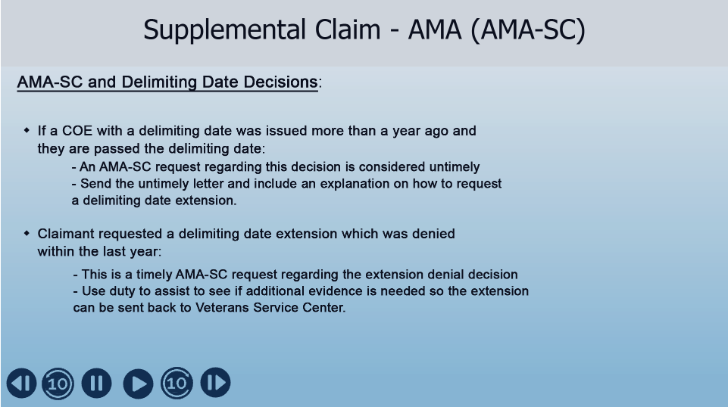 |  | Display Slide 30 “Supplemental Claim - AMA (AMA-SC)”  A note about Delimiting Date Decisions:  1. If a COE with a delimiting date was issued more than a year ago. Claimant has now been told they are passed the delimiting date. If they submit an AMA-SC request, this will be considered untimely. The initial decision was made when the COE was issued. Send the untimely letter and include an explanation on How to request a delimiting date extension.  2. If a claimant requested a delimiting date extension which was denied within the last year. This will be a timely AMA-SC request regarding the extension denial decision. Use duty to assist to see if additional evidence is needed so the extension can be sent back to Veterans Service Center.
 | 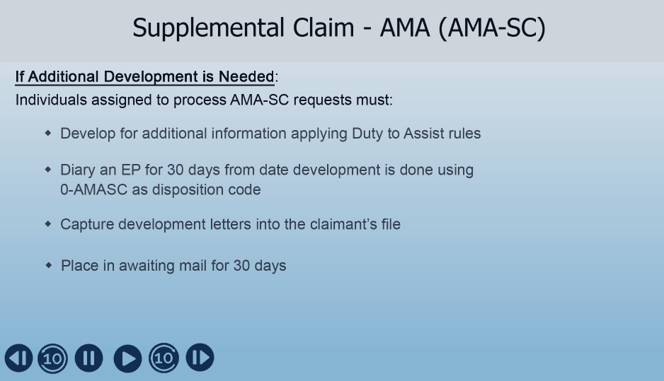 |  | Display Slide 31 “Supplemental Claim - AMA (AMA-SC)”  Follow these steps if additional development is needed:  - Develop for additional information following Duty to Assist rules  - Diary an EP for an additional 30 days from date development is done using 0-AMASC as disposition code  - Make sure to capture development letters into the claimant’s electronic file  - Place in awaiting mail in electronic file for 30 days
 | 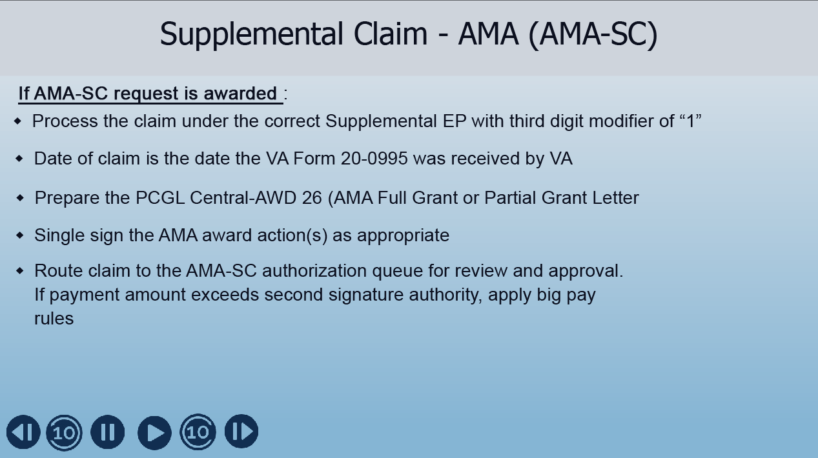 |  | Display Slide 32 “Supplemental Claim - AMA (AMA-SC)”  When granting an AMA-SC:  - Process the claim under the correct Supplemental EP with third digit modifier of “1”  - Use the date of claim the 20-0995 was received by VA  - Prepare AMA Full Grant or Partial Grant award letter (PCGL Central-AWD 26)  - AMA award actions can be single signed as appropriate (See manual reference M22-4 Part 3 Chapter 2 Part II subpart b. 3A)  - Awards involving changes to eligibility require a second signature. Route these claims to AMA-SC authorization queue for review and approval  - If payment amount exceeds second signature authority, make sure to follow Big Pay rules.
 | 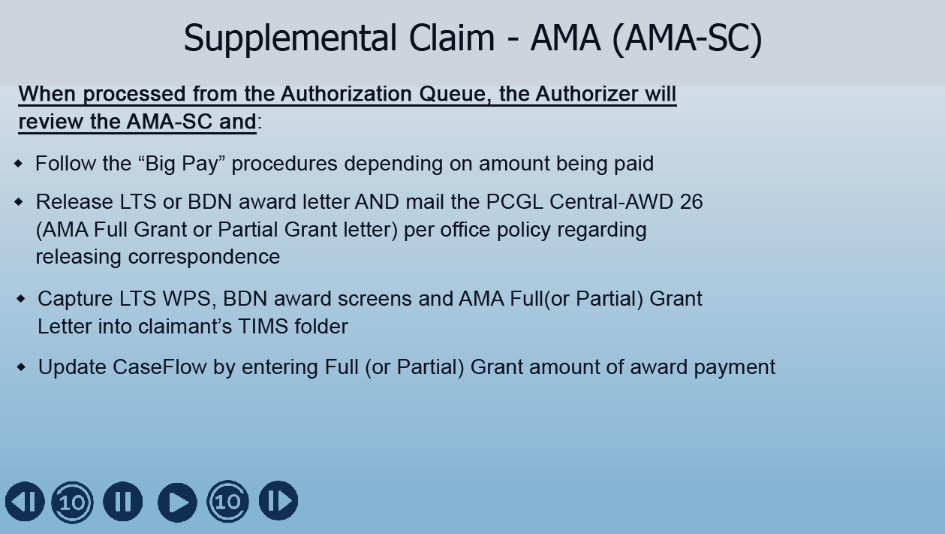 |  | Display Slide 33 “Supplemental Claim - AMA (AMA-SC)”  If the AMC-SC is worked from the Authorization Queue, the authorizer should first make sure the AMA-SC award is not a big pay. If it is a Big Pay, follow “Big Pay” procedures regarding additional signatures based on amount being paid and refer to Big Pay memo issued by your RPO  If it is not a “Big Pay” then the Authorizer will:  - Release system award letter and mail AMA Full Grant or Partial Grant letter (PCGL Central-AWD 26  - Capture any applicable screens and the AMA Full Grant or Partial Grant letter into claimant’s electronic file  Update Caseflow by entering Full (or Partial) grant amount of the award payment
 | 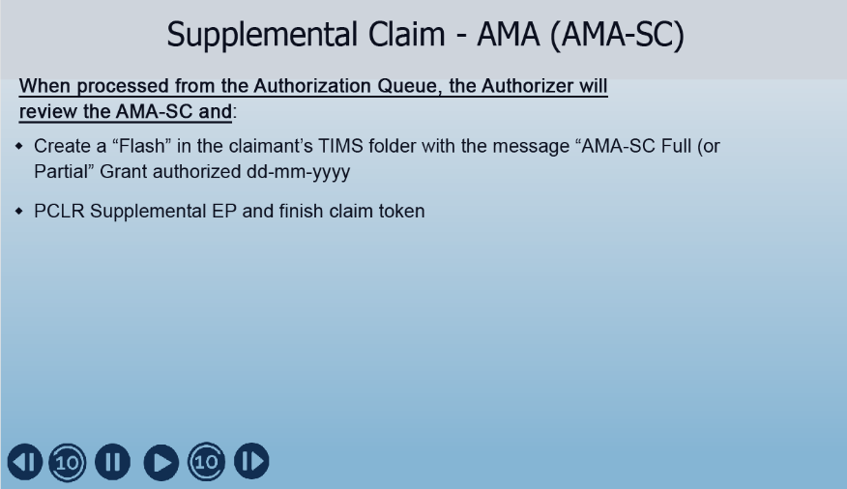 |  | Display Slide 34 “Supplemental Claim - AMA (AMA-SC)”  You will also create a “Flash” in the claimant’s electronic file with the message “Supplemental Claim – AMA Full (or Partial) Grant authorized and make sure to include the day, month, and year  And finally, PCLR the Supplemental EP and finish the claim token
 | 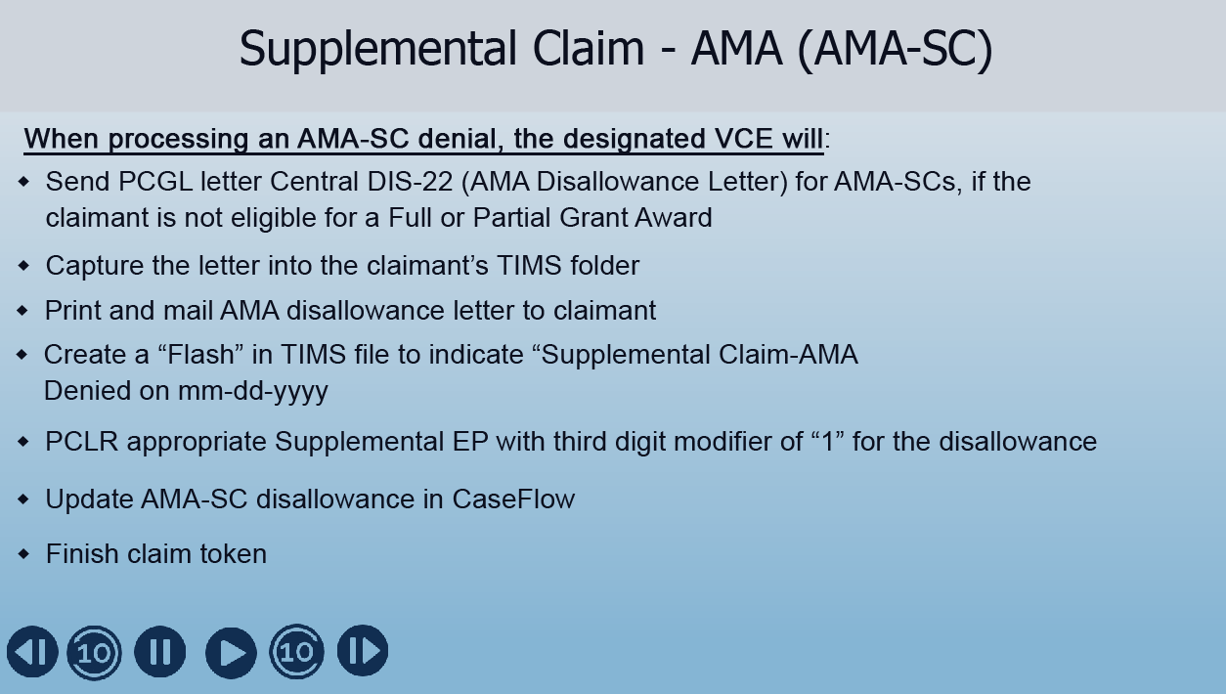 |  | Display Slide 35 “Supplemental Claim - AMA (AMA-SC)”  So what do we do when we cannot approve an AMA-SC? This slide shows the steps to take when processing an AMA-SC denial.  The designated VCE will prepare the AMA Disallowance Letter (PCGL Letter Central DIS-22) for AMA-SCs and will capture the letter in the claimant’s electronic file as well as print and mail this Disallowance letter to the claimant.  Next the VCE will create a “Flash” in the electronic file to indicate the Supplemental Claim-AMA was denied and include the month, day and year.  The VCE will then PCLR the appropriate Supplemental EP with third digit modifier of “1” for the disallowance and will update AMA-SC disallowance in Caseflow before Finishing the claim token
 | 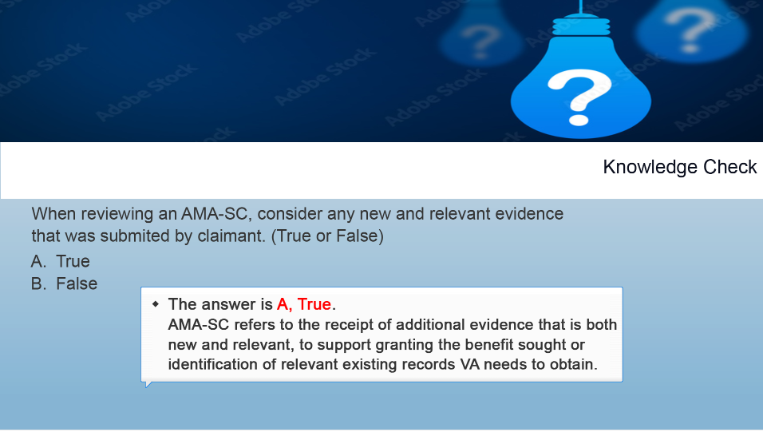 |  | Display Slide 36 “Knowledge Check”  Now it’s time for a knowledge check to see what you have learned. Is the following statement true or false?  When reviewing an AMA-SC, consider any new and relevant evidence the claimant may have submitted.  The answer is A, True. AMA-SC refers to the receipt of additional evidence that is both new and relevant, to support granting the benefit sought or identification of relevant existing records VA needs to obtain.
 | 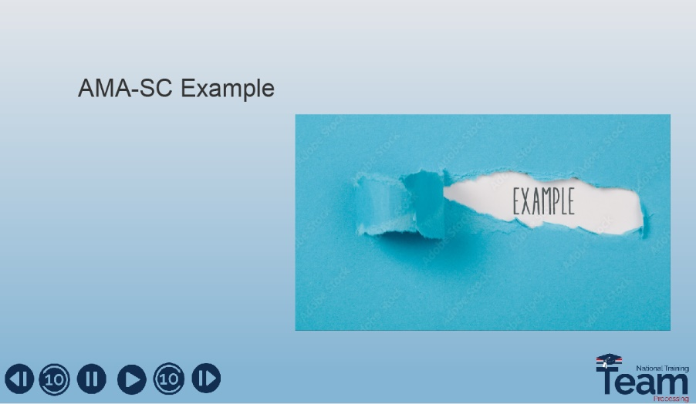 |  | Display Slide 37 “AMA-SC Example”  Now that we have discussed processing procedures for an AMA-SC, let’s take a look at an example of an AMA-SC request that we received and how it was processed.
 | 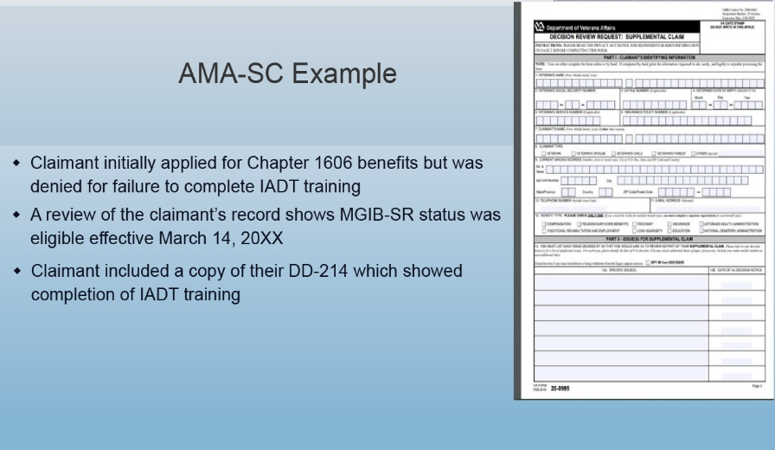 |  | Display Slide 38 “AMA-SC Example”  In this example, the claimant applied for chapter 1606 benefits and was denied for not completing the required IADT training.  When submitting the AMA-SC request, the claimant included documentation showing IADT training was completed.  Upon review of the claimant’s electronic file, there was also evidence showing that the MGIB-SR (chapter 1606) status was eligible
 | 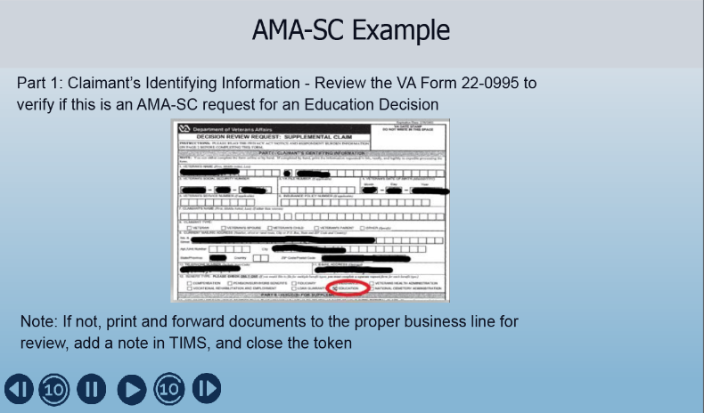 |  | Display Slide 39 “AMA-SC Example”  Before beginning the processing of the request, first make sure it is an AMA-SC request for an “Education Claim” and not for another benefit. In this particular case, you can see in the red circle that this is an education claim.  If you receive a request for another benefit, print the documents and forward them to the appropriate division for their review, include a note in the electronic file and finish token.
 | 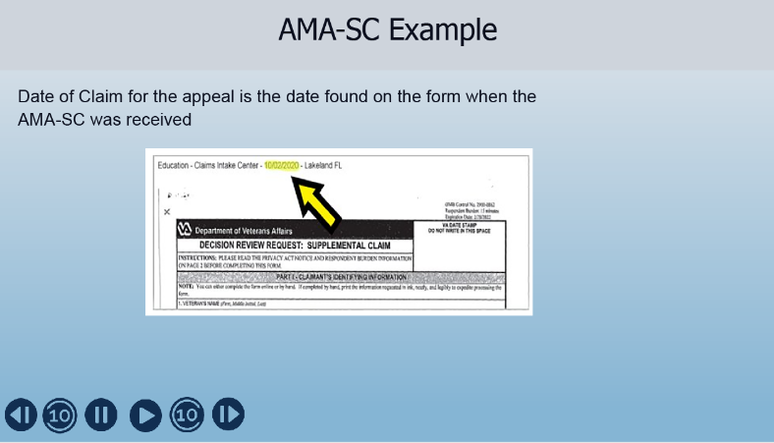 |  | Display Slide 40 “AMA-SC Example”  When the AMC-SC claim needs CEST in BDN, use the date the document was electronically date stamped. It is typically found in the upper corner of the document.  In this particular case, the date of claim would be 10/20/2020
 | 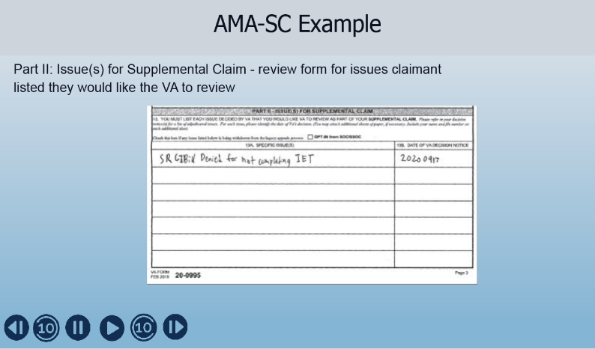 |  | Display Slide 41 “AMA-SC Example”  Next, look at part II of the form. This is where the claimant lists the issues that led to the filing of the AMA-SC request.  In this particular case, the claimant wrote they are submitting the request because they were denied SR GI Bill for not completing IET, which we construed as IADT
 | 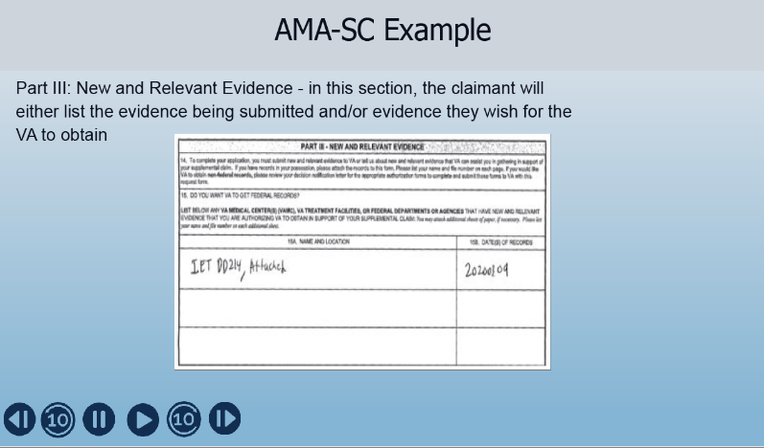 |  | Display Slide 42 “AMA-SC Example”  Part III of the form is where the claimant lists any evidence they are submitting and/or any evidence they don’t have but wish for VA to assist them with obtaining, which would fall under Duty to Assist.  In this case, the claimant submitted copies of paperwork showing IADT was completed as well as a copy of the DD 214
 | 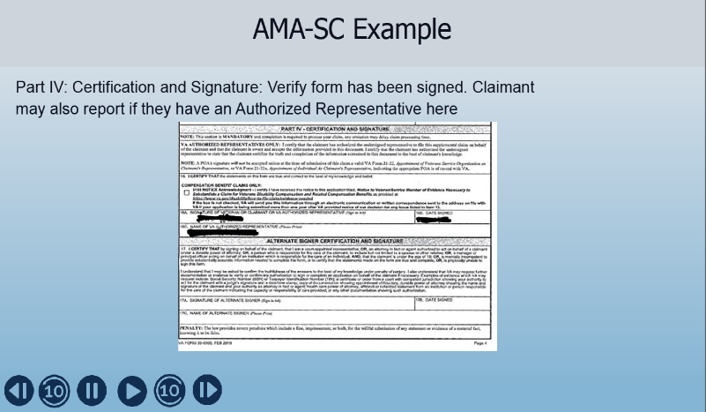 |  | Display Slide 43 “AMA-SC Example”  Finally, in part IV, look for the claimant’s signature and if they have an Authorized Representative.  Please note that the claimant must sign the form, or we cannot accept the AMA-SC. If they are unable to sign, there is a section for an alternate signature on the claimant’s behalf
 | 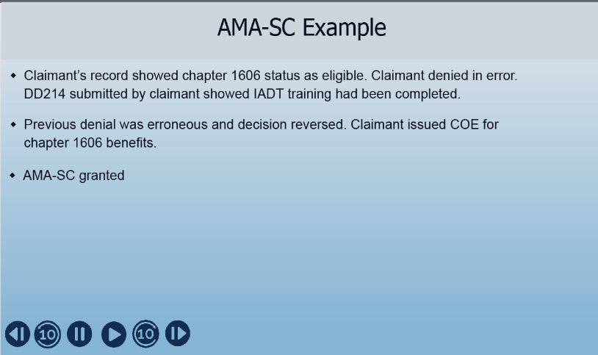 |  | Display Slide 44 “AMA-SC Example”  Let’s recap our example,  A review of the claimant’s electronic file showed chapter 1606 status as eligible. In this case, it looks like the claimant was initially denied in error. The DD214 showed the IADT training was completed.  Note that if the VIS screen had not shown chapter 1606 eligibility, “Duty to Assist” would have required the VA to confirm chapter 1606 eligibility with DoD.  In this case, the previous denial was reversed, and the AMA-SC was granted. The claimant was issued a COE for chapter 1606 benefits.
 | 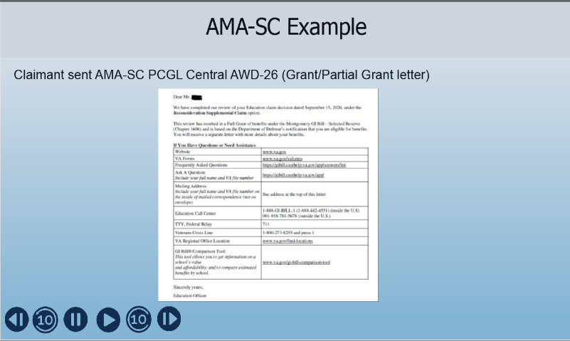 |  | Display Slide 45 “AMA-SC Example”  Make sure to send the PCGL Central Award-26 letter if an additional unmodified letter is sent by the system. In this case, the letter would be sent in addition to the COE  If a modified letter is sent, it is easier to just add the “full-grant” language to the beginning of that letter.
 | 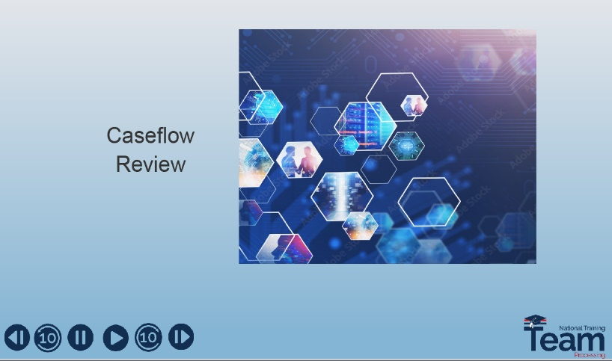 |  | Display Slide 46 “Caseflow Review”  We will spend the next few slides explaining Caseflow and how to input an AMA-SC request
 | 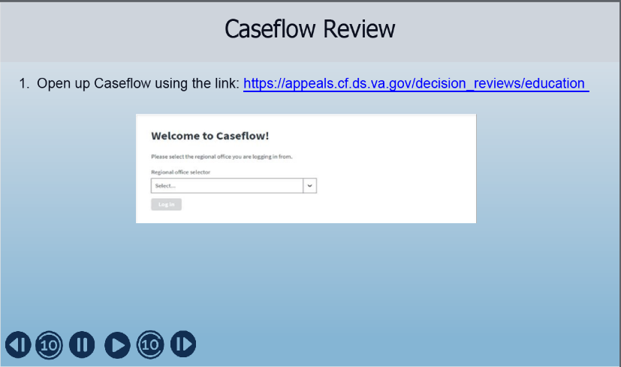 |  | Display Slide 47 “Caseflow Review”  First, you will open Caseflow. A link to open Caseflow can be found on this slide if you do not already have this saved.  Upon logging into Caseflow and verifying your credentials, the “Welcome to Caseflow” screen should appear. On this screen you will select your Regional Office from the drop-down menu, then click “Log in”
 | 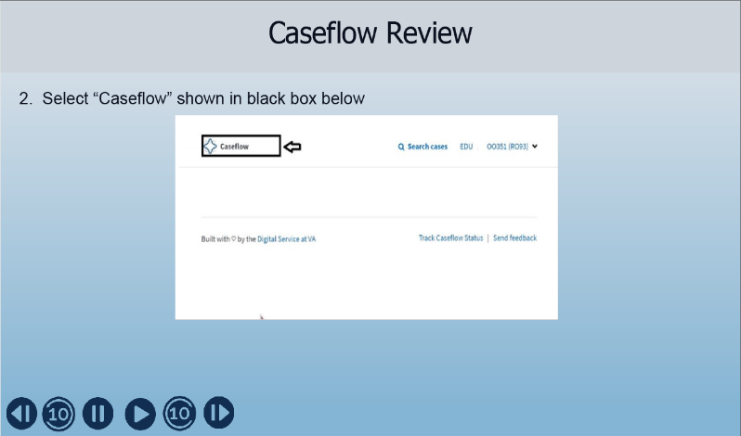 |  | Display Slide 48 “Caseflow Review”  Once you have selected your Regional Office, the screen shown on this slide should appear. From here, select “Caseflow” as shown in the black box and note that the word “Education should be after the word “Caseflow”
 | 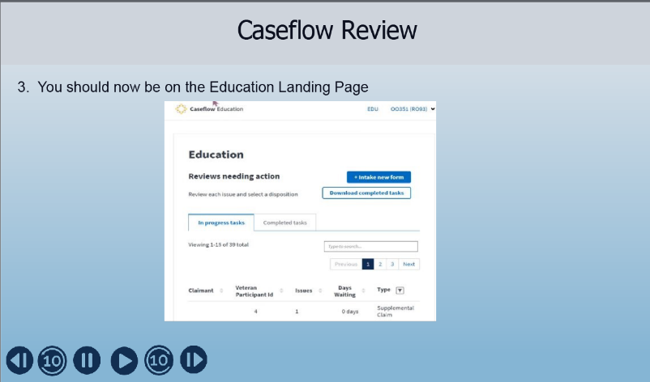 |  | Display Slide 49 “Caseflow Review”  After selecting “Caseflow Education” as shown on the previous slide, this page should open. Just a note, if you recently used Caseflow, you may be directed to this page without the screen from the previous slide appearing.  From here you either input a new form by selecting “Intake new form” or search for “in progress tasks” or search for “completed tasks”
 | 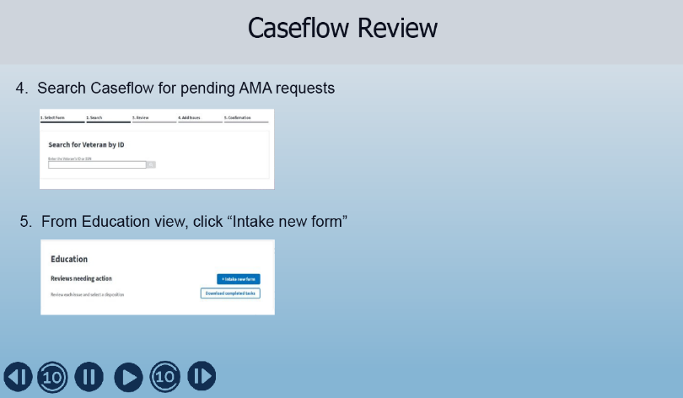 |  | Display Slide 50 “Caseflow Review”  Before taking any action, first enter the claimant’s social security number to perform a search to make sure there is not a pending Education AMA request for the issue being claimed.  If there is no pending Education AMA request for your issue, click on “Intake new form” to create a new record in Caseflow  If however there is a pending Education AMA request, verify that it is not for the same issue. If it is for the same issue, send the inappropriate action notice to claimant. Otherwise continue entering this type of request into Caseflow.  All other invalid requests are not tracked in Caseflow
 | 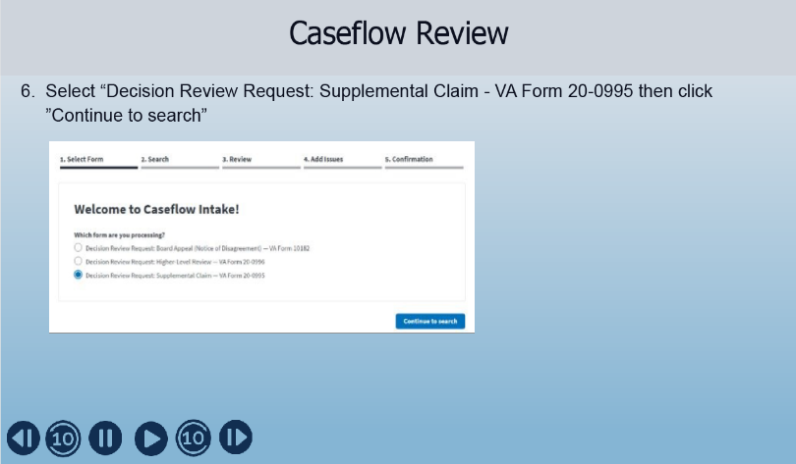 |  | Display Slide 51 “Caseflow Review”  After selecting the “Intake New Form” button, the screen that appears on this slide will open up.  When you receive this screen, select which AMA lane applies.  In the example shown, you will select “Decision Review Request” Supplemental Claim – VA Form 20-0995
 | 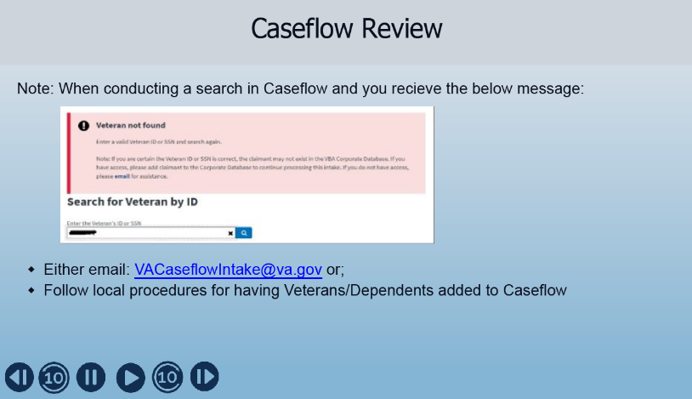 |  | Display Slide 52 “Caseflow Review”  When doing a search, if the “Veteran not found” message appears, before you can continue in Caseflow;  - Either email VACaseflowIntake@va.gov. They will need to enter the veteran into the VBA Corporate Database or;  - Follow your local procedures for adding veterans and dependents to Caseflow.  Once you receive notification that the veteran or dependent is added, proceed with updating Caseflow
 | 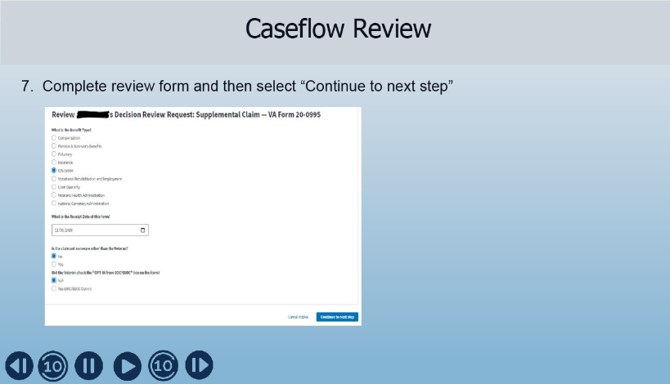 |  | Display Slide 53 “Caseflow Review”  On this screen, you will need to complete the following fields.  - Select “Education”  - Then Input the date that the 20-0995 was received  - Next, select if this is the veteran or not  - Then select N/A
 | 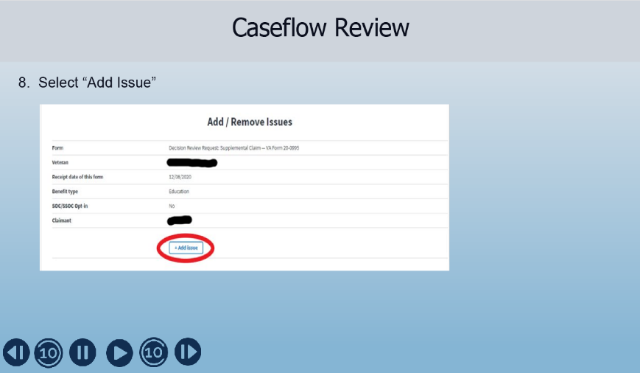 |  | Display Slide 54 “Caseflow Review”  On this screen, select “Add issue”  You will then be prompted to complete the fields with the pertinent information related to the decision being appealed.
 | 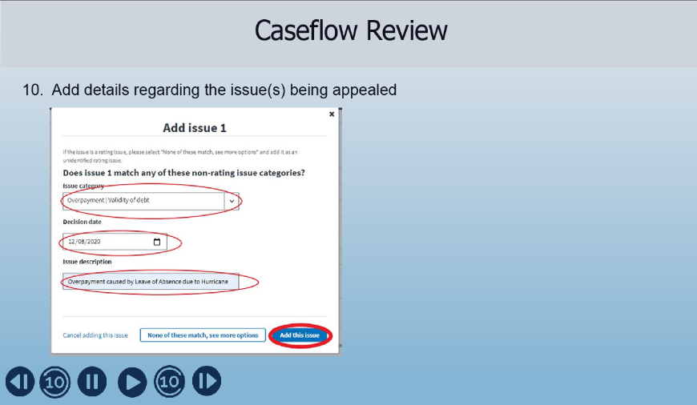 |  | Display Slide 55 “Caseflow Review”  Now add the information related to the decision being appealed.  - Use the drop-down menu and select the “issue category”. Make sure to choose the best one that matches the issue under review. If there is no matching category, select “None of these match, see more options” and follow the prompts to manually enter the category  - Next, enter the “Decision date” of the issue being reviewed. This should have been provided by the claimant on the form 20-0995. However, if necessary, you can verify it with the information found in the electronic file.  - Provide a brief narrative description of the issue(s) under review. Click “Add this issue”  - If needed, this step can be repeated to add additional issues when there are multiple issues being appealed at the same time.  - Once all of the issues have been added, Select “Next”. This will create a task in Caseflow.
 | 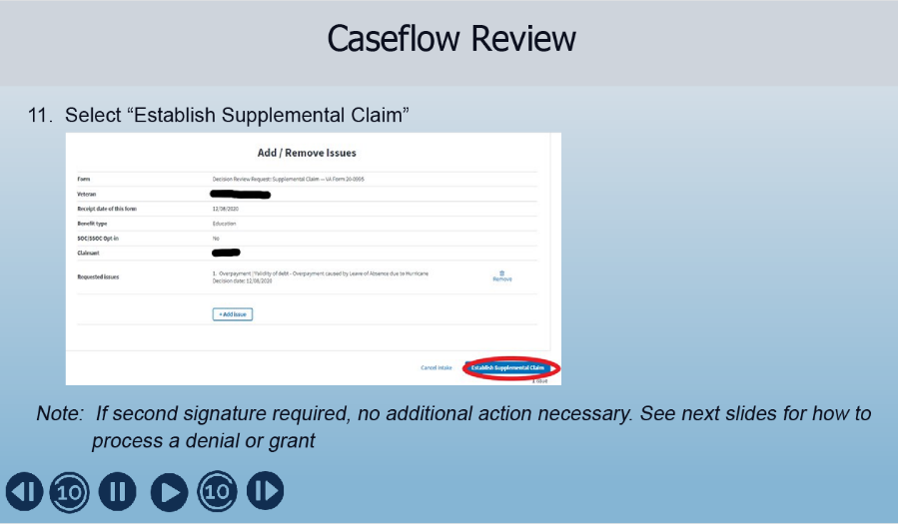 |  | Display Slide 56 “Caseflow Review”  Review this screen to make sure the information is correct. If so, click “Establish Supplemental Claim” button. This will create a task in Caseflow.  If multiple signatures are needed, you will take no further action in Caseflow. Instead, you will route the file to the Authorizer who will review the claim and update Caseflow
 |  |  | Display Slide 57 “Caseflow: Granting an Appeal or Processing a Denial”  The next several slides will show you what to do when granting or denying an appeal. This applies to anyone who is authorizing the claim whether it is the initial reviewer or if the case was sent to an authorizer.
 | 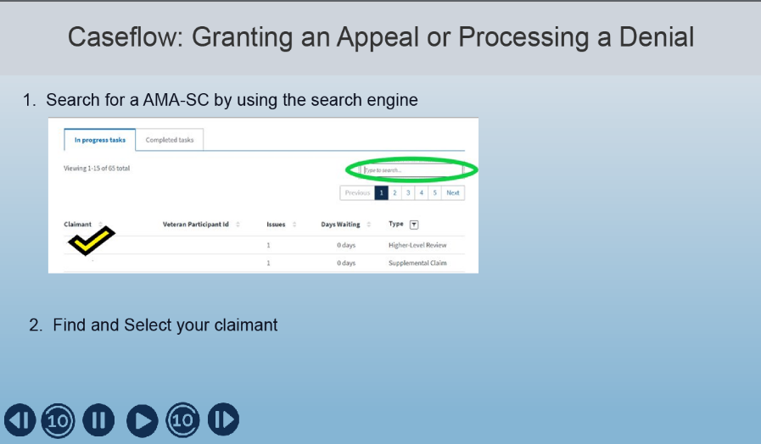 |  | Display Slide 58 “Caseflow: Granting an Appeal or Processing a Denial”  This is a screen shot of the Caseflow screen.  You will follow these steps when you are updating a denial or you are authorizing a request that required multiple signatures.  First begin by searching for an AMA-SC by using the search engine to find and select your claimant.
 | 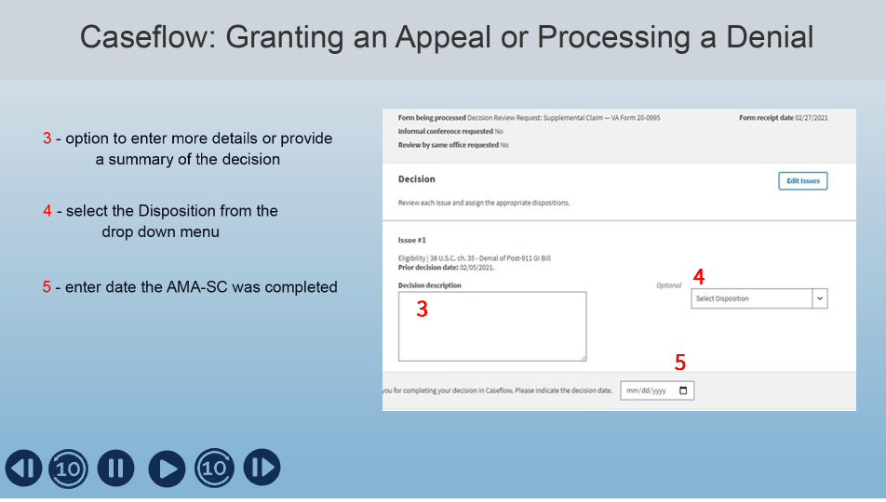 |  | Display Slide 59 “Caseflow: Granting an Appeal or Processing a Denial”  - Section 3 on screen is where you can enter the “Decision description” to add more details or to provide the summary of the decision. This section is optional.  - Section 4 is where you will select the Disposition from the drop-down menu. You will select “Granted” for a full or partial grant.  - In Section 5 enter the date you completed the AMA-SC in the decision date box using the format mm/dd/yyyy
 | 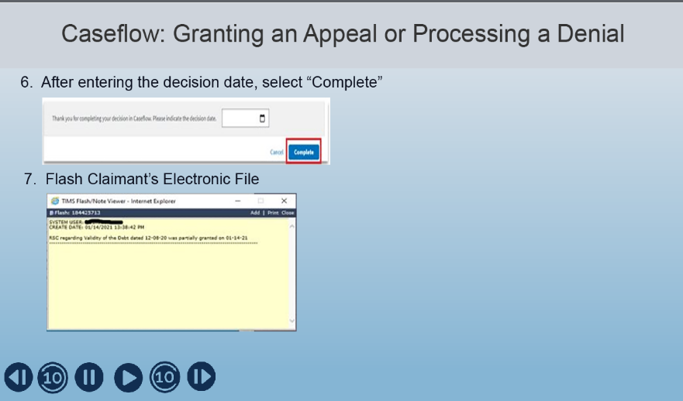 |  | Display Slide 60 “Caseflow: Granting an Appeal or Processing a Denial”  After completing all fields, click “Complete”  Make sure to add a “Flash” to the electronic file with the AMA-SC decision and the date of the decision included.
 | 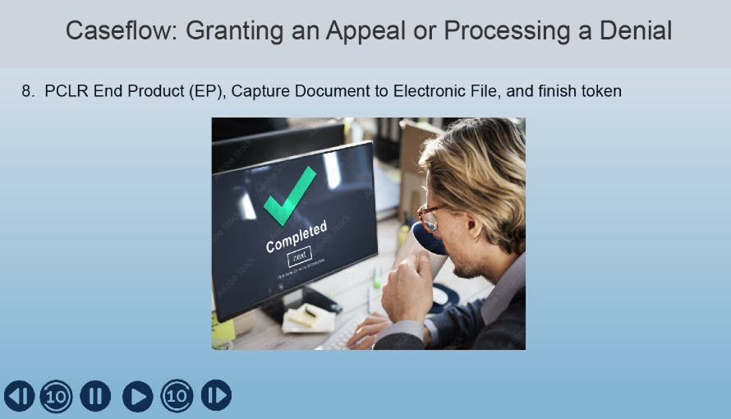 |  | Display Slide 51 “Caseflow: Granting an Appeal or Processing a Denial”  Finally, PCLR an EP in BDN and capture the screen to the electronic file and finish the token
 | 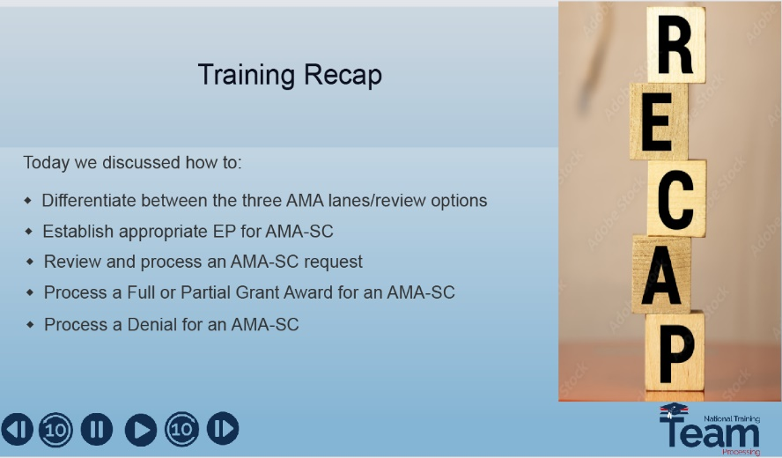 |  | Display Slide 62 “Recap”  Today we discussed how to:  - Differentiate between the three AMA lane/review options  - Know the appropriate EP to use when taking credit for completing the AMA-SC and.  - Learned how to review and process a claim under the AMA-SC option
 | 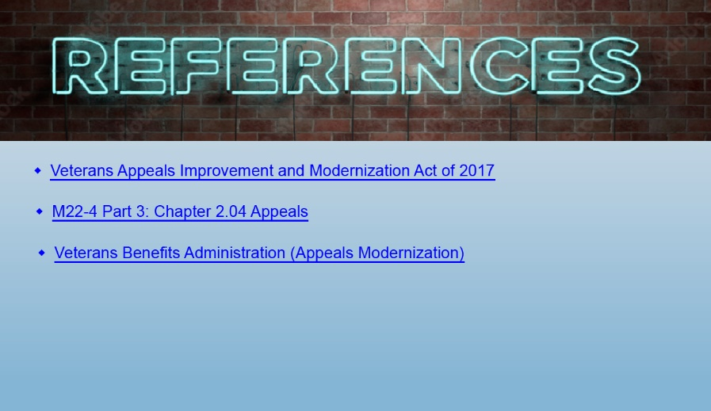 |  | Display Slide 63 “References”  On this slide is a list of the references used when creating this presentation.
 | 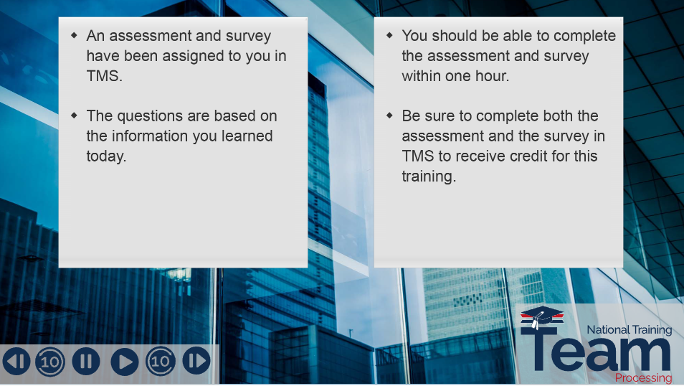 |  | Display Slide 64  The assessment and survey have been assigned to you in TMS.  The assessment is comprised of several questions.  The questions are based on the information you learned today.  You should be able to complete the assessment and survey within one hour.  Be sure to complete both the assessment and the survey in TMS to receive credit for this training
 |  |  | Display Slide 65  Thank you and have a good day

