 | VBMS-Fiduciary  Centralized Benefits Communications Management (CBCM)

INSTRUCTIONS for using CBCM to send out correspondence and notification
PURPOSE: To provide the fiduciary hub employees with high-level steps on how to send out correspondence and notification letters using CBCM  DISCLAIMER: All Claim ID#s, File #s, and names are fictitious and for use only in the VBMS Fiduciary training environment. |  | WARNING: This is not a formal document and is for Internal Use Only.

Create a package via the eFolder | - Select the applicable document(s) using the boxes for each desired document  - Then select Add to Package from the Action drop down menu  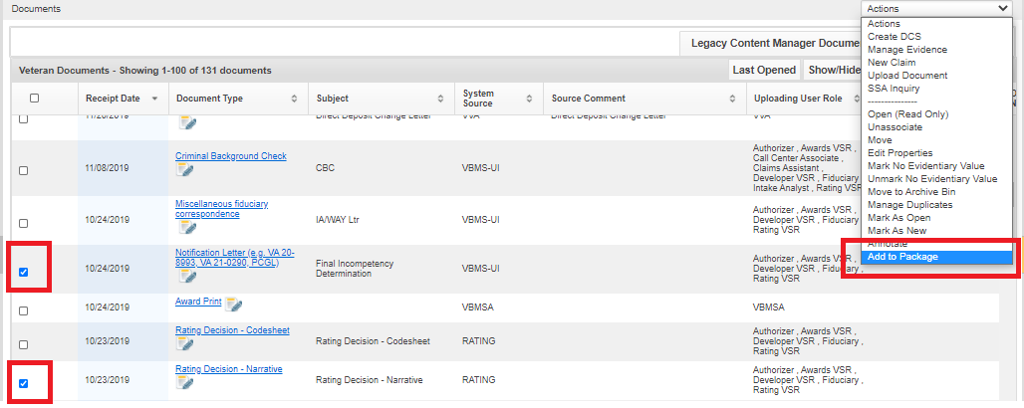
Create a package via the eFolder | - Then choose to add the document(s) to a new or existing package  - if a new package is created, a package name is required (i.e. Due Process Notification 11-3-20)  - If either Add & Return to eFolder or Add & Go to Package Manager is selected, the user will have the option of adding additional documents to the package.  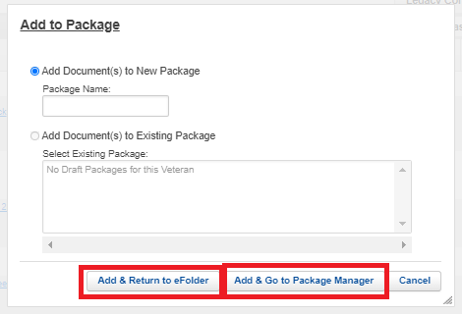
Creating Packages in Package Manager | - Create a new or existing package by clicking on the Package Manager from the Veteran’s drop-down menu  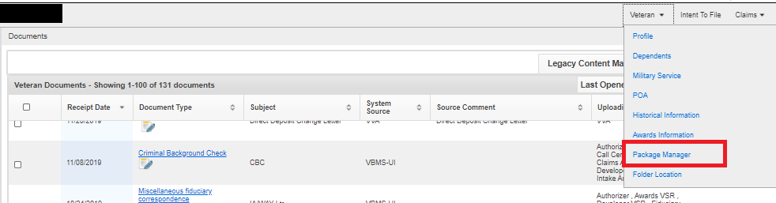
Creating Packages in Package Manager | - If the package was automatically created and inserted into Package Manager by VBMS-Fid, the complete package will be on the Packages tab.  - From this tab, the user will be able to select the correct package to review the documents and add recipients  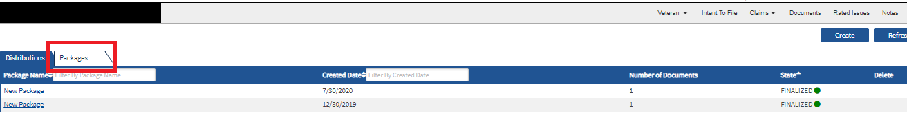
Creating Packages in Package Manager | - To build a new package click Create  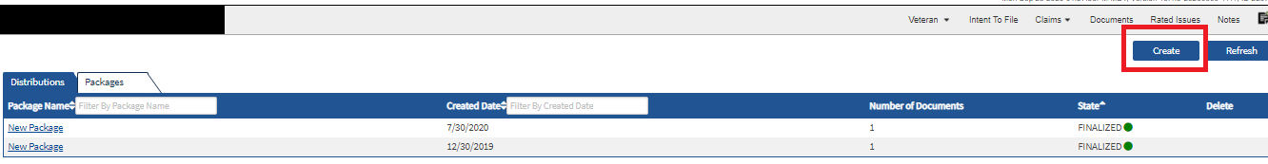  - The user may then select an existing package or a new package  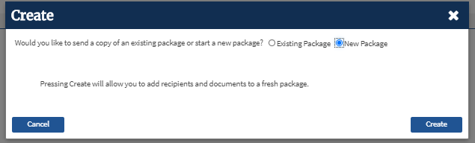
Creating Packages in Package Manager | - For new packages, the user will have to name the package and select Add Document(s)  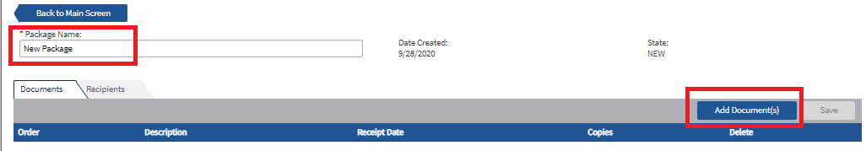
Creating Packages in Package Manager | - The available drop down allows the user to choose from documents in the beneficiary’s eFolder or Standard enclosures  - Once the appropriate documents have been selected and moved to the box on the right, select Add Documents  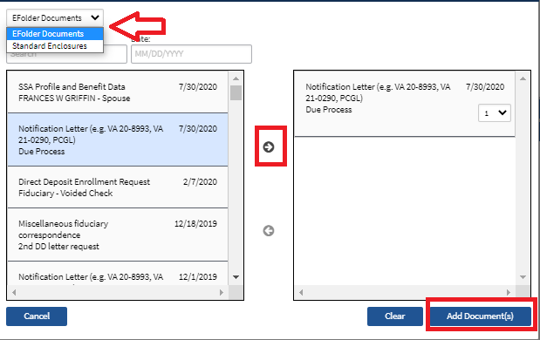
Creating Packages in Package Manager | - After the documents are added, click Save  - Continue to the Recipients tab (this will be grayed out until the package is saved)  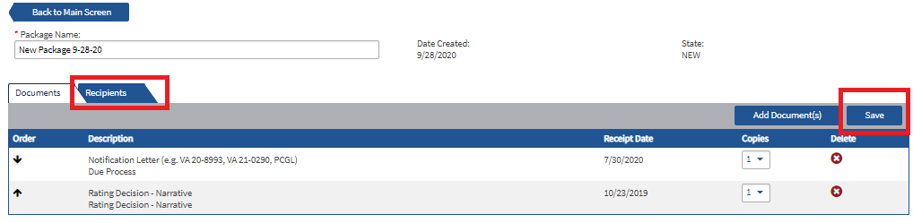
Addressing Correspondence | - On the Recipients tab, the user can address the package to the desired recipients.  - Select Add Recipient to add a new option for a recipient  - If the Veteran is the recipient, select the Veteran is recipient option  - If the Veteran is NOT the recipient, complete the name and address boxes  - Select Add Recipient to add another option for a recipient  - If the correspondence needs to be sent to the beneficiary’s POA, select Organization as the recipient type  - Copies of letters for VSOs will be mailed to the SOJ  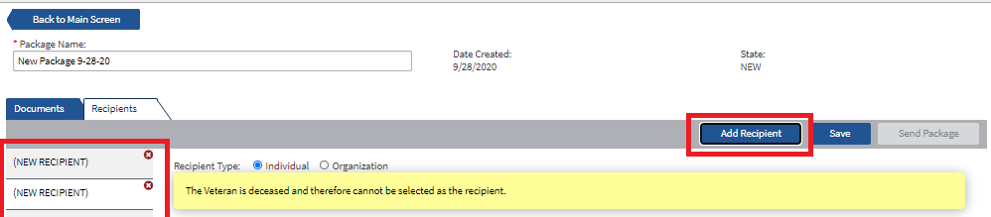
Addressing Correspondence | - Once the recipients and addresses are entered, select Send Package for each recipient  - A draft status is indicated by a yellow circle by the recipients' name  - Draft status that has been successfully sent to CBCM is indicated by a yellow envelope  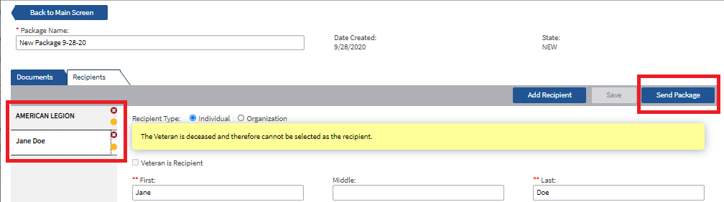
Main Screen | - The Main Screen has a Distributions and Packages tab  - Distributions tab will display all correspondence and the recipients  - Packages tab will only display the individual package  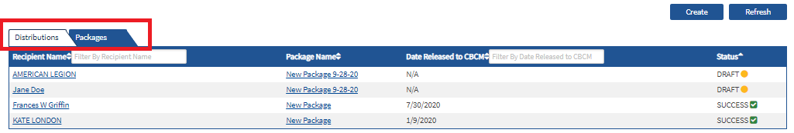
Main Screen | - The Distributions tab indicates the status of the packages created  - Draft – package created but not sent  - In Progress- package created and sent to CBCM for processing  - Success- package processed by CBCM  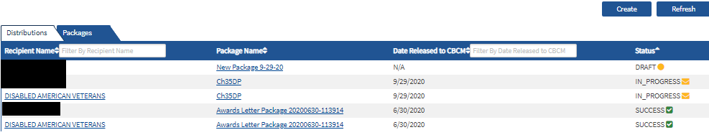
Deleting a Package Created in Error | - Select the Packages tab on the Main Screen  - Select the trash can icon and indicate the package should be deleted when prompted  - Note- Once a package has been sent to CBCM, the user is unable to delete the package  