Accuracy of Disability Benefit Evaluations for Veterans’ Service Connected Heart Diseases

Trainee Handout

**Table of Contents**

Objectives 2

References 3

Topic 1: Cardiovascular Disability Benefits Questionnaire (DBQ) Sufficiency 4

Topic 2: Cardiovascular Disability Evaluation 6

Practical Exercise 1 8

Objectives

Given all available resources to include the live manual, rating activity personnel will be required to accomplish the following lesson objectives.

* Determine the sufficiency of the disability benefits questionnaires (DBQ) when evaluating claims for heart disease.
* Determine the appropriate disability evaluation when deciding claims for heart disease.

References

All M21-1 references are found in the [Live Manual Website](https://vaww.compensation.pension.km.va.gov/).

* 38 CFR 3.102, Reasonable doubt
* 38 CFR 4.7, Choosing between two levels of evaluation
* 38 CFR 4.104, Schedule of ratings-cardiovascular system
* 38 CFR 3.309(e), Disease associated with exposure to certain herbicide agents
* M21-1 Part IV, Subpart ii.2.C, Service Connection (SC) for disabilities resulting from exposure to environmental hazards or service in the Republic of Vietnam (RVN)
* [Compensation Service Novel Coronavirus (COVID-19) Operational Information Page](https://vbaw.vba.va.gov/bl/21/corona.htm)

Topic 1: Cardiovascular Disability Benefits Questionnaire (DBQ) Sufficiency

**Determining Sufficiency of Cardio DBQ**

* A disability benefits questionnaire is determined to be insufficient if it does not contain enough findings to render a decision on the claim. This could include missed fields on the disability benefits questionnaire or conflicting or unclear statements by the medical provider.
* The RVSR must request clarification when necessary when making disability evaluations. If a medical provider indicates one measurement was used to evaluate the heart disease but then provided an additional statement that another measurement was better. The RVSR should request clarification from the medical provider if the disability benefits questionnaire is insufficient.

**Reasonable Doubt**

|  |  |
| --- | --- |
| Reasonable doubtallows claims processors to resolve conflicting evidence in favor of the Veteran if evidence is equal and not due to insuffiency or lack of clarity.  Reasonable doubt does not apply if the evidence is unclear or incomplete, such as in the case of insufficient, missing, or conflicting information on a disability benefits questionnaire.  **In these instances, RVSRs should seek medical clarification before completing a disability evaluation.** | **Note*:*** RVSRs evaluate the credibility and probative value of all data and determine the approximate balance of positive and negative evidence for or against a finding. In those cases, for which there is an approximate balance of positive and negative evidence, the reasonable doubt rule would apply, and such doubt should be resolved in the Veteran’s favor. 38 CFR 3.102 |

**Higher of Two Evaluations**

Higher of two evaluationsallows for a higher percentage to be assigned during the evaluation in the Veteran’s favor if warranted by available evidence if there is doubt between which two percentage evaluations to assign.

* However, the evidence must equally (or approximately equally) support two levels of evaluation in order for the higher evaluation to be awarded. RVSRs should not grant the higher of two evaluations. **In these instances, RVSRs should seek medical clarification before completing a disability evaluation**

**Note:** Where there is a question as to which of two evaluations shall be applied, the higher evaluation will be assigned if the disability picture more nearly approximates the criteria required for that rating. Otherwise, the lower rating will be assigned.

**Determining when to return inadequate exam**

|  |  |
| --- | --- |
| **If…** | **Then…** |
| A medical provider may have indicated one measurement was used to evaluate the heart disease but then provided an additional statement that another measurement was better | decision makers should request clarification from the medical provider if the DBQ is insufficient. |
| the evidence is ambiguous or incomplete, such as in the case of insufficient or conflicting information on a DBQ | decision makers to seek medical clarification before completing a disability evaluation. |
| the DBQ requires clarification | the decision maker should not inappropriately apply reasonable doubt or “higher of two evaluations”, the examination should be returned for clarification. |

Topic 2: Cardiovascular Disability Evaluation

**Proper Cardiovascular Evaluation**

When evaluating heart conditions, METs testing is required, with some exceptions.

* When METs testing cannot be conducted for health reasons, the medical provider may provide an estimate of the METs by interviewing the Veteran to determine the lowest activity level at which the veteran reports symptoms of heart disease.
* In some situations, however, Veterans may have both service connected disabilities and disabilities not related to service. Disabilities that are not related to service may also have an impact on METs results. The medical provider must state in the examination that the estimated METs are due solely to the Veteran’s claimed service connected heart disability.

**Important**: The chart below explains the general criteria for evaluating heart disease.

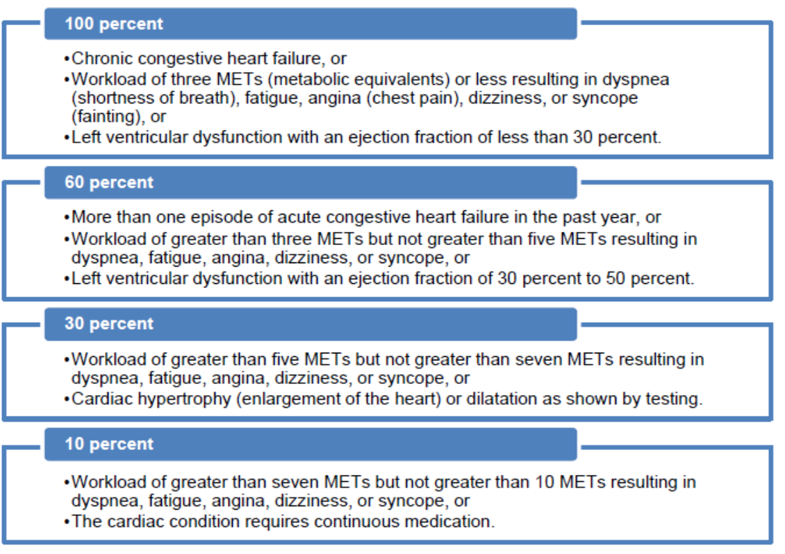

**Note:**

In addition to this refresher training the OIG recommended that the Under Secretary for Benefits implement a plan to:

1. Incorporate the system-generated instructions for medical providers directly into the heart disability benefits questionnaire (instead of separately on the examination re quest) and determine whether additional revisions are necessary to ensure medical providers’ findings are sufficient for evaluation purposes.
2. Ensure medical providers who complete heart disability benefits questionnaires are made aware of common problem areas related to the questionnaire format and system-generated instructions and are provided guidance on how to avoid giving conflicting or insufficient information.

**Interpreting Cardiovascular DBQ**

The diagnosis section, shown below, contains a list of several heart related diagnoses that a medical provider can select that may not be relevant to the decision.

Table 1:

Medical providers have the opportunity to select several diagnoses listed on the DBQ.

* However, providing a new diagnosis of a heart condition not claimed by the Veteran or that is not service connected could be problematic. New diagnoses require VBA **to obtain clarification to determine whether these conditions affect the MET level or whether any of the conditions should be considered for service connection.**

The unrelated diagnoses sometimes conflict with responses to a later question on the DBQ regarding METs due solely to the heart condition as shown below.

**Example:**



# Practical Exercise

*Directions: Answer the following questions. You may use your Student Handout.*

1. **Scenario:** A Veteran filed a claim for service connection for ischemic heart disease. A medical provider completed a disability benefits questionnaire to assess this condition. The medical provider listed four heart conditions in the diagnosis section, including atrial fibrillation, which was not linked to the Veteran’s service nor claimed by the veteran. The medical provider then reported the METs level due to the heart conditions listed in the diagnosis section, including atrial fibrillation. Thus, there was a conflict on the disability benefits questionnaire findings because the METs included a condition not claimed nor related to the veteran’s military service.
2. **Scenario:** A medical provider documented a MET level of greater than three to five on the disability benefits questionnaire and indicated it was not due to the heart condition in the diagnosis section. The medical provider then gave the same MET level of greater than three to five that was due to the heart condition in the second METs testing section of the disability benefits questionnaire. The medical provider listed in the rationale two other medical conditions but did not indicate whether or to what extent these other conditions affected the METs. The medical provider also stated that the LVEF was a more accurate finding of cardiovascular manifestations. Due to these multiple instances of unclear information, the RVSR should return the disability benefits questionnaire to the medical provider for clarification on what measurement to use instead of evaluating the heart condition based on the MET level provided.
3. **Scenario***:* A medical provider reported a Veteran’s cardiac dilatation on a disability benefits questionnaire and associated the dilatation with a condition not related to the Veteran’s military service. A VBA decision maker assigned a 30-percent evaluation for the dilatation.