Vbms-r TipMaster Prompts for Addressing Chap 35

and

SMC HB Entitlement

Trainee Handout

**Table of Contents**

[Objectives 2](#_Toc436922582)

[References 3](#_Toc436922583)

[Topic 1: Purpose of TipMaster Within VBMS-R 4](#_Toc436922584)

[Topic 2: TipMaster Prompts For 38 USC Chap 35 6](#_Toc436922585)

[Topic 3: TipMaster Prompts For SMC HB 11](#_Toc436922586)

[Practical Exercise 15](#_Toc436922589)

[VBMS-R TipMaster Level II Assessment](#LA) 16

Objectives

In order to accomplish the purpose of this lesson, the RVSR will be required to accomplish the following lesson objectives.

TheRVSRwill be able to:

* Explain the purpose of the VBMS-R TipMaster prompts.
* Identify the action required when the VBMS-R TipMaster prompts entitlements for consideration.
* Identify when to address 38 USC Chapter 35 entitlement.
* Identify when to address SMC HB.

References

* *All M21-1 references are found in the* [Adjudication](https://vaww.compensation.pension.km.va.gov/) Procedures Manual*.*
* [38 CFR 3.350 Special Monthly Compensation](https://www.ecfr.gov/cgi-bin/text-idx?SID=ad275643432556b9dda942343fb89296&mc=true&node=pt38.1.3&rgn=div58" \l "se38.1.3_1350)
* [38 CFR 3.807 Dependents’ educational assistance; certification](https://www.ecfr.gov/cgi-bin/text-idx?SID=ad275643432556b9dda942343fb89296&mc=true&node=pt38.1.3&rgn=div58" \l "se38.1.3_1807)
* [M21-1 Part IV, Subpart ii, 2.H: Special Monthly Compensation](https://vaww.vrm.km.va.gov/system/templates/selfservice/va_kanew/help/agent/locale/en-US/portal/554400000001034/content/554400000014571/M21-1-Part-IV-Subpart-ii-Chapter-2-Section-H-Special-Monthly-Compensation-SMC?articleViewContext=article_view_browse_tree&isFeatured=undefined&topic=undefined)
* [M21-1 Part III, Subpart iii.6.c: Department of Veterans Affairs Educational Benefits under 38 U.S.C. Chapter 35](https://vaww.vrm.km.va.gov/system/templates/selfservice/va_kanew/help/agent/locale/en-US/portal/554400000001034/content/554400000014182/M21-1-Part-III-Subpart-iii-Chapter-6-Section-C-Department-of-Veterans-Affairs-VA-Education-Benefits-Under-38-USC-Chapter-35?articleViewContext=article_view_browse_tree&isFeatured=undefined&topic=undefined)
* [M21-1 Part III, Subpart iv.6.D-Codesheet Section](https://vaww.vrm.km.va.gov/system/templates/selfservice/va_kanew/help/agent/locale/en-US/portal/554400000001034/content/554400000014207/M21-1-Part-III-Subpart-iv-Chapter-6-Section-D-Codesheet-Section?articleViewContext=article_view_browse_tree&isFeatured=undefined&topic=undefined)
* [M21-1 Part III, Subpart iv.5.A Principals of Reviewing Evidence and Decision Making](https://vaww.vrm.km.va.gov/system/templates/selfservice/va_kanew/help/agent/locale/en-US/portal/554400000001034/topic/554400000003097/Chapter-05-Evaluating-Evidence-and-Making-a-Decision)
* [VBMS Rating User Guide](https://vbaw.vba.va.gov/VBMS/docs/VBMS_Rating_User_Guide_Release_19_0_4.pdf)

Topic 1: Purpose of Vbms-R TipMaster

Purpose of TipMaster

The TipMaster is an embedded “help-aid” that provides prompts for the RVSR to consider during the rating process. In this training we will discuss the prompts as how they relate to entitlements SMC, and Chap 35 benefits.

The TipMaster will open based on the decision being managed and the entries made on the Issue Management tab.

Using TipMaster

When the TipMaster prompted is activated follow the following steps to ensure proper attention is given to the issue that generated the prompt the TipMaster will open based on the decision being managed and the entries made on the Issue Management tab.

* Issues are listed in TipMaster indicate that an issue (s) should be addressed as suggested within the prompt box (see attached screen shot of TipMaster slide 13).
* Select the issue you want to review. you can highlight any issue in the list, but the first issue will be automatically highlighted.
* The tip text that applies to the highlighted issue is shown in the tip for box on the right.
* Citations are listed in the citations box.
* Select the citation you want to review. you can highlight any citation in the list, but the first citation will be automatically highlighted.
* She law that applies to this citation is shown in the pertinent law for box on the right.
* Select ok to return to the issue summary screen

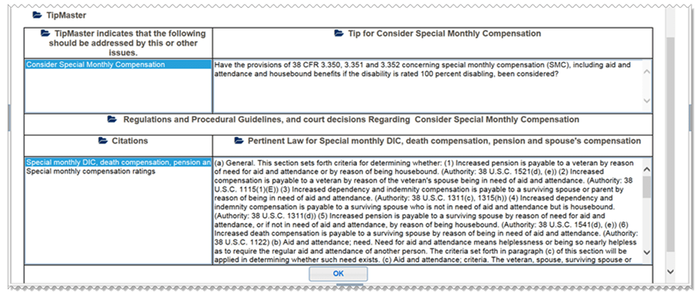

**Topic 2: TipMaster Prompts For 38 USC Chapter 35**

**Scenario 1: Establishing DEA/Chap 35:**

Presented with the following scenario:

* Veteran is service-connected at 100 percent disabling for posttraumatic stress disorder (PTSD), September 11, 2018.
* Medical evidence of Record supports no future examination is warranted, as the total disability will continue for the remainder of the Veteran’s life.

**Reminder:** Ancillary Benefits are secondary benefits that are to be considered when evaluating claims for compensation, pension or Dependency and Indemnity Compensation (DIC).

**Please Note:** The attached screens shot to this student handout coincide with the Power Point presentation.

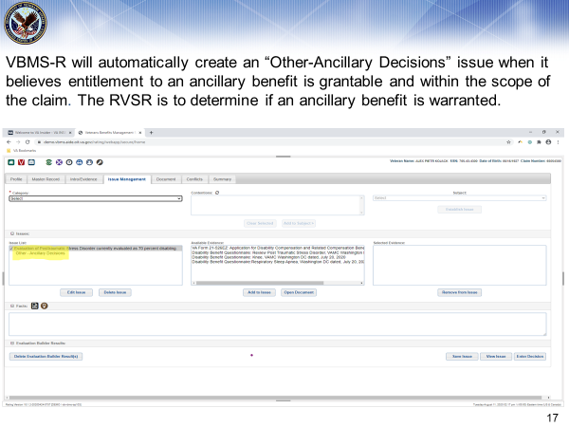

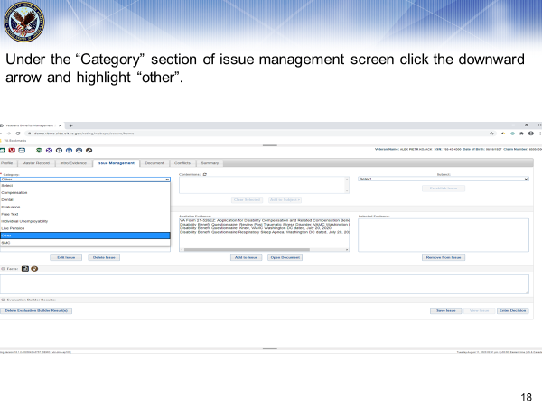

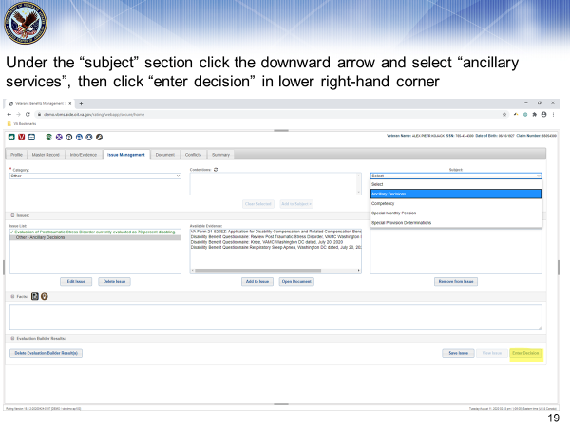

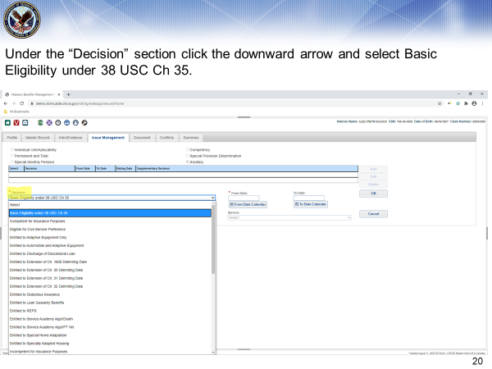

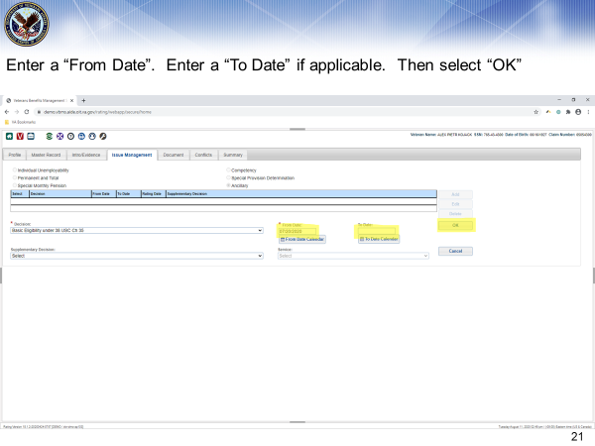

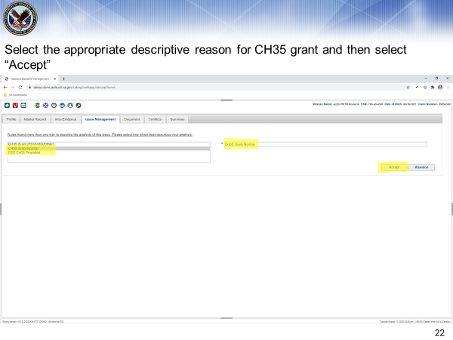

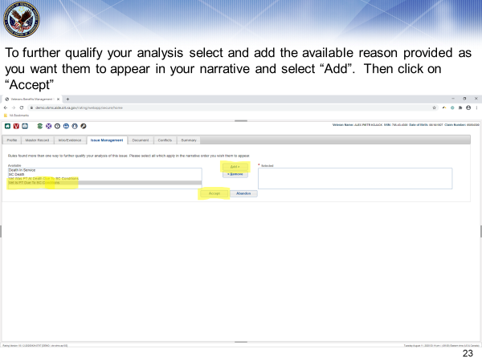

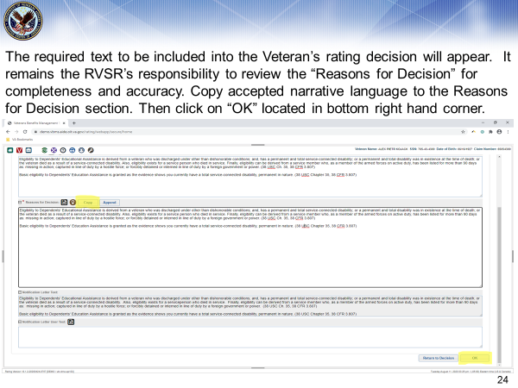

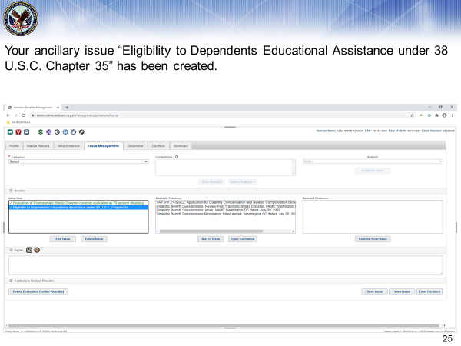

Topic 3: TipMaster Prompt for Special Monthly Compensation (SMC) Housebound (HB)

**Prompts for SMC Housebound (HB) - Scenario 2**

In the case where the RVSR has granted a Veteran a single issue at 100% and other service-connected issues add up to 60%, VBMS-R will prompt the RVSR after clicking on the **“document tab”** to review the rating decision for additional entitlements, specifically SMC HB entitlement. The following screen shots demonstrate the steps the RVSR is to take.

**Please Note:** The attached screens shot to this student handout coincide with the Power Point presentation.

**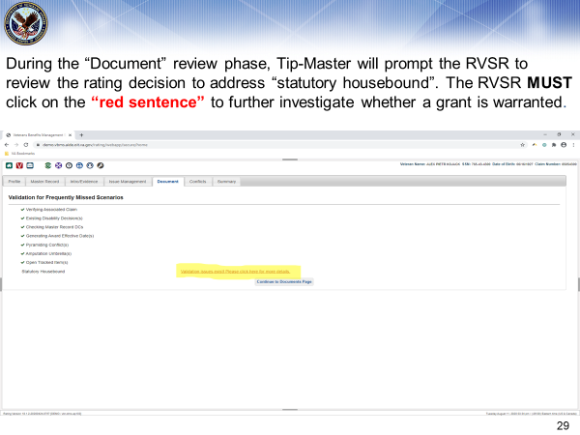**

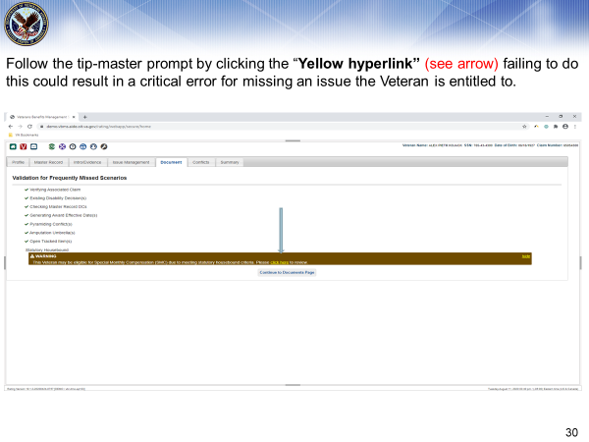

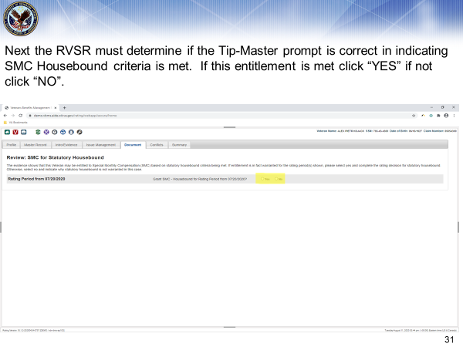

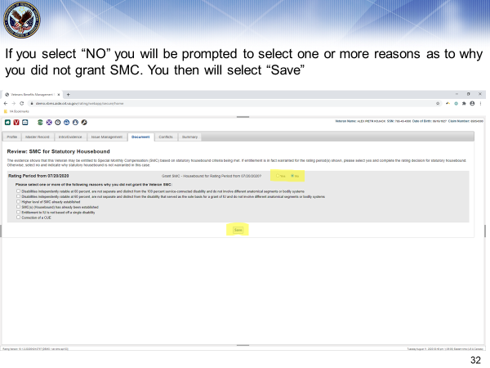

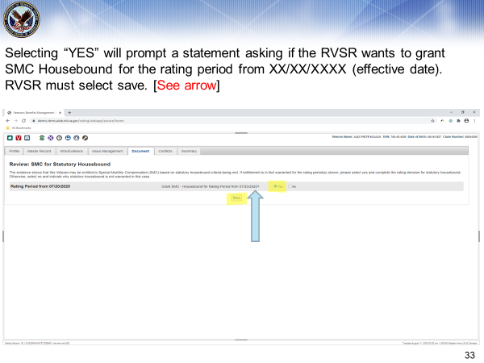

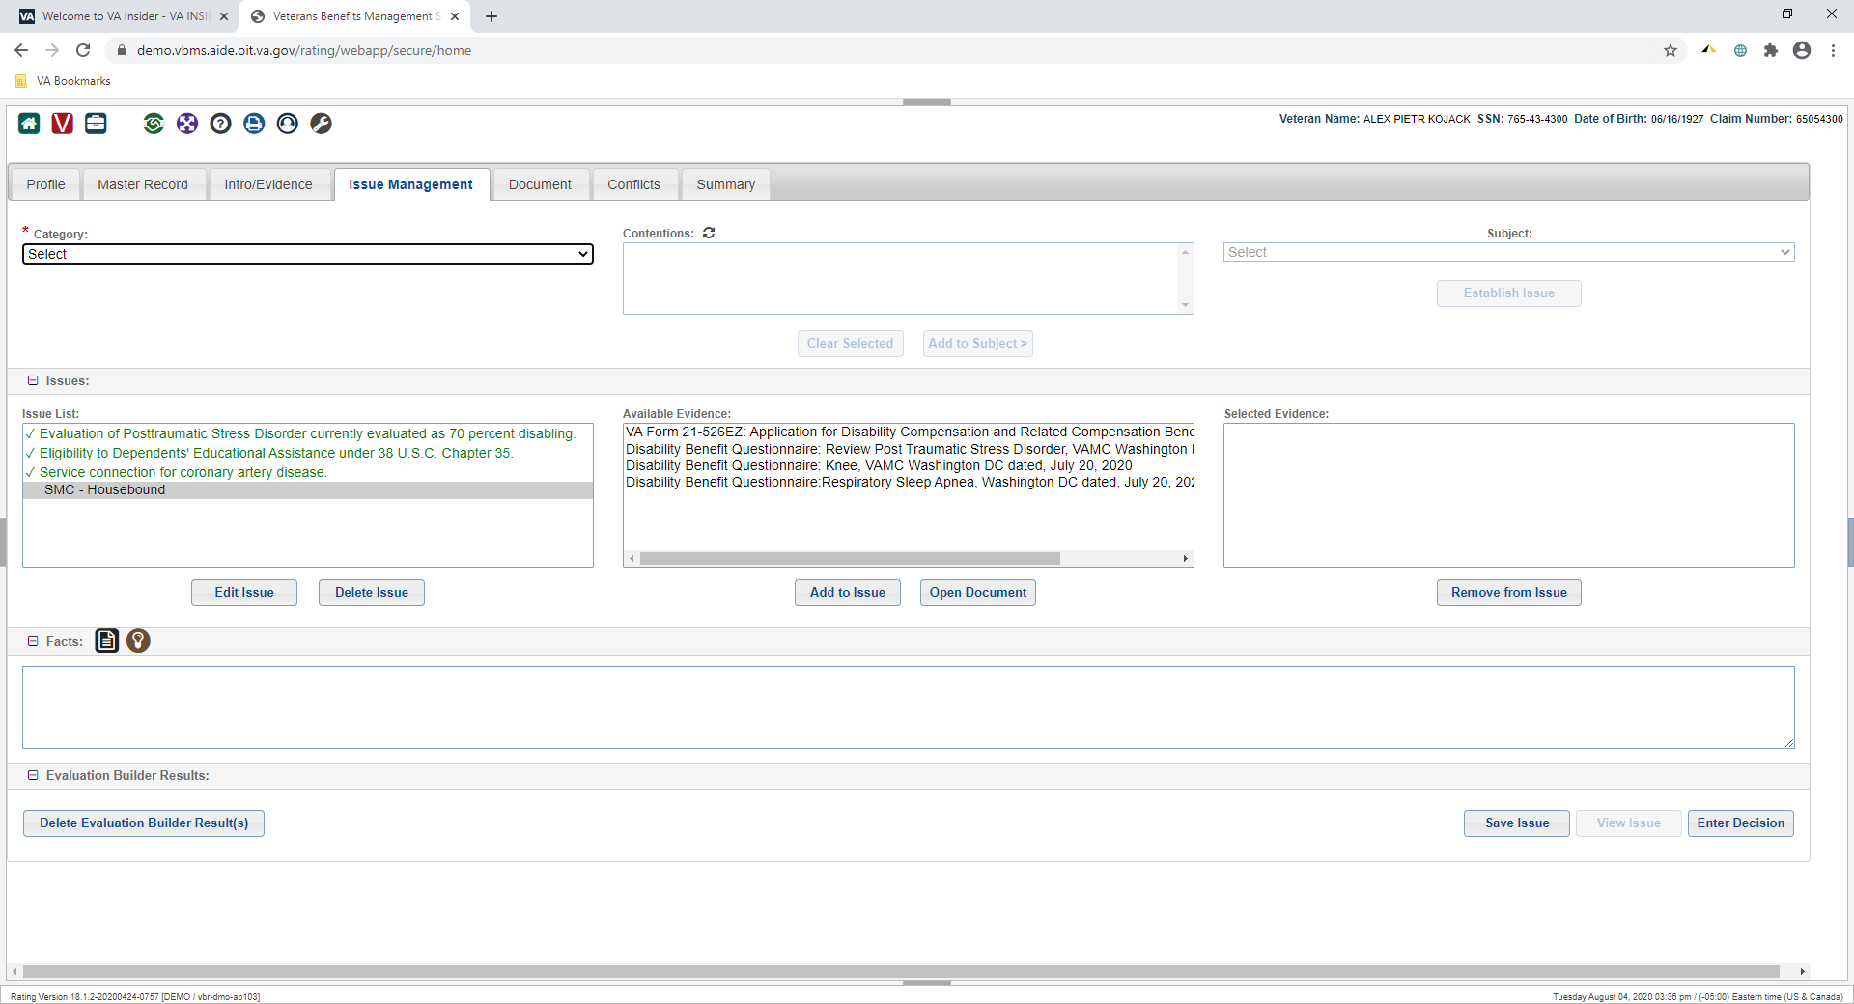



Practical Exercise

**Directions:** Review the following questions, and provide the correct answer to each one. The PowerPoint slides, student handout, M21-1 Adjudication Procedures Manual, or any other references and regulations can be utilized.

1. What is the purpose of the embedded “TipMaster” Prompt?
2. True or False. Citations accompany the prompted TipMaster view?
3. Will TipMaster prompts automatically create an “issue” within VBMS-R?
4. What section of VBMS-R will the RVSR select “Ancillary Decisions?
5. What section of VBMS-R TipMaster will the RVSR select Basic Eligibility under 38 USC Ch 35?
6. Once the RVSR “clicks” on the document tab to review the rating decision, if there is an issue to address what action must the RVSR take?
7. If the RVSR determines that SMC HB is not warranted what must the RVSR do?
8. What regulation will assist you with granting SMC HB?

Vbms-r TipMaster Prompts for Addressing Chap 35 and SMC HB Entitlement

You have completed the instructional part of training on VBMS-R TipMaster Prompts for Addressing Chap 35 and SMC HB Entitlement. You must log in to TMS and enter the TMS ID# to complete the online assessment and survey to receive credit for this training. The assessment requires a score of 80% to pass. Any available resource can be utilized to complete the assessment. This includes but not limited to lesson handout, internet/intranet web sites, job aides, PowerPoint and any applicable reference materials. You will have unlimited attempts to pass this assessment.