(VSR VIP Pre-D) Dependency Development for

Pre-Determination

Trainee Handout

**Table of Contents**

Objectives 2

References 3

Topic 1: Basic Eligibility and Policies 4

Topic 2: Claims Forms 6

Topic 3: Claims Establishment and System Updates 8

Topic 4: Development Requirements for Pre-Determination 11

Practical Exercise 15

Objectives

At the end of this lesson, you will be able to:

* Identify the overall disability rating required for a Veteran to be eligible for additional benefits for dependents
* Identify the types of dependents for whom the Veteran may be paid additional compensation
* Define the terms *relationship* and *dependency* for the purposes of determining a Veteran’s entitlement to additional benefits for a claimed dependent
* Identify the most commonly used VA forms for claiming additional benefits for dependents
* Identify the appropriate end product (EP) control based on given scenarios and claim circumstances
* Express the proper contentions needed based on given scenarios and claim circumstances
* Discuss the potential changes to fully developed claim (FDC) status based on given scenarios and claim circumstances
* Recall the procedures to follow when a Veteran claims entitlement to additional compensation for a dependent using a non-prescribed form
* Recall the procedures to follow when a Veteran’s claim for additional compensation for a dependent is not substantially complete

References

* [38 CFR 3.4(b)(2)](https://www.ecfr.gov/cgi-bin/text-idx?SID=2eb3a1647cf22e71b98a5cc2647a85a5&mc=true&node=se38.1.3_14&rgn=div8), Compensation. Disability Compensation. An additional amount
* [38 CFR 3.50(a)](https://www.ecfr.gov/cgi-bin/text-idx?SID=3ffc910db19239d5678ab14c650713bd&mc=true&node=se38.1.3_150&rgn=div8), Spouse
* [38 CFR 3.57](https://www.ecfr.gov/cgi-bin/text-idx?SID=3ffc910db19239d5678ab14c650713bd&mc=true&node=se38.1.3_157&rgn=div8), Child
* [38 CFR 3.204](https://www.ecfr.gov/cgi-bin/text-idx?SID=1ce31eae2df6edd7a0ef5fc591371cab&mc=true&node=se38.1.3_1204&rgn=div8), Evidence of dependents and age
* [38 CFR 3.401(b)](https://www.ecfr.gov/cgi-bin/text-idx?SID=dbfb9cf4e753f3f155f2bbd6100dff18&mc=true&node=se38.1.3_1401&rgn=div8), Veterans. Dependent, additional compensation or pension for
* [M21-1, Part I, 1.A.4.f,](https://vaww.vrm.km.va.gov/system/templates/selfservice/va_kanew/help/agent/locale/en-US/portal/554400000001034/content/554400000013969/M21-1-Part-I-Chapter-1-Section-A-Description-and-General-Information-on-Duty-to-Notify-and-Duty-to-Assist#4f) Definition: Substantially Complete Application
* [M21-1, Part III, Subpart i, 3.B](https://vaww.vrm.km.va.gov/system/templates/selfservice/va_kanew/help/agent/locale/en-US/portal/554400000001034/content/554400000014110/M21-1-Part-III-Subpart-i-Chapter-3-Section-B-Processing-Fully-Developed-Claims-FDCs), Processing Fully Developed Claims (FDCs)
* [M21-1, Part III. Subpart ii, 1.C.8.a,](https://vaww.vrm.km.va.gov/system/templates/selfservice/va_kanew/help/agent/locale/en-US/portal/554400000001034/content/554400000014112/M21-1-Part-III-Subpart-ii-Chapter-1-Section-C-Initial-Screening-Policies#8a) Accepting Outdated Versions of a VA Form
* [M21-1, Part III, Subpart ii, 2.B.1.b,](https://vaww.vrm.km.va.gov/system/templates/selfservice/va_kanew/help/agent/locale/en-US/portal/554400000001034/content/554400000014119/M21-1-Part-III-Subpart-ii-Chapter-2-Section-B-Claims-for-Disability-Compensation-and-or-Pension-and-Claims-for-Survivors-Benefits#1b) Requirements for a Complete Claim Received on or After March 24, 2015
* [M21-1, Part III, Subpart iii, 1.F.2](https://vaww.vrm.km.va.gov/system/templates/selfservice/va_kanew/help/agent/locale/en-US/portal/554400000001034/content/554400000071983/M21-1-Part-III-Subpart-iii-Chapter-1-Section-F-Record-Maintenance-During-the-Development-Process#2), Utilizing Contentions and Special Issue Indicators Associated with the Claimed Issues
* [M21-1, Part III, Subpart iii, 5.A](https://vaww.vrm.km.va.gov/system/templates/selfservice/va_kanew/help/agent/locale/en-US/portal/554400000001034/content/554400000015798/M21-1-Part-III-Subpart-iii-Chapter-5-Section-A-General-Information-on-Relationship-and-Dependency), General Information on Relationship and Dependency
* [Letter Creator](https://vbaw.vba.va.gov/bl/21/rating/rat00.htm) tool (Follow the link to the Job Aids page, then click on the link for the tool.)
* [VBMS Core User Guide](https://vbaw.vba.va.gov/VBMS/docs/VBMS_Core_User_Guide_Release_19_0.pdf)

Topic 1: Basic Eligibility and Policies

**Additional Compensation for Dependents**

Per 38 CFR 3.4(b)(2), the Department of Veterans Affairs (VA) may pay additional disability compensation for certain dependents: spouse, child(ren), and/or dependent parent(s). In order to receive this benefit, there are certain requirements that must be met to establish eligibility on the part of the Veteran and the Veteran’s relationship to the claimed individual(s).

First and foremost, a Veteran must have an overall combined disability rating of at least 30% to be eligible to receive additional compensation for dependents. This evaluation must be granted by rating decision before the claimed individual(s) can be established as dependent(s) and the additional compensation can be paid.

**Dependents for VA Purposes**

As stated above, the Code of Federal Regulations (CFRs) identify the types of dependents – spouse, child(ren), dependent parent(s) – considered for this additional benefit. The lists below provide further elaboration on these dependents and even some common family members who cannot be considered dependents for VA purposes.

**Dependents:**

* Spouse
* Biological child (under age 18)
* Stepchild (under age 18)
* Adopted child (under age 18)
* School child (age 18-23)
* Child incapable of self-support (Helpless child)
* Parent (financial dependency must be shown)

**Not Dependents:**

* Ex-spouse (divorce finalized)
* Grandchild (not adopted)
* Stepchild when no longer a member of the Veteran’s household (exceptions apply)
* Foster child
* Mother-in-law or father-in-law

**Relationship vs. Dependency**

Both the relationship of the individual to the Veteran and the dependency of the individual upon the Veteran must be established in order to pay the additional compensation for that individual.

For VA purposes, *relationship* refers to an individual’s legal status with respect to the Veteran (i.e. all legal requirements fulfilled to be considered legally married, legal status as the Veteran’s biological child, stepchild, or adopted child, etc.).

In most cases, VA will accept the entries a Veteran makes on *VA Form 21-686c* as sufficient proof of the following:

* Marriage
* Dissolution of a marriage
* Birth of a child
* Introduction of a stepchild into a Veteran’s family, or
* Death of a dependent

In other words, the information provided on the form by the Veteran concerning their relationship is accepted as valid, unless one of the exceptions to the policy applies. (*M21-1 III.iii.5.A.2.b.)*

The term *dependency* refers to the question of whether or not an individual is financially “dependent” on the Veteran.

As outlined in *M21-1 III.iii.5.A.1.d*, there are circumstances in which VA assumes financial dependency already exists without requiring any proof. Once VA determines a marital relationship exists between a Veteran and their spouse or once VA establishes an individual a child of the Veteran, VA assumes financial dependency exists. VA does not require proof of financial dependency under either of these circumstances.

However, there are circumstances in which financial dependency is not assumed and must be proven. The primary example of this is dependent parent(s). VA does require proof of financial dependency in order to pay additional compensation for a parent. (*M21-1 III.iii.5.A.1.e*)

Now that we understand the eligibility requirements and the types of individuals who can be considered for this additional compensation, let’s look at how the Veteran can file a claim for these benefits.

Topic 2: Claims Forms

**Prescribed Forms for Claiming Additional Benefits for Dependents**

Requests to add a dependent to an award must be filed on one of the prescribed forms noted in the last row of the table in *M21-1, Part III, Subpart ii, 2.B.1.b*.

The most common forms are:

* *VA Form 21-686c, Application Request to Add and/or Remove Dependents*
* *VA Form 21-674, Request for Approval of School Attendance*
* *VA Form 21P-509, Statement of Dependency of Parent(s)*
* *VA Form 21-0538, Mandatory Verification of Dependents* (December 2017 version or earlier)

*VA Form 21-686c, Application Request to Add and/or Remove Dependents*, is the primary form used to collect the information needed to establish a legal relationship exists between a Veteran and a claimed dependent. Upon reviewing the completed *VA Form 21-686c*, it must be determined if additional evidence, forms, or information are required.

*VA Form 21-674, Request for Approval of School Attendance,* must be provided, in addition to *VA Form 2-686c*, for consideration of entitlement to additional compensation for a school-aged child (age 18-23) currently attending school. All school attendance information, including the name of the institution, starting dates, and expected graduation date, must be provided by the Veteran. The financial information on this form is not required when the benefit under consideration is disability compensation, but is required when the benefit under consideration is pension.

*VA Form 21P-509, Statement of Dependency of Parent(s),* must be used to claim entitlement to additional compensation for a parent(s). The form requests information that establishes the relationship between the Veteran and parent(s) as well as financial information that establishes the dependency of the parent(s) on the Veteran. VA Form 21-686c is not required when claiming entitlement to additional compensation for a parent(s).

*VA Form 21-0538, Mandatory Verification of Dependents,* must be completed periodically by the Veteran to confirm the status of dependents already on their award. Only the December 2017 or earlier versions of the form may be used to *initiate* the process of adding a spouse or child to an award when the Veteran mentions them on this form; claims processors must request additional information (beyond what this form requires the Veteran to provide) in order to determine entitlement. The newer versions of the VA Form 21-0538 (versions later than December 2017) cannot be used to initiate a claim to add a dependent to the Veteran’s award.

**Form Completion by VBA Employees**

At times, the VSR may see these forms in the claim folder that were signed by a VA employee. VA authorizes its regional office and call center employees to

* complete *VA Form 21-686c* and *21-674*, using information they obtain from a claimant over the telephone, and
* sign the form on the claimant’s behalf.

The form must include clear identification of the employee executing the form through a digital signature or a wet signature, when electronic submission is not available. A separate *VA Form 27-0820, Report of General Information*, is ***not*** needed in this case.

**VA Form 21-686c (September 2018 or Later)** *(See M21-1, Part III, Subpart iii, 5.A.4.d)*

With the publication of the September 2018 version of *VA Form 21-686c*, the Veteran is notified upfront of the information/evidence needed to entitlement to additional compensation for a claimed dependent, similar to how EZ forms work.

If the Veteran filed a claim for additional compensation for dependents on a ***September 2018 or later*** version of *VA Form 21-686c,* but the Veteran did not provide the information/evidence the form requires, the VSR should ***not*** undertake development to obtain the missing information or evidence. Failure to provide all required information or evidence for the claimed dependent will result in a denial of the claim for that individual.

**When a Prescribed Form is Not Needed**

VA ***does not*** require Veterans to use a specific form to report a change in a dependent’s status that will result in ***removal*** of the dependent from the Veteran’s award. The Veteran may report such changes

* in writing
* by telephone, e-mail, or fax, or
* through eBenefits.

At a minimum, the Veteran must provide the date (month, day, and year) of the event (divorce, death of a dependent, marriage of a child, etc.) that necessitates the removal. Follow the instructions in *M21-1, Part III, Subpart iii, 5.L.4.f*, if the information is not provided.

Now that we have an understanding of the forms Veterans must submit when claiming entitlement to additional compensation for dependents, we will discuss the end products (EPs) that control the claims and the system updates, such as contentions and FDC/FDC excluded indicators that might need updating during pre-determination development.

Topic 3: Claims Establishment and System Updates

As we learned in the previous section, there are several prescribed forms that must be used to claim additional compensation for dependents. The most common is VA Form 21-686c, which allows Veterans to claim entitlement to addtiiona compensation for spouses and all types of children and request removal of all three types of dependents, spouse, child, and parent.

VA Form 21-674 is an additional form needed for providing more information concerning a school child. VA Form 21P-509 is specifically for claiming entitlement to additional compensation for parents. And VA Form 21-0538, though primarily intended to serve as a form for verifying dependent status, can also be used to initiate a claim for a dependent, although it does not request the information needed to determine entitlement.

These forms serve as the means by which a Veteran can submit a valid claim for additional benefits based on their dependents. Once received, an end product (EP) must be established so the claim is not lost, and contentions must be added for each individual the Veteran claims as a dependent. Special issue indicators must also be evaluated to see if receipt of this claim impacts the FDC status of other pending claims. This topic will address claim establishment and system updates.

**End Product (EP) Control**

Based on the circumstances of the claim being worked, there are several options for EPs that may be used to control a claim for additional benefits for dependents. Determining the correct EP is based on the following rules:

EP 130 (*free-standing dependency EP*) – Establish an EP 130 when VA receives a claim for additional compensation for dependents

* by itself,
* in conjunction with or while an EP 020 or 040 is pending, or
* while an EP 110 or 010 is pending, under the circumstances of the exception listed under the EP 110 or 010 section below.

EP 130 is the most common end product that is used to control claims for additional benefits for dependents. These claims are typically worked by separate special teams and are not typically part of pre-determination development for VSRs. However, there are circumstances in which the issue of entitlement to additional compensation for dependents impacts development.

EP 110 or 010 (*original EP*) – If a claim for additional compensation for dependents is received in conjunction with an original claim for disability compensation or while an EP 110 or 010 is being developed, regardless of whether VA received the claims at the same time, add the contentions to the original EP (110 or 010). *Do not* establish a separate EP 130.

*Exception:* If a rating was completed on an EP 010 or 110, assigning a single or combined evaluation of at least 30%, and at least one issue is deferred for further action (continuing the EP), a separate EP 130 should be established if VA subsequentlyreceives a claim for additional compensation for a dependent(s) while the EP 010 or 110 is still pending.

EP 020 - When a Veteran files a claim for additional compensation for a child the Veteran claims is incapable of self-support, commonly known as a helpless child, the EP used to control the decision for that child must be a rating EP 020 (unless part of an original claim). These claims require the review of medical evidence and completion of a rating decision by an RVSR to make the eligibility determination.

**Dependency Contentions**

Once the end product (EP) is established, the claimed dependents must be reflected on the contention screen in VBMS. An individual contention must be added for *each* dependent, to include the name of the dependent.

For example:

* dependency claim for [***name of spouse***]
* dependency claim for [***name of child***]

**Note**:When adding a contention, enter Administrative Issue in the Classification field and No in the Medical field to indicate that the issue is not medical, but rather administrative, and does not require a rating decision.

**Dependency Claims and Fully Developed Claim (FDC) Status**

The receipt of a claim for additional compensation for a dependent may affect the status of a Fully Developed Claim (FDC) for disability compensation.

If an original claim is received as an FDC, and a claim for additional benefits for dependents (on the prescribed form and substantially complete) is received on the same day, the original claim should stay in FDC status (*Fully Developed Claim*), as the claims were received simultaneously.

However, a claim for disability compensation must be excluded from the FDC program under the following circumstances:

* An FDC is pending and a claim for additional compensation for a dependent(s) is subsequently received (*FDC Excluded – Additional Claim Submitted*),
* An FDC and claim for additional compensation for a dependent(s) is received simultaneously, but the claim for dependent(s) is incomplete or not on the prescribed form (*FDC Excluded – Necessary Form(s) Not Submitted*)
* A claim for additional compensation for a dependent(s) is pending and VA subsequently receives an FDC (*FDC Excluded – Claim Pending*)

Remember, VA does not treat claims for additional benefits for a dependent(s) as an FDC, but such claims can potentially affect the FDC status of other compensation claims. Along with ensuring the correct EP and contentions are reflected in VBMS, the VSR should also ensure that the FDC status is accurate based the timing of receipt of a claim for additional compensation for a dependent(s). For more information about circumstances under which FDC exclusion is necessary, please refer to *M21-1 III.i.3.B.2.a* and *III.i.3.B.2.b*.

Now that we have an understanding of the EPs that control claims for additional compensation for dependents, as well as the system updates that might be needed, particularly contentions and FDC status, we can move on to discuss development actions that might be needed during pre-determination development.

Topic 4: Development Requirements for Pre-Determination

As we have learned, Veterans often submit their claim for additional benefits for a dependent(s) after VA assigns a disability rating of 30% or more. They may submit the claim individually or with a claim for entitlement to a higher disability rating. Regardless of the timing of receipt of the claim for additional compensation for a dependent(s), if the Veteran’s original claim has been completed in full or if the Veteran already has a single or combined disability rating of at least 30%, the claim is assigned an EP 130 and worked by a separate team.

We also learned there is no requirement that Veterans wait to submit a claim for additional conpensation benefits for a dependent(s) until after VA has assigned a single or combined disability rating of at least 30%. Veterans may submit the claim concurrently with the submission of an original claim for compensation. When a claim for additional compensation for a dependent(s) is submitted while VA is working on an original claim (EP 110 or 010), the developing VSR must ensure all systems are updated accurately, as discussed in the previous topic.

The VSR must also make sure any potential development that might be needed is completed alongside the development for the medical conditions claimed. These development actions, though limited by the new guidance surrounding the updated VA Form 21-686c, include actions to take when the claim is not submitted on a prescribed form or the prescribed form is not substantially complete. This section will discuss those required development actions.

**Claim *Not* Submitted on a Prescribed Form**

One development action a pre-determination VSR might need to take is notifying the Veteran if the claim for additional compensation for a dependent(s) is not submitted on a prescribed form.

If a request for additional compensation for dependents is not received on a prescribed form, first attempt to contact the Veteran via telephone to complete *VA Form 21-686c* and/or *VA Form 21-674*, on their behalf. The manual reference for prescribed forms is *M21-1 III.ii.2.B.1.b.*

If contact is successful, complete and sign the form, upload it into the VBMS eFolder, and update the systems as appropriate. The date of claim is the day of completion and upload of the form into VBMS. *M21-1 III.iii.5.A.4.n.*

If contact is *unsuccessful*:

* And EP 110 or 010 is pending, establish an EP 400 – *Correspondence;* if EP 130 exists, change to EP 400 *- Correspondence*
* Use the Letter Creator tool to generate the *Request for Application for Dependency* letter
* Upload a copy of the letter into the VBMS eFolder and send via Package Manager
* Clear EP 400 – *Correspondence*
* Ensure contentions added to reflect dependent(s) claimed on something other than a prescribed form are removed from the EP 110 or 010

*Please Note:* A claim received on a non-prescribed form is considered a request for application (RFA); use the *Correspondence*  claim label and manually send the Dependency RFA letter to the Veteran. If the RFA claim label is used, the Service-Connected Compensation RFA letter will automatically be generated and uploaded into the eFolder instead of the RFA Dependency letter. Additionally, the EP 400 – *RFA* is cleared automatically at establishment.

**Criteria for a Claim to be Substantially Complete**

The form a claimant uses to initiate the process of adding a dependent to their award must be “substantially complete,” which means it must contain:

* The claimant’s name
* The claimant’s relationship to the Veteran, if applicable
* The benefit the claimant is seeking
* The claimant’s signature

In the case of a claim for additional benefits for dependents, the Veteran must list the individual dependent(s) for whom they wish to receive additional compensation. It is not enough to simply claim entitlement to additional compensation because they have dependents. Naming the individual(s) fulfills the requirement to identify “the benefit the claimant is seeking.”

Remember, a form may fail to provide all the evidence/information VA requires to add a dependent to a claimant’s award, but this does not mean the claim is not substantially complete. If the criteria listed above is met, even if specific information is missing, the claim is substantially complete and should be placed under EP control.

**Claim is *Not* Substantially Complete**

Another development action pre-determination VSRs might need to take is notifying the Veteran of receipt of a claim that is not substantially complete. Again, it is important to remember there is a distinct difference between a claim that is simply missing some required information and a claim that is not substantially complete.

If the claim does not meet the requirements of a substantially complete claim as noted in the previous section, follow the steps outlined in *M21-1 III.iii.5.A.4.b.* (referenced in *III.iii.5.A.4.d.* as well):

* Print or make a copy of the form
* Highlight the blocks that require completion (may need to print to PDF and highlight missing information electronically)
* If an EP 110 or 010 exists, establish an EP 400 – *Correspondence*
* If an EP 130 was established based on receipt of the incomplete claim, change it to an EP 400
* Attach the form to a letter that:
  + Instructs the claimant to complete the highlighted portions of the form, and
  + Informs the claimant that VA will not pay benefits based upon submission of the form unless they complete the form and return it within one year of the date of the correspondence (*Note:* The *Incomplete Application* letter in the Letter Creator tool may be used to generate this letter.)
* Combine the PDF version of the letter with the electronically highlighted form using Adobe Pro, then upload them into the eFolder and send them to the Veteran via Package Manager
* Clear the EP 400 – *Correspondence*
* If an EP 110 or 010 is pending, delete any contentions that were added based on the incomplete claim

VA will take no further action until the claimant returns the form with the required information.

**Claim is Substantially Complete**

The last situation to discuss is what to do when a claim for entitlement to additional compensation for a dependent(s) is substantially complete.

Again, it is important to remember several things:

* First, VSRs will typically be dealing with the issue of entitlement to additional compensastion benefits for a dependent(s) in the context of original claims (EP 110/010), when no separate EP 130 will be pending. Any EP 130 that is pending will be worked by a separate special team.
* Second, the newest *VA Form 686c* describes all evidence, information, and forms a Veteran must submit for each type of dependent claimed. Because of this, M21-1 tells VSRs not to undertake any development to obtain information/evidence/forms the Veteran failed to submit with *VA Form 21-686c*. It is with this understanding that we discuss the last set of actions.

Based on the steps as outlined in *M21-1 III.iii.5.A.4.d.,* the VSR should do the following:

* Ensure the form is substantially complete (if not, see directions from section above)
* Establish EP control based on the benefit claimed, unless the appropriate EP is already pending (in our case, EP 110/010 should be pending)

Part of working every claim is ensuring the systems have been properly updated. So along with checking to ensure the EP is established and correct, VSRs must also check for other system updates discussed in our earlier section that might be necessary: contentions for the dependents and FDC status, if needed.

The manual reference states that if the Veteran has no running award (which would be the case for an original claim), only complete these first two steps. The remaining steps should be completed by a Post team as they include reviewing the form to determine that VA received all needed information and making grant/denial decisions for the dependents. This function is specifically for the Post team because along with that determination, VA would also need to know if the rating decision has granted the required 30% or more disabling to make the Veteran eligible for the additional benefits for dependents.

Practical Exercise

1. A Veteran must have an overall combined disability rating of at least ______ to be eligible to receive additional compensation for dependents.
2. The Department of Veterans Affairs (VA) may pay additional disability compensation for the following three types of dependents:
3. For VA purposes, ____________ refers to an individual’s legal status with respect to the Veteran. The term ___________ refers to the question of whether or not an individual is financially reliant on a Veteran.
4. Which of the following forms is not a prescribed form to be used to file a claim for additional benefits for dependents? (*Describe who can be claimed using each form*)
   1. VA Form 21-674
   2. VA Form 21-686c
   3. VA Form 21-4138
   4. VA Form 21P-509
5. Indicate which of the following cannot be considered a dependent for VA purposes:
   1. Spouse
   2. School child (20 years old)
   3. Foster child
   4. Biological child (12 years old)
   5. Mother in-law (financially dependent)
   6. Helpless child (25 years old)
   7. Grandchild, not adopted
   8. Financially dependent parent
6. Which letter in Letter Creator should be used to notify the Veteran that the claim submitted for additional benefits for dependents was not submitted on a prescribed form?
   1. Incomplete Application letter
   2. Request for Application for Dependency letter
   3. Informal Claim letter
   4. Request for Application letter
7. Which EP should be established to notify the Veteran that the claim submitted for additional benefits for dependents was not submitted on a prescribed form, if the claim was submitted with an original claim for disability compensation (EP110/010)?
   1. EP 400 – Request for Application
   2. EP 130 – Dependency
   3. EP 290 – Administrative
   4. EP 400 – Correspondence
8. Which letter in Letter Creator should be used to notify the Veteran that the claim submitted for additional benefits for dependents was not substantially complete?
   1. Request for Application letter
   2. Informal Claim letter
   3. Incomplete Application letter
   4. Request for Application for Dependency letter

**Scenario Assessments - End Products (EP), Contentions, and Fully Developed Claim Status**

For each of the following scenarios, review the information provided and determine:

* which end product (EP) should be used to control the claim submitted,
* what contentions should be listed under the EP, and
* whether the claim should be considered FDC or FDC excluded.

If the instructor has assigned small groups, the trainees should work together in their groups to present an assessment of their assigned scenario to the classroom.

***Scenario #1***:

The Veteran files an original claim for compensation, submitting the following *VA Form 21-526EZ* and *VA Form 21-686c* (both forms substantially complete) on August 8, 2020.

*VA Form 21-526EZ*:

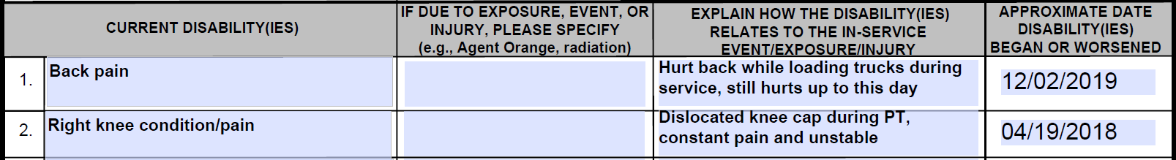

*VA Form 21-686c*:

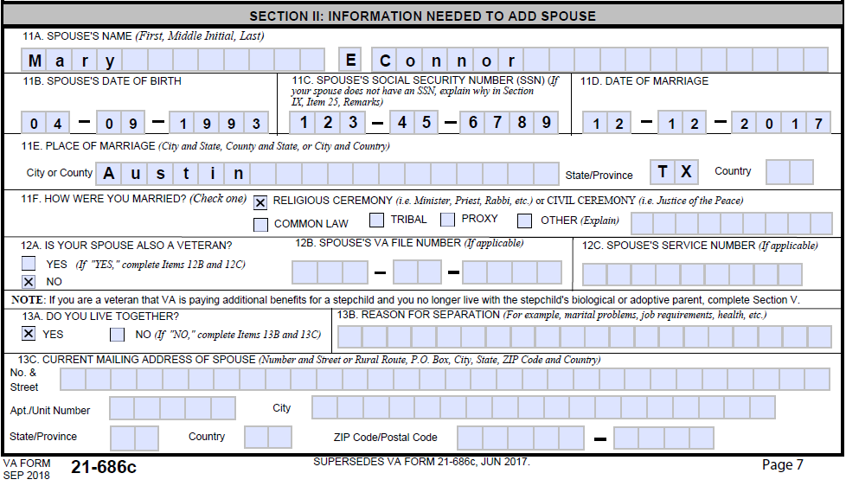

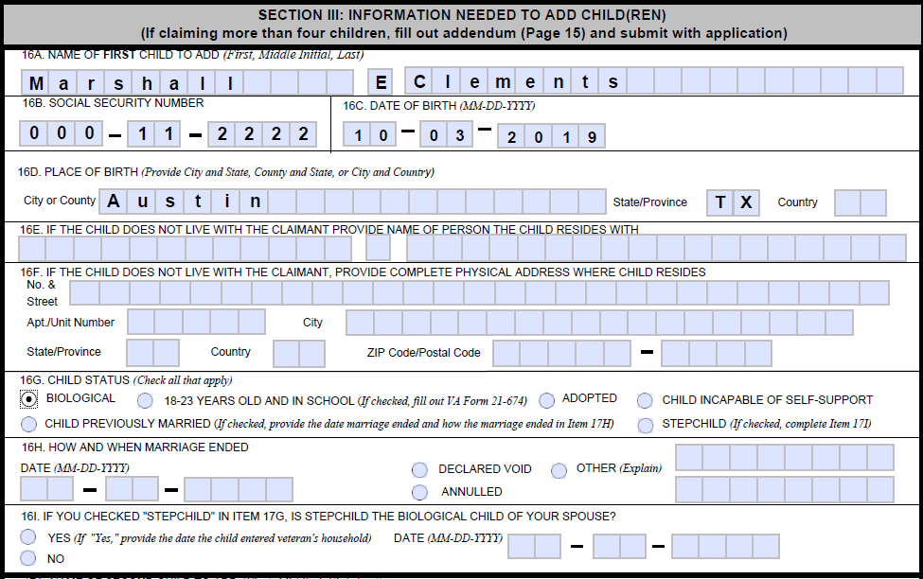

Based on the scenario and the images provided:

* What EP(s) should be used to control this claim?

* What contentions should be listed in VBMS under the EP(s)?
* Should this claim be excluded from FDC status?

***Scenario #2***:

The Veteran is currently service-connected at 40% disabling. She submits a claim for additional benefits for dependents using *VA Form 21-686c* and *VA Form 21-674*, both substantially complete.

*VA Form 21-686c*:

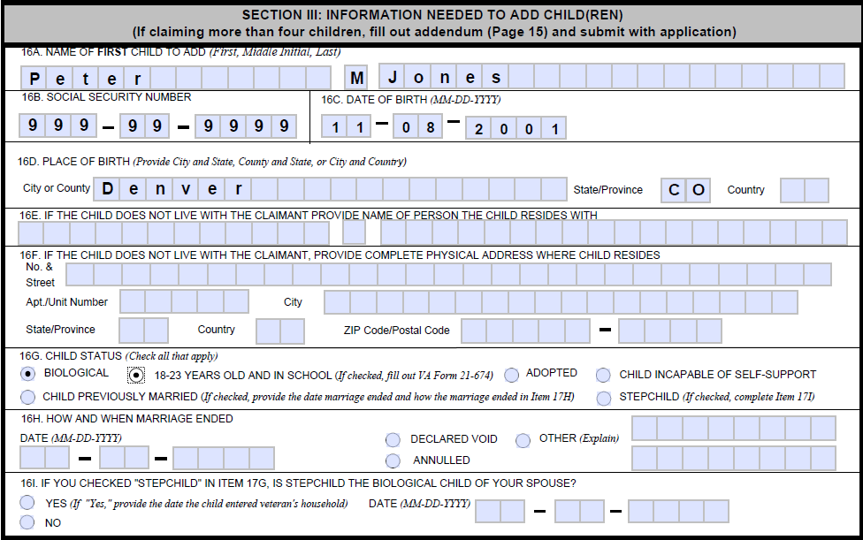

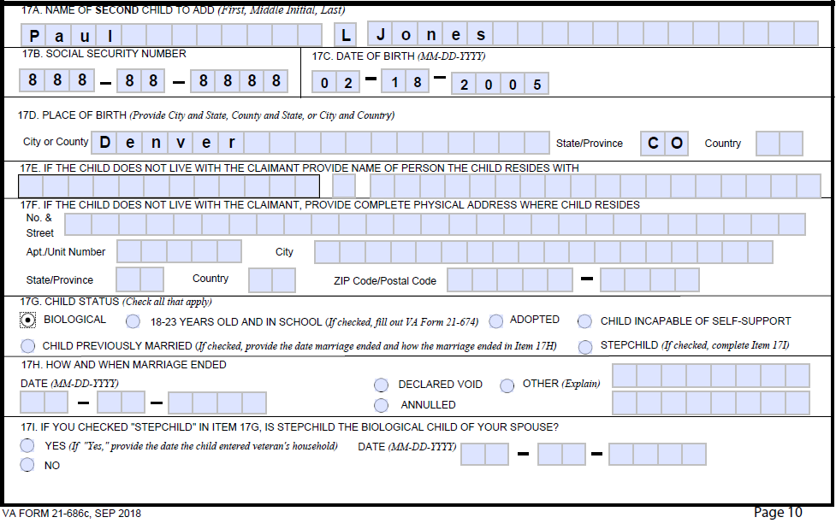

*VA Form 21-674*:

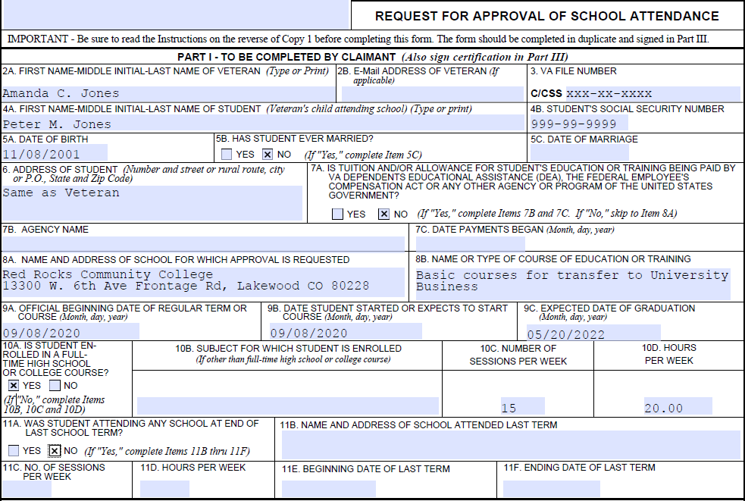

Based on the scenario and the images provided:

* What EP(s) should be used to control this claim?
* What contentions should be listed in VBMS under the EP(s)?
* Should this claim be excluded from FDC status?

***Scenario #3***:

The Veteran is currently service-connected at 60% disabling. He submits the following non-original claim using *VA Form 21-526EZ* on July 20, 2020, and a claim for additional benefits for dependents using *VA Form 21-686c* on August 3, 2020. Both claims are substantially complete.

*VA Form 21-526EZ*:

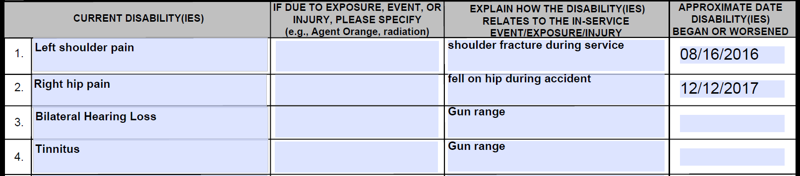

*VA Form 21-686c*:

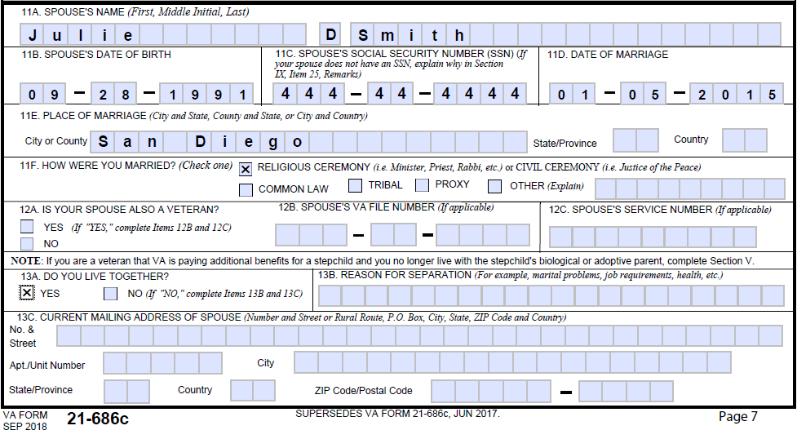

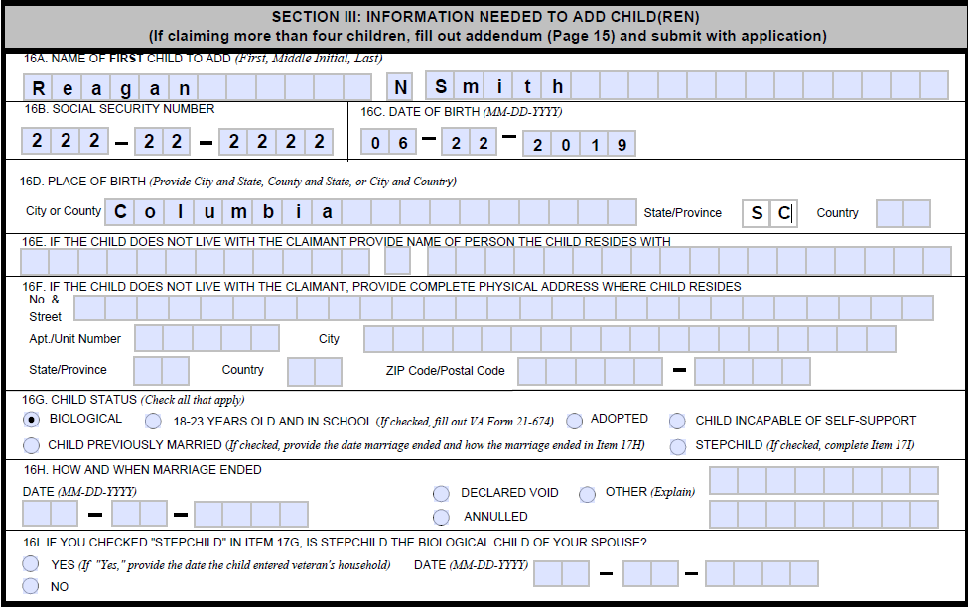

Based on the scenario and the images provided:

* What EP(s) should be used to control this claim?
* What contentions should be listed in VBMS under the EP(s)?
* Should this claim be excluded from FDC status?

***Scenario #4***:

The Veteran is currently service-connected at 30% disabling. She submits a claim for additional benefits for dependents using *VA Form 21-686c* on April 13, 2020, as well as medical evidence showing that her 20 year-old son is permanently incapable of self-support. On June 2, 2020, she also submits a claim for increased compensation using *VA Form 21-526EZ.* Both forms are substantially complete.

*VA Form 21-686c*:

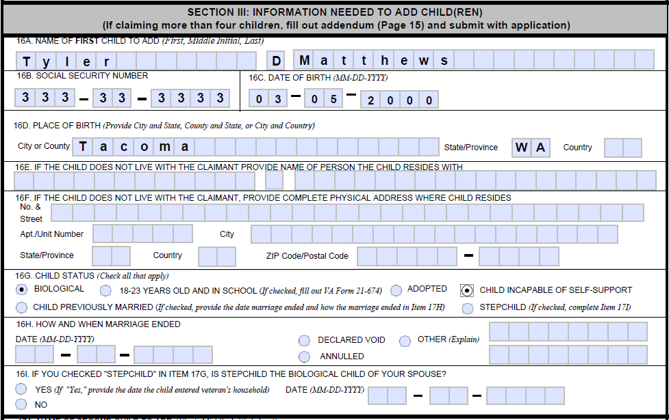

*VA Form 21-526EZ:*



Based on the scenario and the images provided:

* What EP(s) should be used to control this claim?
* What contentions should be listed in VBMS under the EP(s)?
* Should this claim be excluded from FDC status?

***Scenario #5***:

The Veteran submits an original claim for compensation on January 21, 2020, submitting VA Form 21-526EZ and VA Form 21-686c, both substantially complete. The Veteran then submits another VA Form 21-526EZ on March 5, 2020, while the first claim is still in process.

*VA Form 21-526EZ*:

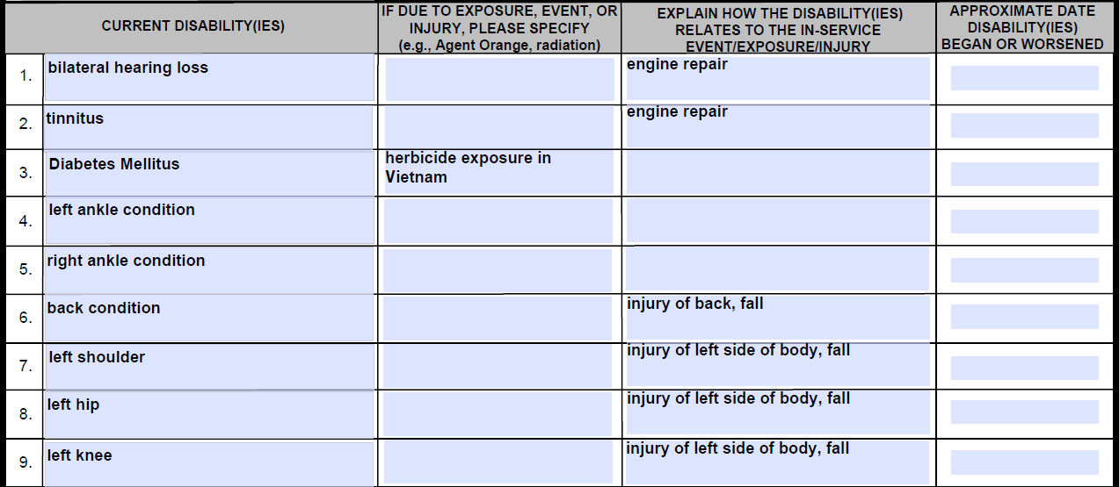

*VA Form 21-686c*:

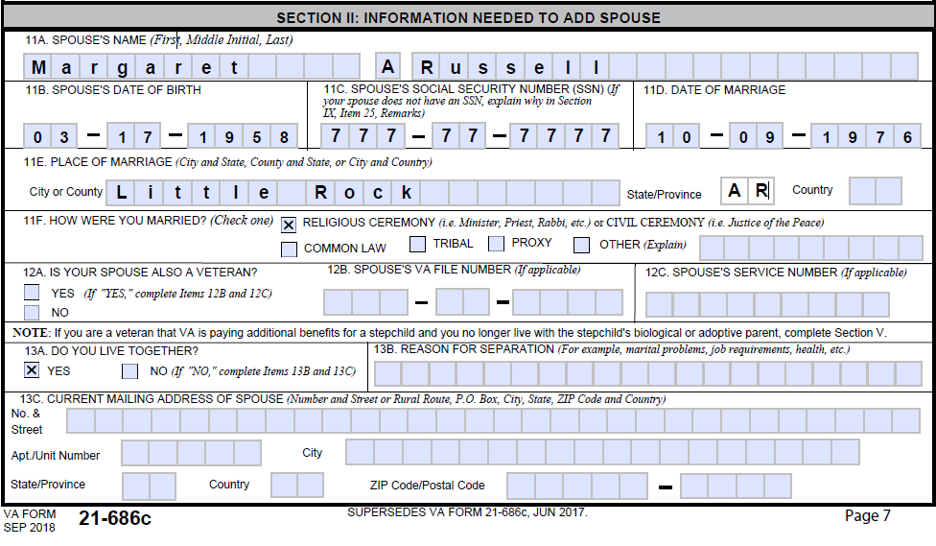

*Additional VA Form 21-526EZ*:

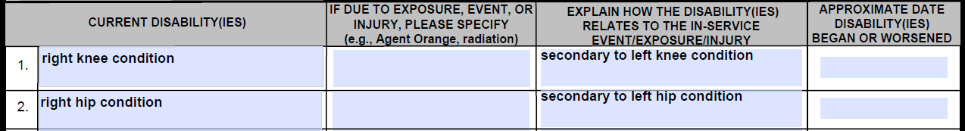

Based on the scenario and the images provided:

* What EP(s) should be used to control this claim?
* What contentions should be listed in VBMS under the EP(s)?
* Should this claim be excluded from FDC status?