Disappearance Of a Veteran

Trainee Handout

**Table of Contents**

[Objectives 2](#_Toc46754700)

[References 3](#_Toc46754701)

[Topic 1: Procedures for Obtaining a Veteran’s Address 4](#_Toc46754702)

[Topic 2: Taking Final Action When a Correct Address is Unobtainable 7](#_Toc46754703)

[Topic 3: 810 WIs Associated With a Veteran’s Disappearance 10](#_Toc46754704)

[Topic 4: Payments to Dependents Upon the Disappearance of a Veteran 13](#_Toc46754705)

[Topic 5: Actions to Take When VA Obtains a Current Address or Upon Reappearance of a Veteran 14](#_Toc46754706)

[Practical Exercise 16](#_Toc46754707)

Objectives

* Identify the procedures for obtaining a Veteran’s address
* Apply the final actions to take if a current address is unobtainable
* Identify the actions a claims processor must take when processing 810 work items (WIs) associated with the disappearance of a Veteran
* Recognize the principles of paying benefits to the dependents of a Veteran whose whereabouts are unknown
* Identify the steps to take upon the reappearance of a Veteran

References

All M21-1 references are found in the [Compensation and Pension Knowledge Management (CPKM) portal](https://vaww.compensation.pension.km.va.gov/).

[38 CFR 3.158 – Abandoned Claims](https://www.ecfr.gov/cgi-bin/text-idx?SID=ad275643432556b9dda942343fb89296&mc=true&node=pt38.1.3&rgn=div58#se38.1.3_1158)

[38 CFR 3.656 – Disappearance of Veteran](https://www.ecfr.gov/cgi-bin/text-idx?SID=ad275643432556b9dda942343fb89296&mc=true&node=pt38.1.3&rgn=div58#se38.1.3_1656)

[M21-1 III.ii.1.B.6 – Handling Returned Undeliverable Mail](https://vaww.vrm.km.va.gov/system/templates/selfservice/va_kanew/help/agent/locale/en-US/portal/554400000001034/content/554400000014111/M21-1-Part-III-Subpart-ii-Chapter-1-Section-B-Mail-Management?query=returned%20mail#6)

[M21-1 III.vi.8 – Miscellaneous Authorization Issues](https://vaww.vrm.km.va.gov/system/templates/selfservice/va_kanew/help/agent/locale/en-US/portal/554400000001034/content/554400000014302/M21-1,%20Part%20III,%20Subpart%20vi,%20Chapter%208%20-%20Miscellaneous%20Authorization%20Issues)

[M21-5 7.E – Filling a Substantive Appeal](https://vaww.vrm.km.va.gov/system/templates/selfservice/va_kanew/help/agent/locale/en-US/portal/554400000001034/content/554400000139940/M21-5-Chapter-7-Section-E-Filing-a-Substantive-Appeal)

Topic 1: Procedures for Obtaining a Veteran’s Address

**Overview**

When the Department of Veterans Affairs (VA) sends mail to a Veteran which is returned as undeliverable, the Intake Processing Center (IPC) takes steps to find a new address and resend the correspondence. However, if their efforts are unsuccessful and VA considers the mail to be “essential,” the IPC establishes an end product (EP) 290 – *Disappearance of Veteran* and assigns the EP to the non-rating lane.

If the Veteran has a running award, VA may eventually suspend or discontinue it if an updated address cannot obtain.

**First Steps for Obtaining a Correct Address**

Upon receipt of essential mail returned as undeliverable, IPC will follow the procedures described in [M21-1 III.ii.1.B.6.d](https://vaww.vrm.km.va.gov/system/templates/selfservice/va_kanew/help/agent/locale/en-US/portal/554400000001034/content/554400000014111/M21-1,-Part-III,-Subpart-ii,-Chapter-1,-Section-B---Mail-Management) to locate a valid mailing address.

Since telephone numbers are less likely to change when a Veteran moves, whenever possible, use telephone development as the first step in obtaining a correct address for undeliverable mail. Document the results of attempts to contact the Veteran by telephone in accordance with [M21-1 III.iii.1.B.](https://vaww.vrm.km.va.gov/system/templates/selfservice/va_kanew/help/agent/locale/en-US/portal/554400000001034/content/554400000014111/M21-1-Part-III-Subpart-ii-Chapter-1-Section-B-Mail-Management#6e)  
  
Follow the steps in the table below when telephone development fails to obtain the correct address for undeliverable essential mail.

| **Step** | **Action** |
| --- | --- |
| 1 | Review the claims folder to ensure the address used on the undeliverable mail matches the current address of record. |
| 2 | Is a yellow-colored USPS sticker that shows a forwarding address on the envelope in which VA originally enclosed the mail?   * If *yes*, go to Step 8. * If *no*, go to the next step. |
| 3 | Perform a Share inquiry to determine whether the corporate record, master record, or pending issue has a different or more current address than that shown on the returned mail.    Was a different address found?   * If *yes*, go to Step 8. * If *no*, go to the next step. |
| 4 | Access Automated Medical Information Exchange (AMIE)/Compensation and Pension Record Interchange (CAPRI) to determine whether the Veterans Health Administration (VHA) has a more current address or telephone number.  Was a different address found?   * If *yes*, go to Step 8. * If *no*, go to the next step.   ***Note***:  If the claims folder shows the last record of contact with the claimant predates the last date of medical treatment shown in AMIE/CAPRI, the address in VHA’s record may be more accurate. |
| 5 | Utilize web-based, address locator services, to include those for which VA pays a fee for access, to search for a correct mailing address. Place or upload a copy of the search results in the claims folder.  Was a different and current address found?   * If *yes*, go to Step 8. * If *no*, go to the next step.   ***Note***:  VA typically authorizes a limited number of employees per RO to access its fee-based address locator services. |
| 6 | Query Social Security Administration (SSA) records through Share to determine whether the addressee is actively in receipt of Social Security benefits.  When the Veteran is in receipt of active benefits, review the records to determine whether they contain a correct address.  Was the addressee actively in receipt of Social Security benefits, and was a different address found?   * If *yes*, go to Step 8. * If *no*, go to the next step.   ***Note***:  Do not utilize addresses from SSA records when the Veteran is not in receipt of Social Security benefits, as the address is likely not current. |
| 7 | * Make a VBMS and/or MAP-D note documenting all failed attempts to find a correct address, and * follow the procedures in  [M21-1, Part III, Subpart ii, 1.B.6.g](https://vaww.vrm.km.va.gov/system/templates/selfservice/va_kanew/help/agent/locale/en-US/portal/554400000001034/content/554400000014111/M21-1-Part-III-Subpart-ii-Chapter-1-Section-B-Mail-Management#6g). |
| 8 | Is the mail a legacy decision notice?   * If *yes*, follow the procedures in [M21-5, Chapter 7, Section E.2.b](https://vaww.vrm.km.va.gov/system/templates/selfservice/va_kanew/help/agent/locale/en-US/portal/554400000001034/content/554400000014111/M21-1-Part-III-Subpart-ii-Chapter-1-Section-B-Mail-Management?query=returned%20mail#5) to resend the legacy appeal decision letter * If *no*, go to Step 9 |
| 9 | Is a related EP still pending?   * If *yes*, follow the procedures in [M21-1, Part III, Subpart ii, 1.B.6.e](https://vaww.vrm.km.va.gov/system/templates/selfservice/va_kanew/help/agent/locale/en-US/portal/554400000001034/content/554400000014111/M21-1-Part-III-Subpart-ii-Chapter-1-Section-B-Mail-Management?query=%22Nonessential%20mail%22#6e). * If *no*, follow the procedures in  [M21-1, Part III, Subpart ii, 1.B.6.f](https://vaww.vrm.km.va.gov/system/templates/selfservice/va_kanew/help/agent/locale/en-US/portal/554400000001034/content/554400000014111/M21-1-Part-III-Subpart-ii-Chapter-1-Section-B-Mail-Management?query=%22Nonessential%20mail%22#6f).   ***Note***:  A related EP is an EP that is or was pending for the claim or other action associated with the original sending of the mail. |

***Important***:  To avoid duplication of efforts, document all attempts to locate a correct address by

* associating screen prints of third-party address locator service results with the claims folder, and
* noting the system(s) used during a search.

**Final Attempts to Obtain an Updated Address**

If direct deposit information is available, use Letter Creator to send a *Bank Letter* to the Veteran’s financial institution with a 30-day suspense(located in the IPC tab). If an address is identified within 30 days, resend the returned mail and clear the pending EP 290.

If direct deposit information is unavailable, or there was no response to the *Bank Letter*, follow the guidance in [M21-1 III.ii.1.B.6.i](https://vaww.vrm.km.va.gov/system/templates/selfservice/va_kanew/help/agent/locale/en-US/portal/554400000001034/content/554400000014111/M21-1-Part-III-Subpart-ii-Chapter-1-Section-B-Mail-Management#6) (discussed in the next topic).

Topic 2: Taking Final Action When a Correct Address Is Unobtainable

|  |  |
| --- | --- |
| **If…** | **Then associate the returned mail and its original envelope with the claims folder, and ...** |
| no award is running | * take no further action, * and clear EP 290 |
| * no award is running, and * a claim is pending | * deny the pending claim for the reason *Whereabouts Unknown* under the Basic Eligibility tab in VBMS-A * send notice to the claimant’s last known address * clear the pending EP 290 and EP(s) associated with the pending claim(s), and * consider the claim abandoned one year following the date of request. |
| an award is running | * clear the pending EP 290 and EP(s) associated with the pending claim(s), if one is pending * send notice of proposed adverse action to discontinue benefits to the last address of record * establish EP 600 with a suspense date that is 65 days from the date of the notice of proposed adverse action, and * suspend benefits if the beneficiary does not respond within 60 days – notify the Veteran of the action taken. |

When suspending benefits as stated above, the decision notice to the Veteran should also provide the applicable laws and regulations: 38 CFR 3.158 and 38 CFR 3.656.

*Additional notes:*

* If the award is suspended due to undeliverable checks, it is acceptable to send contemporaneous notice rather than a notice of proposed adverse action.
* Refer to [38 CFR 3.158(a)](https://www.ecfr.gov/cgi-bin/text-idx?SID=ad275643432556b9dda942343fb89296&mc=true&node=pt38.1.3&rgn=div58#se38.1.3_1158) for more information on when a claim is considered abandoned and what to do if a new claim is received.

**Denial of Pending Claim – No Running Award**

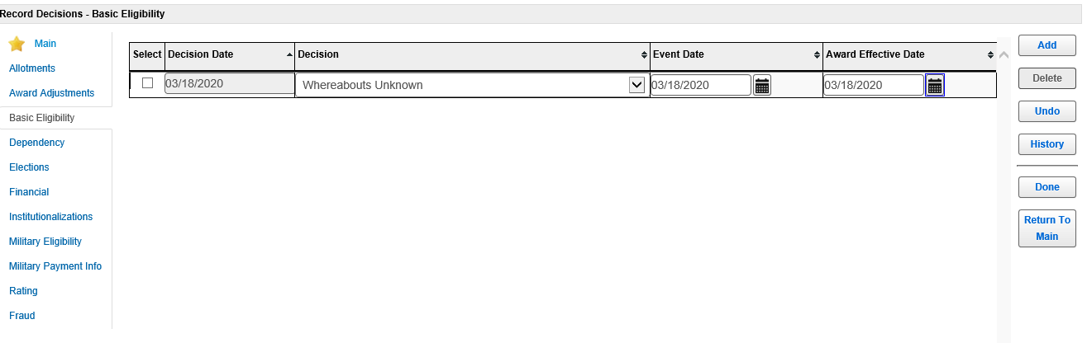

If there isn’t a running award but a claim is pending, use the Basic Eligibility tab in VBMS-A to deny the claim for the reason *Whereabouts Unknown.* **Use today’s date as the event date and award effective date. Generate the award and notification as normal**.

**Suspending a Running Award (PPT Slide 10)**

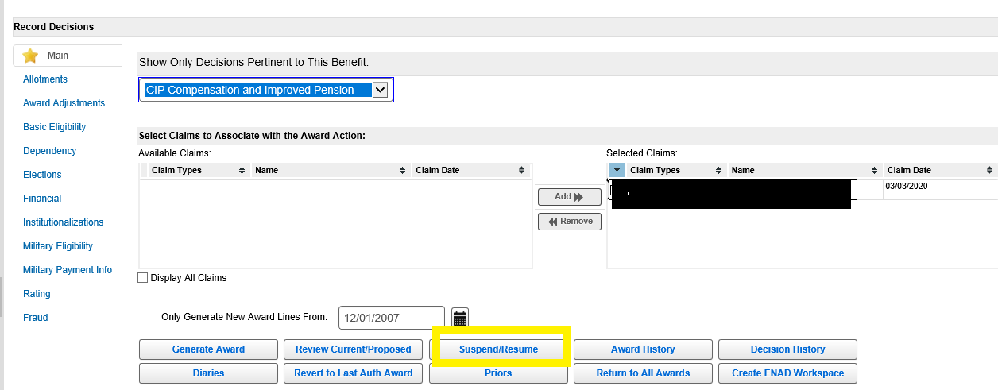Top of Form

After selecting Record Decisions in VBMS-A, click on Suspend/Resume to begin the process of suspending a running award.

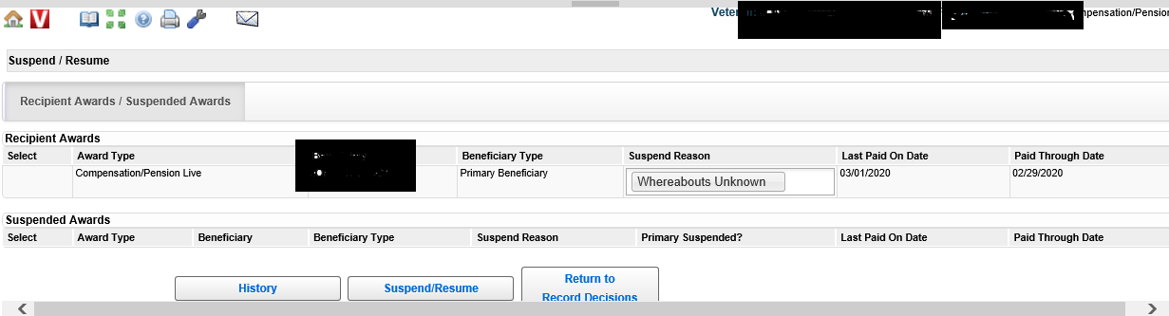

Choose *Whereabouts Unknown* for the Suspend Reason. Benefits should be suspended effective the date VA last paid the Veteran. The system will auto-populate the Last Paid on Date field with this date. (The Award Information tab in Share also displays the date VA last paid a beneficiary.) Click on the Suspend/Resume button to go to the next screen.

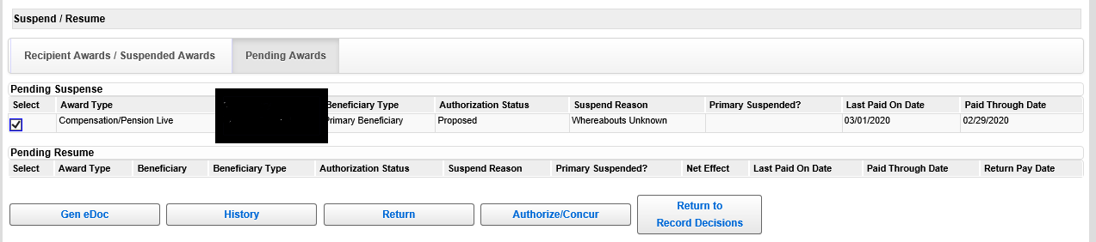

The suspense action should now be pending in VBMS-A. This action must be authorized by a Senior Veterans Service Representative (SVSR), or another authorizing employee, on the Suspend/Resume screen.

Topic 3: 810 WIs Associated With a Veteran’s Disappearance

**Generation of 810 WIs Associated With a Veteran’s Disappearance**

When two consecutive checks to a Veteran are returned indicating *Whereabouts Unknown* or *Moved Left No Address*, payments are automatically suspended during processing of the returned check, and an *810 Work Item, Notice of Benefit Payment Transaction* (810WI) is generated with message code 612*, Account Suspended – Undeliverable Payment*.

**Processing an 810WI**

|  |  |
| --- | --- |
| **If…** | **Then...** |
| no award action is required | * allow the suspension to continue, and * follow the instructions in [M21-1, Part III, Subpart vi, 8.1.c](https://vaww.vrm.km.va.gov/system/templates/selfservice/va_kanew/help/agent/locale/en-US/portal/554400000001034/content/554400000014302/M21-1,-Part-III,-Subpart-vi,-Chapter-8---Miscellaneous-Authorization-Issues#1c) following receipt of the six-month follow-up notice on the 810WI. |
| * the Department of Veterans Affairs (VA) subsequently receives notice of a valid address, and * entitlement is otherwise in order | restart the award effective the date in the LAST PAID DATE field on the AWARD INFORMATION tab in Share. |
| in compensation cases, there is a deduction for payment of   * National Service Life Insurance * U.S. Government Life Insurance Premiums * Veterans Mortgage Life Insurance Premiums, or * insurance loan payments | take award action to continue the insurance deduction. |

**Finding Deductions in Share**

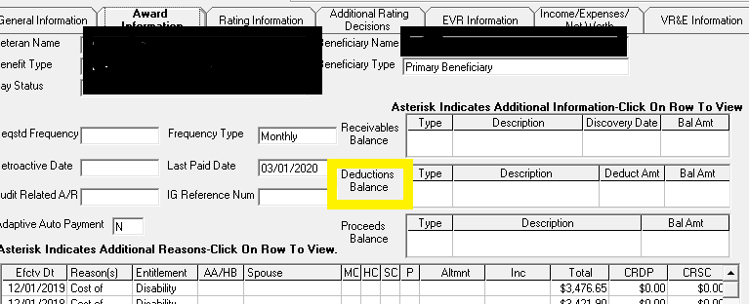

The Deductions Balance section on the Award Information tab in Share shows the type of deduction, a description of the deduction, deduction amounts, and the overall balance of the deduction (if applicable).

The Last Paid Date for the Veteran’s award is also located to the left of the Deductions Balance.

**Actions to Take Upon Receipt of a Six-Month Follow-Up Notice on an 810WI**

Following receipt of a six-month follow-up notice on an 810WI, attempt to obtain a current address from the Veteran by telephone. If efforts are successful, then update the corporate record to reflect the correct address and resume the Veteran’s award in VBMS-A effective the date VA last paid the Veteran (discussed in Topic 5).

If efforts to obtain an address by telephone are unsuccessful, then follow Steps 1 through 6 of the procedure described in [M21-1 III.ii.1.B.6.d.](https://vaww.vrm.km.va.gov/system/templates/selfservice/va_kanew/help/agent/locale/en-US/portal/554400000001034/content/554400000014111/M21-1,-Part-III,-Subpart-ii,-Chapter-1,-Section-B---Mail-Management#6) These are the initial steps that the IPC takes upon receipt of undeliverable essential mail (also see p. 4-6 of this handout).

If these procedures are followed and an address is not obtained, then take the following steps:

* Leave a note in VBMS detailing what actions were taken to obtain a correct address, and
* Stop the Veteran’s award as of the date in the LAST PAID DATE field on the AWARD INFORMATION tab in Share, using *Whereabouts Unknown* in the DECISION field on the BASIC ELIGIBILITY tab.

Provide the Veteran with a decision notice as to the action taken and provide the applicable laws and regulations: 38 CFR 3.158 and 38 CFR 3.656.

***Important:***When a Veteran’s award is stopped for the above reason, the decision notice associated with this action will likely be returned as undeliverable.  If this occurs, there is ***no*** need to treat the returned decision notice as undeliverable mail.

Topic 4: Payments to Dependents Upon the Disappearance of a Veteran

**Payments to Dependents**

Under [38 CFR 3.656](http://www.ecfr.gov/cgi-bin/text-idx?SID=1fc030aea94a472b0906597411a7e462&mc=true&node=se38.1.3_1656&rgn=div8), if a Veteran was receiving, or was entitled to receive, disability compensation and their whereabouts remain unknown for a period of 90 days or more, those benefits may be paid to or for

* a spouse,
* children, or
* parents.

**Eligibility Criteria**

In order for VA to pay benefits to dependents of a Veteran whose whereabouts are unknown, the dependent, or someone on their behalf, must make a specific request using VA Form 21-0788*, Information Regarding Apportionment of Beneficiary’s Award*.

If the legal relationship to the Veteran is not already established, the claimant must also complete and submit VA Form 21-686c, *Application Request to Add and/or Remove Dependents* and provide any required supporting documentation.

If VA Form 21-0788 is received within one year of the last date VA paid benefits to the Veteran, then VA may pay benefits to the dependent effective that same date. However, if more than one year has elapsed, benefits may only be paid to the dependent effective the first of the month following the date VA received the application form.

**Payment Rates to Dependents**

In compensation cases, the rate payable to the dependent(s) is either the current Dependency and Indemnity Compensation (DIC) rate or the rate of compensation payable to the Veteran, whichever is less.

Please refer to [M21-1 III.vi.8.2](https://vaww.vrm.km.va.gov/system/templates/selfservice/va_kanew/help/agent/locale/en-US/portal/554400000001034/content/554400000014302/M21-1,%20Part%20III,%20Subpart%20vi,%20Chapter%208%20-%20Miscellaneous%20Authorization%20Issues#2) for additional information regarding payments to dependents upon the disappearance of a Veteran.

Topic 5: Actions to Take When VA Obtains a Current Address or Upon Reappearance of a Veteran

**When VA Obtains a Current Address**

When a valid mailing address is received for the Veteran, resume their award effective the Last Paid Date and notify the Veteran of the decision made. Provide the applicable laws and regulations for the notification letter: 38 CFR 3.158 and 38 CFR 3.656.

***Note:***Per [38 CFR 3.158(c)](https://www.ecfr.gov/cgi-bin/text-idx?SID=ad275643432556b9dda942343fb89296&mc=true&node=pt38.1.3&rgn=div58" \l "se38.1.3_1158), payments can be resumed effective the date VA last paid benefits to the Veteran, regardless of how much time has passed since the Veteran’s award was suspended or stopped. There is no time limit regarding retroactive benefits in this instance*.* (only applies to awards *not* paid to a dependent based on disappearance of the Veteran).

If VA is paying the Veteran’s benefits to their dependent(s) based on the Veteran’s disappearance:

* Discontinue any awards to their dependent(s) effective the date VA last paid benefits (see the Date Last Paid field on the Award Information tab in SHARE)
* Send a decision notice to the dependent(s), informing them of the reason the award was discontinued, and
* Resume the Veteran’s award in accordance with the facts found and send them a decision notice.

**Resuming the Veteran’s Award in VBMS-A if Suspended**

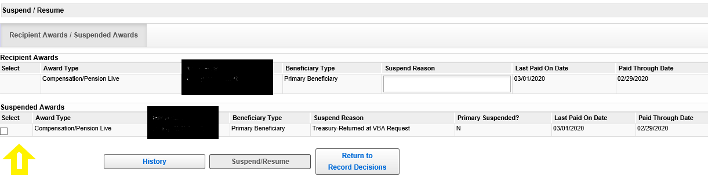

Benefits are resumed using the Suspend/Resume screen in VBMS-A. Select the box under the Suspended Awards heading and then click on the Suspend/Resume button.

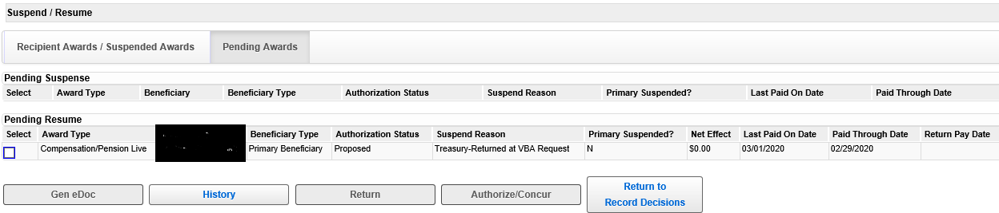

The award should now be pending resumption. An SVSR will need to authorize the action. To authorize, check the box under the Pending Resume heading and then click the Authorize/Concur button.

**Awards Stopped Due to Whereabouts Unknown**

If an award has been discontinued altogether due to *Whereabouts Unknown*, go to the Basic Eligibility tab in Share, delete the *Whereabouts Unknown* decision, and generate the award. **Make sure to also resume the award if suspended.**

Practical Exercise

1. What two CFR regulations provide guidance regarding Veterans whose whereabouts are unknown?

2. If VA has exhausted all efforts to obtain a Veteran’s current address, and no award is running but a claim is pending, which Basic Eligibility reason is used in VBMS-A to deny the claim?

3. What tab can you use in Share to determine if a Veteran has an insurance deduction from his award?

4. A Veteran’s payments were discontinued effective 2/01/2016 due to Whereabouts Unknown. VA has since received notice of a valid address on 1/28/2020. What is the effective date for resuming the Veteran’s award?