Generate Award Override (GAO) and

Gross and Net Rate Adjustments

Trainee Handout

**Table of Contents**

Objectives 2

References 3

Topic 1: Generate Award Override (GAO) 4

Topic 2: Processing an Award using the GAO Function 5

Topic 3: Other Adjustments in VBMS-A 11

Practical Exercise 15

Objectives

Upon completion of this lesson, the trainee will be able to:

* Define the function of the Generate Award Override (GAO) process
* Demonstrate how to process an award using the GAO function in VBMS-A
* Explain the five GAO processing actions and identify the correct use of each action to adjust a Veterans award
* Understand the other adjustment options that may be needed when adjusting an award
* Demonstrate the location and functionality of the other adjustment options within VBMS-A

References

* [M21-1, Part III, Subpart v, 8.B Paying Benefits to the Dependent(s) of an Incarcerated Veteran](https://vaww.vrm.km.va.gov/system/templates/selfservice/va_kanew/help/agent/locale/en-US/portal/554400000001034/content/554400000014272/M21-1-Part-III-Subpart-v-Chapter-8-Section-B-Paying-Benefits-to-the-Dependents-of-an-Incarcerated-Veteran?query=GAO)
* [M21-1, Part III, Subpart vi, 4.D Awards and Payments for Benefits due to Philippine Service](https://vaww.vrm.km.va.gov/system/templates/selfservice/va_kanew/help/agent/locale/en-US/portal/554400000001034/content/554400000014294/M21-1-Part-III-Subpart-vi-Chapter-4-Section-D-Awards-and-Payments-for-Benefits-Due-to-Philippine-Service?query=GAO)
* [M21-1, Part V, Subpart iii, 1.C Section 306 Pension & Old-Law Pension](https://vaww.vrm.km.va.gov/system/templates/selfservice/va_kanew/help/agent/locale/en-US/portal/554400000001034/content/554400000014413/M21-1-Part-V-Subpart-iii-Chapter-1-Section-C-Section-306-Pension-and-Old-Law-Pension?query=GAO)
* [M21-1, Part V, Subpart iii, 1.D Parent’s DIC](https://vaww.vrm.km.va.gov/system/templates/selfservice/va_kanew/help/agent/locale/en-US/portal/554400000001034/content/554400000014418/M21-1-Part-V-Subpart-iii-Chapter-1-Section-D-Parents-DIC?query=GAO)
* VBMS-A User Guide (Log in to VBMS-A & click “Awards Help”)
* [VETSNET Awards User Guide](https://vbaw.vba.va.gov/VetsNet/Awards_Docs/Awards%20User%20Guide.pdf)

All M21-1 references are found in the [Compensation and Pension Knowledge Management (CPKM) Portal](https://vaww.vrm.km.va.gov/system/templates/selfservice/va_kanew/help/agent/locale/en-US/portal/554400000001034/topic/554400000003061/M21-1-Adjudication-Procedures-Manual).

Topic 1: Generate Award Override (GAO)

The Generate Award Override (GAO) function is used to bypass system edits and modify a proposed generated award when, after verifying accuracy of data entry and decision input, the proposed award is incorrect (i.e. is missing award lines or contains inaccurate payment amounts). To modify the generated award, the user has the option to either copy the award lines generated to begin the required changes or to start with an empty set of award lines. Award lines may be modified, removed, or added using this feature.

Awards generated using the GAO function always require a third signature before the award is finalized. This is because users are manually overriding the system and it is critical that the changes are accurate and required.

Refer to M21-1 III.v.8.B.1.g, V.iii.1.D.5.d, III.vi.4.D.2.f and V.iii.1.C.4.i for specific circumstances which may require use of the GAO function. Please note that additional circumstances may arise requiring the GAO function, which will be determined on a case-by-case basis.

Award transactions requiring use of the GAO function should be made in VBMS-A but may be made in VETSNET Awards when necessary. The functionality in both systems is virtually the same. Please note that this lesson will only cover processing an award using the GAO function in VBMS-A. For more information about processing a GAO award in VETSNET, refer to the VETSNET-Awards User Guide.

The GAO function should only be used when no other option exists for correcting an incorrect award. This is because the GAO function is overriding the system and can cause issues and complications to a Veteran’s award. Additionally, once the GAO function is used when processing an award, it must be used again with each subsequent award. Lastly, if the award is returned for any reason, the modifications made to the proposed award using the GAO function will not be saved, so GAO will have to be used again to recreate the desired changes.

Topic 2: Processing an Award using the GAO Function

Awards requiring use of the GAO function should be processed in VBMS-A. Take the following actions after logging in to VBMS-A:

Begin by recording all the necessary decisions and generating an award.

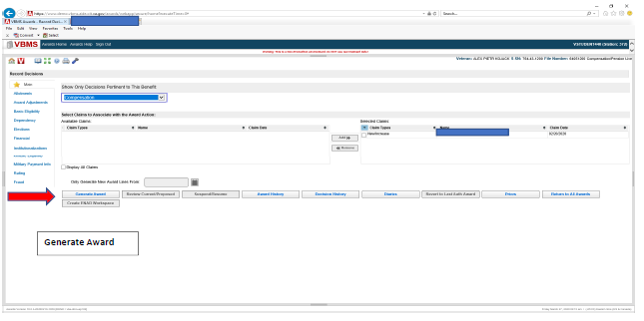

After clicking on the “Generate Award” button, select “Continue Generation.”

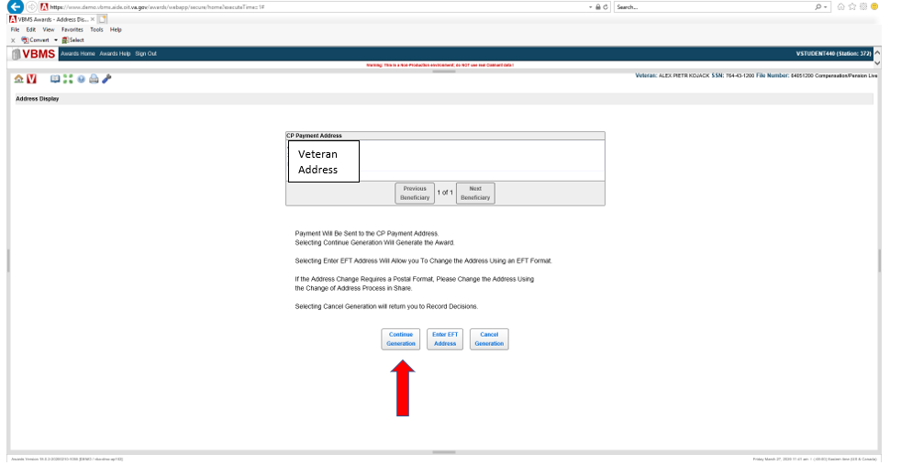

At this screen select “GAO.”

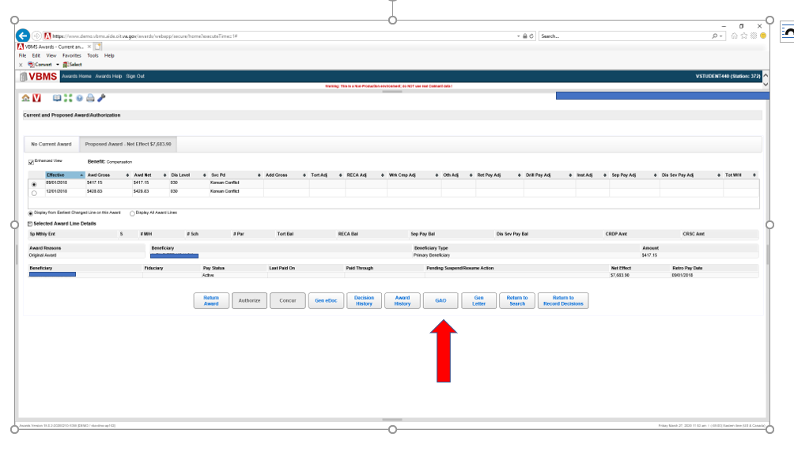

A message will display offering the option to copy the proposed award lines. Selecting “No” will open a blank GAO screen where all the lines must be manually constructed. Selecting “Yes” will open the GAO screen with all the proposed award lines displayed.



Once a selection is made, the following screen will appear. The actions that can be taken on this screen are “Add, Edit, Delete, Purge, Revert and/or Generate.”

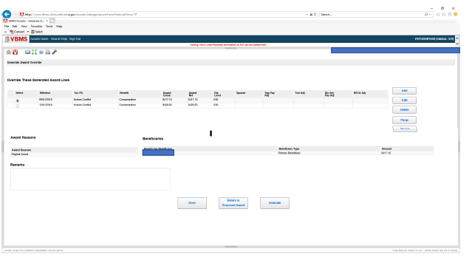

A breakdown of the selections are as follows:

* The “Add” button allows the operator to add a new award line.
* The “Edit” button displays the selected record in the detail area for modificition.
* The “Delete” button will delete the selected record.
* Selecting “Purge” completely removes all GAO updates since the last authorized award.
* The “Revert” button restores all items to the stored values as they existed when the page was first accessed.

Once selecting the “Add” or “Edit” button, the system will display the GAO Worksheet. The information populated in the worksheet fields will be from the award line that was highlighted at the time the “Add” or “Edit” button was selected. All fields with an asterisk (“Benefit, Effective, Svc Pd, Dis Level, Award Gross”) require an entry but can be edited.

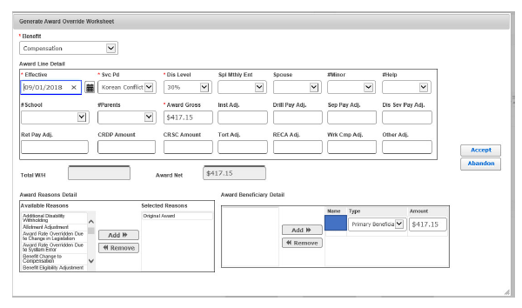

The following is an example of how to add an award line.



1

3

4

3

3

2

1. Benefit – Select the benefit type of the award
2. Enter the award“Effective”date for the new award line
3. Update all other fields requiring a change. **NOTE:** the “Award Gross” and the “Amount” must be the same.
4. Select “Accept” to save the data, close the screen and return to the GAO screen, which will be displayed with the newly added award line.

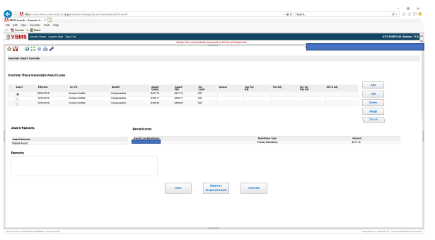

6

5

1. Record the justification for overriding the system in the “Remarks” block.

**NOTE**: Ensure the remarks include a detailed note as to the specific adjustment made and why use of the GAO function was necessary.

6. Select “Generate” to generate the award.

On the proposed award tab, an asterisk will be displayed next to the award line that was created using the GAO function, as shown below.

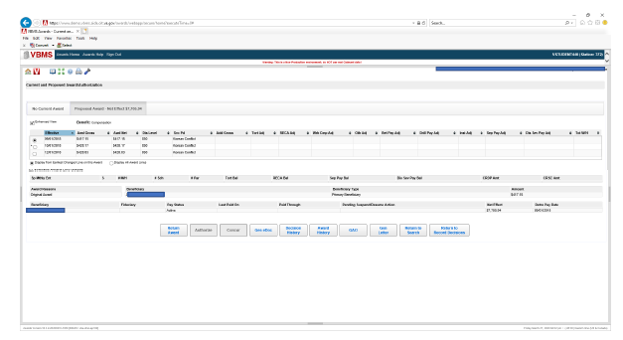

The following are the additional GAO functions:

**Delete Record** - In the event award lines need to be deleted, click the award line that needs to be deleted. Click the “Delete” button and click “Accept”. The following dialog box will appear.



**Purging All GAO Worksheets** - In the event all previous prior payment information needs to be purged, click on one line, select “Purge” and the following dialog box will appear.



Selecting “Yes” will purge all previous payment information since the last authorized award event. When finished, click the “Done” button.

**Reverting GAO Worksheet Changes** - In order to restore all prior payment information to the original values after using the add, edit, or delete function, click the “Revert” button. The following dialog box will appear.



By selecting “Yes” all of the prior payment information will be restored back to the stored values as they existed when the page was first accessed.

Topic 3: Other Adjustments in VBMS-A

Besides the GAO function, VBMS-A has other functionalities that allow the VSR to manually adjust a system-generated rate or create a new payment line that the system could not generate on its own due to system limitations. These functions are found among the multiple selections within the Other Adjustments tab in the Award Adjustments screen in VBMS-A. These functions include: Add to Gross Rate, Replace Gross Rate, and Preserve Net Rate.

It is important to note that the use of these Other Adjustment functions does not require a third-person signature like the GAO function. These functions only require the signatures of the promulgating VSR and the authorizing VSR. Therefore, it is very important for the VSR to be knowledgeable concerning the use of these functions and accurate in their data entry for claims that require them.

**Add to Gross Rate**

The Add to Gross Rate function allows the VSR to add an additional amount to the system-generated payment line, effectively increasing the payment by the adjusted amount entered for the period of time specified.

M21-1 requires use of the Add to Gross Rate function in the elimination of an overpayment that results from correcting an administrative error. When the error that originally paid the Veteran more than their entitled amount is corrected, the system will show the new, lower entitlement amount, which will result in an overpayment. However, since the overpayment was due to an administrative error on the part of the VA and not the fault of the Veteran, the overpayment will not be charged to the Veteran and should be corrected using this Add to Gross Rate function so that the overpayment is eliminated. (M21-1 III.vi.2.B.3.e)

Also, this function could potentially be used in situations such as the historical “kicker” rate payable for the month of March 1992, a one-time increase paid that month based on a delayed cost-of-living adjustment increase from an earlier time period.

**Replace Gross Rate**

The Replace Gross Rate function does exactly what it says, replacing the gross rate amount generated by the system with the amount entered on that screen for the indicated period of time.

There are no instructions in M21-1 that require the use of this functionality at this time. However, the VA system user guide (VETSNET) provides an example of when this function might possibly be used. For example, when processing a claim that will pay benefits retroactively prior to October 1, 1982, VBMS-A cannot calculate rates prior to that date due to system limitations. Using the Replace Gross Rate function would allow the VSR to create those award lines and properly pay the Veteran.

**Preserve Net Rate**

The Preserve Net Rate function can be used to prevent other actions that might fully withhold the benefits payable, such as a withholding due to receipt of separation benefits. M21-1 is very specific about the circumstances under which this function should be used.

M21-1 III.v.4.B.4.b provides step-by-step instructions for using the Preserve Net Rate function under a given set of circumstances that includes awarding benefits to a Veteran who received Voluntary Separation Pay from the Air Force.

M21-1 III.v.4.B.7.a provides step-by-step instructions for using the Preserve Net Rate function when granting a request that VA adjust the amount of a withholding (that is in place to recoup separation benefits) because of extreme financial hardship.

**Location of Functions Within VBMS-A**

When the VSR has logged into VBMS-A, entered the Veteran’s file number, and selected the appropriate end product (EP) under which they will create the award, the VSR can begin the process of adding the needed adjustment by selecting the Award Adjustments screen from the main menu on the left side of the screen.

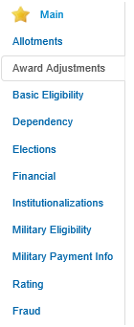

Once selected, the system will open the Award Adjustments screen, the same screen the VSR would use to make adjustments based on a Veteran’s receipt of military pay, such as retired pay, separation or severance pay and drill pay. (The VSR may remember the Award Adjustments screen has tabs that allow for the recoupment of/adjustments for each type of military pay.) The VSR must then select the Other Adjustments tab to access the Add to Gross Rate, Replace Gross Rate, or Preserve Net Rate functions.



When the VSR selects the Other Adjustments tab, the following screen appears.

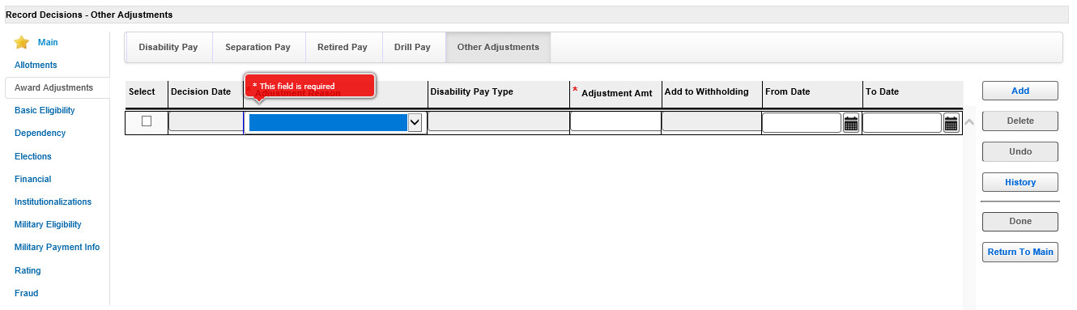

The VSR must first select the adjustment reason (Add to Gross Rate, Replace Gross Rate, Preserve Net Rate).

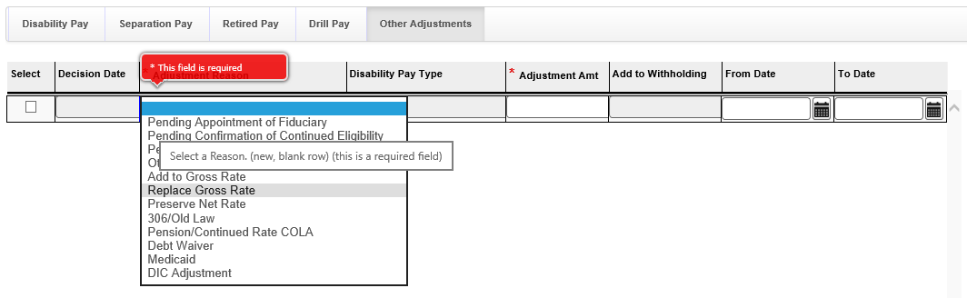

After making the appropriate selection, the VSR must complete the remaining fields, which includes fields for the adjustment amount and the dates for which the adjustment will begin and end.

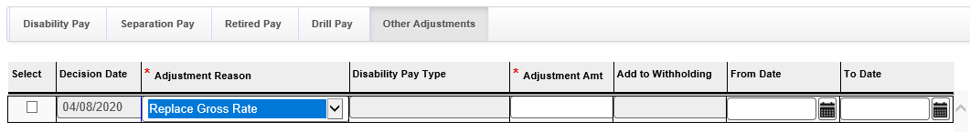

As always, when entering data into VBMS-A, the VSR must be sure to select the Done button prior to leaving the page in order to save the data that has been entered.



After saving the data, the VSR can leave the Other Adjustments tab and take any other actions or enter any other decisions that must be recorded prior to generating the award.

The VSR will need to follow through with the remainder of the award generation and decision notification process as they normally would for other award transactions. The promulgated award and appropriate decision notice would need to be routed to an authorizer for review and finalization.

*Note:* It is extremely important that the promulgating VSR provide a thorough explanation to the authorizing VSR in the **Remarks** section as to the adjustment action taken and the purpose behind that action.

For example, the VSR might explain the award was processed to correct the system concerning an administrative error, but in order to eliminate the overpayment, the VSR used the Add to Gross Rate function, adding $230 from May 1, 2019 to September 1, 2019.

This note will help the authorizer understand what action was taken and the reason for the action. Without these types of notes, the authorizer might have to spend an excessive amount of time trying to determine what action was taken and the purpose behind it.

Once authorized, the adjustment entered will remain in VBMS-A for that Veteran unless removed. If award actions are subsequently taken that include the time period covered by the adjustment, the VSR should be mindful of how that adjustment line then impacts the new award action and make corresponding adjustments, if needed.

The use of GAO or one of the other Award Adjustment options results in manual manipulation of entitlement amounts or payments to beneficiaries. It is critical that VSRs understand the implications of manual manipulation of an award and how to properly implement the adjustments on the current and future awards.

Practical Exercise

Please answer the following questions:

1. Explain what the GAO function is and what it is used for.
2. Give three reasons why the user should only use GAO when necessary.
3. Name the five actions that can be taken using the GAO function and their outcome.
4. List the three types of adjustments other than GAO that are discussed in this training and the functions that they perform.
5. In what screen and under what tab in VBMS-A can these three adjustments be found?