**Department of Veterans Affairs, Veterans Benefits Administration, Fiduciary Service, STAFF**

**Examination Request Routing Assistant (ERRA)**

**Purpose**

This document provides an overview of ERRA tool

# Design

The ERRA tool is designed as a guide to assist in the routing of Compensation and Pension (C&P) examination requests.

The tool’s search results include information about the

* application to use for submitting the examination request
* facility routing location
* the routing location and exam list comments
* exam type details, and
* approximate distance (from the ZIP code entered, including driving distance and estimated time).

The ERRA tool determines if the C&P examination request should be sent to a Veterans Health Administration (VHA) facility or a contract examiner. This determination is based on the VHA’s workload capacity to complete timely C&P examinations, which is updated daily.

For VHA routing locations, ERRA makes distance calculations based on “As the Crow Flies” orthodromic distance. Wherever possible, ERRA also makes calculations based on driving distance and time.

# Application

Per ***M21-1 III.iv.3.A.1.d,*** use of the ERRA tool is mandatory for VA claims processors. Exceptions for mandatory use of the ERRA tool are examination request involving

* examination clarification
* examination addenda
* corrections to insufficient/inadequate examinations
* Medical opinions in support of claims filed under 38 U.S.C. 1151, or
* acceptable clinical evidence (ACE) examinations completed by a VHA practitioner assigned to serve the RO

# Usage

The ERRA tool can be found using the link on the Compensation service website under the *Medical Disability Exam Quality & Program Management Office (218)* heading or the following link:

<http://vbacoweb03.dva.va.gov/bl/21/ERRA/default.asp>

Claims processors input the ZIP code where the Veteran or beneficiary will reside at the time of the examination.

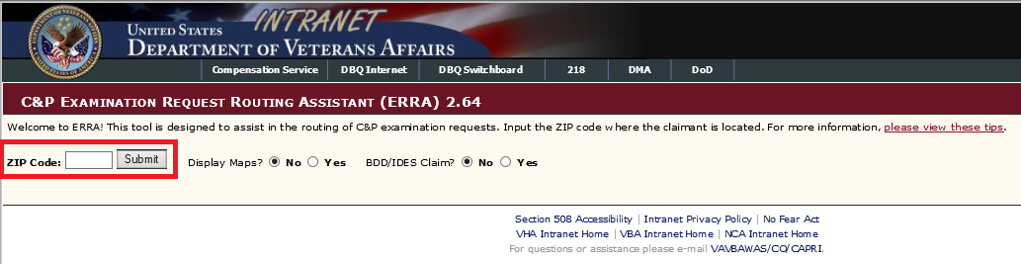

The ERRA tool makes a determination on whether examinations should be sent to VA (use CAPRI) or to a contract examiner (use VBMS) based on the type of examination needed. This determination is updated daily based on VA’s interval capacity to complete timely C&P examinations.

The ERRA tool will identify the

* 10 VA examination facilities nearest the ZIP code entered, and/or
* Contract examiner associated with the ZIP code entered, if applicable

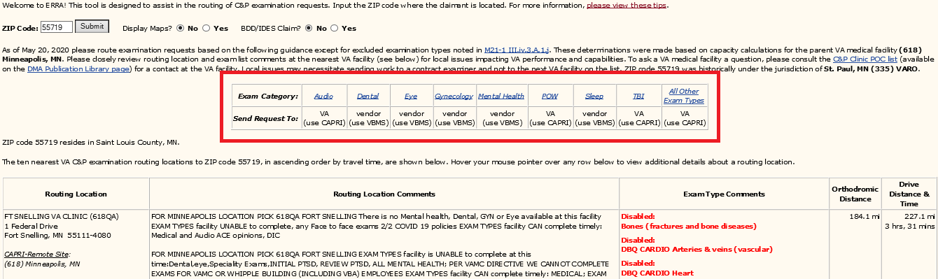

VA resources will be utilized to the fullest extent possible in performing examinations, but the use of contract/vendor resources is authorized whenever a VA examination facility has reached or exceeded maximum capacity.

Exam Category: Type of examination being requested.

Send Request To: This is the name and address of the routing location as it appears on the exam request screen in CAPRI.

Routing Location – This is the name and address of the routing location as it appears on the exam request screen in CAPRI.

Routing Location Comments – Any comments VHA has supplied in CAPRI related to the routing location (available exam types, capacity, timeliness).

Exam Type Comments – The ability to indicate which exam types are inactive and to add comments for individual exam types

Orthodromic Distance – The approximate mileage “as the crow flies” between the ZIP code input and the ZIP code of the routing location

Drive Distance & Time – ERRA calculates an approximate driving distance and time

Claims processors are required to associate the ERRA tool’s inquiry results with the claims folder. When uploading the results to the Veterans Benefits Management System (VBMS), users should identify the document by entering the following information:

SUBJECT: *ERRA Results*

CATEGORY – *TYPE: Medical Records- VAX& AMIE- Request Worksheets: VA Exam Worksheet*

SOURCE: *VBMS*

*ASSOCIATE TO: (End product for which examination is being requested)*

# Notes

* Any justifiable deviation from the ERRA tool’s recommendations must be explained as a

remark in the examination request’s body.

* When routing an examination request, take into account any Veterans or beneficiaries preferences or topography/driving concerns.

* Requests for C&P examinations scheduled through a designated contractor are limited to the geographic area specified by the contractual agreement.

* Examinations ***must not*** be requested from contract examiners under the circumstances specified in the [*Contract Exam Exclusions List*.](https://vaww.vrm.km.va.gov/system/templates/selfservice/va_kanew/help/agent/locale/en-US/portal/554400000001034/content/554400000056862/Contract-Exam-Exclusions-list) Claims examiners may also see M21-1 III.iv.3.A.1.j