**CAPRI Job Aid**

Pick the VAMC based on the ERRA recommendation.

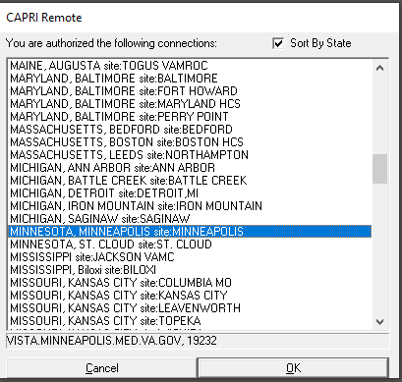

Enter in the veteran’s SSN to find the veteran in the VHA’s data base. If they have never been seen before at the VHA, then you will have to enter in new patient information.

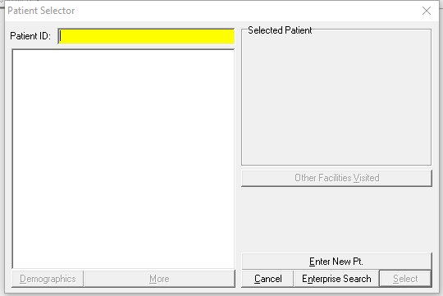

Capri will bring you to the C&P page where you can add a new request.

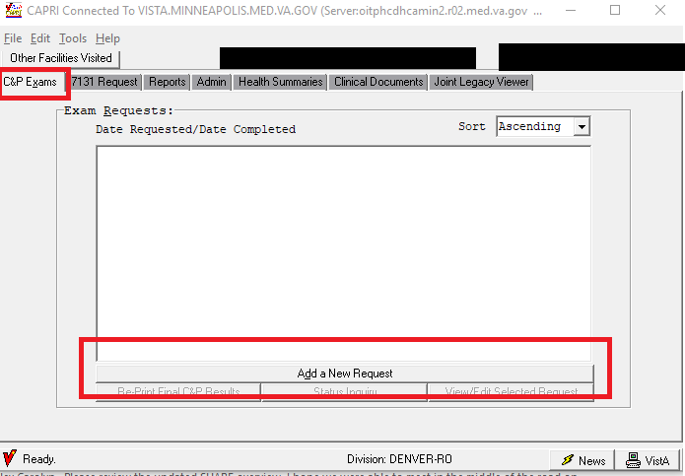

If you did not enter a new patient, make sure to verify the address, then click “ok”.

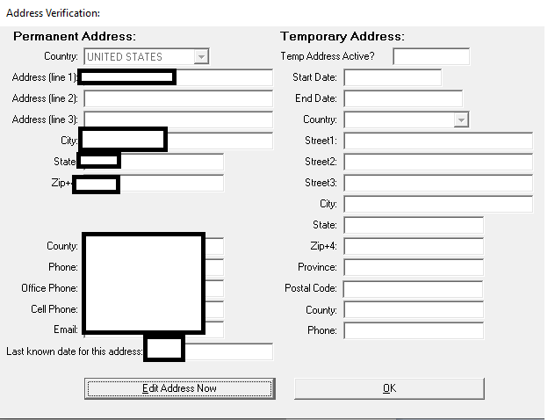

Complete the fields on the next screen:

Claims folder is not required because this is asking if a physical file needs to be shipped to and received at the VAMC.

The eFolder is available.

For claim type, select original because the competency contention is what we are referring to.

If there are any special considerations, let the VAMC know.

If there was a previous rating exam, put that date in the last rating exam date box.

The routing location will be based on where the ERRA tool said to go.

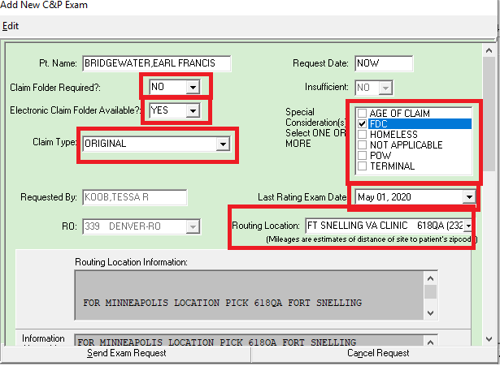

Scroll down and select the DBQ(s) you need. Then in the comments copy and paste the ERB you created. Then click “send exam request”.

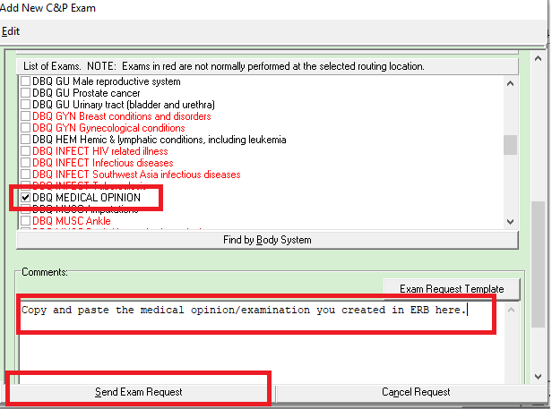

Then your exam request will be submitted. When it’s complete, VHA usually uploads the exam results right to VBMS. However, you may check capri for results. You will know it is completed because next to the date requested will be another date with the day it is completed. You can double click on the exam request and scroll down to the “exams requested”. If it is complete you will see “(COMPLETE)” next to the exam. You can double click next to your exam to retrieve the results.

